 **Bangladesh Open University**

**School of Science and Technology**

**Bsc in Computer Science and Engineering**

**Lab report no. : lab-02.**

**Report on : Stack**

**Course title : Data Structure Lab**

**Course code : CSE21P6**

**Submitted By :**

**Student’s name :MD Rafsan Jani.**

**Student’s ID : 18-0-52-020-023.**

**Semester : 2nd year, 1st semester.**

**Session : 2018 – 2019.**

**Batch : 6th.**

**Submitted To :**

**Mr Md. Mahbub Hasan**

**Assistant Professor,**

**Department of Computer Science and Engineering**

**DUET**

**Date of Submission : 25 January, 2021.**

**Study Center : Dhaka University of Engineering and Technology, Gazipur**

Implement linear search.

**print ("-----Lnear Search-----")**

**def leaner_search(data):**

**list = []**

**for x in data:**

**list.append(x)**

**print ("[##] data is recorded .. Now Search Data in Record")**

**def run():**

**print("-"*10)**

**search_data = raw_input("[+]Input for Search data in record==>")**

**for x in list:**

**if search_data in x:**

**print ("[+] Your input ({}) data is found in ({}) this Record ".format(search_data,x))**

**else:**

**print("[!!!] Your input ({}) data Is NOT found in ({}) this recoderd ".format(search_data,x))**

**while 1: run()**

**if __name__ == "__main__":**

**data = raw_input("[+]input data For Store (Use Space) ===>").split(',')**

**leaner_search(data)**

OUT PUT

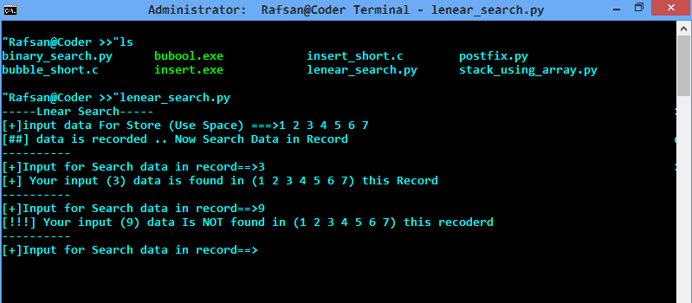

implement binary search.

**print ("-------Binary Search -------")**

**def binary_search(data):**

**global inp_data**

**global list**

**list = []**

**for x in data:**

**list.append(x)**

**print ("-"*10)**

**print ("[+]Record Data in list")**

**print ("-"*10)**

**inp_data = raw_input("[+] Now Search data ===>")**

**last = 0**

**high = len(list)-1**

**mid = 0**

**while last<=high:**

**mid = (high+last)//2**

**if list[mid] <inp_data:**

**last = mid+1**

**elif list[mid]>inp_data:**

**high=mid-1**

**else:**

**return mid**

**return -1**

**if __name__ == "__main__":**

**global inp_data**

**global list**

**data = raw_input("[+] Insert Data (Use Space) ===>").split(' ')**

**result = binary_search(data)**

**if result != -1:**

**print ("#"*10)**

**print ("[+] Yes Your input data ({}) is found in ({}) ".format(inp_data,list))**

**else:**

**print ("!"*10)**

**print ("[-] No Your data ({}) is not found in ({}) ".format(input_data,list))**

OUT PUT

