 **Bangladesh Open University**

**School of Science and Technology**

**Bsc in Computer Science and Engineering**

**Lab report no. : lab-03.**

**Report on : Stack**

**Course title : Data Structure Lab**

**Course code : CSE21P6**

**Submitted By :**

**Student’s name :Rabiya Akter.**

**Student’s ID : 18-0-52-020-054.**

**Semester : 2nd year, 1st semester.**

**Session : 2018 – 2019.**

**Batch : 6th.**

**Submitted To :**

**Mr Md. Mahbub Hasan**

**Assistant Professor,**

**Department of Computer Science and Engineering**

**DUET**

**Date of Submission : 25 January, 2021.**

**Study Center : Dhaka University of Engineering and Technology, Gazipur**

sort an array using Bubble sort

**#include <stdio.h>**

**void bubble_sort(int a[], int n) {**

**int i = 0, j = 0, tmp;**

**for (i = 0; i < n; i++) { // loop n times - 1 per element**

**for (j = 0; j < n - i - 1; j++) { // last i elements are sorted already**

**if (a[j] > a[j + 1]) { // swop if order is broken**

**tmp = a[j];**

**a[j] = a[j + 1];**

**a[j + 1] = tmp;**

**}**

**}**

**}**

**}**

**int main() {**

**printf("\n-------Short Arry using Bubbole Short Program-------\n");**

**int a[100], n, i;**

**printf("[+]Define your array Size ==>");**

**scanf("%d", &n);**

**for (i = 0; i < n; i++)**

**{**

**printf("[+] Ok now you Enter for No in Arry[%d]==>",i);**

**scanf("%d", &a[i]);**

**}**

**bubble_sort(a, n);**

**printf("\n-------======---------\n");**

**printf("[+] Operation Compleate ... Now your your Shorted Array is:===>");**

**for (i = 0; i < n; i++)**

**{**

**printf("%d ", a[i]);**

**}**

**return 0;**

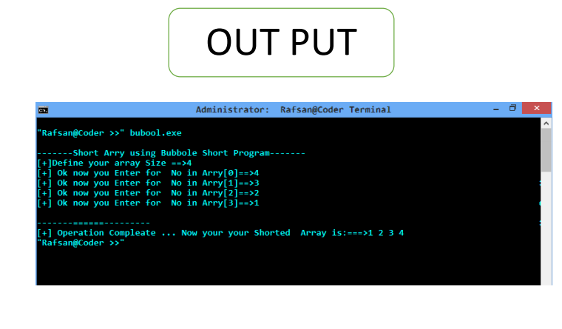**}**

**]]]]]**

**#include <stdio.h>**

**int main()**

**{**

**int n, i, j, temp;**

**int arr[64];**

**printf("Enter number of elements\n");**

**scanf("%d", &n);**

**printf("Enter %d integers\n", n);**

**for (i = 0; i < n; i++)**

**{**

**scanf("%d", &arr[i]);**

**}**

**for (i = 1 ; i <= n - 1; i++)**

**{**

**j = i;**

**while ( j > 0 && arr[j-1] > arr[j])**

**{**

**temp = arr[j];**

**arr[j] = arr[j-1];**

**arr[j-1] = temp;**

**j--;**

**}**

**}**

**printf("Sorted list in ascending order:\n");**

**for (i = 0; i <= n - 1; i++)**

**{**

**printf("%d\n", arr[i]);**

**}**

**return 0;**

**}**

