SPL Assignment :- 3 About How can I Write in a Text File with User input Features Support Using C Programming Code

This Assignment   
Create By   
MD Rafsan Jani   
Roll : 023

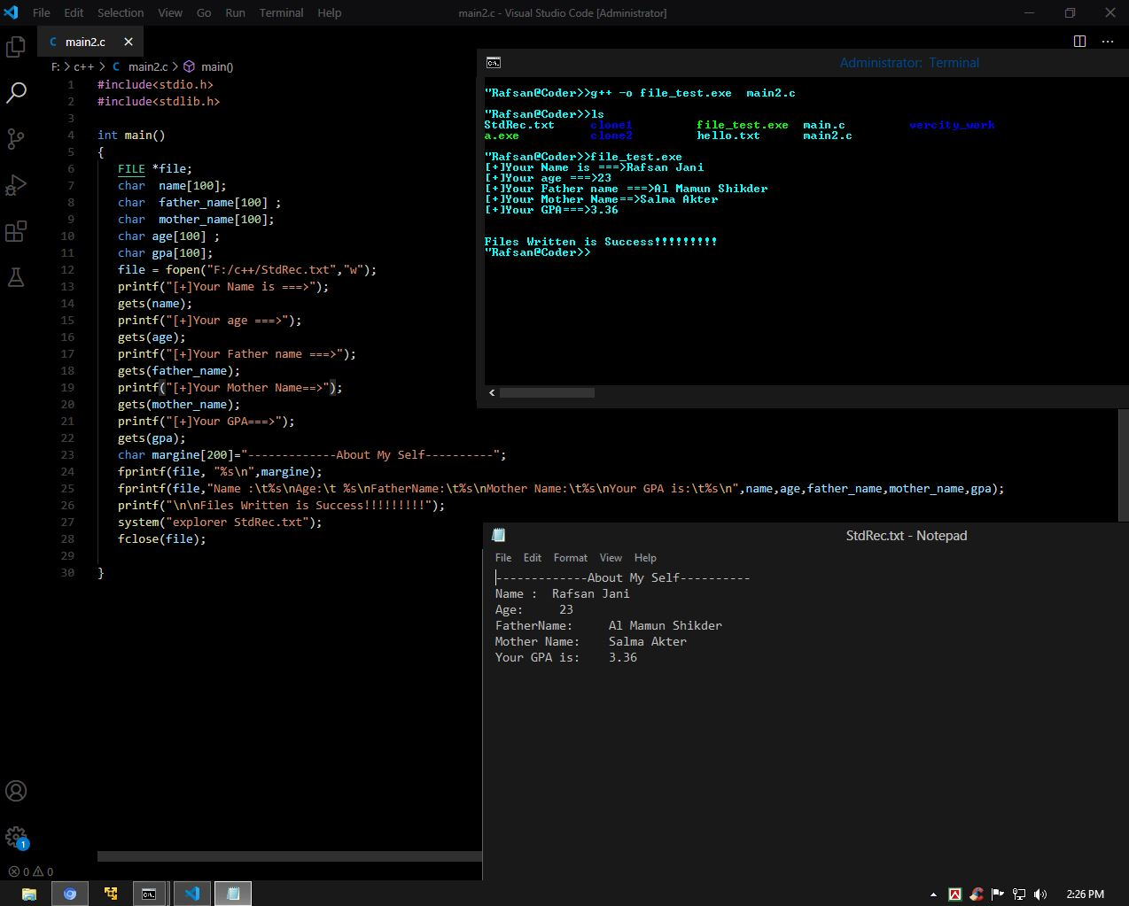

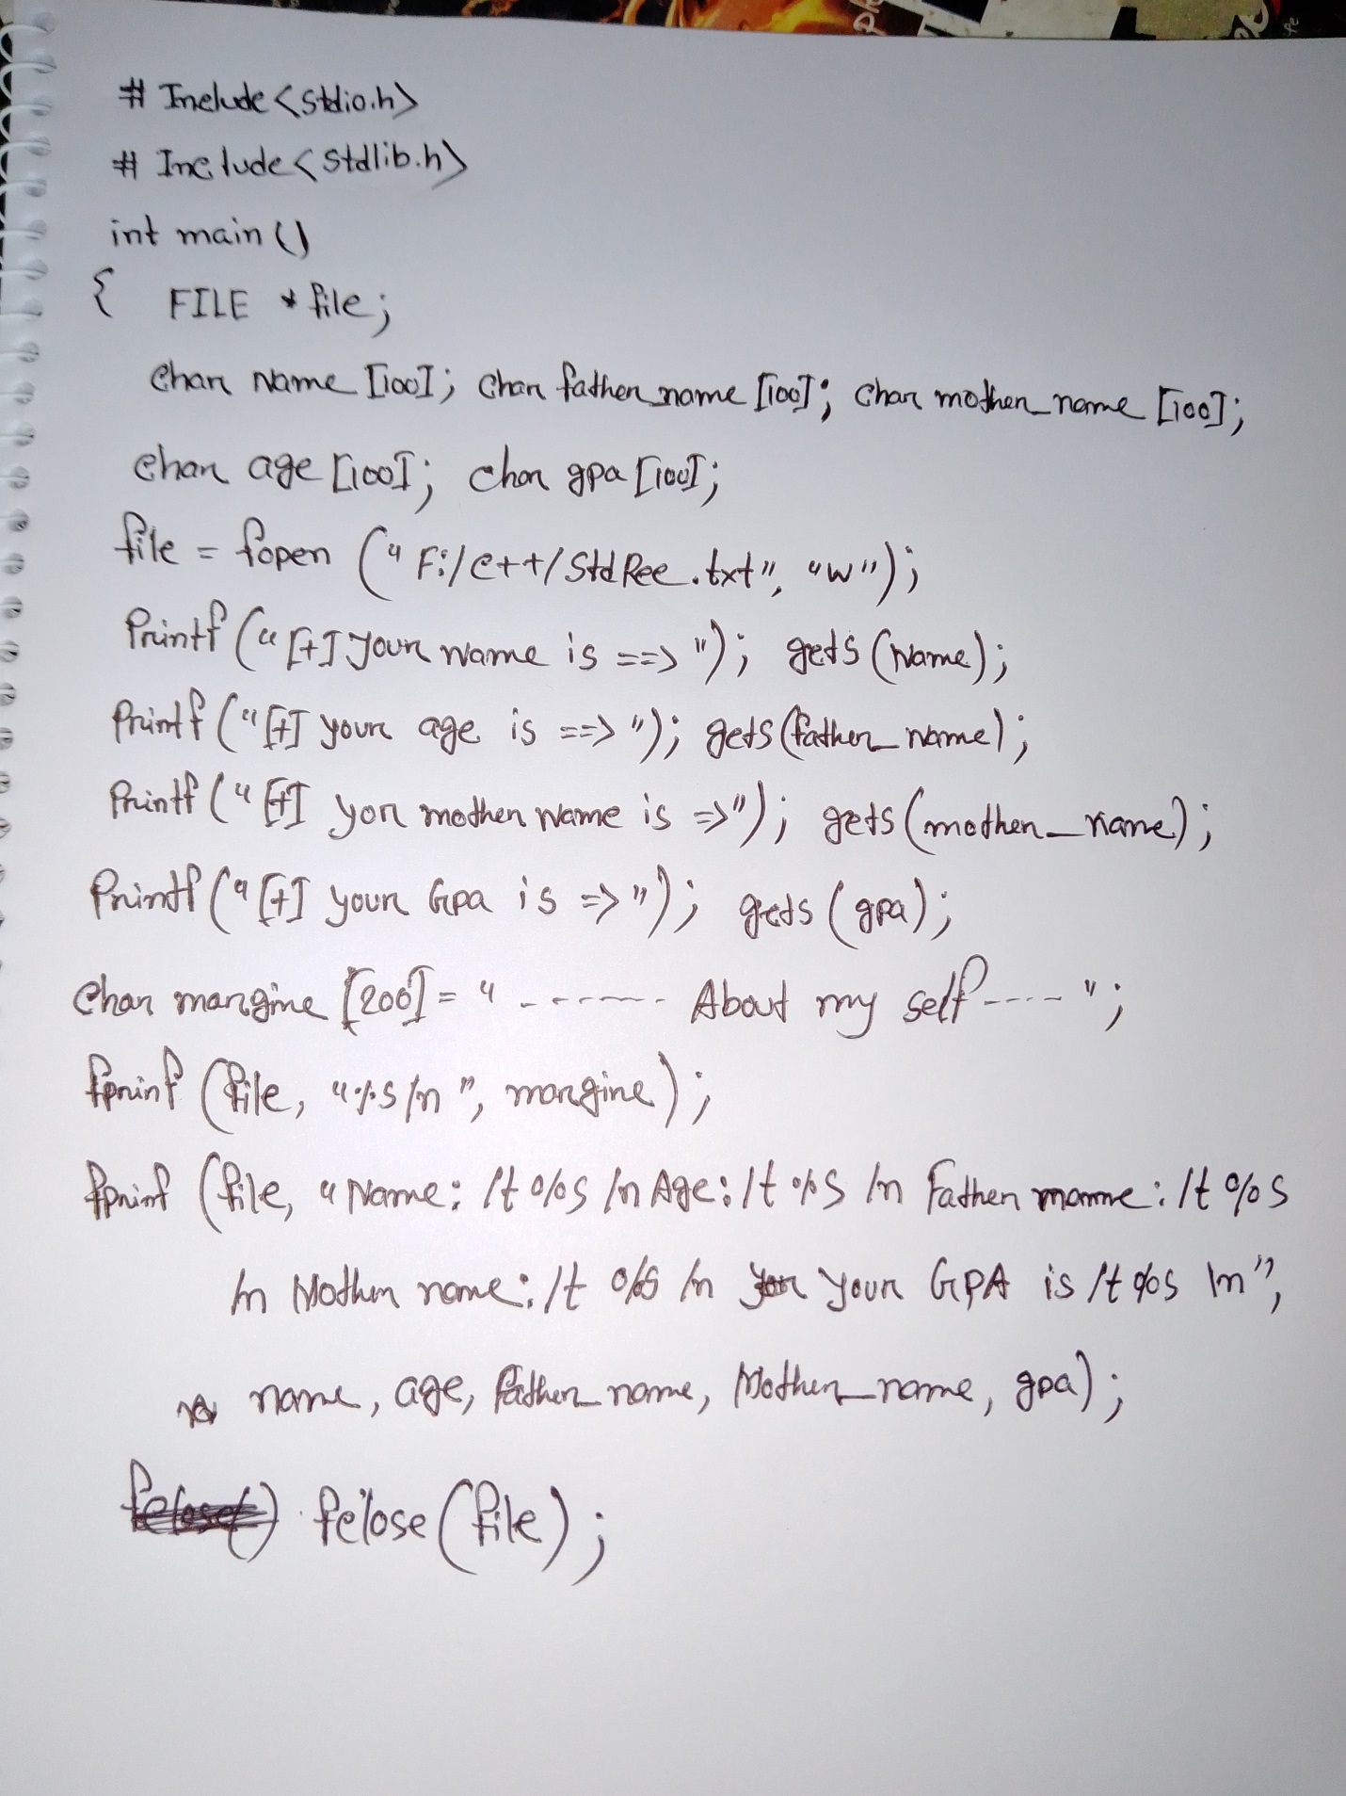

Thank You