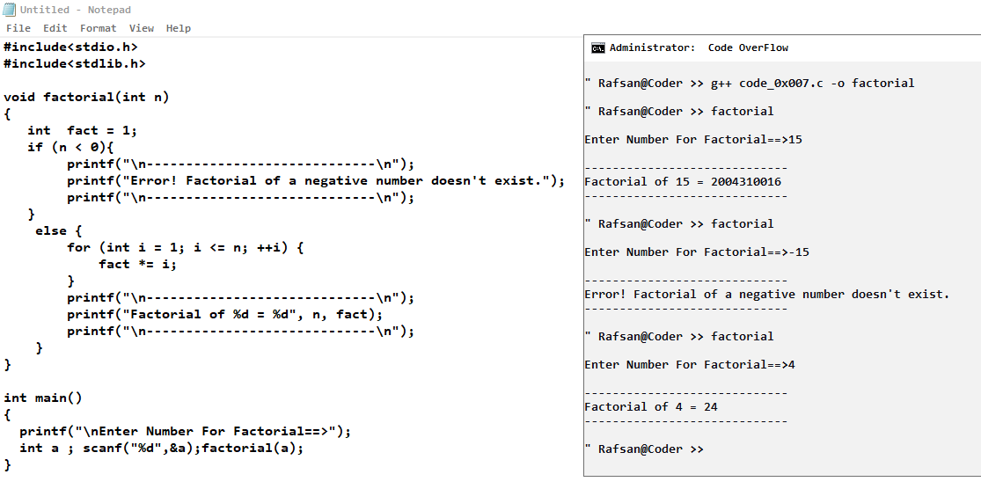

**Factorial >> code_0x007.c**

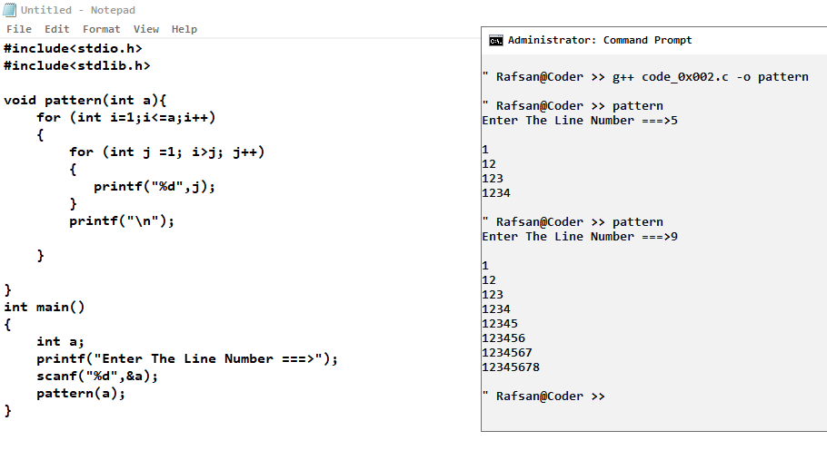

**Pattern >> code_0x002.c**

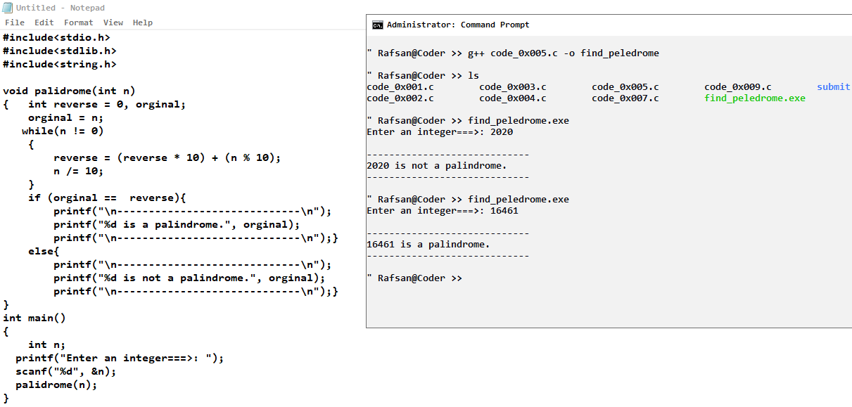

**Palindrome >> code_0x005.c**

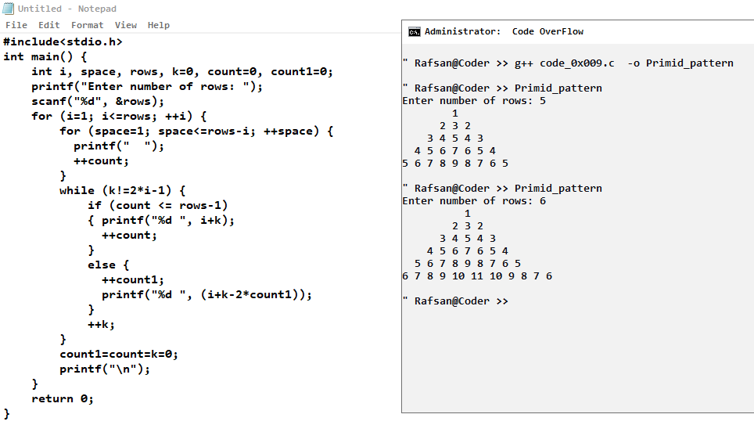

**Piramid_Pattern >> code_0x009.c**

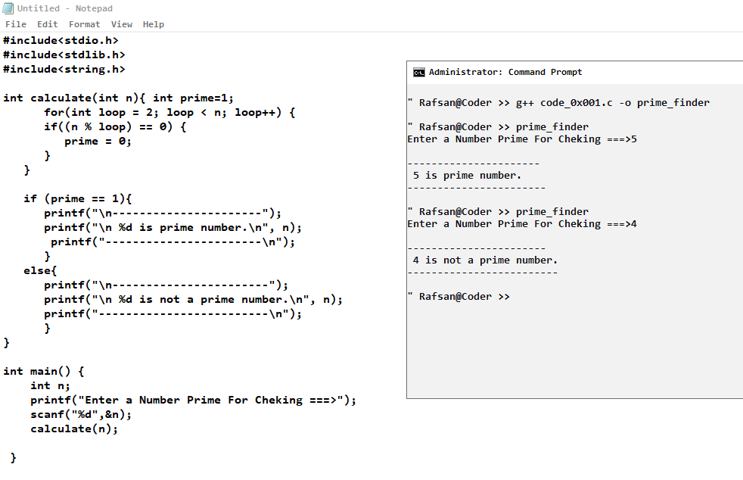

**Prime_finder >> code_0x001.c**

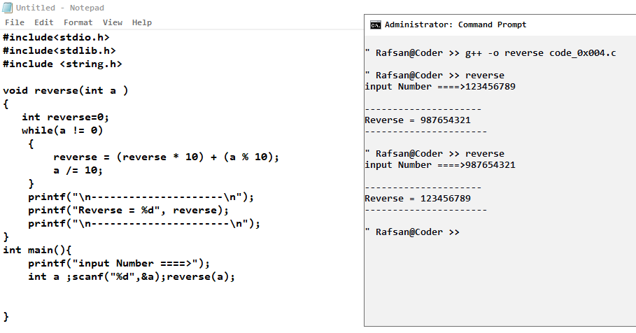

**Reverse >> code_0x004.c**

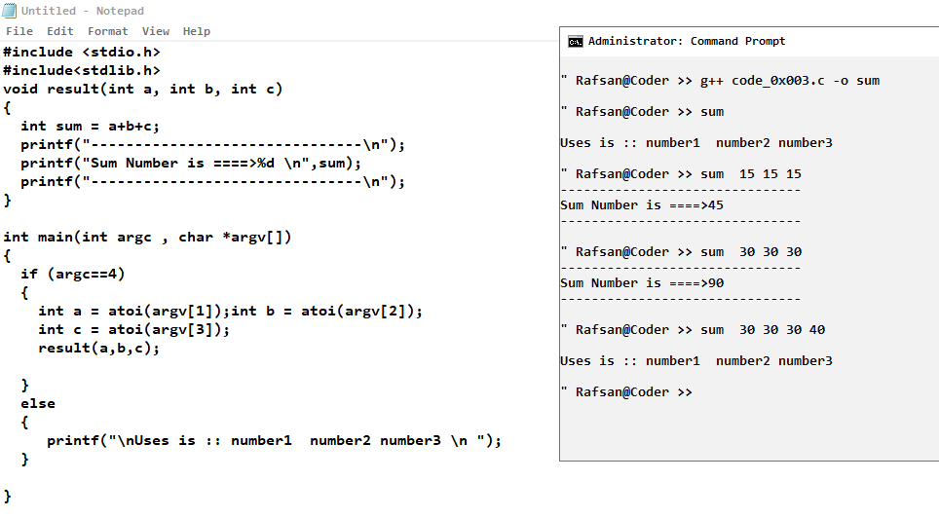

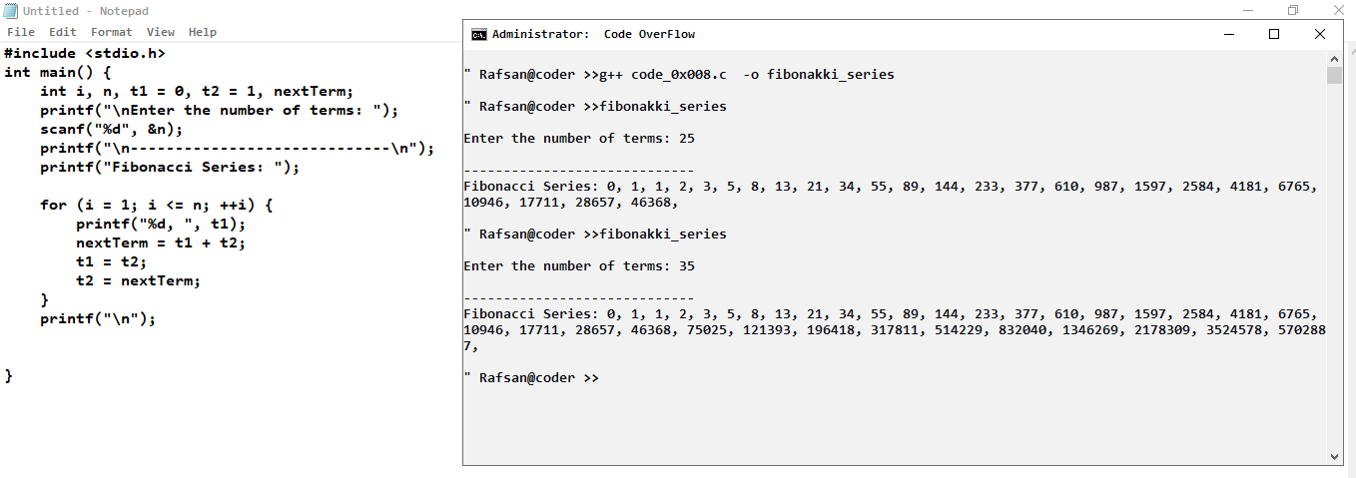

**Sum >> code_0x003.c**

**Fibonakki_series >> code_0x008.c**