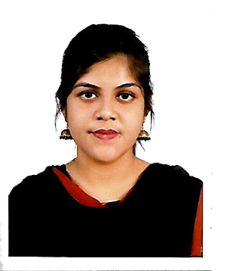

**Kashafa Sehejat Sezuti**

**Address**: 34/B, 3rd Colony, Lalkuthi Mazar Road,Mirpur-1

Dhaka -1216

**Mobile No**: +8801521330588

**Email**: [sezutikashfa@gmail.com](mailto:sezutikashfa@gmail.com)

**Objective:** Purposes to work in an environment that would be enable me to exert my academic knowledge as well as contribute to institution goals and would provide excellent opportunity for career advancement and personal growth.

**Education:**

|  |  |  |
| --- | --- | --- |
| **BSc**  **Institution** :American International University-Bangladesh  **Subject** : Computer Science & Engineering  **Academic Year:** 2016-2019  **CGPA: 3.86** | **HSC**  **Institution**: Dhaka City Collage  **Passing Year:** 2015  **Background** : Science  **GPA: 4.67** | **SSC**  **Institution**: Motijheel Government Girl’s High School  **Passing Year:** 2013  **Background** : Science  **GPA: 5.00** |

**Language Proficiency:** Bangla, English.

**Academic Achievements:**

• Achieved Merit-based scholarship (60%) for last six consecutive academic semesters.

• 2016-2017 Dean’s Award.

• 2017-2018 Dean’s Award.

**Familiarity with Computers:**

* **Programming Language**: C, C++, C#, JAVA, PHP, HTMLS5, CSS3, ASP.Net, Bootstrap 4 and JS.
* **Database**: Oracle, MySQL, SQL Server.
* **Project Management Tools**: Visual studio, Notepad++, Eclipse, Code blocks.
* **Others**: Computer Graphics, Web Design

**Projects:**

* Freelancing website developed using **asp.net** (group project)
* BD Jobs (online job portal system) using **php, java script, html5, css3, ajax**.
* Emergency Medical Service developed by **asp .net**
* Blood donate (Blood Bank) developed by **.net**
* Broadband Management System by **java**

**Extra-Curriculum Activities:**

* Club Member (AIUB Shomoy Club).
* Volunteer.
* Event Organizer

**Skills:**

* **Software:** Microsoft Word, Power Point, Excel, Database, Email and Browsing.
* **Communication**: Excellent Interpersonal, communication and presentational skills

**Work experience:**

* **InterCloud Limited**

*3House No. Ga-30/G, Pragati Sarani, Bir Uttam Rafiqul Islam Ave, Dhaka 1212*

*Academic Programs Intern*  
 11th February, 2019 – 21th April, 2019 (10 weeks)

**References:**

1. **Mashiour Rahman**

Associate Professor, Associate Dean-In-Charge [FST]

American International University-Bangladesh

E-mail: mashiour@aiub.edu

Cell: + 88 01711521065

1. **Dr. Dip Nandi**

Associate Professor, DIRECTOR [FST]

Department of Computer Science

American International University-Bangladesh

E-mail: dip.nandi@aiub.edu

Cell: +88 02 8816173-4

1. **Abhijit Bhowmik**

Senior Assistant Professor, Special Assistant [OSA].

Department of Computer Science

American International University-Bangladesh

E-mail: abhijit@aiub.edu

Cell: +8801926836045