MAT 120 (lab)
Mathematica
Problem Sheet 1

Mathematical Functions: Basic Arithmetic and Elementary Functions

1. Write down the following expressions in mathematica and get the simplified form

a) 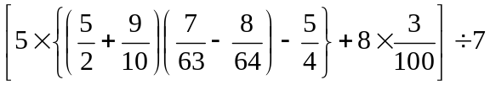
b) 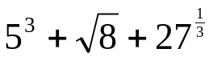
2. Find the approximate value of the expression given in 1 (b) up to 20th digit after decimal point. [Hint: use function N[] ]
3. Write down the following expression in mathematica and find out its approximate value up to 20th digit after decimal point.
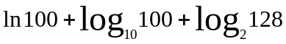

4. Write down the following expressions in mathematica:

a) 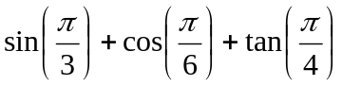
b) 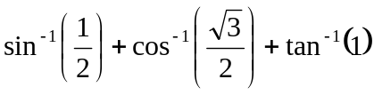
c) 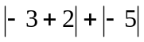
d) 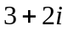
e) 
f) 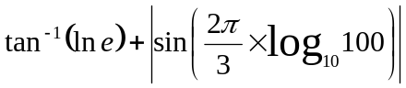
g) 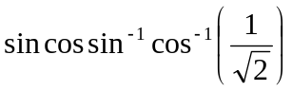
h) 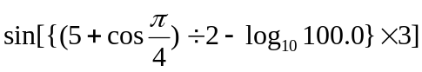
i) 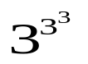and 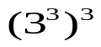

5. Write a = 5, b=6 then find a+b. Then clear a and b

6. Find the approximate values of i) , ii) e up to 20th digit after decimal point.

