MAT 120 (Lab)
Mathematica
Problem Sheet 2
Algebraic Computation: Basic Algebra & Formula Manipulation
- Write down the following algebraic expressions in mathematica:
- 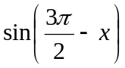 b) 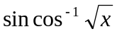 c) 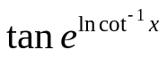
2. Find the value of the expression 1a) by replacing x by  (Use function ReplaceAll[])
3. a) Write down the expression: 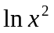
- Simplify the expression under condition: 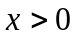 [Use function Simplify[]]
4. a) Write down the expression: 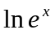
- Simplify the expression under condition: R
5. a) Write down the expression: 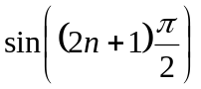
- Simplify the expression under condition: Z
6. a) Write down the expression: 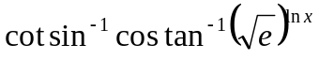
b) Simplify the expression under condition:
7. a) Write down the expression: 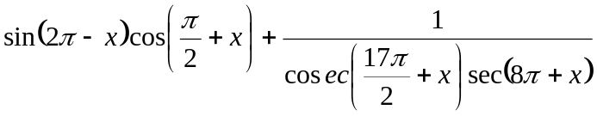
b) Simplify the expression
8. Simplify the expression: 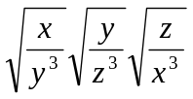 under condition 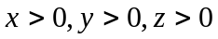
9. Factorize the following expressions: (Use function Factor[])
a) 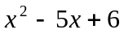 b)
10. Expand the following expressions: (Use function Expand[])
a) 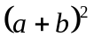 b) 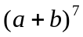
11. Express the following fraction as a linear combination of partial fractions: (Use function Apart[])
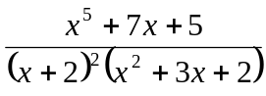
12. Express the following combination of fractions as a single fraction: (Use function Together[])
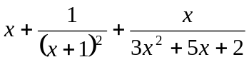
13. Cancel out the common factors of numerator and denominator from the given function: (Use function Cancel[])
