MAT 120 (lab)
Mathematica
Problem Sheet 3

Building Functions

- Build a function which takes a value as an argument and gives the value of
a) 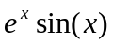 b) 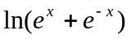
2. Build a function which takes two values and as arguments and gives the
value of a) 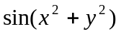 b) 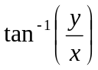
Numerical Computation: Sums & Products
- Find the summation of the following series:
a)
b)
c) 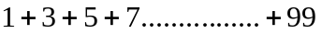
d) 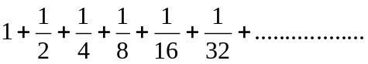 up to
2. Find the summation of the following series:
3. Find the product of the following series:
a) 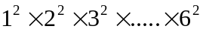
b)
4. Build a function called FormulaOfSummation[] which takes a number x as an
argument and provide the formula to compute the summation of the following
series up to n’th term.
Try to find FormulaOfSumation[1], FormulaOfSumation[2] and
FormulaOfSumation[3]
Numerical Computations: Equation Solving
1. Find the solution of the following equations:
a) 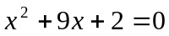
b) 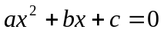
c) 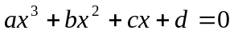
d)
e) 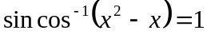
2. Solve the equations.
a) 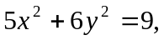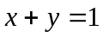
b)

3. Solve the equation 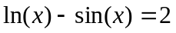
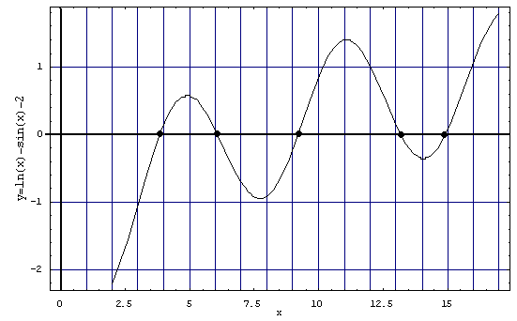
A 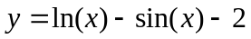vs. x graph is plotted above. The x coordinate of the points where the curve cuts the x axis are the roots of the equation. We can see there are roots near x = 4, 6, 9, 13 and 15. Find root near x=4

4. Solve the equations: 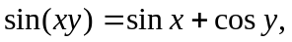 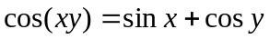for x and y
The curves representing the two equations are shown below. The thick curve is for the first equation and the thin curve is for the second equation. The coordinates of the point of intersection will be the solutions of the two equations. We can see there is a solution near x=0.6, y= 1.4. Find the approximate solutions.





