MAT 120 (Lab)
Mathematica
Problem Sheet 4
Graphics and Sound: 2D Plot, ContourPlot, PolarPlot, ParametricPlot
1. a) Plot the curve of following relation:
 for 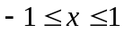
b) Label the axes
2. a) Plot the curve of following relation:
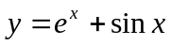 for 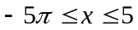
b) Label the axes
3. a) Plot the curves of following two relations in a single graph
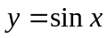 and 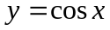both for 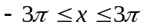
b) Use two different colors to distinguish them
4. a) Plot the curves of the following two relations in a single graph
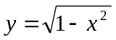 for and y = 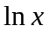 for 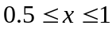
b) Use two different colors to distinguish them.
5. Draw the curves representing the following relations:
a) 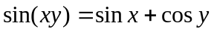 for 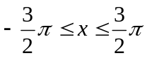 and 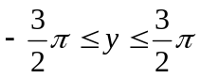
b) 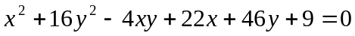for 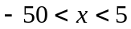 and -20 < y < 20

6. Draw the curves of the following equations in polar coordinates system:
a) 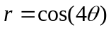for 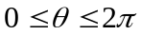 b) 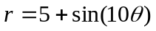for
7. Draw the curves of the following parametric equations:
a) 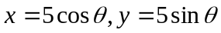 for
b) 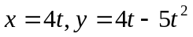for 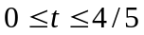

Graphics and Sound: 3D Plot, ContourPlot3D, RevolutionPolt3D,
1. Draw the curvatures corresponding to the following equations:
a) 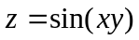for 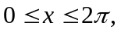and 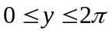
Label the axes by using AxesLabel option
b) 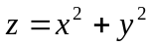 for 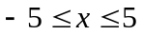 and 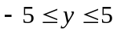
2. Show both of the curvatures, corresponding to the following equations, in a single 3D graph.
for and
and 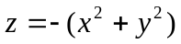 for and

