MAT 120 (lab)
Mathematica
Problem Sheet 5

Calculus: Limit, Derivative, Integration and Taylor’s series
1. Find out the following limit:
i) 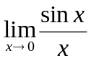 ii) 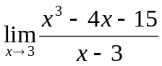 iii) 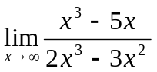
2. Find out the first, second and third derivatives of following functions with respect to x
i) 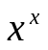
ii) 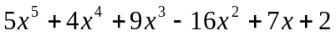
3. 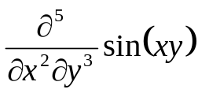 = ?
4. Work out the following indefinite integrals
i) 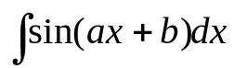 ii) 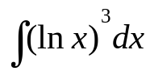
5. Evaluate the following definite integrals
i) 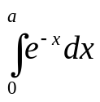 ii) 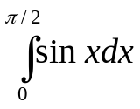
6. Work out the Taylor series of the following functions about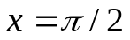, up to order 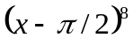
i) 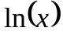 ii) 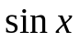
Optimization: Relative maxima and minima
7. Find the relative minimum and relative maximum of the following function:
