MAT 120 (lab)
Mathematica
Problem Sheet 6
- Solve the differential equation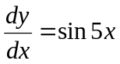
- a) Solve the equation for y as a function of x
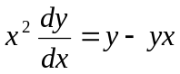
b) Find a special solution of the above mentioned equation for the following initial value
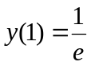
- a) Solve the equation for y as a function of x
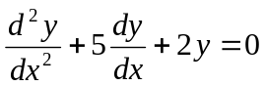
b) Find a special solution of the above mentioned equation for the following conditions
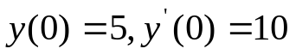
- Solve the following equation numerically for y, for the given conditions and the given interval of x
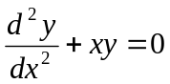
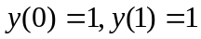
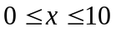
- Solve the following equation numerically for y, for the given conditions and the given interval of t
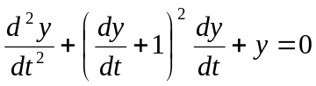
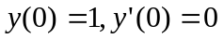
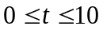
- Solve the following equation numerically for y, for the given conditions and the given interval of x
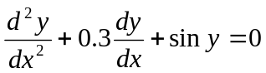
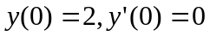
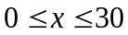

- See the following diagram of an RLC circuit where V is the AC voltage source

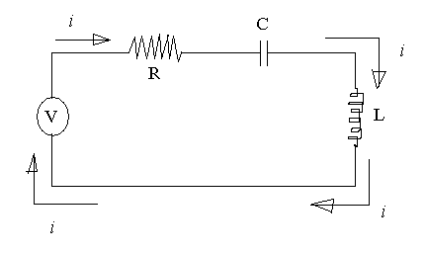

Here, R = resistance of the resistor
C = capacitance of the capacitor
L = inductance of the inductor
i = current flow through the circuit
From Electromagnetism we know
Voltage across the resistor, 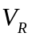= i R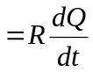. Here Q is charge and t is time
Voltage across the capacitor, 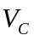=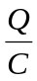where Q is the charged stored in the capacitor.
Voltage across the inductor, 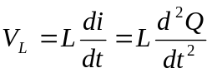
The electromotive force is given by
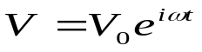
Applying Kirchoff’s loop voltage law we can write
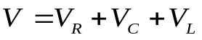
- 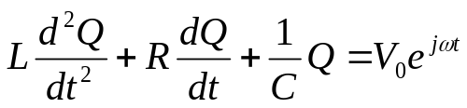

Now solve this equation for Q as a function of t
Then find i as a function of t by just differentiating Q with respect to t

