

Daffodil International University

Daffodil Smart City (DSC), Savar, Dhaka

Department of Computing and Information System

Semester Project on

Website Development Essentials

Semester Fall-2023

|  |  |
| --- | --- |
| Prepared By | Submitted To |
| Name: Md. Rafsan Bin Habib | Name: Mr. Israfil |
| ID: 232-16-052 | Designation: Lecturer |
| Department: CIS | Department: CIS |
| Batch- 18-B | Daffodil International University |

# Acknowledgement

I express my heartfelt gratitude to the Almighty ALLAH (SWT) for guiding me throughout this project and providing me the strength to complete it. I would like to extend my sincere appreciation to my teacher, Mr. Israfil, for providing me with the opportunity to work on this project and for his valuable guidance and feedback that have helped me grow and learn.

I would also like to thank my parents for their unwavering support, encouragement, and motivation throughout my academic journey. Their love and belief in me have been my biggest source of inspiration.

I am grateful to Daffodil International University for providing me with an environment that has helped me develop my knowledge and skills.

Lastly, I would like to dedicate this project to those who are differently-abled and have thirst for knowledge. Their determination and resilience are a true inspiration to us all.

# Contents

#### Theory Part:

**Task 1** 1

A ....................................................................................................................1

B ....................................................................................................................3

#### Task 2 4

A ...................................................................................................................4

B ...................................................................................................................6

C ...................................................................................................................8

D ...................................................................................................................9

#### Task 3 12

A ....................................................................................................................12

B ....................................................................................................................14

#### Lab Part:

A ....................................................................................................................16

B ....................................................................................................................16

C ....................................................................................................................16

# Introduction

A portfolio is a website that typically provides a brief introduction to who I am, my professional background, and the key highlights of my skills and expertise. It serves as a snapshot that quickly communicates my values to potential employers, clients or collaborators.

**Task 1:**

**Theory Part**

### Describing the CSS box model and its components and how does understanding the box model impact my ability to design and position elements on a web page effectively:

The CSS box model is a fundamental concept in web design and layout. It defines how elements on a web page are rendered and how their dimensions are calculated. Understanding the box model is crucial for effective web design and positioning of elements. **The CSS box model consists of four main components:**

**Content:** This is the innermost part of the box and represents the actual content of the element, such as text, images or other media.

**Padding:** Padding is the space between the content and the element’s border. It can be set using properties like **‘padding-top’**, ‘**padding-right**’, ‘**padding-bottom**’, ‘**padding-left**’. Padding creates an inner buffer around the content, providing space within the element.

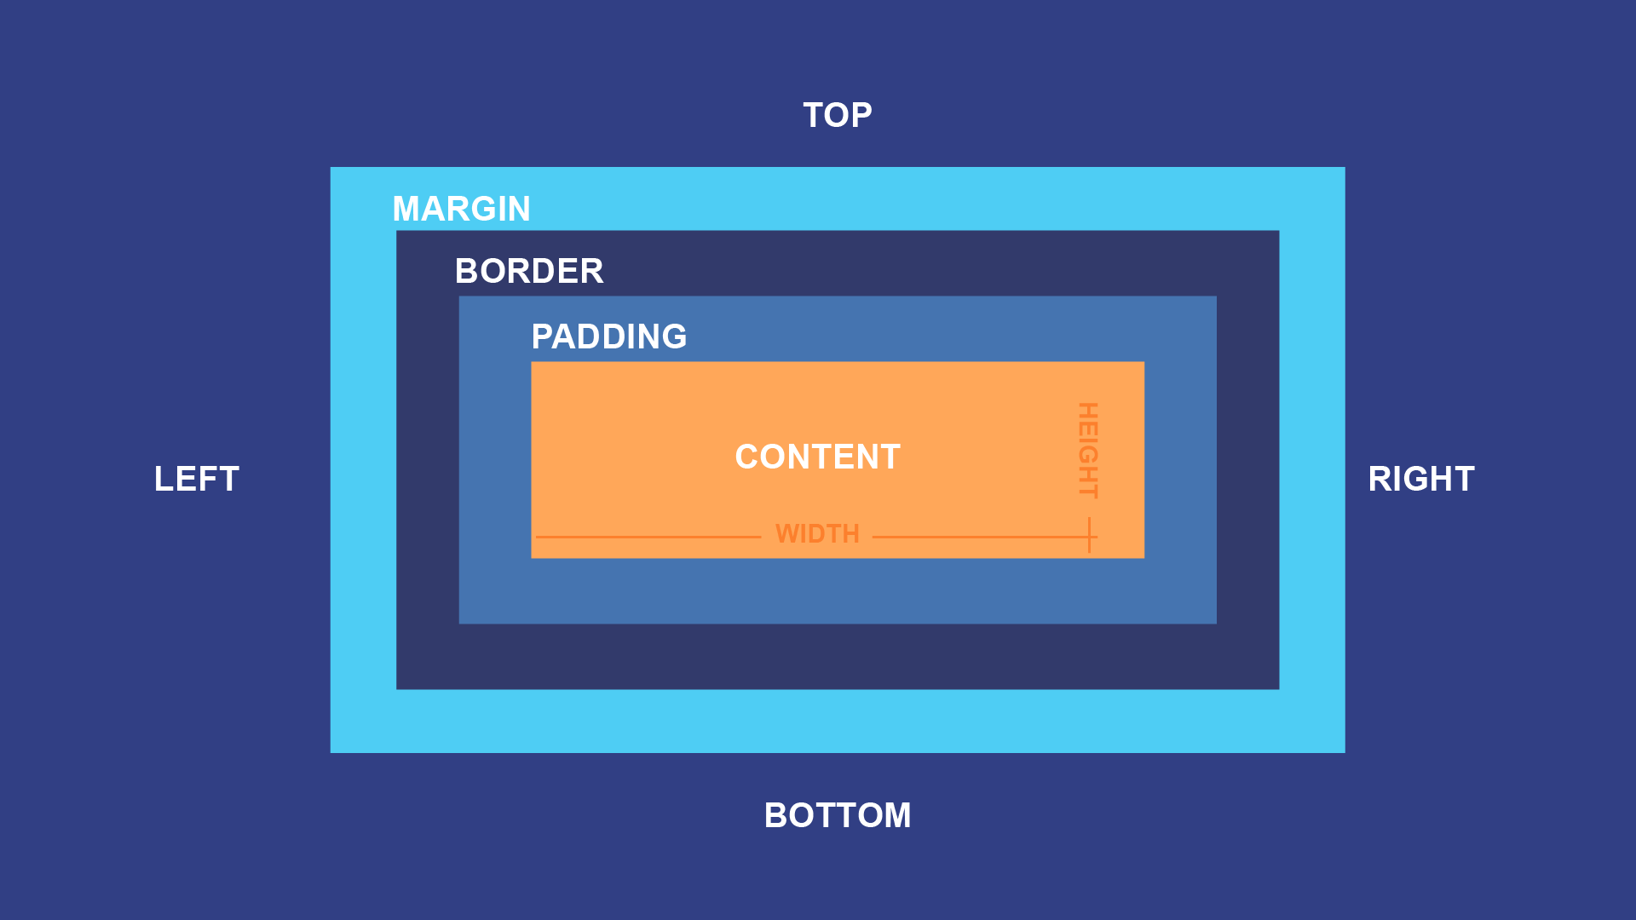

**Border:** The border is the edge that surrounds the padding and content. It is defined using properties like **‘border-width**’, ‘**border-style**’ and ‘**border-color**’. Borders can be used to visually separate elements or add decorative elements to them.

**Margin:** The margin is the space between the element's border and neighboring elements. It is set using properties like ‘**margin-top’**, **‘margin-right’**, **‘margin-bottom’** and **‘margin-left’**. Margins are used to control the spacing and layout of elements relative to other elements on the page.

* **Understanding the box model is essential for several reasons:**
* **Layout Control:** By manipulating the padding, border, and margin properties, I can precisely control the spacing and positioning of elements on a web page. This allows me to create visually appealing and well-structured layouts.
* **Responsive Design:** Understanding the box model is crucial for creating responsive designs that adapt to different screen sizes and devices. By adjusting margins and padding, I can ensure that my elements are appropriately spaced and sized on various screens.
* **Debugging:** When elements on a web page don't appear as expected, understanding the box model helps me to identify and fix layout issues. I can use developer tools to inspect an element's box model properties and make necessary adjustments.
* **Compatibility:** Different web browsers may interpret the box model slightly differently. Understanding these variations and using CSS reset or normalization techniques can help ensure consistent rendering across browsers.
* **Box Sizing:** The default box-sizing property in CSS is **‘content-box’** which calculates the width and height of an element based on its content, padding, and border. Understanding box sizing and using the **‘border-box’** value can simplify layout calculations by including padding and border within the specified width and height.

### Explaining the roles of HTML, CSS, and Bootstrap in building a personal portfolio website and how these do technologies contribute to the overall design and functionality:

* HTML, CSS, and Bootstrap are three essential technologies used in building a personal portfolio website. Each of these technologies plays a distinct role in contributing to the overall design and functionality of the website:
* **HTML (Hypertext Markup Language):** HTML serves as the backbone of a web page. It defines the structure and content of the web page by using elements, tags, and attributes. HTML is responsible for creating the core structure of my personal portfolio website. It outlines the layout and hierarchy of elements, such as headings, paragraphs, lists, links, images, and more. It provides the content and semantic meaning of the page, ensuring accessibility and search engine optimization (SEO).
* **CSS (Cascading Style Sheets):** CSS is used for styling and formatting the HTML content. It controls the visual presentation, including colors, fonts, spacing, and layout. CSS enhances the visual appeal of my personal portfolio website. It allows me to apply custom styles and design choices, making my website unique and visually pleasing. With CSS, I can control the size and position of elements, define responsive layouts for different screen sizes, and ensure a consistent look and feel across the site.
* **Bootstrap:** Bootstrap is a popular front-end framework that provides a set of pre-designed, responsive CSS and JavaScript components and utilities. Bootstrap streamlines the development process by offering ready-made components like navigation bars, buttons, modals, and grids. Here's how Bootstrap contributes to my portfolio website:
* **Responsiveness:** Bootstrap ensures that my website is responsive by default, meaning it adapts well to various screen sizes and devices.
* **Consistency:** It enforces a consistent design language across my site, reducing the need for extensive custom CSS.
* **Efficiency:** Bootstrap components save development time and effort. I can quickly add and customize elements without starting from scratch.
* **JavaScript functionality:** Bootstrap includes JavaScript plugins that add interactivity and functionality to my site, such as carousels, tooltips, and form validation.

**Task 2:**

### Creating the HTML structure for the “Home Page” section of my portfolio, including the elements for the introduction, a professional photo and a call-to-action button:

* **Here is a structure of form:**

<header class="header">

        <a href="#" class="logo">Rafsan.</a>

    <nav class="navbar">

            <a href="#" class="active">Home</a>

            <a href="file:///C:/Users/User1/Desktop/WDE_Project/about_me.html" target="_blank">About Me</a>

            <a href="file:///C:/Users/User1/Desktop/WDE_Project/skills.html" target="_blank">Skills</a>

            <a href="file:///C:/Users/User1/Desktop/WDE_Project/project.html" target="_blank">Projects</a>

            <a href="file:///C:/Users/User1/Desktop/WDE_Project/edu.html" target="_blank">Education</a>

        </nav>

    </header>

<section class="home">

        <div class="home-content">

            <h1>Hi, I'm Rafsan Bin Habib</h1>

            <h3>Competitive Programmer</h3>

            <p>I Like to participate in programming contest. I have solved many

                problems in Code Forces, Hacker Rank and Bee Crowd. I really loved to solve problems.

            </p>

            <div class="btn-box">

                <a href="#">Compete Me</a>

                <a href="#">Let's Talk</a>

            </div>

        </div>

        <div class="home-sci">

            <a href="https://www.facebook.com/RafsanBinHabib.129?mibextid=ZbWKwL" target="_blank"><i class="fa-brands fa-facebook-f"></i></a>

            <a href="https://www.linkedin.com/in/rafsan-bin-habib-13b01b276/" target="_blank"><i class="fa-brands fa-linkedin-in"></i></a>

            <a href="https://github.com/RafsanBinHabib" target="_blank"><i class="fa-brands fa-github"></i></a>

        </div>

        <span class="home-imgHover"></span>

    </section>

* **Here is the Outcome:**

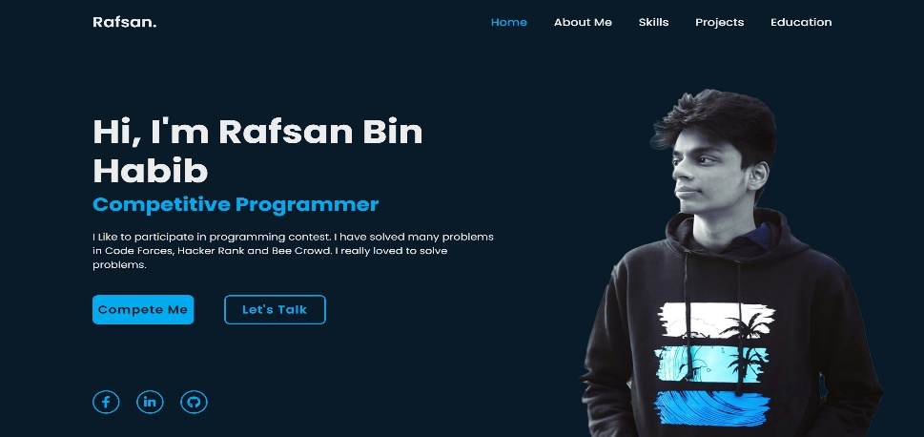

### Applying Bootstrap classes to make my portfolio website responsive. Describing how I ensured that the layout adapts well to both desktop and mobile screens:

* To make my portfolio website responsive using Bootstrap, I can apply Bootstrap classes to various elements to ensure that the layout adapts well to both desktop and mobile screens. **Here's an updated version of the HTML structure with Bootstrap classes:**

<!DOCTYPE html>

<html lang="en">

<head>

<meta charset="UTF-8">

<meta name="viewport" content="width=device-width, initial-scale=1.0">

<title>Your Portfolio - Home</title>

<!-- Link to Bootstrap CSS -->

<link rel="stylesheet" href="https://cdn.jsdelivr.net/npm/bootstrap/dist/css/bootstrap.min.css">

<!-- Your custom CSS styles can be linked here -->

<link rel="stylesheet" href="styles.css">

</head>

<body>

<header>

<!-- Bootstrap Navbar can be added here if needed -->

</header>

<section id="home" class="bg-light">

<div class="container">

<div class="row align-items-center">

<div class="col-md-6">

<div class="intro">

<h1>Your Name</h1>

<h2>Web Developer & Designer</h2>

<p>Welcome to my portfolio website. I create beautiful and functional websites.</p>

<a href="#portfolio" class="btn btn-primary btn-lg">View My Work</a>

</div>

</div>

<div class="col-md-6">

<div class="professional-photo text-center">

<img src="your-photo.jpg" alt="Your Professional Photo" class="img-fluid rounded-circle">

</div>

</div>

</div>

</div>

</section>

<!-- Additional sections and content can be added here -->

<footer class="bg-dark text-white">

<!-- Footer content can be added here -->

</footer>

<!-- Link to Bootstrap JS and Popper.js -->

<script src="https://cdn.jsdelivr.net/npm/bootstrap/dist/js/bootstrap.min.js"></script>

<script src="https://cdnjs.cloudflare.com/ajax/libs/popper.js/2.9.3/umd/popper.min.js"></script>

</body>

</html>

**On a phone browsers:**

The portfolio's layout will be adjusted to fit the narrower screen width, ensuring that the content is still readable and accessible.

The columns and elements may stack vertically to accommodate the limited horizontal space.

Navigation menus transform into dropdown menus and it is hidden behind a toggle button to save space.

* **The output will be:**

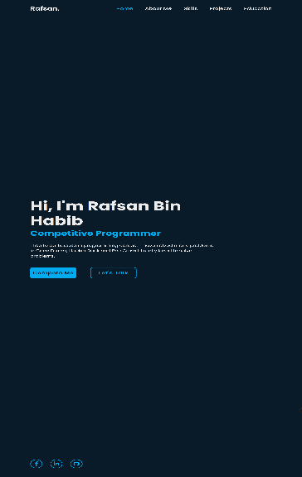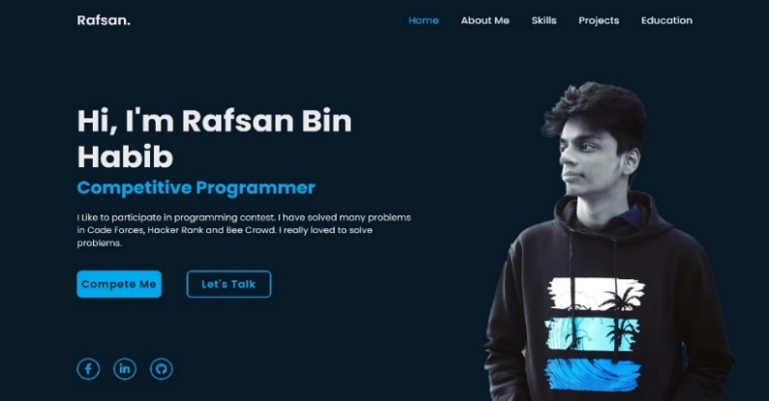

### Using CSS to style the "About Me" section. Sharing a CSS code snippet that changes the font style and color of the text:

* **Here is the CSS Code:**

.navbar a {

    font-size: 18px;

    color: #ededed;

    text-decoration: none;

    font-weight: 500;

    margin-left: 35px;

    transition: .3s;

}

.navbar a:hover,

.navbar a.active {

    color: #00abf0;

}

.home {

    height: 100vh;

    display: flex;

    align-items: center;

    padding: 0 10%;

}

.home-content {

    max-width: 600px;

}

.home-content h3 {

    position: relative;

    font-size: 56px;

    font-weight: 700;

    line-height: 1.2;

    color: #00abf0;

}

.home-content h3::before{

    content: '';

    position: absolute;

    top: 0;

    right: 0;

    width: 100%;

    height: 100%;

    background: #081b29;

    animation: showRight 1s ease forwards;

    animation-delay: 1s;

}

.home-content p {

    position: relative;

    font-size: 16px;

    margin: 20px 0 40px;

}

.home-content p::before{

    content: '';

    position: absolute;

    top: 0;

    right: 0;

    width: 100%;

    height: 100%;

    background: #081b29;

    animation: showRight 1s ease forwards;

    animation-delay: 1.6s;

}

.home-content .btn-box {

    position: relative;

    display: flex;

    justify-content: space-between;

    width: 345px;

    height: 50px;

}

.home-content .btn-box::before{

    content: '';

    position: absolute;

    top: 0;

    right: 0;

    width: 100%;

    height: 100%;

    background: #081b29;

    animation: showRight 1s ease forwards;

    animation-delay: 1.9s;

    z-index: 2;

}

.btn-box a {

    position: relative;

    display: inline-flex;

    justify-content: center;

    align-items: center;

    width: 150px;

    height: 100%;

    background: #00abf0;

    border: 2px solid #00abf0;

    border-radius: 8px;

    font-size: 19px;

    color: #081b29;

    text-decoration: none;

    font-weight: 600;

    letter-spacing: 1px;

    z-index: 1;

    overflow: hidden;

    transition: .5s;

}

.btn-box a:hover {

    color: #00abf0;

}

.btn-box a:nth-child(2) {

    background: transparent;

    color: #00abf0;

}

.btn-box a:nth-child(2):hover {

    color: #081b29;

}

.btn-box a:nth-child(2)::before {

    background: #00abf0;

}

.btn-box a::before {

    content: '';

    position: absolute;

    top: 0;

    left: 0;

    width: 0;

    height: 100%;

    background: #081b29;

    z-index: -1;

    transition: .5s;

}

.btn-box a:hover::before {

    width: 100%;

}

/* KEYFRAMES ANIMATION */

@keyframes showRight {

    100%{

        width: 0;

    }

}

@import url('https://fonts.googleapis.com/css2?family=Poppins:wght@300;400;500;600;700&display=swap');

* {

    margin: 0;

    padding: 0;

    font-family: 'Poppins', sans-serif;

    box-sizing: border-box;

}

body {

    background: #081b29;

    color: #ededed;

}

.header {

    position: fixed;

    top: 0;

    left: 0;

    width: 100%;

    padding: 20px 10%;

    background: transparent;

    display: flex;

    justify-content: space-between;

    align-items: center;

    z-index: 100;

}

.logo {

    position: relative;

    font-size: 25px;

    color: #ededed;

    text-decoration: none;

    font-weight: 600;

}

.

    content: '';

    position: absolute;

    top: 0;

    right: 0;

    width: 100%;

    height: 100%;

    background: #081b29;

    animation: showRight 1s ease forwards;

    animation-delay: .4s;

}

.navbar a {

    font-size: 18px;

    color: #ededed;

    text-decoration: none;

    font-weight: 500;

    margin-left: 35px;

    transition: .3s;

}

.navbar a:hover,

.navbar a.active {

    color: #00abf0;

}

.home {

    height: 100vh;

    display: flex;

    align-items: center;

    padding: 0 10%;

}

.home-content {

    max-width: 600px;

}

.home-content h3 {

    position: relative;

    font-size: 56px;

    font-weight: 700;

    line-height: 1.2;

    color: #00abf0;

}

.home-content h3::before{

    content: '';

    position: absolute;

    top: 0;

    right: 0;

    width: 100%;

    height: 100%;

    background: #081b29;

    animation: showRight 1s ease forwards;

    animation-delay: 1s;

}

.home-content p {

    position: relative;

    font-size: 16px;

    margin: 20px 0 40px;

}

.home-content p::before{

    content: '';

    position: absolute;

    top: 0;

    right: 0;

    width: 100%;

    height: 100%;

    background: #081b29;

    animation: showRight 1s ease forwards;

    animation-delay: 1.6s;

}

.home-content .btn-box {

    position: relative;

    display: flex;

    justify-content: space-between;

    width: 345px;

    height: 50px;

}

.home-content .btn-box::before{

    content: '';

    position: absolute;

    top: 0;

    right: 0;

    width: 100%;

    height: 100%;

    background: #081b29;

    animation: showRight 1s ease forwards;

    animation-delay: 1.9s;

    z-index: 2;

}

.btn-box a {

    position: relative;

    display: inline-flex;

    justify-content: center;

    align-items: center;

    width: 150px;

    height: 100%;

    background: #00abf0;

    border: 2px solid #00abf0;

    border-radius: 8px;

    font-size: 19px;

    color: #081b29;

    text-decoration: none;

    font-weight: 600;

    letter-spacing: 1px;

    z-index: 1;

    overflow: hidden;

    transition: .5s;

}

.btn-box a:hover {

    color: #00abf0;

}

.btn-box a:nth-child(2) {

    background: transparent;

    color: #00abf0;

}

.btn-box a:nth-child(2):hover {

    color: #081b29;

}

.btn-box a:nth-child(2)::before {

    background: #00abf0;

}

.btn-box a::before {

    content: '';

    position: absolute;

    top: 0;

    left: 0;

    width: 0;

    height: 100%;

    background: #081b29;

    z-index: -1;

    transition: .5s;

}

.btn-box a:hover::before {

    width: 100%;

}

/* KEYFRAMES ANIMATION */

@keyframes showRight {

    100%{

        width: 0;

    }

}

### Designing a "Projects" section that showcases my projects. How I incorporate CSS instead of Bootstrap components like ‘Modals’ or ‘Carousels’ to present project details:

### Here is the HTML Code:

<section class="home">

<div id="services">

<div class="container">

<h1 class="sub-title">Projects</h1>

<div class="services-list">

<div>

<h2>Coming Soon</h2>

<p>Lorem ipsum dolor sit amet consectetur adipisicing elit. Tempore hic error illo doloremque,

atque non magni nemo nostrum voluptas quasi facilis eveniet ad expedita, debitis natus eum

quidem nihil ipsam.</p>

<a href="#">Learn more</a>

</div>

<div>

<h2>Coming Soon</h2>

<p>Lorem ipsum dolor sit amet consectetur adipisicing elit. Tempore hic error illo doloremque,

atque non magni nemo nostrum voluptas quasi facilis eveniet ad expedita, debitis natus eum

quidem nihil ipsam.</p>

<a href="#">Learn more</a>

</div>

<div>

<h2>Coming Soon</h2>

<p>Lorem ipsum dolor sit amet consectetur adipisicing elit. Tempore hic error illo doloremque,

atque non magni nemo nostrum voluptas quasi facilis eveniet ad expedita, debitis natus eum

quidem nihil ipsam.</p>

<a href="#">Learn more</a>

</div>

## 

## Here is the CSS Code:

.services-list div a{

    text-decoration: none;

    color: #ededed;

    font-size: 12px;

    margin-top: 20px;

    display: inline-block;

}

.services-list div:hover{

background-color: #00abf0;

transform: translateY(-10px);

}

/* KEYFRAMES ANIMATION */

@keyframes showRight {

    100%{

        width: 0;

    }

}

.sub-title{

    font-size: 50px;

    color: #00abf0;

}

#services{

    padding: 30px 0;

}

.services-list{

    display: grid;

    grid-template-columns: repeat(auto-fit, minmax(250px, 1fr));

    grid-gap: 40px;

    margin-top: 50px;

}

.services-list div{

    background: #0b2639;

    padding: 40px;

    font-size: 13px;

    font-weight: 300;

    border-right: 10px;

    transition: backgroun 0.5s, transform 0.5s;

}

.services-list div i{

    font-size: 50px;

    margin-bottom: 30px;

}

.services-list div h2{

    font-size: 30px;

    font-weight: 500;

    margin-bottom: 15px;

}

## Here, I use CSS instead of Bootstrap to showcase my projects in portfolio. I have used CSS ‘padding’ and ‘margin’ property to make the project showcase.

## If I used Bootstrap ‘modals’ instead of CSS then the HTML & CSS code will be:

<section id="projects" class="bg-light">

<div class="container">

<div class="row">

<div class="col-md-4">

<div class="card mb-4">

<img src="project1.jpg" class="card-img-top" alt="Project 1">

<div class="card-body">

<h5 class="card-title">Project 1</h5>

<p class="card-text">A brief description of the project.</p>

<button type="button" class="btn btn-primary" data-toggle="modal" data-target="#project1Modal">Learn More</button>

</div>

</div>

</div>

<!-- Add more project cards as needed -->

</div>

</div>

</section>

<!-- Project 1 Modal -->

<div class="modal fade" id="project1Modal" tabindex="-1" role="dialog" aria-labelledby="project1ModalLabel" aria-hidden="true">

<div class="modal-dialog modal-lg" role="document">

<div class="modal-content">

<div class="modal-header">

<h5 class="modal-title" id="project1ModalLabel">Project 1 Details</h5>

<button type="button" class="close" data-dismiss="modal" aria-label="Close">

<span aria-hidden="true">&times;</span>

</button>

</div>

<div class="modal-body">

<!-- Add detailed project information here -->

<p>Project details, images, and other information go here.</p>

</div>

<div class="modal-footer">

<button type="button" class="btn btn-secondary" data-dismiss="modal">Close</button>

<!-- Add additional action buttons if needed -->

</div>

</div>

</div>

</div>

**Task 3:**

### Analyzing the importance of effective navigation in a personal portfolio website. How Bootstrap's navigation components improve the user experience and accessibility of my portfolio:

* **Effective navigation is crucial in a personal portfolio website for several reasons:**
* **User Experience:** Navigation is the primary way for users to explore my portfolio. It helps them find the information they're looking for quickly and easily.
* **Accessibility:** Proper navigation ensures that my website is accessible to a wider audience, including individuals with disabilities who may rely on screen readers or keyboard navigation. Clear and organized navigation helps in meeting accessibility standards and guidelines.
* **Showcasing my Work:** A portfolio website's primary purpose is to showcase my work. Effective navigation ensures that my projects and achievements are prominently displayed and easy to access. Users should be able to view my work without frustration.
* **Professionalism:** A well-designed navigation menu conveys professionalism and attention to detail. It reflects positively on my skills and dedication to my craft.
* **Engagement:** Good navigation encourages users to explore more of my content. When they can easily find what interests them, they are more likely to spend time on my website, view my work, and potentially contact me for opportunities.
* **Bootstrap's navigation components can significantly improve the user experience and accessibility of my portfolio in the following ways:**
* **Responsive Design:** Bootstrap's navigation components are inherently responsive. They adapt to different screen sizes and devices, ensuring that my portfolio looks and functions well on both desktop and mobile devices. This is crucial because a significant portion of web traffic comes from mobile users.
* **Accessibility:** Bootstrap places a strong emphasis on accessibility. Its navigation components come with built-in ARIA roles and attributes that make my navigation menus more screen reader-friendly and navigable via keyboard.
* **Pre-Designed Menus:** Bootstrap provides pre-designed navigation menus, such as the Navigation bar component, which can save my time in building and styling my navigation. These menus are customizable, allowing me to match my portfolio's design while ensuring usability.
* **Dropdowns:** If you have a large number of portfolio items or categories, Bootstrap's dropdown menus can help organize them effectively. This prevents clutter in my main navigation and enhances the user experience.
* **Collapse for Mobile:** Bootstrap's Navigation bar component automatically collapses into a mobile-friendly menu when viewed on smaller screens. This is essential for maintaining usability on smartphones and tablets.
* **Navigation Bar Branding:** Bootstrap allows me to easily add branding elements, such as my logo, to the navigation bar. This reinforces my personal brand and makes my portfolio instantly recognizable.

### Examining the use of visual elements, such as icons or graphics, to represent my technical skills. How this visual representation enhance the overall presentation of my skills:

## Using visual elements like icons or graphics to represent my technical skills can enhance the overall presentation of my skills in several ways:

## Visual Appeal: Icons and graphics add visual appeal to my portfolio and break up text-heavy content. They make my skills section more engaging and attractive to visitors.

## Clarity: Visual representations of skills can make it easier for visitors to quickly understand my proficiency level in various areas. Icons or graphics can convey information more efficiently than paragraphs of text.

## Efficiency: Icons and graphics provide a concise way to communicate my skills, saving space and reducing the need for lengthy descriptions. This allows visitors to scan my skills quickly.

## Universal Understanding: Many icons are widely recognized and have universal meanings. For example, using a wrench icon for technical skills or a paintbrush icon for design skills instantly conveys the nature of my expertise without the need for lengthy explanations.

## Branding: Icons and graphics can be customized to match my personal brand or the overall design of my portfolio website. This consistency reinforces my branding and makes my portfolio more memorable.

## Visual Hierarchy: By using different icons or graphics styles, sizes, or colors, I can create a visual hierarchy that highlights my most important or strongest skills. This guides visitors' attention to what matters most.

## Accessibility: When used appropriately, icons can enhance accessibility. They can provide visual cues that help users with cognitive disabilities or those who may not speak the same language as the text on my website.

## Interactivity: Icons and graphics can be interactive. For example, hovering over a skill icon could reveal additional information or link to relevant projects or certifications, creating a more engaging user experience.

## Consistency: Using a consistent set of icons or graphics for similar types of skills (e.g., programming languages, design tools) creates a sense of order and cohesion in my skills section.

## Lab Part

1. **Designed my portfolio websites step by step. Written necessary code for my development and tried to use fewer files for less complexity. The coding part must have a minimum of two files one for HTML and another for CSS (if use JavaScript then one for JavaScript). Write the code and make one folder for one website with the necessary documents.**
2. **Published my websites in GitHub, here (**[RafsanBinHabib.github.io](https://github.com/RafsanBinHabib/RafsanBinHabib.github.io)**) is an accessible link.**
3. **No need to answer. This section depends on my creativity and uniqueness of my two websites.**

**--The End--**