**Problem set-1 Task B**

1. First, I have created a python web server, create a dictionary to hold a JSON objects for a couple of records and then we add RESTful APIs for each supported operations.
2. Execute the program & the web server will ready to service.
3. Open the web browser & you see that the web service is available in the URL

<http://localhost:500/tmpDB/timedelta>

1. You can also check it from terminal with curl command

$curl –i http://localhost:500/tmpDB/timedelta

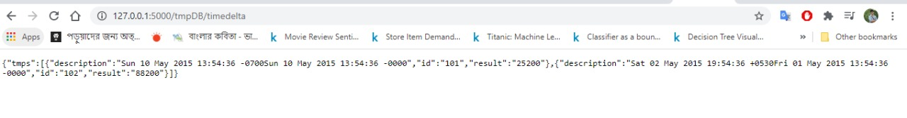

**Problem set-1 Task C**

1. In the code we will find the object with the node id and send the JSON object in the data. Here I have used the list comprehension technique in Python

<http://localhost:500/tmpDB/timedelta>/101

$curl –i <http://localhost:500/tmpDB/timedelta/101>

