**Contact Book Management System**

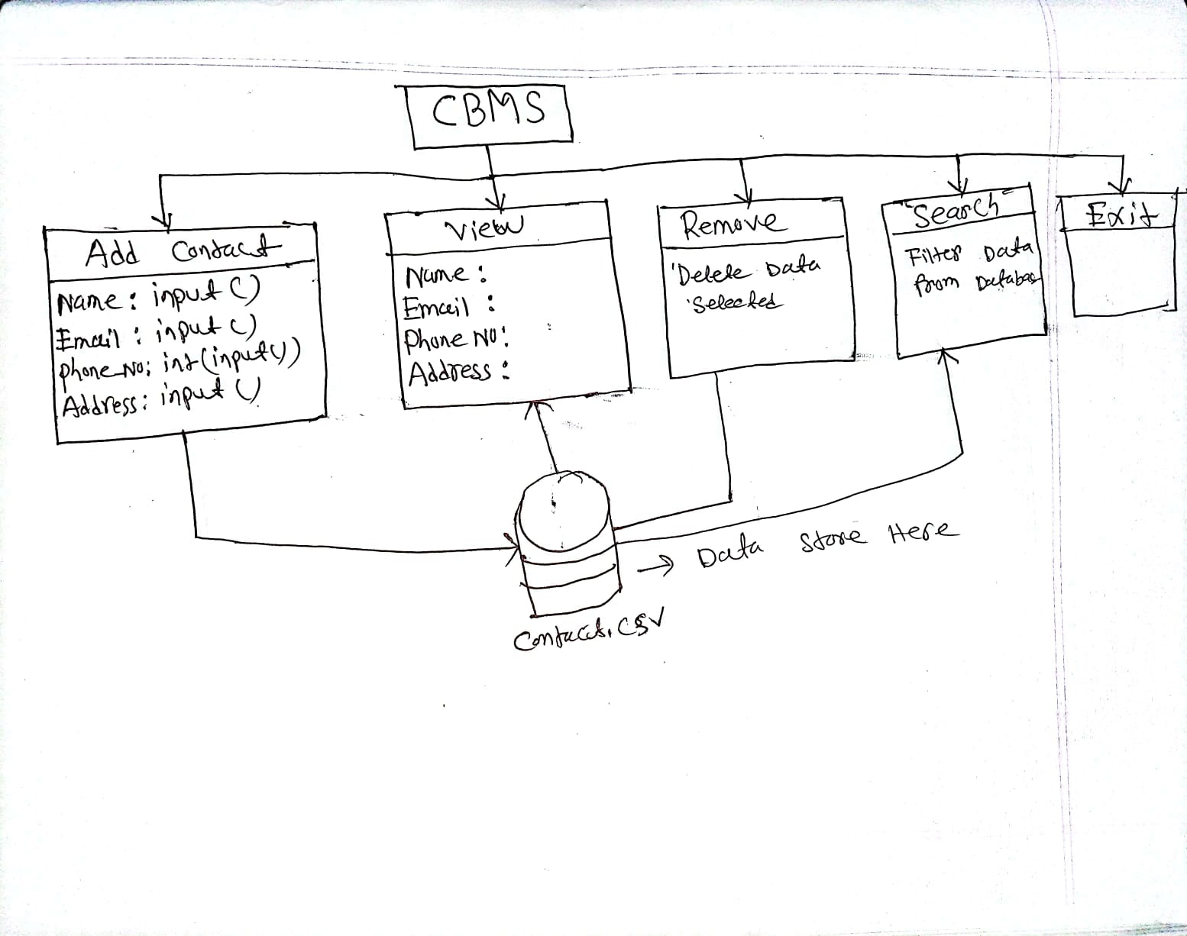

* Name
* Email
* Phone Number
* Address

Exit

View

Remove

Search

Add Contact

**CBMS**