**Government College of Arts, Science and Commerce Sanquelim – Goa**

**Subject: Computer Science**

**(Data Software Engineering E-Manual)**

CUIN:20S127

NAME: Vedant Dinkar Bhonsle

TyBSc (Computer Science)

**PRACTICAL 1:**

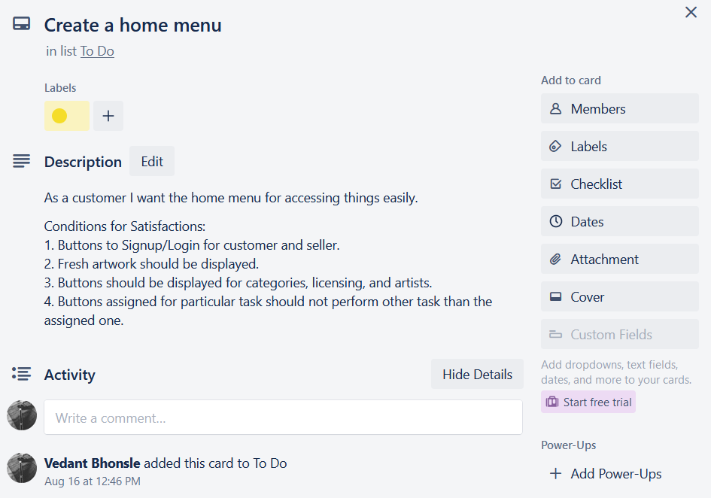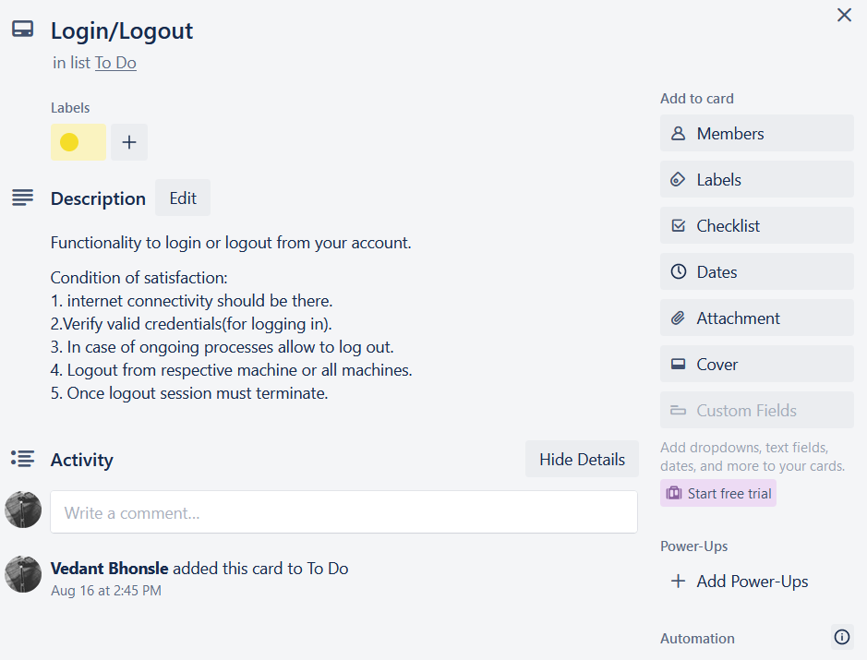

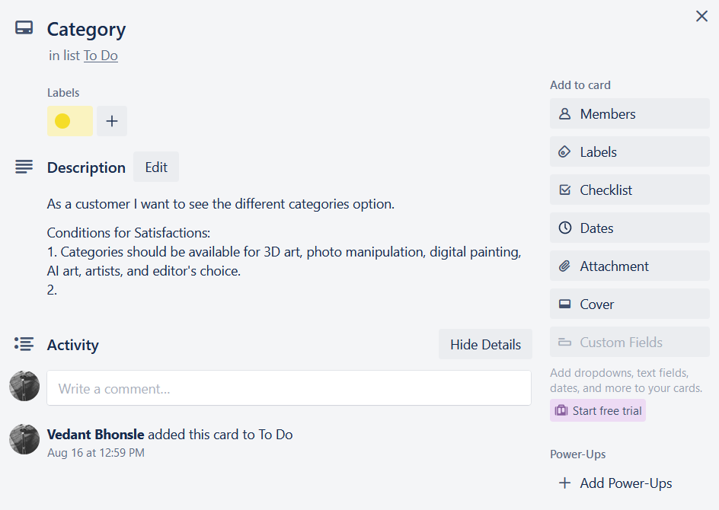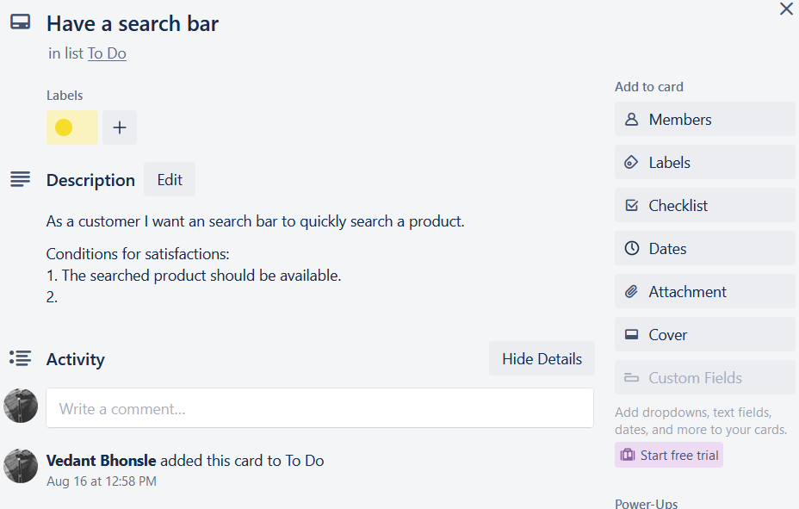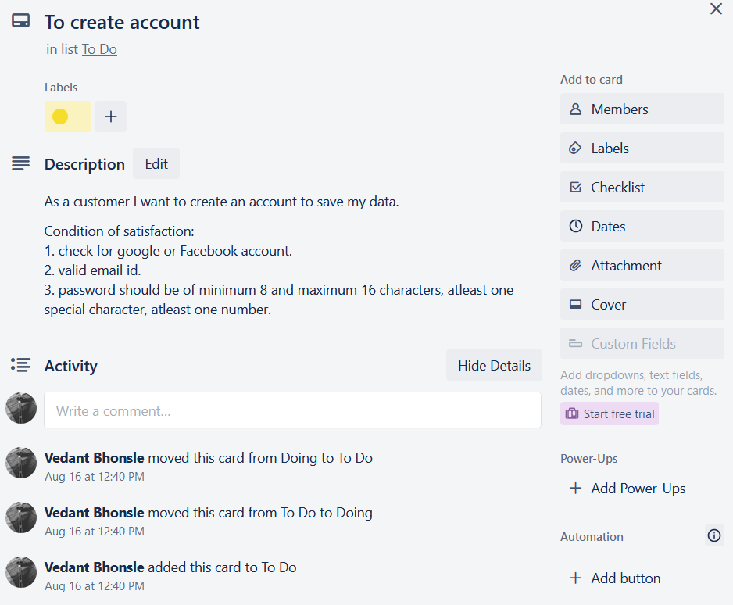

**PRACTICAL 2:**

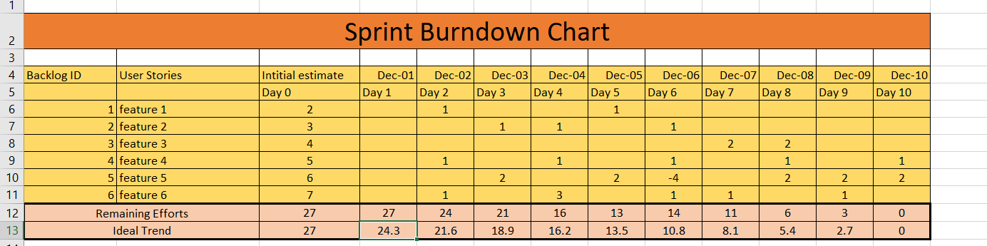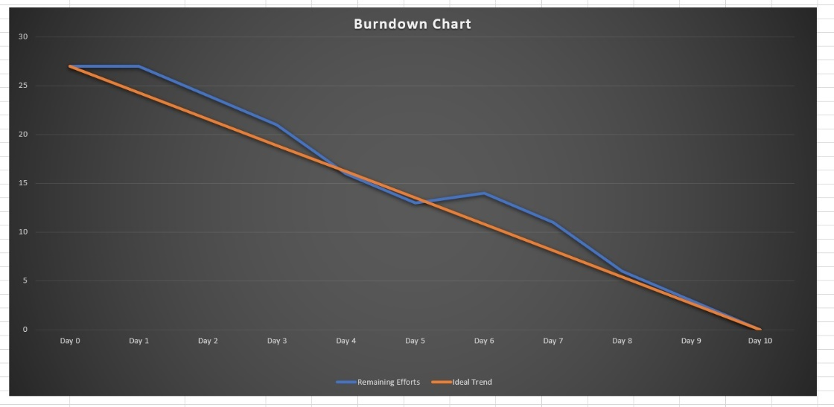

**PRACTICAL 3:**

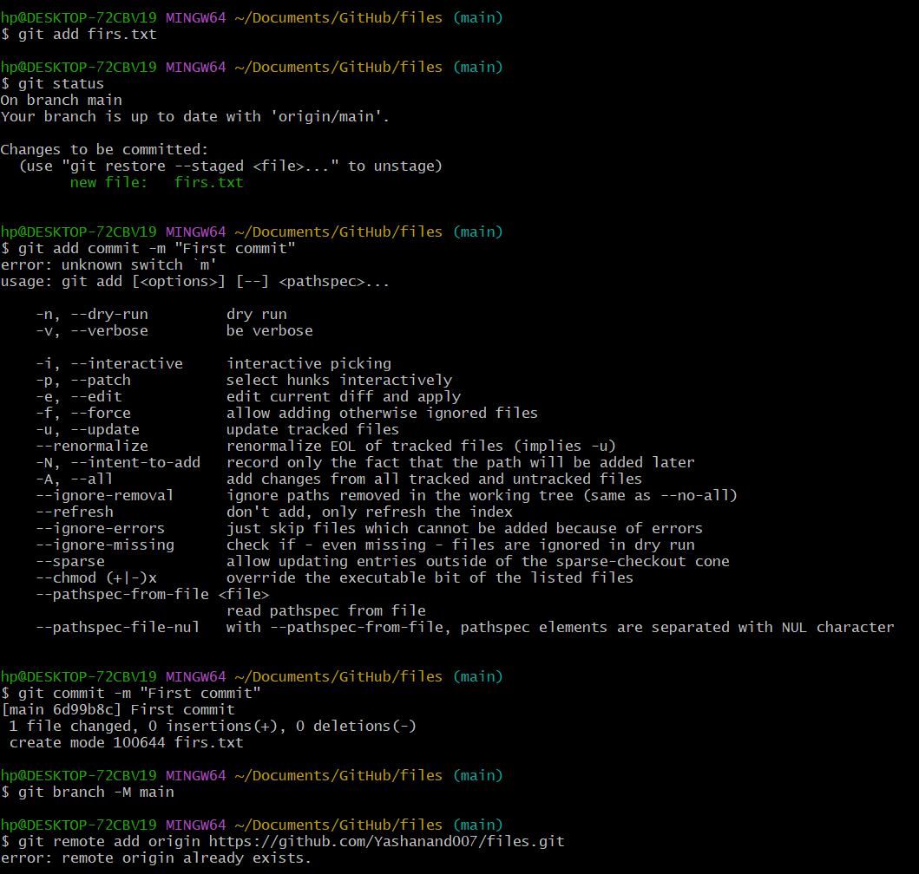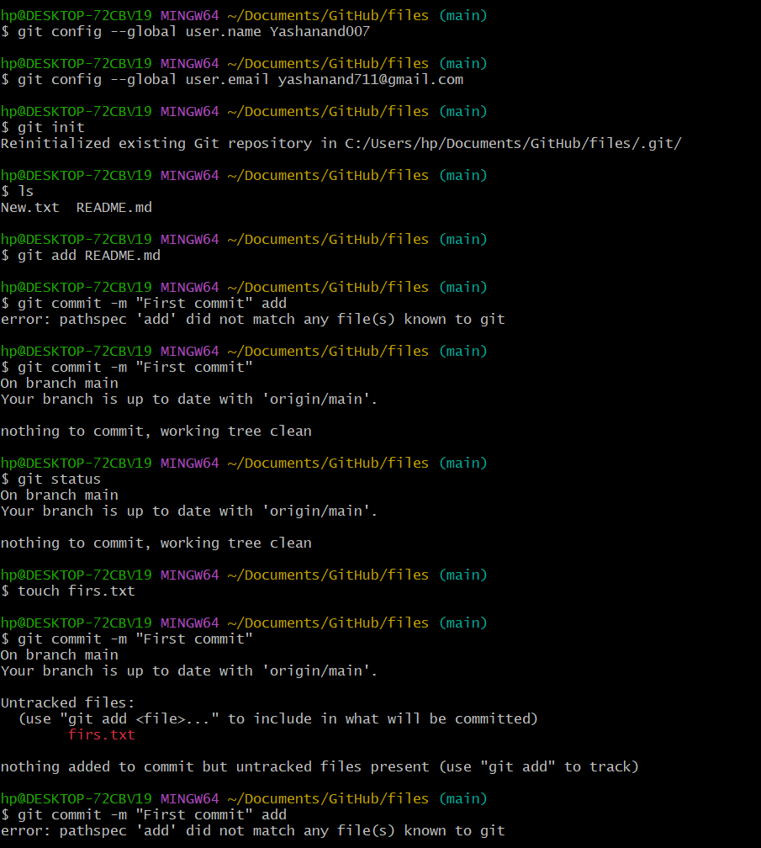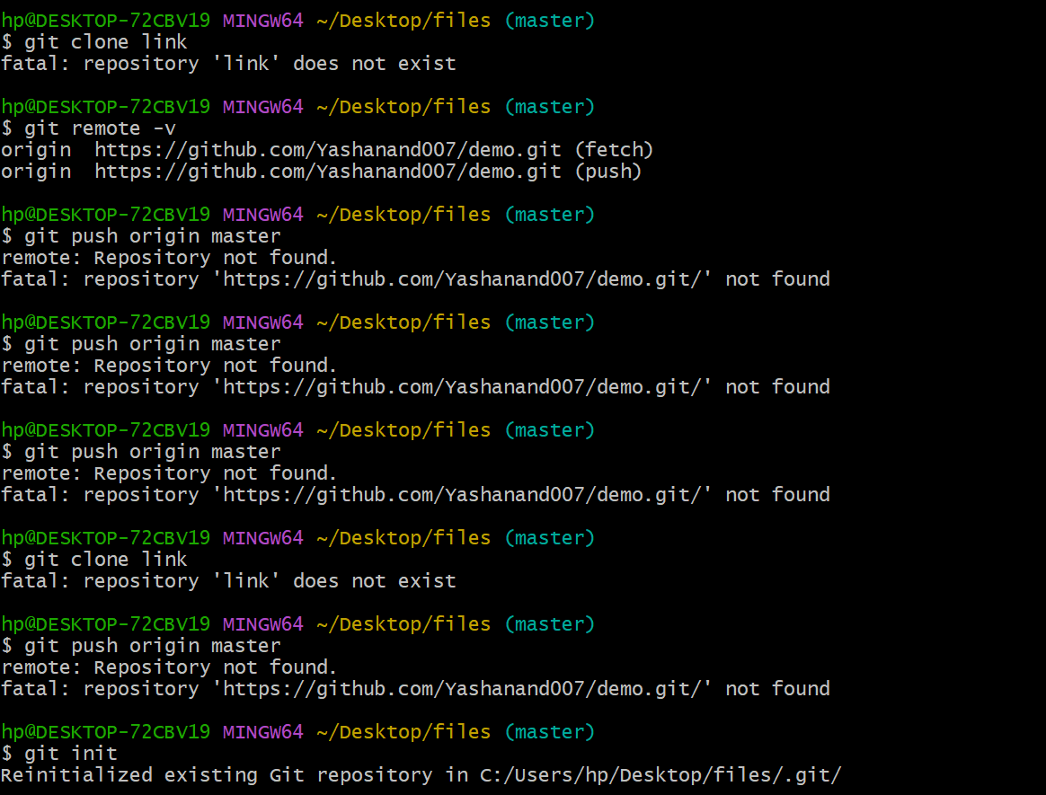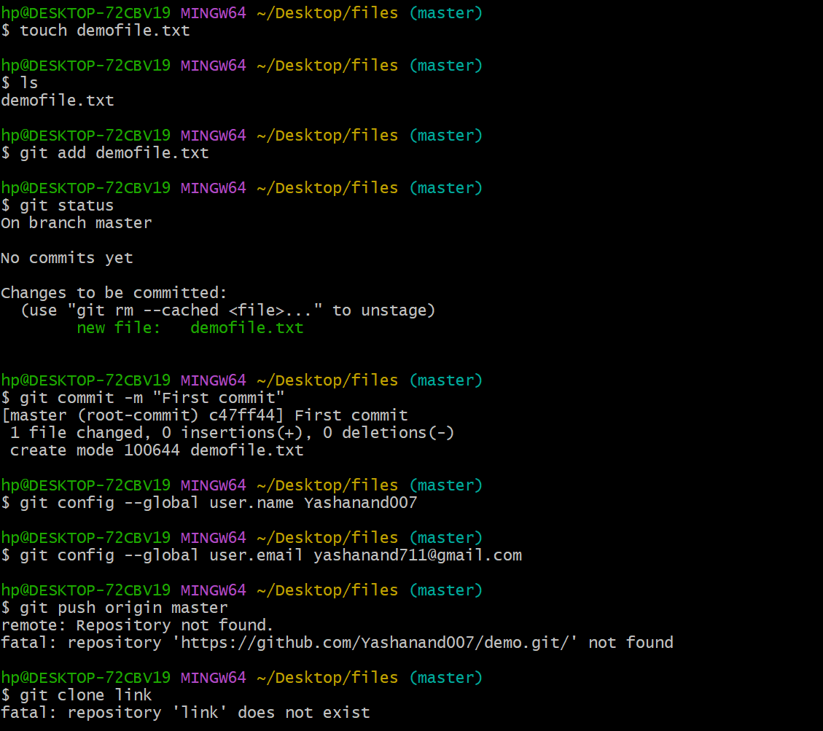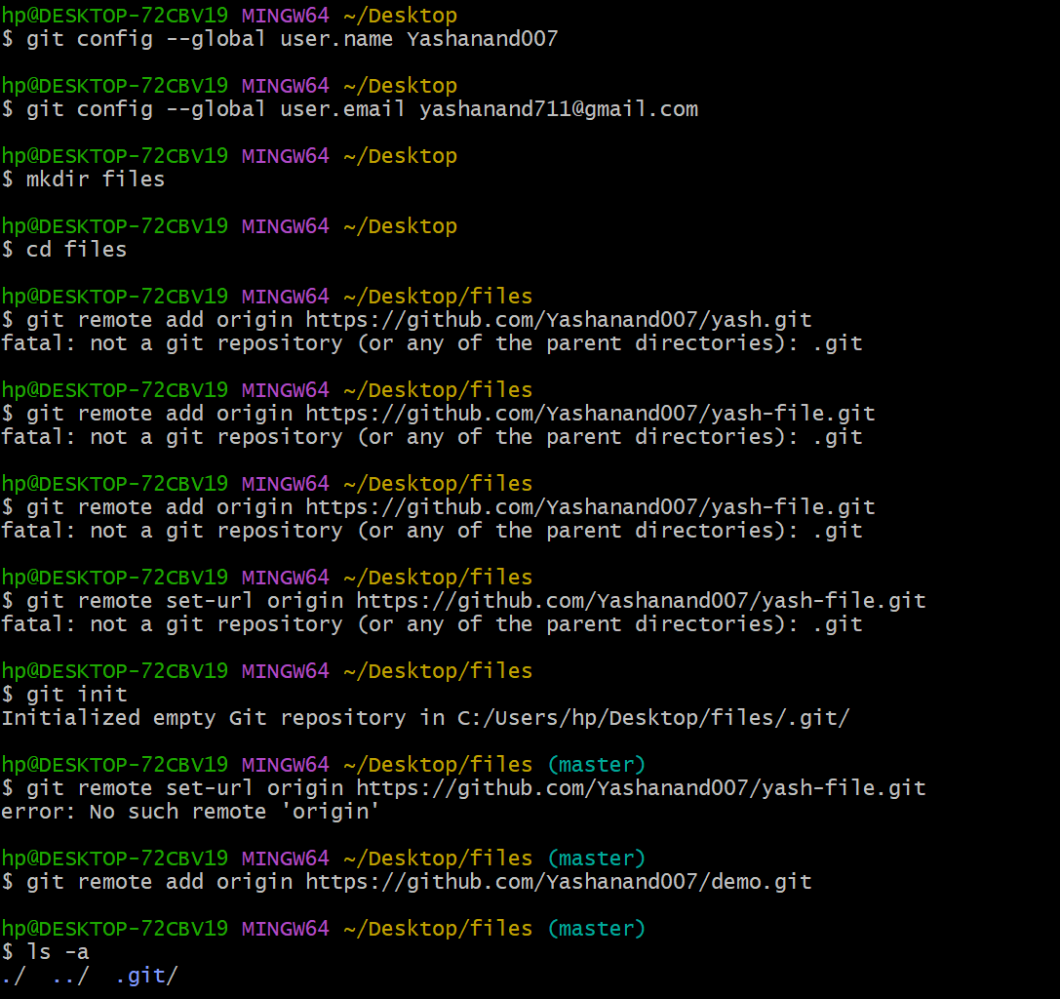

**PRACTICAL 4:**

package com.coderolls.SampleProject;

/**

* Hello world!

*

*/

public class App

{

public static void main( String[] args )

{

System.***out***.println( "Hello World!" );

}

}

package com.coderolls.SampleProject;

public class PasswordGenerator {

public String generatePassword(String name, int yearOfBirth) {

String password = null;

if (name.length() <= 4) {

password = name + yearOfBirth;

} else {

String str = name.substring(0, 4);

password = str + yearOfBirth;

}

return password;

}

}

package com.coderolls.SampleProject;

import junit.framework.Test;

import junit.framework.TestCase;

import junit.framework.TestSuite;

/**

* Unit test for simple App.

*/

public class AppTest

extends TestCase

{

/**

* Create the test case

*

* @param testName name of the test case

*/

public AppTest( String testName )

{

super( testName );

}

/**

* @return the suite of tests being tested

*/

public static Test suite()

{

return new TestSuite( AppTest.class );

}

/**

* Rigourous Test :-)

*/

public void testApp()

{

assertTrue( true );

}

}

package com.coderolls.SampleProject;

import org.junit.Test;

import junit.framework.TestCase;

public class PasswordGeneratorTest extends TestCase {

@Test

public void testGeneratePassword() {

String name = "Joseph";

int yearOFBirth = 1998;

String expected = "Jose1998";

PasswordGenerator passwordGenerator = new PasswordGenerator();

String actual = passwordGenerator.generatePassword(name, yearOFBirth);

assertEquals(expected, actual);

}

@Test

public void testGeneratePassword_nameLessThan4Charaters() {

String name = "Nic";

int yearOFBirth = 2002;

String expected = "Nic2002";

PasswordGenerator passwordGenerator = new PasswordGenerator();

String actual = passwordGenerator.generatePassword(name, yearOFBirth);

assertEquals(expected, actual);

}

}

**PRACTICAL 5:**

package Refactoring;

public class Shape {

String color;

String getcolor() {

return color;

}

void setcolor(String c_color) {

color = c_color;

}

}

package Refactoring;

public class NewShape {

double area;

public NewShape() {

super();

}

}

package Refactoring;

public class Circle extends NewShape {

float radius;

public float getRadius() {

return radius;

}

public void setRadius(float r_radius) {

radius = r_radius;

area = 10;

}

}

package Refactoring;

public class Rectangle extends NewShape {

float length, breadth;

public float getBreadth() {

return breadth;

}

public void setBreadth(float b_breadth) {

breadth = b_breadth;

}

public double rectangle_area(double length, double breadth) {

return length;

}

public void setLength(float l_length) {

length = l_length;

}

}

package Refactoring;

public class Startup {

public static void main(String[] args) {

// **TODO** Auto-generated method stub

Circle c = new Circle();

c.setRadius(5);

float rad = c.getRadius();

*circle_area*(rad);

Rectangle r = new Rectangle();

r.setLength(10);

r.setBreadth(5);

float len = (float) r.rectangle_area(0, 0);

float bred = r.getBreadth();

*rectangle_area*(len, bred);

}

public static void rectangle_area(float len, float bred) {

double area1 = len * bred;

System.***out***.println(area1);

}

public static void circle_area(float rad) {

double area = 3.14 * rad * rad;

System.***out***.println(area);

}

}

**PRACTICAL 6:**

package Selenium_test;

import org.openqa.selenium.By;

import org.openqa.selenium.WebDriver;

import org.openqa.selenium.chrome.ChromeDriver;

public class Demo {

public static void main(String[] args) {

System.setProperty("webdriver.chrome.driver",

"D:\\Selenium_test\\exe_files\\chromedriver_win32\\chromedriver.exe");

WebDriver driver = new ChromeDriver();

driver.get("https://www.linkedin.com");

driver.manage().window().maximize();

driver.findElement(By.id("session_key")).sendKeys("iamlordvoldem0rtt007@gmail.com");

driver.findElement(By.id("session_password")).sendKeys("GbAwVB8gds9u4TF");

driver.findElement(By.xpath("//*[@id=\"main content\"]/section[1]/div/div/form/button")).click();

String u = driver.getCurrentUrl();

if (u.equals("https://www.linkedin.com/feed/?trk=homepage-basic_signin-form_submit")) {

System.out.println("Test case passed.");

} else {

System.out.println("Test case failed.");

}

driver.close();

}

}

