Raghu Tirumala

Final Project CSS430

**Results Running Test5.java**

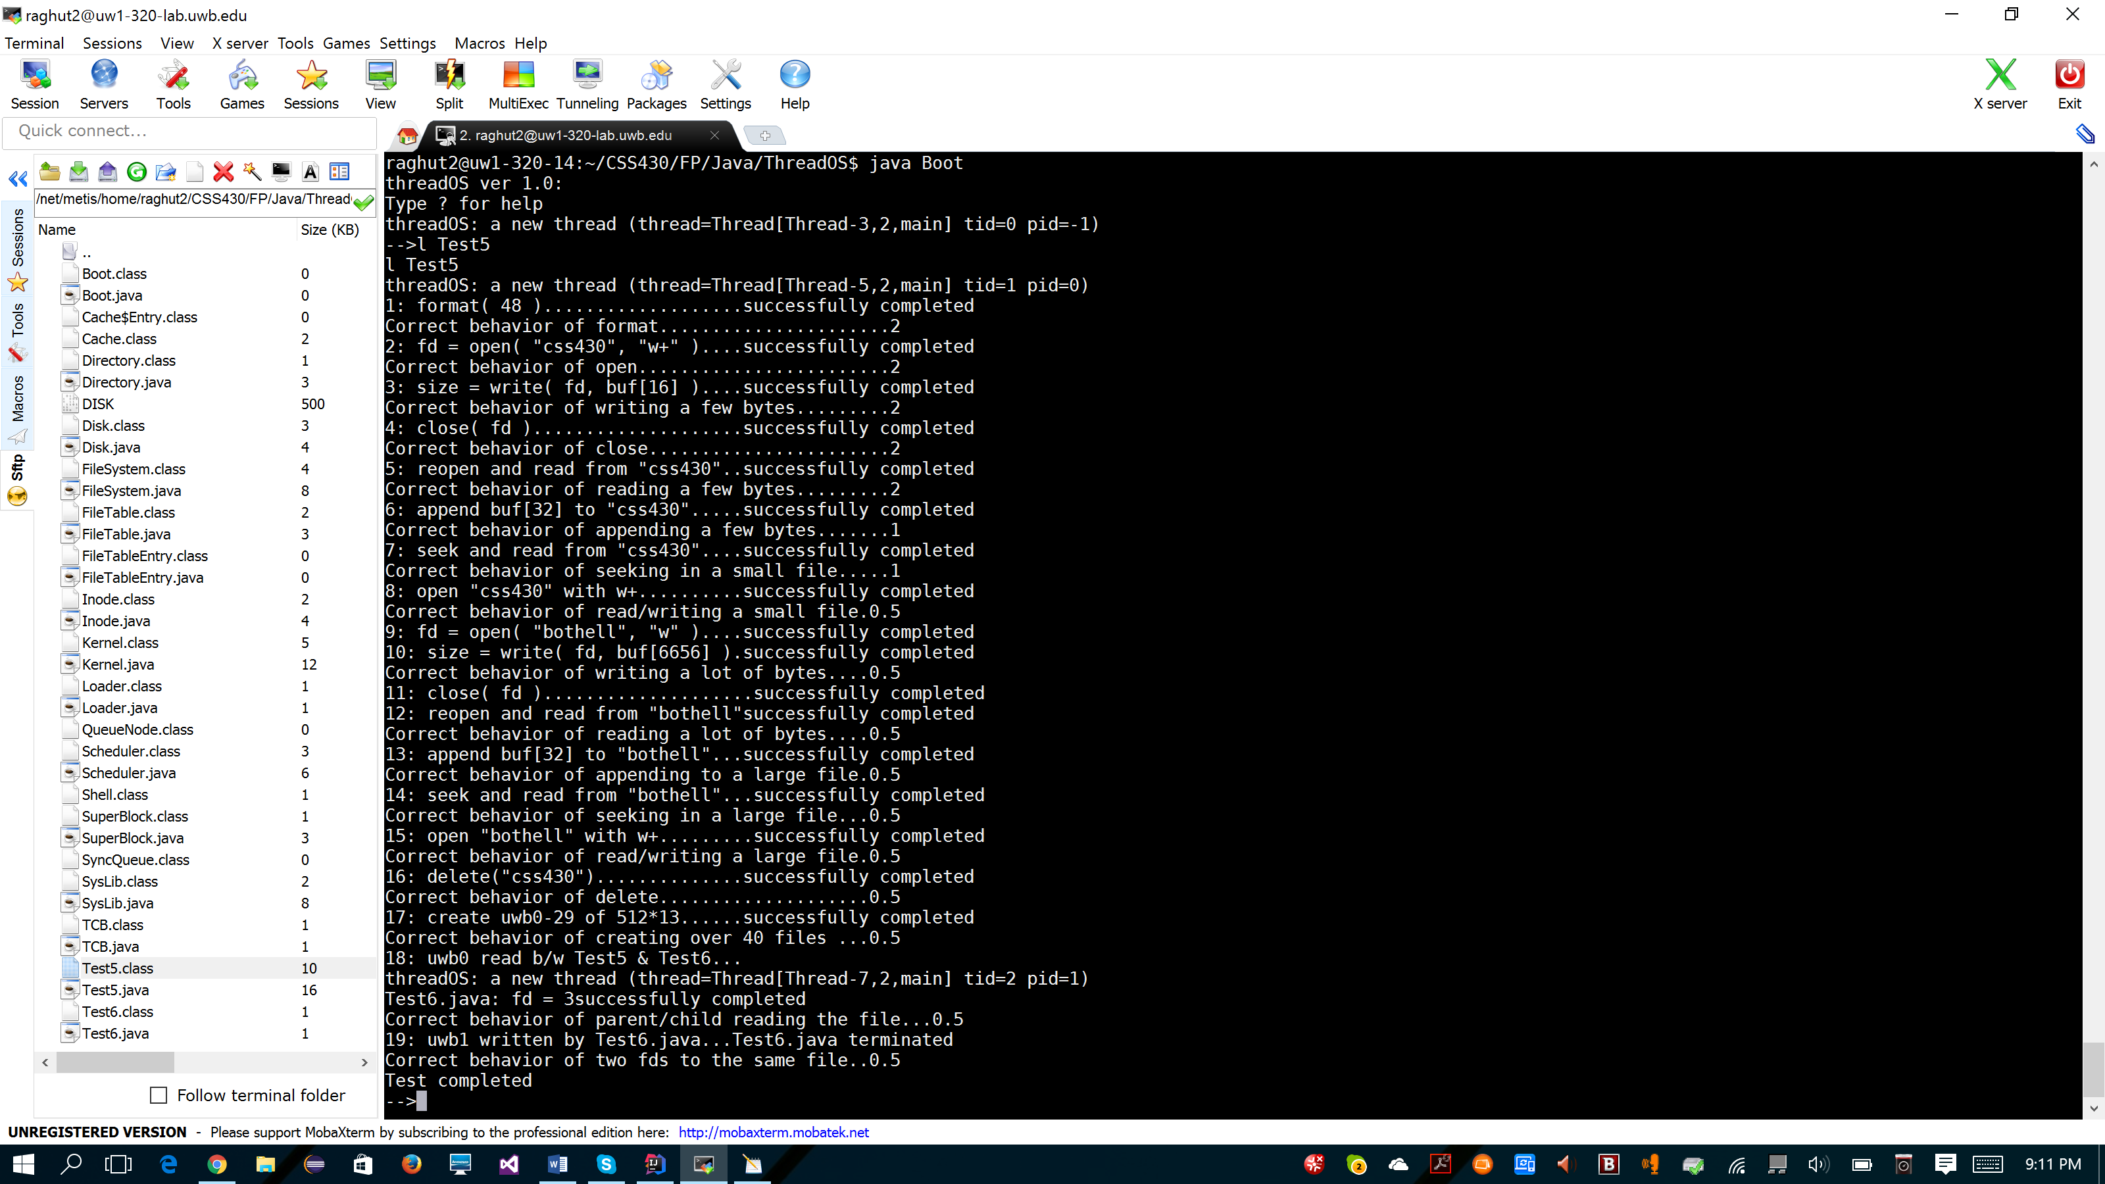

**Classes**

**SuperBlock**

The first disk block. (Block 0). Used to describe number of disk blocks and inodes in the system. Also keeps track of the freelist. No user threads operate on this block it is only for the OS.

**Inode**

Each inode keeps track of one file in the system. Keeps track of information such as whether it has been used, read, or written to as well as keeping track of how many threads are accessing the file.

**Directory**

This class represents the root directory of this single level file system. Takes in the max inodes to be created, (size of file system) and keeps track of which inodes are currently in use.

**FileTable**

Shared table among all threads that keeps track of all the files in the system. Consists of FileTableEntry objects which hold an inode of a specific file in addition to the mode the file is in (read-only, write-only, read&write, append).