**Running Test3 with Kernel.old**

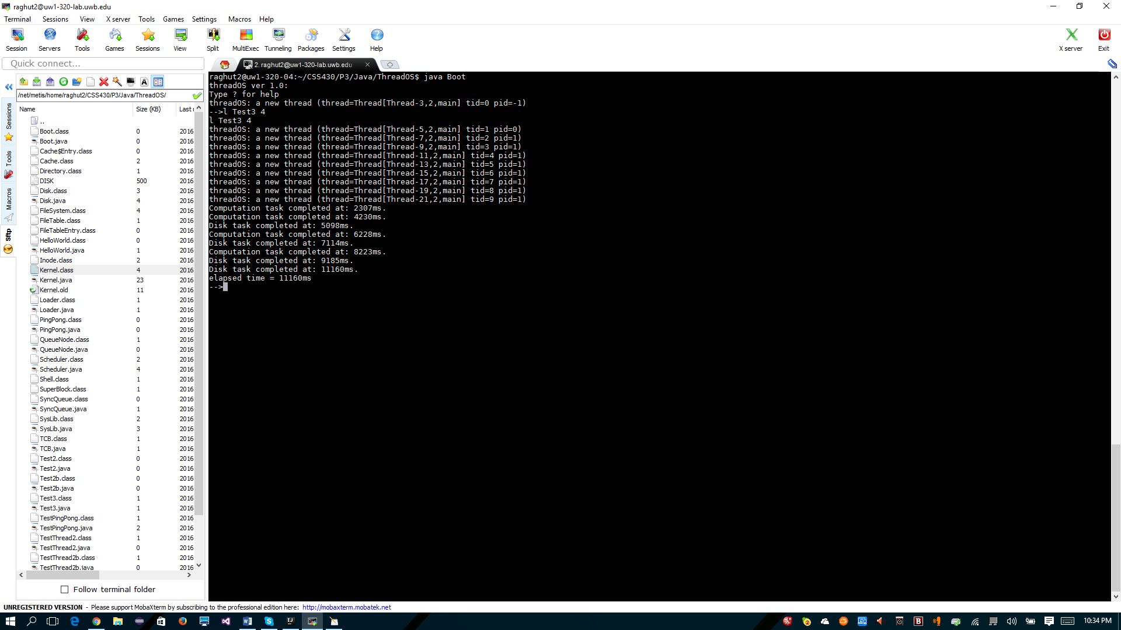

**Running Test3 with new Kernel**

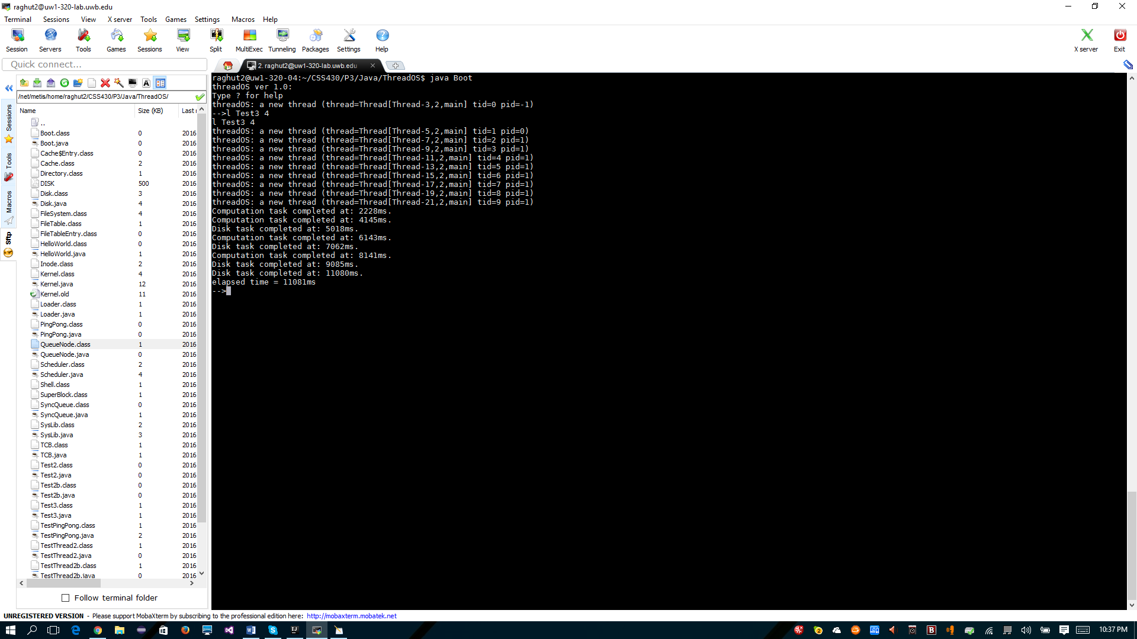

It appears that I did not experience any speed up when I removed busy waiting from Kernel.java.