**Project: AirLine Booking Portal**

1. **Starting of page contains User button and Admin button.**

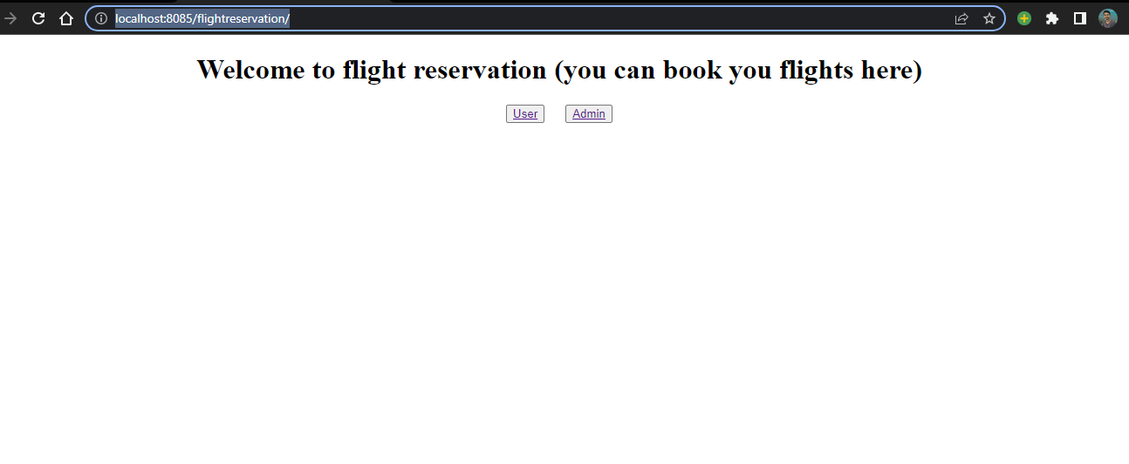

**Lets get into User pages:-**

**Operations can done by User:**

1. **Search Flights for an appropriate date and can enter total number of travelers**
2. **From Flight result he/she can book the flight**
3. **For moving to further he/she has to give personal information**
4. **After page will move to payment gateway**
5. **After successful payment user can see the transaction details and information about booked flight.**

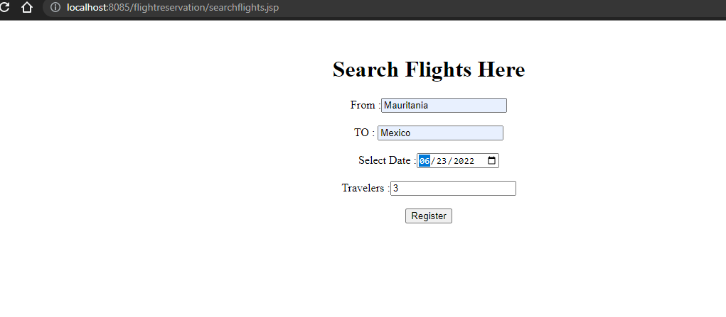**1**

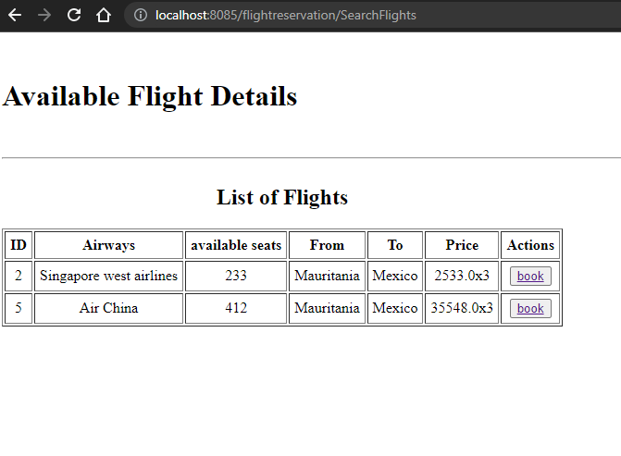**2**

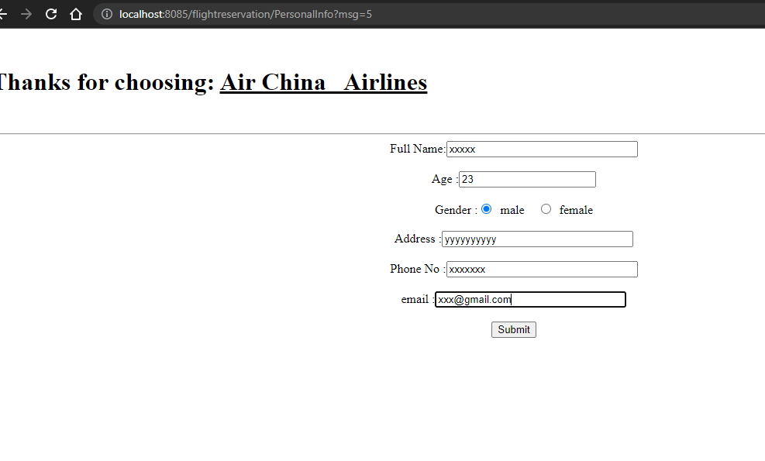**3**

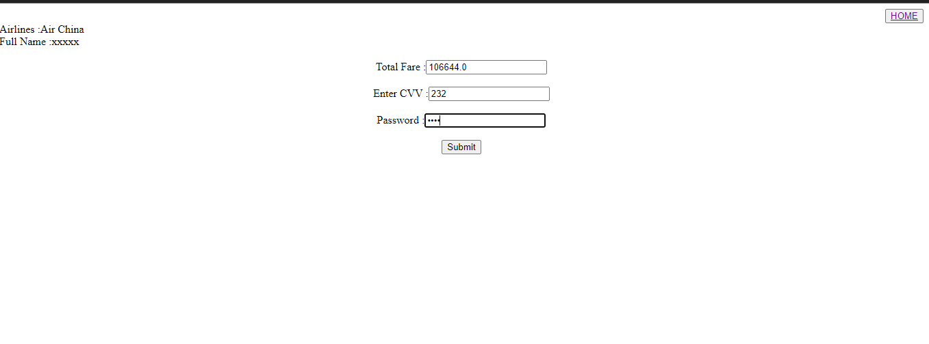**4**

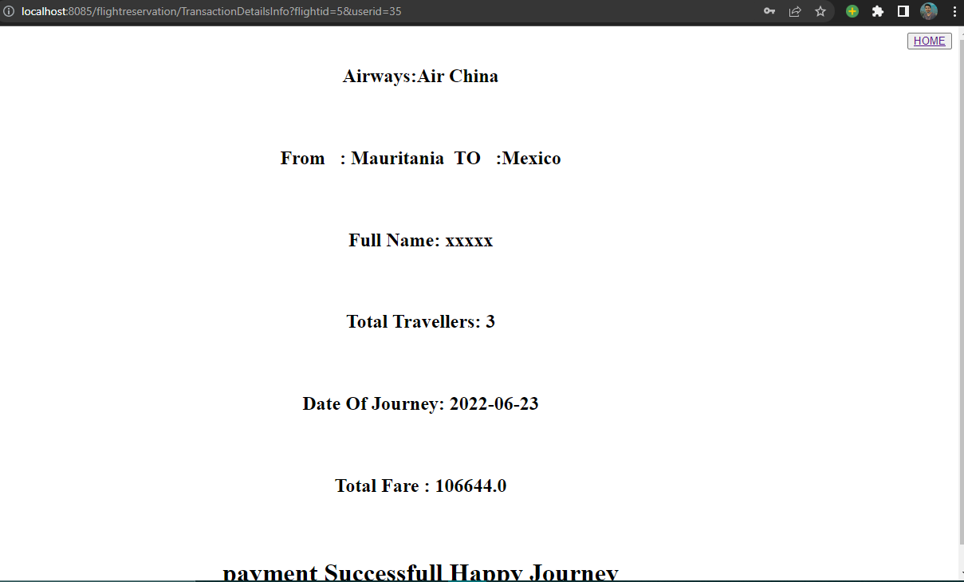

**5**

**Now lets get into admin part:-**

**Operations can done by Admin:**

1. **Login page is used to validate the details of admin if details are not matched then it will throw an error**

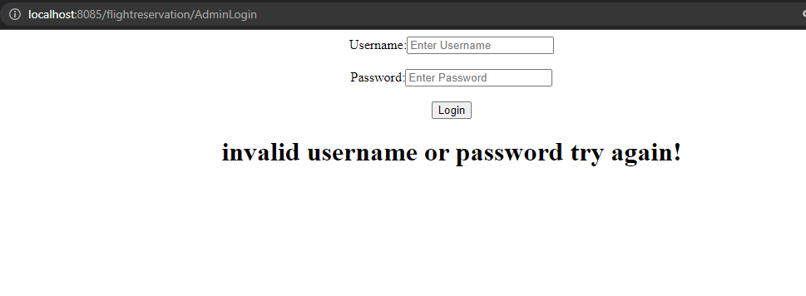

1. **After successful login admin can see list of flights, airlines and route**

**Admin can perform crud operations for all of the lists.**

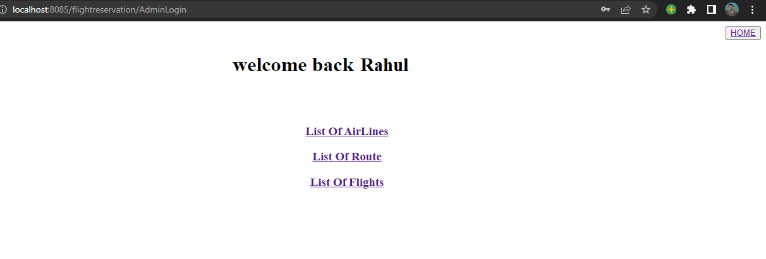

1. **If clicks on list of AirLines then page will show all the list of airlines**

**After entering into this page admin can edit, delete, add new airlines and read the list of data.**

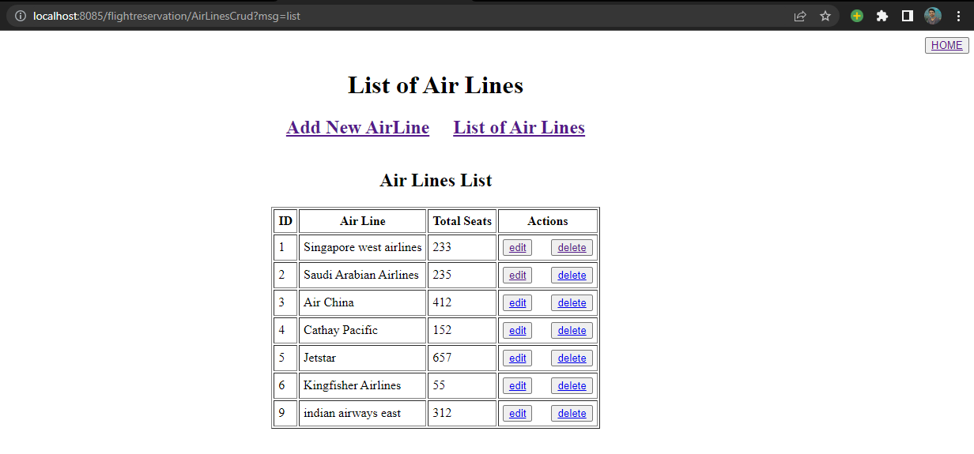

**To edit:-**

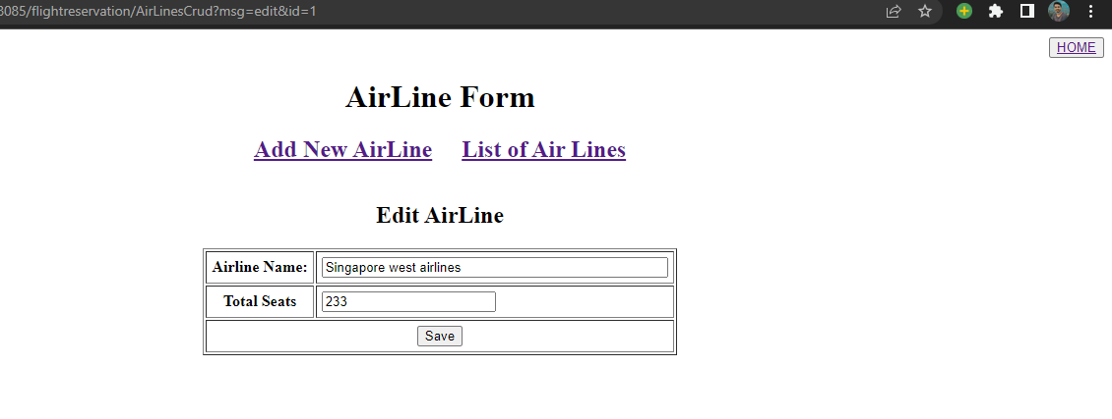

**To Add new Airline:-**

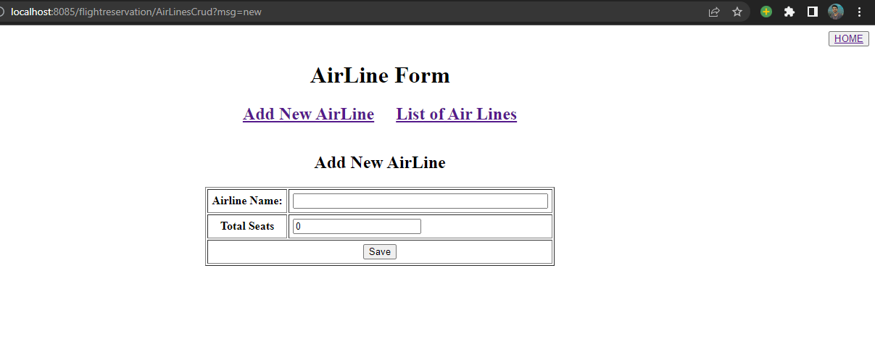

1. **In the same way remaining flight and route data can also be done by admin**

**I have uploaded this project to git:-**

**https://github.com/Raga1930/JavaFSPhase2Project.git**