**Raga Ranjini R**

**19001198**

**POSTMAN**

Generally, Postman job is to make sure the letter is received by the intended receiver. This way enables us to communicate with someone away from us.

Similarly, Postman API allows us to communicate with server. Postman API gained popularity because of its ease of use and variety of features.

Among several features, some of the features that I understand are:

* API client operations – GET, POST, PUT, DELETE and some more HTTP methods like this.
* Automated Testing
* Collections – can save the requests and responses.

The process involved:

1. We send request.
2. API server receives request and returns a response.
3. Postman receives response and display it in the interface.

GET - Fetch data.

POST – Insert new data.

PUT – Modify the existing data.

DELETE – Deletes the data.

-------------------------------------------------------------GET------------------------------------------------------------------

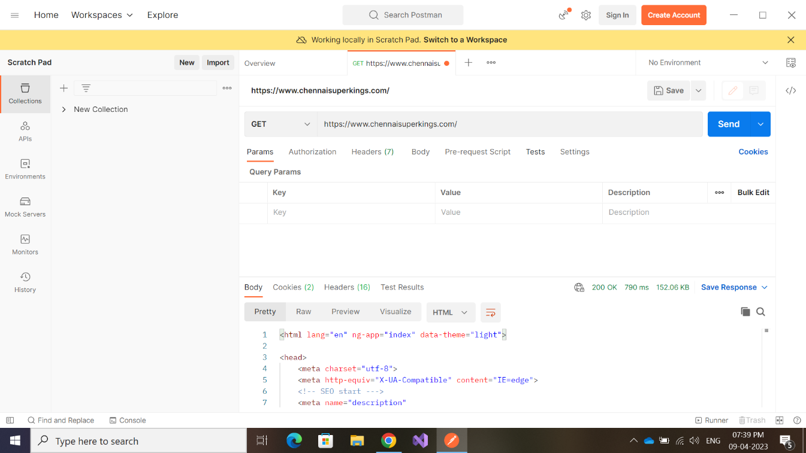

//COLLECTIONS

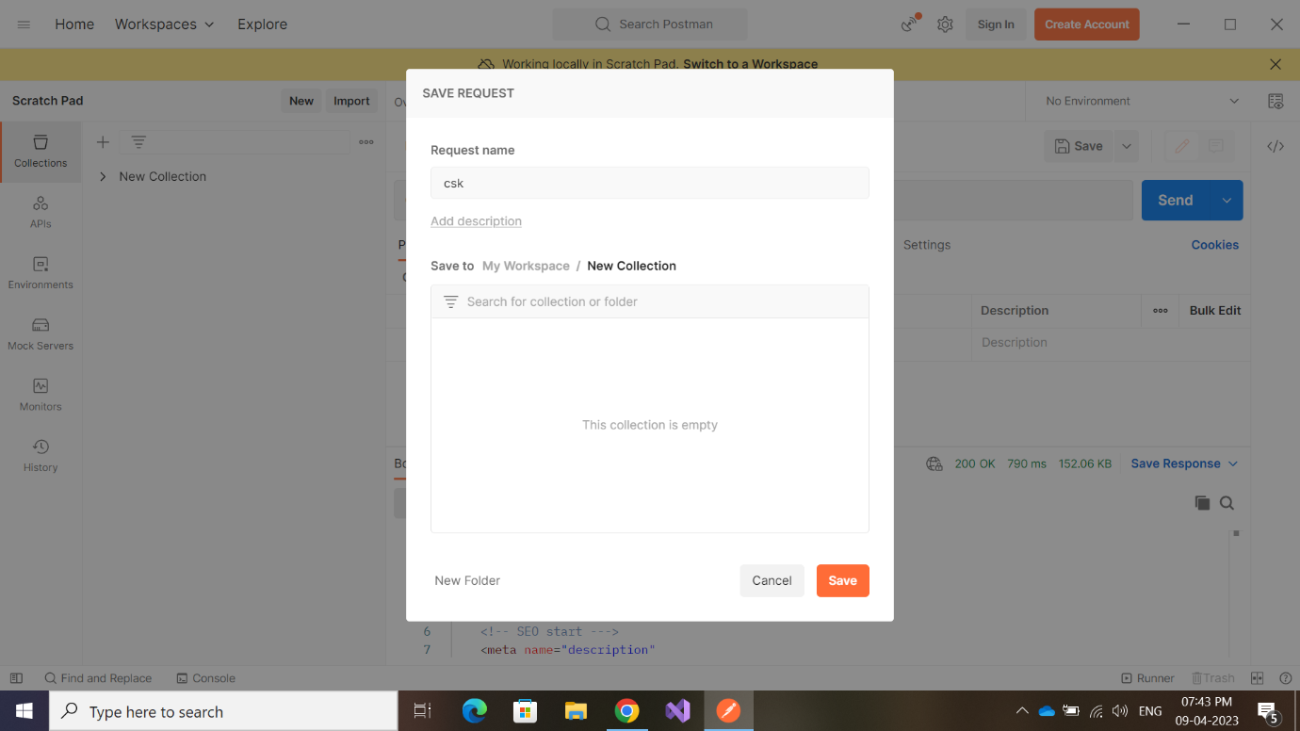

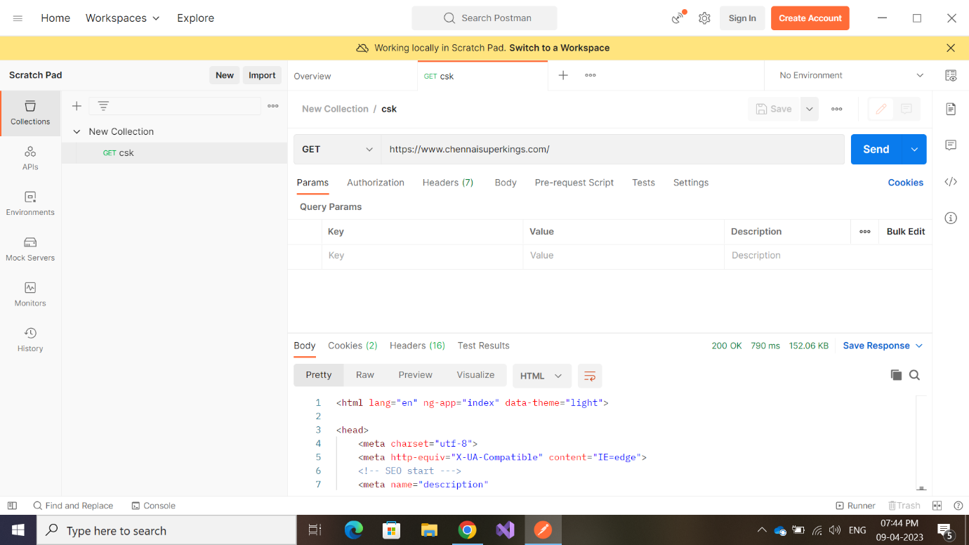

-----------------------------------------------------------GET---------------------------------------------------------------------

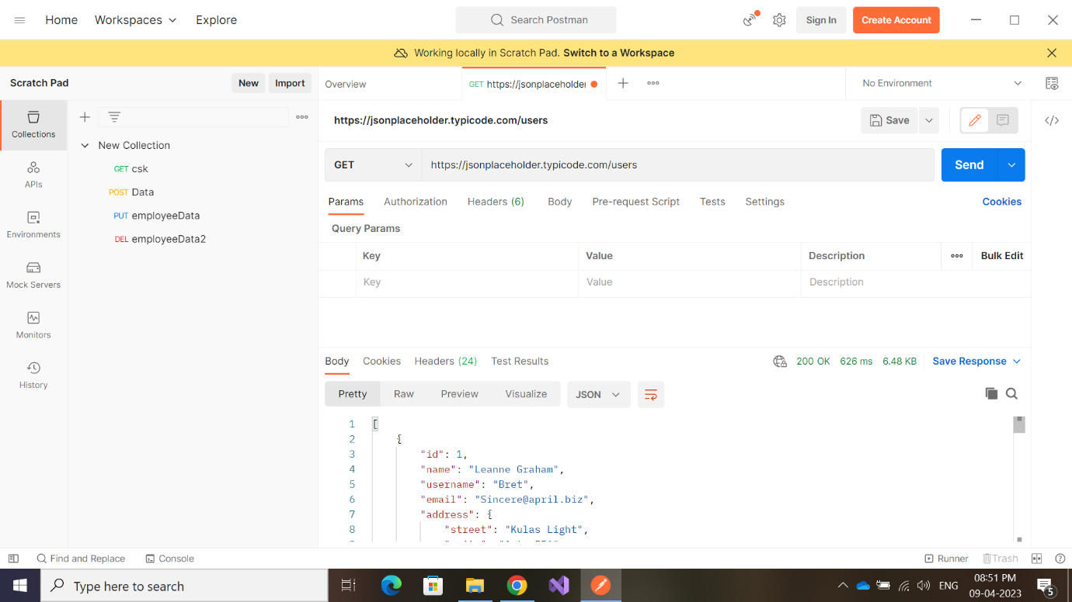

**200 OK – successfully retrieved data ! }**

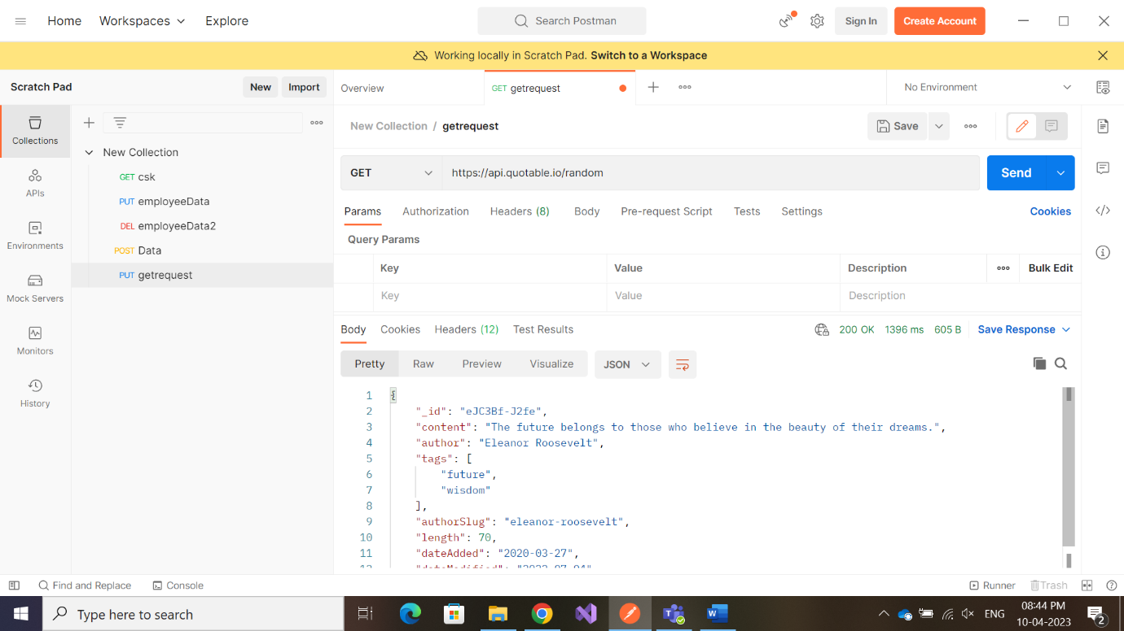

----------------------------------------------------------POST-------------------------------------------------------------------

**{ 201 Created – Successfully posted new data ! }**

**-----------------------------------------------PUT-------------------------------------------------**

