**2023 dataset without the id feature and k-means**

Autoencoders epochs = 50

FFNN = 100

Fpr = 0.0005451

Autoencoders epochs = 100

FFNN epochs = 100

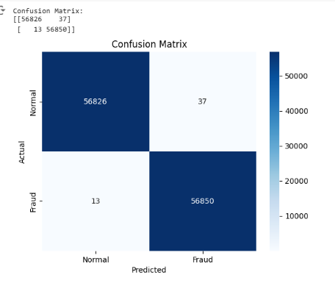

Fpr = 0.0006506

FFNN = 150 epochs

