MONIMAN Guides

BST-GBT-BK2

# Introduction

MONIMAN aims to assist geotechnical design work from creating finite-element PLAXIS model to sensitivity analysis of geotechnical and structural parameters to the behavior of the designed geotechnical engineering system, to fully automated back analysis and cost optimization driven site monitoring data.

In MONIMAN, our engineering best practices and scientific literature databases are put together as database libraries. For example, the most common soils are available in the soil libraries for Mohr-Column, Hardening Soil, and Hardening Soil small strain for the user to select.

We structure MONIMAN as modularized program using classes and modules of Python programming language. By using this structure, newly developed functionalities can be easily added to the existing program. Currently, MONIMAN is written in Python 3.4(.5) together with the below main packages.

* plxscripting (PLAXIS scripting package) for interacting with PLAXIS
* PyQt 5.6.0 (public Python package) for creating graphical user interface
* matplotlib 2.0.2 (public Python package) for plotting
* numpy 1.11.3, scipy 0.18.1 (public Python package) for numerical calculations
* scikit-learn 0.18.1, pyDOE 0.3.8
* json 2.0.9, Pickle

Executing MONIMAN will open the graphical interface as shown in Figure 1.

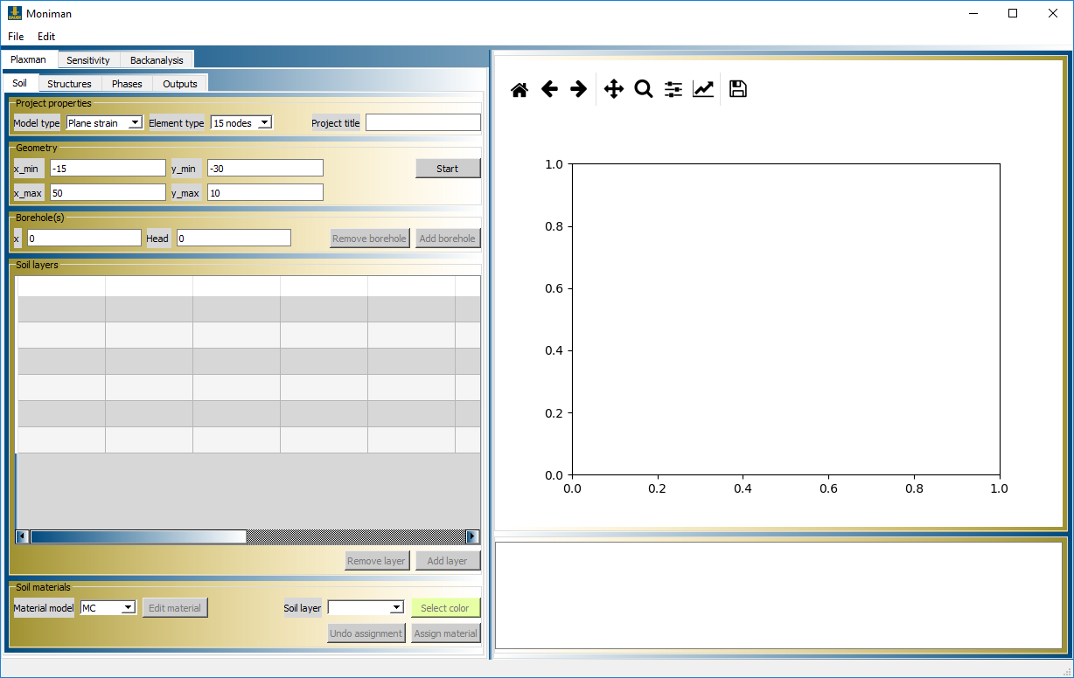

Figure 1. Current MONIMAN user interface

MONIMAN is the path in which your MONIMAN is placed.

MONIMAN_OUTPUTS is the place you want to store MONIMAN’s generated output files. The user can set their desired folder for MONIMAN_OUTPUTS.

PLAXIS2D and PLAXIS2D_SCRIPTING are the paths in which your PLAXIS2D and its scripting package are installed.

# MONIMAN – Plaxman

Plaxis bv has recently provided users a Python scripting interface to interact with PLAXIS kernel in both Input and Output modes. The use of Python scripting allows us to automate the process of model creation and output processing. This not only helps to reduce the time spent on PLAXIS substantially but also opens up opportunities for efficient implementations of sensitivity and backanalysis tools. MONIMAN-Plaxman assists in creating such a Python script of the PLAXIS input file

MONIMAN-Plaxman starts with setting the model geometry of the soil all along the way to inserting structures and creating the staged constructions. Most processes are self-explained and we try to catch errors and exceptions as much as possible to make the program stable.

**Relations used in soil definitions:**

MC:

$$G_{ref}=\frac{E'}{2(1+v^{'})}$$

HS:

$$E_{oed}^{ref}=v_{e}P^{at}{\left(\frac{P^{ref}}{P^{at}}\right)}^{w_{e}}$$

Atmospheric pressure $P^{at}$ is taken to be 100 $kN/m^{2}$. If referenced pressure is also set to be the same as atmospheric pressure, the above relation becomes

$$E_{oed}^{ref}=v_{e}100$$

The other stiffness moduli of HS model are related to $E_{oed}^{ref}$ the ratios

$$\frac{E_{50}^{ref}}{E_{oed}^{ref}}=const_{1}$$

$$\frac{E_{ur}^{ref}}{E_{50}^{ref}}=const_{2}$$

$K0nc$ is dependent on friction angle $φ$ by the relation

$$K0nc=1-sin⁡(φ)$$

HSsmall:

$$G_{0}^{ref}=\frac{E_{ur}^{ref}}{2.4}\frac{E_{dyn}}{E_{sta}}$$

You may notice that MONIMAN tries to suggest the next values, for example a strut or ground anchor where placed where the horizontal position of the wall is. We aim to make MONIMAN-Plaxman flexible to allow for the creation of any complicated retaining wall cases we face in everyday jobs but at the same time we try to keep it as simple as possible to save development time. We rather develop features that PLAXIS does not provide.

The predefined staged constructions in the tab **Phases** include the following actions.

* Wall construction: The wall(s) is activated, all line loads and point loads are activated as well.
* Excavation: The selected soil clusters are deactivated but not set to dry. Setting soil clusters dry is done in Dewatering phase instead.
* Anchoring: Activating the selected ground anchor(s) and setting the pre-stressed tension to the free-length part of the ground anchor.
* Strut construction: Activating the selected strut(s)
* Dewatering by lowering water level: Lowering water level for the selected soil clusters to the selected user water level, pore pressure calculation type should be set as ‘Phreatic’. Soil clusters above the phreatic level are automatically set dry.
* Dewatering by lowering drain head: Lowering drain head of the defined drain. Pore pressure calculation type should be set as ‘Steady state ground water flow’. Soil clusters above the phreatic level are automatically set dry.

In addition to the predefined staged constructions, combined phases can be added in the tab **Combined phases** as well. Here, all single actions have to be explicitly set by the user.

During setting up the staged constructions, it is recommended to calculate the defined steps and check the current results in PLAXIS. Unexpected modeling behaviors can be corrected on-the-fly in MONIMAN-Plaxman. If you want to examine the Python script of the created model, please open the Python text file ‘retainting_wall.py’ which is stored under your MONIMAN_OUTPUTS path.

After PLAXIS2D simulation is done, you can go to **Plaxman>Outputs** to view the requested outputs.

# MONIMAN – Sensitivity

*Sensitivity analysis* helps to quantitatively determine how much sensitivity each of the selected soil parameters has on the considered observed system responses (such as wall displacement, anchor/strut forces, and surface settlement or a combination of several observations). ***Sensiman*** currently provides the user with options for performing *local sensitivity analysis* as well *global sensitivity analysis*.

**Local sensitivity analysis** is used to quickly determine parameter sensitivity at the current parameter values. By default, each parameter is in turn perturbed by 5 percent to the lower bound and upper bound while the remaining parameters are at their current values. The total sensitivity score, $tss$, for the *i-th* parameter is calculated using a L2-norm of the difference between the observed quantities resulting from the lower-bound parameter set and those from the upper-bound parameter set as follows.

$$tss_{i}={\left[\sum_{j}{{\left(u_{j}\left(m_{i}^{max}\right)-u_{j}(m_{i}^{min})\right)}^{2}}\right]}^{1/2}$$

**Global sensitivity analysis** provides a global estimation of the sensitivity scores in the parameter space with the expense of more FE model evaluations. But thanks to the use of *Metamodeling*, global sensitivity analysis becomes practically feasible.

**Metamodeling**:

* Gaussian process regressor
* POD

# MONIMAN – Back-analysis

Back-analysis is a computational model-based method to look for soil and/or structural parameters that fit the modeled outputs to the corresponding measurements on site. ***Backman*** provides the user with options to perform fast back-analysis using the unscented Kalman filter (UKF) and a thorough global search for a parameter set that best fits the modeled output to measured data by global optimization using the Particle Swarm Optimization (PSO). Again, the burden of overly many FE model evaluations is relieved by basing the global optimization on the already trained metamodel.

**The unscented Kalman filter (UKF)**: The Kalman filter is a computationally efficient method for the model based parameter identification. The UKF is particularly efficient because it does not require gradient calculations for the model parameter updating. Further details for the use of the UKF for geotechnical back-analysis is reported in [Nguyen and Nestorovic 2015].

**The Particle Swarm Optimization (PSO)**:

Nguyen, L.T. and Nestorović, T., 2015. Nonlinear Kalman filters for model calibration of soil parameters for geomechanical modeling in mechanized tunneling. *Journal of Computing in Civil Engineering*, *30*(2), p.04015025.

# MONIMAN – Cost-analysis