***Dimensioning Capping Beam***

* From *Outputs* window, click on *Dim cross-section (1 in fig 1),* which opens *Cross-section dimensioning* window *(fig 2).*

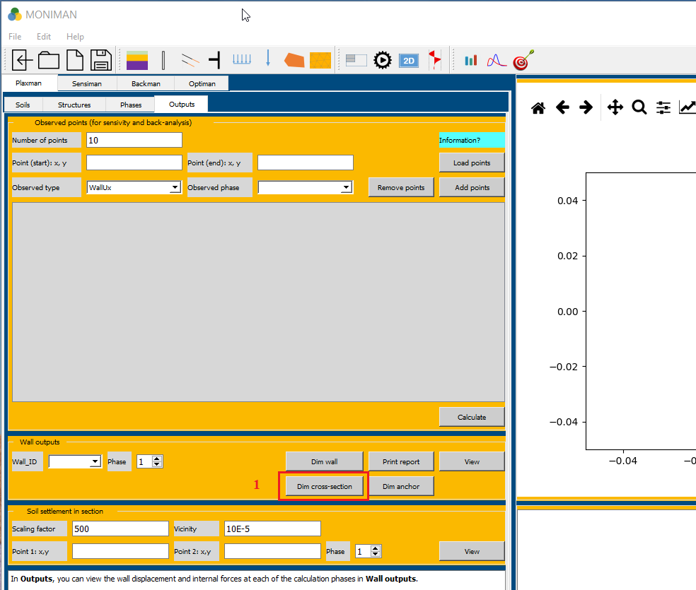

*(fig 1)*

The *Materials and PSF* menu consist of settings to select the *Code, Concrete grade, Steel grade* and *Design situation.*

* In *Code* menu, select *EN 1992-1-1:2004 + AX:2010 + NA:2011 (1 in fig 2)*.
* Select the *C 30/37* for *Concrete grade* under *Concrete* menu *(2 in fig 2).*
* Select *B500A* for *Steel grade, no crack* for *Crack width* in *Reinforcement menu (3 in fig 2).*
* Select *BS-P: Persistent* for *Design situation* in *PSF* menu *(4 in fig 2).*
* The materials concrete *C 30/37* and steel *B500A* are visible from the right side of *Wall dimensioning* window *(5 in fig 2).*

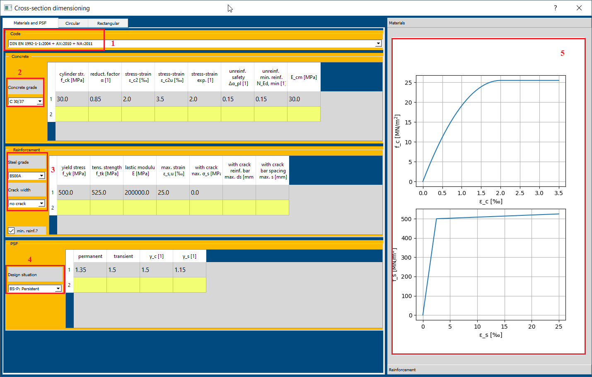

*(fig 2)*

***Rectangular Cross-section***

Select *Rectangular* from the top bar *(1 in fig3).*

The *Cross-section* menu allows defining the geometry for capping beam *(2 in fig3)*.

* In *Cross-section* menu, assign *Thickness D [m] = 1.2, Width of trench BT [m] = 2.8, Sep. to edge H1 [mm] = 100, Sep. to edge H2 [mm] = 100.*
* The two dash line *(****-*** *-* ***-*** *-* ***-*** *-)* indicates main direction and long dash line *(- - - - - )* indicates the orthogonal direction *(3 in fig 3)*.

In the *Internal forces and required reinforcement* menu, required reinforcement areas are calculated for the given forces.

* Assign *Permanent force* for *Normal force (compression is negative) N [kN] =* -1000, *Bending moment M [kNm] = 2000* and *Shear force Q [kN] = 1000 (4 in fig 3).*
* The required reinforcement area for main and orthogonal direction for *Symmetry* and *Non-symmetry* are calculated *(5 in fig 3)*.

The *Given reinforcement* menu, consists of sheets to assign the values for *n* number of bars and *Dia. [mm]* for designing the reinforcement.

* Considering the symmetry, the *Required A_s1 [cm^2]* and *Required A_s1 [cm^2]* are 42.84.
* In *Vertical* *reinforcement* sheet *(6 in fig 3)*, assign *n* = 9 and *Dia. [mm] =* 25 for first main direction and second main direction.
* Provide the minimum reinforcement at first and second orthogonal directions, i.e., *n = 2* and *Dia. [mm] =* 25.
* The given reinforcement can be verified visually from the reinforcement diagram at right side *(7 in fig 3).*

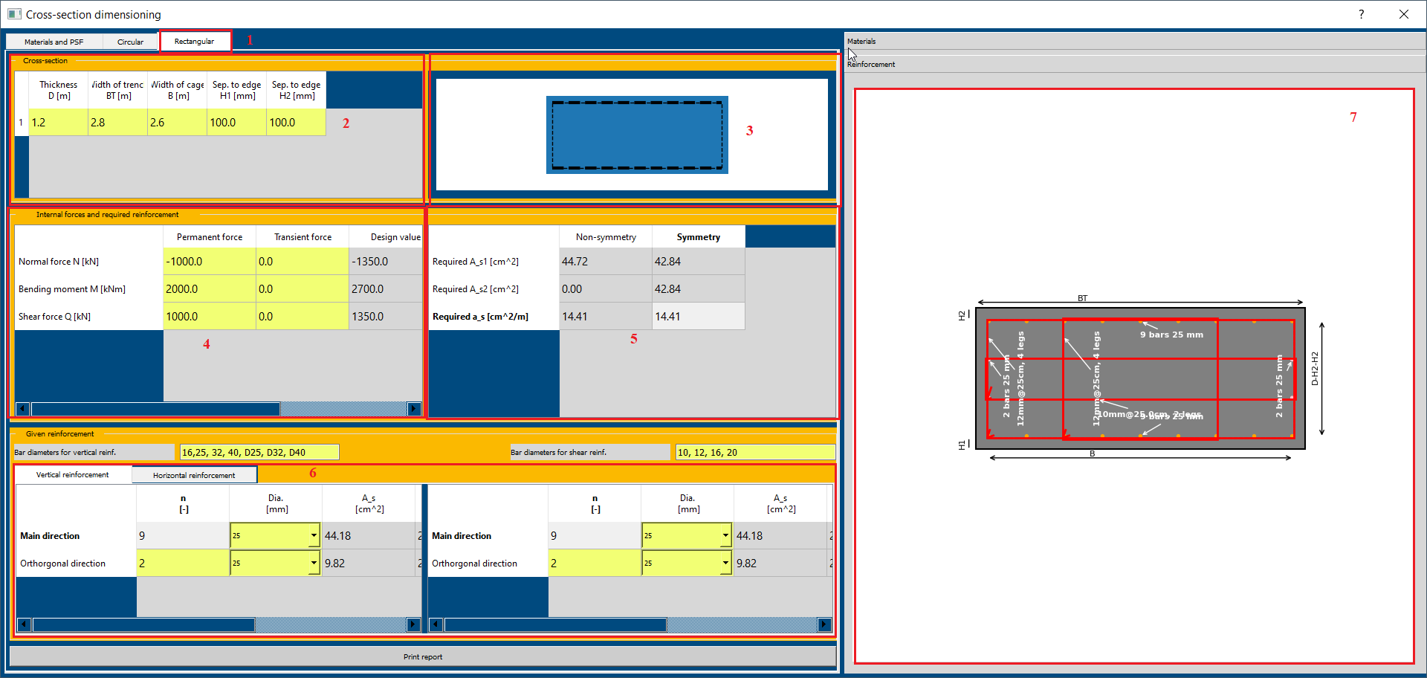

*(fig 3)*

* For horizontal reinforcement the *Required a_s [cm^2/m]* = 14.41.
* In *Horizontal reinforcement*  sheet *(fig 4)*, for *Main direction,* select 12 for *dia. d [mm]* and assign *n legs =* 4*, spacing [cm] =* 25and *Embraces [-] =* 1 9; 3 7.
* Add *‘* ***;*** *’* between two different set of *Embraces.* For above value, 1 9 is first set and 3 7 is second set.
* For *Orthogonal direction* to provide a minimum reinforcement, select 10 for *dia. d [mm]* and assign *n legs =* 4*, spacing [cm] =* 25and *Embraces [-] =* 2 3

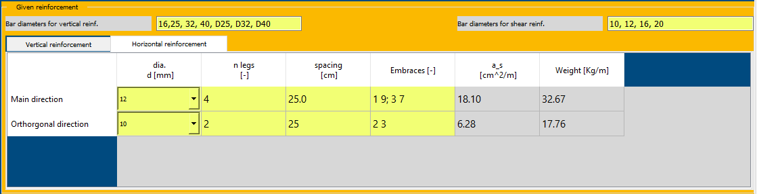

*(fig 4)*

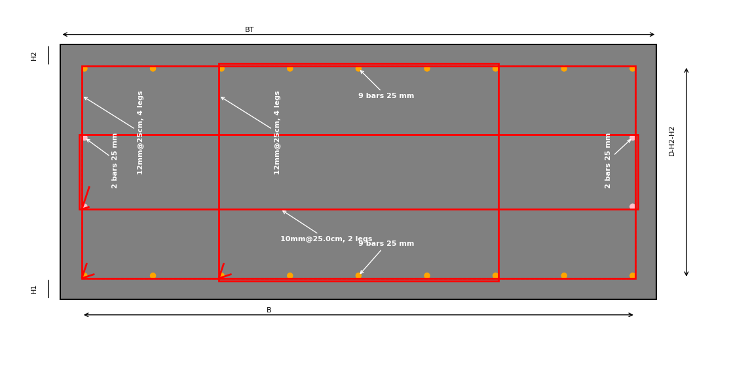

*(fig 5)*