***Dimensioning Wall (Piled Wall)***

The below tutorial walks through the steps for dimensioning of a secant pile wall. The secant piles are 1.2 m in diameter, the spacing between secondary piles is 2.0 m.

The partial input parameters for reinforcement calculation follow EC 2. The calculation is without crack control and without minimum reinforcement. The user is recommended to check for minimum reinforcement following information in EN 1536.

The safety factor on loads follow EC 7 for the design situation BS-T. We use concrete grade C30/37 and steel B500A.

***Geometry***

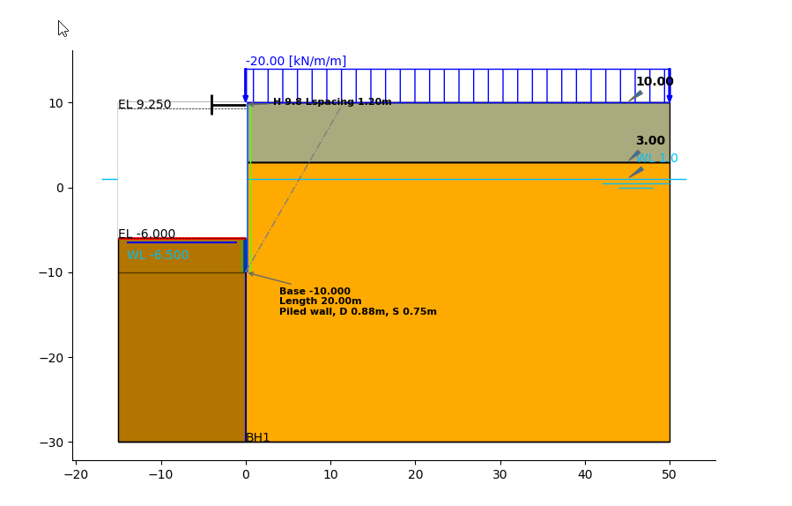

***Phases***

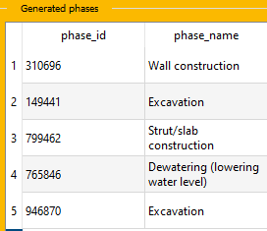

***Loading internal forces from Moniman***

***Extracting wall outputs***

After Calculation in plaxis 2D is finished, to extract wall outputs and forces of the wall for excavation phases *(phase 2 and phase 3)* follow the below steps,

* Click on *View.* The *Plaxis 2D Advanced Output server* and *Wall outputs* menu of Moniman appears.
* For exporting the wall outputs data for phase 2, change the *Phase* to 2 *(1 in fig 1)* and click on *Export data (2 in fig 1)*
* Repeat the above step for phase 5.
* Close the *Wall outputs* window and *Plaxis 2D Advanced Output server.*
* The exported wall output data are stored in *project folder \wall_outputs* file path.

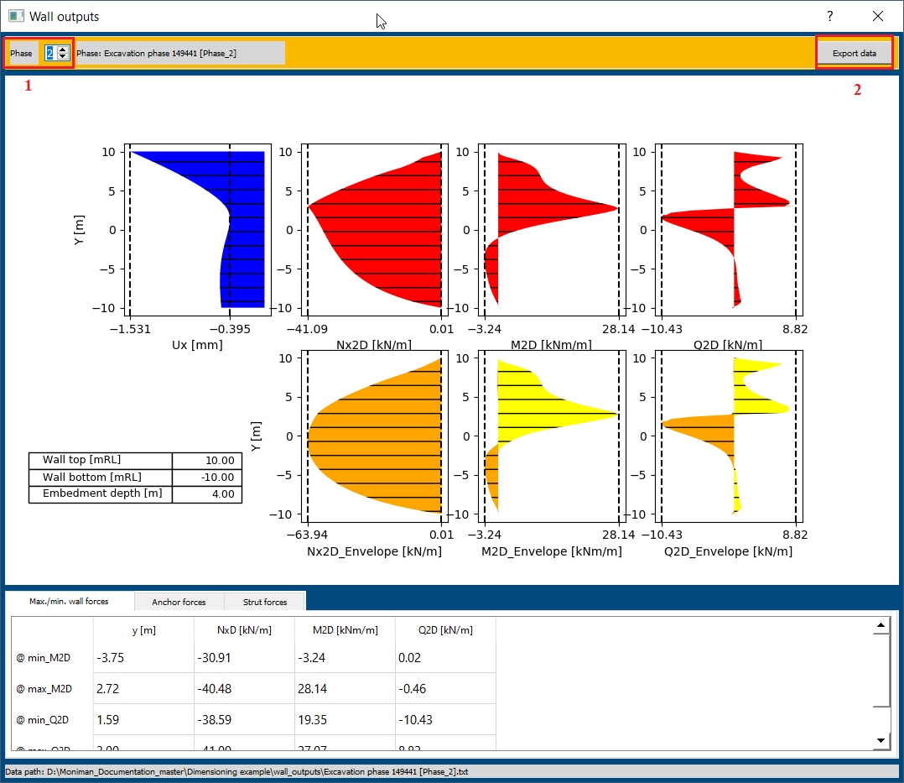

*(fig 1)*

***Dimensioning***

* From *Outputs,* In *Wall outputs* menu*,* Click on *Dim wall,* the *Wall dimensioning* window appears.
* Select *Materials and PSF* from top bar.

The *Materials and PSF* menu consist of settings to select the *Code, Concrete grade, Steel grade* and *Design situation.*

For the current tutorial select the materials and PSF as follows,

* In *Code* menu, select *EN 1992-1-1:2004 (Eurocode 2) (1 in fig 2)*.
* Select the *C 30/37* for *Concrete grade* under *Concrete* menu *(2 in fig 2).*
* Select *B500A* for *Steel grade, no crack* for *Crack width* in *Reinforcement menu (3 in fig 2).*
* Select *BS-P: Persistent* for *Design situation* in *PSF* menu *(4 in fig 2).*
* The materials concrete *C 30/37* and steel *B500A* are visible from the right side of *Wall dimensioning* window *(5 in fig 2).*

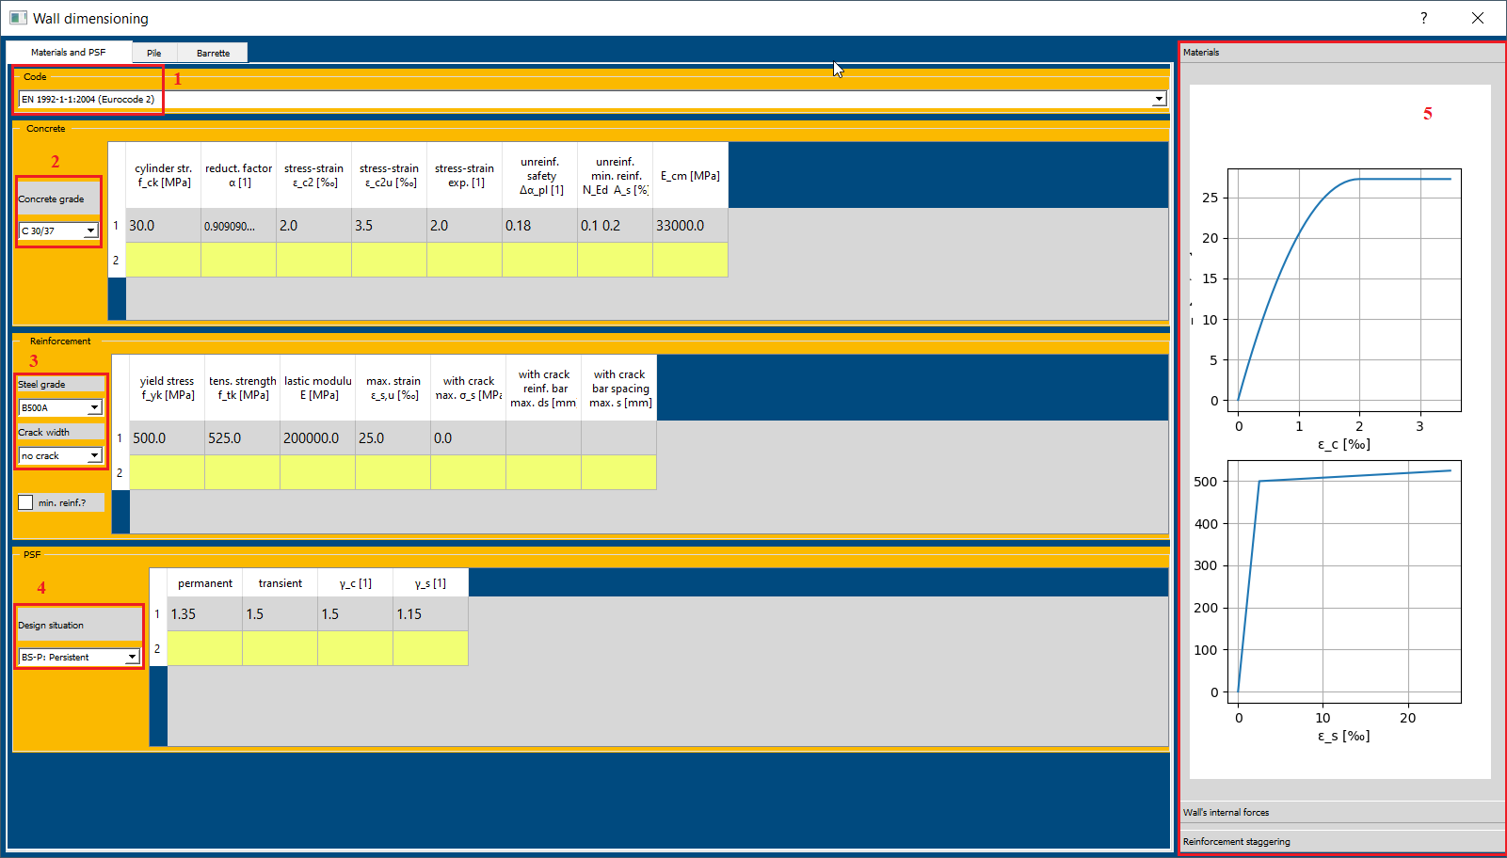

*(fig 2)*

* Next, Select *Pile* from the top bar.
* Check *Wall position, x =* 0.0 *(1 in fig 3)* and Select *py_StB* method.
* Click on *Load wall’s internal forces (2 in fig 3).*
* Select the text files for phase 2 and 5 from the *Project directory…\wall_outputs folder* extracted during wall outputs (view option). Click on *Open* and the wall internal forces are plotted on the right side of *Wall dimensioning* window.
* Click on *Calculate the required reinforcement (3 in fig 3).* The required reinforcement for phase 2 and 5 are plotted on the right side of *Wall dimensioning* window *(4 in fig 3).*
* The calculated area for phase 2 and 5 are indicated by blue and orange color curves *(4 in fig 3).* The black color line indicates the Reinforcement staggering area provided.

*A_s [cm2]* curves represent area for vertical reinforcements.

*a_s [cm2 / m]* curves represent area for shear reinforcements.

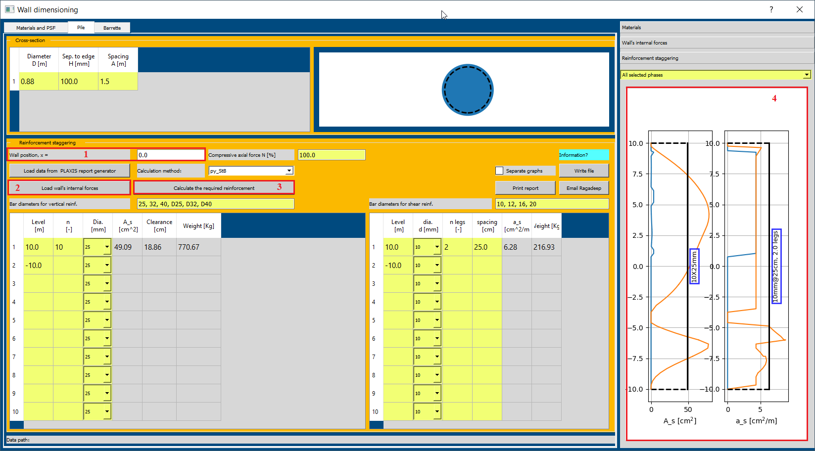

*(fig 3)*

***Reinforcement Staggering***

* Change the *n =* 12 and diameter *Dia. [mm] =* 32 mm in vertical reinforcement sheet *(1 in fig 4)* to satisfy for vertical reinforcement area *A_s [cm2]* required by internal forces.
* Change the diameter *dia. d [mm] =* 12 mm in shear reinforcement sheet *(2 in fig 4)* to satisfy for shear reinforcement area *a_s [cm2 / m]* required by internal forces.
* There is shift in black line *(5 in fig 4)* representing the area provided for vertical reinforcement 12 bars of 32 mm *(12x32mm)* and shear reinforcement 12mm@25cm, 2legs which satisfies required reinforcements.
* For certain cases, there is an option to assign different areas for different levels *(3 in fig 4).*

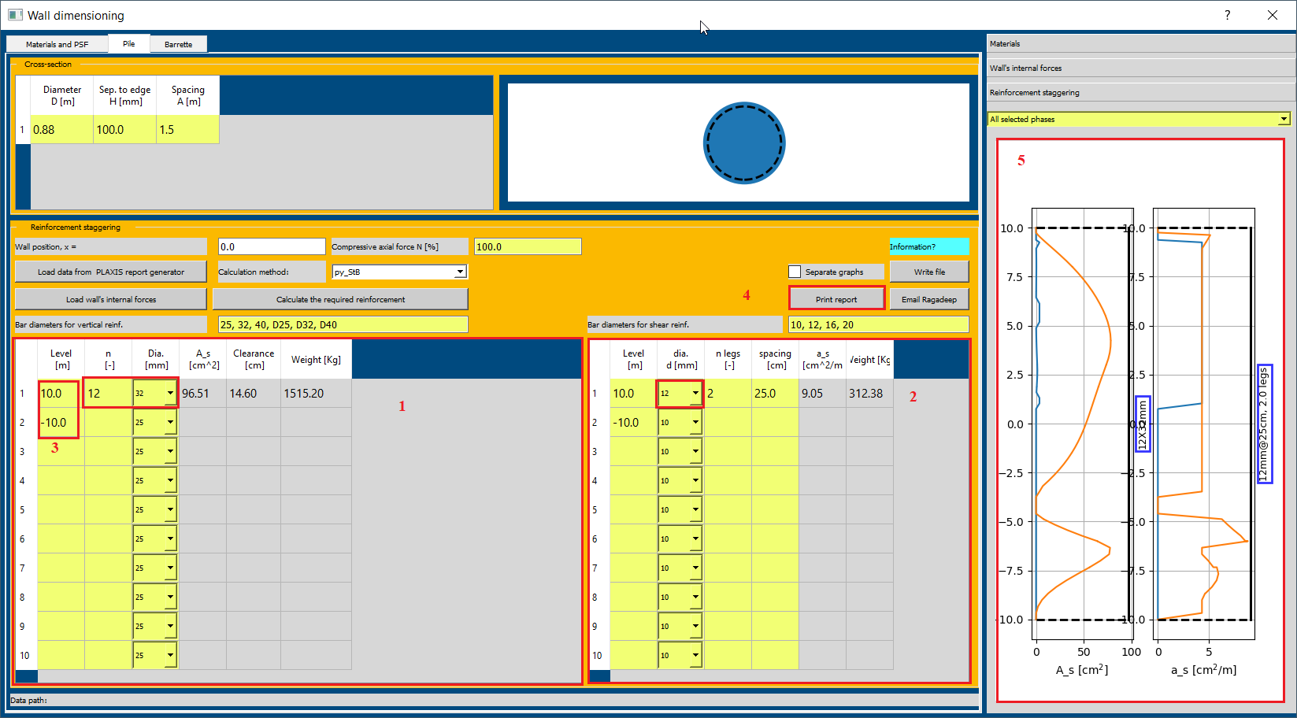

*(fig 4)*

* Click on *Print Report (4 in fig 4)* to print report for Reinforcement Staggering.

***Loading internal forces from Plaxis 2D report generator***

The procedure for dimensioning of wall is the same as with loading wall internal forces from MONIMAN. The below tutorial focuses on data export in PLAXIS2D and loading data for wall dimensioning with MONIMAN.

***Dimensioning***

* From *Outputs,* In *Wall outputs* menu*,* Click on *Dim wall,* the *Wall dimensioning* window appears.
* Select *Materials and PSF* from top bar.

The *Materials and PSF* menu consist of settings to select the *Code, Concrete grade, Steel grade* and *Design situation.*

* In *Code* menu, select *EN 1992-1-1:2004 (Eurocode 2) (1 in fig 5)*.
* Select the *C 30/37* for *Concrete grade* under *Concrete* menu *(2 in fig 5).*
* Select *B500A* for *Steel grade, no crack* for *Crack width* in *Reinforcement menu (3 in fig 5).*
* Select *BS-P: Persistent* for *Design situation* in *PSF* menu *(4 in fig 5).*
* The materials concrete *C 30/37* and steel *B500A* are visible from the right side of *Wall dimensioning* window *(5 in fig 5).*



*(fig 5)*

* Next, Select *Pile* from the top bar.
* In *Cross-section* menu *(1 in fig 6)*, assign *Diameter D [m] = 0.88, Sep. to edge H [mm] = 100* and *Spacing A [m] = 1.5.*
* In Reinforcement Staggering menu, Assign the *Wall position, x = 0.0 (2 in fig 5).*
* Click on *Load data from PLAXIS report generator (3 in fig 6),* and select folder containing the *Plaxis 2D report generator* files.
* The internal forces are plotted at the right side of the *Wall dimensioning* window *(5 in fig 6)*

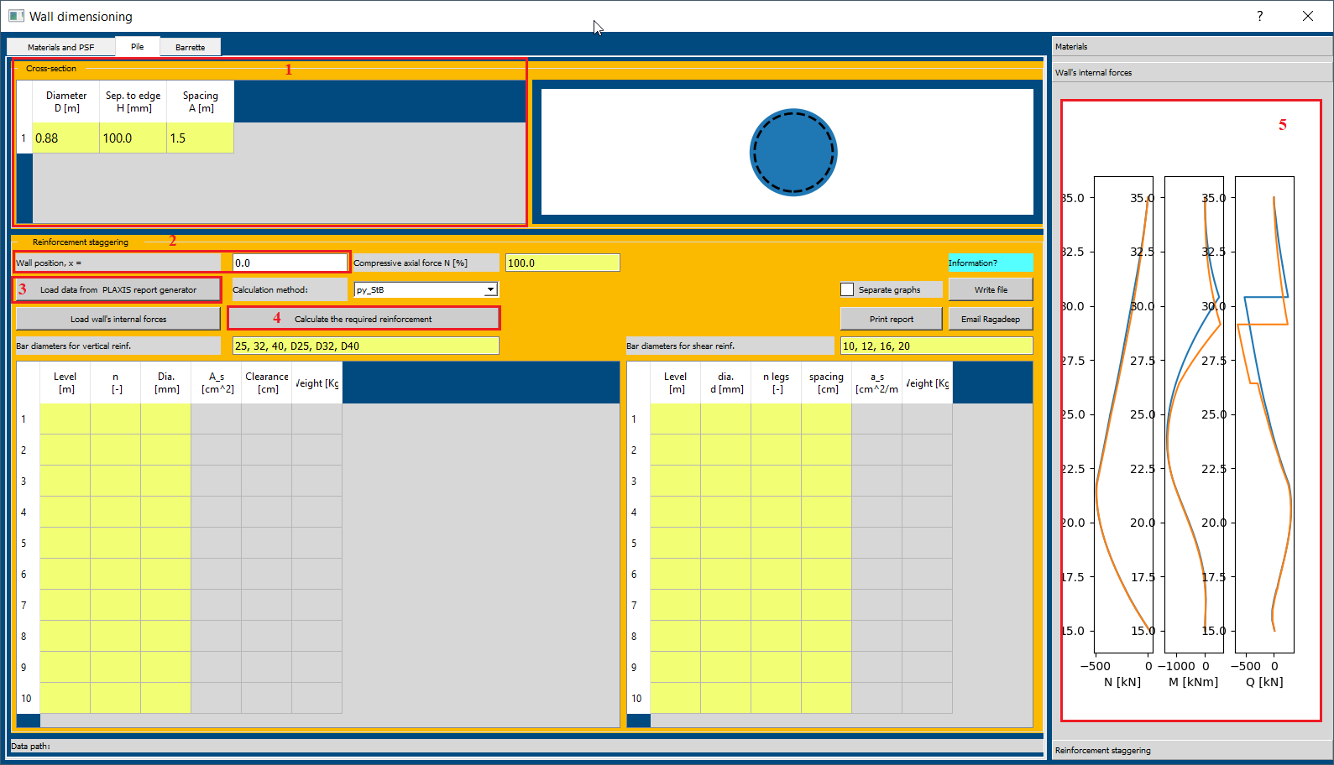

*(fig 6)*

* Click on *Calculate the required reinforcement (4 in fig 6)* and internal forces are plotted on the right side of *Wall dimensioning* window.

***Reinforcement Staggering***

* In vertical reinforcement sheet, assign levels 35.0, 27.5 and 15.0 and change the *n* and *Dia. [mm]* according to sheet in *1 in fig 7.*
* Similarly, for shear reinforcement sheet, assign the values as show in *2 in fig 7.*
* The black line representing the provided reinforcement satisfies the calculated required reinforcement *(3 in fig 7).*

*A_s [cm2]* curves represent area for vertical reinforcements.

*a_s [cm2 / m]* curves represent area for shear reinforcements.

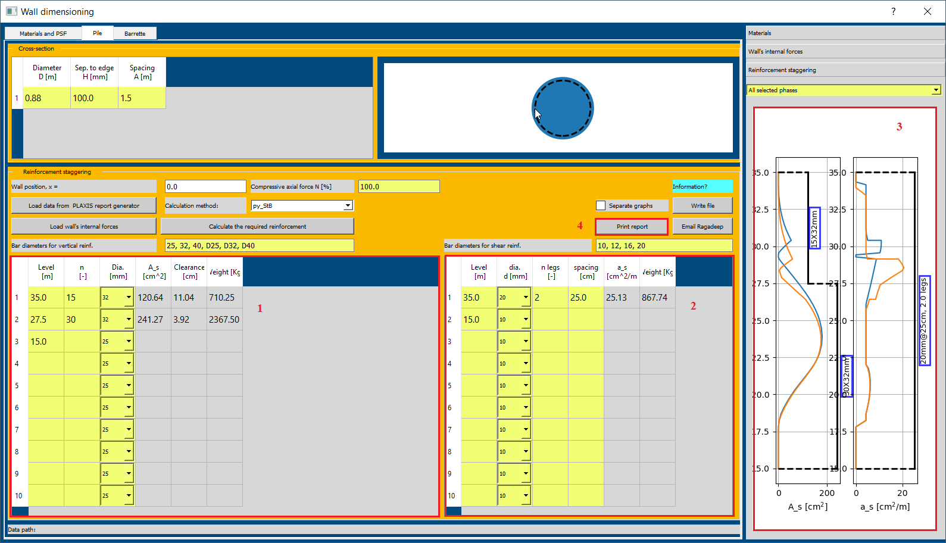

*(fig 7)*

* Click on *Print Report (4 in fig 7)* to print report for Reinforcement Staggering.