***Dimensioning Wall (Piled Wall)***

The below tutorial walks through the steps for dimensioning of a secant pile wall. The secant piles are 1.2 m in diameter, the spacing between secondary piles is 2.0 m.

The partial input parameters for reinforcement calculation follow EC 2. The calculation is without crack control and without minimum reinforcement. The user is recommended to check for minimum reinforcement following information in EN 1536.

The safety factor on loads follow EC 7 for the design situation BS-T. We use concrete grade C30/37 and steel B500A.

***Geometry***

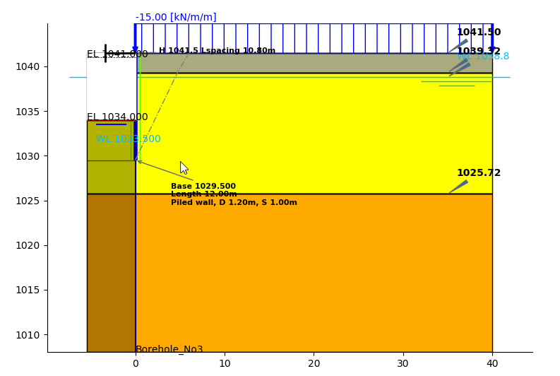

*(fig 1)*

***Phases***

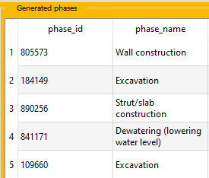

*(fig 2)*

***Extracting Wall outputs***

After calculation *(1 in fig 3)* is finished, to extract wall outputs and forces of the wall for excavation phases *(phase 2 and phase 5)* follow the below steps,

* From *Outputs* , In *Wall outputs* menu,Click on *View (2 in fig 3).* The *Plaxis 2D Advanced Output server* and *Wall outputs* menu of Moniman appears.

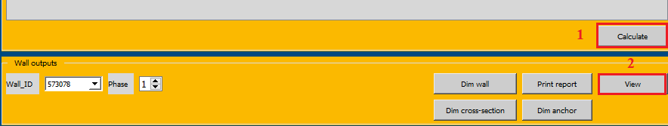

*(fig 3)*

* For exporting the wall outputs data for phase 2, In *Wall outputs* menu, change the *Phase* to 2 *(1 in fig 4)* and click on *Export data (2 in fig 4)*
* Similarly export the wall outputs data for phase 5.
* The exported wall output data are stored at */project directory…/wall_outputs/* folder.
* Close the *Wall outputs* window and *Plaxis 2D Advanced Output server.*

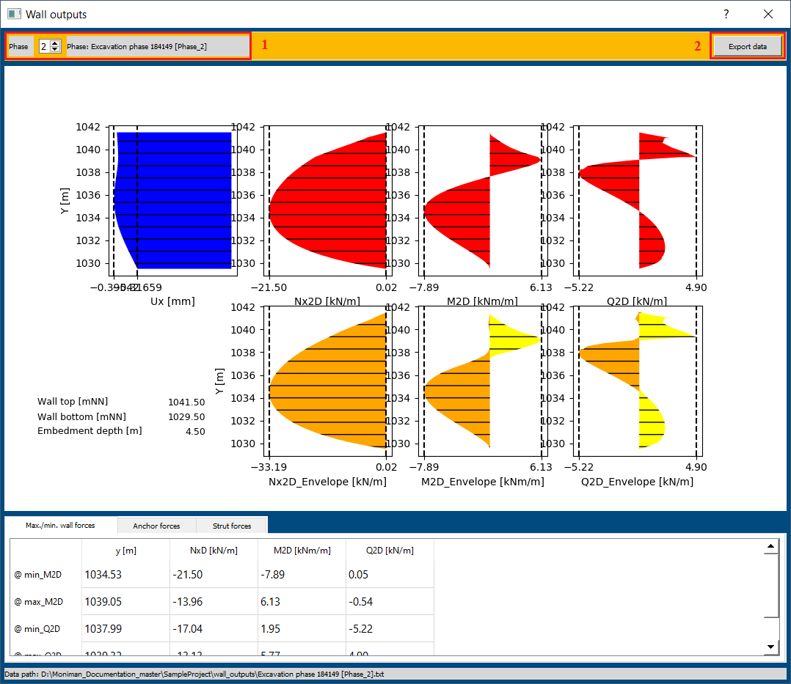

*(fig 4)*

***Dimensioning***

* From *Outputs,* In *Wall outputs* menu*,* Click on *Dim wall (1 in fig 5),* the *Wall dimensioning* window appears.

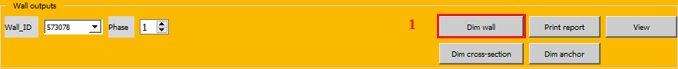

*(fig 5)*

The *Materials and PSF* menu consist of settings to select the *Code, Concrete grade, Steel grade* and *Design situation.*

To select the materials and PSF for current tutorial follow below steps,

* In *Wall dimensioning,* Select *Materials and PSF* from top bar.
* In *Code* menu, select *EN 1992-1-1:2004 + AX:2010 + NA:2011 (1 in fig 6)*.
* Select the *C 30/37* for *Concrete grade* under *Concrete* menu *(2 in fig 6).*
* Select *B500A* for *Steel grade, no crack* for *Crack width* in *Reinforcement menu (3 in fig 6).*
* Select *BS-T: Transient* for *Design situation* in *PSF* menu *(4 in fig 6).*
* The materials concrete *C 30/37* and steel *B500A* are visible from the right side of *Wall dimensioning* window *(5 in fig 6).*

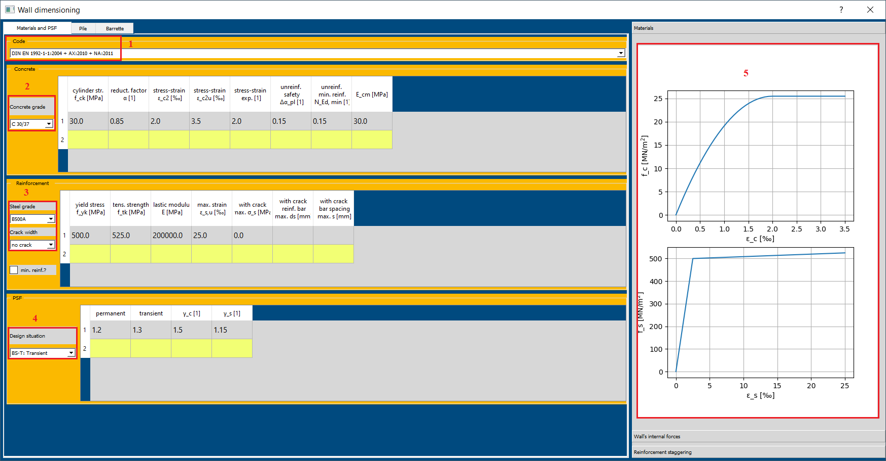

*(fig 6)*

***Loading Internal Forces***

***Loading Internal Forces from Moniman extracted data***

* Select *Pile* from the top bar of *Wall dimensioning* window.
* Check *Wall position, x =* 0.0 *(1 in fig 7)* and Select *py_StB* method.
* Click on *Load wall’s internal forces (2 in fig 7)* for using the wall outputs data exported using Moniman. Internal forces from one or more calculation phases can be then selected. Note that the shown internal forces are values already multiplied with the pile spacing between secondary (reinforced) piles.

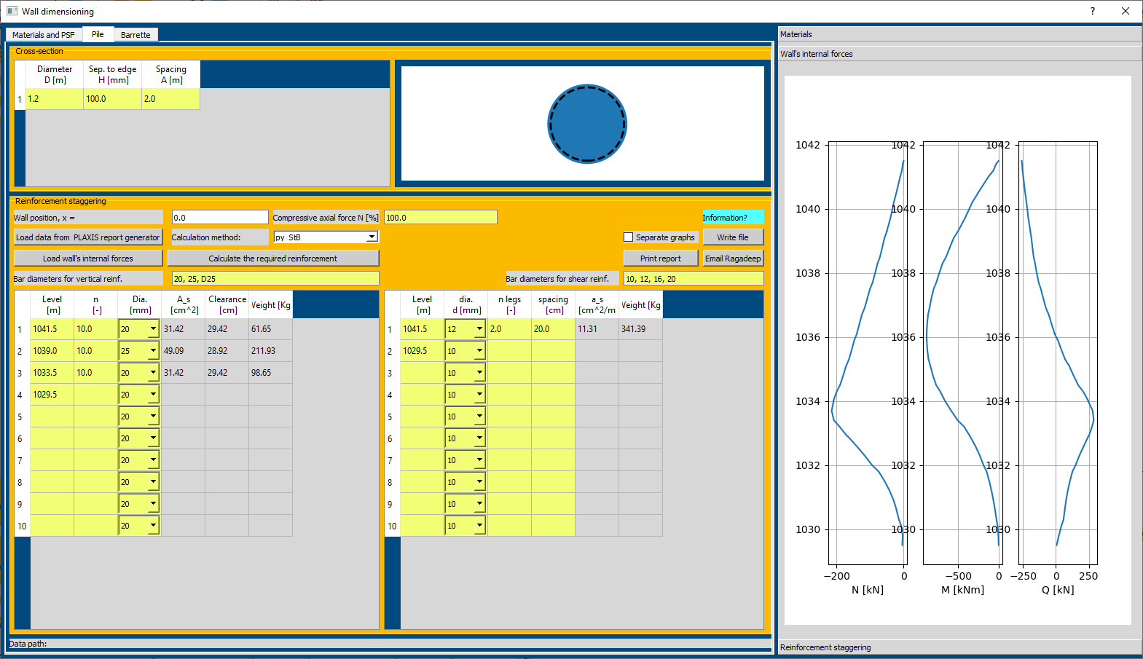

(fig 7)

* Select the text files for phase 2 and 5 from the *project directory…/wall_outputs folder* Click on *Open* and the wall internal forces are plotted on the right side of *Wall dimensioning* window.
* Click on *Calculate the required reinforcement (3 in fig 8).* The required reinforcement for phase 2 and 5 are plotted on the right side of *Wall dimensioning* window *(4 in fig 3).*

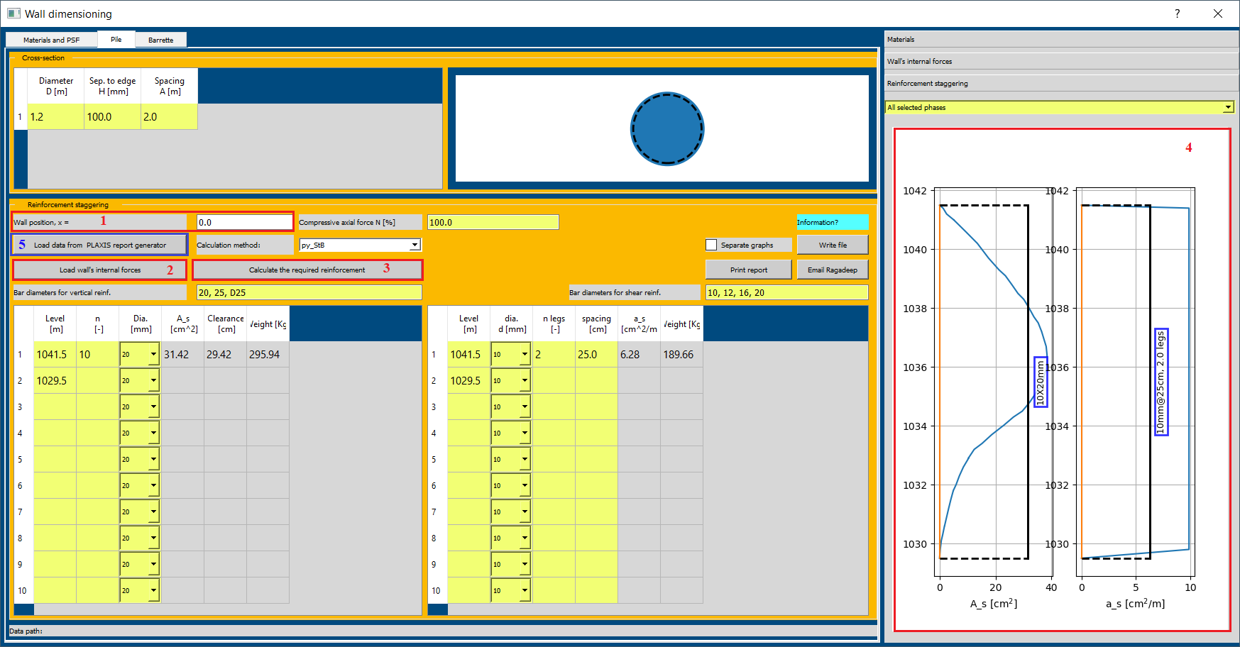

*(fig 8)*

* In the plot for calculated required reinforcement *(4 in fig 8)*, *A_s [cm2]* represents area of vertical reinforcements and *a_s [cm2 / m]* represents area of shear reinforcements
* The black color line represents the Reinforcement area provided, which is lesser than required.

***Loading Internal Forces from Plaxis report generator***

* Select *Pile* from the top bar of *Wall dimensioning* window.
* Check *Wall position, x =* 0.0 (5 in fig 8) and Select *py_StB* method.
* Click on *Load data from PLAXIS report generator (2 in fig 8)* for using data exported using *PLAXIS report generator.*
* Select folder containing the *Plaxis 2D report generator* files.
* The internal forces are plotted at the right side of the *Wall dimensioning.*
* Click on *Calculate the required reinforcement (3 in fig 8).* The required reinforcement areas are plotted on the right side of *Wall dimensioning* window.
* Follow the similar procedure as below for reinforcement staggering *(which is case for loading forces from Moniman tutorial)*

***Reinforcement Staggering***

* The *Bar diameters for vertical reinforcement (1 in fig 8)* and *Bar diameters for shear reinforcement (2 in fig 8)* contains various diameters for the bars.

***Vertical Reinforcement A_s [cm2]***

* The left side sheet *(3 in fig 8)* is to work for Vertical Reinforcement which provides option for *Level [m], n [-]* and *Dia. [mm].*
* From *4 in fig 8,* the provided *A_s [cm2]* vertical reinforcement area is less than required reinforcement area at levels from 1039 to 1033.
* Let’s provide three different staggering’s *10x20mm* at levels *1041.5 to 1039*, *20x25mm* at levels *1039 to 1033.5* and *10x20mm* at levels *1033.5 to 1029.5.*
* To assign different levels, double click on 1029.5 *(row 2 & col Level [m])* and change it to 1039. Similarly assign *row 3 & 4* with 1033.5 and 1029.5.
* To provide staggering at levels 1041.5 to 1039, consider *row 1,* and assign *n* 10 for 10 bars and change the *Dia. [mm]* to *20mm.*
* The provided staggering is plotted at *5 in fig 9* and the plot is dynamic i.e., any changes in the reinforcement sheet is noticeable on plot.
* For levels 1039 and 1033.5, consider *row 2,* and assign *n* 10 and change the *Dia. [mm]* to *25mm.*
* For levels 1033.5 and 1029.5, consider *row 2,* and assign *n* 10 and change the *Dia. [mm]* to *25mm.*

***Shear Reinforcement a_s [cm2 / m]***

* The right side sheet *(4 in fig 9)* is to work for Shear Reinforcement which provides option for *Level [m], Dia. [mm], n legs [-]* and *Spacing[cm]*
* From *4 in fig 9,* the provided shear reinforcement area is less than required reinforcement area.
* Let’s provide *12mm@20cm, 2.0 legs* through out from level 1041.5 to 1029.5.
* Consider *row 1,* change *dia. d [mm] 12,* assign *n legs =* 2, *spacing [cm] = 20.*

The provided vertical reinforcement area and shear reinforcement area can be verified from the plot *(5 in fig 9)*

* Click on *Print Report (6 in fig 9)* to print report for Reinforcement Staggering.

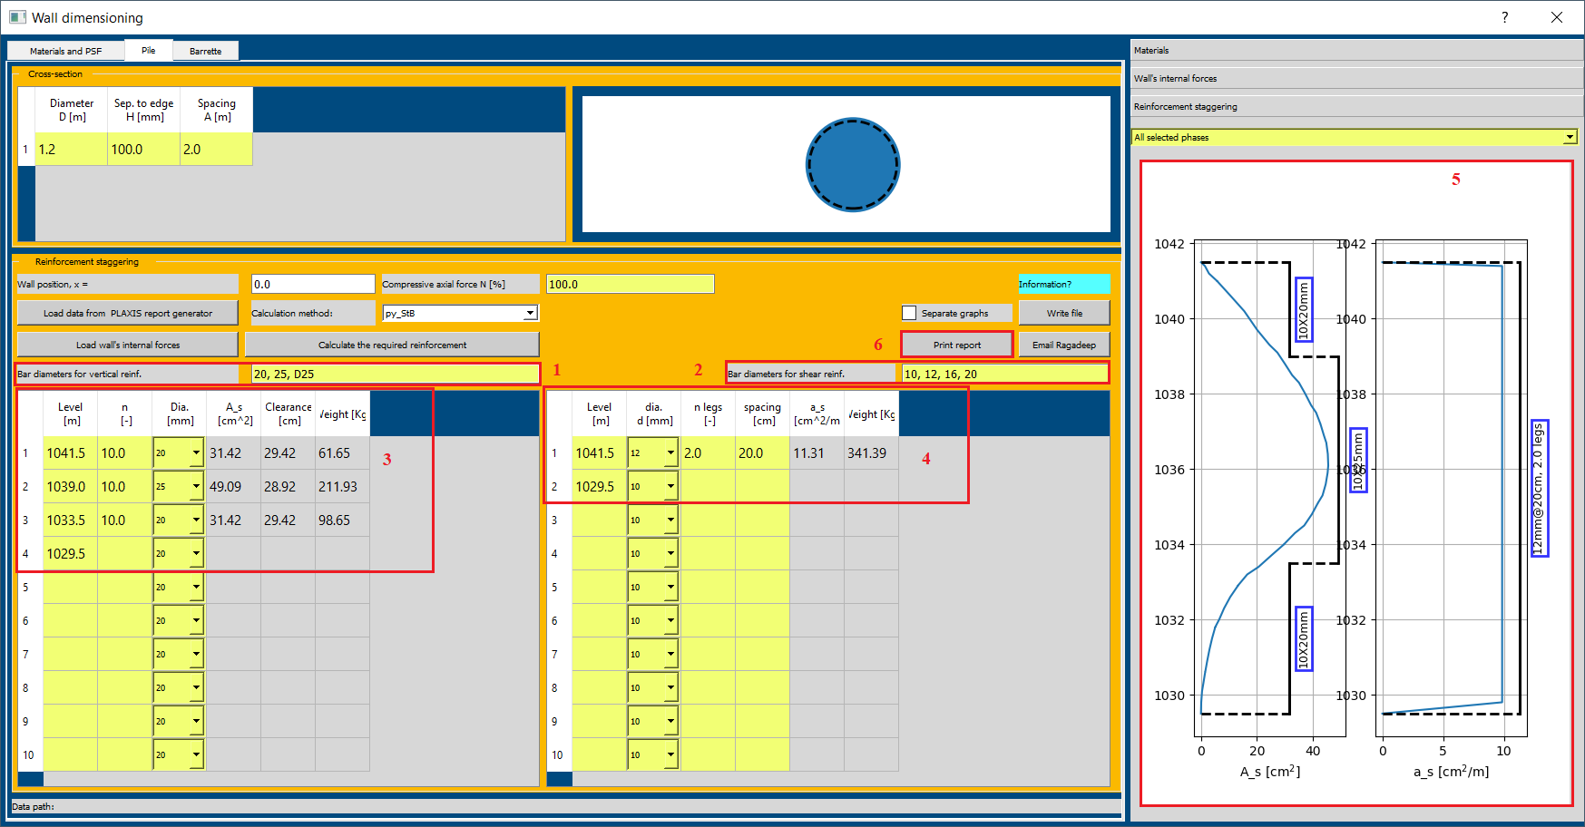

*(fig 9)*

**Additonal notes**

Dimensioning for a panel of diaphragm walls can be carried out in the same way.

This wall dimensioning tool can also be used for independent PLAXIS2D model, that is PLAXIS2D model that is not created using MONIMAN. To use this functionality the user needs to click on ‘Load data from PLAXIS report generator’ when loading internal forces and point to the folder ‘Report’ which is generated by PLAXIS generator.

The steps for data exporting using PLAXIS report generator is shown in the following.

Open PLAXIS2D Output report generator from menu File\ Report generator …. Then select Separate data files. The folder shown in Directory is where the data will be exported.

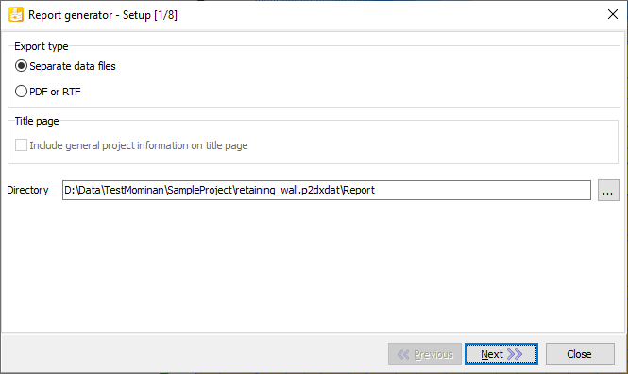

Click on Next to select the phases from which internal forces should be exported.

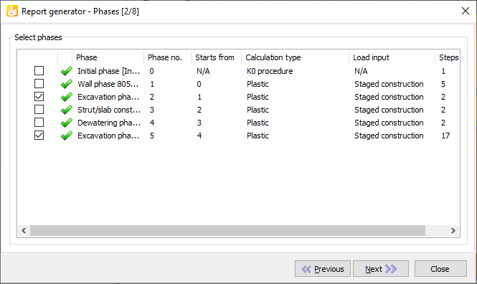

Click then 3 times Next to come to Structure views and then select the Table of total displacements under Deformations,

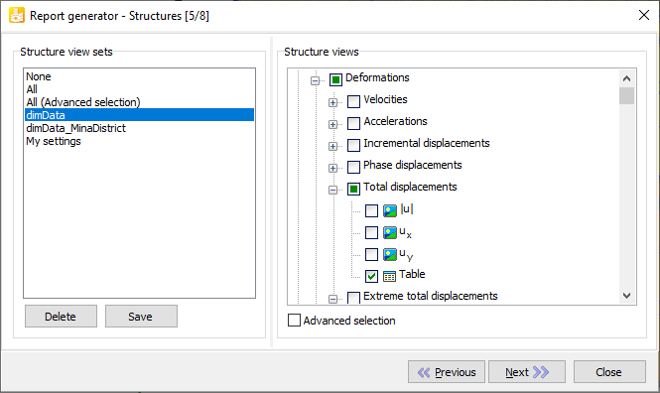

and the Table of plate force envelopes under Forces.

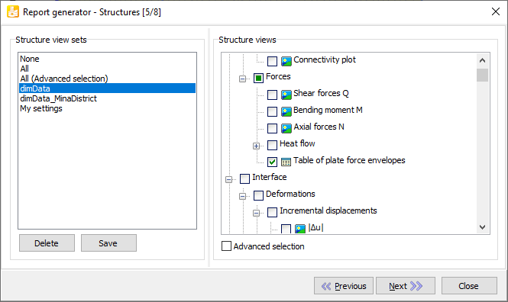

Click Next two more times and then click on Export to finish.

