**2. RETAINING WALL WITH ANCHORS**

The objectives of this tutorial are as follows,

* Modeling the retaining wall with anchors / Plaxman.
* Sensitivity analysis of parameters and metamodeling / Sensiman.
* Back-analysis using Particle Swarm Optimization *(PSO)* / Backman.

**PLAXMAN**

Start Moniman by double clicking the **D:\Data\Downloads\moniman_logo-6.png** icon of the input program. The Moniman window appears, consisting of four tabsheets *Plaxman, Sensiman, Backman* and *Optiman (1 in fig 2.1).*

The left half of Moniman consist of tab sheets where you input values for modelling *(2 in fig 2.1)* and right part contains model diagram in the top *(3 in fig 2.1)* and terminal in the bottom *(4 in fig 2.1)*.

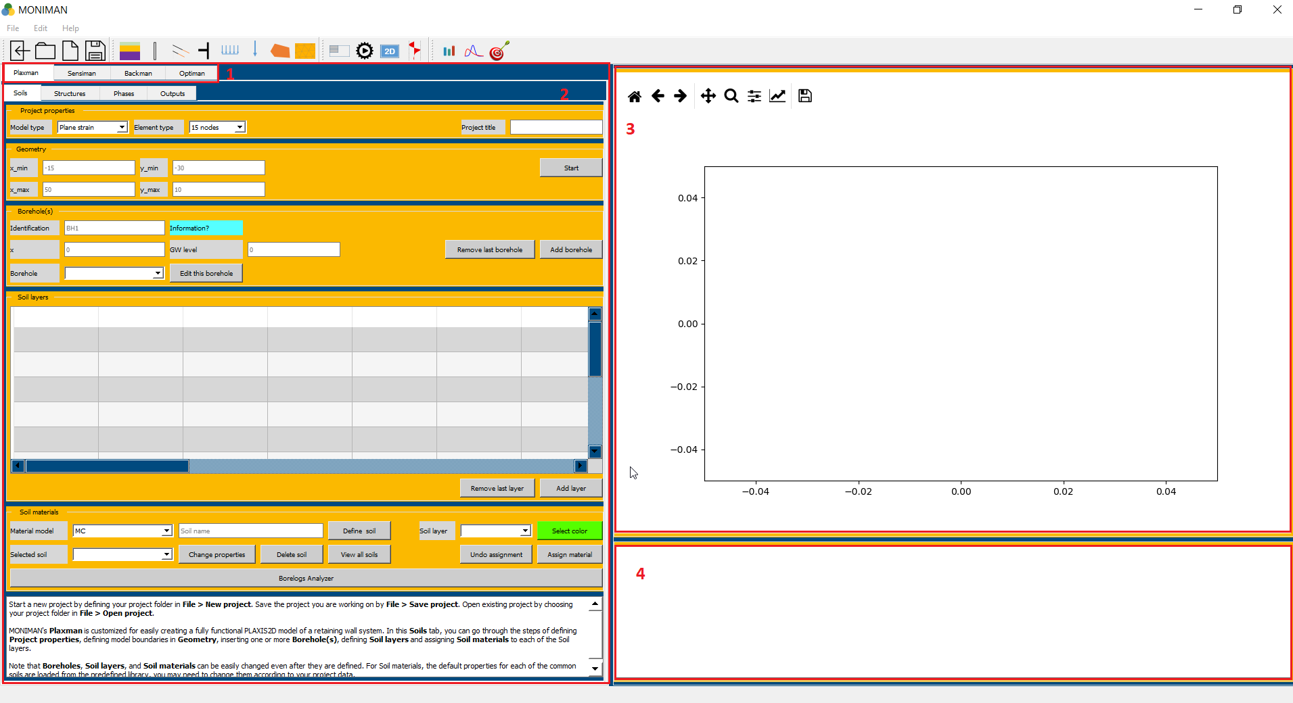

*(fig 2.1)*

* To start a new project, create a folder in file explorer at your desired path.
* Open Moniman, click on *File* --> *New project* or click on ** and select a created folder.
* To open an existing moniman project folder, click on *File --> Open project* or click on 
* Remember to save the project regularly while working with Moniman by clicking on icon  or *File--> Save project.*

*Note: Do not use any special characters or spaces while assigning the names or values.*

***Soils***

***Project properties***

The first step in every analysis is to set the basic parameters of the finite element model. This is done in the Project properties menu under soils. The settings include the type of model, Element type and project title.

To enter the appropriate settings for Retaining wall calculation follow these steps,

* Select *Plane strain* for *Model type* and *15 nodes* for *Element type (1 in fig 1.2)*.
* Enter the *Project title* as *Retaining Wall.*

***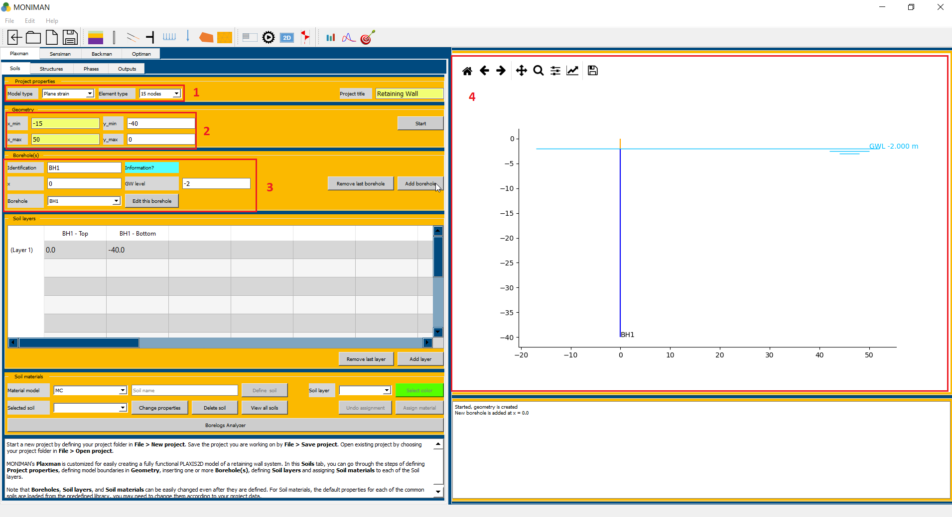***

*(fig 1.2)*

***Geometry***

The *Geometry* menu includes the settings to define the drawing area.

* Assign -15, 50, -40, 0 to *x\_min, x\_max, y\_min,* and *y\_max* respectively *(2 in fig 1.2)*.
* Click on *Start,* which updates the drawing area in the model diagram *(4 in fig 1.2)*.

***Borehole(s)***

Borehole menu includes settings to define water table. For Retaining wall project to assign ground water level at -2m elevation,

* Enter *BH1* in Identification, and type 0 in *x, -2* in *GW level (3 in fig 1.2)* and click on *Add borehole*. The borehole is updated in the model diagram *(4 in fig 1.2)*

***Soil layers***

The soil layers menu includes the sheet with layers as rows and elevations as columns.

In order to construct the soil stratigraphy follow these steps,

* Double click on cell for *(Layer 1) and (BH1 – Bottom)* and change the value to *-5 (1 in fig 1.3)*, which is bottom elevation of layer 1 *(Fill)* and click on *Add layer.* The layer 1 is geometrically defined.
* Similarly, assign -8, -12, -40 for layer 2, layer 3 and layer 4 and click on Add layer *(2 in fig 1.3)*.

*Remember to click Add layer for the last layer assigned. Moniman shows (Layer 5), BH1- Top and BH1 – Bottom as -40, -40 which needs to be ignored.*

* The added layers appear on the model diagram *(3 in fig 2.3).*

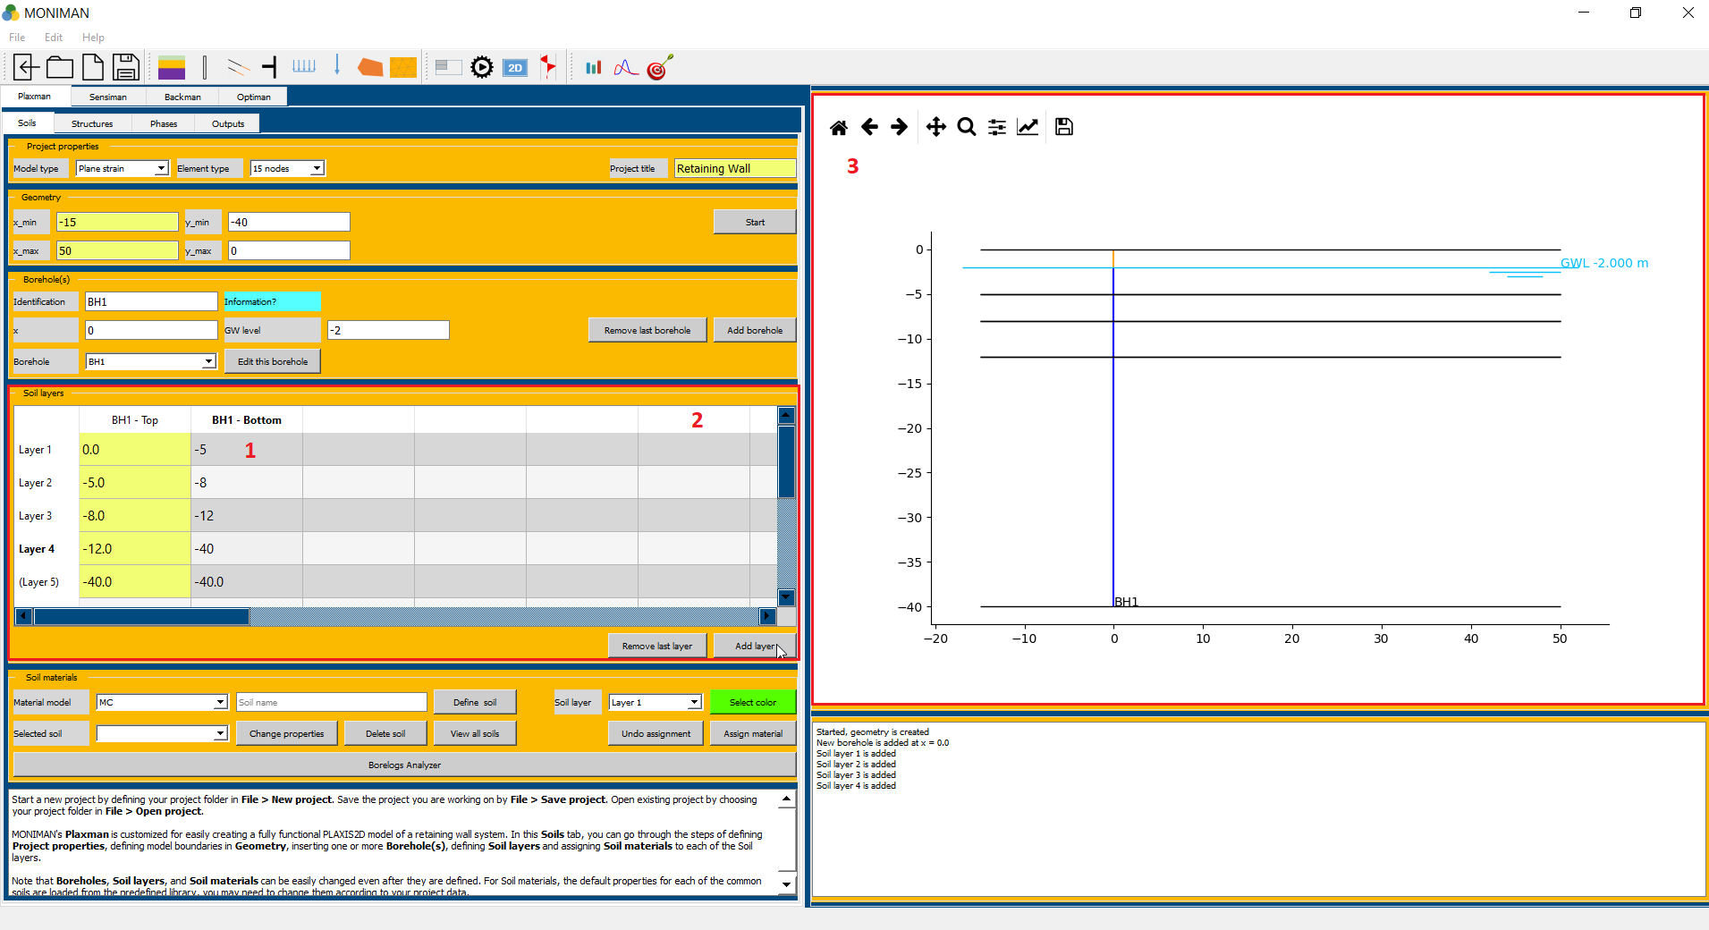

*(fig 2.3)*

***Soil materials***

In order to simulate the behavior of the soil, a suitable soil model and appropriate material parameters must be assigned to the layers defined earlier. Accordingly, the *Soil materials* menu consist of predefined library of soils, which can be changed according to your project.

To define the required soils for the current project follow these steps,

* Select *HSsmall* for *Material Model*  in *Soil material* menu *(1 in fig 2.4)* to consider *Hardening Soil model with small-strain stiffness.*
* Type *Fill* in *Soil name (2 in fig 2.4)* and click on *Define soil (3 in fig 2.4),* which pop up *HSsmall properties* window *(fig 2.5)*.

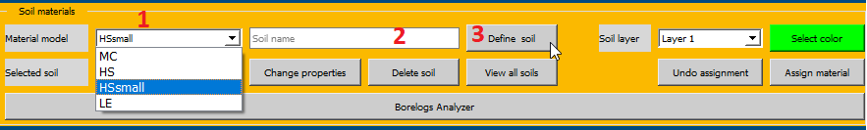

*(fig 2.4)*

* In *HSsmall properties*, select *Fill* in *Material name* *(1 in fig 2.5)* and click on *Load.* Click on *OK* to define the fill soil.

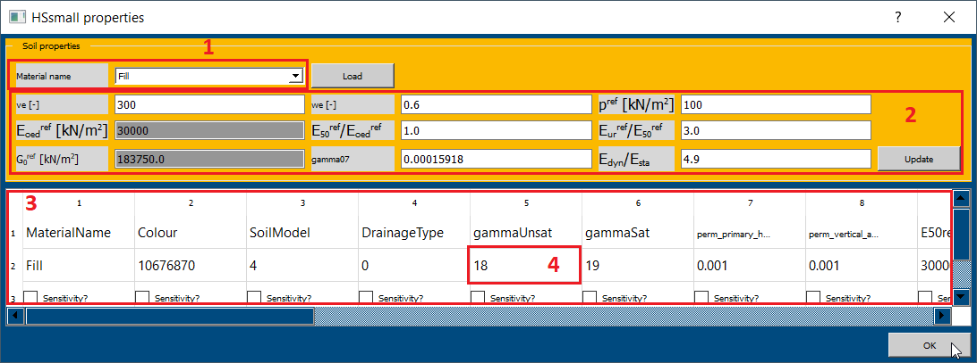

*(fig 2.5)*

*You can change the parameter values here, according to the needs of different project.*

*For example if you change ve[-], we[-] values (2 in fig 2.5), you have to click on update first and next change the values in sheet (3 in fig 2.5). You can change the values in the sheet by double clicking on the previous value (4 in fig 2.5) and typing new value.*

* Similarly, define sand medium, sand dense and gravel dense soils from predefined library by selecting respective soils from *Material name* in *HSSmall properties (1 in fig 2.5).*

Assigning the defined soil to defined layer requires the following steps,

* For assigning Fill soil to layer 1, select *Fill\_HSsmall\_\_* in *Selected soil (1 in fig 2.6),* select *Layer 1* in *Soil layer,* select desired *color* and click on assign material *(2 in fig 2.6)*. The assigned soil appears on model diagram.

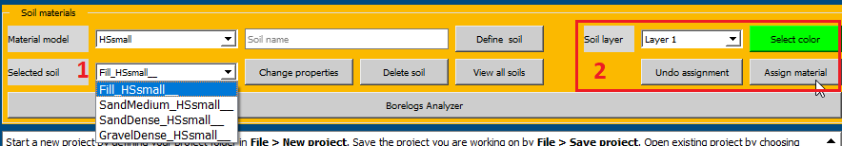

*(fig 2.6)*

* For assigning Sand medium soil to layer 2, select *SandMedium\_HSsmall\_\_* in *Selected soil,* select *Layer 2* in *Soil layer,* select desired *color* and click on assign material.
* Similarly assign Sand dense to layer 3 and Gravel Dense to layer 4. After assigning soils, the soils appear in the model diagram *(3 in fig 2.7)* and is verifiable from *Soil layers (2 in fig 2.7).*

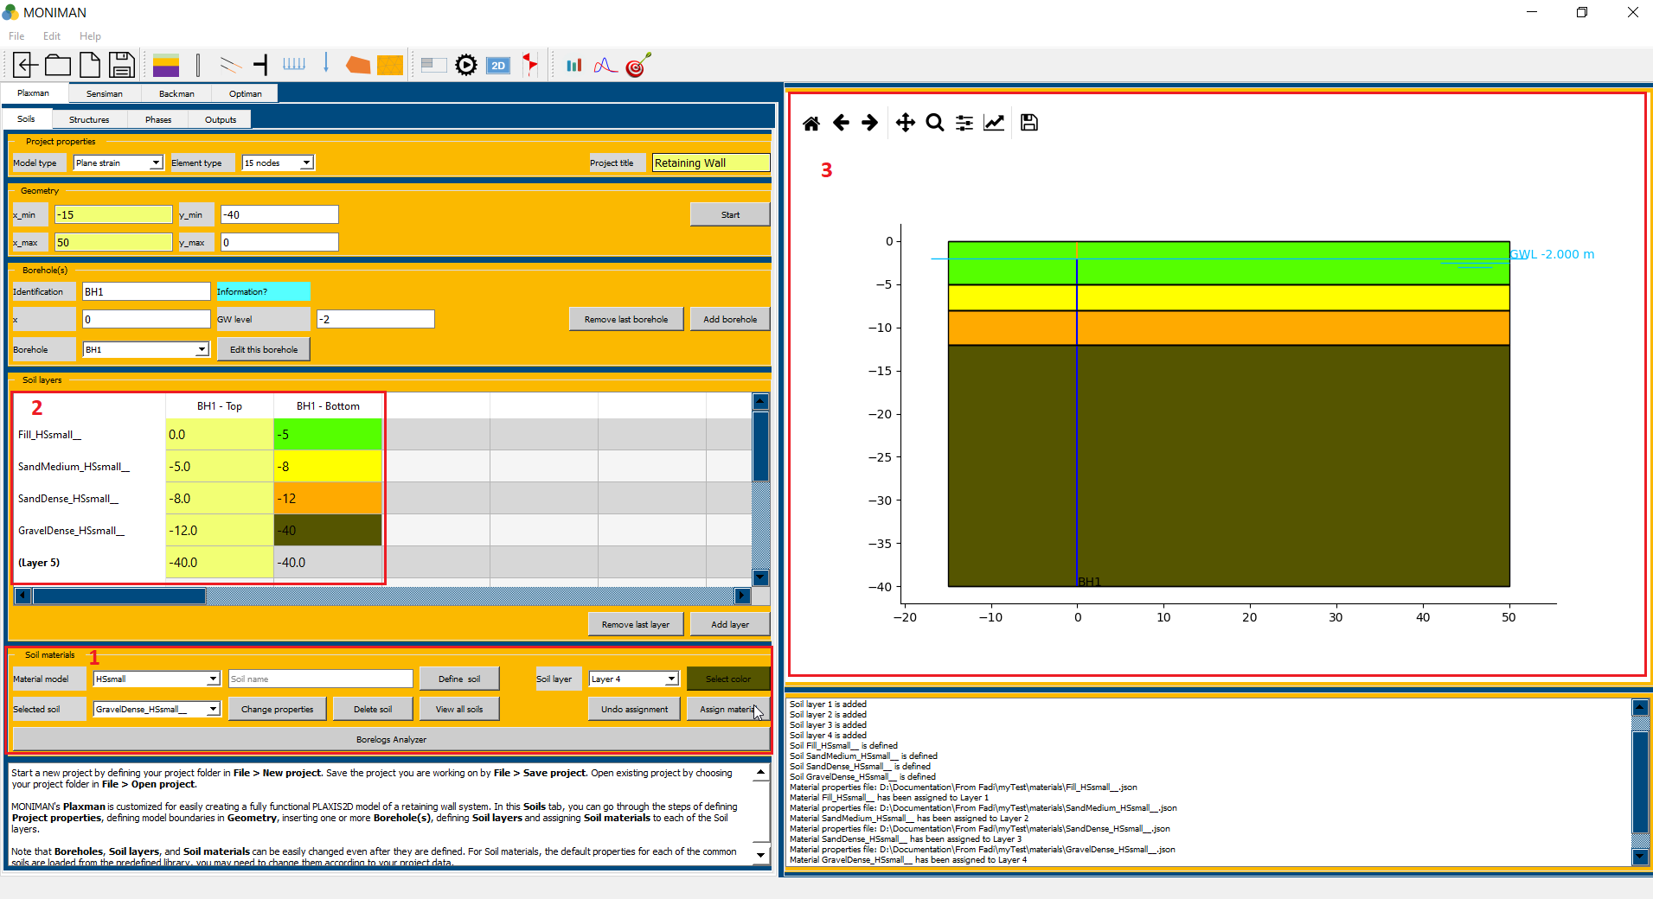

*(fig 2.7)*

*Note: Remember to save the project.*

***Structures***

***Walls***

* Click on *Structures*, and select *Walls* from the vertical sidebar *(1 of fig 2.8).*

The wall menu consists of top point, bottom point and defining wall properties settings.

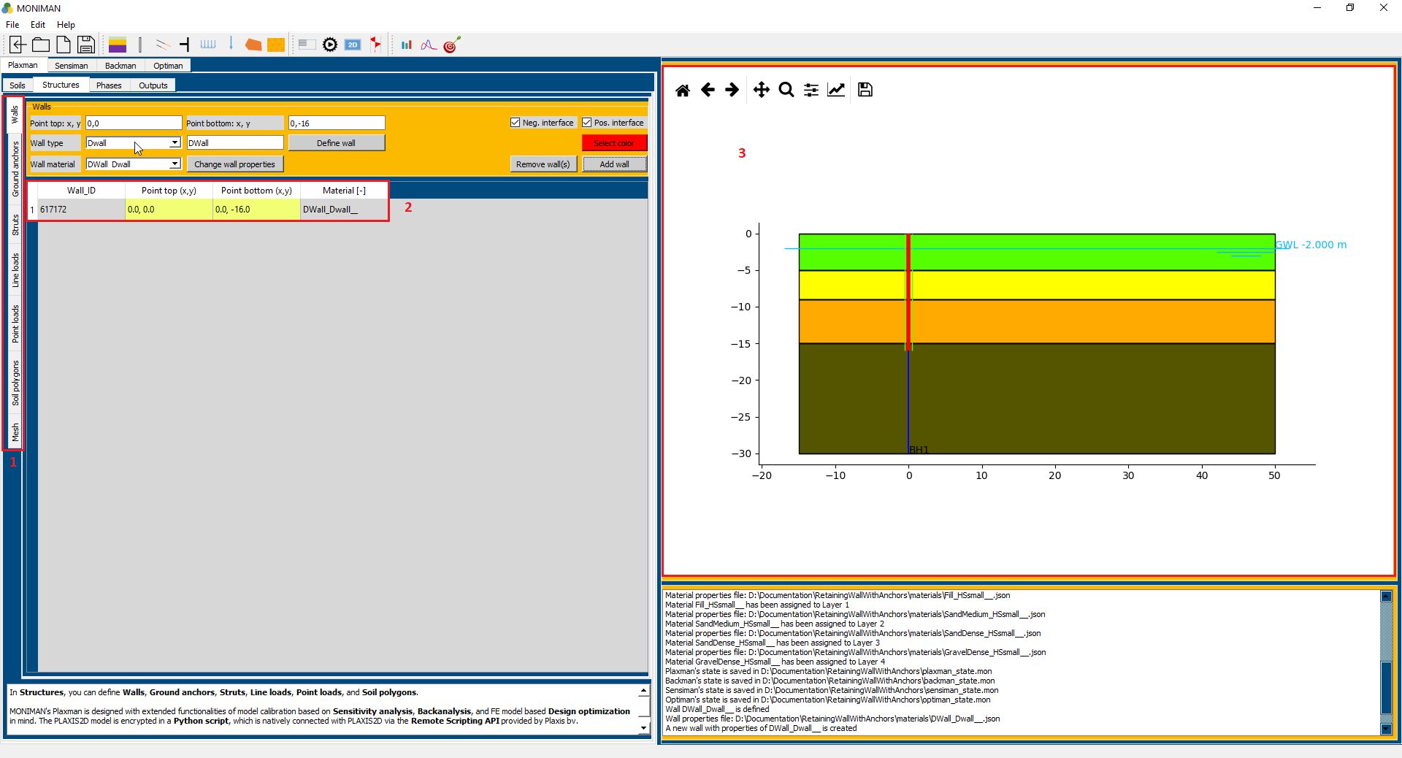

*(fig 2.8)*

* Assign (0, 0) and (0, -16) as top point and bottom point.
* To define wall material, select *DWall* from *Wall type* and type DWall in *Wall name*. Click on *Define wall*, which pop up *Dwall properties* window *(fig 9).* Change *d* value to 1m and click on *update.* Click *OK* to define wall.

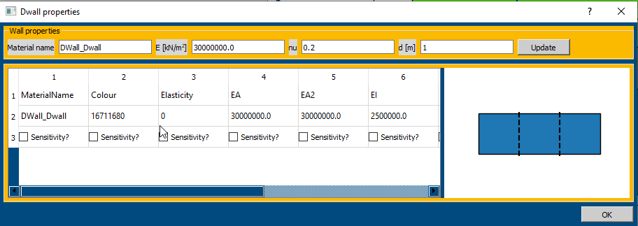

*(fig 2.9)*

* Select *DWall\_DWall\_\_* in *Wall material*, Select *color* and click on *Add wall*.
* The Wall added can be verified from the table *(2 of fig 2.8)* and in the model diagram *(3 of fig 2.8).*

***Ground Anchors***

* Select *Ground Anchors* from the vertical sidebar.

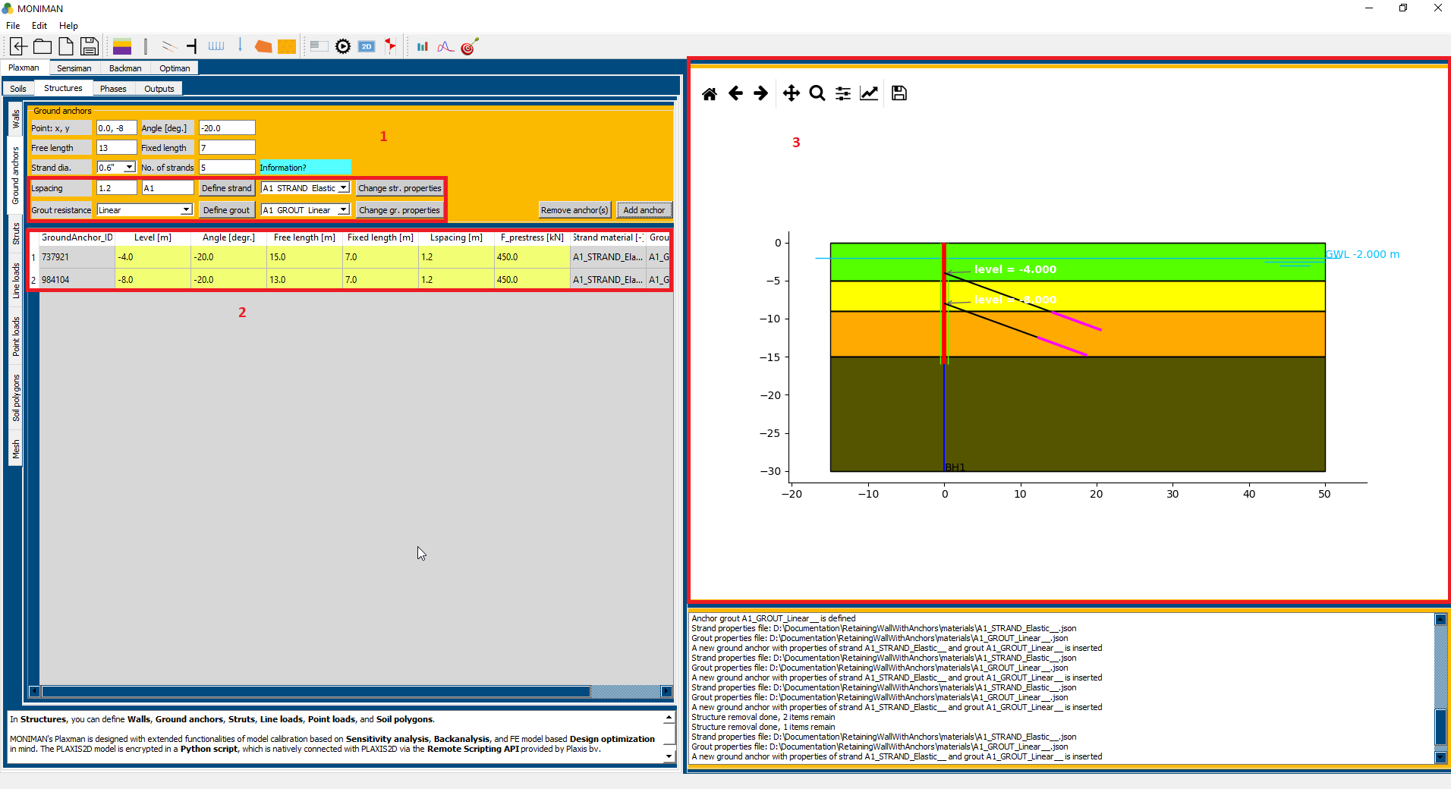

*(fig 2.10)*

The Ground anchors menu consist of settings for defining strand and grout material *(1 in fig 2.10)*, assigning the free length and fixed length.

* Assign 1.2 for *Lspacing,* type A1 in Anchor name, click on *Define strand*, which pop up *Strand properties for A1* window *(fig 2.11).*
* Select *Elastic* as *Material type* and click on *Load* and then *OK.*

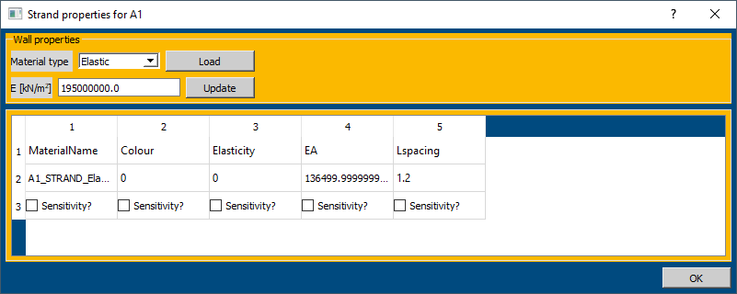

*(fig 2.11)*

* Select *Linear* in *Grout Resistance* and click on *Define Grout,* which pop up *Linear skin resistance grout properties for A1* and Click *OK (fig 2.12).*

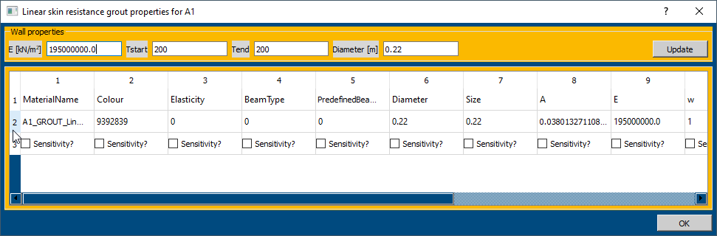

*(fig 2.12)*

* To assign the first anchor, type *0, -4* in *Point:x, y, -20* in *Angle [ deg.], 15* in *Free length, 7* in *Fixed Length, 0.6”* in *Strand dia., 5* in *No. of stands (fig 2.10).*
* Then, Select *A1\_STRAND\_Elastic\_\_* and *A1\_GROUT\_Linear\_\_* and Click on *Add anchor (1 in fig 2.10).*
* Similarly, Add next anchor by assigning *0, -8* to *Point:x, y, -20* to *Angle [ deg.], 13* to *Free length, 7* to *Fixed Length, 0.6”* to *Strand dia., 5* to *No. of stands.*
* Select *A1\_STRAND\_Elastic\_\_* and *A1\_GROUT\_Linear\_\_* and Click on *Add anchor.*
* The Anchors added can be verified in the table *(2 in fig 2.10)* and model diagram *(3 in fig 2.10).*

***Line Loads***

* Select Line Loads from the vertical sidebar.

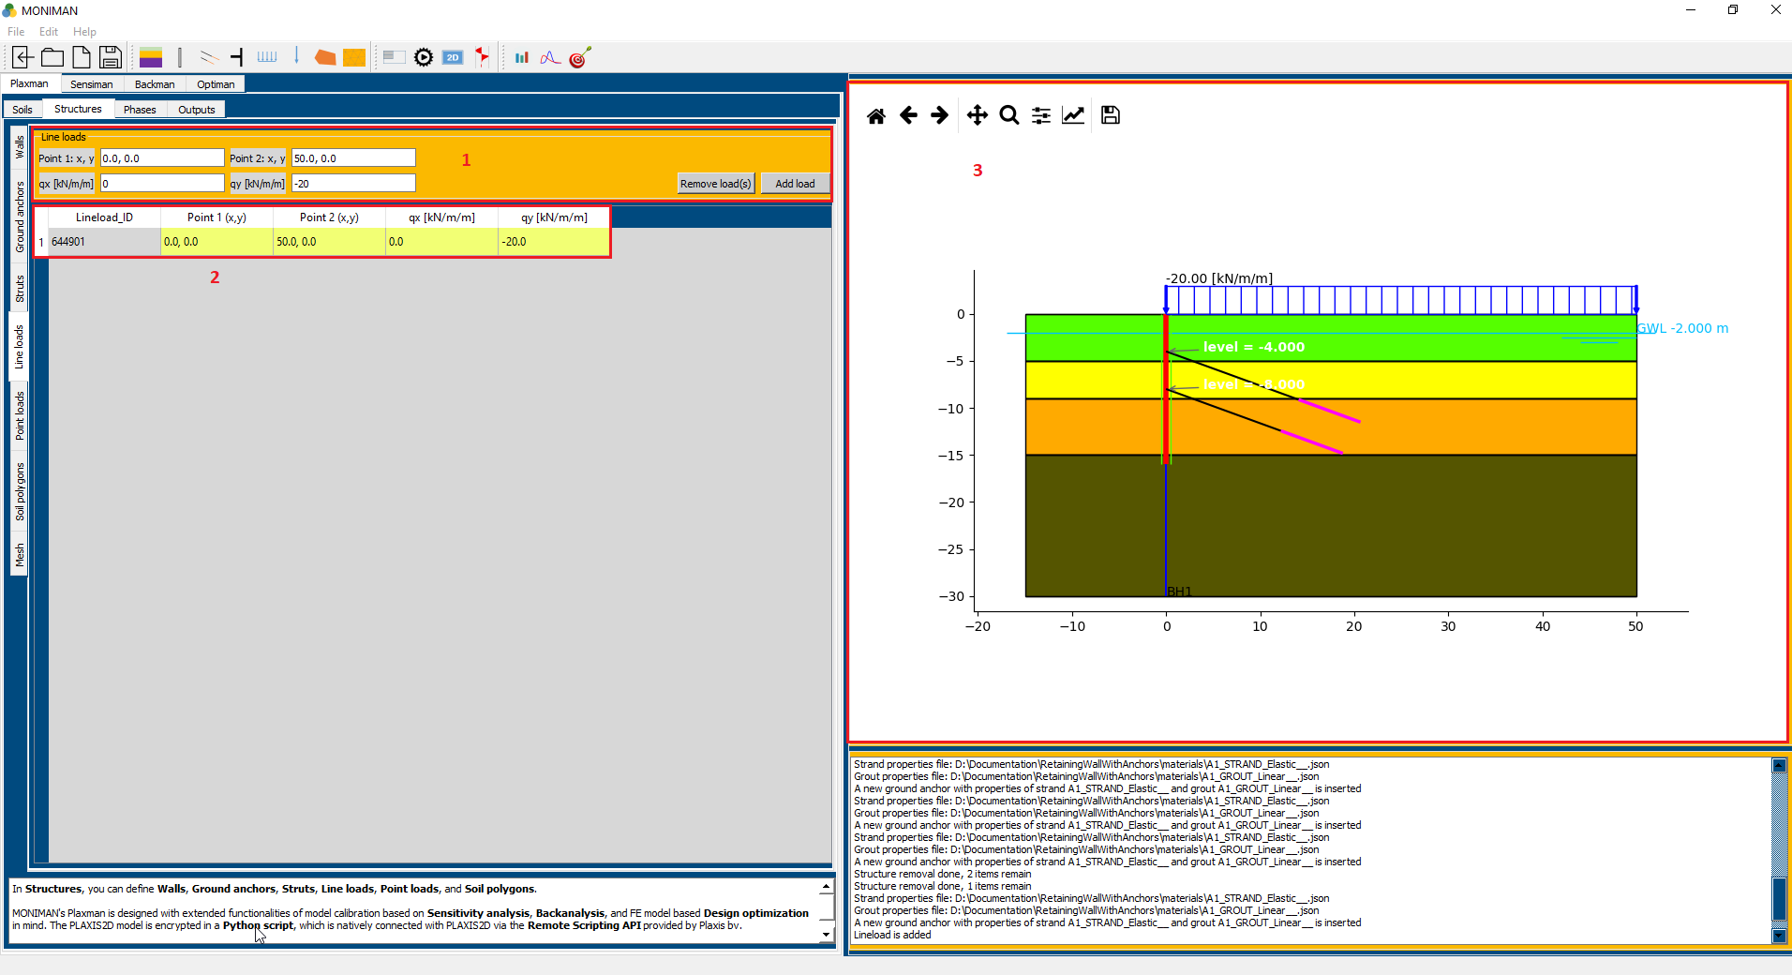

*(fig 2.13)*

* Assign *Point 1:x, y* as *0,0* and *Point 2:x, y* as *50,0 (1 in fig 2.13)*
* Assign *qy [kN/m/m]* as *-20* and click on *Add load.*
* The Line load added can be verified from the table *(2 in fig 2.13)* andthe *model diagram (3 in fig 2.13).*

***Mesh***

* Select *Medium* for Element distribution and click on Apply mesh *(fig 2.14).*

*By default, a mesh with medium element distribution is applied. Visually, applying mesh will change colors of the structures into grey, which helps in visual inspection of the staged constructions in Phases.*

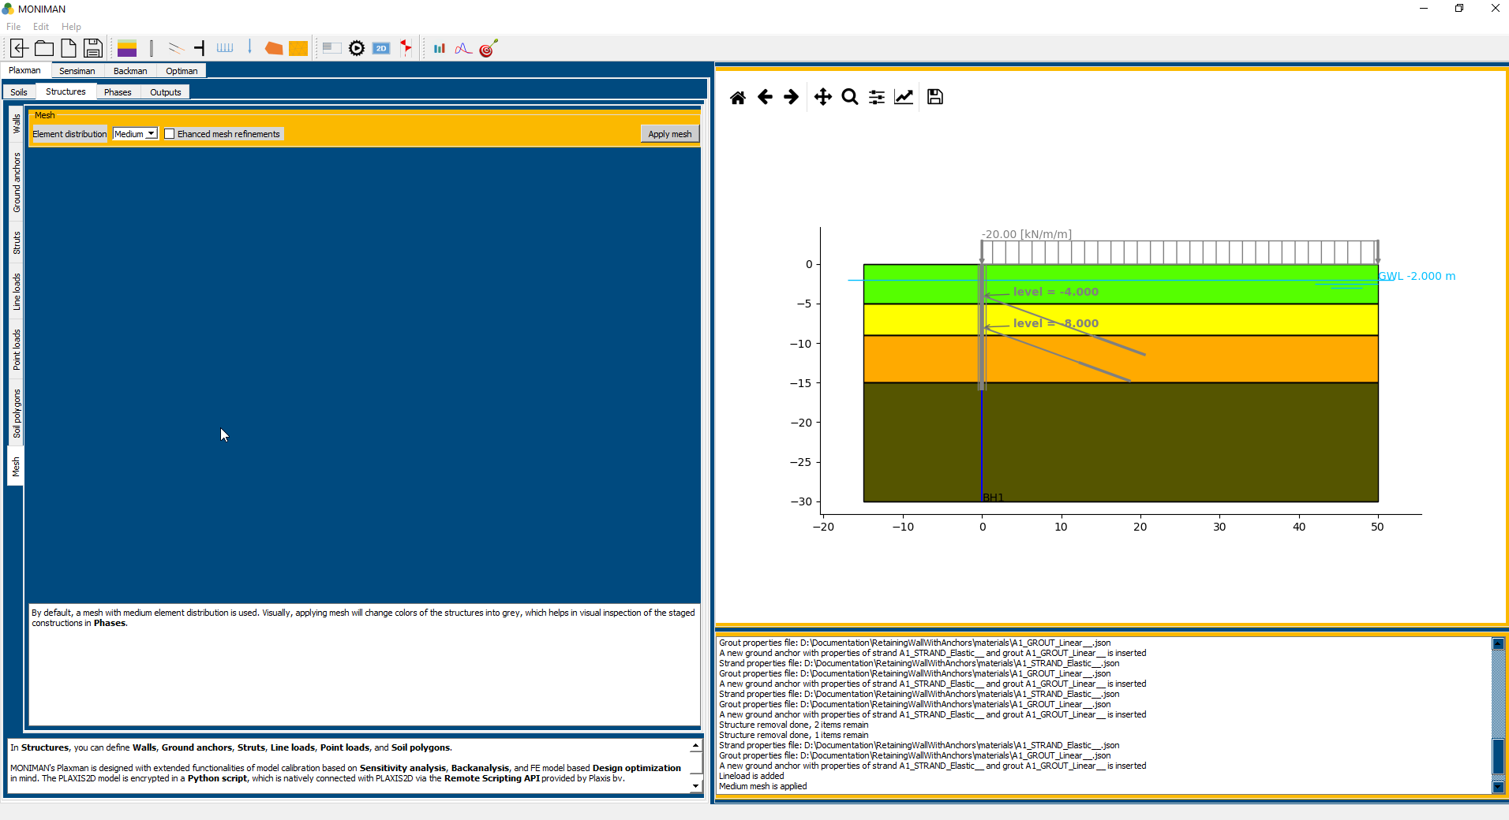

*(fig 2.14)*

***Phases***

In *Phases*, components of the phased excavations such as *Soil clusters* and *Water levels* or a *Drain* can be created. These components are used for configuring the calculation phases in *Predefined phases* (for predefined single-action phases) or *Combined phases* (for combined-action phases).

In *Automated phases*, the recreation of the excavation components is not needed. These components will be automatically generated.

* Select *Phases* from the top bar of *Plaxman*.
* For generating Automated phases, Select *Automated phases* from the sidebar.

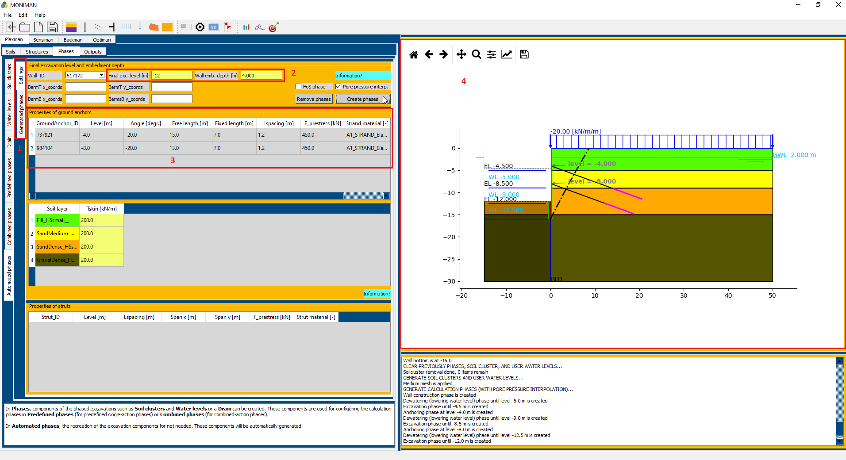

*(fig 2.15)*

* Select *Settings (1 in fig 2.15).* Assign *Final exc. Level [m]* to -12 and *Wall emb. Depth [m]* to 4 *(2 in fig 2.15).*
* Select *Pore pressure interp.* and Click on *Create phases.*
* To view the generated phases *(fig 2.16)*, click on *Generated phases* *(1 in fig 2.15)* from the vertical sidebar of *Automated phases.*
* The excavation can be verified from the model diagram *(4 in fig 2.15).*

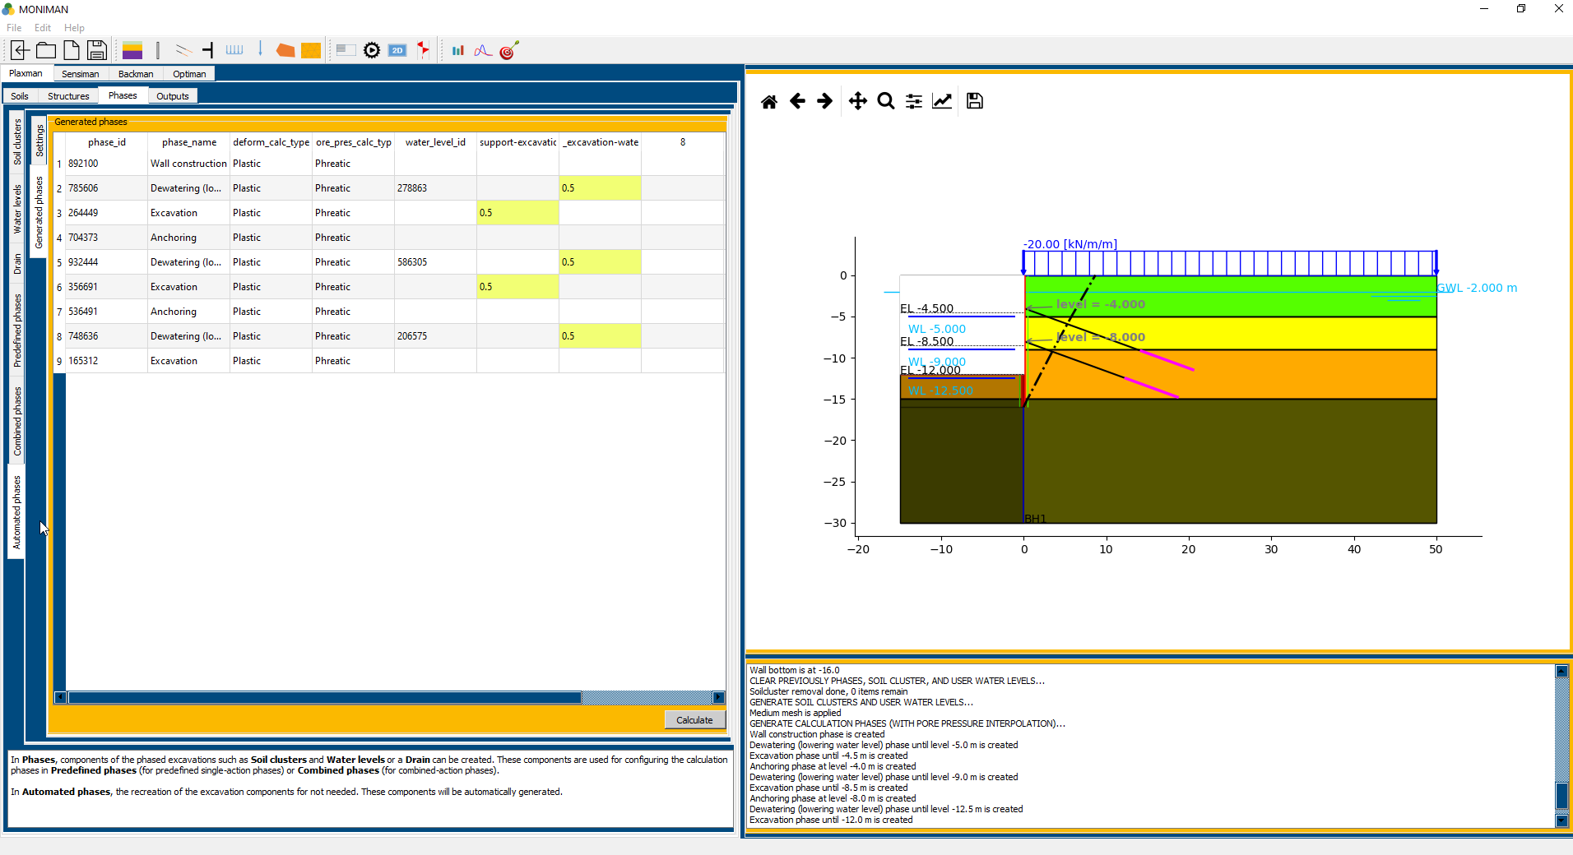

*(fig 2.16)*

***Outputs***

In *Outputs*, you can view the wall displacement and internal forces at each of the calculation phases in *Wall outputs.*

*Dimensioning* should link you to an external reinforcement curtailment dimensioning tool.

*Observation points* can be added for use in *Sensiman* and *Backman.* You can calculate the model here, the observed quantities at observation points will be exported to a text file in 'measurement' under your project folder.

* Select *Output* from the *top bar* of *Plaxman.*
* Click on *Calculate* for calculation *(1 in fig 2.17).*
* After Calculation is finished, select *phase* in *Wall outputs* and click on *view* *(2 in fig 2.17)* for wall displacement and internal forces of the selected phase *(fig 2.18).*
* The Plaxis file with name *retaining\_wall* will be stored in the folder selected for the current project.

**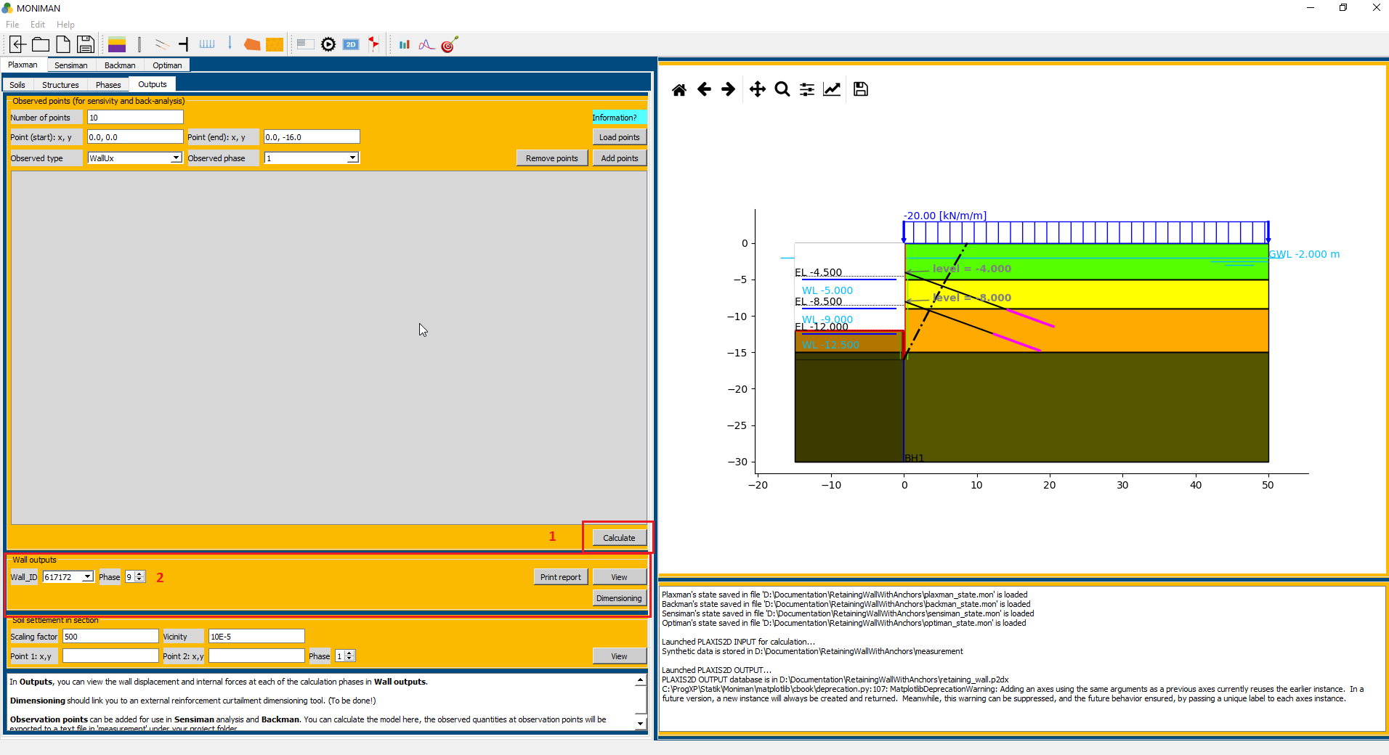**

*(fig 2.17)*

**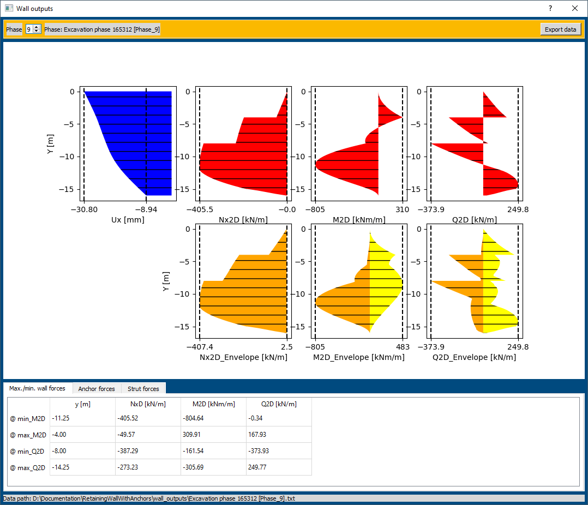**

*(fig 2.18)*

**SENSIMAN**

***Observation points for sensitivity and back-analysis***

Adding observation points for Sensiman and Backman,

* Select Plaxman. Click on Outputs .
* In *Observed points ( for sensitivity and back-analysis),* assign *33* to *Number of points,* assign *(0,0)* to *Point (start): x, y,* assign *(0,-16)* to *Point (end): x, y.*
* Select *WallUx* for *Observed type* and *3* for *Observed phase* and click on *Add points.*
* Next, select *6* for *Observed phase* and click *Add points*, and similarly, add points for phase 9.

***Settings***

In the Back-Analysis, to make the process robust, it is recommended to reduce the number of input parameters based on their importance to the model by Sensitivity Analysis.

* To select input soil parameters for Sensitivity Analysis, click on *Sensiman* from the top main bar *(1 in fig 2.19)* and click on *Settings (2 in fig 2.19).*

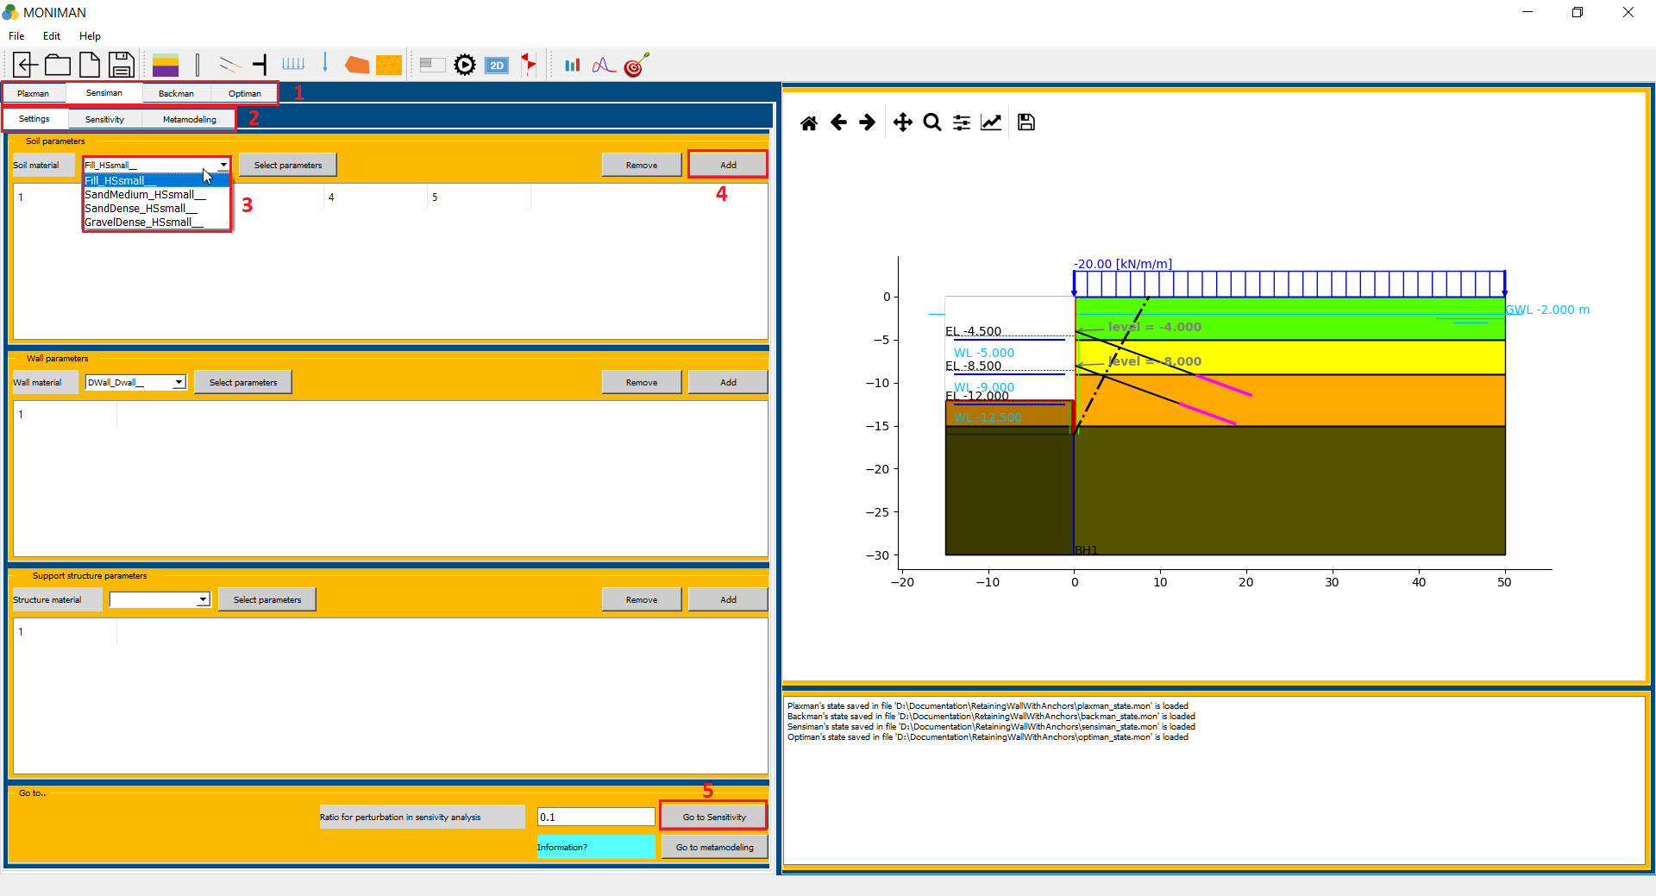

*(fig 2.19)*

* In *Soil parameters* menu, select *Fill\_HSsmall\_\_* from *Soil material (3 in fig 2.19)* and click on *Select parameters* which pop up *HSsmall properties(fig 2.20).*

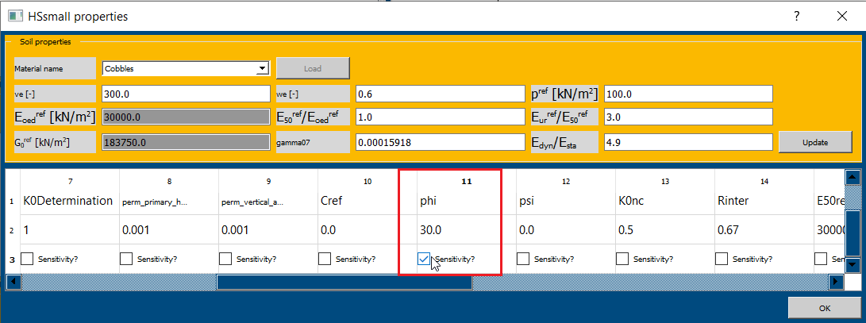

*(fig 2.20)*

* Click on the checkbox of *Sensitivity?* for *phi* *(fig 2.20)* and *ve* parameter and click on OK and click on *Add (4 in fig 2.19).*
* Repeat the process for remaining soils, by selecting the respective soil from *Soil material*, *ve* and *phi* parameters from *Select parameters,* and clicking on *Add* to assign the parameters of respective soil.
* After adding parameters, the range of values for parameters can be viewed and changed in *Soil parameters* menu *(fig 2.21).*

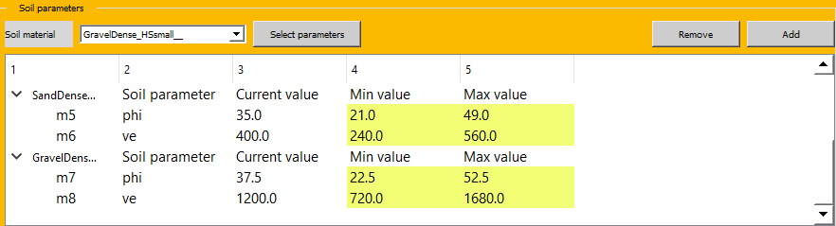

*(fig 2.21)*

* After adding the all required parameters, click on *Go to Sensitivity (5 in fig 2.19)* which opens *Sensitivity* menu.

*Note: Do not directly click on Sensitivity or Metemodeling from the top bar of Sensiman for the first time or whenever there are changes in Settings menu. Instead, click on Go to Sensitivity or Go to metamodeling.*

***Sensitivity***

In *Sensitivity* menu, the parameter ranges assigned can be viewed in *Parameter ranges (1 in fig 2.22).*

* Click on *Start* in *Sensitivity analysis (2 in fig 2.22),* to start Sensitivity analysis.

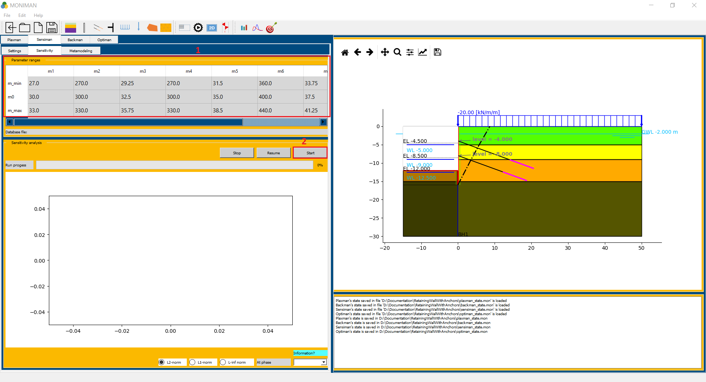

*(fig 2.22)*

* After Sensitivity analysis is finished, a graph of *Sensitivity scores (%)* and *Parameter* is plotted for all phases *(1 in fig 2.23)*.

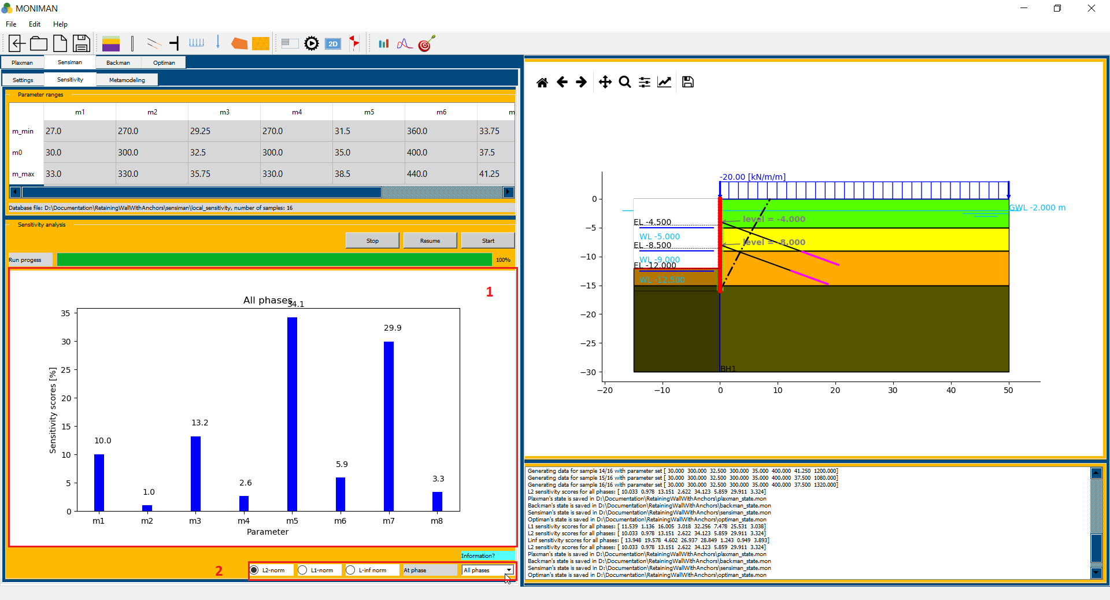

*(fig 2.23)*

* There are options to view the results for different norms and different phases *(2 in fig 2.23).*
* The parameters *m1 (phi of Fill), m3 (phi of Sand Medium), m5 (phi of Sand Dense), m6 (ve of Sand Dense), m7 (phi of Gravel Dense)* and *m8 (ve of Gravel Dense),* have high sensitivity scores and are considered for *Metamodeling.*

***Metamodeling***

* Go back to Settings, by clicking on *Settings* in the top bar for *Sensiman.*
* Remove all the parameters and add the sensitive parameters *(1 in fig 2.24)*, *m1 (phi of Fill), m3 (phi of Sand Medium), m5 (phi of Sand Dense), m6 (ve of Sand Dense), m7 (phi of Gravel Dense)* and *m8 (ve of Gravel Dense).*

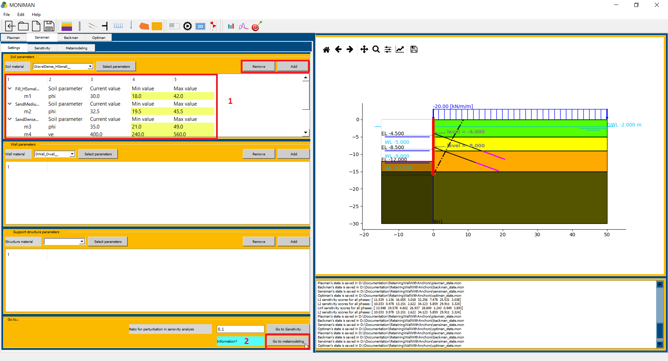

*(fig 2.24)*

* After adding sensitive parameters, click on *Go to Metamodeling (2 in fig 2.24)* which opens *Metamodeling* menu *(fig 2.25).*

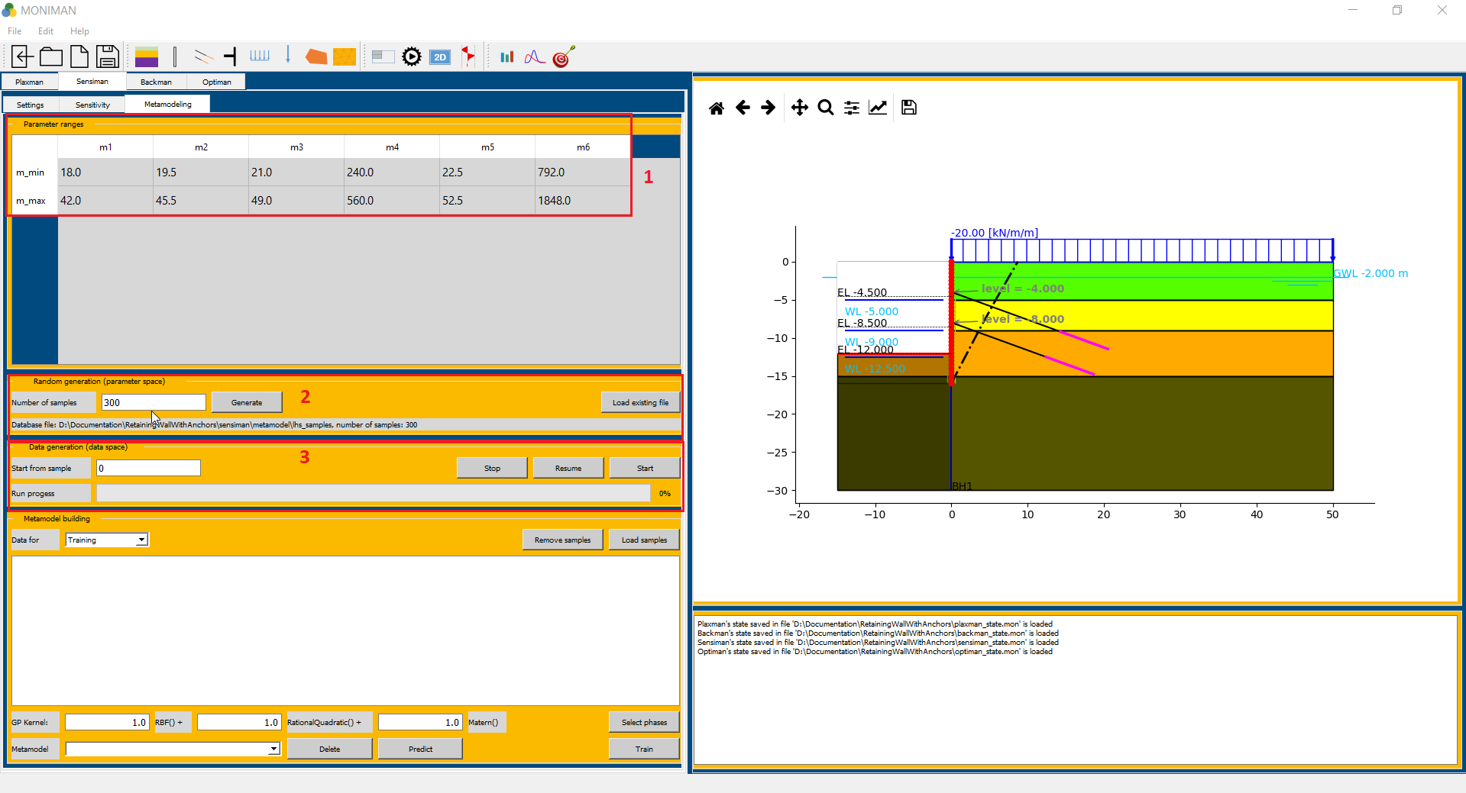

*(fig 2.25)*

* The range for parameters are visible in the *Parameters ranges* menu *(1 in fig 2.25).*
* To generate the training samples for the metamodel, assign *300* to *Number of samples* and click on *Generate*. The generated samples containing parameter values are stored in the *Database file* path *(2 in fig 2.25)*.
* Click on *Start* in *Data generation (data space) (3 in fig 2.25).* This starts generating training samples by calculating the deflections for generated parameter samples.
* There is setting to load samples generated by clicking *Load existing file* and selecting the file, *project folder.../sensiman/metamodel/lhs\_samples.* Then assign the value to *Start from sample* by checking the files in *project folder…/sensiman/metamodel.*
* After generation of 300 samples, rename the folder *project folder.../sensiman/metamodel* as *training.*
* Similarly for generating validation samples, assign *30* to *Number of samples* andclick on *Generate and* click on *Start* in *Data generation.*
* After generation of 30 samples, rename the folder *project folder…/sensiman/metamodel* as *validation.*

Training and validation of metamodel from generated *training* and *validation* samples,

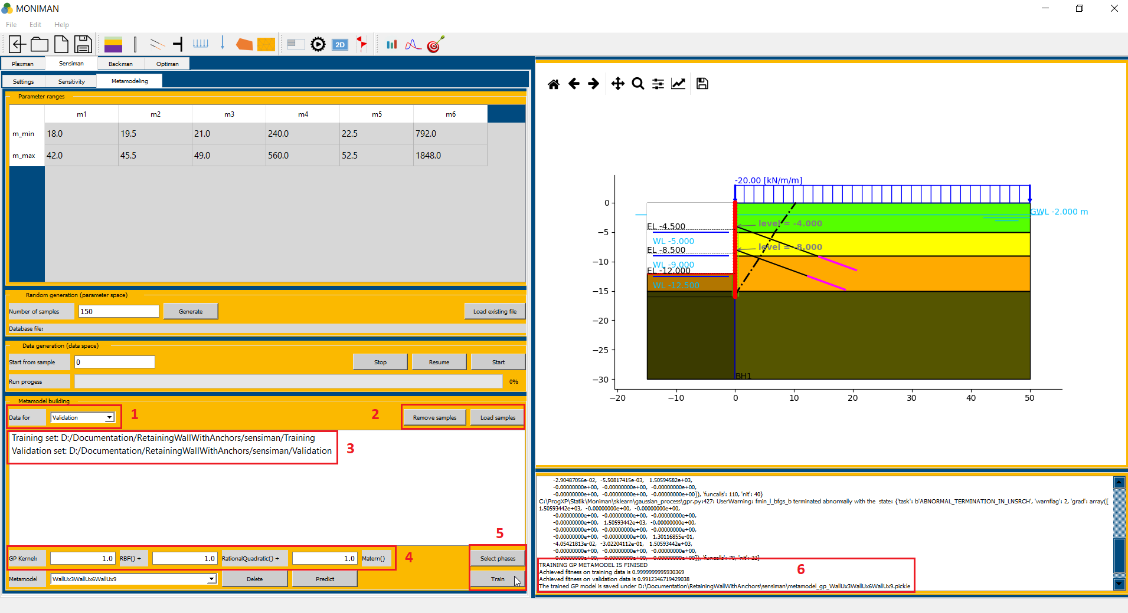

*(fig 2.26)*

* In *Metamodel building,* select *Training* in *Data for (1 in fig 2.26)* and click on *Load samples* *(2 in fig 2.26)* and select *project folder…/sensiman/training* folder.
* Then, select *Validation* in *Data for (1 in fig 2.26)* and click on *Load samples (2 in fig 2.26)*  and select *project folder…/sensiman/validation* folder.
* The *Training set* and *Validation set* paths can be verified *(3 in fig 2.26).*
* To select the phases to be considered for metamodeling, click on *select phases (5 in fig 2.26),* which pop up *Select the considered observation phases.*
* Check for *phase 3, 6,* and *9* and click *OK (5 in fig 2.26).*
* Click on *Train (5 in fig 2.26),* which starts training and validation.
* The start and finish of the Gaussian process model can be tracked in the terminal at the right bottom of *Moniman (6 in fig 2.26).*
* After the training and validation of metamodel is finished, *Moniman* pop up *Metamodel validation* curves *(fig 2.26)*
* *Metamodel validation* curves are plotted with *displacements* as the horizontal axis *and wall depth* as the vertical axis. The plot consists of *metamodel* curve *(blue)* resulted from the Gaussian Process Regression of Training examples and *FE model* curve *(red dashed)* plotted from *Validation* samples *(fig 2.26).*
* The results of training and validation values are shown in the terminal on the right bottom of the moniman *(6 in fig 2.26).*

*Achieved fitness on training data is 0.9999*

*Achieved fitness on validation data is 0.9912*

* The trained GP model is saved as pickle file with the path *project folder…/sensiman/*

*metamodel\_gp\_WallUx3WallUx6WallUx9.pickle*

* The kernel for Gaussian Process Regression is a combination of *RBF, Rational Quadratic* and *Matern* and there is setting to tune hyper-parameter values for *RBF, RationalQuadratic and Matern* kernels *(4 in fig 2.26).*

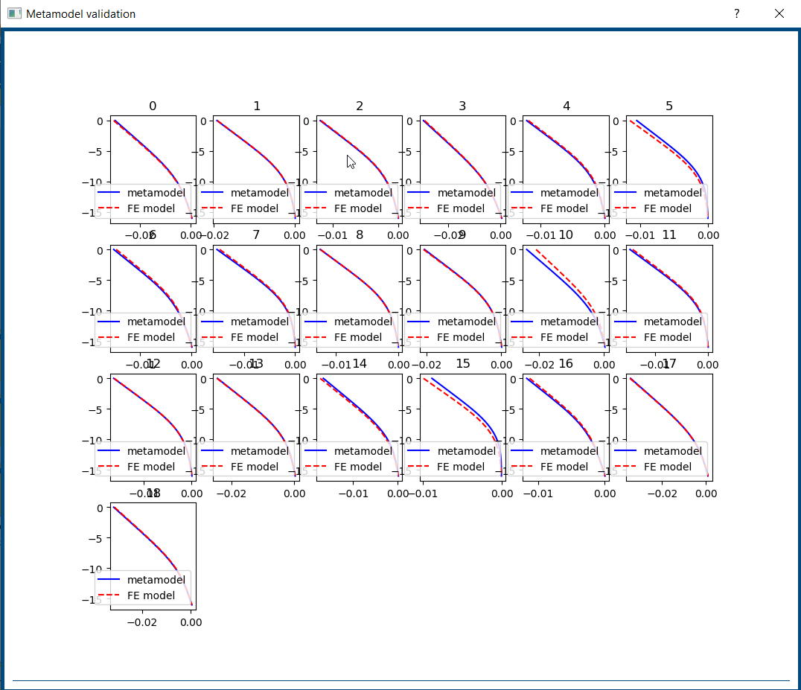

*(fig 2.27)*

**BACKMAN**

*Back analysis* aims to improve the values for soil parameters by fitting the modelled outputs to the corresponding site measurements.

MONIMAN's Backman provides the user with options to perform fast back-analysis using the *unscented Kalman filter* *(UKF)* and a thorough global search for a parameter set that best fits the modelled output to measured data by global optimization using the *Particle Swarm Optimization* *(PSO)*. For *PSO*, the burden of overly many FE model evaluations is relieved by basing the global optimization on the already trained metamodel.

Back analysis can be potentially used for excavations in difficult ground conditions to back calculate soil parameters from the monitored data. Then a monitoring based design approach *(EC7: Observational method for design)* can be advantageous both for securing safety and achieving cost efficiency.

***Settings***

The Ux site data values must be in *mm* and *.txt* format *(text format) (fig 2.29).*

To upload the site data for Back Analysis,

* Select Settings in Backman. In *Site data* menu, select *WallUx* for *Measured quantity (1 in fig 2.27)* and *3* in *phase (2 in fig 2.28)* and click on *Load site data (3 in fig 2.28).*

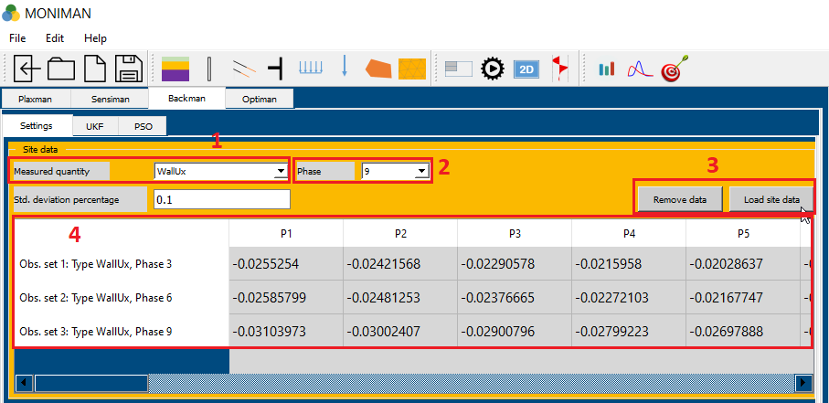

*(fig 2.28)*

* Select the site data for phase 3 in text format file *(fig 2.29)* and click on *Open.*
* Similarly, select the site data for phase 6 and phase 9 by changing the *Phase* to *6 and 9* and loading the site data for phase 6 and 9.
* The loaded site data can be verified *(4 in fig 2.28).*

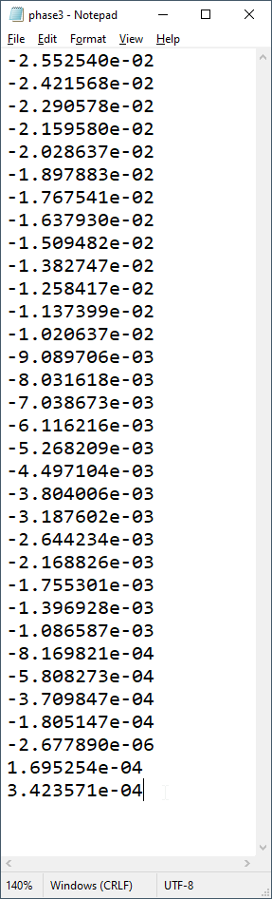

*(fig 2.29)*

The *Soil parameters* menu consist of settings to select soil parameters for back analysis. The selected soil parameters are improved by fitting the modelled outputs to the corresponding site data.

* Select *Fill\_HSsmall\_\_* for *Soil material (1 in fig 2.30)* and click on *Select parameters (2 in fig 2.30)* which pop up *HSsmall properties* menu.
* For parameter *phi* check for *Sensitivity?* box and click on *OK.*
* Click on *Add (3 in fig 2.30)* to add the parameter *phi* for fill soil*.*
* Similarly add *phi for SandMedium, phi and ve for SandDense, and phi and ve for GravelDense.*
* After adding all the soils, change the *Min value* and *Max value (4 in fig 2.30)* for all the soils depending on the range of values used to train metamodel. These values can be obtained from *sensitive* parameters added earlier for the generation of training and validation *(1 in fig 2.24) or (1 in fig 2.25).*
* The selected soil parameters for back analysis can be verified *(5 in fig 2.30).*

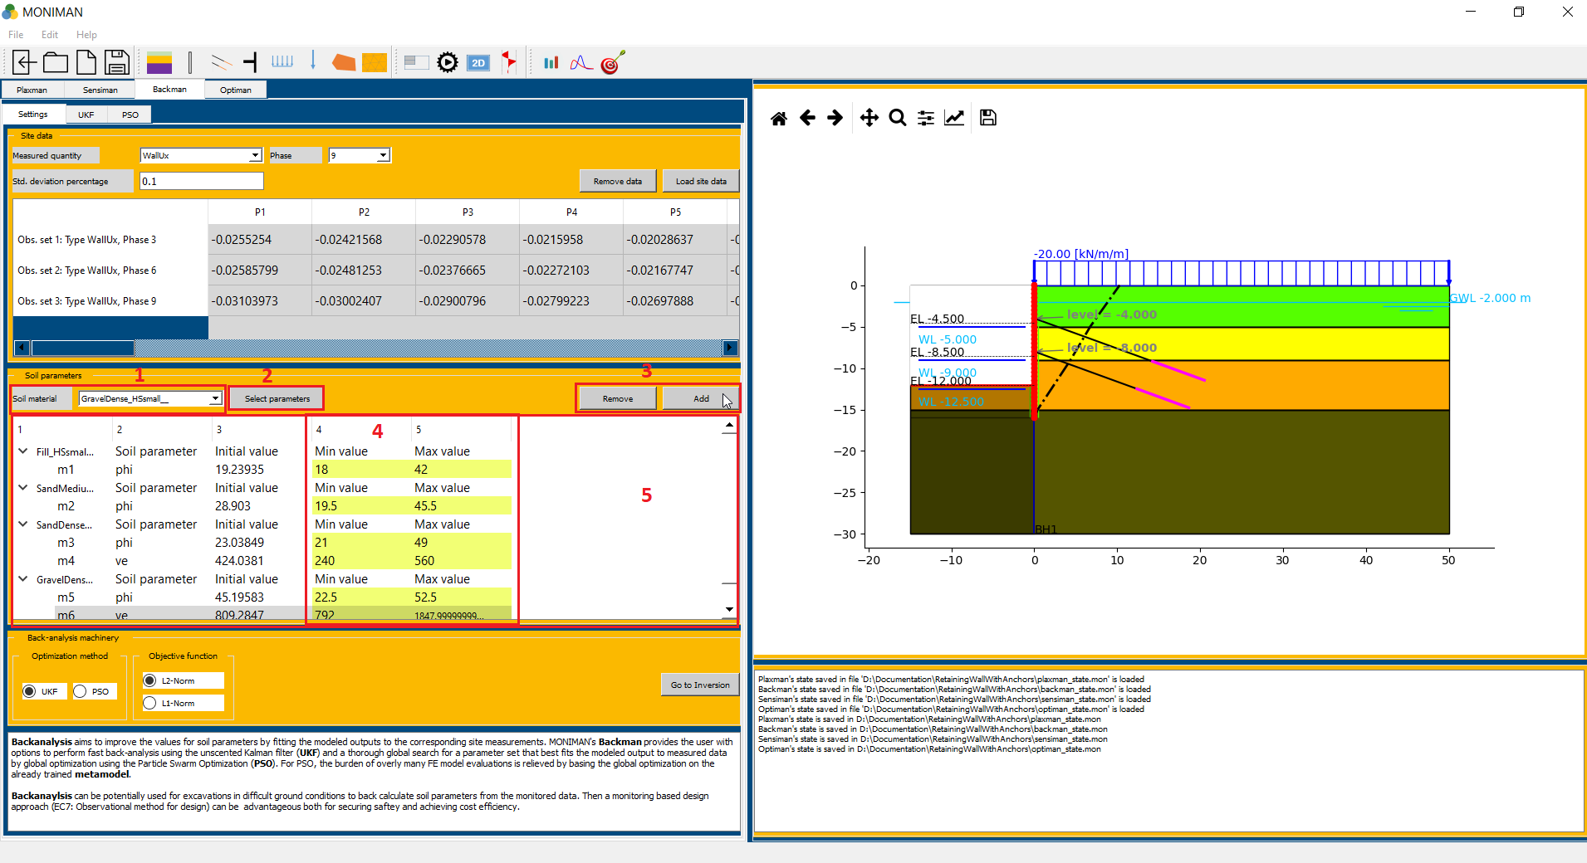

*(fig 2.30)*

***Back analysis using Particle Swarm Optimization (PSO)***

* In *Back-analysis machinery (fig 2.31),* select PSO for *Optimization method (1 in fig 2.31)* and *L2-norm* for *Objective function (2 in fig 2.31)* and click on *Go to Inversion (3 in fig 2.31)* which opens *PSO* menu.

*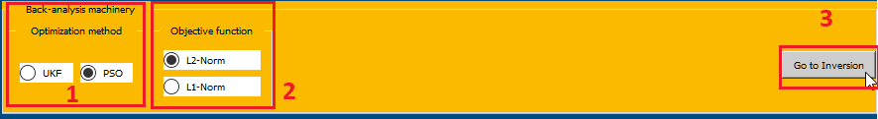*

*(fig 2.31)*

* Check for selected soil parameter ranges in *Parameter ranges* menu *(1 in fig 2.32).*
* In *Metamodel selection* menu, click on *Load metamodel (2 in fig 2.32),* and select pickle file *project folder…/sensiman/metamodel\_gp\_WallUx3WallUx6WallUx9.pickle* and click on *Open.*
* In the *Run status* menu, assign *500* for *# Iteration (3 in fig 2.32), 80* for *population, 0.5* for *c1, 1.25* for *c2,* select *PSO Ring (3 in fig 2.32)* and select *Phase\_9* for *Plot at phase (4 in fig 2.32).*
* Click on *Start (5 in fig 2.32)* to begin Back-analysis.

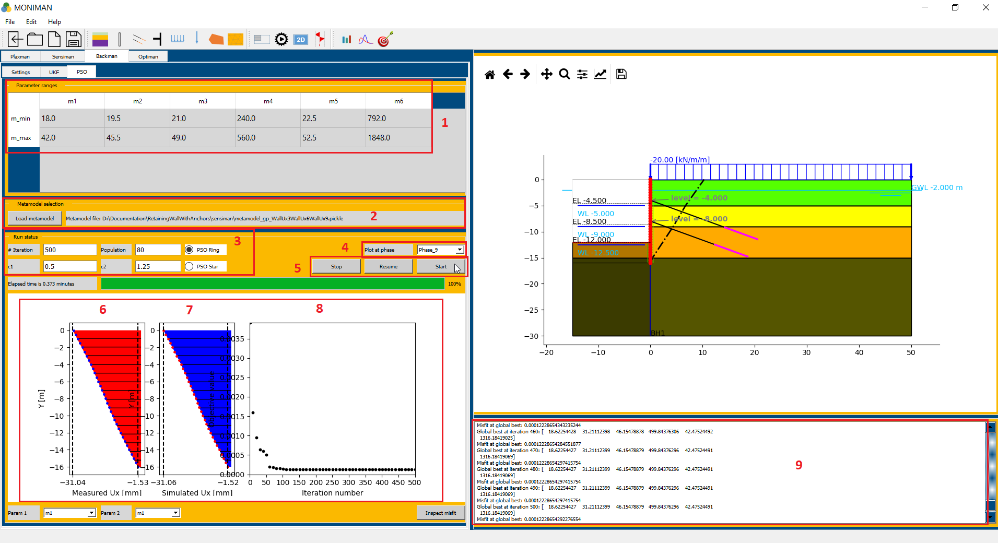

*(fig 2.32)*

* The *Run status* menu consists of three plots, *measured Ux (site data) (6 in fig 2.32), Simulated Ux ( 7 in fig 2.32) and Iteration number vs Misfit at global best (8 in fig 2.32).*
* In the third plot, the *Misfit at global best* decreases with increasing *Iteration number* *(8 in fig 2.32)* and for each iteration, values are printed in the terminal *(9 in fig 2.32).*
* In the terminal, for *Global best at iteration 500*, the soil parameters values can be noted as *[ 18.62, 31.2, 46.15, 499.84, 42.475, 1316.18]* and *Misfit global best* is *0.0001222865 (9 in fig 2.30).*
* The corresponding improved soil parameter values are as follows*, Fill phi = 18.62, Sand Medium phi = 31.2, Sand Dense phi = 46.15 and ve = 499.84, Gravel Dense phi = 42.475 and ve = 1316.18.*