**3. RETAINING WALL WITH STRUTS**

The objectives of this tutorial are as follows,

* Modeling the retaining wall with struts / Plaxman.
* Back analysis using Unscented Kalman Filter *(UKF)* / Backman.

**D:\Data\Downloads\moniman_logo-6.png**  Start *Moniman* by double-clicking on the icon.

* To create a new project, click on *File* --> *New project* and select folder.
* Save the project by *File* --> *Save project* and open the existing project by *File* --> *Open project.* (*fig 3.1*)

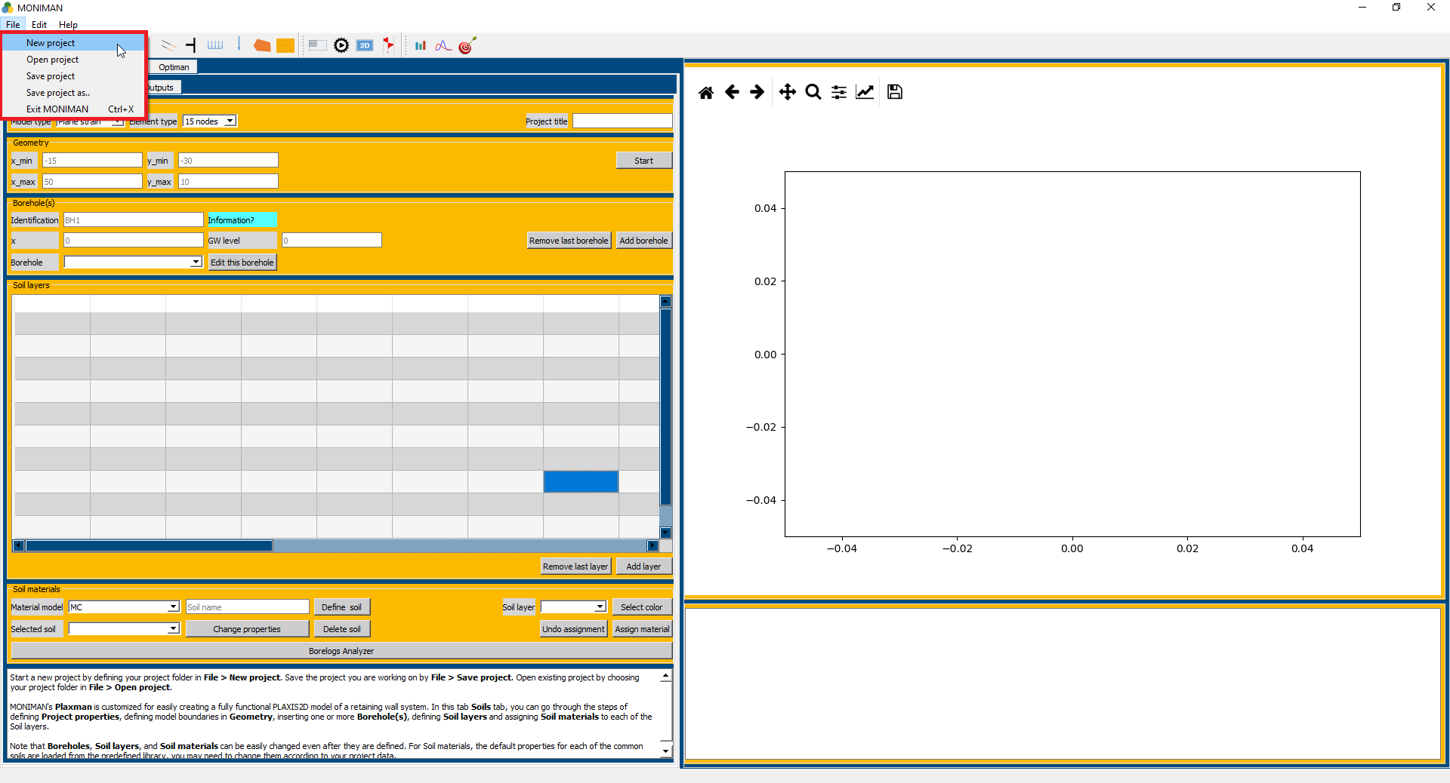

*(fig 3.1)*

* The Moniman window appears with four tab sheets *Plaxman, Sensiman, Backman and Optiman (1 in fig 3.2).* Select *Plaxmann* and click on *Soils* to start modelling *(2 in fig 3.2).*

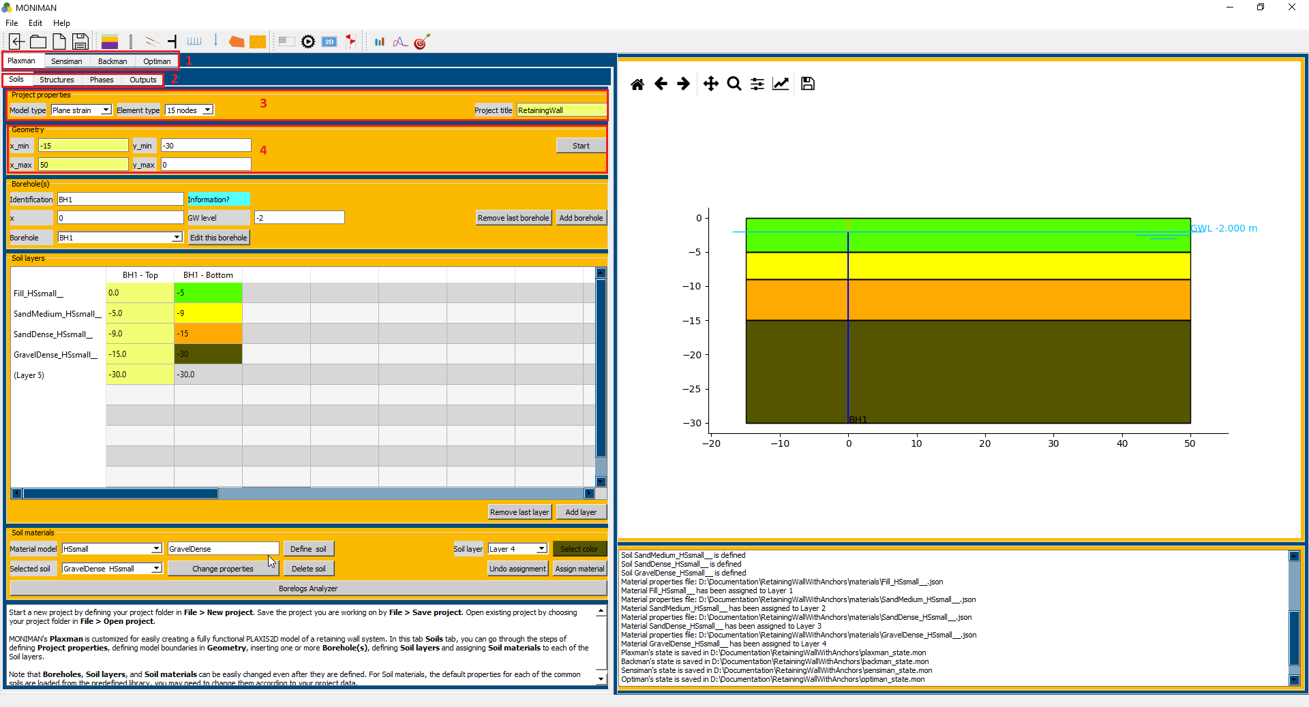

*(fig 3.2)*

*Note: Do not use special characters for naming and entering values.*

The first menu in the *Soils*, *Project properties* consist of settings *Model type* and *Element type* to set up the basic properties of the finite element model *(3 in fig 3.2).*

* Select Plane strain for *Model type* and 15 nodes for *Element type*. Enter the *Project title* as *RetainingWall*

The *Geometry* menu includes the setting to define the size of the drawing area *(4 in fig 3.2)*

* Assign *x\_min, x\_max, y\_min, y\_max* equal to -15, 50, -30, 0 respectively and click on start.

The *Borehole* menu consists of setting to define the Ground Water Level *(1 in fig 3.3).*

* To create Borehole, name the *Identification* as BH1*,* assign *x = 0, GW level = -2* and click on *Add borehole.*

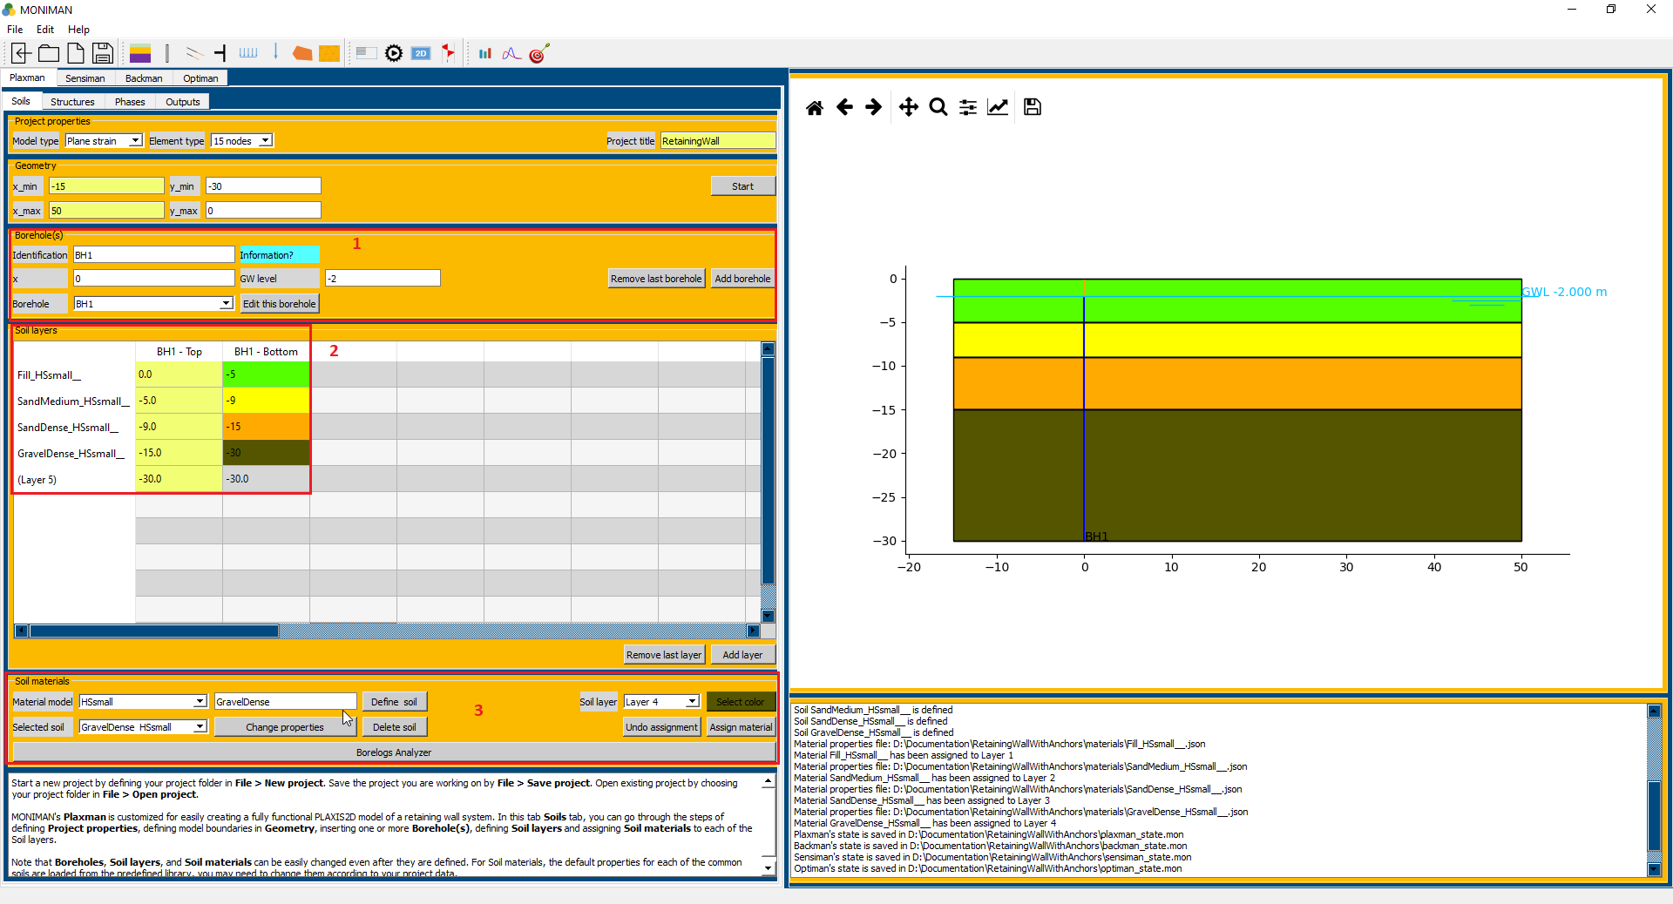

*(fig 3.3)*

***Soil stratigraphy***

The *Soil layers* menu consist of a table with rows as layers and columns as top and bottom elevation to define soil strata *(2 in fig 3.3).*

* In the *Soil layers*, select the element for *Layer 1* and *BH1-Bottom* and assign -5. Click on *Add Layer* to define the first soil layer.
* Next for *BH1-Bottom* of *Layer 2, Layer 3, Layer 4* assign -9, -15, -30 respectively and click on *Add layer* after assigning the value to each layer.

*Remember to Click Add layer for the last layer assigned.*

The Soil Materials contains the settings to define the soils and assign it to the layers defined *(3 in fig 3.3).*

* For defining the Fill soil, select *HSsmall* from *Material Model*.
* Type *Fill* in Soil name and click on *Define soil.* This pop up the *HSsmall* *properties* window *(fig 3.4).*
* In *HSsmall* *properties* window, Select Material name as *Fill* and click on *Load*. The values are predefined and according to the project, they may be changed. Click *OK* to define.

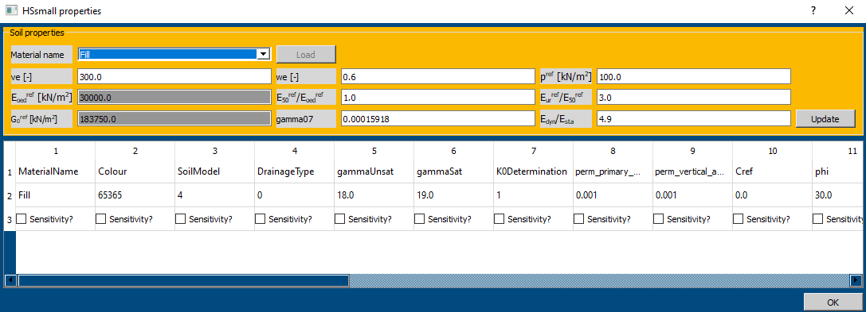

*(fig 3.4)*

* For remaining soils, change the *Soil name* and click on *Define soil* and *load* soils for *Sand medium, Sand Dense* and *Gravel Dense* respectively from the predefined library.



*(fig 3.5)*

* Assigning the defined soil material to soil layers requires, selecting the respective soil in *Selected soil,* respectivelayer in *Soil layer* and *color* and click on *Assign material (fig 3.5).*
* For example, for the first fill soil layer, select *Fill\_HSsmall\_\_* in *Selected soil, layer1* in *Soil layer,* select *color* and click on *Assign material.*
* Assign similarly for Sand medium, Sand Dense and Gravel Dense.

***Structures***

***Walls***

* Click on *Structures*, and select *Walls* from the vertical sidebar *(1 of fig 3.6).*

The wall menu consists of top point, bottom point and defining wall properties settings.

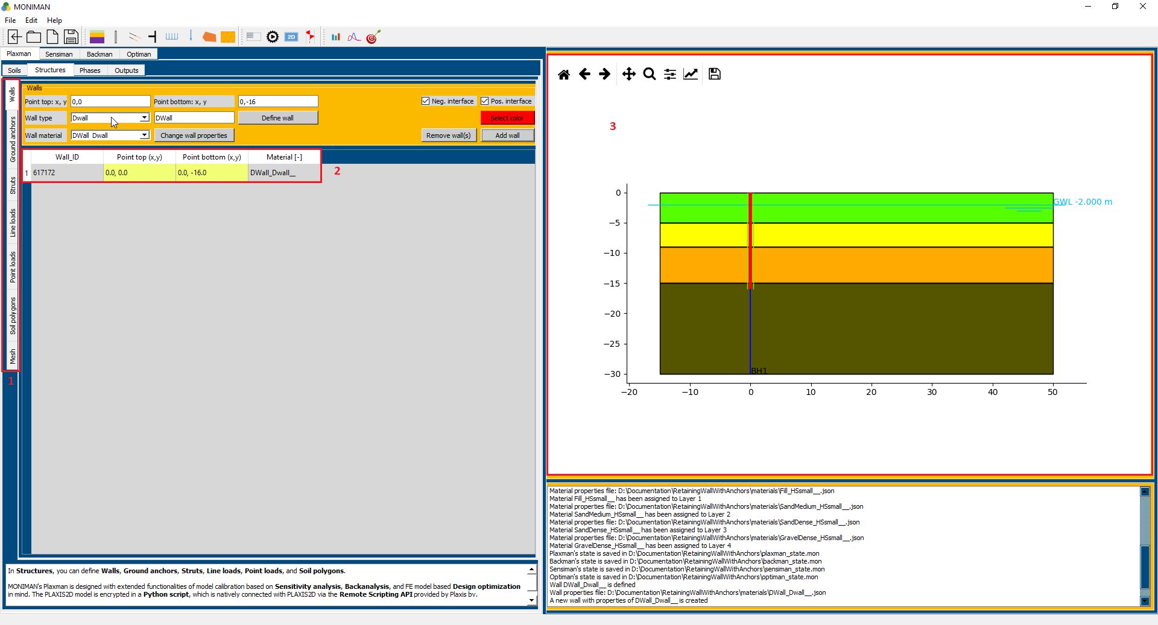

*(fig 3.6)*

* Assign (0, 0) and (0, -16) as top point and bottom point.
* Select *DWall* from *Wall type* and type DWall in *Wall name*. Click on *Define wall*, which pop up *Dwall properties* window *(fig 3.7).* Change *d* value to 1m and click on *update.* Click *OK* to define wall.

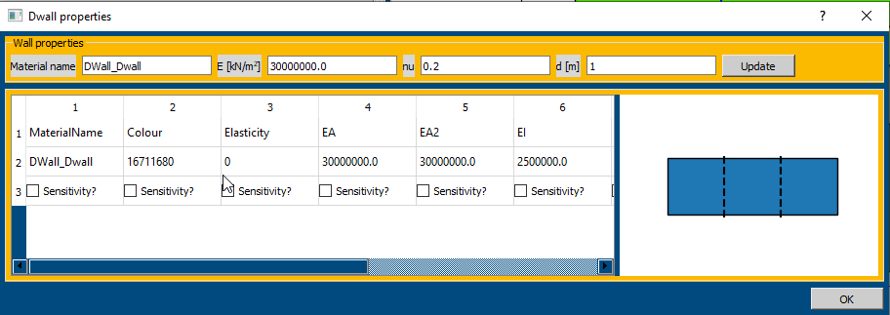

*(fig 3.7)*

* Select *DWall\_DWall\_\_* in *Wall material*, Select *color* and click on *Add wall*.
* The Wall added can be verified from the table *(2 of fig 3.6)* and in the model diagram *(3 of fig 3.6).*

***Struts***

* Select *Struts* from the vertical sidebar.

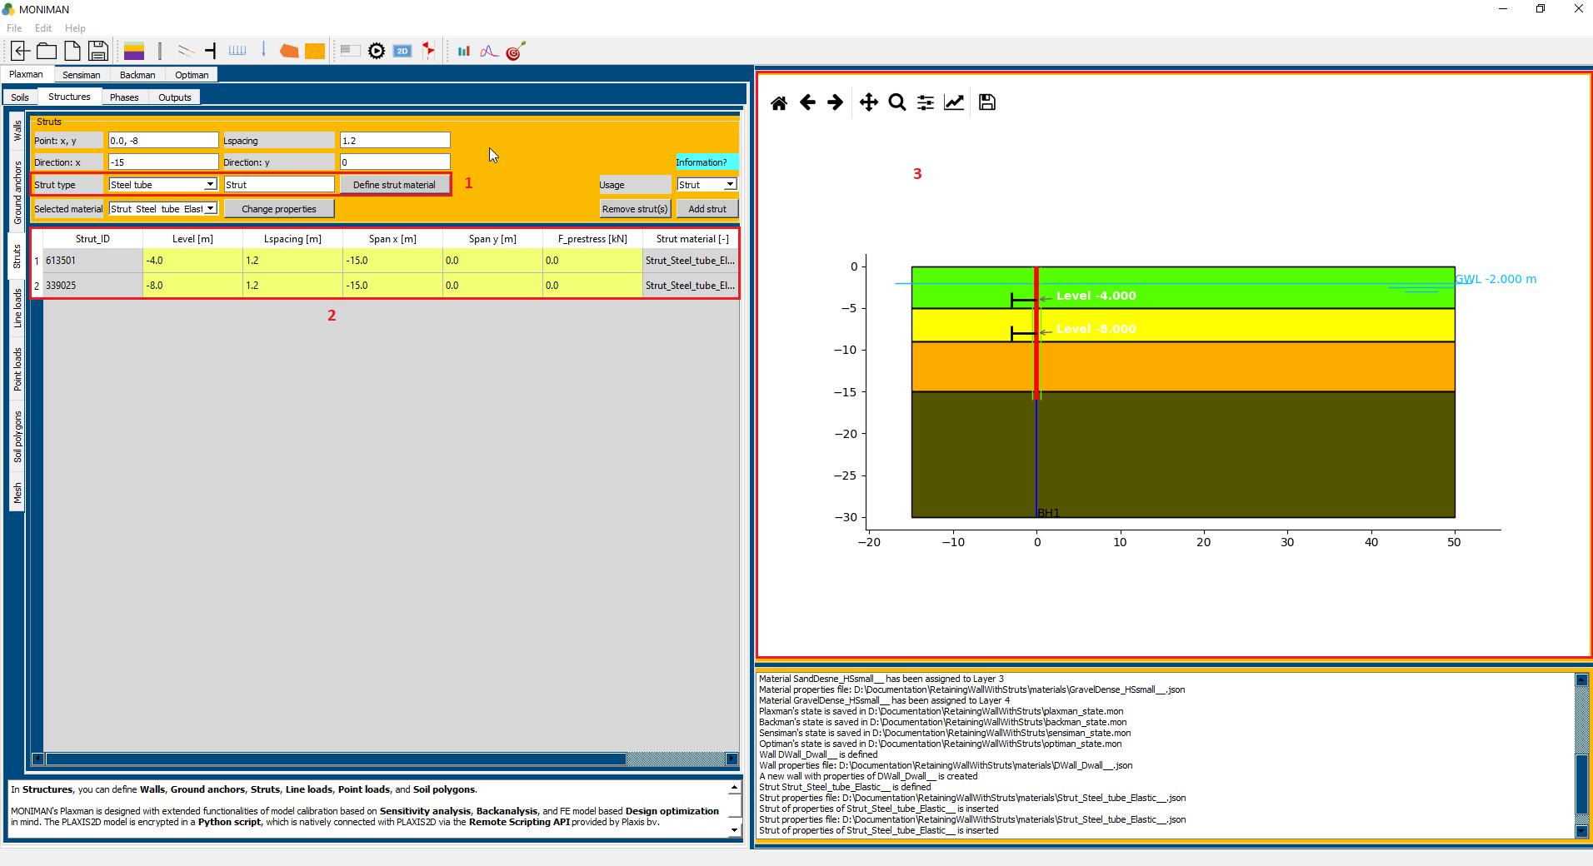

*(fig 3.8)*

The *Struts* menu consist of settings for defining strut material, assigning spacing and point.

* To define strut material *(1 in fig 3.8)*, select *Steel tube* from *Strut type,* type *Strut* in *Strut name* and click on *Define strut material* which pop up *Strut properties for Strut* window *(fig 3.9).*

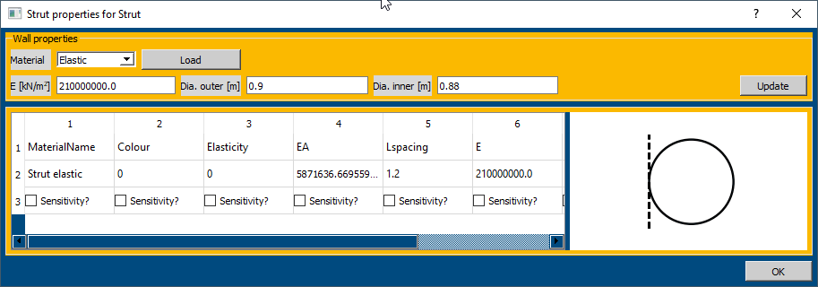

*(fig 3.9)*

* Select *Elastic* from *Material* and click on *Load.* Change *Dia. Outer [m]* to *0.9* and *Dia. Inner [m]* to 0.88 and click on *Update* and *OK.*
* The strut material *Strut\_Steel\_tube\_Elastic\_\_* is defined.
* To assign the strut at point (0, -4), Assign the *Point:x, y* to *0,-4,* assign *Lspacing* to *1.2, Direction: x* to *-15, Direction: y* to *0.*
* Select *Strut\_Steel\_tube\_Elastic\_\_* from *Selected material, Usage* as *Strut* and click on *Add strut.*
* The strut at point (0, -4) is added and can be verified *(2 and 3 in fig 3.8).*
* To assign the strut at point (0, -8), Assign the *Point:x, y* to *0,-8,* assign *Lspacing* to *1.2, Direction: x* to *-15, Direction: y* to *0.*
* Select *Strut\_Steel\_tube\_Elastic\_\_* from *Selected material, Usage* as *Strut* and click on *Add strut.*
* The strut at point (0, -8) is added and can be verified *(2 and 3 in fig 3.8).*

***Line Loads***

* Select Line Loads from the vertical sidebar.

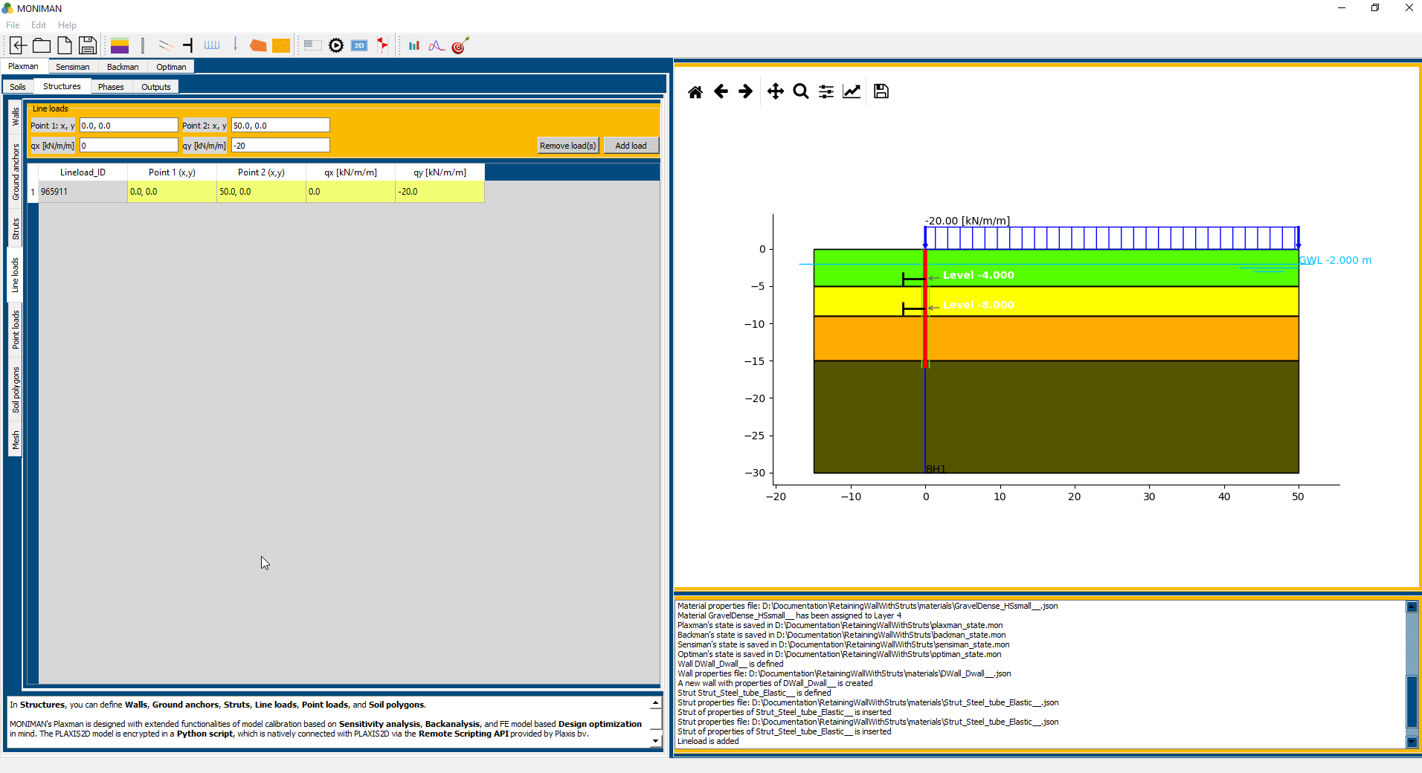

*(fig 3.10)*

* Assign *Point 1:x, y* as *0,0* and *Point 2:x, y* as *50,0 (fig 3.10)*
* Assign *qy [kN/m/m]* as *-20* and click on *Add load.*
* The Line load added can be verified from the table *(fig 3.10)* andthe model diagram *(fig 3.10).*

***Mesh***

* Select *Medium* for Element distribution and click on Apply mesh *(fig 3.10).*

*By default, a mesh with medium element distribution is applied. Visually, applying mesh will change colors of the structures into grey, which helps in visual inspection of the staged constructions in Phases.*

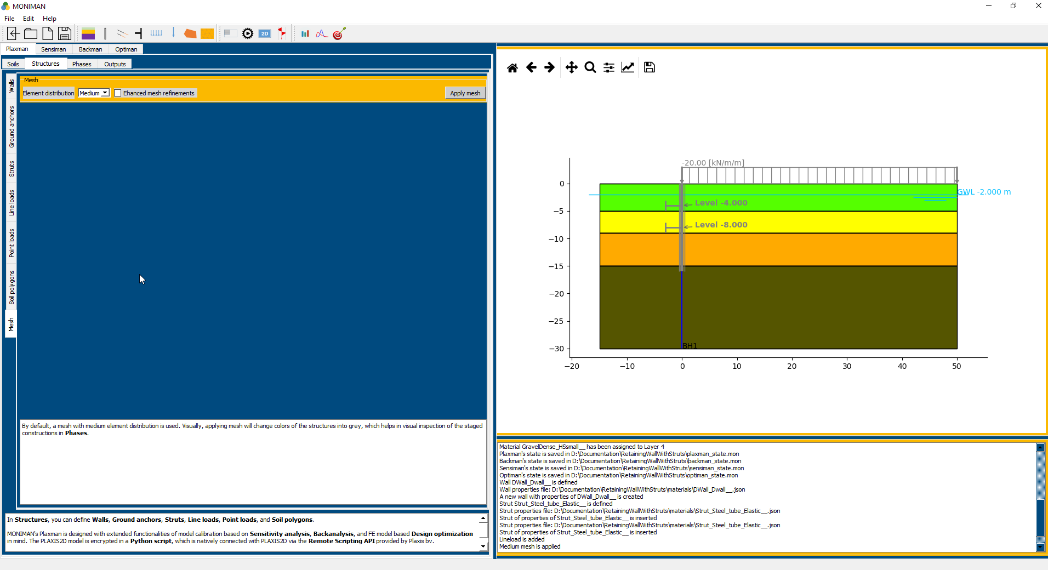

*(fig 3.11)*

***Phases***

In *Phases*, components of the phased excavations such as *Soil clusters* and *Water levels* or a *Drain* can be created. These components are used for configuring the calculation phases in *Predefined phases* (for predefined single-action phases) or *Combined phases* (for combined-action phases).

In *Automated phases*, the recreation of the excavation components is not needed. These components will be automatically generated.

* Select *Phases* from the top bar of *Plaxman*.
* For generating Automated phases, Select *Automated phases* from the sidebar.

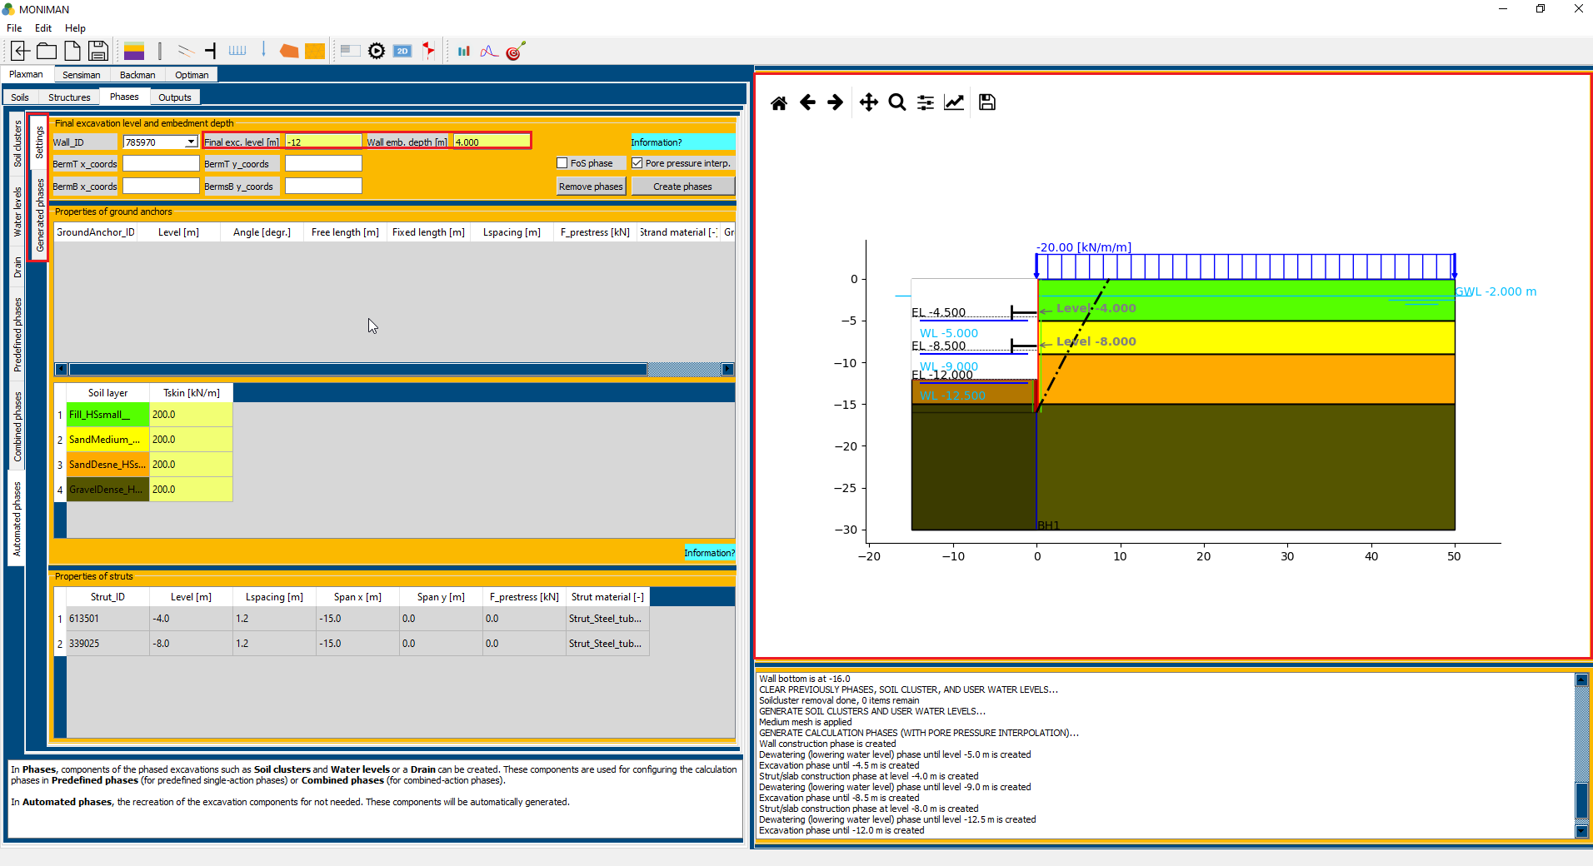

*(fig 3.12)*

* Select *Settings (1 in fig 3.12).* Assign *Final exc. Level [m]* to -12 and *Wall emb. Depth [m]* to 4 *(2 in fig 3.12).*
* Select *Pore pressure interp.* and Click on *Create phases.*
* To view the generated phases *(fig 3.13)*, click on *Generated phases* *(1 in fig 3.13)* from the vertical sidebar of *Automated phases.*
* The excavation can be verified from the model diagram *(3 in fig 3.12).*

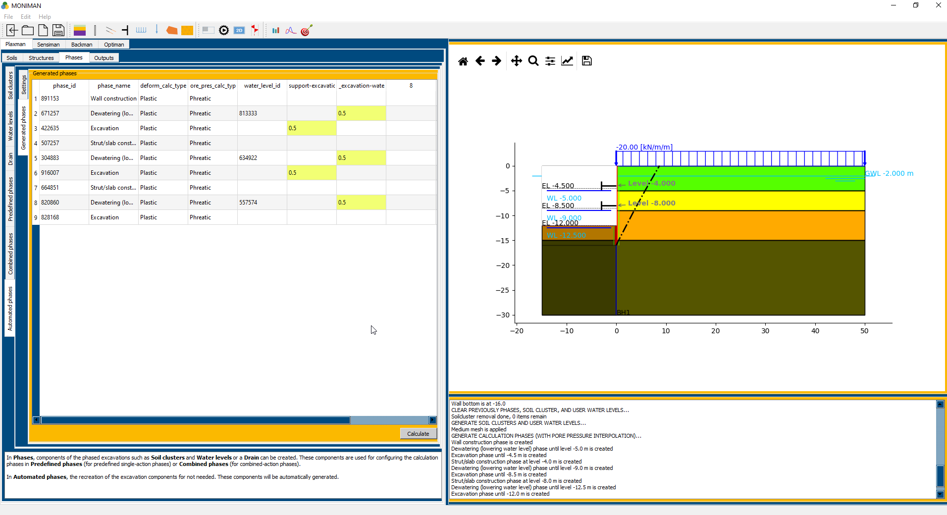

*(fig 3.13)*

***Outputs***

In *Outputs*, you can view the wall displacement and internal forces at each of the calculation phases in *Wall outputs.*

*Dimensioning* should link you to an external reinforcement curtailment dimensioning tool.

*Observation points* can be added for use in *Sensiman* and *Backman.* You can calculate the model here, the observed quantities at observation points will be exported to a text file in 'measurement' under your project folder.

* Select *Output* from the *top bar* of *Plaxman.*
* Click on *Calculate* for calculation *(1 in fig 3.14).*
* After Calculation is finished, select *phase* in *Wall outputs* and click on *view* *(2 in fig 3.14)* for wall displacement and internal forces of the selected phase *(fig 3.15).*
* The Plaxis file with name *retaining\_wall* will be stored in the folder selected for the current project.

**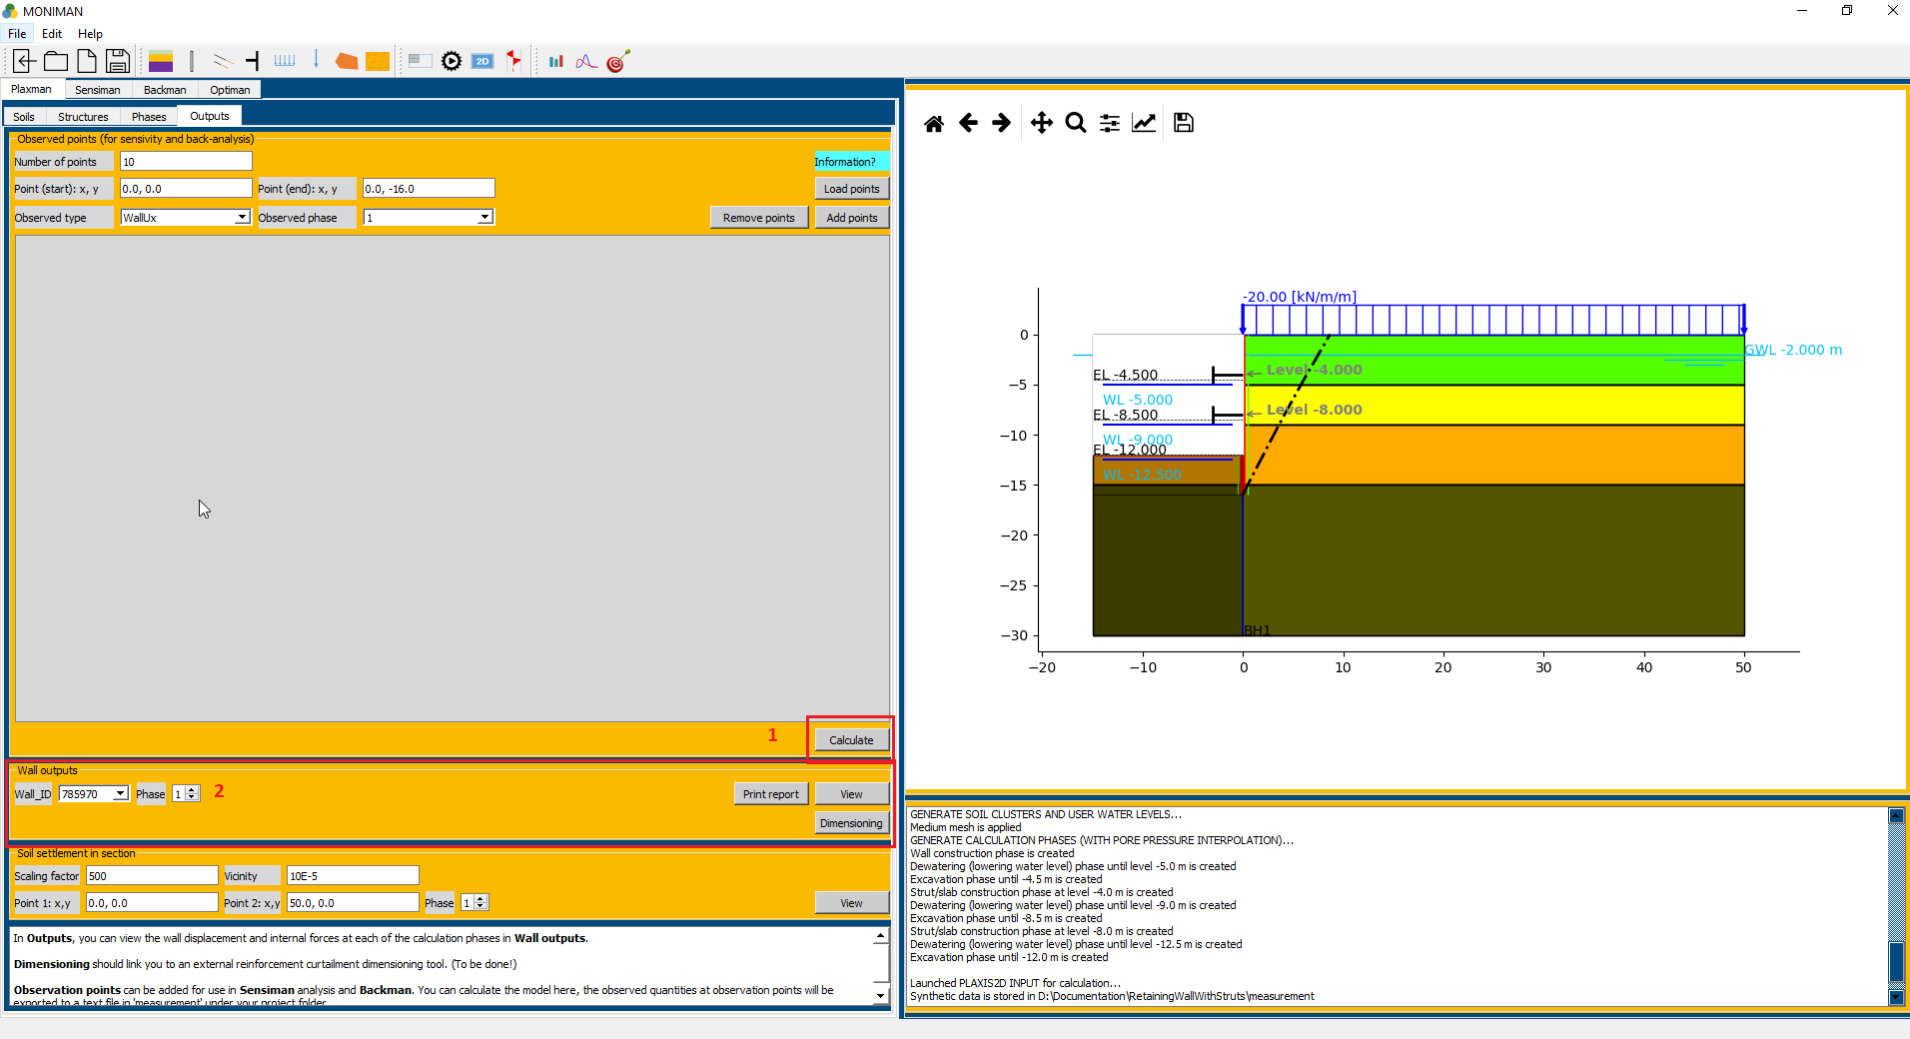**

*(fig 3.14)*

**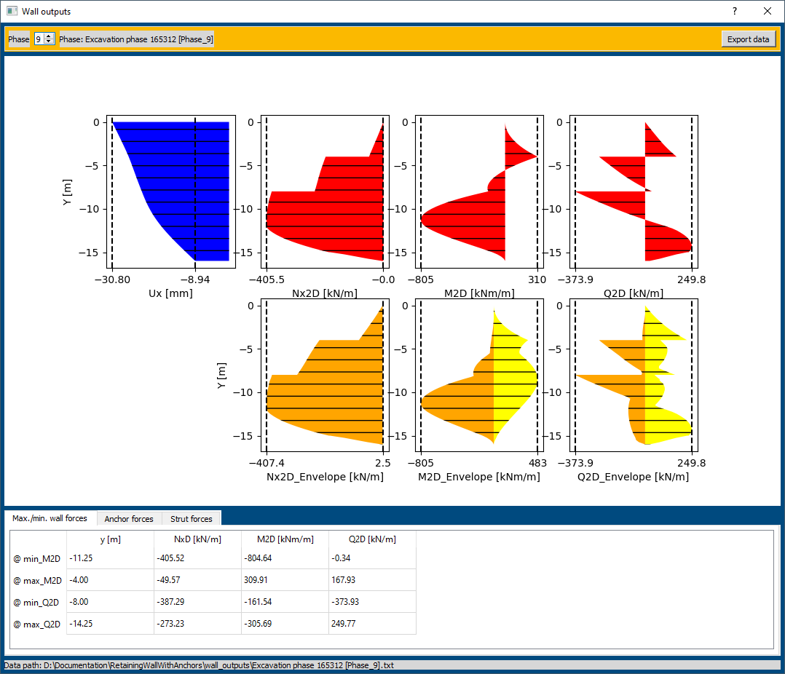**

*(fig 3.15)*

**BACKMAN**

*Back analysis* aims to improve the values for soil parameters by fitting the modelled outputs to the corresponding site measurements. MONIMAN's Backman provides the user with options to perform fast back-analysis using the *unscented Kalman filter* *(UKF)* and a thorough global search for a parameter set that best fits the modelled output to measured data by global optimization using the *Particle Swarm Optimization* *(PSO)*. For *PSO*, the burden of overly many FE model evaluations is relieved by basing the global optimization on the already trained metamodel.

Back analysis can be potentially used for excavations in difficult ground conditions to back calculate soil parameters from the monitored data. Then a monitoring based design approach (EC7: Observational method for design) can be advantageous both for securing safety and achieving cost efficiency.

***Settings***

The Ux site data values must be in *mm* and *.txt* format *(text format).*

To upload the site data for Back Analysis,

* Click on *Backman*. Select *Settings* from the top bar for *Backman.*
* In *Site data* menu, select *WallUx* for *Measured quantity* and *3* in *phase (1 in fig 3.16)* and click on *Load site data (2 in fig 3.16).*

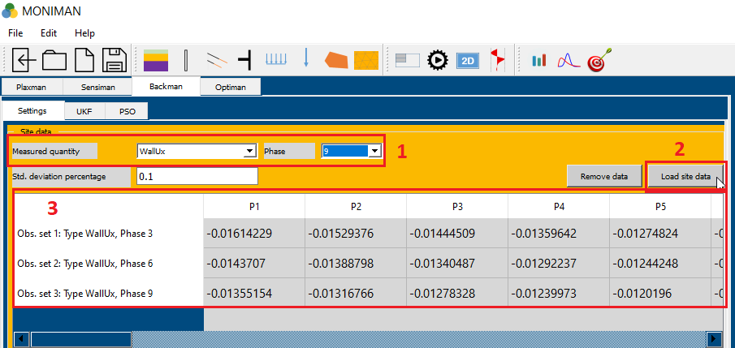

*(fig 3.16)*

* Select the site data for phase 3 in text format file *(fig 3.17)* and click on *Open.*
* Similarly, select the site data for phase 6 and phase 9 by changing the *Phase* to *6 and 9* and loading the site data for phase 6 and 9.
* The loaded site data can be verified *(3 in fig 3.16).*

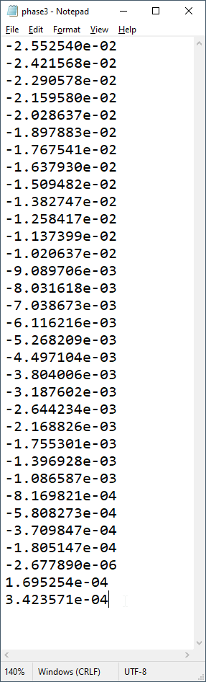

*(fig 3.17)*

The *Soil parameters* menu consist of settings to select soil parameters for back analysis. The selected soil parameters are improved by fitting the modelled outputs to the corresponding site data.

The parameters *phi* and *ve* for all soil parameters are considered. To add the parameters follow these steps,

* Select *Fill\_HSsmall\_\_* for *Soil material* and click on *Select parameters (1 in fig 3.18).*

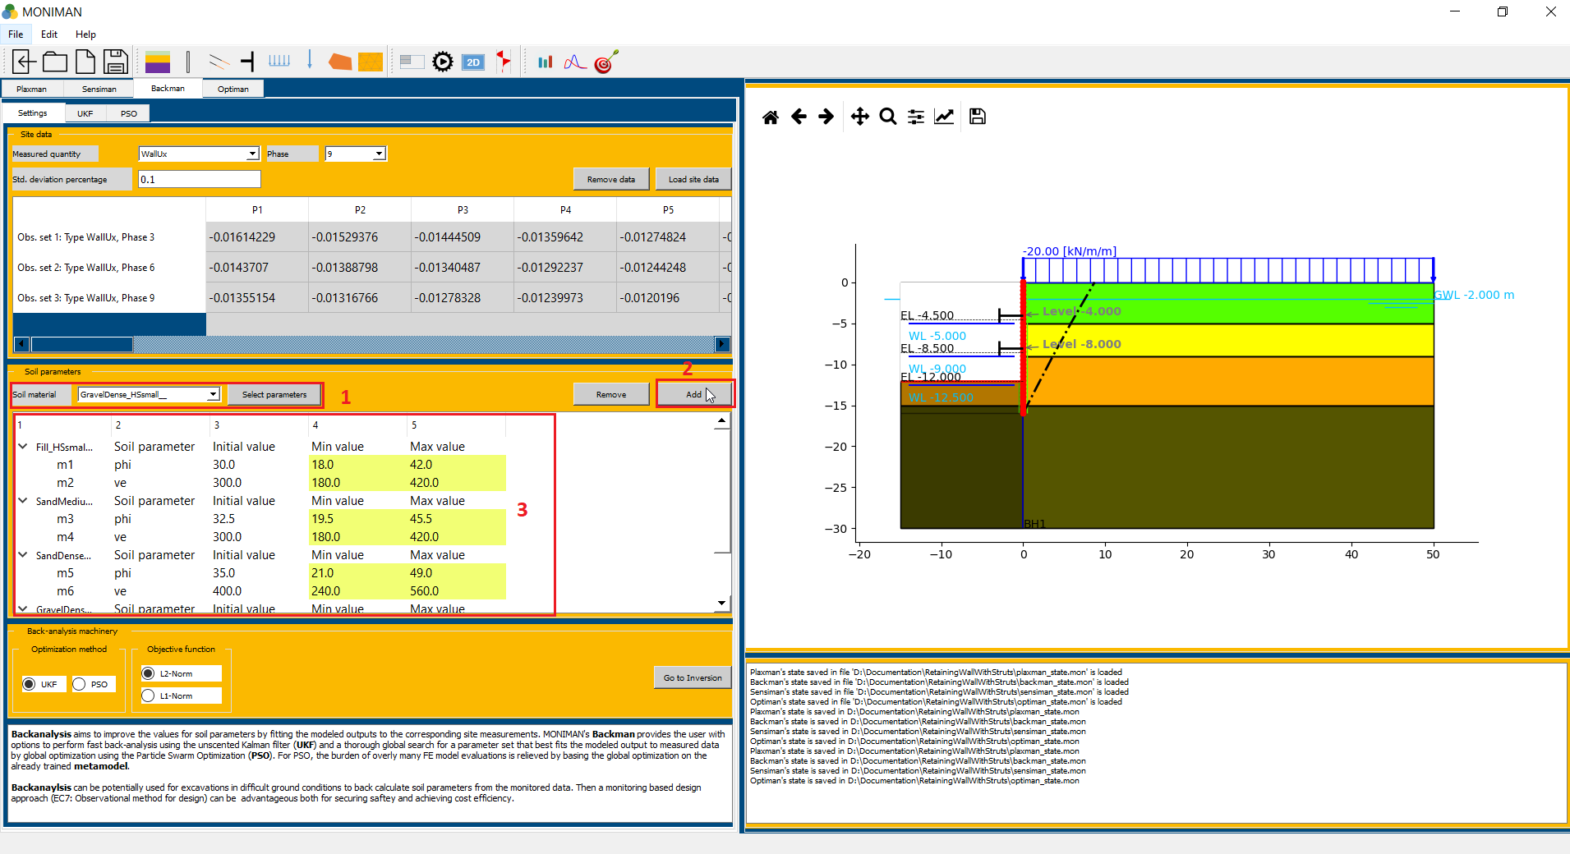

*(fig 3.18)*

* The *HSsmall properties* appears *(fig 3.19)*. For *phi* and *ve* parameters, check on *Sensitivity?* box and Click on *OK.*

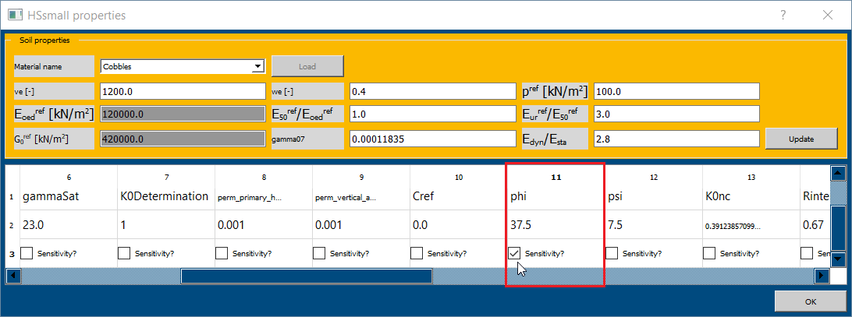

*(fig 3.19)*

* Click on *Add (2 in fig 3.18)* to add *phi* and *ve* parameters for fill soil.
* Similarly add *phi* and *ve* parameters for *SandMedium, SandDense and GravelDense.*
* The selected soil parameters for back analysis can be verified *(3 in fig 3.18)*

***Back analysis using Unscented Kalman filter (UKF)***

* In *Back-analysis machinery* select *UKF* for *optimization method (1 in fig 3.20), L2-Norm* for *Objective function (2 in fig 3.20)* and click on *Go to Inversion (3 in fig 3.20).*

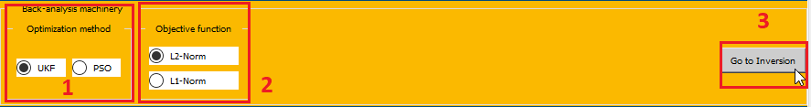

*(fig 3.20)*

* Check for selected soil parameter ranges in *Initial mean and covariances* menu.
* In *Run status* menu, assign *2* for *# Iterations (1 in fig 3.21)* and select *Phase\_9* for *Plot at phase (2 in fig 3.21)* and click on *Start (3 in fig 3.21).*
* The *Run status* menu consists of three plots, *measured Ux (site data) (4 in fig 3.21), Simulated Ux ( 5 in fig 3.21) and Objective value vs Iteration number (6 in fig 3.21).*

*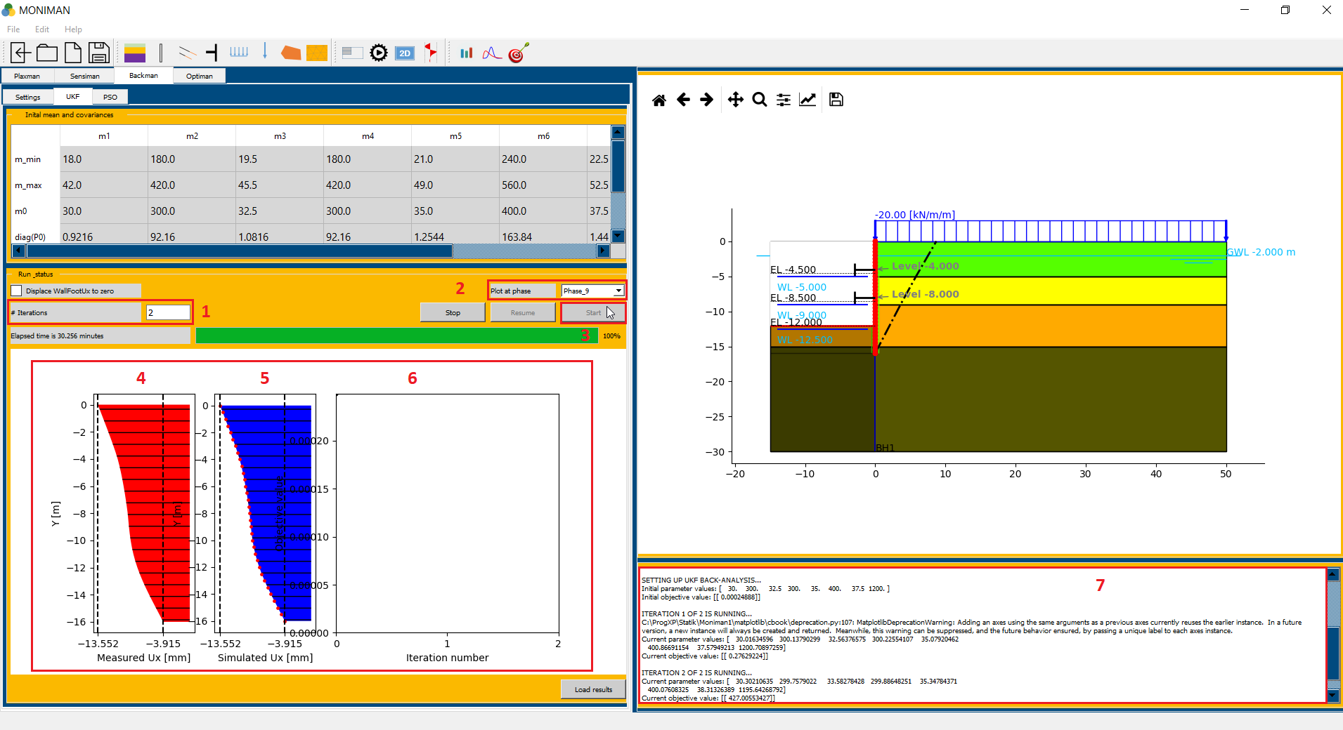*

*(fig 3.21)*

* In terminal, for *iteration 2 (7 in fig 3.21),* the soil parameters values can be noted as *[ 30.3, 299.75, 33.58, 299.86, 35.34, 400, 37.58, 1200.7 ]* and *Current objective value* as *427*
* The corresponding improved soil parameter values are as follows*,* Fill *phi = 30.3* and *ve = 299.75,* Sand Medium *phi = 33.58* and *ve = 299.86,* Sand Dense *phi = 35.34* and *ve = 400,* Gravel Dense *phi = 37.58* and *ve = 1200.7*