**1. RETAINIG WALL WITH STRUTS FOR RECONSTRUCTION**

The objectives of this first tutorial are,

* Modeling the retaining wall with struts for reconstruction.

**PLAXMAN**

Start Moniman by double clicking the **D:\Data\Downloads\moniman_logo-6.png** icon of the input program. The Moniman window appears, consisting of four tabsheets *Plaxman, Sensiman, Backman* and *Optiman (1 in fig 1.1).*

The left half of Moniman consist of tab sheets where you input values for modelling *(2 in fig 1.1)* and right part contains model diagram in the top *(3 in fig 1.1)* and terminal in the bottom *(4 in fig 1.1)*.

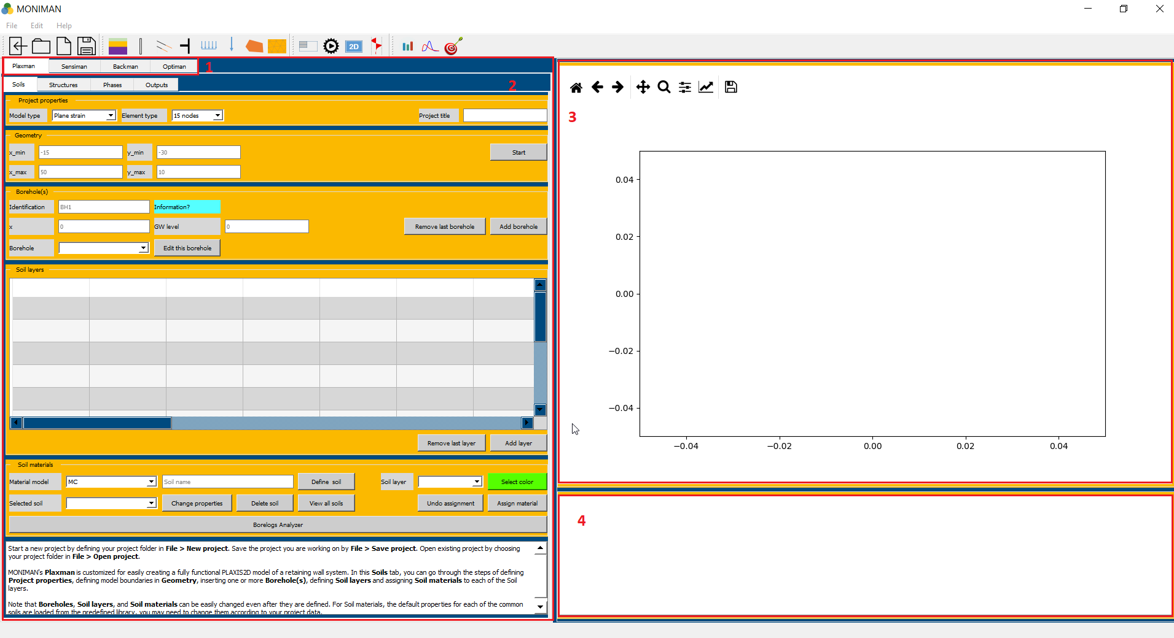

*(fig 1.1)*

* To start a new project, create a folder in file explorer at your desired path.
* Open Moniman, click on *File* --> *New project* or click on ** and select a created folder.
* To open an existing moniman project folder, click on *File --> Open project* or click on 
* Remember to save the project regularly while working with Moniman by clicking on icon  or *File--> Save project.*

*Note: Do not use any special characters or spaces while assigning the names or values.*

***Soils***

***Project properties***

The first step in every analysis is to set the basic parameters of the finite element model. This is done in the Project properties menu under soils. The settings include the type of model, Element type and project title.

To enter the appropriate settings for Retaining wall calculation follow these steps,

* Select *Plane strain* for *Model type* and *15 nodes* for *Element type (1 in fig 1.2)*.
* Enter the *Project title* as *Retaining Wall.*

***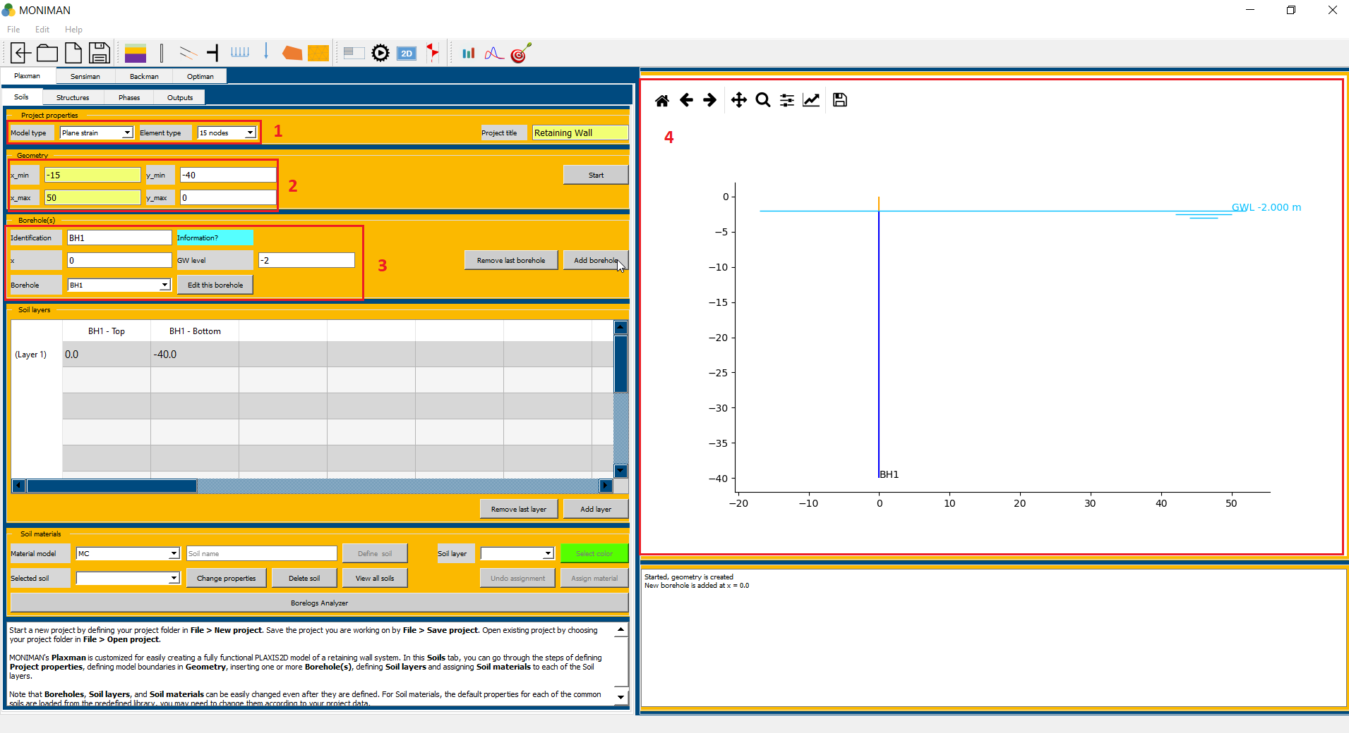***

*(fig 1.2)*

***Geometry***

The *Geometry* menu includes the settings to define the drawing area.

* Assign -15, 50, -40, 0 to *x\_min, x\_max, y\_min,* and *y\_max* respectively *(2 in fig 1.2)*.
* Click on *Start,* which updates the drawing area in the model diagram *(4 in fig 1.2)*.

***Borehole(s)***

Borehole menu includes settings to define water table. For Retaining wall project to assign ground water level at -2m elevation,

* Enter *BH1* in Identification, and type 0 in *x, -2* in *GW level (3 in fig 1.2)* and click on *Add borehole*. The borehole is updated in the model diagram *(4 in fig 1.2)*

***Soil layers***

The soil layers menu includes the sheet with layers as rows and elevations as columns.

In order to construct the soil stratigraphy follow these steps,

* Double click on cell for *(Layer 1) and (BH1 – Bottom)* and change the value to *-5 (1 in fig 1.3)*, which is bottom elevation of layer 1 *(Fill)* and click on *Add layer.* The layer 1 is geometrically defined.
* Similarly, assign -8, -12, -40 for layer 2, layer 3 and layer 4 and click on Add layer *(2 in fig 1.3)*.

*Remember to click Add layer for the last layer assigned. Moniman shows (Layer 5), BH1- Top and BH1 – Bottom as -40, -40 which needs to be ignored.*

* The added layers appear on the model diagram *(3 in fig 1.3).*

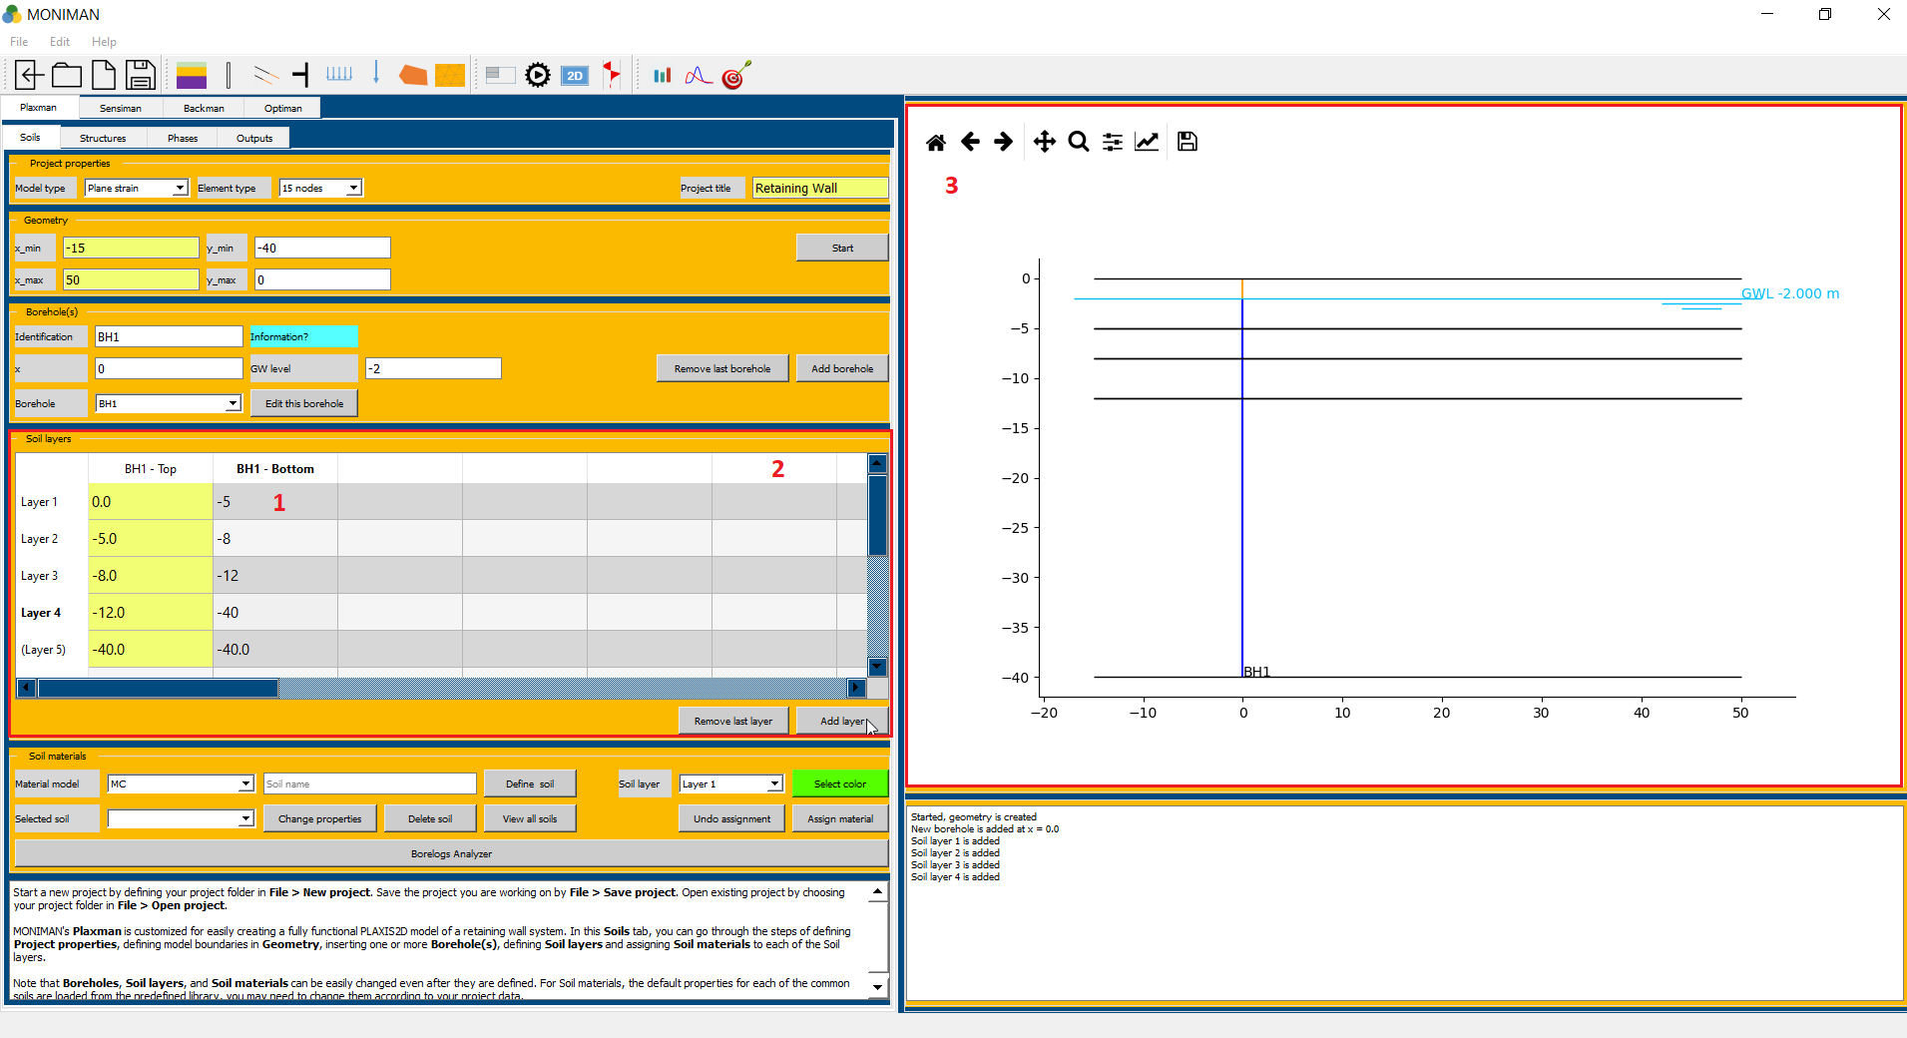

*(fig 1.3)*

***Soil materials***

In order to simulate the behavior of the soil, a suitable soil model and appropriate material parameters must be assigned to the layers defined earlier. Accordingly, the *Soil materials* menu consist of predefined library of soils, which can be changed according to your project.

To define the required soils for the current project follow these steps,

* Select *HSsmall* for *Material Model*  in *Soil material* menu *(1 in fig 1.4)* to consider *Hardening Soil model with small-strain stiffness.*
* Type *Fill* in *Soil name (2 in fig 1.4)* and click on *Define soil (3 in fig 1.4),* which pop up *HSsmall properties* window *(fig 1.5)*.

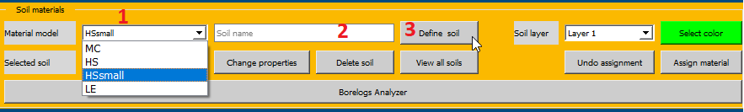

*(fig 1.4)*

* In *HSsmall properties*, select *Fill* in *Material name* *(1 in fig 1.5)* and click on *Load.* Click on *OK* to define the fill soil.

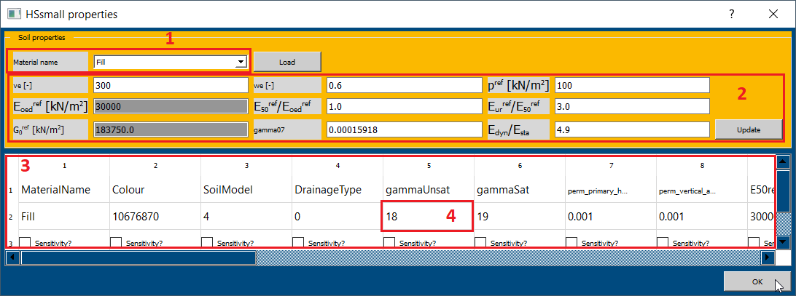

*(fig 1.5)*

*You can change the parameter values here, according to the needs of different project.*

*For example if you change ve[-], we[-] values (2 in fig 1.5), you have to click on update first and next change the values in sheet (3 in fig 1.5). You can change the values in the sheet by double clicking on the previous value (4 in fig 1.5) and typing new value.*

* Similarly, define sand medium, sand dense and gravel dense soils from predefined library by selecting respective soils from *Material name* in *HSSmall properties (1 in fig 1.5).*

Assigning the defined soil to defined layer requires the following steps,

* For assigning Fill soil to layer 1, select *Fill\_HSsmall\_\_* in *Selected soil (1 in fig 1.6),* select *Layer 1* in *Soil layer,* select desired *color* and click on assign material *(2 in fig 1.6)*. The assigned soil appears on model diagram.

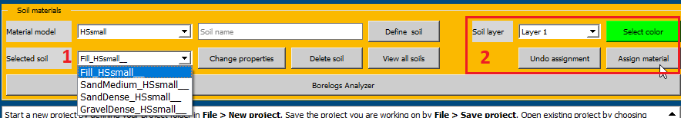

*(fig 1.6)*

* For assigning Sand medium soil to layer 2, select *SandMedium\_HSsmall\_\_* in *Selected soil,* select *Layer 2* in *Soil layer,* select desired *color* and click on assign material.
* Similarly assign Sand dense to layer 3 and Gravel Dense to layer 4. After assigning soils, the soils appear in the model diagram *(3 in fig 1.7)* and is verifiable from *Soil layers (2 in fig 1.7).*

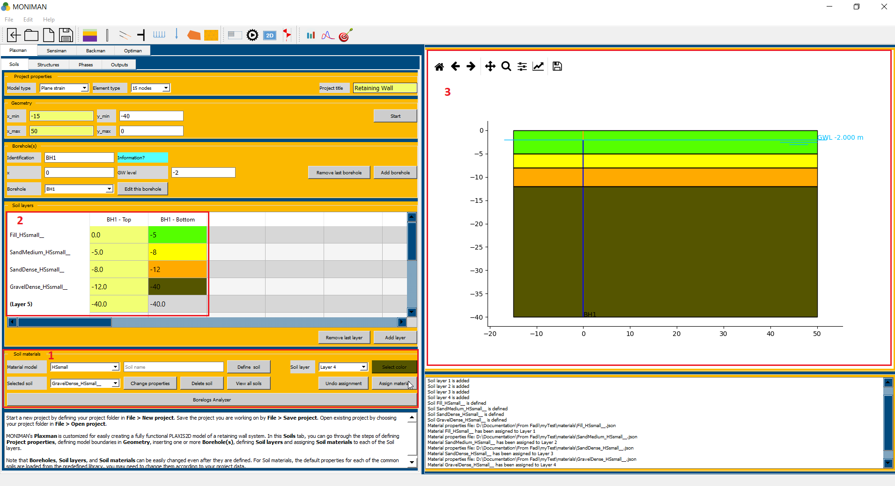

*(fig 1.7)*

*Note: Remember to save the project.*

***Structures***

Select Structures from the top bar under Plaxman. The structural elements are created in structures mode of Plaxman.

***Walls***

The *Walls* menu includes settings for wall dimensions and wall properties.

To assign DWall for the current project follow these steps,

* First, define the wall properties by, selecting *DWall* for *Wall type* and type *Dwall* in *Wall name* and click on *Define wall,* which pop up *DWall properties* windows *(fig 1.8).*
* Change the wall thickness, by assigning *1* for *d[m]* and click on *update,* to update values dependent on d. Click on *OK* to define DWall property.

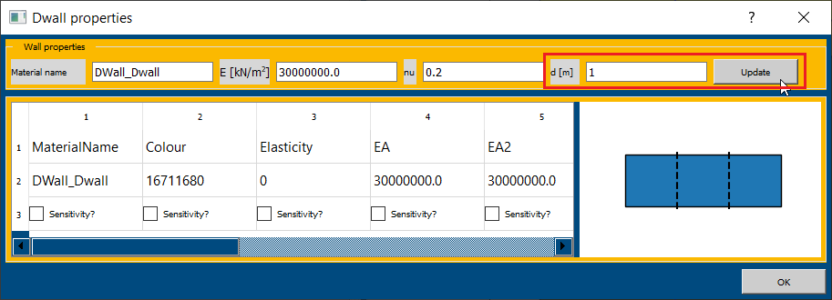

*(fig 1.8)*

* Second, to assign the defined wall, type *(0, -1)* in *Point top: x, y* and *(0, -14)* in *Point bottom: x, y ( 1 in fig 1.9).* Select *DWall\_DWall\_\_* for *Wall material (2 in fig 1.9),* select *color* and click on *Add wall (3 in fig 1.9).*
* The wall is updated in model diagram *(5 in fig 1.9)* and is verifiable from the table*(4 in fig 1.9)*.

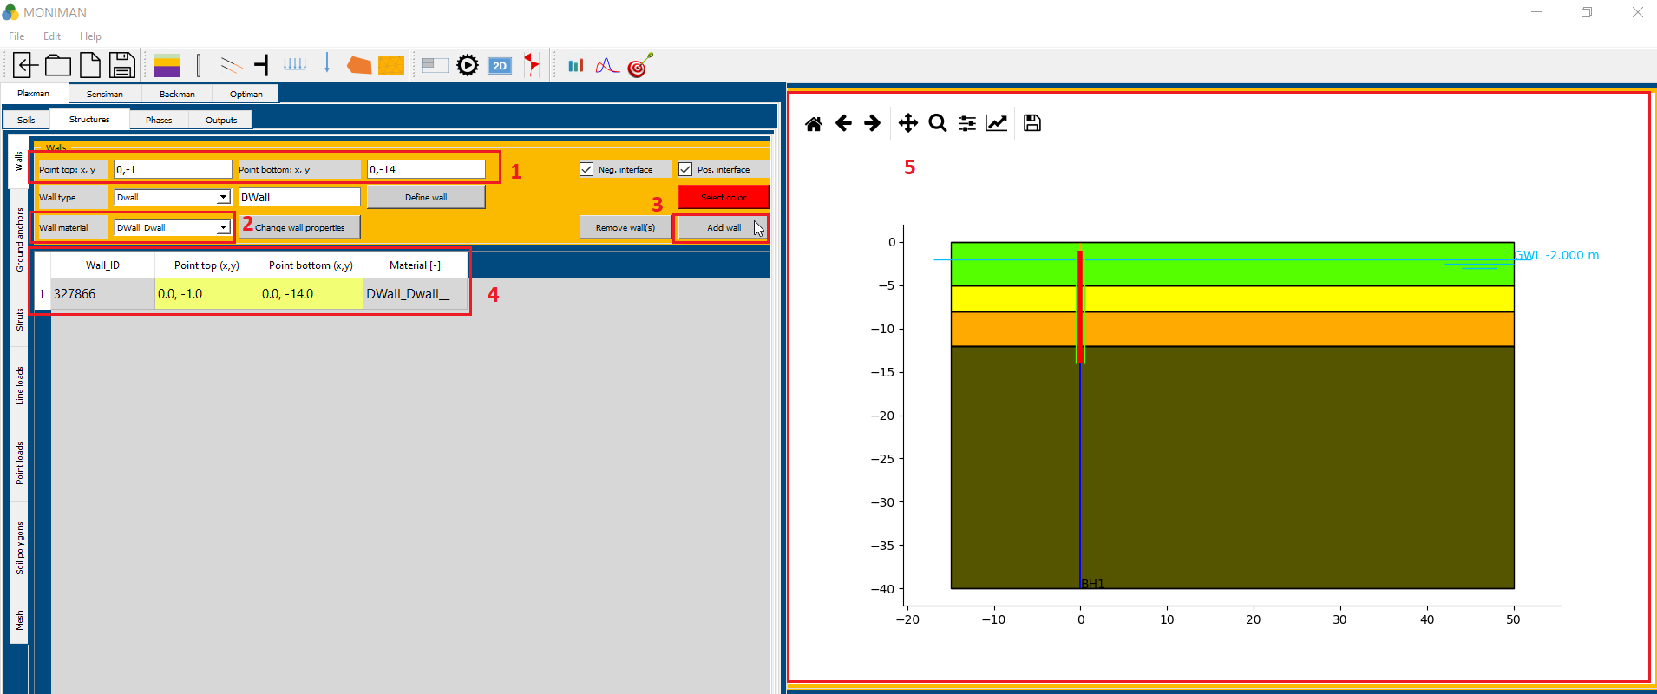

*(fig 1.9)*

***Struts***

* Select *Struts* from the vertical bar. The current tutorial consist of four struts, which are two temporary struts, one raft and one slab.
* To define temporary strut material for excavation, select *Steel tube* for *Strut type,* type *S1* in *Strut name* and click on *Define strut material,* which pop up *Strut properties for S1* window *(fig 1.10)*.

**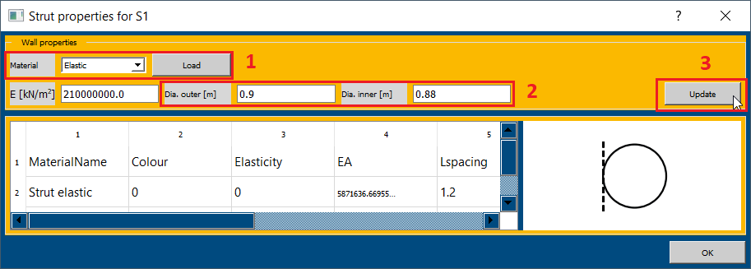**

*(fig 1.10)*

* In *Strut properties for S1* window, select *Elastic* for *Material* and click on *Load (1 in fig 1.10).*
* Change, *Dia. outer [m]* to *0.9* and *Dia. inner [m]* to 0.88 *(2 in fig 1.10)* and click on *Update (3 in fig 1.10).* Click on *OK* to define *S1* strut material.
* For assigning struts, type *(0, -2)* in *Point: x, y, 1.2* in *Lspacing, -10* in *Direction: x (1 in fig 1.11).*
* Select *S1\_Steel\_tube\_Elastic\_\_* in *Selected material (2 in fig 1.11).* Select *Strut* in *Usage* *(3 in fig 1.11)* and click on *Add strut (4 in fig 1.11).* The strut at *(0, -2)* appears in the model diagram *(6 in fig 1.11)*.
* Similarly, type *(0, -6)* in *Point: x, y, 1.2* in *Lspacing, -10* in *Direction: x.* Select *S1\_Steel\_tube\_Elastic\_\_* in *Selected material.* Select *Strut* in *Usage* and click on *Add strut.* The strut at *(0, -6)* appears in the model diagram.

**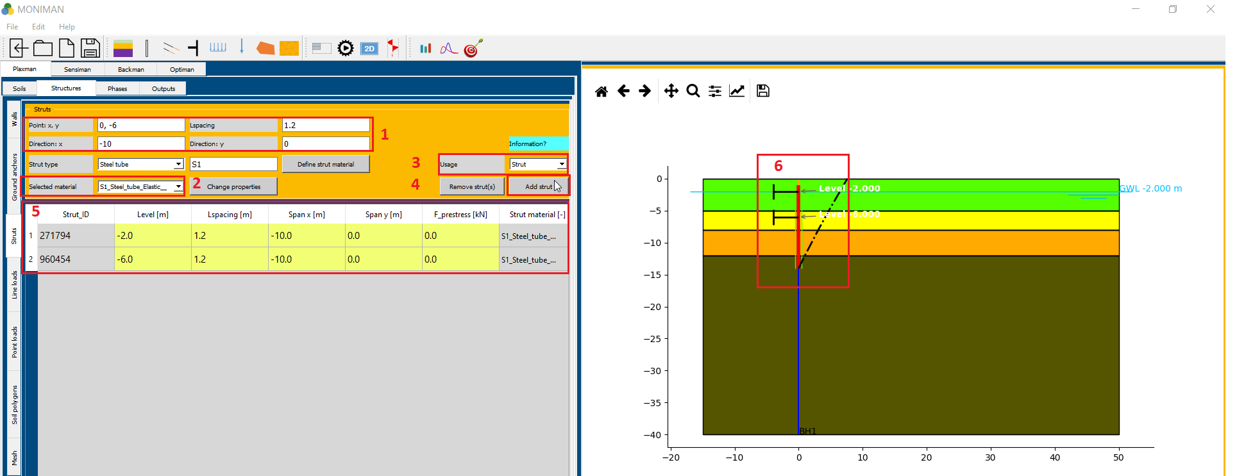**

*(fig 1.11)*

* To define raft material, select *RC slab* from *Strut type,* type *raft* in *Strut name,* and click on *Define strut material.*
* The *Strut properties for raft* window appears. Select *Elastic* for *Material (1 in fig 1.12)* and click on *Load*, Select *C30/37* for *Concrete grade (2 in fig 1.12)* and click on *Update.*
* Click on *OK* to define raft properties.

**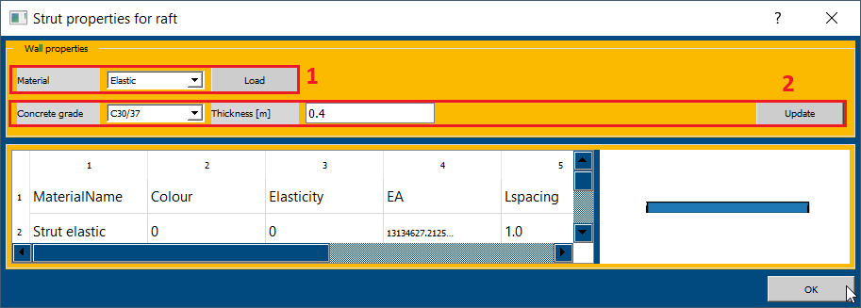**

*(fig 1.12)*

* To assign raft, type *(0, -9)* in *Point: x, y, 1* in *Lspacing, -1* in *Direction: x.* Select *raft\_RC\_slab\_Elastic\_\_* in *Selected material (1 in fig 1.13).* Select *Slab* in *Usage (2 in fig 1.13)* and click on *Add strut.* The raft at *(0, -9)* appears in the model diagram.

**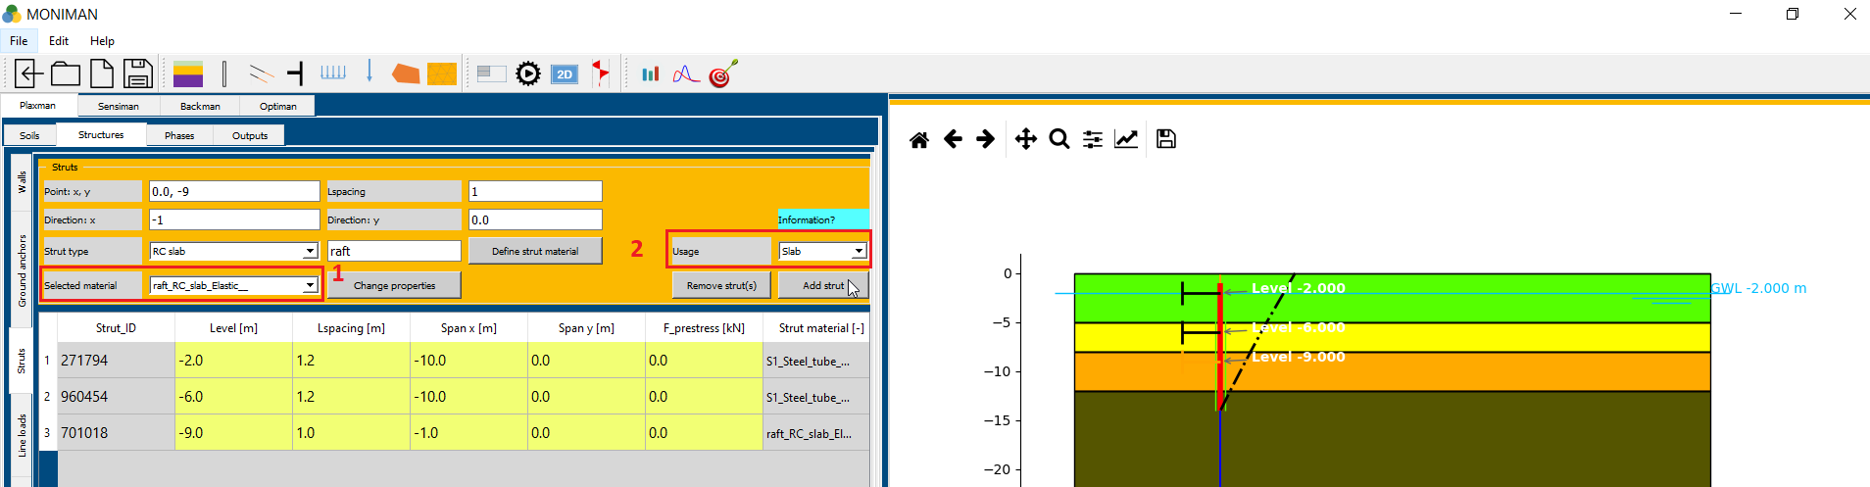**

*(fig 1.13)*

* To define slab material, select *RC slab* from *Strut type,* type *slab* in *Strut name,* and click on *Define strut material.*
* The *Strut properties for slab* window appears. Select *Elastic* for *Material* click on *Load*, Select *C30/37* for *Concrete grade* and click on *Update.*
* Click on *OK* to define slab properties.
* To assign slab, type *(0, -4)* in *Point: x, y, 1* in *Lspacing, -6* in *Direction: x.* Select *slab\_RC\_slab\_Elastic\_\_* in *Selected material (1 in fig 1.14).* Select *Slab* in *Usage* and click on *Add strut.* The raft at *(0, -4)* appears in the model diagram.
* All four struts are verifiable from the table *(2 in fig 1.14)* in struts and model diagram *(3 in fig 1.14)*.

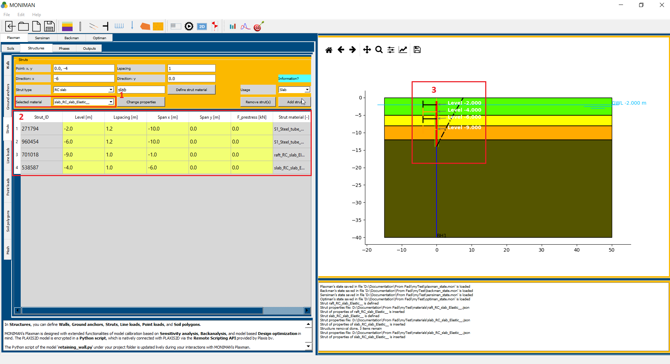

*(fig 1.14)*

***Soil polygons***

To add additional soil polygons apart from soil stratigraphy, *Soil polygons* menu consist of *Free polygons for soil (homogeneous soil)* and *Improved soil polygons (soil layer-dependent).*

For current tutorial to add Concrete polygon of building follow these steps,

* In *Free polygons for soil (homogeneous soil)* menu, to define concrete material, select *MC* for *Material model (1 in fig 1.16),* type *concrete* in *Soil name,* and click on *New material.*

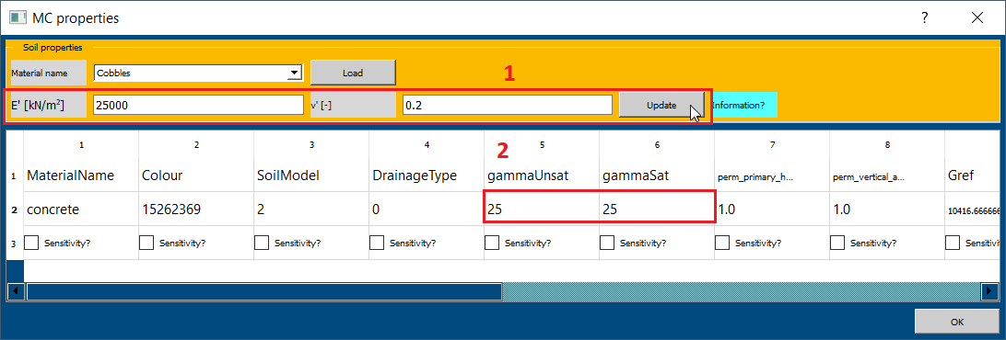

*(fig 1.15)*

* The *MC properties window* appears *(fig 1.15)*. Select any soil in *Material name* and click on *Load*. Edit *E’ [kN/m2]* to *25000, ν’ [-]* to *0.2* *(1 in fig 1.15)* and click on *Update.*
* Change the values of *gammaUnsat* and *gammaSat* to *25 (2 in fig 15), Cref* to *513, phi* to *35* and click on *OK.*
* To assign the defined concrete material as a soil polygon, select *concrete\_MC\_\_* for *Polygon material (2 in fig 1.16).*
* To add points of polygon, assign first point *(10, 0)* to *Polygon point: x, y* and click on *Add point (3 in fig 1.16).*
* Similarly, add second point *(25,0),* third point *(25, -3)* and fourth point *(10, -3).* You have to follow this order while adding points.
* Select *color* and click on *Add polygon.* The concrete polygon appears in the model diagram *(4 in fig 1.16).*

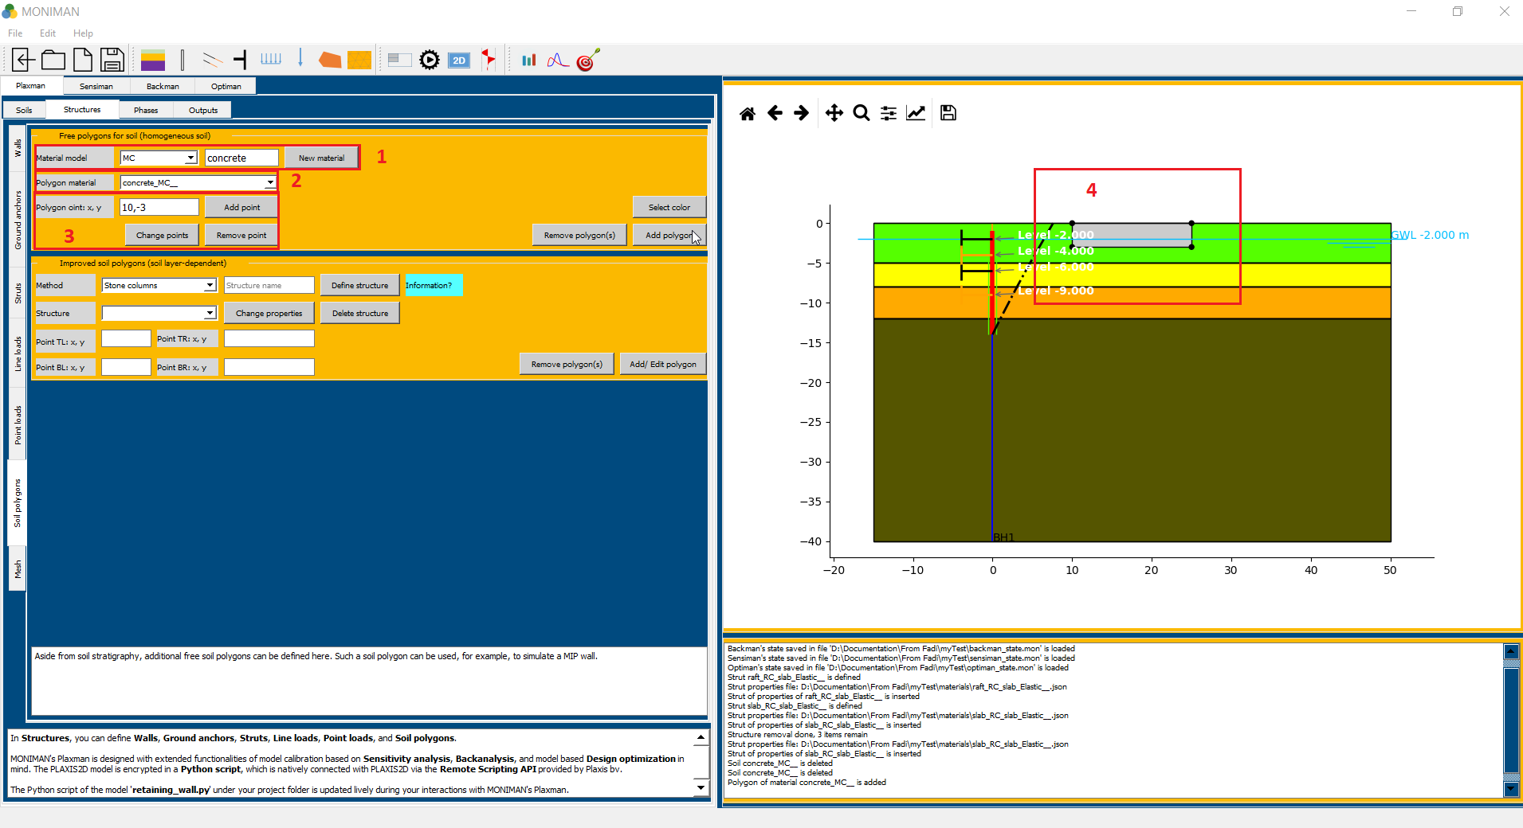

*(fig 1.16)*

***Line loads***

* Click on *Line loads* from the vertical bar.
* To assign the building load of 100 kN/m2, Enter *(10, 0)* in *Point 1: x, y* and *(25, 0)* in *Point 2: x, y.*
* Type *0* for *qx [kN/m/m],* and -100 for *qy [kN/m/m]* and click on *Add load.*
* The load added is verifiable from the model diagram *(3 in fig 1.17)* and table in the *Line loads* menu *(2 in fig 1.17)*.

**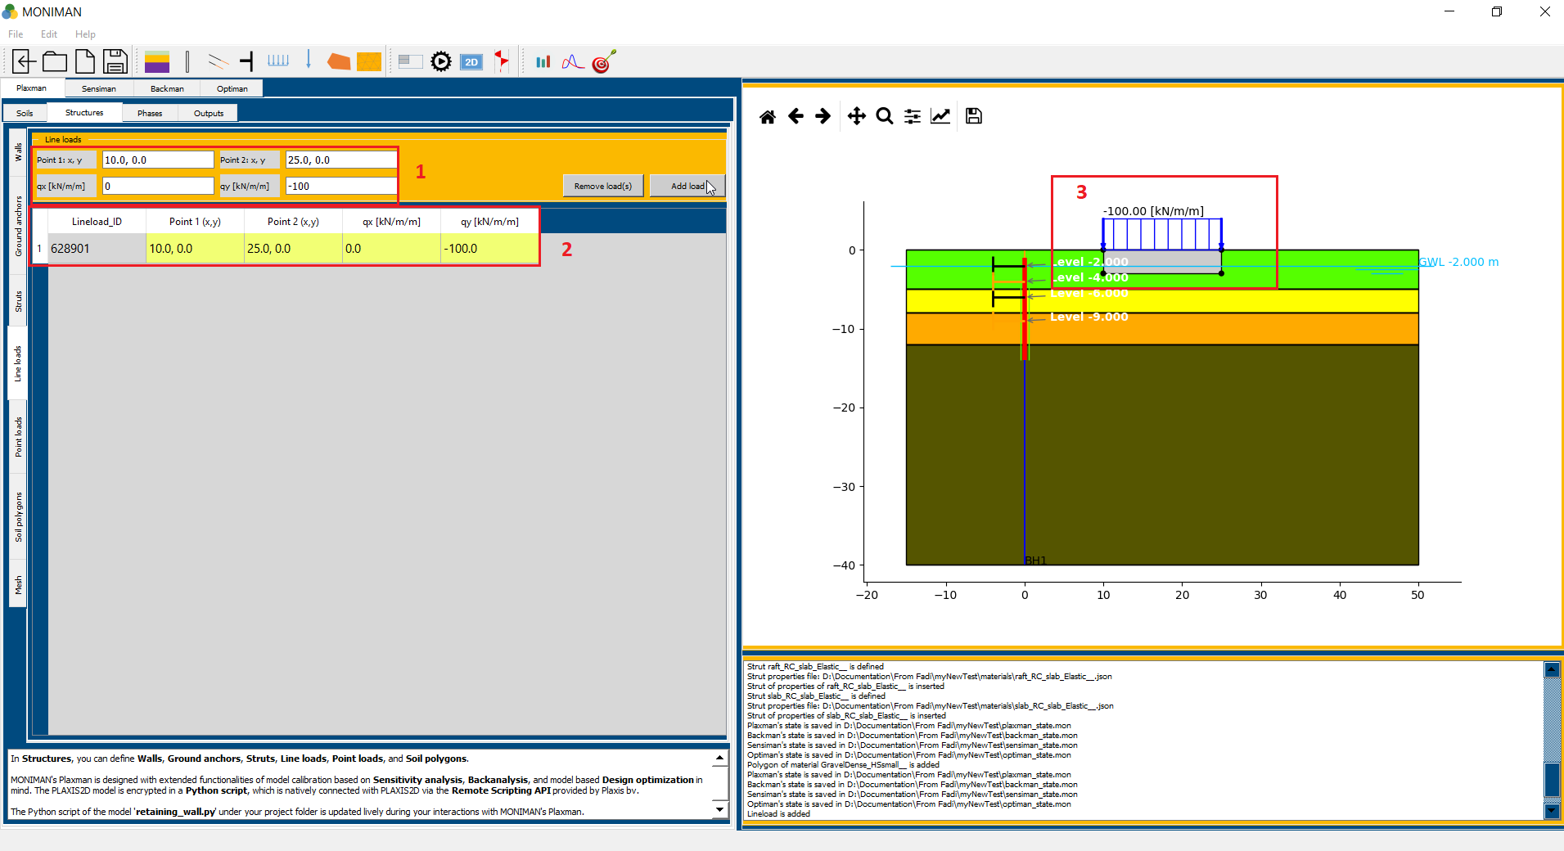**

*(fig 1.17)*

***Mesh***

* Select *Mesh* from vertical bar.
* In mesh menu, select *medium* for *Element distribution (1 in fig 1.18)* and click on *Apply mesh.*
* Applying mesh will change the color of structures into grey *(2 in fig 1.18)*.

**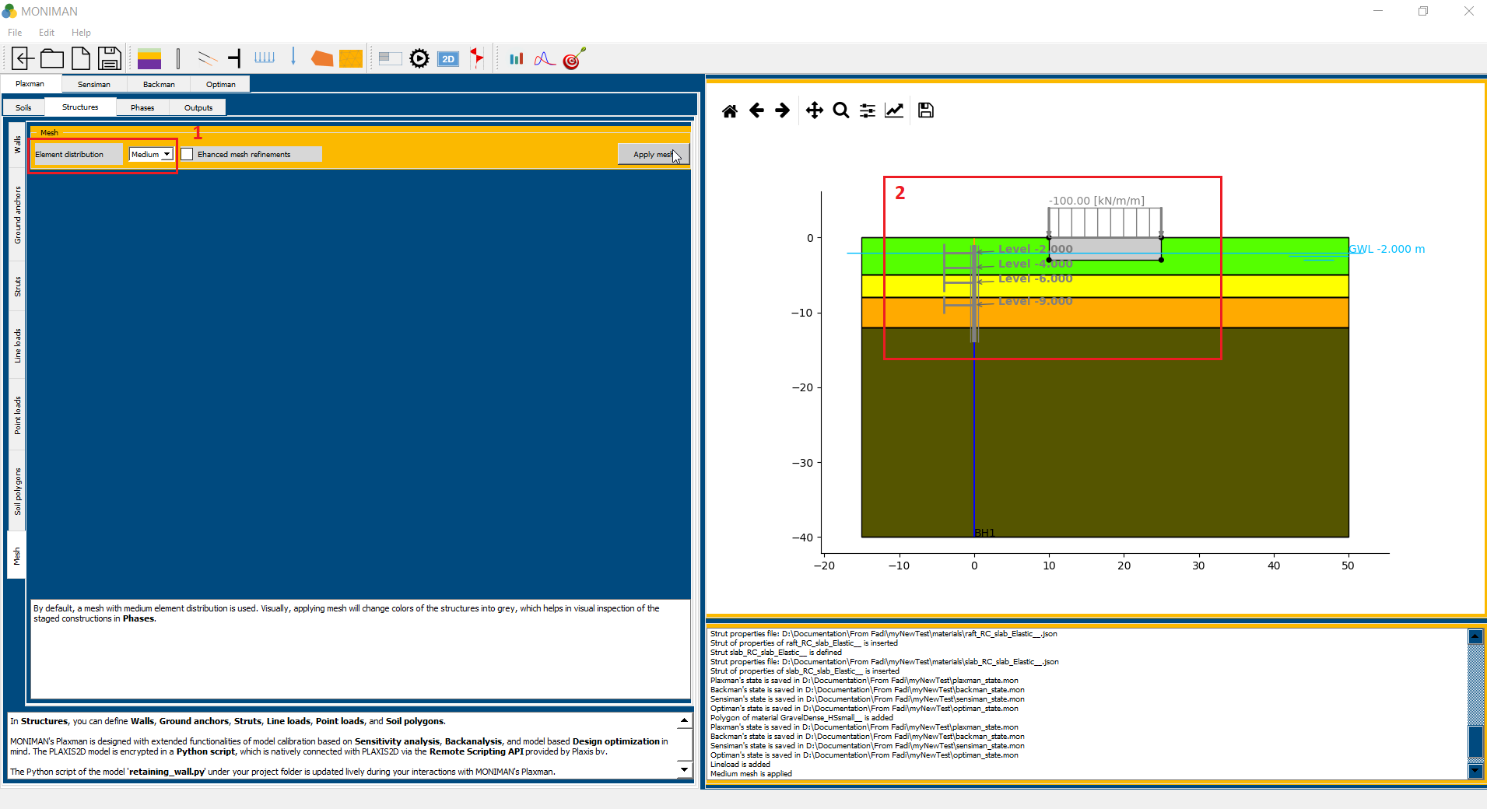**

*(fig 1.18)*

***Phases***

***Automated phases***

In Phases, components of the phased excavations such as Soil clusters and Water levels or a Drain can be created. These components are used for configuring the calculation phases in Predefined phases (for predefined single-action phases) or Combined phases (for combined-action phases).

In Automated phases, the creation of the excavation components are not needed. These components will be automatically generated.

In current tutorial, to use Automated phases follow these steps,

* Select *Automated phases* from the vertical bar. Click on *Settings.*
* In *Final excavation level and embedment depth,* check for *Wall\_ID* defined during *Walls* in *Structures* stage. Assign *-12* to *Final exc. level [m]* and *2* to *Wall emb. Depth [m] (1 in fig 1.19).*
* To add berms at top with points *(0,-1), (0.5,-0.5), (1,-0.5), (5,0)* , assign *0, 0.5, 1, 5* to *BermT x\_coords* and *-1, -0.5, -0.5, 0* to *BermT y\_coords (2 in fig 1.19).*
* To add berms at bottom with points *(-15,-12), (-4,-12), (-4,-10), (0,-10),* assign *-15, -4, -4, 0* to *BermB x\_coords* and *-12, -12, -10, -10*  to *BermB y\_coords.*
* Check *FoS phase* and *Pore pressure interp.* and click on *Create phases (3 in fig 1.19).*

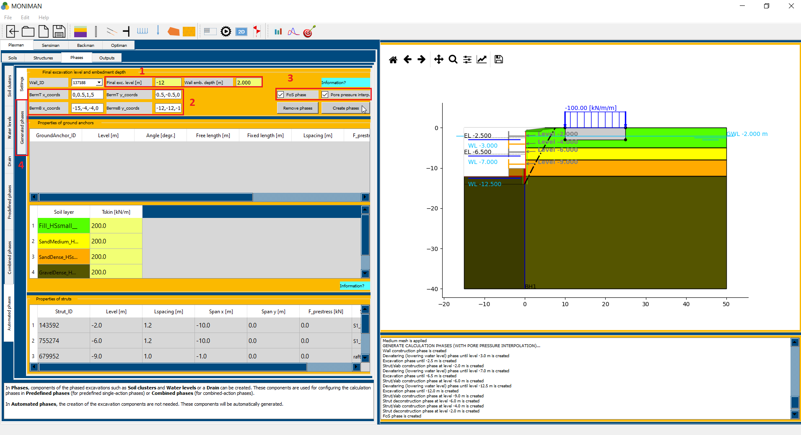

*(fig 1.19)*

* Click on *Generated phases* from vertical bar *(4 in fig 1.19)*, the *Generated phases* table appears *(1 in fig 1.20)* and the phases are verifiable in the model diagram *( 2in fig 1.20)*.

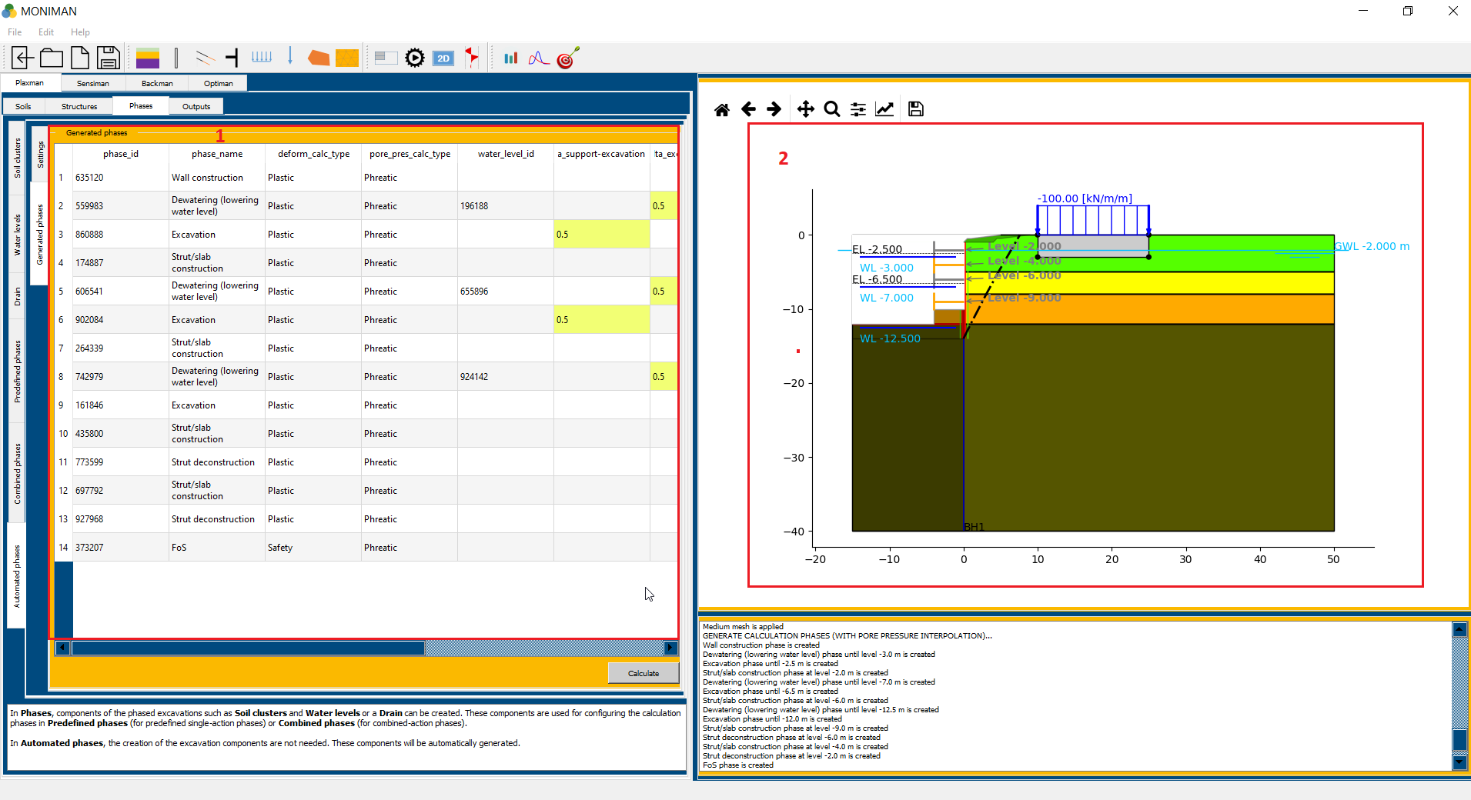

*(fig 1.20)*

***Outputs***

* Select *Outputs* from the top bar and click on *Calculate (1 in fig 1.21).*
* *Plaxis 2D* will run the calculations and the *PLAXIS 2D Project* file is saved in the project folder as *retaining\_wall.p2dx*

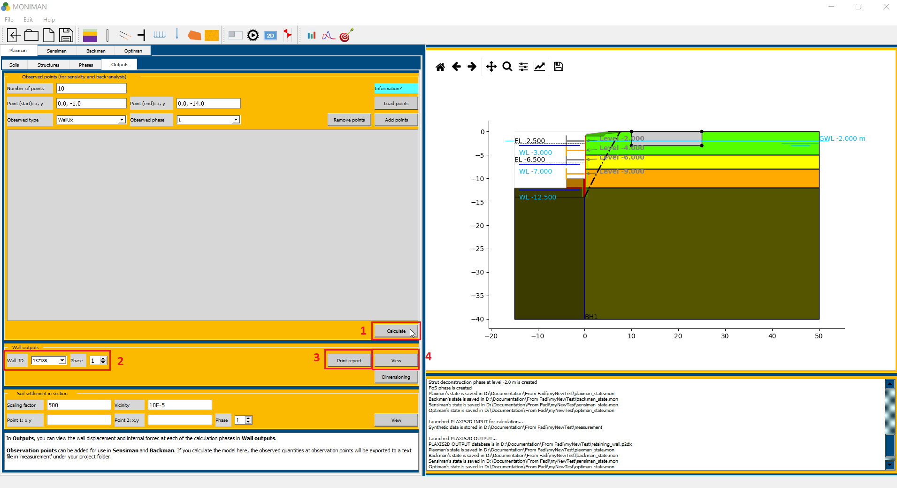

*(fig 1.21)*

* In *Wall outputs* menu, select *Wall\_ID* and *Phase* *(2 in fig 1.21)* and click on *View (4 in fig 1.21).*
* The *Wall outputs* menu appears, which consist of wall displacement and internal forces at selected phase *(fig 1.22)*. The phase can be changed at *Phase* *(1 in fig 1.22).*

*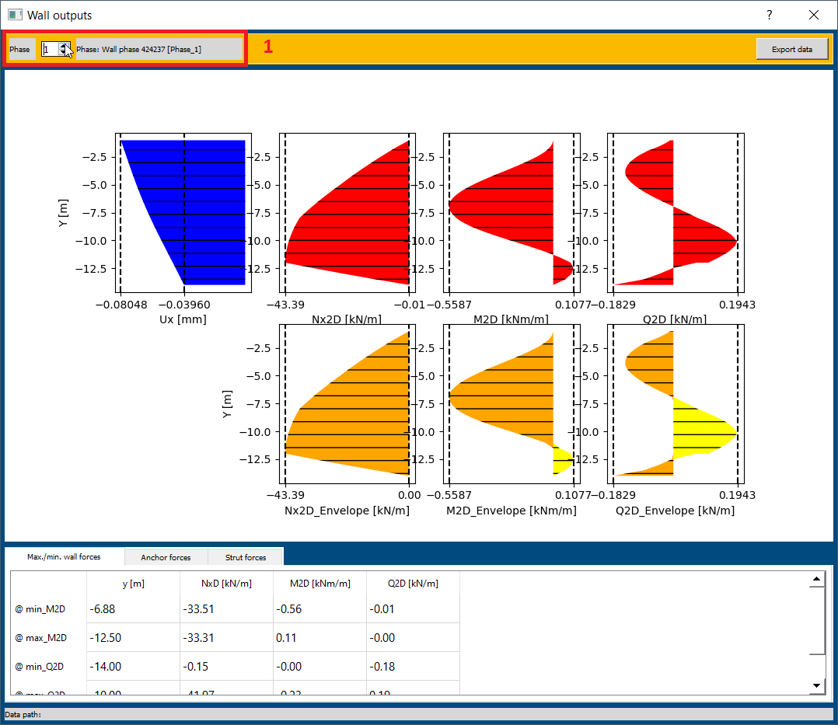*

*(fig 1.22)*

* To generate report, click on *Print report (3 in fig 1.21)* in *Wall outputs.* The pdf file with *Report\_RetainingWall* will be saved in the project folder.