RoadGuard AI Frontend Architecture
Architecture diagram and implementation notes for the current React frontend
This document explains how the RoadGuard AI frontend is structured today. It covers routing, page composition, shared state, browser storage, maps, report actions, and the realistic backend boundary for adding PostgreSQL with PostGIS later.
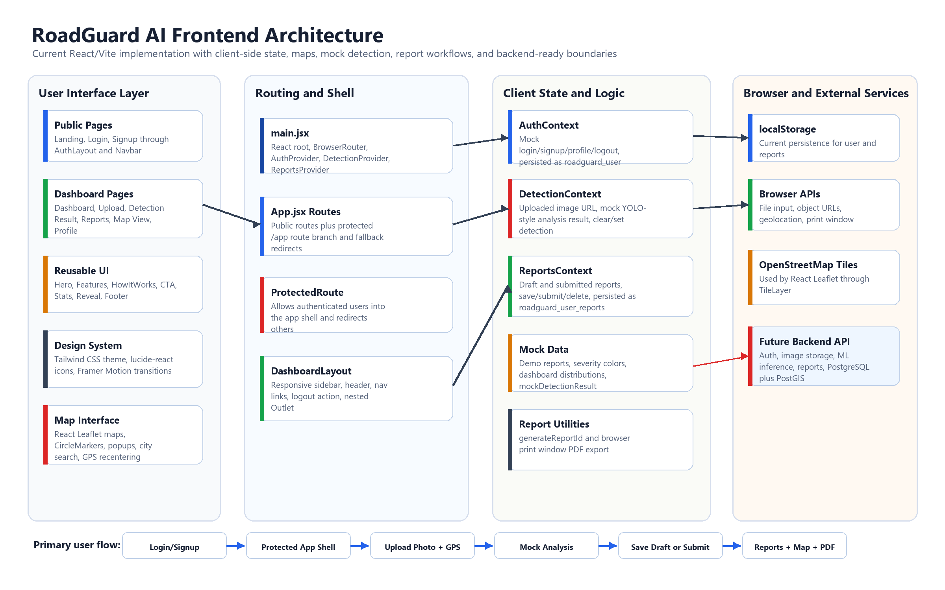

Current Frontend Layers
Layer | Implementation | Responsibility
Application boot | src/main.jsx | Mounts React, enables BrowserRouter, and wraps App with Auth, Detection, and Reports providers.
Routing | src/App.jsx | Defines public routes, protected app routes, nested dashboard routes, and redirects.
Layout shell | DashboardLayout and AuthLayout | Provides dashboard navigation, responsive sidebar, header controls, auth page framing, and nested content outlet.
Feature pages | Dashboard, Upload, DetectionResult, Reports, MapView, Profile | Implements the citizen reporting workflow, map view, profile management, and report browsing.
Shared UI | Hero, Navbar, Footer, CTA, Features, HowItWorks, Stats, Reveal | Supports the landing experience and repeated presentation sections.
Styling and motion | Tailwind CSS, Framer Motion, lucide-react | Controls the visual system, responsive layout, animation, and iconography.

Primary Data Flow
Current flow: A user signs in through the mock AuthContext, enters the protected app shell, uploads or captures a road image, attaches GPS through the browser geolocation API, runs the mock analysis flow, then saves a draft or submits the report through ReportsContext.
Step | Frontend module | State or output
Authenticate | Login.jsx, Signup.jsx, AuthContext | Creates a mock user and persists roadguard_user in localStorage.
Capture evidence | Upload.jsx | Stores a browser object URL for the selected image and requests GPS coordinates.
Analyze | DetectionContext, mockData | Combines mockDetectionResult with image, report id, GPS, severity, score, and priority.
Review result | DetectionResult.jsx | Shows damage overlay, metrics, map pin, and actions for draft, submit, and PDF download.
Persist report | ReportsContext | Stores drafts and submitted reports in roadguard_user_reports in localStorage.
Visualize | Reports.jsx, MapView.jsx, Dashboard.jsx | Merges user reports with mock reports for tables, charts, filters, and Leaflet markers.

State and Persistence
Area | Current frontend source | Current persistence | Backend ready replacement
User session | AuthContext | localStorage key roadguard_user | Real auth session from backend or Supabase Auth.
Detection result | DetectionContext | React state only | ML inference API response linked to uploaded image and report id.
Reports | ReportsContext | localStorage key roadguard_user_reports | Reports table in PostgreSQL with PostGIS geometry for coordinates.
Images | Upload.jsx object URL | Temporary browser object URL | Object storage path plus metadata stored on report record.
Map data | mockReports plus user reports | Bundled mock data and localStorage | API query with geospatial filtering, severity filters, and pagination.
PDF export | reportUtils.downloadReportPDF | Browser print window | Client generated PDF or backend generated official report document.

Backend Integration Boundary
The frontend can keep its current route and page structure when a backend is added. The main change should be replacing context internals with service calls while preserving the page-level API used by the components.
Frontend contract | Future API or service | Why it matters
login, signup, logout, updateProfile | Authentication service | Moves mock auth out of localStorage and enables real identity, roles, and session expiry.
analyzeImage(imageUrl, gps, reportId) | Image upload plus detection inference endpoint | Connects captured road evidence to ML output and permanent storage.
saveDraft, submitReport, deleteReport | Reports API | Allows report lifecycle tracking, moderation, authority review, and multi-device access.
MapView report query | PostgreSQL/PostGIS search endpoint | Supports nearby potholes, bounding box queries, city filters, and severity-based map layers.
downloadReportPDF | Report export endpoint or client PDF renderer | Produces consistent downloadable documents for submitted complaints.

Recommended Frontend Direction
Keep the current React Router structure and provider boundaries because they already match the product workflow. As the project grows, introduce a small services layer between contexts and backend APIs, then migrate localStorage data to PostgreSQL/PostGIS through authenticated endpoints.
For the next version, the most useful frontend change is to create dedicated API modules for auth, reports, detection, uploads, and map queries. That will let the pages stay stable while persistence moves from the browser to the backend.

