Veritas: A Hybrid Transformer and Credibility-Feature Framework for Fake News Detection
NAVEEN ST  Department of Computer Science and Engineering  Rajalakshmi Engineering College  Chennai, Tamil Nadu, India  naveen.st.2024.cse@rajalakshmi.edu.in | RAGAVENDHAN A  Department of Computer Science and Engineering  Rajalakshmi Engineering College  Chennai, Tamil Nadu, India  ragavendhan.a.2024.cse@rajalakshmi.edu.in
Abstract—Online platforms distribute news at a speed that exceeds manual verification, and misleading articles frequently resemble legitimate reporting in vocabulary, structure, and presentation. Detection systems that rely on a single lexical classifier therefore return opaque scores that are difficult to audit. This paper presents Veritas, a hybrid fake news detection architecture that treats classification as a two-phase decision pipeline. First, deterministic validity gates evaluate language, minimum content length, and text extractability before any model is invoked. Second, admissible articles are scored by a fine-tuned transformer encoder whose output is fused with interpretable linguistic indicators, source-reputation evidence, and cross-source corroboration through a weighted function. A calibrated confidence band routes uncertain articles to human review instead of forcing a binary verdict. The platform is organized as a React client, a FastAPI inference service, PyTorch and Hugging Face Transformers, and a PostgreSQL audit store. The design offers explainable outcomes, bounded input handling, and linear preprocessing cost. The paper also identifies limitations of text-only evidence and outlines multimodal and propagation-aware extensions.
Keywords—fake news detection, misinformation, transformer, RoBERTa, linguistic features, explainable AI, text classification

I. INTRODUCTION
Social media and messaging platforms allow an article to reach millions of readers within hours. Fact-checking organizations cannot review every claim at that rate, and readers must decide quickly whether a headline deserves trust. Conventional automated approaches treat the task as plain text classification: an article is converted to a bag of words, a classifier returns a label, and the reasoning remains hidden. Such a process is brittle because deceptive articles often imitate the tone of genuine journalism, while genuine breaking news may contain emotional language that resembles sensational content.
The resulting ambiguity produces two costs. First, a model may be applied to inputs that carry no usable signal, such as empty pages, navigation text, or unsupported languages, producing confident but meaningless outputs. Second, users receive a single probability without any indication of which evidence produced it. Veritas reframes the activity as staged evidence evaluation. It distinguishes admissibility from classification: an article enters the scoring stage only when mandatory input predicates hold, and is scored only after that decision.
The principal contributions are a finite-domain data model, a deterministic validity filter, a fused scoring function combining neural and interpretable evidence, and a server-side architecture that keeps model access behind authenticated boundaries. The work draws on fake news survey literature [1], [7] and pretrained language representations [2], [5], [6].

II. SYSTEM ARCHITECTURE

A. Layered Application Topology
Veritas separates presentation, orchestration, and inference. A React client collects the article text or URL and renders the verdict, while a FastAPI service owns all model access, preprocessing, and persistence. Model weights, API credentials, and source-reputation lists remain on the server and are never delivered to the browser. This separation keeps the decision logic auditable and allows the inference service to scale independently of the interface [8].
Each request is authenticated, its payload is validated against a typed schema, and the article is passed to the pipeline. Results, confidence values, and explanation features are written to a PostgreSQL audit store so that a verdict can be reproduced and reviewed. Administrative operations such as model replacement use a separate privileged path.

B. Inference Serving Path
A request flows from the browser to the authenticated gateway, then to the validity gates, the fusion scorer, and the response builder, as shown in Fig. 1. The transformer is loaded once per worker process and executed in batched, evaluation-only mode, which avoids repeated initialization cost. This path centralizes authorization and prevents the client from invoking the model or modifying stored results directly.
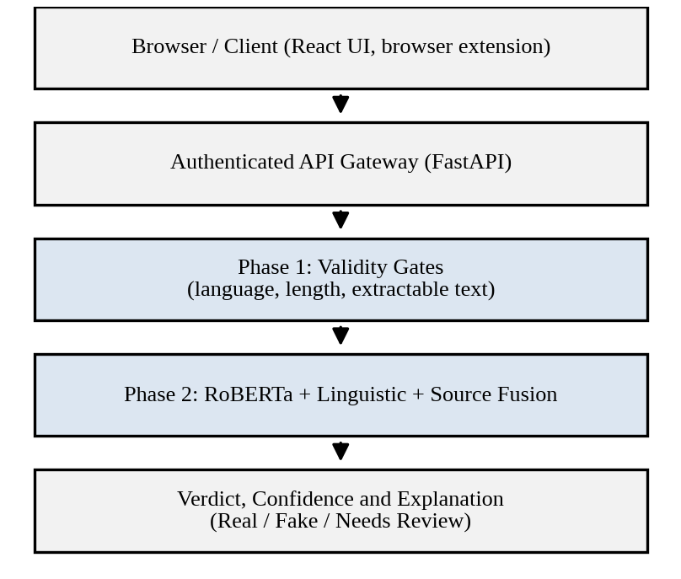
Fig. 1. Proposed Veritas request flow and two-phase decision pipeline.

III. DATA MODELING AND FINITE DOMAINS
A finite domain makes a comparison meaningful before it is executed. Veritas defines the verdict label as a closed enumeration containing REAL, FAKE, and NEEDS_REVIEW, and the language field as a closed set of supported codes. The token count is a bounded integer, and the source domain is mapped to an ordered reputation tier: UNKNOWN, LOW, MEDIUM, or HIGH. A stored record contains the article text hash, detected language, token count, source tier, component scores, final score, and verdict.
TABLE I
FINITE DOMAINS USED BY THE DETECTOR
Attribute | Domain representation | Decision use
Language | Closed set (ISO 639-1) | Validity gate
Token count | Bounded integer | Validity gate
Verdict label | Closed enum | Output class
Text embedding | Dense vector, 768-d | Transformer score
Source domain | Reputation tier | Source score
Enumerations prevent a value such as “fake”, “Fake News”, and “misleading” from silently becoming distinct categories in the audit store. They do not eliminate semantic work: the boundary between satire, opinion, and deliberate fabrication remains contested, and the label set is therefore kept deliberately small. A uniqueness constraint on the text hash additionally prevents duplicate submissions from distorting statistics.

IV. THE DETECTION ALGORITHM

A. Hard Validity Gates
Let d be a submitted article and let G denote the set of mandatory predicates. An article is admissible only when its detected language belongs to the supported set, its token count lies between a minimum length and the encoder limit of 512 tokens, and its text can be extracted without markup residue. Each predicate is evaluated once per article using constant-time categorical or integer comparisons, so preprocessing is linear in the article length.
Articles that fail a predicate are not scored. They receive an explicit reason, such as insufficient content or unsupported language, which converts a vague failure into a deterministic and explainable outcome. Over-long articles are truncated by a head-and-tail strategy that retains the headline and the concluding paragraphs.

B. Fused Scoring and Abstention
For each admissible article, the fine-tuned encoder produces a fake-class probability Pₜ(d). Interpretable evidence is added through three bounded components: a source-risk value S(d) derived from the reputation tier, a linguistic-risk value L(d) built from indicators such as sensational punctuation, clickbait phrasing, and all-capital ratio, and a corroboration-risk value C(d) that grows when no independent source reports the claim. All components lie in the closed interval from zero to one.
Score(d) = αPₜ(d) + βS(d) + γL(d) + δC(d) (1)
The weights α, β, γ, and δ are nonnegative and sum to one, with α receiving the largest share. Two thresholds τₗ and τᵤ partition the score: values below τₗ are labeled REAL, values above τᵤ are labeled FAKE, and values between them are labeled NEEDS_REVIEW and routed to a human reviewer. Model quality is reported with precision P, recall R, and the F1 measure.
F1 = 2PR / (P + R) (2)
If n is the token count, transformer self-attention requires O(n²d) work for hidden size d, which is bounded because n is capped at 512. The linguistic and source components are O(n) and O(1), respectively. The two-phase design prevents a high neural probability from being produced for an input that lacks any usable content.

V. IMPLEMENTATION AND EVALUATION
The encoder is a RoBERTa-base model [6] fine-tuned with PyTorch and the Hugging Face Transformers library, using a cross-entropy objective, AdamW optimization, and early stopping on validation F1. A TF-IDF with logistic regression baseline [8], [9] is retained for comparison because it is fast and inspectable. Experiments are planned on the LIAR [3], FakeNewsNet [4], and ISOT collections, with stratified train, validation, and test partitions and source-disjoint splits to reduce publisher leakage.
Authentication uses token-based sessions in which a token is treated as evidence of authenticated state rather than unrestricted authority. Every mutation is validated server-side, secrets are held in environment variables, and dependency versions are locked. Calibration is checked with reliability curves, and the thresholds τₗ and τᵤ are chosen on the validation partition to meet a target precision for the FAKE class.

VI. DISCUSSION AND LIMITATIONS
Finite domains permit O(1) categorical verification and make the pipeline explainable: a submitter can be told whether language, length, source tier, or model confidence determined the outcome. The abstention band is especially suitable for misinformation work because a wrongly confident FAKE label can suppress legitimate reporting, while a human-reviewed uncertain case carries lower risk.
The same structure introduces rigidity. Pretrained encoders inherit the topical and temporal bias of their training data, so performance may decline on events that appear after fine-tuning. Text-only evidence cannot verify a claim against the world, and source reputation lists require maintenance. Linguistic indicators may also penalize non-native writing styles unfairly. These limitations motivate human confirmation and later evidence stages rather than hidden automated rejection.

VII. CONCLUSION AND FUTURE WORK
Veritas defines a practical algorithmic basis for fake news detection. Finite domains convert ambiguous input into comparable state; deterministic gates identify admissible articles; and fused scoring orders them without obscuring uncertainty. The architecture combines a React client, FastAPI inference, a fine-tuned transformer, and an audited PostgreSQL store so that data access and decisions remain server controlled.
Future work will add claim-level retrieval against fact-checking databases, multilingual encoders, and image-text consistency analysis for multimodal posts. Propagation-aware features derived from sharing behavior [10] may further improve early detection, and active learning will route reviewer decisions back into training.

ACKNOWLEDGMENT
The authors thank the Department of Computer Science and Engineering, Rajalakshmi Engineering College, for academic guidance and infrastructure support.

REFERENCES
[1] K. Shu, A. Sliva, S. Wang, J. Tang, and H. Liu, “Fake news detection on social media: A data mining perspective,” ACM SIGKDD Explorations Newsletter, vol. 19, no. 1, pp. 22–36, 2017.
[2] J. Devlin, M.-W. Chang, K. Lee, and K. Toutanova, “BERT: Pre-training of deep bidirectional transformers for language understanding,” in Proc. NAACL-HLT, 2019, pp. 4171–4186.
[3] W. Y. Wang, “‘Liar, liar pants on fire’: A new benchmark dataset for fake news detection,” in Proc. 55th Annu. Meeting Assoc. Comput. Linguistics (ACL), 2017, pp. 422–426.
[4] K. Shu, D. Mahudeswaran, S. Wang, D. Lee, and H. Liu, “FakeNewsNet: A data repository with news content, social context, and spatiotemporal information for studying fake news on social media,” Big Data, vol. 8, no. 3, pp. 171–188, 2020.
[5] A. Vaswani et al., “Attention is all you need,” in Proc. Adv. Neural Inf. Process. Syst. (NIPS), 2017, pp. 5998–6008.
[6] Y. Liu et al., “RoBERTa: A robustly optimized BERT pretraining approach,” arXiv:1907.11692, 2019.
[7] X. Zhou and R. Zafarani, “A survey of fake news: Fundamental theories, detection methods, and opportunities,” ACM Comput. Surv., vol. 53, no. 5, pp. 1–40, 2020.
[8] H. Ahmed, I. Traore, and S. Saad, “Detection of online fake news using N-gram analysis and machine learning techniques,” in Proc. ISDDC, 2017, pp. 127–138.
[9] F. Pedregosa et al., “Scikit-learn: Machine learning in Python,” J. Mach. Learn. Res., vol. 12, pp. 2825–2830, 2011.
[10] S. Vosoughi, D. Roy, and S. Aral, “The spread of true and false news online,” Science, vol. 359, no. 6380, pp. 1146–1151, 2018.

