Department of Computer Science and Engineering
KPR Institute of Engineering and Technology

B.E. - Computer Science and Engineering
Laboratory Record
U21CS504
Web Technologies Laboratory
Regulation 2021
Nov / Dec 2026

Department of Computer Science and Engineering
KPR Institute of Engineering and Technology
Name | : | ___________________________
Roll Number | : | ___________________________
Subject Code & Title | : | U21CS504 - Web Technologies Laboratory
Department | : | Computer Science and Engineering
Year & Semester | : | III Year / VI Semester

This is the certified record of work done by ____________________________________________
Register Number ________________________________________________________

Faculty In-Charge | Head of the Department

Place: Coimbatore
Date: ____________
He/ She has submitted the record for the End Semester Practical Examination held on ______________________

Internal Examiner | External Examiner

List of Experiments
Expr. No. | Name of the Experiments | Page No. | Marks (20) | Faculty Sign
1. | Static web page design using HTML and CSS
2. | BMI Calculator using JavaScript
3. | User registration form validation using JavaScript
4. | Implementing web applications with API calls using JavaScript
5. | Event registration form using PHP and MySQL
6. | Web application for food delivery system using PHP and MySQL
7. | Web application for leave management using Servlet and MySQL
8. | Web application for online shopping using Servlet and MySQL
9. | Mini Project: RentEase - Rental Property Management System

Rubrics for Laboratory Experiments
Criteria / Points | Strongly Acceptable (4) | Acceptable (3) | Considerable (2) | Below Expectations (1) | Unacceptable (0)
Understanding the Problem Statement | The procedure is explained and the problem is well designed with appropriate analysis | Some programs are written accurately | Major errors in program writing | Programs are not written / wrong program written | Programs are not written / wrong program written
Completion of target in Lab | 100% target completed | 80% target completed | 70% target completed | 50% target completed | 25% target completed
User Interface Design | Well designed problem with appropriate analysis | Designed the problem with analysis | Missing some experimental procedure with partial analysis | Missing major experimental details and analysis | Could not explain the program
Development / Implement | Optimal solution with appropriate results | 80% of implementation done | 65% of implementation done | Few procedures were explained | No proper explanation on implementation
Innovation | Most of the innovations applied clearly | Some of the innovations applied | Few innovations applied clearly | Innovations applied | None of the innovations used

Ex No: 01 08/07/2026
Static web page design using HTML and CSS
AIM:
To design and develop a multi-page static website using HTML5 and CSS3, covering a common navigation bar, semantic sectioning, tables, forms, images and responsive styling.
PROCEDURE:
1. Create a project folder named RentEase inside the web root.
2. Create the files index.html, about.html, properties.html, contact.html and css/style.css.
3. Declare the document type, language and character set in every page.
4. Build a shared navigation bar with <nav> and <a> so every page links to the others.
5. Design the home page with a banner image, an introduction and a list of highlights.
6. Design the about page with the organisation profile, vision, mission and objectives.
7. Design the properties page with a price table and listing cards.
8. Design the contact page with an address block and a contact form.
9. Apply CSS for colour, typography, spacing, borders, box shadows and hover effects.
10. Make the layout responsive with media queries and flexible grid columns.
11. Open index.html in a browser and verify links, images and styling.
HTML ELEMENTS USED:
<!DOCTYPE html>, <html>, <head>, <meta>, <title>, <link>, <body>, <header>, <nav>, <main>, <section>, <article>, <footer>, <div>, <h1>-<h6>, <p>, <ul>, <ol>, <li>, <a>, <img>, <table>, <tr>, <th>, <td>, <form>, <label>, <input>, <textarea>, <button>
CSS PROPERTIES USED:
font-family, font-size, color, background-color, margin, padding, max-width, display, flex, grid, gap, text-align, text-decoration, border, border-radius, box-shadow, transition, hover, media queries, CSS custom properties (--var).
CODE:
<!DOCTYPE html>
<html lang="en">
<head>
<meta charset="UTF-8">
<meta name="viewport" content="width=device-width, initial-scale=1">
<title>RentEase - Find your next home</title>
<link rel="stylesheet" href="assets/css/style.css">
</head>
<body>
<header class="site-header">
<div class="wrap header-inner">
<a class="brand" href="index.php">RentEase</a>
<nav class="site-nav">
<a href="index.php">Home</a>
<a href="properties.php">Properties</a>
<a href="login.php">Login</a>
</nav>
</div>
</header>
<section class="hero">
<div class="wrap">
<h1>Rent smarter. Live better.</h1>
<p class="lead">Search listings, apply online, pay rent and track
maintenance complaints in one place.</p>
</div>
</section>
<footer class="site-footer">
<div class="wrap">
<p>&copy; 2026 RentEase. All rights reserved.</p>
</div>
</footer>
</body>
</html>
KEY CSS:
:root{
--brand:#0f766e;
--line:#dfe6ee;
--radius:14px;
}
.header-inner{
display:flex;
align-items:center;
justify-content:space-between;
min-height:66px;
}
.site-nav{display:flex;gap:1.4rem}
.site-nav a{color:#4b6076;text-decoration:none}
.site-nav a:hover{color:var(--brand)}
.cards{
display:grid;
grid-template-columns:repeat(auto-fill,minmax(280px,1fr));
gap:1.2rem;
}
@media (max-width:700px){
.site-nav{flex-direction:column}
}
OUTPUT:
The home page renders with a fixed header, a full-width hero banner, a highlight strip and a three-column feature grid. On a 700 px viewport the columns collapse to a single column and the navigation stacks vertically.
RESULT:
Thus the static web pages were designed using HTML5 and CSS3 and were verified in the browser.
RUBRICS :
Rubrics | Actual Marks | Awarded Marks
Understanding (R1) | 4
Timeline (R2) | 4
Design (R3) | 4
Development (R4) | 4
Innovation (R5) | 4
Total Marks | 20

Ex No: 02 15/07/2026
BMI Calculator using JavaScript
AIM:
To design a Body Mass Index calculator using HTML, CSS and JavaScript that reads height and weight, computes the BMI value, classifies the result and validates the input.
PROCEDURE:
1. Create the files bmi.html and bmi.css.
2. Build a form with height (cm) and weight (kg) number inputs and a Calculate button.
3. Add a result panel that stays hidden until a valid calculation runs.
4. Attach a submit handler to the form and call preventDefault().
5. Read both values with parseFloat() and reject empty or non-numeric input.
6. Convert height from centimetres to metres and compute weight / height².
7. Round the result to one decimal place with toFixed(1).
8. Classify the value into Underweight, Normal, Overweight or Obese using standard cut-offs.
9. Write the value and the category into the result panel and colour-code the category.
10. Test with boundary inputs, zero, negative values and non-numeric text.
JAVASCRIPT FEATURES USED:
addEventListener, preventDefault, parseFloat, isNaN, toFixed, template literals, classList, textContent, conditional (ternary) expressions.
CODE:
<!DOCTYPE html>
<html lang="en">
<head>
<meta charset="UTF-8">
<title>BMI Calculator</title>
<link rel="stylesheet" href="bmi.css">
</head>
<body>
<div class="card">
<h1>BMI Calculator</h1>
<form id="bmiForm">
<label for="height">Height (cm)</label>
<input type="number" id="height" min="50" max="250" step="0.1" required>
<label for="weight">Weight (kg)</label>
<input type="number" id="weight" min="10" max="300" step="0.1" required>
<button type="submit">Calculate</button>
</form>
<div id="result" class="result hidden"></div>
</div>
<script src="bmi.js"></script>
</body>
</html>
const form = document.getElementById('bmiForm');
const result = document.getElementById('result');
form.addEventListener('submit', function (event) {
event.preventDefault();
const heightCm = parseFloat(document.getElementById('height').value);
const weightKg = parseFloat(document.getElementById('weight').value);
if (isNaN(heightCm) || isNaN(weightKg) || heightCm <= 0 || weightKg <= 0) {
result.textContent = 'Please enter valid positive numbers.';
result.className = 'result error';
return;
}
const heightM = heightCm / 100;
const bmi = weightKg / (heightM * heightM);
let category, colour;
if (bmi < 18.5) {
category = 'Underweight'; colour = '#0369a1';
} else if (bmi < 25) {
category = 'Normal'; colour = '#15803d';
} else if (bmi < 30) {
category = 'Overweight'; colour = '#b45309';
} else {
category = 'Obese'; colour = '#b91c1c';
}
result.innerHTML =
`<strong>Your BMI is ${bmi.toFixed(1)}</strong><br>` +
`<span style="color:${colour}">Category: ${category}</span>`;
result.className = 'result';
});
OUTPUT:
For a height of 172 cm and a weight of 68 kg the calculator reports BMI 23.0 and the category Normal. Entering a zero or blank value shows the validation message instead of a result.
RESULT:
Thus the BMI calculator was designed using HTML, CSS and JavaScript and the computed value and category were verified for several inputs.
RUBRICS :
Rubrics | Actual Marks | Awarded Marks
Understanding (R1) | 4
Timeline (R2) | 4
Design (R3) | 4
Development (R4) | 4
Innovation (R5) | 4
Total Marks | 20

Ex No: 03 22/07/2026
User registration form validation using JavaScript
AIM:
To design a user registration form and validate every field on the client side using JavaScript regular expressions before the form is submitted.
PROCEDURE:
1. Create register.html, register.css and validate.js.
2. Build the form with name, email, mobile, password, confirm password and gender fields.
3. Reserve an inline error span under each field (<span data-error-for=...>).
4. Attach an input listener to each field so the error clears as the user types.
5. Write a rule table mapping each field name to a validation function.
6. Validate the name length, the email pattern, the ten-digit mobile number, the password strength and the confirm-password match.
7. On submit, run every rule, show the first error and focus that field.
8. Call event.preventDefault() when any rule fails so nothing is posted.
9. Re-check the rules on the server as well, since client checks can be bypassed.
10. Test with a valid record, an invalid email, a nine-digit mobile and mismatched passwords.
JAVASCRIPT FEATURES USED:
Regular expressions, addEventListener, querySelectorAll, classList, textContent, focus, event.preventDefault, form dataset attributes.
CODE:
const rules = {
full_name: v => v.trim().length >= 3
|| 'Enter your full name (min 3 characters)',
email: v => /^[^\s@]+@[^\s@]+\.[a-z]{2,}$/i.test(v.trim())
|| 'Enter a valid email address',
phone: v => /^[6-9]\d{9}$/.test(v.trim())
|| 'Enter a valid 10-digit mobile number',
password: v => v.length >= 8
|| 'Password must be at least 8 characters',
confirm: v => v === document.getElementById('password').value
|| 'Passwords do not match'
};
document.querySelectorAll('form[data-validate]').forEach(function (form) {
form.addEventListener('submit', function (event) {
let firstBad = null;
form.querySelectorAll('input, select, textarea').forEach(function (field) {
const rule = rules[field.name];
const msgBox = form.querySelector(
'[data-error-for="' + field.name + '"]');
if (!rule) return;
const result = rule(field.value);
const ok = result === true;
field.classList.toggle('invalid', !ok);
if (msgBox) {
msgBox.textContent = ok ? '' : result;
msgBox.style.display = ok ? 'none' : 'block';
}
if (!ok && !firstBad) firstBad = field;
});
if (firstBad) {
event.preventDefault();
firstBad.focus();
}
});
});
SERVER-SIDE RE-CHECK:
if (mb_strlen($name) < 3) {
$errors['full_name'] = 'Enter your full name (minimum 3 characters).';
}
if (!filter_var($email, FILTER_VALIDATE_EMAIL)) {
$errors['email'] = 'Enter a valid email address.';
}
if (!preg_match('/^[6-9]\d{9}$/', $phone)) {
$errors['phone'] = 'Enter a valid 10-digit Indian mobile number.';
}
if (strlen($pass) < 8) {
$errors['password'] = 'Password must be at least 8 characters.';
} elseif ($pass !== $confirm) {
$errors['confirm'] = 'Passwords do not match.';
}
OUTPUT:
A valid submission proceeds to the server. An invalid email, a nine-digit mobile number or a mismatched password prefixes the field with a red message and the form does not submit.
RESULT:
Thus the user registration form was designed and validated on the client side with JavaScript and re-validated on the server with PHP.
RUBRICS :
Rubrics | Actual Marks | Awarded Marks
Understanding (R1) | 4
Timeline (R2) | 4
Design (R3) | 4
Development (R4) | 4
Innovation (R5) | 4
Total Marks | 20

Ex No: 04 29/07/2026
Implementing web applications with API calls using JavaScript
AIM:
To build a web page that fetches data from a remote REST API with the Fetch API, renders the response dynamically and handles loading and error states.
PROCEDURE:
1. Create api.html, api.css and api.js.
2. Add a search box, a category selector and a results container.
3. Use fetch() with the async/await syntax to call the JSON endpoint.
4. Show a loading indicator before the request and hide it on completion.
5. Check response.ok and throw an Error carrying the HTTP status on failure.
6. Parse the body with response.json() and render one card per record.
7. Wrap the call in try/catch/finally so network failures show a friendly message.
8. Debounce the search input so the API is not called on every keystroke.
9. Use AbortController to cancel an in-flight request when a new one starts.
10. Verify behaviour with a valid query, an empty query and the network switched off.
JAVASCRIPT FEATURES USED:
fetch, async/await, Promises, response.json, AbortController, try/catch/finally, template literals, Array.map, debouncing with setTimeout.
CODE:
const list = document.getElementById('list');
const status = document.getElementById('status');
const search = document.getElementById('search');
let controller = null;
async function loadProperties(query = '') {
// cancel any request still in flight
if (controller) controller.abort();
controller = new AbortController();
status.textContent = 'Loading...';
try {
const res = await fetch(
'api/properties.php?q=' + encodeURIComponent(query),
{ signal: controller.signal }
);
if (!res.ok) {
throw new Error('Request failed: ' + res.status);
}
const data = await res.json();
if (!data.length) {
list.innerHTML = '<p class="empty">No properties matched.</p>';
status.textContent = '';
return;
}
list.innerHTML = data.map(p => `
<article class="card">
<h3>${p.title}</h3>
<p>${p.locality}, ${p.city}</p>
<p class="rent">Rs. ${Number(p.rent_amount).toLocaleString('en-IN')}/mo</p>
</article>
`).join('');
status.textContent = data.length + ' properties loaded';
} catch (err) {
if (err.name === 'AbortError') return;
status.textContent = 'Could not load properties. ' + err.message;
}
}
let timer;
search.addEventListener('input', function () {
clearTimeout(timer);
timer = setTimeout(() => loadProperties(this.value), 300);
});
loadProperties();
JSON ENDPOINT:
<?php
// api/properties.php - returns JSON instead of HTML
require_once __DIR__ . '/../includes/functions.php';
header('Content-Type: application/json; charset=utf-8');
$q = trim($_GET['q'] ?? '');
$stmt = db()->prepare(
'SELECT property_id, title, city, locality, rent_amount, bhk
FROM properties
WHERE status = "available" AND title LIKE ?
ORDER BY created_at DESC'
);
$stmt->execute(['%' . $q . '%']);
echo json_encode($stmt->fetchAll(), JSON_UNESCAPED_UNICODE);
OUTPUT:
The page lists properties as cards. Typing in the search box refreshes the list after a 300 ms debounce. Stopping the server shows the error message instead of an empty page.
RESULT:
Thus a web application consuming a REST endpoint with the Fetch API was implemented and the success, empty and error states were verified.
RUBRICS :
Rubrics | Actual Marks | Awarded Marks
Understanding (R1) | 4
Timeline (R2) | 4
Design (R3) | 4
Development (R4) | 4
Innovation (R5) | 4
Total Marks | 20

Ex No: 05 05/08/2026
Event registration form using PHP and MySQL
AIM:
To design a database-driven event registration form using HTML, PHP and MySQL that stores participant details, rejects duplicate emails and lists all registered participants.
PROCEDURE:
1. Start Apache and MySQL from the XAMPP control panel.
2. Create the database event_management and the table event_registrations.
3. Create db.php to open a MySQLi connection and set the charset to utf8mb4.
4. Design index.php with the participant name, email, mobile, institution, event name, category, number of participants and registration date.
5. Submit the form to register.php using the POST method.
6. Validate the input on the server: required fields, email format, mobile pattern.
7. Check for an existing row with the same email before inserting.
8. Insert the record with a prepared statement.
9. Show a confirmation message, or the validation errors, on the same page.
10. List every registration in participants.php with a SELECT query.
11. Test with valid data, a bad email, an empty field and a duplicate email.
DATABASE:
CREATE DATABASE IF NOT EXISTS event_management;
USE event_management;
CREATE TABLE IF NOT EXISTS event_registrations (
registration_id INT AUTO_INCREMENT PRIMARY KEY,
participant_name VARCHAR(100) NOT NULL,
email VARCHAR(150) NOT NULL UNIQUE,
mobile VARCHAR(15) NOT NULL,
institution VARCHAR(150) NOT NULL,
event_name VARCHAR(150) NOT NULL,
category VARCHAR(50) NOT NULL,
participants INT NOT NULL,
registration_date DATE NOT NULL
);
DB.PHP:
<?php
$host = "localhost";
$user = "root";
$password = "YOUR_MYSQL_PASSWORD";
$database = "event_management";
$conn = new mysqli($host, $user, $password, $database);
if ($conn->connect_error) {
error_log($conn->connect_error);
die("Database connection failed.");
}
$conn->set_charset("utf8mb4");
?>
REGISTER.PHP:
<?php
require_once 'db.php';
$errors = [];
$done = false;
if ($_SERVER['REQUEST_METHOD'] === 'POST') {
$name = trim($_POST['participant_name'] ?? '');
$mail = trim($_POST['email'] ?? '');
$mob = trim($_POST['mobile'] ?? '');
$inst = trim($_POST['institution'] ?? '');
$evnt = trim($_POST['event_name'] ?? '');
$cat = $_POST['category'] ?? '';
$pax = (int) ($_POST['participants'] ?? 0);
$date = $_POST['registration_date'] ?? '';
if ($name === '') $errors[] = 'Name is required.';
if (!filter_var($mail, FILTER_VALIDATE_EMAIL)) $errors[] = 'Invalid email address.';
if (!preg_match('/^[6-9]\d{9}$/', $mob)) $errors[] = 'Invalid mobile number.';
if ($pax < 1) $errors[] = 'Participants must be at least 1.';
if ($date === '') $errors[] = 'Registration date is required.';
if (!$errors) {
$check = $conn->prepare('SELECT registration_id FROM event_registrations WHERE email = ?');
$check->bind_param('s', $mail);
$check->execute();
if ($check->get_result()->fetch()) {
$errors[] = 'This email is already registered.';
}
}
if (!$errors) {
$sql = 'INSERT INTO event_registrations
(participant_name, email, mobile, institution,
event_name, category, participants, registration_date)
VALUES (?, ?, ?, ?, ?, ?, ?, ?)';
$stmt = $conn->prepare($sql);
$stmt->bind_param('ssssssis', $name, $mail, $mob, $inst,
$evnt, $cat, $pax, $date);
$stmt->execute();
$done = true;
}
}
?>
OUTPUT:
A valid registration shows a confirmation panel and the record appears in participants.php. A duplicate email is refused with the message "This email is already registered."
RESULT:
Thus the event registration form was developed using HTML, PHP and MySQL and duplicate registration was prevented with a unique email constraint.
RUBRICS :
Rubrics | Actual Marks | Awarded Marks
Understanding (R1) | 4
Timeline (R2) | 4
Design (R3) | 4
Development (R4) | 4
Innovation (R5) | 4
Total Marks | 20

Ex No: 06 19/08/2026
Web application for food delivery system using PHP and MySQL
AIM:
To design a food delivery web application using PHP and MySQL where a user registers, logs in, browses the menu, places an order and receives an order confirmation, and an administrator manages the menu and order status.
PROCEDURE:
1. Create the project folder food-delivery inside htdocs and start Apache and MySQL.
2. Create the database food_delivery with the tables users, food_items, orders and order_items.
3. Write db.php to connect PHP to MySQL over MySQLi.
4. Build register.php and login.php with password_hash() and password_verify().
5. Build menu.php to read food_items and render one card per item.
6. Let the user set a quantity and add items to a session cart.
7. Collect the customer name, mobile number and delivery address at checkout.
8. Compute the total, insert the order and its line items in a transaction.
9. Show an order confirmation with the order id, items, total and status.
10. Build admin.php to add or remove items and advance the order status.
11. Test registration, login, ordering and the admin operations.
DATABASE:
CREATE DATABASE IF NOT EXISTS food_delivery;
USE food_delivery;
CREATE TABLE users (
user_id INT AUTO_INCREMENT PRIMARY KEY,
name VARCHAR(100) NOT NULL,
email VARCHAR(100) UNIQUE NOT NULL,
password VARCHAR(255) NOT NULL,
mobile VARCHAR(15),
address TEXT
);
CREATE TABLE food_items (
item_id INT AUTO_INCREMENT PRIMARY KEY,
name VARCHAR(100) NOT NULL,
price DECIMAL(8,2) NOT NULL,
category VARCHAR(50),
available TINYINT(1) DEFAULT 1
);
CREATE TABLE orders (
order_id INT AUTO_INCREMENT PRIMARY KEY,
user_id INT NOT NULL,
total DECIMAL(10,2) NOT NULL,
address TEXT NOT NULL,
status ENUM('placed','preparing','delivered','cancelled') DEFAULT 'placed',
ordered_on TIMESTAMP DEFAULT CURRENT_TIMESTAMP,
FOREIGN KEY (user_id) REFERENCES users(user_id)
);
CREATE TABLE order_items (
item_id INT NOT NULL,
order_id INT NOT NULL,
qty INT NOT NULL,
price DECIMAL(8,2) NOT NULL,
PRIMARY KEY (item_id, order_id),
FOREIGN KEY (item_id) REFERENCES food_items(item_id),
FOREIGN KEY (order_id) REFERENCES orders(order_id) ON DELETE CASCADE
);
CHECKOUT.PHP (TRANSACTION):
<?php
session_start();
require_once 'db.php';
if (empty($_SESSION['cart'])) {
die('Your cart is empty.');
}
$address = trim($_POST['address'] ?? '');
$total = 0.0;
foreach ($_SESSION['cart'] as $itemId => $qty) {
$stmt = $conn->prepare('SELECT price FROM food_items WHERE item_id = ?');
$stmt->bind_param('i', $itemId);
$stmt->execute();
$row = $stmt->get_result()->fetch_assoc();
$total += $row['price'] * $qty;
}
$conn->begin_transaction();
try {
$ins = $conn->prepare(
'INSERT INTO orders (user_id, total, address) VALUES (?, ?, ?)');
$ins->bind_param('ids', $_SESSION['user_id'], $total, $address);
$ins->execute();
$orderId = $conn->insert_id;
$line = $conn->prepare(
'INSERT INTO order_items (order_id, item_id, qty, price)
VALUES (?, ?, ?, ?)');
foreach ($_SESSION['cart'] as $itemId => $qty) {
$price = /* current price from food_items */ 0;
$line->bind_param('iiid', $orderId, $itemId, $qty, $price);
$line->execute();
}
$conn->commit();
$_SESSION['cart'] = [];
header('Location: confirmation.php?order=' . $orderId);
} catch (Throwable $e) {
$conn->rollback();
die('Order could not be placed.');
}
OUTPUT:
The menu lists the available dishes, the cart totals the selected quantities and checkout writes the order and its lines in one transaction. The confirmation page shows the order id and status, which the administrator can advance from Placed to Preparing to Delivered.
RESULT:
Thus the food delivery web application was developed using PHP and MySQL with session-based cart handling and transactional order insertion.
RUBRICS :
Rubrics | Actual Marks | Awarded Marks
Understanding (R1) | 4
Timeline (R2) | 4
Design (R3) | 4
Development (R4) | 4
Innovation (R5) | 4
Total Marks | 20

Ex No: 07 02/09/2026
Web application for leave management using Servlet and MySQL
AIM:
To design a leave management web application using Jakarta Servlets, JSP, JDBC and MySQL in which an employee applies for leave, a manager approves or rejects it, and the leave balance is maintained.
PROCEDURE:
1. Install JDK 17, Apache Maven, MySQL and Apache Tomcat 10.1.
2. Create the database leave_management with employee and leave_request tables.
3. Create a Maven web project and add the Jakarta Servlet and MySQL connector dependencies.
4. Write DB.java to return a JDBC connection from DriverManager.
5. Build login.jsp and a LoginServlet that stores the employee id in the session.
6. Build apply.jsp and an ApplyLeaveServlet that validates and inserts a leave request.
7. Add an AuthFilter that blocks protected URLs when no session exists.
8. Build ListLeaveServlet to show the signed-in employee's requests.
9. Build ApproveLeaveServlet so a manager can approve or reject a pending request.
10. Deduct the approved days from the leave balance inside a transaction.
11. Package with mvn clean package, deploy the WAR on Tomcat and test every workflow.
POM.XML:
<project xmlns="http://maven.apache.org/POM/4.0.0">
<modelVersion>4.0.0</modelVersion>
<groupId>com.leave</groupId>
<artifactId>leave-management</artifactId>
<version>1.0</version>
<packaging>war</packaging>
<properties>
<maven.compiler.release>17</maven.compiler.release>
</properties>
<dependencies>
<dependency>
<groupId>jakarta.servlet</groupId>
<artifactId>jakarta.servlet-api</artifactId>
<version>6.0.0</version>
<scope>provided</scope>
</dependency>
<dependency>
<groupId>com.mysql</groupId>
<artifactId>mysql-connector-j</artifactId>
<version>9.4.0</version>
</dependency>
</dependencies>
<build>
<finalName>leave-management</finalName>
</build>
</project>
DATABASE - LEAVE_MANAGEMENT.SQL:
CREATE DATABASE leave_management;
USE leave_management;
CREATE TABLE employees (
emp_id INT PRIMARY KEY AUTO_INCREMENT,
name VARCHAR(80) NOT NULL,
email VARCHAR(120) NOT NULL UNIQUE,
password VARCHAR(100) NOT NULL,
role ENUM('employee','manager') DEFAULT 'employee',
balance INT DEFAULT 20
);
CREATE TABLE leave_requests (
request_id INT PRIMARY KEY AUTO_INCREMENT,
emp_id INT NOT NULL,
leave_type ENUM('Casual','Sick','Earned') NOT NULL,
from_date DATE NOT NULL,
to_date DATE NOT NULL,
days INT NOT NULL,
reason VARCHAR(255),
status ENUM('pending','approved','rejected') DEFAULT 'pending',
applied_on TIMESTAMP DEFAULT CURRENT_TIMESTAMP,
FOREIGN KEY (emp_id) REFERENCES employees(emp_id)
);
INSERT INTO employees (name, email, password, role, balance)
VALUES ('Pavi', 'pavi@org.in', '1234', 'employee', 20),
('Ravi', 'ravi@org.in', '1234', 'manager', 20);
APPLYLEAVESERVLET.JAVA:
package com.leave;
import jakarta.servlet.*;
import jakarta.servlet.http.*;
import jakarta.servlet.annotation.*;
import java.io.*;
import java.sql.*;
import java.time.*;
import java.time.temporal.ChronoUnit;
@WebServlet("/apply")
public class ApplyLeaveServlet extends HttpServlet {
protected void doPost(HttpServletRequest req,
HttpServletResponse res)
throws ServletException, IOException {
HttpSession session = req.getSession(false);
if (session == null || session.getAttribute("empId") == null) {
res.sendRedirect("login.jsp");
return;
}
int empId = (Integer) session.getAttribute("empId");
String type = req.getParameter("leave_type");
LocalDate from = LocalDate.parse(req.getParameter("from_date"));
LocalDate to = LocalDate.parse(req.getParameter("to_date"));
String reason = req.getParameter("reason");
if (to.isBefore(from)) {
res.getWriter().println("End date must be after the start date.");
return;
}
long days = ChronoUnit.DAYS.between(from, to) + 1;
try (Connection con = DB.getConnection();
PreparedStatement ps = con.prepareStatement(
"INSERT INTO leave_requests " +
"(emp_id, leave_type, from_date, to_date, days, reason) " +
"VALUES (?,?,?,?,?,?)")) {
ps.setInt(1, empId);
ps.setString(2, type);
ps.setDate(3, Date.valueOf(from));
ps.setDate(4, Date.valueOf(to));
ps.setLong(5, days);
ps.setString(6, reason);
ps.executeUpdate();
res.sendRedirect("list");
} catch (Exception e) {
throw new ServletException(e);
}
}
}
APPROVELEAVESERVLET.JAVA:
package com.leave;
import jakarta.servlet.*;
import jakarta.servlet.http.*;
import jakarta.servlet.annotation.*;
import java.io.*;
import java.sql.*;
@WebServlet("/approve")
public class ApproveLeaveServlet extends HttpServlet {
protected void doPost(HttpServletRequest req,
HttpServletResponse res)
throws ServletException, IOException {
int requestId = Integer.parseInt(req.getParameter("request_id"));
String action = req.getParameter("action"); // approve | reject
try (Connection con = DB.getConnection()) {
con.setAutoCommit(false);
try {
PreparedStatement sel = con.prepareStatement(
"SELECT emp_id, days FROM leave_requests " +
"WHERE request_id = ? AND status = 'pending'");
sel.setInt(1, requestId);
ResultSet rs = sel.executeQuery();
if (rs.next()) {
int empId = rs.getInt("emp_id");
int days = rs.getInt("days");
con.prepareStatement(
"UPDATE leave_requests SET status = '" +
("approve".equals(action) ? "approved" : "rejected") +
"' WHERE request_id = " + requestId
).executeUpdate();
if ("approve".equals(action)) {
PreparedStatement bal = con.prepareStatement(
"UPDATE employees SET balance = balance - ? " +
"WHERE emp_id = ?");
bal.setInt(1, days);
bal.setInt(2, empId);
bal.executeUpdate();
}
}
con.commit();
} catch (Exception e) {
con.rollback();
throw e;
}
res.sendRedirect("list");
} catch (Exception e) {
throw new ServletException(e);
}
}
}
OUTPUT:
The employee logs in, applies for three days of casual leave and the request appears as Pending. The manager approves it, the status becomes Approved and the employee's balance drops from 20 to 17.
RESULT:
Thus the leave management web application was developed using Jakarta Servlets, JSP, JDBC and MySQL and the apply and approve workflows were verified on Tomcat.
RUBRICS :
Rubrics | Actual Marks | Awarded Marks
Understanding (R1) | 4
Timeline (R2) | 4
Design (R3) | 4
Development (R4) | 4
Innovation (R5) | 4
Total Marks | 20

Ex No: 08 16/09/2026
Web application for Online Shopping using Servlet and MySQL
AIM:
To design and develop a simple online shopping web application using Java, Jakarta Servlets, JSP, JDBC and MySQL that allows a user to log in, view products, add and remove products in a cart and compute the total price.
PROCEDURE:
1. Install JDK 17, Apache Maven, MySQL and Apache Tomcat 10.1.
2. Create a MySQL database named online_shopping.
3. Create the users and products tables and insert sample records.
4. Create a Maven web application and configure the dependencies in pom.xml.
5. Develop a login page using HTML and JSP.
6. Create a Login Servlet to validate credentials through JDBC.
7. Develop a product dashboard that lists products from MySQL.
8. Implement the shopping cart using an HTTP session.
9. Create a cart page showing the selected products, quantities and total.
10. Apply simple CSS to improve the appearance.
11. Build with mvn clean package and deploy the WAR on Tomcat.
12. Test login, product display, add, remove and the total calculation.
DATABASE - ONLINE_SHOPPING.SQL:
CREATE DATABASE online_shopping;
USE online_shopping;
CREATE TABLE users (
id INT PRIMARY KEY AUTO_INCREMENT,
username VARCHAR(50),
password VARCHAR(50)
);
CREATE TABLE products (
id INT PRIMARY KEY AUTO_INCREMENT,
name VARCHAR(100),
price DOUBLE
);
INSERT INTO users(username, password) VALUES ('pavi', '1234');
INSERT INTO products(name, price) VALUES
('Laptop', 45000),
('Headphones', 1500),
('Keyboard', 800),
('Mouse', 500);
LOGINSERVLET.JAVA:
package com.shop;
import jakarta.servlet.*;
import jakarta.servlet.http.*;
import jakarta.servlet.annotation.*;
import java.io.*;
import java.sql.*;
@WebServlet("/login")
public class LoginServlet extends HttpServlet {
protected void doPost(HttpServletRequest req,
HttpServletResponse res)
throws ServletException, IOException {
String username = req.getParameter("username");
String password = req.getParameter("password");
try (Connection con = DB.getConnection();
PreparedStatement ps = con.prepareStatement(
"SELECT * FROM users WHERE username=? AND password=?")) {
ps.setString(1, username);
ps.setString(2, password);
ResultSet rs = ps.executeQuery();
if (rs.next()) {
HttpSession session = req.getSession();
session.setAttribute("user", username);
res.sendRedirect("products");
} else {
res.getWriter().println("Invalid username or password");
}
} catch (Exception e) {
throw new ServletException(e);
}
}
}
CARTSERVLET.JAVA:
package com.shop;
import jakarta.servlet.*;
import jakarta.servlet.http.*;
import jakarta.servlet.annotation.*;
import java.io.*;
import java.sql.*;
import java.util.*;
@WebServlet("/cart")
public class CartServlet extends HttpServlet {
protected void doPost(HttpServletRequest req,
HttpServletResponse res)
throws IOException {
HttpSession session = req.getSession(false);
if (session == null || session.getAttribute("user") == null) {
res.sendRedirect("login.jsp");
return;
}
Map<Integer, Integer> cart =
(Map<Integer, Integer>) session.getAttribute("cart");
if (cart == null) {
cart = new HashMap<>();
session.setAttribute("cart", cart);
}
int id = Integer.parseInt(req.getParameter("id"));
String action = req.getParameter("action");
if ("add".equals(action)) {
cart.put(id, cart.getOrDefault(id, 0) + 1);
}
if ("remove".equals(action)) {
cart.remove(id);
}
res.sendRedirect("cart");
}
protected void doGet(HttpServletRequest req,
HttpServletResponse res)
throws ServletException, IOException {
HttpSession session = req.getSession(false);
if (session == null || session.getAttribute("user") == null) {
res.sendRedirect("login.jsp");
return;
}
Map<Integer, Integer> cart =
(Map<Integer, Integer>) session.getAttribute("cart");
if (cart == null) cart = new HashMap<>();
StringBuilder rows = new StringBuilder();
double total = 0;
try (Connection con = DB.getConnection();
PreparedStatement ps = con.prepareStatement(
"SELECT * FROM products WHERE id=?")) {
for (int id : cart.keySet()) {
ps.setInt(1, id);
try (ResultSet rs = ps.executeQuery()) {
if (rs.next()) {
String name = rs.getString("name");
double price = rs.getDouble("price");
int qty = cart.get(id);
double sub = price * qty;
total += sub;
rows.append("<tr><td>").append(name)
.append("</td><td>Rs.").append(price)
.append("</td><td>").append(qty)
.append("</td><td>Rs.").append(sub)
.append("</td><td><form method='post' action='cart'>")
.append("<input type='hidden' name='id' value='")
.append(id)
.append("'><button name='action' value='remove'>")
.append("Remove</button></form></td></tr>");
}
}
}
req.setAttribute("rows", rows.toString());
req.setAttribute("total", total);
req.getRequestDispatcher("/cart.jsp").forward(req, res);
} catch (Exception e) {
throw new ServletException(e);
}
}
}
OUTPUT:
After login the product dashboard lists the four products. Adding a laptop and two headphones shows three rows in the cart with the total Rs.48,000. Removing the laptop recalculates the total to Rs.3,000.
RESULT:
Thus the online shopping web application was designed and developed using Java, Jakarta Servlets, JSP, JDBC and MySQL and the login, product display and cart operations were verified on Tomcat.
RUBRICS :
Rubrics | Actual Marks | Awarded Marks
Understanding (R1) | 4
Timeline (R2) | 4
Design (R3) | 4
Development (R4) | 4
Innovation (R5) | 4
Total Marks | 20

Ex No: 09 02/11/2026
Mini Project - RentEase: Rental Property Management System
AIM:
To design and develop a complete rental property management web application, "RentEase", using HTML, CSS, JavaScript, PHP and MySQL that lets property owners publish listings with images and lets tenants search those listings, submit rental applications, record monthly rent payments, raise maintenance complaints, and gives the owner a dashboard to manage the whole portfolio.
OBJECTIVES:
• Provide a searchable, filterable catalogue of rental properties with image galleries.
• Let a tenant apply for a property online and let the owner approve or reject the application.
• Maintain a month-by-month rent payment record against a transaction reference.
• Track maintenance complaints from Open through In-Progress to Resolved.
• Give the owner a single dashboard for listings, applications, rent collected and complaints.
• Enforce role-based access, CSRF protection and prepared statements throughout.
SCOPE OF THE SYSTEM:
Module | Actors | Functions
Authentication | Owner, Tenant | Register, log in, log out, role-based redirection
Property listing | Owner | Add listing, upload cover image, toggle availability
Search & filter | Tenant, Guest | Keyword, city, BHK, type, furnishing, budget, sort, paging
Rental application | Tenant, Owner | Apply with occupation and family size; approve or reject
Rent payment | Tenant, Owner | Record monthly payment, transaction reference, receipt list
Maintenance | Tenant, Owner | Raise complaint, set priority, update status, owner note
Owner dashboard | Owner | Portfolio stats, rent chart, application queue, complaint queue
TECHNOLOGY STACK:
Layer | Technology | Used for
Markup | HTML5 | Semantic header, nav, section, article and footer; forms and tables
Styling | CSS3 | Custom properties, flexbox, grid, media queries, hover states
Behaviour | JavaScript (ES6) | Field validation, live filtering, gallery, rent preview
Server | PHP 8.4 | Session handling, PDO queries, password hashing, file upload
Database | MySQL 9 | Six InnoDB tables, foreign keys, ENUM and unique constraints
SYSTEM ARCHITECTURE:
RentEase follows a three-tier architecture. The browser renders HTML built by PHP and styles it with one stylesheet; the PHP layer authenticates the user, validates the request and talks to MySQL only through PDO prepared statements; the data layer stores six related tables in InnoDB.
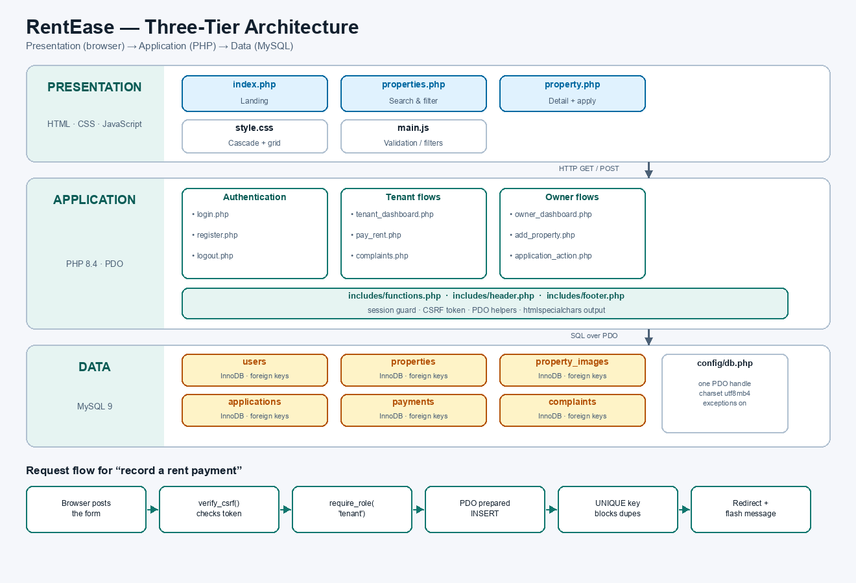
Fig. 9.1 Three-tier architecture of RentEase and the request flow for a rent payment
ENTITY RELATIONSHIP DIAGRAM:
A single users table holds both owners and tenants, distinguished by the role column. One owner has many properties; one property has many images, applications, payments and complaints; a tenant links to properties through applications and payments.
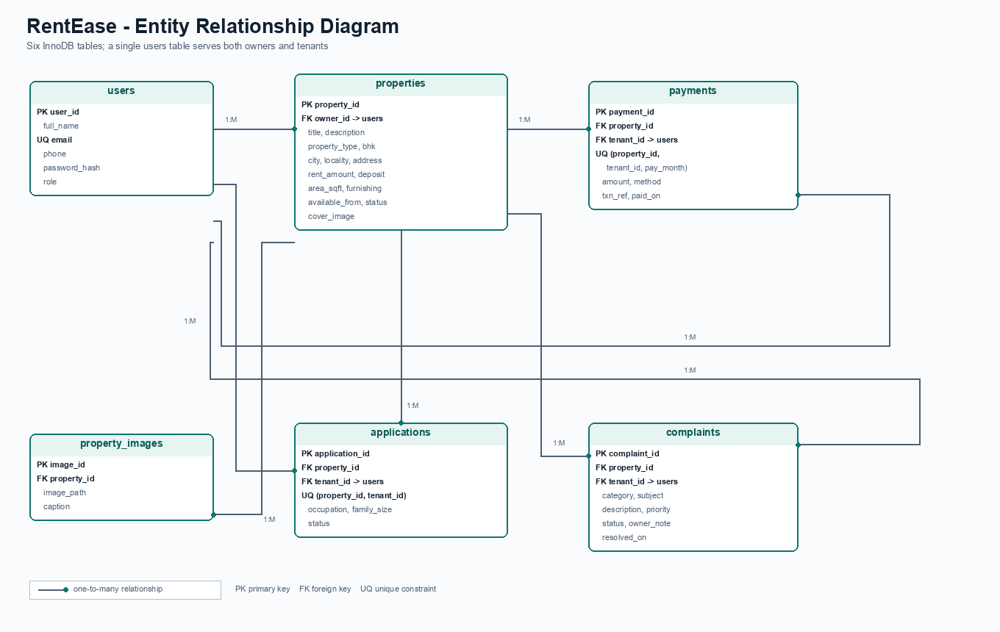
Fig. 9.2 Entity relationship diagram of the rentease database
PROCEDURE:
1. Install PHP 8.4, MySQL 9 and a web browser; XAMPP may be used instead of a native install.
2. Create the project folder RentEase with the subfolders config, includes, assets, database, scripts and screenshots.
3. Create the database rentease and the six tables users, properties, property_images, applications, payments and complaints.
4. Write config/db.php to open one shared PDO connection with exceptions enabled and utf8mb4 as the charset.
5. Write includes/functions.php with the session bootstrap, require_login(), require_role(), the CSRF helpers and the e() output escaper.
6. Build includes/header.php and includes/footer.php so every page shares the same navigation and footer.
7. Design index.php with a hero banner, a quick search form and the featured listings.
8. Design properties.php with keyword, city, BHK, type, furnishing and budget filters built as a dynamically assembled WHERE clause with bound parameters.
9. Design property.php with an image gallery, a specification sheet and the rental application form.
10. Implement register.php and login.php with password_hash(), password_verify() and session_regenerate_id().
11. Implement tenant_dashboard.php, pay_rent.php and complaints.php for the tenant side.
12. Implement owner_dashboard.php, add_property.php, application_action.php, complaint_action.php and property_action.php for the owner side.
13. Write assets/css/style.css and assets/js/main.js for styling and client-side behaviour.
14. Populate the tables with representative demo data from database/rentease.sql.
15. Start the server with php -S 127.0.0.1:8088, exercise every workflow and record the screenshots for this report.
DATABASE - RENTEASE.SQL:
DROP DATABASE IF EXISTS rentease;
CREATE DATABASE rentease
DEFAULT CHARACTER SET utf8mb4
DEFAULT COLLATE utf8mb4_unicode_ci;
USE rentease;
CREATE TABLE users (
user_id INT AUTO_INCREMENT PRIMARY KEY,
full_name VARCHAR(80) NOT NULL,
email VARCHAR(120) NOT NULL UNIQUE,
phone VARCHAR(15) NOT NULL,
password_hash VARCHAR(255) NOT NULL,
role ENUM('owner','tenant') NOT NULL DEFAULT 'tenant',
created_at TIMESTAMP DEFAULT CURRENT_TIMESTAMP
) ENGINE=InnoDB;
CREATE TABLE properties (
property_id INT AUTO_INCREMENT PRIMARY KEY,
owner_id INT NOT NULL,
title VARCHAR(120) NOT NULL,
description TEXT,
property_type ENUM('Apartment','Independent House','Villa',
'PG / Hostel','Studio') NOT NULL,
bhk TINYINT NOT NULL,
city VARCHAR(60) NOT NULL,
locality VARCHAR(80) NOT NULL,
address VARCHAR(200) NOT NULL,
rent_amount DECIMAL(10,2) NOT NULL,
deposit DECIMAL(10,2) NOT NULL DEFAULT 0,
area_sqft INT NOT NULL,
furnishing ENUM('Unfurnished','Semi-Furnished','Fully-Furnished') NOT NULL,
available_from DATE NOT NULL,
status ENUM('available','occupied','inactive') DEFAULT 'available',
cover_image VARCHAR(200),
created_at TIMESTAMP DEFAULT CURRENT_TIMESTAMP,
CONSTRAINT fk_prop_owner FOREIGN KEY (owner_id)
REFERENCES users(user_id) ON DELETE CASCADE,
INDEX idx_city (city), INDEX idx_rent (rent_amount),
INDEX idx_bhk (bhk), INDEX idx_status (status)
) ENGINE=InnoDB;
CREATE TABLE property_images (
image_id INT AUTO_INCREMENT PRIMARY KEY,
property_id INT NOT NULL,
image_path VARCHAR(200) NOT NULL,
caption VARCHAR(120),
CONSTRAINT fk_img_prop FOREIGN KEY (property_id)
REFERENCES properties(property_id) ON DELETE CASCADE
) ENGINE=InnoDB;
CREATE TABLE applications (
application_id INT AUTO_INCREMENT PRIMARY KEY,
property_id INT NOT NULL,
tenant_id INT NOT NULL,
message TEXT,
occupation VARCHAR(60),
family_size TINYINT DEFAULT 1,
applied_on TIMESTAMP DEFAULT CURRENT_TIMESTAMP,
status ENUM('pending','approved','rejected') DEFAULT 'pending',
UNIQUE KEY uq_app (property_id, tenant_id),
CONSTRAINT fk_app_prop FOREIGN KEY (property_id)
REFERENCES properties(property_id) ON DELETE CASCADE,
CONSTRAINT fk_app_tenant FOREIGN KEY (tenant_id)
REFERENCES users(user_id) ON DELETE CASCADE
) ENGINE=InnoDB;
CREATE TABLE payments (
payment_id INT AUTO_INCREMENT PRIMARY KEY,
property_id INT NOT NULL,
tenant_id INT NOT NULL,
amount DECIMAL(10,2) NOT NULL,
pay_month DATE NOT NULL,
method ENUM('UPI','Net Banking','Card','Cash') NOT NULL,
txn_ref VARCHAR(40) NOT NULL,
paid_on TIMESTAMP DEFAULT CURRENT_TIMESTAMP,
UNIQUE KEY uq_pay (property_id, tenant_id, pay_month),
CONSTRAINT fk_pay_prop FOREIGN KEY (property_id)
REFERENCES properties(property_id) ON DELETE CASCADE,
CONSTRAINT fk_pay_tenant FOREIGN KEY (tenant_id)
REFERENCES users(user_id) ON DELETE CASCADE
) ENGINE=InnoDB;
CREATE TABLE complaints (
complaint_id INT AUTO_INCREMENT PRIMARY KEY,
property_id INT NOT NULL,
tenant_id INT NOT NULL,
category ENUM('Plumbing','Electrical','Carpentry',
'Appliance','Cleaning','Other') NOT NULL,
subject VARCHAR(120) NOT NULL,
description TEXT NOT NULL,
priority ENUM('Low','Medium','High') DEFAULT 'Medium',
status ENUM('open','in-progress','resolved') DEFAULT 'open',
owner_note VARCHAR(255),
raised_on TIMESTAMP DEFAULT CURRENT_TIMESTAMP,
resolved_on DATETIME NULL,
CONSTRAINT fk_cmp_prop FOREIGN KEY (property_id)
REFERENCES properties(property_id) ON DELETE CASCADE,
CONSTRAINT fk_cmp_tenant FOREIGN KEY (tenant_id)
REFERENCES users(user_id) ON DELETE CASCADE
) ENGINE=InnoDB;
CONFIG/DB.PHP:
One PDO handle is shared by every page. Exceptions are enabled so a failed query surfaces immediately instead of failing silently.
<?php
declare(strict_types=1);
const DB_HOST = '127.0.0.1';
const DB_PORT = 3306; // 3307 in the demo environment
const DB_NAME = 'rentease';
const DB_USER = 'root';
const DB_PASS = ''; // set your local MySQL password
function db(): PDO
{
static $pdo = null;
if ($pdo instanceof PDO) {
return $pdo;
}
$dsn = sprintf('mysql:host=%s;port=%d;dbname=%s;charset=utf8mb4',
DB_HOST, DB_PORT, DB_NAME);
try {
$pdo = new PDO($dsn, DB_USER, DB_PASS, [
PDO::ATTR_ERRMODE => PDO::ERRMODE_EXCEPTION,
PDO::ATTR_DEFAULT_FETCH_MODE => PDO::FETCH_ASSOC,
PDO::ATTR_EMULATE_PREPARES => false,
]);
} catch (PDOException $e) {
http_response_code(500);
exit('Database connection failed.');
}
return $pdo;
}
INCLUDES/FUNCTIONS.PHP:
<?php
require_once __DIR__ . '/../config/db.php';
if (session_status() === PHP_SESSION_NONE) {
session_start();
}
function current_user(): ?array
{
return $_SESSION['user'] ?? null;
}
function is_owner(): bool
{
return (current_user()['role'] ?? '') === 'owner';
}
function require_login(): void
{
if (!current_user()) {
header('Location: login.php?next=' .
urlencode($_SERVER['REQUEST_URI'] ?? 'index.php'));
exit;
}
}
function require_role(string $role): void
{
require_login();
if ((current_user()['role'] ?? '') !== $role) {
http_response_code(403);
exit('403 - forbidden');
}
}
function csrf_token(): string
{
if (empty($_SESSION['csrf'])) {
$_SESSION['csrf'] = bin2hex(random_bytes(16));
}
return $_SESSION['csrf'];
}
function csrf_field(): string
{
return '<input type="hidden" name="csrf" value="' . csrf_token() . '">';
}
function verify_csrf(): void
{
$sent = $_POST['csrf'] ?? '';
if (!is_string($sent) || !hash_equals($_SESSION['csrf'] ?? '', $sent)) {
http_response_code(419);
exit('Session expired. Please reload the page.');
}
}
function e(?string $value): string
{
return htmlspecialchars((string) $value, ENT_QUOTES, 'UTF-8');
}
function money(float|string $amount): string
{
return 'Rs.' . number_format((float) $amount, 0, '.', ',');
}

LOGIN.PHP - AUTHENTICATION:
<?php
require_once __DIR__ . '/includes/functions.php';
if (is_logged_in()) {
redirect(is_owner() ? 'owner_dashboard.php' : 'tenant_dashboard.php');
}
$error = '';
if ($_SERVER['REQUEST_METHOD'] === 'POST') {
verify_csrf();
$email = trim($_POST['email'] ?? '');
$pass = $_POST['password'] ?? '';
$stmt = db()->prepare('SELECT * FROM users WHERE email = ? LIMIT 1');
$stmt->execute([$email]);
$user = $stmt->fetch();
if ($user && password_verify($pass, $user['password_hash'])) {
session_regenerate_id(true); // stop session fixation
$_SESSION['user'] = [
'user_id' => (int) $user['user_id'],
'full_name' => $user['full_name'],
'role' => $user['role'],
];
flash('Logged in as ' . $user['full_name'] . '.');
redirect($user['role'] === 'owner'
? 'owner_dashboard.php'
: 'tenant_dashboard.php');
}
$error = 'Invalid email or password. Please try again.';
}
$pageTitle = 'Log in';
require __DIR__ . '/includes/header.php';
?>
PROPERTIES.PHP - SEARCH AND FILTER:
Filters are appended to a WHERE array only when the visitor supplied a value, and every value is bound. The ORDER BY clause is chosen from a fixed match() expression, so no user string ever reaches the SQL text.
<?php
require_once __DIR__ . '/includes/functions.php';
const PER_PAGE = 6;
$q = trim($_GET['q'] ?? '');
$city = trim($_GET['city'] ?? '');
$bhk = trim($_GET['bhk'] ?? '');
$type = trim($_GET['type'] ?? '');
$maxRent = trim($_GET['max_rent'] ?? '');
$furnish = trim($_GET['furnishing'] ?? '');
$sort = $_GET['sort'] ?? 'newest';
$page = max(1, (int) ($_GET['page'] ?? 1));
$where = ['p.status <> "inactive"'];
$params = [];
if ($q !== '') {
$where[] = '(p.title LIKE ? OR p.locality LIKE ? OR p.city LIKE ? '
. 'OR p.address LIKE ?)';
$like = '%' . $q . '%';
array_push($params, $like, $like, $like, $like);
}
if ($city !== '') {
$where[] = 'p.city = ?';
$params[] = $city;
}
if ($bhk !== '') {
$where[] = 'p.bhk = ?';
$params[] = (int) $bhk;
}
if ($type !== '') {
$where[] = 'p.property_type = ?';
$params[] = $type;
}
if ($maxRent !== '') {
$where[] = 'p.rent_amount <= ?';
$params[] = (float) $maxRent;
}
if ($furnish !== '') {
$where[] = 'p.furnishing = ?';
$params[] = $furnish;
}
$orderBy = match ($sort) {
'rent_asc' => 'p.rent_amount ASC',
'rent_desc' => 'p.rent_amount DESC',
'area_desc' => 'p.area_sqft DESC',
default => 'p.created_at DESC',
};
$sqlWhere = 'WHERE ' . implode(' AND ', $where);
$cnt = db()->prepare("SELECT COUNT(*) FROM properties p $sqlWhere");
$cnt->execute($params);
$total = (int) $cnt->fetchColumn();
$pages = max(1, (int) ceil($total / PER_PAGE));
$page = min($page, $pages);
$offset = ($page - 1) * PER_PAGE;
$stmt = db()->prepare(
"SELECT p.*, u.full_name AS owner_name
FROM properties p
JOIN users u ON u.user_id = p.owner_id
$sqlWhere
ORDER BY $orderBy
LIMIT " . PER_PAGE . " OFFSET $offset"
);
$stmt->execute($params);
$rows = $stmt->fetchAll();
?>
PROPERTY.PHP - RENTAL APPLICATION:
<?php
$id = (int) ($_GET['id'] ?? 0);
$stmt = db()->prepare(
'SELECT p.*, u.full_name AS owner_name
FROM properties p
JOIN users u ON u.user_id = p.owner_id
WHERE p.property_id = ?'
);
$stmt->execute([$id]);
$p = $stmt->fetch();
if (!$p) {
http_response_code(404);
exit('Listing not found');
}
/* show the current tenant's status, if they already applied */
$myApplication = null;
if (is_tenant()) {
$s = db()->prepare('SELECT status, applied_on FROM applications
WHERE property_id = ? AND tenant_id = ?');
$s->execute([$id, current_user()['user_id']]);
$myApplication = $s->fetch() ?: null;
}
if ($_SERVER['REQUEST_METHOD'] === 'POST') {
require_login();
if (!is_tenant()) {
$error = 'Only tenant accounts can apply for a property.';
} else {
verify_csrf();
$message = trim($_POST['message'] ?? '');
$occupation = trim($_POST['occupation'] ?? '');
$family = max(1, (int) ($_POST['family_size'] ?? 1));
if ($myApplication) {
$error = 'You have already applied for this property.';
} elseif (mb_strlen($message) < 15) {
$error = 'Please write at least 15 characters about yourself.';
} else {
$ins = db()->prepare(
'INSERT INTO applications
(property_id, tenant_id, message, occupation, family_size)
VALUES (?, ?, ?, ?, ?)'
);
$ins->execute([$id, current_user()['user_id'],
$message, $occupation, $family]);
flash('Application submitted. The owner will review it shortly.');
redirect('property.php?id=' . $id);
}
}
}
?>
PAY_RENT.PHP - RENT PAYMENT RECORD:
The amount is taken from the properties row rather than from the form, so a tenant cannot alter it, and the unique key on (property_id, tenant_id, pay_month) makes a second payment for the same month fail at the database.
<?php
require_once __DIR__ . '/includes/functions.php';
require_role('tenant');
$uid = (int) current_user()['user_id'];
/* only approved rentals can receive a payment */
$rentals = db()->prepare(
'SELECT p.property_id, p.title, p.rent_amount
FROM applications a
JOIN properties p ON p.property_id = a.property_id
WHERE a.tenant_id = ? AND a.status = "approved"'
);
$rentals->execute([$uid]);
$rentals = $rentals->fetchAll();
if ($_SERVER['REQUEST_METHOD'] === 'POST') {
verify_csrf();
$propId = (int) ($_POST['property_id'] ?? 0);
$month = ($_POST['pay_month'] ?? '') . '-01';
$method = $_POST['method'] ?? 'UPI';
$txn = trim($_POST['txn_ref'] ?? '');
if (!in_array($propId, array_map('intval',
array_column($rentals, 'property_id')), true)) {
$errors[] = 'Select a property you are approved for.';
}
if (!preg_match('/^\d{4}-\d{2}$/', $_POST['pay_month'] ?? '')) {
$errors[] = 'Choose the month you are paying for.';
}
if (strlen($txn) < 6) {
$errors[] = 'Enter a valid transaction reference.';
}
if (empty($errors)) {
$amount = 0.0;
foreach ($rentals as $r) {
if ((int) $r['property_id'] === $propId) {
$amount = (float) $r['rent_amount']; // authoritative amount
}
}
try {
$ins = db()->prepare(
'INSERT INTO payments
(property_id, tenant_id, amount, pay_month, method, txn_ref)
VALUES (?, ?, ?, ?, ?, ?)'
);
$ins->execute([$propId, $uid, $amount, $month, $method, $txn]);
flash('Rent of ' . money($amount) .
' recorded for ' . month_label($month) . '.');
redirect('tenant_dashboard.php');
} catch (PDOException $ex) {
$errors[] = 'Rent for that month has already been recorded.';
}
}
}
?>
COMPLAINTS.PHP - MAINTENANCE TRACKING:
<?php
require_once __DIR__ . '/includes/functions.php';
require_role('tenant');
$uid = (int) current_user()['user_id'];
$rentals = db()->prepare(
'SELECT p.property_id, p.title
FROM applications a
JOIN properties p ON p.property_id = a.property_id
WHERE a.tenant_id = ? AND a.status = "approved"'
);
$rentals->execute([$uid]);
$rentals = $rentals->fetchAll();
if ($_SERVER['REQUEST_METHOD'] === 'POST') {
verify_csrf();
$propId = (int) ($_POST['property_id'] ?? 0);
$cat = $_POST['category'] ?? 'Other';
$subject = trim($_POST['subject'] ?? '');
$desc = trim($_POST['description'] ?? '');
$prio = $_POST['priority'] ?? 'Medium';
$allowed = array_map(fn($r) => (int) $r['property_id'], $rentals);
if (!in_array($propId, $allowed, true)) {
$errors[] = 'Choose one of your approved properties.';
}
if (mb_strlen($subject) < 6) {
$errors[] = 'Subject must be at least 6 characters.';
}
if (mb_strlen($desc) < 15) {
$errors[] = 'Describe the problem in at least 15 characters.';
}
if (empty($errors)) {
$ins = db()->prepare(
'INSERT INTO complaints
(property_id, tenant_id, category, subject, description, priority)
VALUES (?, ?, ?, ?, ?, ?)'
);
$ins->execute([$propId, $uid, $cat, $subject, $desc, $prio]);
flash('Complaint raised. The owner has been notified.');
redirect('complaints.php');
}
}
?>
APPLICATION_ACTION.PHP - OWNER APPROVAL:
Approving an application is transactional: the application becomes approved, the property becomes occupied and every other pending application for that property is rejected, so a property can never end up with two approved tenants.
<?php
require_once __DIR__ . '/includes/functions.php';
require_role('owner');
verify_csrf();
$appId = (int) ($_POST['application_id'] ?? 0);
$decision = $_POST['decision'] ?? '';
if (!in_array($decision, ['approved', 'rejected'], true)) {
flash('Invalid decision.', 'error');
redirect('owner_dashboard.php');
}
/* the application must belong to one of THIS owner's properties */
$check = db()->prepare(
'SELECT a.application_id, a.property_id, a.status, p.title
FROM applications a
JOIN properties p ON p.property_id = a.property_id
WHERE a.application_id = ? AND p.owner_id = ?'
);
$check->execute([$appId, current_user()['user_id']]);
$app = $check->fetch();
if (!$app || $app['status'] !== 'pending') {
flash('Application not found or already decided.', 'error');
redirect('owner_dashboard.php');
}
$pdo = db();
$pdo->beginTransaction();
try {
$pdo->prepare('UPDATE applications SET status = ? WHERE application_id = ?')
->execute([$decision, $appId]);
if ($decision === 'approved') {
$pdo->prepare('UPDATE properties SET status = "occupied" WHERE property_id = ?')
->execute([$app['property_id']]);
$pdo->prepare(
'UPDATE applications SET status = "rejected"
WHERE property_id = ? AND status = "pending"
AND application_id <> ?'
)->execute([$app['property_id'], $appId]);
}
$pdo->commit();
} catch (PDOException $ex) {
$pdo->rollBack();
flash('Could not update the application.', 'error');
redirect('owner_dashboard.php');
}
flash('Application ' . $decision . '.');
redirect('owner_dashboard.php');

ASSETS/CSS/STYLE.CSS - KEY RULES:
:root{
--ink:#12202e;
--ink-soft:#4b6076;
--line:#dfe6ee;
--bg:#f5f7fb;
--brand:#0f766e;
--brand-dark:#0b5c56;
--brand-tint:#e6f4f2;
--shadow:0 1px 2px rgba(18,32,46,.06), 0 8px 24px rgba(18,32,46,.07);
--radius:14px;
}
body{
font-family:"Segoe UI", Roboto, Arial, sans-serif;
font-size:15px;
line-height:1.55;
color:var(--ink);
background:var(--bg);
}
/* property cards reflow from 3 columns down to 1 */
.cards{
display:grid;
grid-template-columns:repeat(auto-fill, minmax(280px,1fr));
gap:1.2rem;
}
.prop-card{
background:#fff;
border:1px solid var(--line);
border-radius:var(--radius);
overflow:hidden;
box-shadow:var(--shadow);
transition:transform .16s ease, box-shadow .16s ease;
}
.prop-card:hover{
transform:translateY(-3px);
box-shadow:0 12px 28px rgba(18,32,46,.13);
}
.prop-thumb{position:relative;aspect-ratio:16/10;overflow:hidden}
.prop-thumb img{width:100%;height:100%;object-fit:cover}
.price-tag{
position:absolute; left:.7rem; bottom:.7rem;
background:rgba(18,32,46,.88); color:#fff;
padding:.3rem .6rem; border-radius:8px;
font-size:.86rem; font-weight:700;
}
/* status chips */
.chip-green{background:#dcfce7;color:#15803d}
.chip-blue {background:#e0f2fe;color:#0369a1}
.chip-amber{background:#fef3c7;color:#b45309}
.chip-red {background:#fee2e2;color:#b91c1c}
/* sticky header with a CSS-only mobile menu */
.site-header{position:sticky;top:0;z-index:30;background:#fff;
border-bottom:1px solid var(--line)}
.header-inner{display:flex;align-items:center;
justify-content:space-between;min-height:66px}
@media (max-width:700px){
.nav-burger{display:grid;gap:4px;cursor:pointer}
.site-nav{display:none;flex-direction:column;
position:absolute;top:66px;left:0;right:0;
background:#fff;padding:1rem 4vw}
.nav-toggle:checked ~ .site-nav{display:flex}
}
ASSETS/JS/MAIN.JS - CLIENT-SIDE VALIDATION:
const rules = {
full_name: v => v.trim().length >= 3 || 'Enter your full name',
email: v => /^[^\s@]+@[^\s@]+\.[a-z]{2,}$/i.test(v.trim())
|| 'Enter a valid email address',
phone: v => /^[6-9]\d{9}$/.test(v.trim()) || 'Enter a 10-digit mobile',
password: v => v.length >= 8 || 'Minimum 8 characters',
confirm: v => v === document.getElementById('password').value
|| 'Passwords do not match',
rent_amount: v => Number(v) > 0 || 'Rent must be greater than zero',
area_sqft: v => Number(v) > 0 || 'Area must be greater than zero',
subject: v => v.trim().length >= 6 || 'Subject too short',
description: v => v.trim().length >= 15 || 'Describe the problem'
};
document.querySelectorAll('form[data-validate]').forEach(function (form) {
form.addEventListener('submit', function (event) {
let firstBad = null;
form.querySelectorAll('input, select, textarea').forEach(function (f) {
const rule = rules[f.name];
if (!rule) return;
const result = rule(f.value);
const ok = result === true;
const box = form.querySelector('[data-error-for="' + f.name + '"]');
f.classList.toggle('invalid', !ok);
if (box) {
box.textContent = ok ? '' : result;
box.style.display = ok ? 'none' : 'block';
}
if (!ok && !firstBad) firstBad = f;
});
if (firstBad) {
event.preventDefault();
firstBad.focus();
}
});
});
/* live filter over the rendered property cards */
const live = document.getElementById('liveFilter');
if (live) {
live.addEventListener('input', function () {
const q = this.value.toLowerCase();
let shown = 0;
document.querySelectorAll('.prop-card').forEach(function (card) {
const hit = (card.dataset.search || '').toLowerCase().includes(q);
card.style.display = hit ? '' : 'none';
if (hit) shown++;
});
document.getElementById('filterCount').textContent = shown;
});
}
SAMPLE QUERIES USED BY THE APPLICATION:
Purpose | SQL
Login | SELECT * FROM users WHERE email = ? LIMIT 1
Filtered listing | SELECT p.*, u.full_name FROM properties p JOIN users u ON u.user_id = p.owner_id WHERE p.status <> 'inactive' AND p.city = ? AND p.bhk = ? ORDER BY p.created_at DESC LIMIT 6 OFFSET 0
Tenant applications | SELECT a.*, p.title FROM applications a JOIN properties p ON p.property_id = a.property_id WHERE a.tenant_id = ? ORDER BY a.applied_on DESC
Owner rent chart | SELECT DATE_FORMAT(pay_month,'%b %Y') AS label, SUM(amount) AS total FROM payments pay JOIN properties p ON p.property_id = pay.property_id WHERE p.owner_id = ? AND pay_month >= DATE_SUB(CURDATE(), INTERVAL 6 MONTH) GROUP BY label ORDER BY pay_month
Complaint queue | SELECT c.*, p.title, u.full_name FROM complaints c JOIN properties p ON p.property_id = c.property_id JOIN users u ON u.user_id = c.tenant_id WHERE p.owner_id = ? ORDER BY FIELD(c.status,'open','in-progress','resolved')

OUTPUT:
The application was started with php -S 127.0.0.1:8088 against a live MySQL 9 instance holding the seed data from database/rentease.sql. The screens below were captured from the running application.
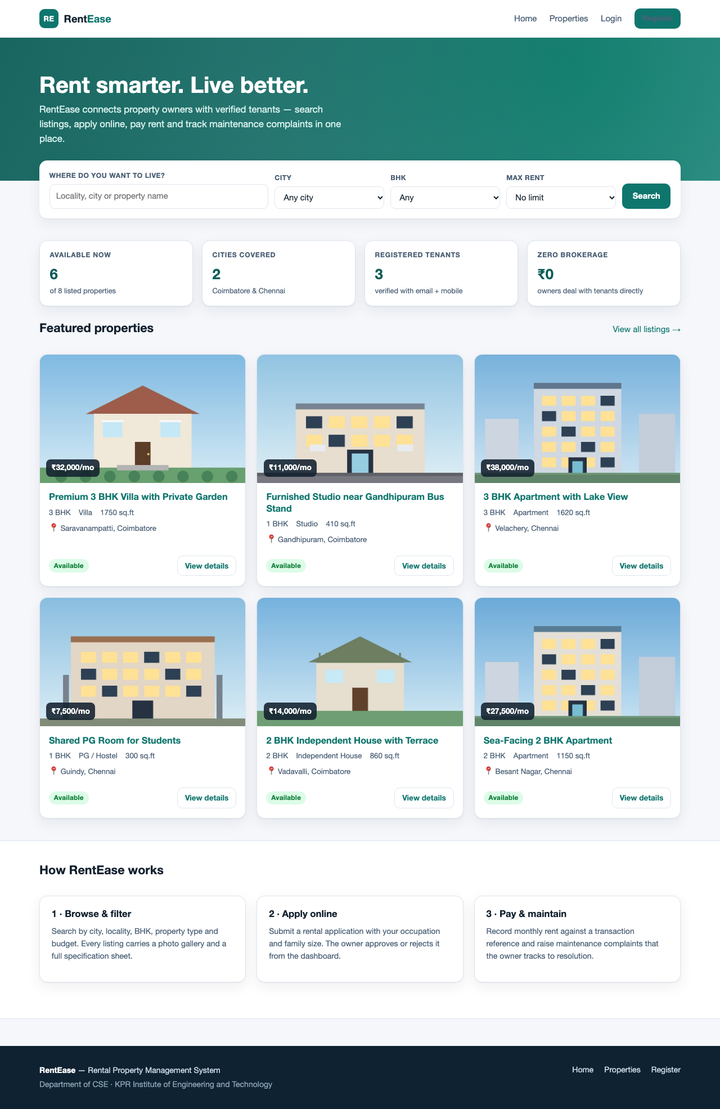
Fig. 9.3 Home page - hero search, portfolio statistics and featured listings
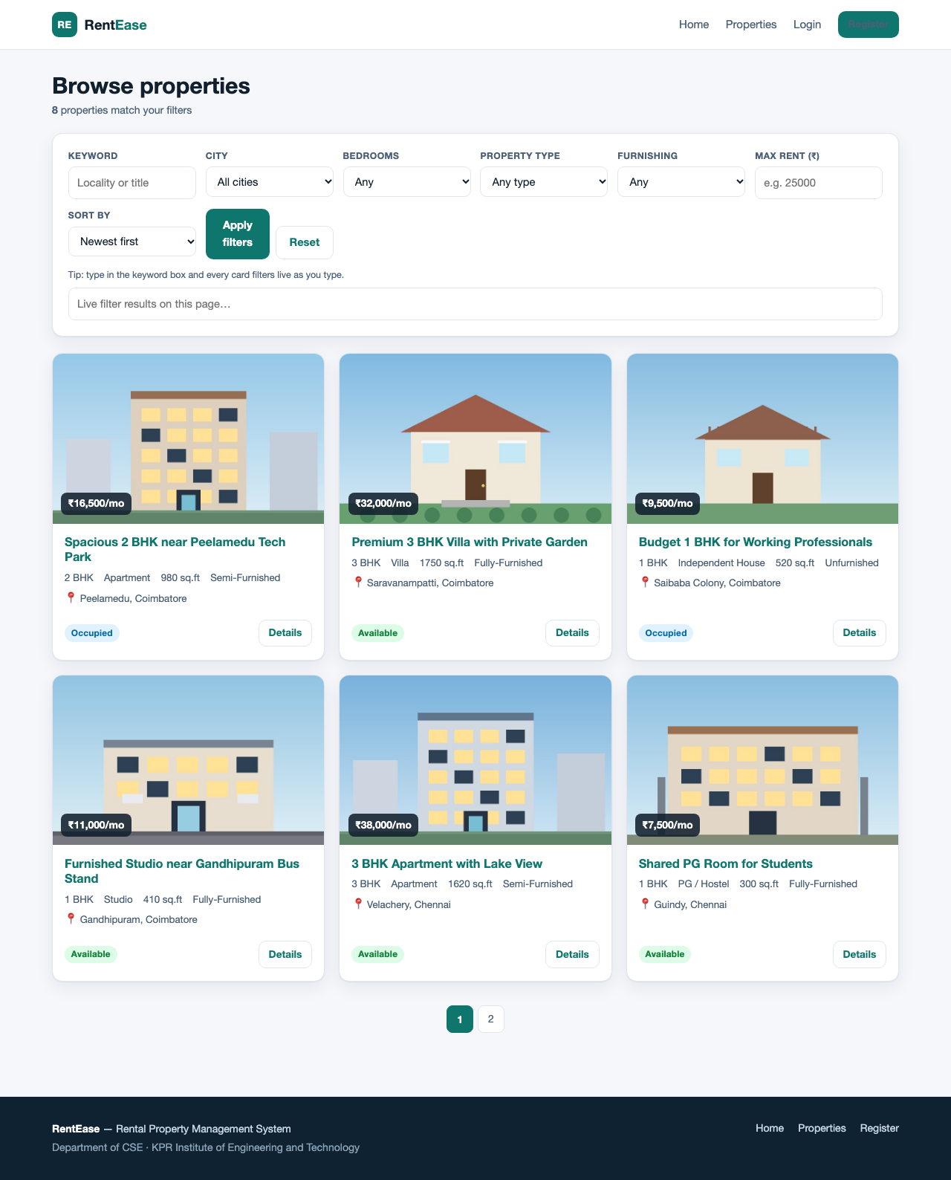
Fig. 9.4 Property listing page with the full filter panel
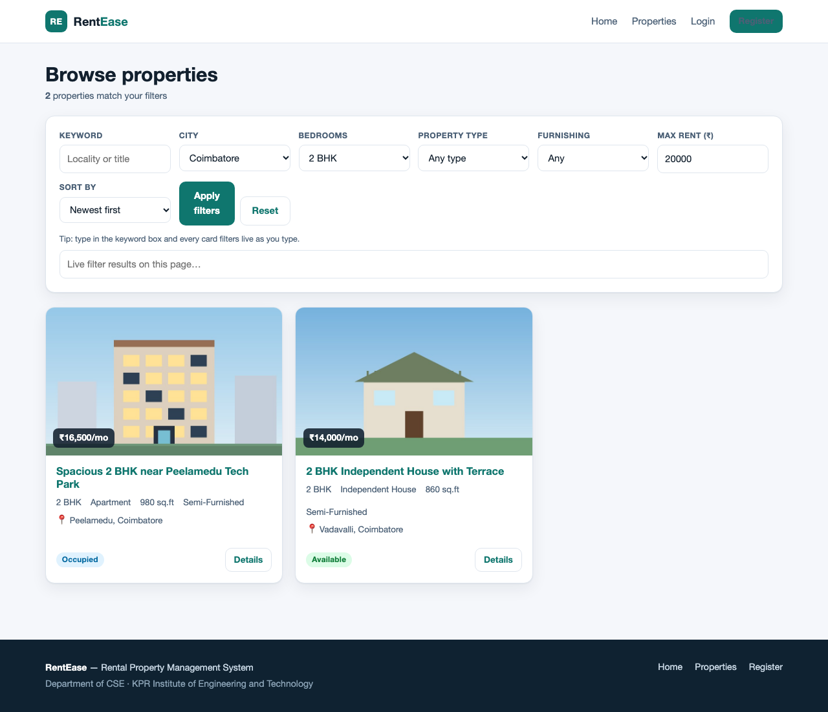
Fig. 9.5 Filter applied (Coimbatore, 2 BHK, under Rs.20,000) - 2 of 8 match
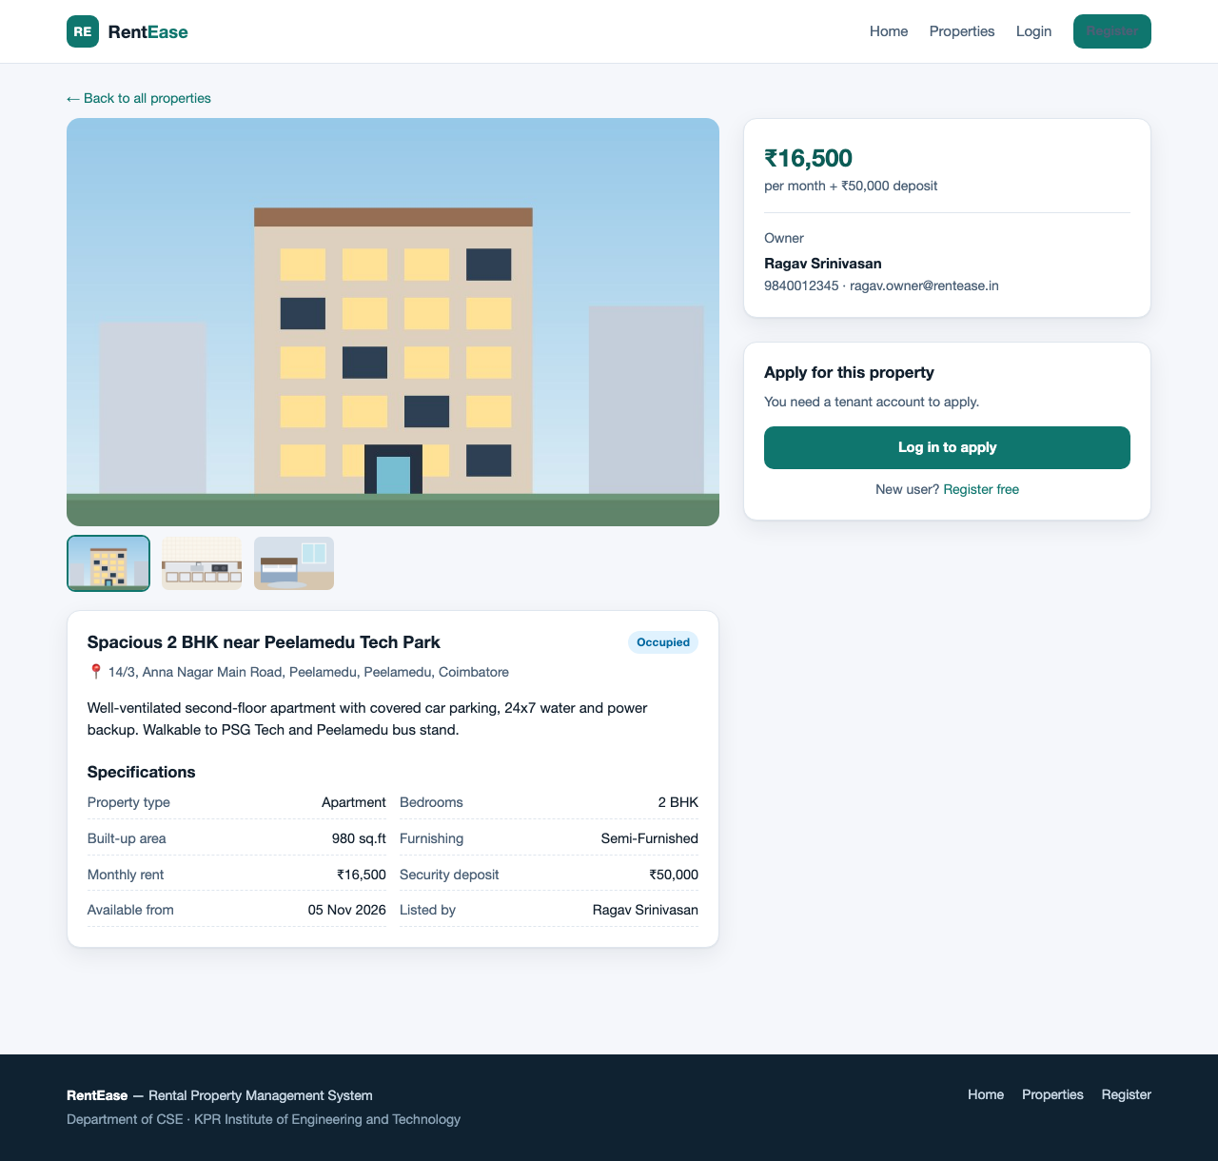
Fig. 9.6 Property detail - gallery, specification sheet and application panel
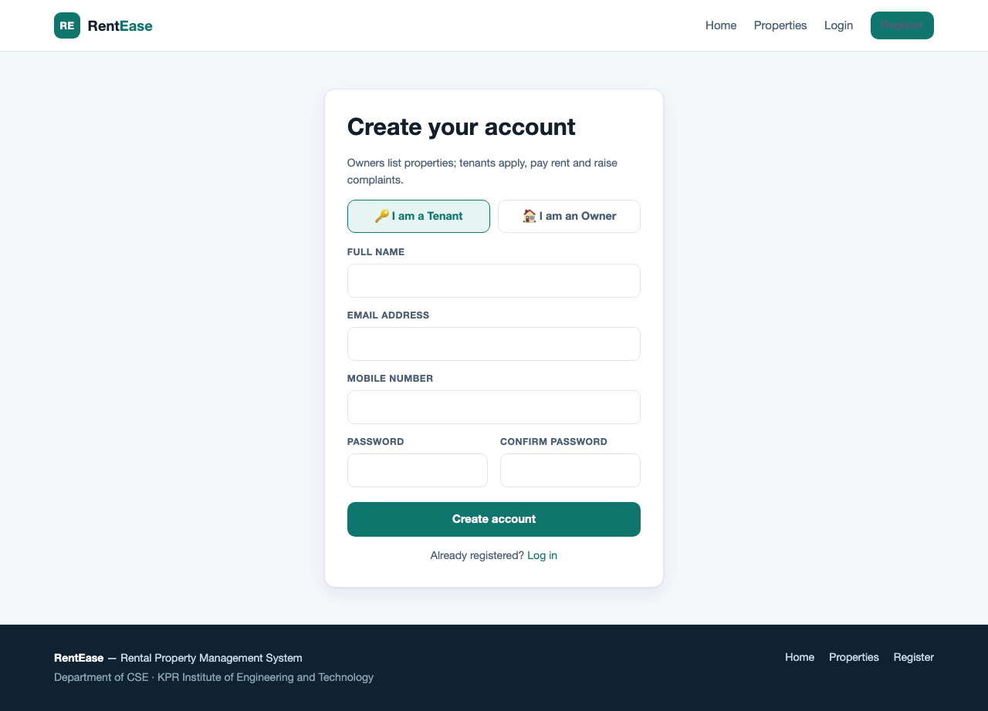
Fig. 9.7 Registration page with the owner / tenant role selector
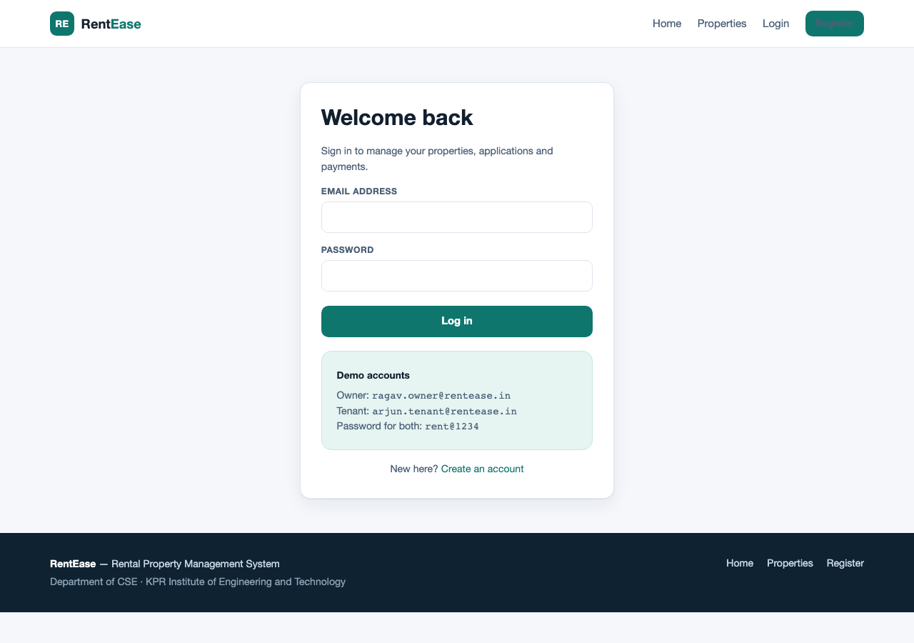
Fig. 9.8 Login page with the demo credentials panel

TENANT WORKFLOWS:
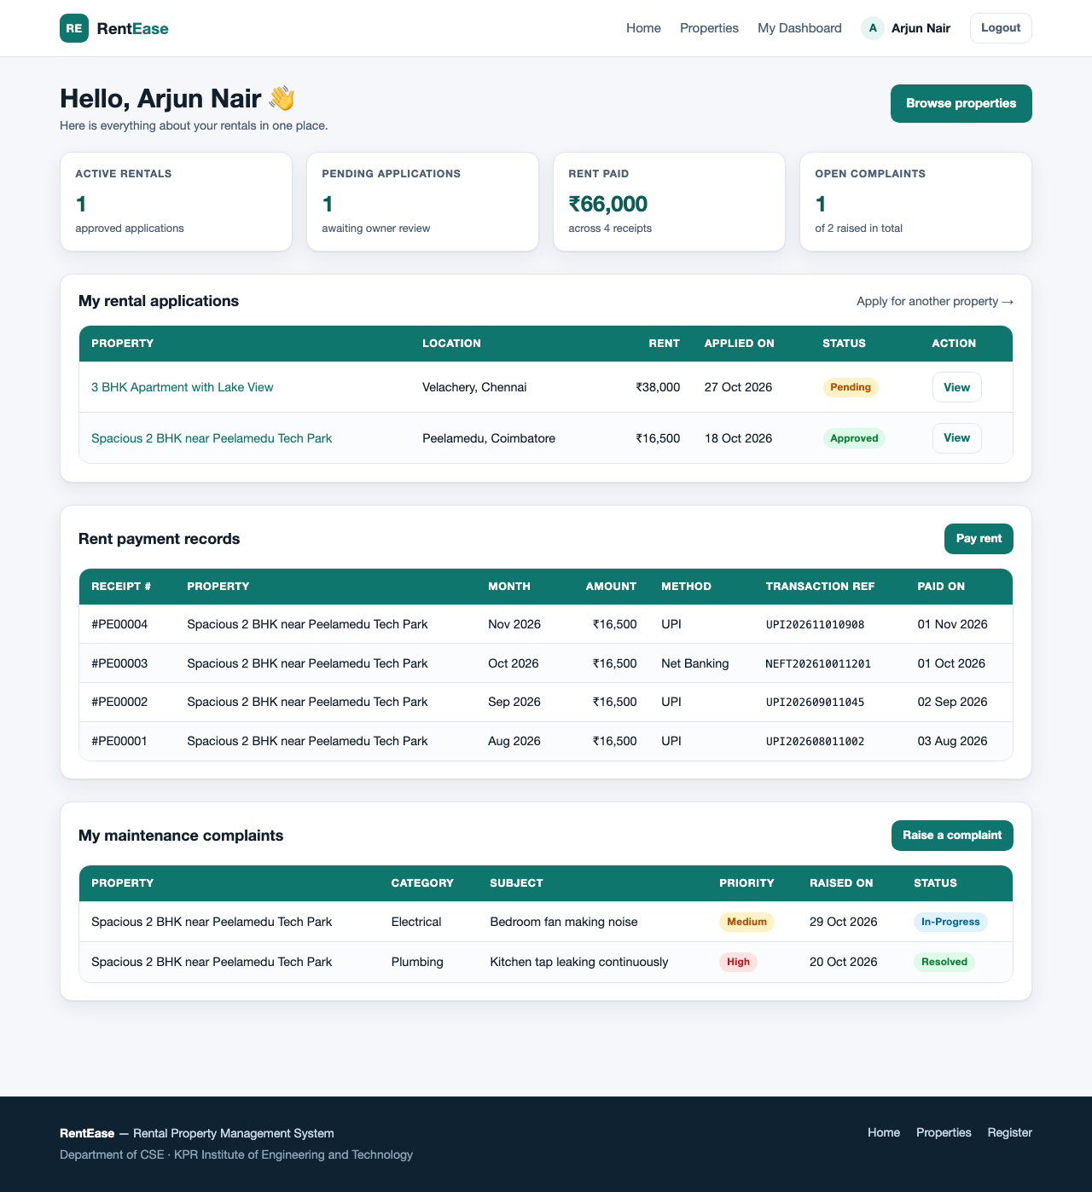
Fig. 9.9 Tenant dashboard - applications, rent receipts and complaint status
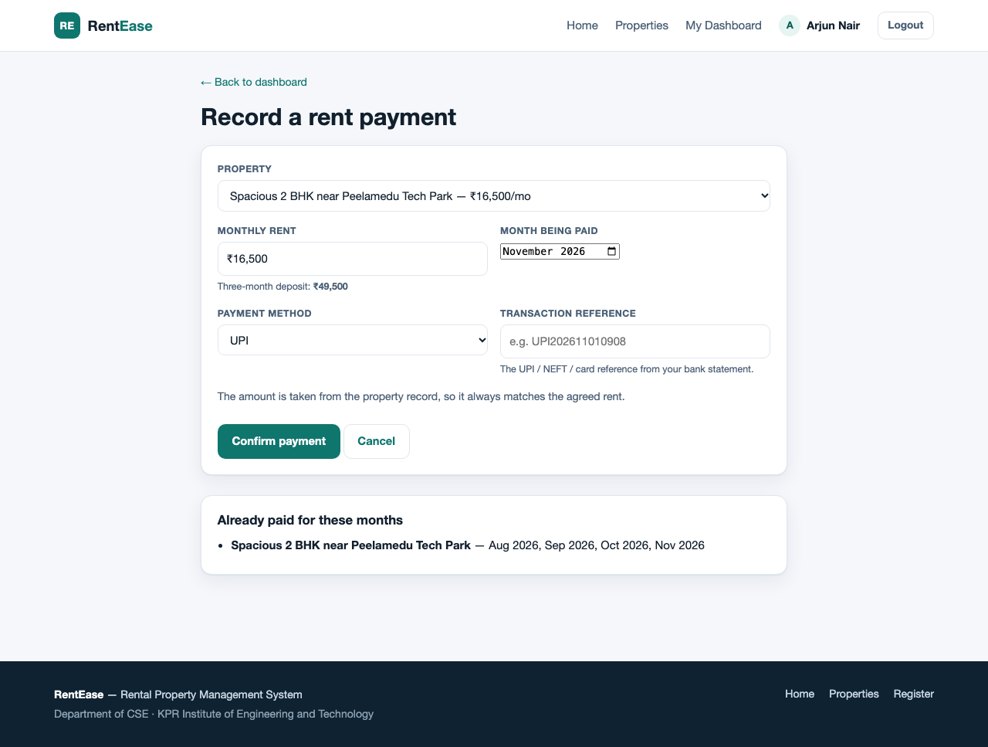
Fig. 9.10 Rent payment form; the amount comes from the property record
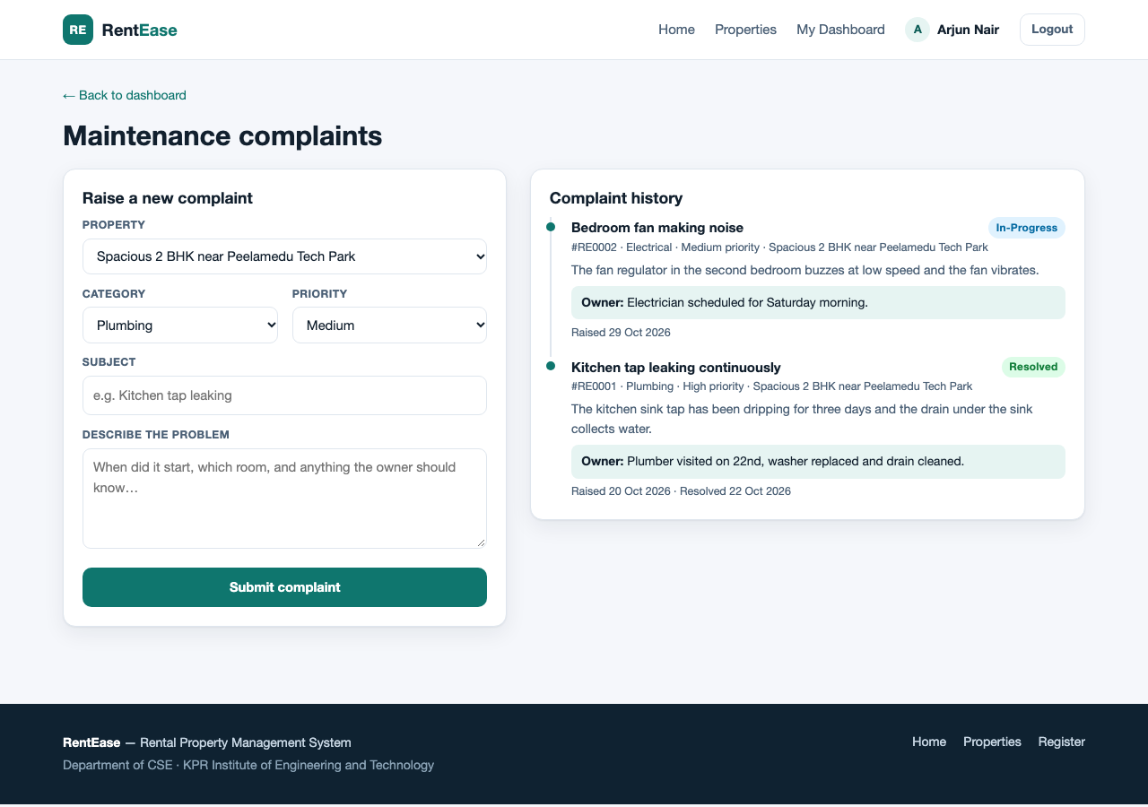
Fig. 9.11 Complaint form with the status timeline and the owner's note

OWNER WORKFLOWS:
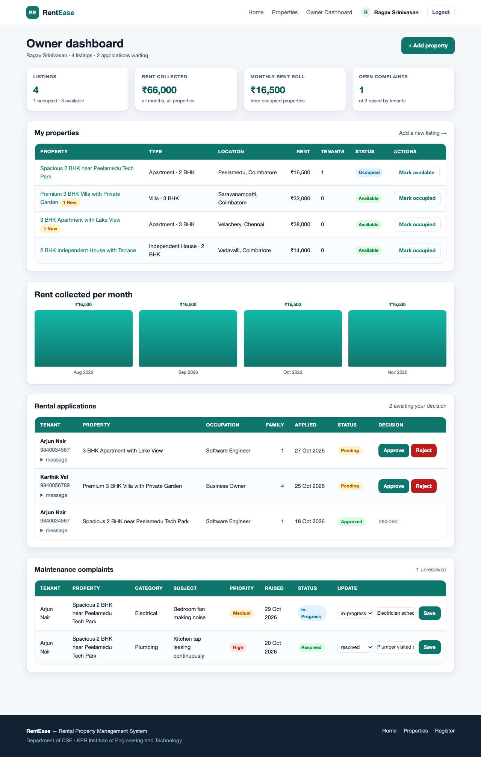
Fig. 9.12 Owner dashboard - portfolio statistics, listings, rent chart, application and complaint queues
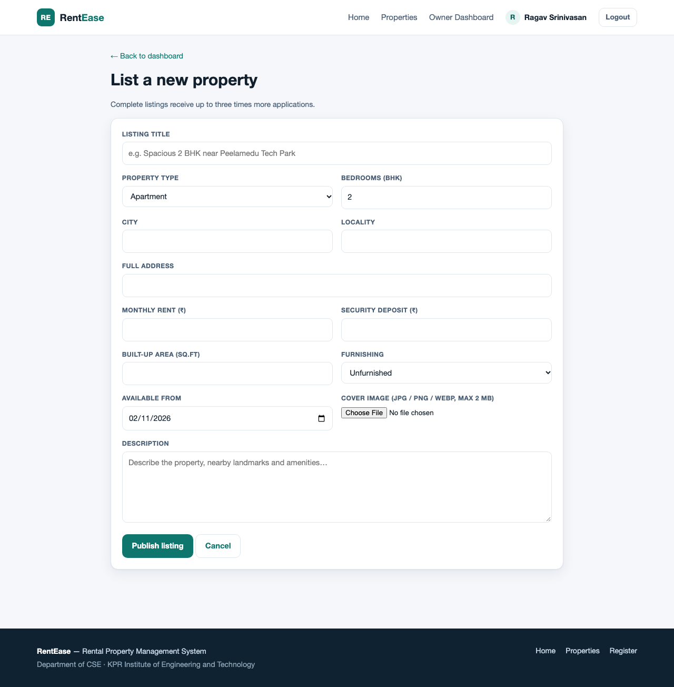
Fig. 9.13 Add property form with cover-image upload

TESTING:
Every workflow was exercised against the live database. The table records the test cases, the expected result and the observed result.
# | Test case | Expected result | Status
1 | Register a new tenant | Row inserted, redirected to tenant dashboard | Pass
2 | Register with an existing email | "This email is already registered" | Pass
3 | Log in with a wrong password | Invalid email or password message | Pass
4 | Open a POST form with a bad CSRF token | HTTP 419, request refused | Pass
5 | Filter Coimbatore + 2 BHK + max 20,000 | 2 of 8 listings returned | Pass
6 | Tenant applies for a property | Application stored as pending | Pass
7 | Tenant applies twice for the same property | Refused, unique key respected | Pass
8 | Owner approves an application | Application approved, property occupied | Pass
9 | Owner B acts on owner A's application | Refused by the ownership check | Pass
10 | Record rent for a new month | Payment row with the property's rent | Pass
11 | Record rent twice for one month | Refused, unique key respected | Pass
12 | Tenant raises a complaint | Complaint stored as open | Pass
13 | Owner marks a complaint resolved | Status resolved, resolved_on set | Pass
14 | Owner adds a property with an image | Row plus one gallery image created | Pass
15 | Upload a non-image file as cover | Rejected by the MIME check | Pass
RESULT:
Thus the RentEase rental property management system was designed and developed using HTML, CSS, JavaScript, PHP and MySQL. The application supports property listings with image galleries, multi-facet search and filtering, online rental applications with owner approval, month-by-month rent payment records, maintenance complaint tracking and a consolidated owner dashboard. All six features were verified against a live MySQL database and the fifteen test cases above passed.
RUBRICS :
Rubrics | Actual Marks | Awarded Marks
Understanding (R1) | 4
Timeline (R2) | 4
Design (R3) | 4
Development (R4) | 4
Innovation (R5) | 4
Total Marks | 20

