Question 1:

Coding:

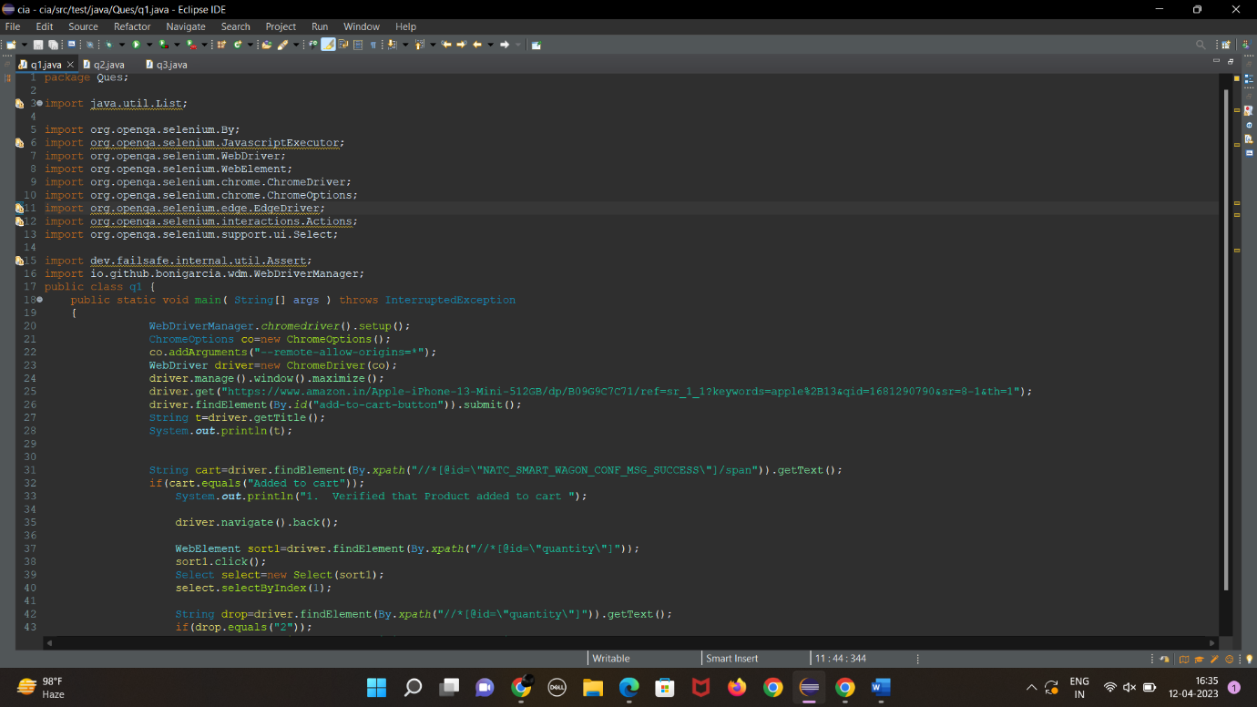

Output:

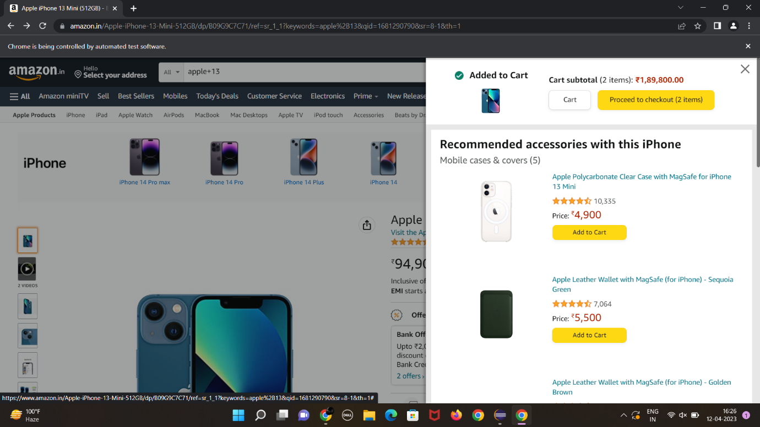

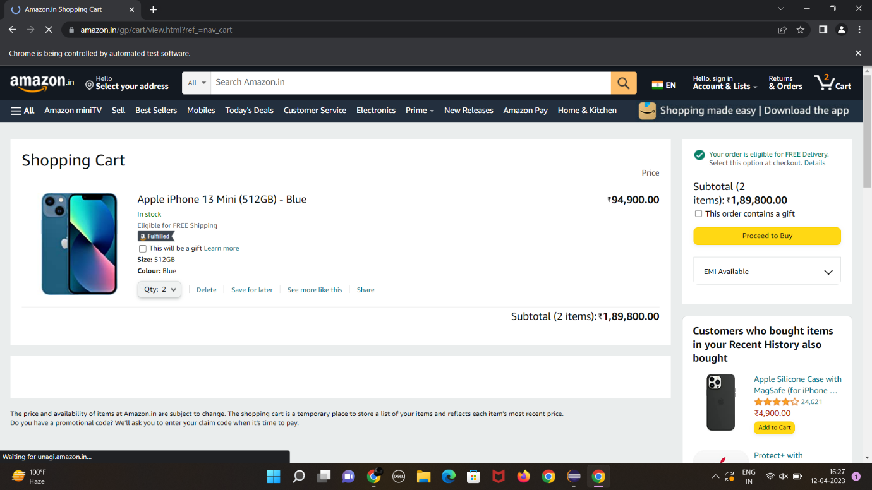

Question 2:

Coding:

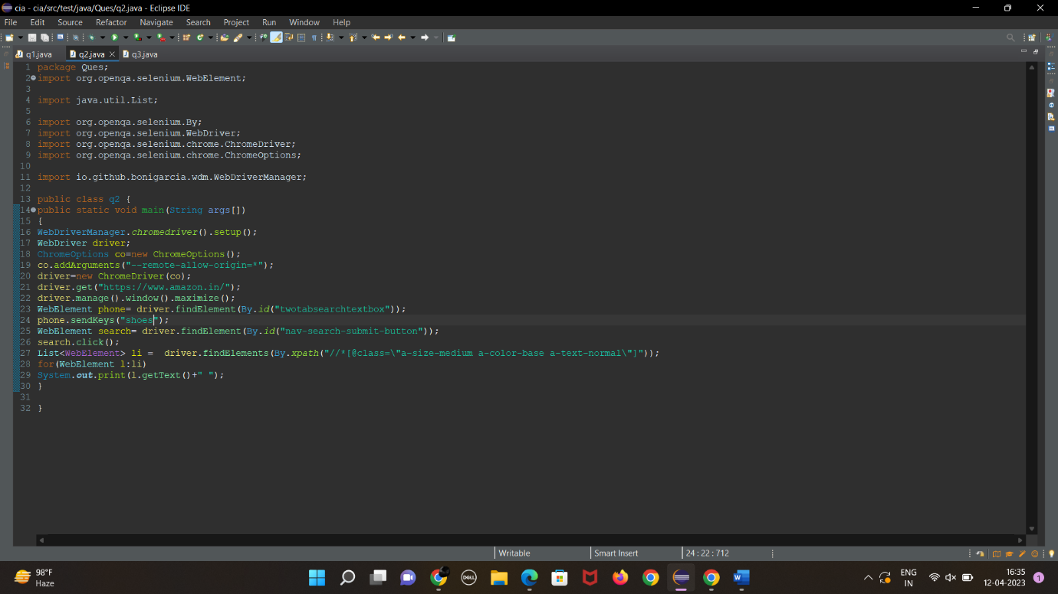

Output:

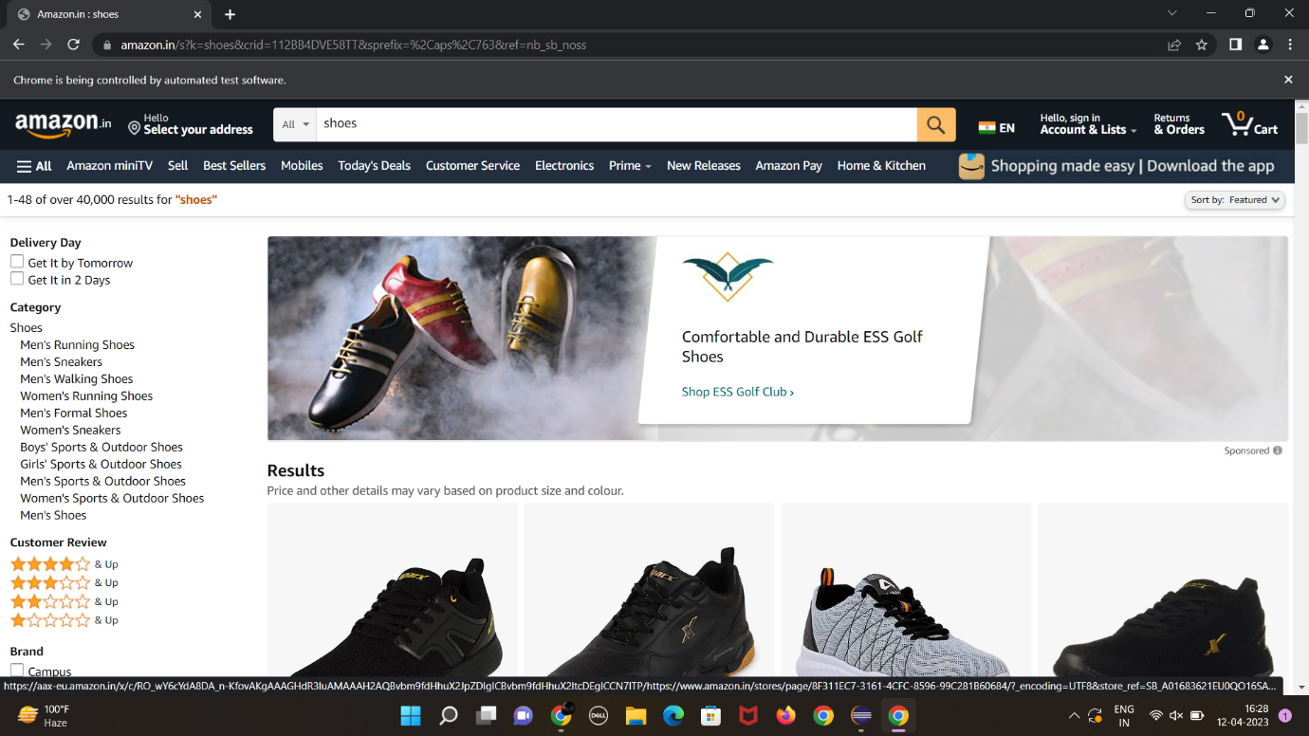

Question 3:

package com.selenium.test.NewTest2.SelTest;

import java.util.List;

import org.openqa.selenium.By;

import org.openqa.selenium.JavascriptExecutor;

import org.openqa.selenium.Keys;

import org.openqa.selenium.WebDriver;

import org.openqa.selenium.WebElement;

import org.openqa.selenium.chrome.ChromeDriver;

import org.openqa.selenium.chrome.ChromeOptions;

import org.openqa.selenium.support.ui.Select;

import io.github.bonigarcia.wdm.WebDriverManager;

/**

* Hello world!

*

*/

public class App

{

public static void main( String[] args ) throws InterruptedException

{

WebDriverManager.chromedriver().setup();

ChromeOptions co = new ChromeOptions();

co.addArguments("--remote-allow-origins=*");

WebDriver driver=new ChromeDriver(co);

driver.get("https://www.amazon.in/ref=nav_logo");

driver.manage().window().maximize();

String title=driver.getTitle();

System.out.println(title);

if(title.equals("Online Shopping site in India: Shop Online for Mobiles, Books, Watches, Shoes and More - Amazon.in")) {

System.out.println("Verified title of the page");

}else {

System.out.println("Title not matched");

}

driver.findElement(By.id("nav-link-accountList")).click();

driver.findElement(By.id("ap_email")).sendKeys("feviliya28@gmail.com");

driver.findElement(By.id("ap_email")).sendKeys(Keys.ENTER);

driver.findElement(By.id("ap_password")).sendKeys("Fevi2802*");

driver.findElement(By.id("ap_password")).sendKeys(Keys.ENTER);

Thread.sleep(2000);

String name=driver.findElement(By.id("nav-link-accountList-nav-line-1")).getText();

if(name.equals("Hello, Feviliya")) {

System.out.println("Successfully, signed in");

}else {

System.out.println("Sign in failed");

}

System.out.println("Testing Ended");

driver.quit();

}

}