**TASK :-**

Create visualization approaches of mobile application for the user given data set. The Visualization approaches include Histogram, Line Chart, Bar Chart and Pie Chart.

**SOURCE CODE :-**

**Activity_main.xml :**

*<?***xml version="1.0" encoding="utf-8"***?>*<**LinearLayout xmlns:android="http://schemas.android.com/apk/res/android"  
 xmlns:tools="http://schemas.android.com/tools"  
 android:layout_width="match_parent"  
 android:layout_height="match_parent"  
 android:gravity="center"  
 android:orientation="vertical"  
 android:padding="10dp"  
 tools:context=".MainActivity"**>  
   
 <**Button  
 android:layout_width="match_parent"  
 android:layout_height="wrap_content"  
 android:id="@+id/Chart1Bar"  
 android:text="BAR CHART"**/>  
  
 <**Button  
 android:layout_width="match_parent"  
 android:layout_height="wrap_content"  
 android:id="@+id/Chart2Line"  
 android:text="LINE CHART"**/>  
  
 <**Button  
 android:layout_width="match_parent"  
 android:layout_height="wrap_content"  
 android:id="@+id/Chart3Pie"  
 android:text="PIE CHART"**/>  
  
</**LinearLayout**>

**Activity_b_a_r_c_h_a_r_t.xml :**

*<?***xml version="1.0" encoding="utf-8"***?>*<**androidx.constraintlayout.widget.ConstraintLayout xmlns:android="http://schemas.android.com/apk/res/android"  
 xmlns:tools="http://schemas.android.com/tools"  
 android:layout_width="match_parent"  
 android:layout_height="match_parent"  
 tools:context=".BARCHART"**>  
  
 <**com.github.mikephil.charting.charts.BarChart  
 android:id="@+id/BarChart"  
 android:layout_width="match_parent"  
 android:layout_height="match_parent"**/>  
</**androidx.constraintlayout.widget.ConstraintLayout**>

**Activity_l_i_n_e_c_h_a_r_t.xml :**

*<?***xml version="1.0" encoding="utf-8"***?>*<**androidx.constraintlayout.widget.ConstraintLayout xmlns:android="http://schemas.android.com/apk/res/android"  
 xmlns:app="http://schemas.android.com/apk/res-auto"  
 xmlns:tools="http://schemas.android.com/tools"  
 android:layout_width="match_parent"  
 android:layout_height="match_parent"  
 tools:context=".LINECHART"**>  
  
 <**com.github.mikephil.charting.charts.LineChart  
 android:id="@+id/lineChart"  
 android:layout_width="match_parent"  
 android:layout_height="match_parent"**/>  
  
</**androidx.constraintlayout.widget.ConstraintLayout**>

**Activity_p_i_e_c_h_a_r_t.xml :**

*<?***xml version="1.0" encoding="utf-8"***?>*<**androidx.constraintlayout.widget.ConstraintLayout xmlns:android="http://schemas.android.com/apk/res/android"  
 xmlns:app="http://schemas.android.com/apk/res-auto"  
 xmlns:tools="http://schemas.android.com/tools"  
 android:layout_width="match_parent"  
 android:layout_height="match_parent"  
 tools:context=".PIECHART"**>  
  
 <**com.github.mikephil.charting.charts.PieChart  
 android:id="@+id/pieChart"  
 android:layout_width="match_parent"  
 android:layout_height="match_parent"**/>  
  
</**androidx.constraintlayout.widget.ConstraintLayout**>

**MainActivity.java :**

**package** com.example.charts;  
  
**import** androidx.appcompat.app.AppCompatActivity;  
**import** android.content.Intent;  
**import** android.os.Bundle;  
**import** android.view.View;  
  
**public class** MainActivity **extends** AppCompatActivity {  
  
 @Override  
 **protected void** onCreate(Bundle savedInstanceState) {  
 **super**.onCreate(savedInstanceState);  
 setContentView(R.layout.***activity_main***);  
  
 findViewById(R.id.***Chart1Bar***).setOnClickListener(**new** View.OnClickListener(){  
 @Override  
 **public void** onClick(View view){  
 startActivity(**new** Intent(getApplicationContext(),BARCHART.**class**));  
 }  
 });  
  
 findViewById(R.id.***Chart2Line***).setOnClickListener(**new** View.OnClickListener(){  
 @Override  
 **public void** onClick(View view){  
 startActivity(**new** Intent(getApplicationContext(),LINECHART.**class**));  
 }  
 });  
  
 findViewById(R.id.***Chart3Pie***).setOnClickListener(**new** View.OnClickListener(){  
 @Override  
 **public void** onClick(View view){  
 startActivity(**new** Intent(getApplicationContext(),PIECHART.**class**));  
 }  
 });  
 }  
}

**BARCHART.java :**

**package** com.example.charts;  
  
**import** androidx.appcompat.app.AppCompatActivity;  
**import** android.os.Bundle;  
**import** android.graphics.Color;  
**import** com.github.mikephil.charting.charts.BarChart;  
**import** com.github.mikephil.charting.data.BarData;  
**import** com.github.mikephil.charting.data.BarDataSet;  
**import** com.github.mikephil.charting.data.BarEntry;  
**import** com.github.mikephil.charting.utils.ColorTemplate;  
**import** java.util.ArrayList;  
**public class** BARCHART **extends** AppCompatActivity {  
  
 BarChart **barChart**;  
 BarData **barData**;  
 BarDataSet **barDataSet**;  
 ArrayList **barEntries**;  
 @Override  
 **protected void** onCreate(Bundle savedInstanceState) {  
 **super**.onCreate(savedInstanceState);  
 setContentView(R.layout.***activity_b_a_r_c_h_a_r_t***);  
  
 **barChart** = findViewById(R.id.***BarChart***);  
  
 **barEntries** = **new** ArrayList<>();  
 **barEntries**.add(**new** BarEntry(1, 2018));  
 **barEntries**.add(**new** BarEntry(2, 2019));  
 **barEntries**.add(**new** BarEntry(3, 2020));  
 **barEntries**.add(**new** BarEntry(4, 2021));  
 **barEntries**.add(**new** BarEntry(5, 2023));  
 **barEntries**.add(**new** BarEntry(6, 2023));  
  
 **barDataSet** = **new** BarDataSet(**barEntries**, **""**);  
 **barData** = **new** BarData(**barDataSet**);  
 **barChart**.setData(**barData**);  
 **barDataSet**.setColors(ColorTemplate.***JOYFUL_COLORS***);  
 **barDataSet**.setValueTextColor(Color.***BLUE***);  
 **barDataSet**.setValueTextSize(18f);  
 }  
}

**LINECHART.java :**

**package** com.example.charts;  
  
**import** androidx.appcompat.app.AppCompatActivity;  
**import** android.os.Bundle;  
**import** com.github.mikephil.charting.charts.LineChart;  
**import** com.github.mikephil.charting.data.Entry;  
**import** com.github.mikephil.charting.data.LineData;  
**import** com.github.mikephil.charting.data.LineDataSet;  
**import** com.github.mikephil.charting.utils.ColorTemplate;  
**import** java.util.ArrayList;  
**import** android.graphics.Color;  
**public class** LINECHART **extends** AppCompatActivity {  
  
 LineChart **lineChart**;  
 LineData **lineData**;  
 LineDataSet **lineDataSet**;  
 ArrayList **lineEntries**;  
 @Override  
 **protected void** onCreate(Bundle savedInstanceState) {  
 **super**.onCreate(savedInstanceState);  
 setContentView(R.layout.***activity_l_i_n_e_c_h_a_r_t***);  
 **lineChart** = findViewById(R.id.***lineChart***);  
  
 **lineEntries** = **new** ArrayList<>();  
 **lineEntries**.add(**new** Entry(100, 2014));  
 **lineEntries**.add(**new** Entry(200, 2015));  
 **lineEntries**.add(**new** Entry(300, 2016));  
 **lineEntries**.add(**new** Entry(400, 2017));  
 **lineEntries**.add(**new** Entry(500, 2018));  
 **lineEntries**.add(**new** Entry(600, 2019));  
  
 **lineDataSet** = **new** LineDataSet(**lineEntries**, **"Company Performance"**);  
 **lineData** = **new** LineData(**lineDataSet**);  
 **lineChart**.setData(**lineData**);  
 **lineDataSet**.setColors(ColorTemplate.***JOYFUL_COLORS***);  
  
 **lineDataSet**.setValueTextColor(Color.***BLUE***);  
 **lineDataSet**.setValueTextSize(18f);  
 }  
}

**PIECHART.java:**

**package** com.example.charts;  
  
**import** androidx.appcompat.app.AppCompatActivity;  
**import** android.os.Bundle;  
**import** android.graphics.Color;  
**import** com.github.mikephil.charting.charts.PieChart;  
**import** com.github.mikephil.charting.data.PieData;  
**import** com.github.mikephil.charting.data.PieDataSet;  
**import** com.github.mikephil.charting.data.PieEntry;  
**import** com.github.mikephil.charting.utils.ColorTemplate;  
**import** java.util.ArrayList;  
**public class** PIECHART **extends** AppCompatActivity {  
  
 PieChart **pieChart**;  
 PieData **pieData**;  
 PieDataSet **pieDataSet**;  
 ArrayList **pieEntries**;  
 ArrayList **PieEntryLabels**;  
 @Override  
 **protected void** onCreate(Bundle savedInstanceState) {  
 **super**.onCreate(savedInstanceState);  
 setContentView(R.layout.***activity_p_i_e_c_h_a_r_t***);  
 **pieChart** = findViewById(R.id.***pieChart***);  
  
 **pieEntries** = **new** ArrayList<>();  
 **pieEntries**.add(**new** PieEntry(8, **"Work"**));  
 **pieEntries**.add(**new** PieEntry(6, **"Task"**));  
 **pieEntries**.add(**new** PieEntry(2, **"Eat"**));  
 **pieEntries**.add(**new** PieEntry(6, **"Sleep"**));  
 **pieEntries**.add(**new** PieEntry(2, **"Mobile"**));  
  
 **pieDataSet** = **new** PieDataSet(**pieEntries**, **"Daily Activities"**);  
 **pieData** = **new** PieData(**pieDataSet**);  
 **pieChart**.setData(**pieData**);  
 **pieDataSet**.setColors(ColorTemplate.***JOYFUL_COLORS***);  
 **pieDataSet**.setSliceSpace(2f);  
 **pieDataSet**.setValueTextColor(Color.***BLUE***);  
 **pieDataSet**.setValueTextSize(10f);  
 **pieDataSet**.setSliceSpace(5f);  
 }  
}

**OUTPUT :-**

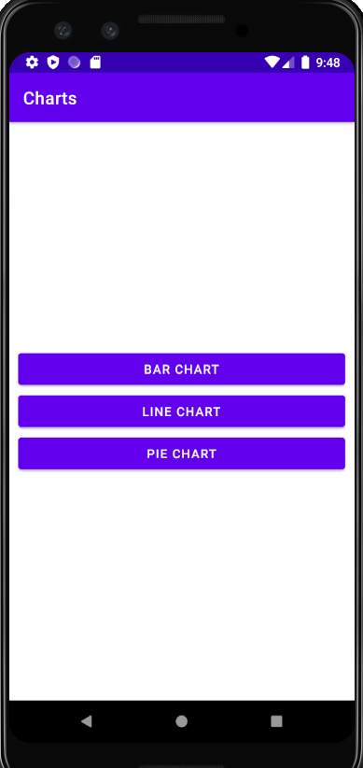

BAR CHART OUTPUT :-

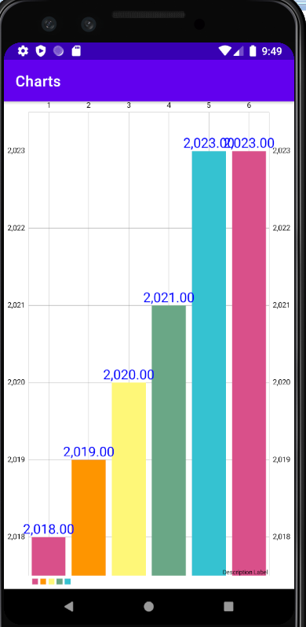

LINE CHART OUTPUT :-

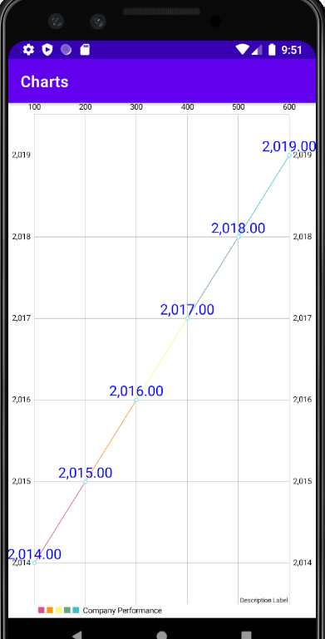

PIE CHART OUTPUT :-

