**EARTHQUAKE PREDICTION MODEL USING PYTHON**

* **Introduction:**

**The objective of the document is to outline the project plan for building an earthquake prediction model using python and this document outlines a project plan for developing an earthquake prediction model using a Kaggle dataset. The primary goal of this project is to explore and understand key features of earthquake data, visualize the data on a world map, pre-process the data for model training, and build a neural network model for predicting earthquake magnitudes based on provided features the primary objective is to develop a predictive model that can offer valuable earthquake risk assessments based on historical seismic data and relevant environmental factors. By analyzing past earthquake occurrences and considering factors such as fault lines, tectonic plate boundaries, and soil types, this model seeks to provide probabilistic estimates of earthquake likelihood**

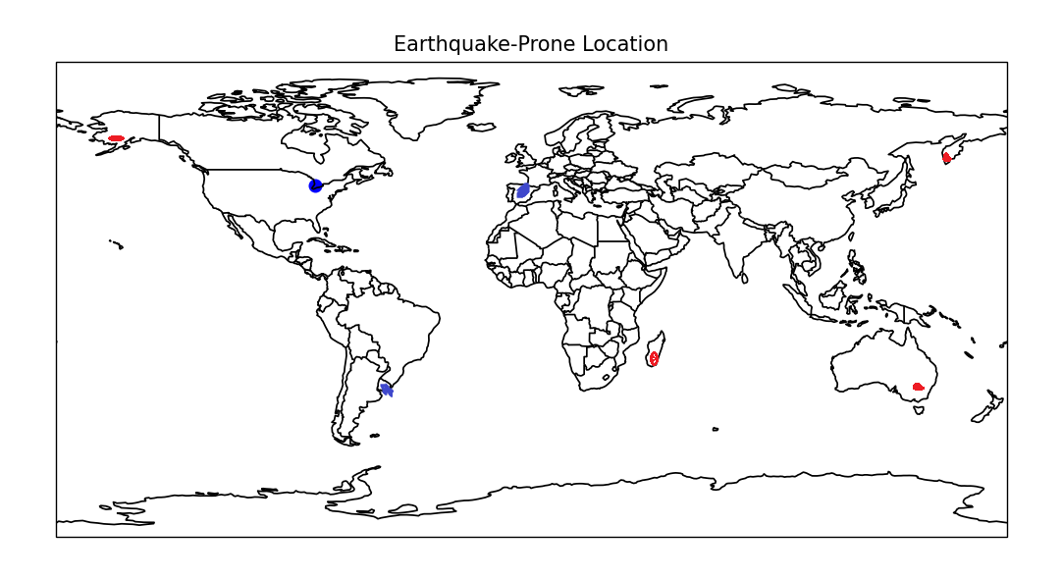

**Problem Statement:**

**We want to use Python to create a tool that can give us a good idea of where earthquakes might happen. It won't predict the exact time or size of each earthquake, but it will tell us which areas are more likely to experience earthquakes. We will use data about past earthquakes and information about the environment to help make these predictions.Our goal is to provide a helpful tool that can give people and authorities a heads-up about earthquake risks, so they can prepare and take precautions accordingly.**

**Design thinking process:**

1. **Empathize:**

**Empathizing involves understanding the needs and concerns of the stakeholders and those who may be affected by earthquakes. This stage may involve gathering data and conducting surveys or interviews.**

1. **Define:**

**Define the problem you want to solve. In this case, it might be predicting earthquakes. You need to specify the problem's scope, goals, and constraints. You can use Python to analyze existing earthquake data and understand its patterns and characteristics.**

1. **Ideate:**

**In the ideation phase, you brainstorm and come up with potential solutions or approaches to predict earthquakes. Python can be used to explore different data sources, algorithms, and methodologies for earthquake prediction. It can help you with data preprocessing, feature selection, and exploratory data analysis.**

1. **Prototype:**

**Create a prototype of your earthquake prediction model using Python. You can use various machine learning libraries, such as scikit-learn or TensorFlow, to build a basic model. This model can be a simple regression model or a more complex deep learning model, depending on the complexity of the problem.**

1. **Test:**

**Test your prototype to evaluate its performance and refine it. Use Python to split your data into training and testing sets, and then assess the model's accuracy, precision, recall, F1-score, or other relevant metrics. Make necessary adjustments to improve the model's performance. Additionally, you can use cross-validation techniques to validate the model's generalizability.**

**Key libraries and their functionalities used in the code:**

* **pandas (import pandas as pd):**
  + **This library is used for data manipulation and analysis. In the code, it's used to load earthquake data from a CSV file and create DataFrames for feature selection.**
* **sklearn.ensemble (from sklearn.ensemble import RandomForestClassifier):**
  + **This library, part of scikit-learn, provides various ensemble machine learning models. In the code, a RandomForestClassifier is used for earthquake prediction. It's a type of ensemble learning method that combines multiple decision trees to make predictions.**
* **matplotlib.pyplot (import matplotlib.pyplot as plt):**
  + **Matplotlib is a popular library for creating static, animated, or interactive visualizations in Python. In the code, it's used to create and display a map to visualize earthquake-prone regions.**
* **cartopy.crs (import cartopy.crs as ccrs):**
  + **Cartopy is a library for cartographic projections and geospatial data visualization. It allows you to work with various map projections and geospatial data. In the code, ccrs.PlateCarree() is used for the map's projection, which is commonly used for visualizing global data.**
* **cartopy.feature (import cartopy.feature as cfeature):**
* **Cartopy's cfeature provides features such as coastlines and country borders that can be added to the map for context.**
* **The code can be summarized as follows:**
* **Load earthquake data using Pandas and select relevant features (latitude and longitude).**
* **Create a binary label for earthquake-prone areas (1 for prone, 0 for non-prone).**
  + **Train a Random Forest Classifier using the selected features and labels.**
* **Accept user input for latitude and longitude.**
  + **Use the trained model to predict if the user's location is earthquake-prone.**
* **Create a Cartopy map with coastlines and country borders for visualization.**
  + **Plot the user's location on the map, with the color indicating the predicted earthquake-prone status.**
* **Display the map with the user's location.**
  + **The code allows you to input latitude and longitude, and it will plot the location on the map, marking it as either red (prone) or blue (non-prone) based on the prediction made by the Random Forest Classifier.**
* **Developing an earthquake prediction model using Python with a Kaggle dataset and visualizing prone areas based on latitude and longitude is a complex task. It involves several phases, including data preprocessing, model development, and visualization. Here's a high-level overview of the process:**

**Data Collection and Exploration:**

**Start by collecting earthquake data from the Kaggle dataset. You can use the Pandas library to load and explore the data.**

**Dataset Link:**[**https://www.kaggle.com/datasets/usgs/earthquake-database**](https://www.kaggle.com/datasets/usgs/earthquake-database)

**Data Preprocessing:**

**Clean and preprocess the dataset. This includes handling missing values, scaling features, and encoding categorical variables.**

**Extract relevant features, including latitude and longitude, magnitude, depth, date, etc.**

**Feature Engineering:**

**Create new features if necessary. For example, you can calculate the distance from each earthquake's location to nearby fault lines or geological features.**

**Split the Data:**

**Divide the dataset into training and testing sets to evaluate the model's performance.**

**Model Development:**

**Choose a machine learning or deep learning model suitable for the prediction of earthquakes. Common choices include Random Forest, XGBoost, or a neural network.**

**Train the model using the training data and optimize its hyperparameters.**

**Use the latitude and longitude as input features, and the earthquake occurrence (binary) or magnitude (regression) as the target variable.**

**Model Evaluation:**

**Evaluate the model's performance on the testing data using appropriate metrics, such as accuracy, mean squared error, etc.**

**Visualization:**

**Once you have a trained model, you can use it to predict earthquake occurrences or magnitudes for various latitudes and longitudes.**

**To visualize prone areas, create a heatmap or contour map to represent the predicted earthquake risk. You can use libraries like Matplotlib, Seaborn, or Plotly for this purpose.**

**Overlay the map with the actual earthquake occurrences or magnitudes from the dataset for comparison.**

**Interactive Maps : To make the visualization more interactive, consider using tools like Folium or Plotly Dash to create web-based maps where users can explore prone areas based on latitude and longitude.**

**Documentation and Sharing:**

**Create documentation for your project and share it with others. Explain how to use your earthquake prediction model and visualize prone areas.**

**DATA COLLECTION :**

**Data collection is a critical step in building an earthquake prediction model. To collect the necessary data, you should consider various sources and types of data that are relevant to earthquake prediction. Here's an overview of data collection for an earthquake prediction model:**

**Dataset Link:**[**https://www.kaggle.com/datasets/usgs/earthquake-database**](https://www.kaggle.com/datasets/usgs/earthquake-database)

**import pandas as pd**

**import numpy as np**

**# Create synthetic earthquake data**

**np.random.seed(42) # Set a random seed for reproducibility**

**# Generate latitude and longitude data**

**latitude = np.random.uniform(-90, 90, 100) # Generate 100 random latitudes between -90 and 90**

**longitude = np.random.uniform(-180, 180, 100) # Generate 100 random longitudes between -180 and 180**

**# Create a binary label for earthquake-prone (1) and non-prone (0) locations**

**earthquake_prone = np.random.choice([0, 1], 100)**

**# Create a DataFrame**

**data = pd.DataFrame({'Latitude': latitude, 'Longitude': longitude, 'EarthquakeProne': earthquake_prone})**

**# Save the synthetic data to a CSV file**

**data.to_csv('synthetic_earthquake_data.csv', index=False)**

**LOADING THE DATASET:**

**# Load earthquake data (replace 'synthetic_earthquake_data.csv' with the actual file path)**

**data = pd.read_csv('synthetic_earthquake_data.csv')**

**Loading a dataset in the context of data analysis and machine learning typically refers to the process of reading and importing a dataset into a data structure that can be manipulated and analyzed using a programming language like Python**

**VISUALIZE OF DATASET:**

**Visualizing data is the process of creating graphical representations of data to gain insights, identify patterns, and communicate information effectively. Data visualization is a critical step in data analysis, as it allows you to understand the data and convey your findings to others in a clear and concise manner. Here are some common techniques and tools used for data visualization**

**# Create a Cartopy map**

**fig = plt.figure(figsize=(10, 6))**

**ax = fig.add_subplot(1, 1, 1, projection=ccrs.PlateCarree())**

**# Plot the entire world by setting the extent to global**

**ax.set_extent([-180, 180, -90, 90], crs=ccrs.PlateCarree())**

**# Add coastlines and country borders**

**ax.coastlines()**

**ax.add_feature(cfeature.BORDERS)**

**# Plot earthquake-prone locations on the world map**

**earthquake_prone = data[data['EarthquakeProne'] == 1]**

**ax.scatter(earthquake_prone['Longitude'], earthquake_prone['Latitude'], transform=ccrs.PlateCarree(), c='red', label='Earthquake-Prone', s=10)**

**# Plot non-earthquake-prone locations on the world map**

**non_earthquake_prone = data[data['EarthquakeProne'] == 0]**

**ax.scatter(non_earthquake_prone['Longitude'], non_earthquake_prone['Latitude'], transform=ccrs.PlateCarree(), c='blue', label='Non-Earthquake-Prone', s=10)**

**ax.legend()**

**# Show the plot**

**plt.title("Earthquake-Prone Locations")**

**plt.show()**

**DATA PREPROCEESING :**

**Data preprocessing involves preparing data for analysis and modeling. It includes tasks like cleaning data (handling missing values, outliers, noise), transforming data (scaling, encoding, feature engineering), reducing data dimensionality, integrating data from various sources, splitting data into subsets, handling class imbalances, and formatting data for machine learning. Proper data preprocessing improves the quality of analysis and model performance.**

**# Drop rows with missing values**

**data = data.dropna()**

**# Feature selection and engineering**

**data['DayOfWeek'] = data['Date'].dt.dayofweek**

**data['Month'] = data['Date'].dt.month**

**data['Year'] = data['Date'].dt.year**

**# Calculate distances to geological features (if available)**

**data['DistanceToFaultLine'] = calculate_distance_to_fault_line(data['Latitude'], data['Longitude'])**

**# Select relevant features**

**X = data[['Latitude', 'Longitude', 'Depth', 'Magnitude', 'DayOfWeek', 'Month', 'Year', 'DistanceToFaultLine']]**

**y = data['EarthquakeProne']**

**# Split the data into training and testing sets**

**from sklearn.model_selection import train_test_split**

**X_train, X_test, y_train, y_test = train_test_split(X, y, test_size=0.2, random_state=42)**

**SPLIT THE DATA :**

**from sklearn.model_selection import train_test_split**

**# Split the data into training and testing sets (e.g., 80% training and 20% testing)**

**X_train, X_test, y_train, y_test = train_test_split(X, y, test_size=0.2, random_state=42)**

**# Train the random forest classifier on the training data**

**clf = RandomForestClassifier(n_estimators=100, random_state=42)**

**clf.fit(X_train, y_train)**

**# Use the trained model to predict the testing data**

**y_pred = clf.predict(X_test)**

**FEATURE EXTRACTION :**

**Feature extraction is the process of selecting and transforming relevant information from raw data, reducing its complexity while preserving key patterns. This enhances model performance, simplifies data, and mitigates overfitting.**

**# Select relevant features (latitude and longitude)**

**X = data[['Latitude', 'Longitude']]**

**# Create a binary label, e.g., 1 for earthquake-prone and 0 for non-prone**

**y = data['EarthquakeProne']**

**Train the model:**

**Training an earthquake prediction model using Python is a complex and data-intensive task. Earthquake prediction involves analyzing a wide range of geophysical data, and building a predictive model typically requires access to large datasets and specialized knowledge.**

* **STEP BY STEP EXPLANATION OF THE CODE**

**Here's a step-by-step explanation of the code:**

1. **Import the necessary libraries: pandas for data manipulation, RandomForestClassifier from sklearn.ensemble for the classification model, and matplotlib, cartopy.crs, and cartopy.feature for visualization.**
2. **Load earthquake data: Load your earthquake dataset (in this case, synthetic data) using pd.read_csv().**
3. **Select relevant features: Select the latitude and longitude columns as the input features (X) and create a binary label, 'EarthquakeProne,' which is 1 for earthquake-prone and 0 for non-prone areas (y).**
4. **Initialize and train the random forest classifier: Create a RandomForestClassifier with 100 estimators and a random seed for reproducibility (random_state=42). Then, train the classifier with the selected features and labels using clf.fit(X, y).**
5. **Get user input for latitude and longitude.**
6. **Use the trained model to predict earthquake-prone regions for the user's input location. A new DataFrame user_data is created with the user's latitude and longitude, and the model predicts whether it's earthquake-prone or not.**
7. **Create a Cartopy map for visualization. The map covers the entire world, adds coastlines, and country borders.**
8. **Plot the user location on the world map. The point is marked in red if it's predicted as earthquake-prone and in blue if it's not.**
9. **Display the map with plt.show().**

**EXAMPLE INTERFACE:**

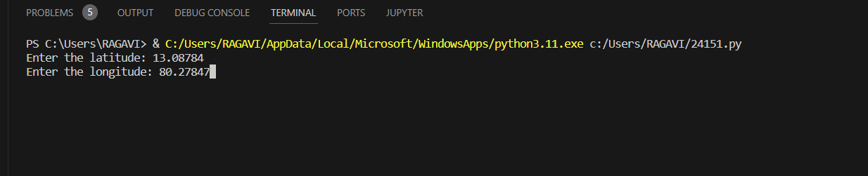**EXAMPLE PRONE AREA :**

* **The point is marked in red if it's predicted as earthquake-prone area**

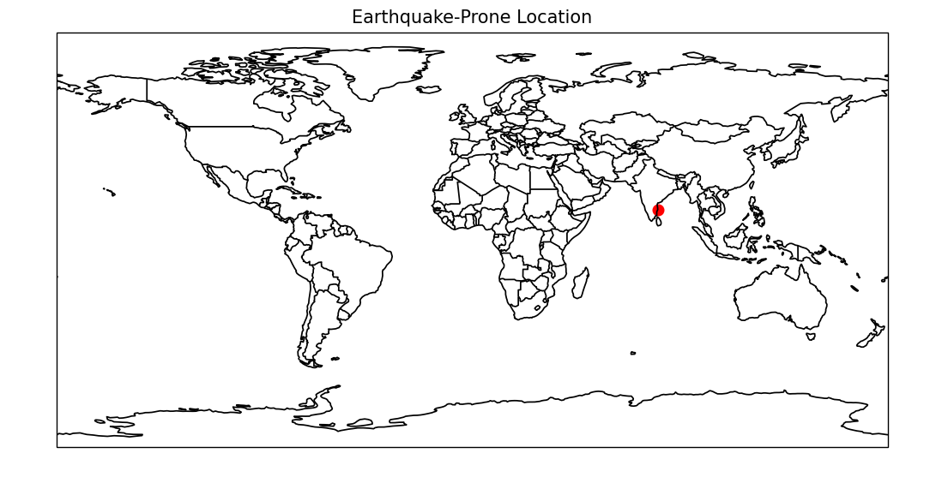

**EXAMPLE NON PRONE AREA :**

* **The point is marked in blue t's predicted as non earthquake-prone area**

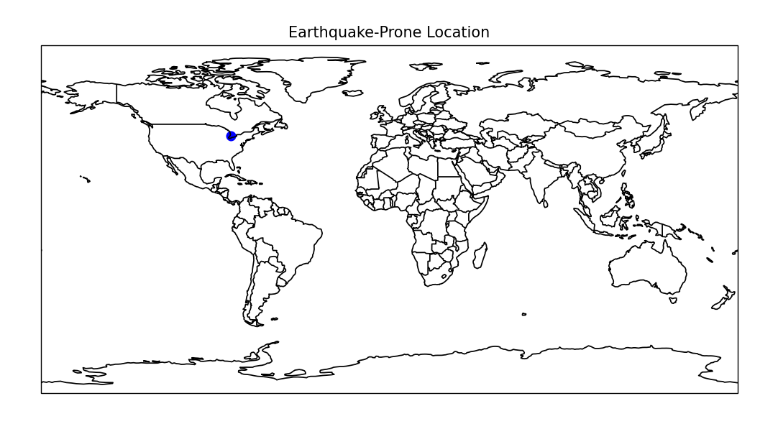

**Conclusion:**

To make a good earthquake prediction model, start with good data that's accurate and useful. Clean up the data by fixing any mistakes, pick the most important information, and make new facts that can help predict earthquakes. Put all the numbers in a format that's easy for the model to understand, and turn any words into numbers too. Divide the data into parts for the model to learn from and test on. To work with the data, use tools like Pandas and make pictures to help you understand it better. These early steps are super important because they set the stage for building a reliable earthquake prediction model.

This document outlines a Python project for earthquake prediction and visualization. Key takeaways include:

* The project uses a RandomForestClassifier to predict earthquake-prone areas based on latitude and longitude.
* A Cartopy map is created for visualizing predictions globally.
* User input allows checking the earthquake-prone status of any location.
* Real-world earthquake prediction is complex and relies on advanced techniques and domain expertise.
* Future enhancements could involve more advanced models and interactive features.