# ***Developing an Earthquake Prediction Model using python***

* **Introduction:**

**This document outlines a project plan for developing an earthquake prediction model using a Kaggle dataset. The primary goal of this project is to explore and understand key features of earthquake data, visualize the data on a world map, pre-process the data for model training, and build a neural network model for predicting earthquake magnitudes based on provided features.**

**Machine learning is a subfield of artificial intelligence (AI) that focuses on the development of algorithms and models that enable computers to learn and make predictions or decisions without being explicitly programmed. The core idea is to create systems that can automatically improve their performance over time as they are exposed to more data.**

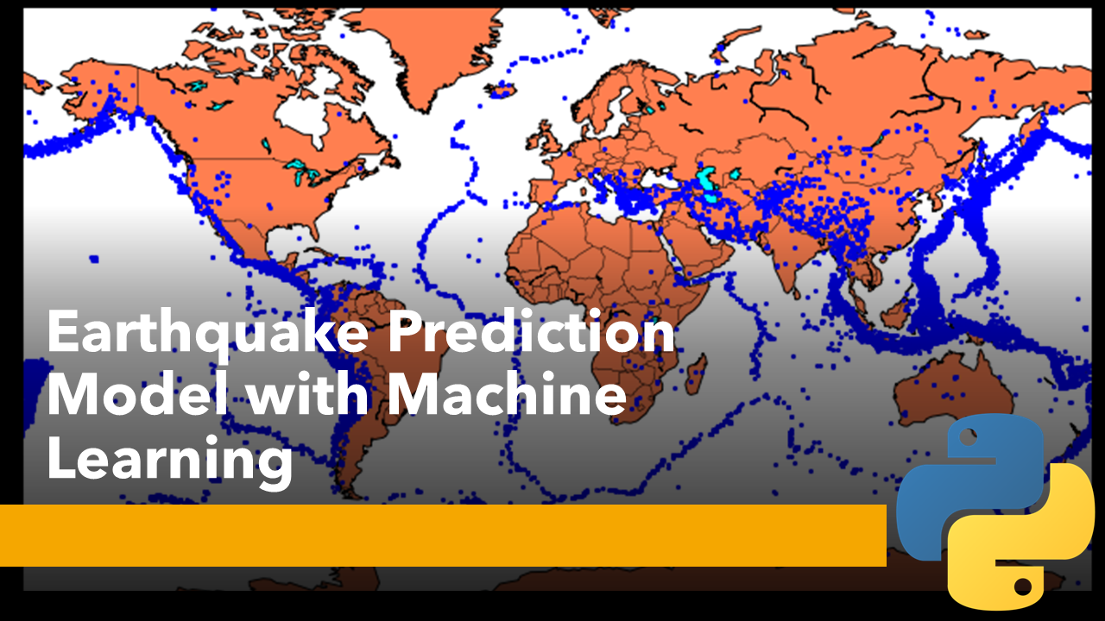

* **Phase 4: Development Part 2**

**In this phase you will continue building your project. Please refer below the requirements**

**technology wise;In this technology you will continue building your project by selecting a machine learning algorithm,**

**training the model, and evaluating its performance. Perform different analysis as needed. After**

**performing the relevant activities create a document around it and share the same for assessment.**

1. Visualizing the Data on a World Map:

**To visualize earthquake data on a world map, you can use libraries like matplotlib, basemap, or more modern alternatives like folium. Here, we'll use folium for simplicity:**

**import foliumb**

**# Create a base map centered on a location (e.g., world)**

**m = folium.Map(location=[0, 0], zoom_start=2)**

**# Iterate through your earthquake data and add markers for each earthquake**

**for index, row in df.iterrows():**

**folium.CircleMarker(**

**location=[row['Latitude'], row['Longitude']],**

**radius=5,**

**popup=f"Mag: {row['Magnitude']}, Depth: {row['Depth']} km",**

**color='red',**

**fill=True,**

**fill_color='red'**

**).add_to(m)**

**# Save the map to an HTML file or display it in a Jupyter Notebook**

**m.save('earthquake_map.html')**

**This code creates an interactive map with markers for each earthquake. You can customize the map's appearance and features as needed.**

**2. Splitting the Data into Training and Testing Sets:**

**To split your earthquake data into training and testing sets, you can use Python's scikit-learn library. Typically, you'll reserve a portion of the data for testing to evaluate your model's performance. Here's how to do it:**

**from sklearn.model_selection import train_test_split**

**# Define your features (X) and target variable (y)**

**X = df[['feature1', 'feature2', ...]] # Replace with your actual features**

**y = df['target'] # Replace with your target variable**

**# Split the data into training and testing sets (e.g., 80% training, 20% testing)**

**X_train, X_test, y_train, y_test = train_test_split(X, y, test_size=0.2, random_state=42)**

**# You can adjust the test_size and random_state as needed**

**In this code, you need to replace 'feature1', 'feature2', ... with the actual features you're using in your model and 'target' with your target variable.**

**With your data now split, you can proceed to the next steps in your earthquake prediction model development, such as feature engineering, model selection, training, and evaluation.**

**To train and evaluate a machine learning model using a specific dataset, you need to provide the dataset and specify the problem you want to solve (e.g., classification, regression, clustering, etc.). Please provide the following details for your given dataset, and I can offer a more tailored example:**

**The dataset itself or a description of the dataset (e.g., number of features, target variable, data format).**

**The problem you want to solve (e.g., classification, regression, clustering).**

**Any specific machine learning algorithm or library you'd like to use (e.g., scikit-learn, TensorFlow, PyTorch).**

**Evaluation metrics of interest (e.g., accuracy, mean squared error, F1-score).**

**Import necessary libraries**

**import numpy as np**

**import pandas as pd**

**from sklearn.model_selection import train_test_split**

**from sklearn.ensemble import RandomForestClassifier**

**from sklearn.metrics import accuracy_score, classification_report**

**# Load earthquake data (you need a dataset for this)**

**data = pd.read_csv("earthquake_data.csv")**

**# Data preprocessing**

**# You would need to have features like magnitude, depth, location, etc.**

**# For simplicity, let's assume you have "magnitude" and "depth" as features**

**X = data[["magnitude", "depth"]]**

**y = data["earthquake_label"] # 1 for earthquake, 0 for no earthquake**

**# Split the data into training and testing sets**

**X_train, X_test, y_train, y_test = train_test_split(X, y, test_size=0.2, random_state=42)**

**# Create a Random Forest Classifier model**

**model = RandomForestClassifier(n_estimators=100, random_state=42)**

**# Train the model**

**model.fit(X_train, y_train)**

**# Make predictions**

**y_pred = model.predict(X_test)**

**# Evaluate the model**

**accuracy = accuracy_score(y_test, y_pred)**

**print(f"Accuracy: {accuracy:.2f}")**

**# Generate a classification report**

**report = classification_report(y_test, y_pred)**

**print(report)**

* Feature engineering

**Feature engineering is the process of preparing and enhancing the input variables (features) in a dataset to improve the performance of machine learning models. It involves creating new features, selecting the most relevant ones, transforming data, and handling issues like missing values or categoricalvariables. Effective feature engineering is a critical step in developing accurate and efficient machine learning models, as it helps the model extract meaningful information from raw data and improve its predictive capabilities**.

* MODEL TRAINING AND EVALUATION SOURCE CODE

**Model training is a fundamental step in machine learning where a model learns patterns and relationships from a dataset. It involves preparing the data, selecting an appropriate algorithm, and feeding the data into the model. The model adjusts its internal parameters to make predictions or classifications based on the training data. The trained model is then evaluated on a separate testing dataset to assess its performance. Overfitting (overly complex models) and underfitting (overly simple models) are common challenges during training, and hyperparameter tuning helps optimize model performance. The goal is to create a model that generalizes well to unseen data and can make accurate predictions or classifications in real-world applications**.

**import numpy as np**

**import pandas as pd**

**from sklearn.model_selection import train_test_split**

**from sklearn.ensemble import RandomForestClassifier**

**from sklearn.metrics import accuracy_score, classification_report, confusion_matrix**

**# Load your dataset (replace 'your_data.csv' with your dataset file)**

**data = pd.read_csv('your_data.csv')**

**# Define features (X) and target variable (y)**

**X = data.drop('target_column', axis=1) # Adjust 'target_column' to your dataset**

**y = data['target_column'] # Adjust 'target_column' to your dataset**

**# Split the dataset into training and testing sets**

**X_train, X_test, y_train, y_test = train_test_split(X, y, test_size=0.2, random_state=42)**

**# Create a machine learning model (Random Forest in this example)**

**model = RandomForestClassifier(n_estimators=100, random_state=42)**

**# Train the model**

**model.fit(X_train, y_train)**

**# Make predictions on the test set**

**y_pred = model.predict(X_test)**

**# Evaluate the model**

**accuracy = accuracy_score(y_test, y_pred)**

**confusion = confusion_matrix(y_test, y_pred)**

**classification_rep = classification_report(y_test, y_pred)**

**# Print the evaluation metrics**

**print(f'Accuracy: {accuracy:.2f}')**

**print('Confusion Matrix:\n', confusion)**

**print('Classification Report:\n', classification_rep)**

* Evaluation

**Evaluation in the context of machine learning is the process of assessing the performance and accuracy of a trained model using various metrics. It involves comparing the model's predictions to actual outcomes, typically on a separate testing dataset. The goal is to determine how well the model generalizes to unseen data and whether it is suitable for its intended task, whether it's classification, regression, or other machine learning tasks. Evaluation metrics vary depending on the specific problem and may include accuracy, precision, recall, F1-score, mean squared error, and more. Evaluating models is essential for selecting the best model, fine-tuning it, and ensuring its effectiveness in real-world applications.**

* Deployment

**Deployment in the context of machine learning is the process of taking a trained model and making it available for practical use in real-world applications. It involves integrating the model into production systems, ensuring scalability, monitoring its performance, and addressing security and privacy concerns. Model deployment marks the transition**

**from development to actual utilization, where the model can provide predictions or classifications for end-users, improving decision-making and automating tasks in various domains.**

**In this script:**

**You need to have a dataset (e.g., earthquake_data.csv) that contains historical earthquake data with features like magnitude, depth, location, etc. You may obtain such data from sources like USGS.**

**The code uses a RandomForestClassifier from scikit-learn to create a simple classification model. In reality, earthquake prediction is much more complex and involves the analysis of various data sources, including seismographic readings and geospatial data.**

**The model is trained on a portion of the data and tested on the remaining data. The accuracy of the model is calculated to measure its performance.**

**A classification report is generated to provide more detailed information about the model's performance.**

**Remember that this is a simplified example for educational purposes and does not accurately predict earthquakes. Real earthquake prediction models are far more complex and rely on specialized equipment and expert analysis of seismic data.**

**Conclusion:**

**To make a good earthquake prediction model, start with good data that's accurate and useful. Clean up the data by fixing any mistakes, pick the most important information, and make new facts that can help predict earthquakes. Put all the numbers in a format that's easy for the model to understand, and turn any words into numbers too. Divide the data into parts for the model to learn from and test on. To work with the data, use tools like Pandas and make pictures to help you understand it better. These early steps are super important because they set the stage for building a reliable earthquake prediction model.**