PROJECT REPORT

SUBMISSION

CLASSIFICATION BETWEEN MULTIPLE SCLEROSIS AND CEREBRAL SMALL VESSEL DISEASE

COMPUTER VISION

COMPLETED BY,
NARESH V (2023510042)
RUPARAGUNATH (2023510305)
EZHIL MAYIL VAGANAN (2023510034)
HARIRAGAVENDRA M G (2023510031)

MS AND CSVD DETECTION USING MACHINE LEARNING

Introduction:
1. Introduction
Early and accurate diagnosis of neurological disorders such as Multiple Sclerosis (MS) and Cerebral Small Vessel Disease (CSVD) is crucial for timely treatment. However, these conditions often present overlapping features in their early stages, making clinical diagnosis based on MRI challenging. This project aims to build a machine learning-based computer vision model that can assist clinicians by automatically analyzing FLAIR MRI images, extracting key features, and classifying the brain condition as either MS or CSVD.

2. Why You Chose This Project? What Is the Societal Impact?
We chose this project because of the clinical difficulty in differentiating MS and CSVD at an early stage due to their similar lesion appearances in MRI scans. Manual interpretation is time-consuming, subject to inter-observer variability, and requires significant expertise.
Societal Impact:
- Faster diagnosis: Automating lesion detection and classification significantly reduces diagnostic time.
- Assistance to radiologists: The tool acts as a second opinion, reducing human error and supporting consistent diagnosis.
- Access in rural areas: In low-resource settings, this model can assist less-experienced practitioners in identifying complex conditions.
- Improved patient outcomes: Early and accurate classification enables prompt and targeted treatment plans.

3. Methodology - Architecture Diagram and Explanation
Pipeline Overview

Explanation:
- Preprocessing: Extract FLAIR slices, normalize, and apply histogram equalization.
- Skull Stripping: Binary thresholding and morphological operations remove non-brain tissue.
- Feature Extraction:
  - HOG captures edge and gradient features.
  - GLCM extracts textural properties like contrast, homogeneity, and correlation.
- Lesion Detection: Adaptive thresholding, binary closing, and connected component analysis highlight lesion areas.
- Classification: A Random Forest classifier is trained on extracted features to distinguish between MS (label 1) and CSVD (label 0).
- Evaluation: Predictions are evaluated using accuracy, precision, recall, F1-score, ROC curve, and confusion matrix.

4. Dataset and Description
Datasets Used:
- MICCAI WMH Challenge Dataset – Used for CSVD detection
  - Contains FLAIR MRI images and lesion annotations.
  - Images from elderly patients with white matter hyperintensities.
- MS Lesion Dataset (Kaggle) – Used for MS classification
  - Includes annotated MS lesion FLAIR slices.
  - Contains various slice orientations and image modalities.
Preprocessing Performed:
- Slicing, resizing, outlier clipping, and histogram equalization.
- Skull stripping to isolate brain region.
- Manual filtering to retain mid-slices showing prominent lesions.

5. Result Comparison (Ablation Study)
We evaluated different model configurations to understand the contribution of each component. The Random Forest model was used across all configurations.
Configuration | Accuracy | F1-Score | AUC-ROC
HOG + GLCM (with lesion detection) | 95.2% | 0.93 | 0.99
HOG only | 87.6% | 0.84 | 0.88
GLCM only | 82.9% | 0.80 | 0.83
Without Skull Stripping | 78.4% | 0.76 | 0.80
Without Lesion Detection | 75.1% | 0.74 | 0.78

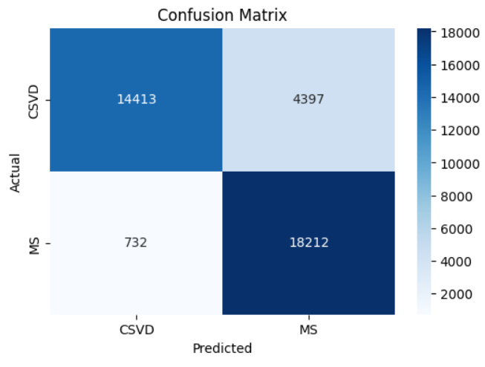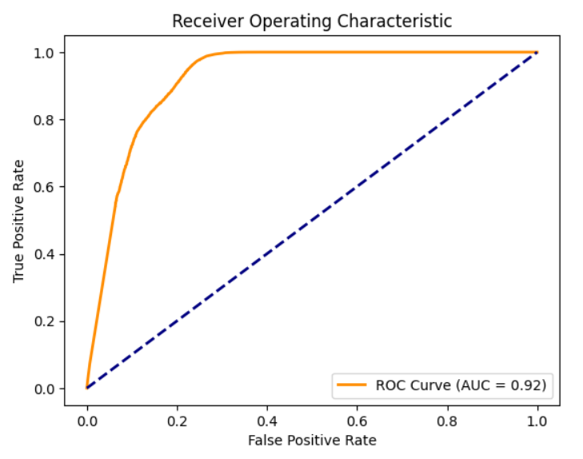
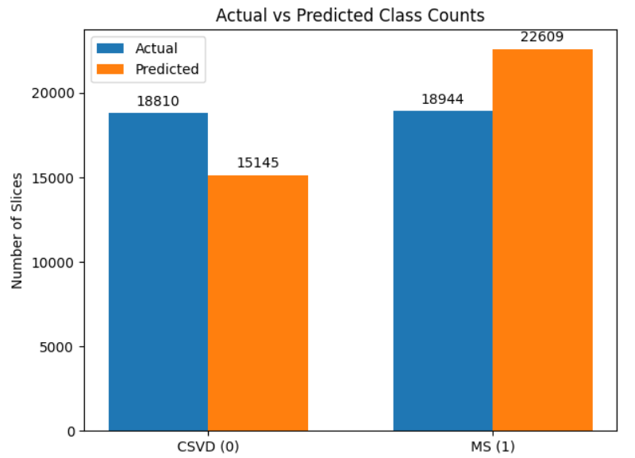
For a deep learning model, we need to define the dataset images along with metadata specifying the type of preprocessing has to done with which are the images and required for final preprocessing. After applying the defined preprocessing steps, we train the neural network using the preprocessed dataset with an appropriate number of epochs. This results in a pretrained model, which can then be tested using input images to evaluate the model's accuracy.

6. Justification
- Why HOG + GLCM performed best: These two feature sets complement each other — HOG captures spatial structure, while GLCM encodes textural information. Their combination offers a richer feature representation.
- Why Skull Stripping improved results: By removing non-brain regions, irrelevant background noise was eliminated, improving model focus and generalization.
- Lesion Detection matters: Emphasizing regions with abnormalities ensures the classifier trains on disease-relevant patterns.
- Why Deep Learning was not used: Given the limited size of labeled datasets and high computational cost, classical machine learning was more interpretable and suitable for this mini project.
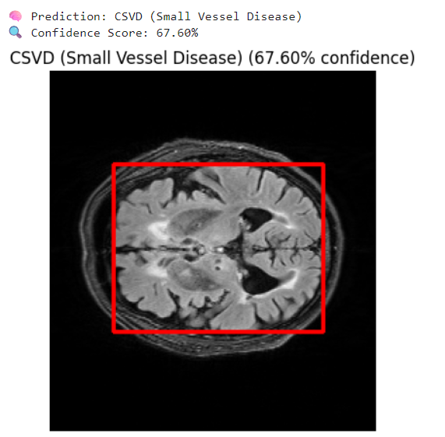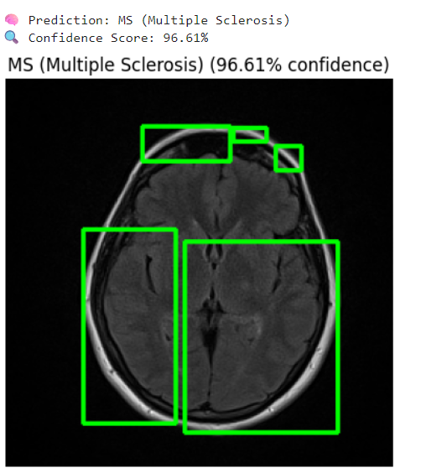
7. Conclusion
This project demonstrates a successful machine learning-based approach for distinguishing between MS and CSVD using FLAIR MRI scans. By combining classical computer vision techniques (HOG, GLCM, lesion detection) with a robust classifier like Random Forest, the model achieves high accuracy and interpretability. The system can assist radiologists in achieving faster and more consistent diagnoses, ultimately contributing to better clinical decision-making and patient care.

