MS PowerPoint Accessibility Techniques
Table of Contents
MS PowerPoint Accessibility Techniques 5
Introduction 5
Accessibility Checker Overview 5
How to Use the Accessibility Checker 6
Mac Accessibility Checker 7
Online Accessibility Checker 8
Other Versions of Microsoft PowerPoint - Accessibility Checker 9
Styles and Appearance 9
Slide Design/Themes 10
Built-in slide themes SHOULD be used. 10
Slide Layout, Slide Master, and Layout Masters 11
Slide Master and Layout Masters 11
Built-in slide layouts SHOULD be used. 13
Slide Transitions and Animations 16
Slide transitions SHOULD be avoided. 16
Animations SHOULD be simple (as opposed to flashy or complex). 18
Color Contrast 19
Small text and images of small text (under 18 point regular font or 14 point bold font) MUST have a contrast ratio of at least 4.5 to 1 with the background. 19
Small text (under 18 point regular font or 14 point bold font) SHOULD have a contrast ratio of at least 7 to 1 with the background. 20
Parts of graphics that are not words but still convey information MUST have a color contrast ratio of at least 3 to 1. 21
Large text and images of large text (at or over 18 regular font or 14 point bold font) MUST have a contrast ratio of at least 3 to 1 with the background. 22
Background patterns SHOULD be avoided. 23
Color to Convey Meaning 25
If color is used to convey information, it MUST be accompanied by a text alternative. 25
The text alternative for information conveyed by color MUST accurately convey the same information without color. 26
If color is used to convey information, it MUST be accompanied by a visible alternative (text, image, graph, etc.) that does not depend on color for meaning. 27
Flashing and Blinking 28
Flashing or blinking content MUST be avoided (unless it meets the specific WCAG permissible criteria). 28
Structural and Semantic Elements 28
Slide Title 29
Each slide MUST have an accurate, informative title. 29
The title of each slide SHOULD be unique. 30
Language 31
The language of the presentation (and any language of parts, if present) MUST be specified. 31
Headers and Footers 34
Headers and footers SHOULD be inserted in the Slide Master or Layout Masters using a new text box or an image. 34
Footnotes and Endnotes 36
Columns 37
Columns MUST be real, semantic columns and not created using the tab key. 37
Superscripts and Subscripts 39
Superscripts and subscripts SHOULD be avoided (with some exceptions). 39
Slide Numbers 40
Text and Fonts 41
Images and Other Graphics 42
Alt Text 42
Long Descriptions 48
Watermarks and Background Images 50
Text Boxes, Shapes, and Other Floating Objects 51
Series of Images 51
Graphs and Charts 52
Links 56
Designate Links Correctly 57
Link Text 59
Visually Distinguishable from Text 62
Links to Other Slides 63
Tables 64
Linked and Embedded Files 67
Multimedia 69
Automatic Captions and Subtitles 70
Math and Equations 71
Speaker Notes and Comments 72
Reading Order 73
Saving and Exporting 75
Summary and Checklist 78
Summary 78
Checklist 78

MS PowerPoint Accessibility Techniques

Introduction
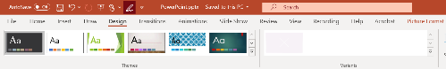
Figure 1: Banner illustrating the concept of document accessibility

Overview
PowerPoint accessibility shares many general concepts with other electronic documents, such as using sufficient color contrast and adding alt text to images. But there are also some unique features to examine, such as slide design and embedded multimedia. In this course, we’ll explore the topics you need to know to create an accessible PowerPoint presentation.

Web Accessibility Guidelines
This curriculum is based on the following web accessibility guidelines:
- WCAG: Web Content Accessibility Guidelines 2.2, Level AA

Conformance to Guidelines
The Web Content Accessibility Guidelines do not refer specifically to electronic documents, but rather to web content in general. If you are publishing your PowerPoint presentation online, it becomes web content and it is important to follow the guidelines outlined in this course. Even if you are not publishing it online but distributing it otherwise, it is strongly recommended to follow these guidelines so that the file is accessible. In our web content curriculum, when we use the words MUST, SHOULD, and MAY in all capital letters, they are in reference to conformance with WCAG 2.0 Level AA as follows:
- MUST: Required
- SHOULD: Strongly recommended
- MAY: Optional or conditionally recommended
In this PowerPoint course, which is part of our accessible document curriculum, the words MUST, SHOULD, and MAY in all capital letters refer to our interpretation of how the WCAG concepts apply to PowerPoint.

Accessibility Checker Overview
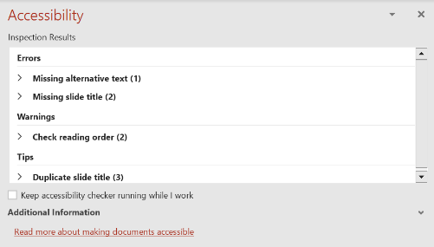
Figure 2: Accessibility Checker pane showing errors, warnings, and tips
Like other Microsoft Office programs, PowerPoint includes a built-in Accessibility Checker. This automatic tool cannot check for all accessibility issues but is a good starting point. To run it, go to the Review tab of the Ribbon and click Check Accessibility. The Accessibility Checker checks your file against a set of possible issues that people who have disabilities might experience in your file. Each issue is classified as an Error, Warning, or Tip.
- Error: An error is for content that makes a file very difficult or impossible for people with disabilities to understand.
- Warning: A warning is for content that in most, but not all, cases makes a file difficult for people with disabilities to understand.
- Tip: A tip is for content that people with disabilities can understand, but that might be better organized or presented in a way that would improve their experience.
You can also turn on a feature to provide automatic alt text for images, which is generated by artificial intelligence. If you use this feature, you may see another type of classification for issues, called Intelligent Services. This means that you should check the suggested alt text for accuracy, completeness, and context. For detailed explanations of the issues the Accessibility Checker looks for, see Rules used by the Accessibility Checker.

How to Use the Accessibility Checker
Windows
- On the Ribbon, click Review > Check Accessibility.
- The Accessibility Checker task pane showing the results appears.
- Click a specific issue to see Additional Information and steps you can take to address the issue.
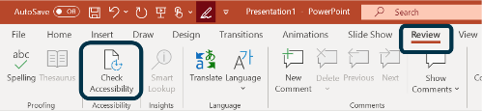
Figure 3: the Accessibility Checker button in the Ribbon
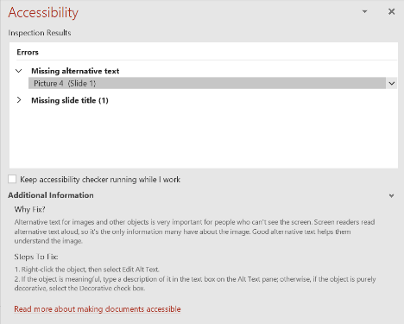
Figure 4: Accessibility Checker dialog box showing errors and explanations

Mac Accessibility Checker
Mac
- On the Ribbon, click Review > Check Accessibility.
- The Accessibility Checker task pane showing the results appears.
- Click a specific issue to see additional explanations and steps you can take to address the issue.
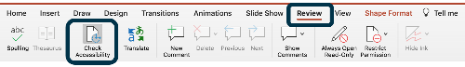
Figure 5: the Accessibility Checker button in the Ribbon
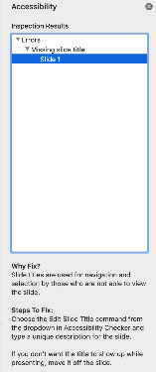
Figure 6: Accessibility checker results pane

Online Accessibility Checker
Online
- On the Ribbon, click the drop-down arrow for More Tabs, then Review > Check Accessibility.
- The Accessibility Checker task pane showing the results appears.
- Unlike the full version of PowerPoint, PowerPoint Online does not offer specific suggestions for how to fix the accessibility issues; it only lists them.
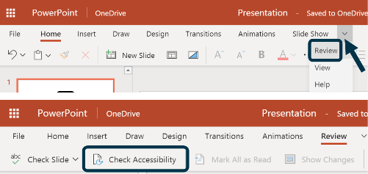
Figure 7: The Accessibility Checker button located within the 'More Tabs' section of the PowerPoint Online Ribbon
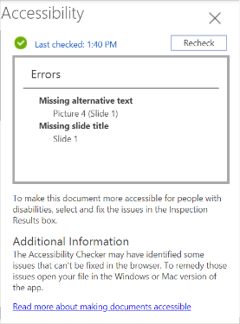
Figure 8: The Accessibility Checker side pane in PowerPoint Online displaying a categorized list of accessibility errors

Other Versions of Microsoft PowerPoint - Accessibility Checker
If you don't see your version of Microsoft Office on this page, refer directly to the Microsoft website for guidance: Microsoft: Using the accessibility checker

Styles and Appearance
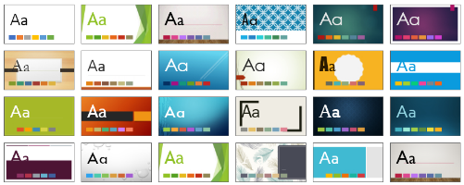
Figure 9: Abstract illustration representing visual design and document accessibility

Introduction:
Good visual styling in a PowerPoint presentation can not only provide a great aesthetic experience for your audience, but it also ensures that your file is accessible to many different users, including people with vision disabilities, reading disabilities, and those who may experience seizures.

Slide Design/Themes

Built-in slide themes SHOULD be used.
PowerPoint offers a selection of built-in slide designs/themes (also known as templates). In newer versions of PowerPoint, they are generally accessible. However, you should always check them for accessibility issues such as poor color contrast or text that is too small to read comfortably. For example, here is a built-in slide theme with poor color contrast between the text and background. The light lime green text against the white background does not meet WCAG minimum requirements. So if you chose to use it, you'd need to tweak the colors to ensure good contrast.

Figure 10: built-in slide theme with poor color contrast between text and background

A word of caution:
Unfortunately, a number of the built-in slide templates have some issues with color contrast. Text against the background may be too difficult to read and fail contrast guidelines, as shown above. The background may have a pattern that makes text against it difficult to read. Other components such as built-in graph color schemes may also have color contrast issues. The good news is that you can modify many of these colors in the slide master/layout masters (discussed below) so you’d only need to fix them once in your presentation. The simpler, cleaner templates are more accessible. Avoid ones with background patterns or gradient colors. Nevertheless, the importance of using these built-in themes is that they ensure good semantic structure and logical reading order, and in many cases good color contrast (though again, you must double check this). Screen readers read the content in the order the elements were added to the slide. So if you were to first place a text box containing the body text and then add a title afterwards, the slide would be read out of the intended order.

Where to Find the Built-In Slide Designs
Windows On the Design tab of the Ribbon, select your choice from the Themes section.
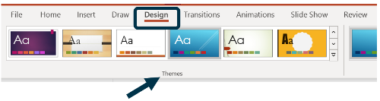
Figure 11: the slide themes section in the Ribbon
Mac On the Design tab of the Ribbon, select your choice from the Themes section.
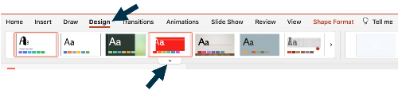
Figure 12: The slide themes section in the PowerPoint Ribbon on macOS
Online On the Design tab of the Ribbon, select your choice from the Themes section.
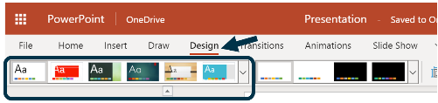
Figure 13: The slide themes section in the PowerPoint Online Ribbon

Slide Layout, Slide Master, and Layout Masters

Slide Master and Layout Masters
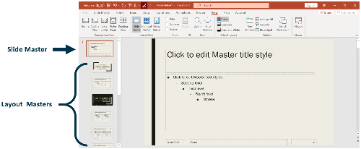
Figure 14: The slide master view interface in Microsoft PowerPoint
Windows Using slide and layout masters in PowerPoint allows you to make styling changes that will affect multiple slides. To open the Slide Master view, go to View > Slide Master. To exit Slide Master View, just select Close Master View on the Ribbon.
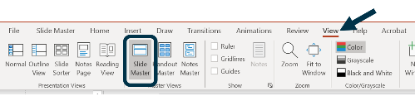
Figure 15: The slide master view button in the Windows Ribbon
The Slide Master appears at the top of the thumbnail pane in the left. Changing the Slide Master will affect all slides that are based on that master in the entire presentation. For example, you might want to use a logo that appears on all slides and use the same font throughout. Below the master slide are Layout Masters. Changing these slides will affect all slides of that type in your presentation. For example, one of the layout options is Title and Content. If you modify this layout master, then all Title and Content slides you insert based on it will have the same layout and design. Mac Using slide and layout masters in PowerPoint allows you to make styling changes that will affect multiple slides. To open the Slide Master view, go to View > Slide Master. To exit Slide Master View, just select Close Master View on the Ribbon.
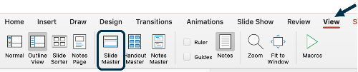
Figure 16: The slide master view button in the PowerPoint Ribbon on macOS
The Slide Master appears at the top of the thumbnail pane in the left. Changing the Slide Master will affect all slides that are based on that master in the entire presentation. For example, you might want to use a logo that appears on all slides and use the same font throughout. Below the master slide are Layout Masters. Changing these slides will affect all slides of that type in your presentation. For example, one of the layout options is Title and Content. If you modify this layout master, then all Title and Content slides you insert based on it will have the same layout and design. Online Slide Master and Layout Masters are not available in PowerPoint Online.

Built-in slide layouts SHOULD be used.
When you insert a new slide into your presentation, you can right-click it and select the Layout option. There you will see a variety of choices, such as Title Slide, Title and Content slide, Picture with Caption, and others. These are slides with pre-designed layout (the text and image boxes in which you place content). It’s a good idea to use these (rather than inserting a blank slide and creating your own text boxes) because they provide good semantic structure and logical reading order. For example, the image below shows one of the built-in slide designs and built-in slide layouts, for a slide containing a picture, a title, and text. The visual order of these three content areas is:
- Picture
- Title
- Text
However, because this slide has been properly assembled, a screen reader user tabbing through it would hear the content in the logical order:
- Title
- Picture
- Text

Figure 17: Example of a slide using a built-in layout with a title, a picture on the left, and a text block on the right.
When you open a new blank presentation in PowerPoint, by default, a plain Title slide appears with a title and subtitle. Right-clicking the title slide in the left navigation menu and selecting New Slide will insert a slide with a built-in title and content layout. You can change the layout by right-clicking it and selecting Layout. Using these built-in options is good. It’s less advisable to insert a blank slide and create your own content areas using Insert > Shapes > Text Box, or to copy/paste content areas in the built-in slide layout. Again, this is because you may inadvertently create content areas that are not in the correct reading order, which would cause confusion for screen reader users. We'll discuss how to check the reading order later in the class.
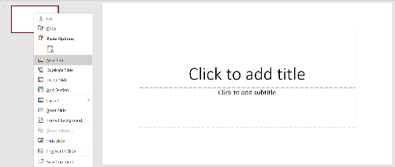
Figure 18: Interface showing a new PowerPoint presentation with a default title slide and the navigation pane on the left.
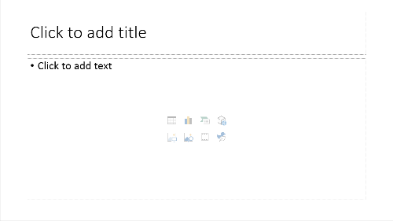
Figure 19: A blank PowerPoint slide using the standard Title and Content layout.

Note:
The built-in slide themes discussed on the prior page and the built-in slide layouts discussed here are closely related. Themes affect the visual styling (colors, fonts, etc.) and layout of content on a slide, whereas layouts affect just the layout of content on a slide. The commonality between them is that you should use both of these built-in options rather than creating your own, because they have accessibility built into them (for the most part).

Bad Example: Built-in Slide Layout Not Used
In this example, the slide has been manually created by inserting a blank slide and then inserting three textboxes (one for the title and two for content areas). However, they have not been inserted in the slide in the correct reading order. They would be announced by a screen reader in this order:
- Left content area
- Right content area
- Title
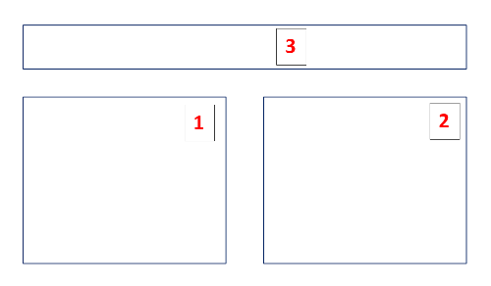
Figure 20: A slide that visually looks correct but was created with manual text boxes, resulting in an incorrect reading order for screen readers.

Good Example: Built-in Slide Layout Used
In this example, the built-in layout for Two Content (with title) has been used. The contents areas are read correctly in order:
- Title
- Left content area
- Right content area
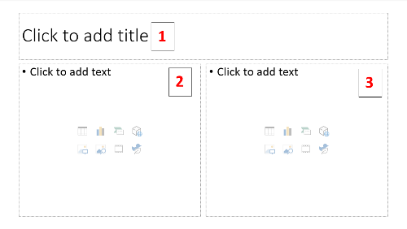
Figure 21: A slide using the 'Two Content' built-in layout, ensuring the title and both content boxes are read in the correct logical sequence.

Slide Transitions and Animations

Slide transitions SHOULD be avoided.
Transitions and animations are sometimes confused or used interchangeably, but they are two distinct features.
- Transitions are applied to the whole slide. For example, you might have your slide fade from black to visible (not advisable).
- Animation effects are applied to items within a slide. For example, you might have each item in a bullet list appear one by one.
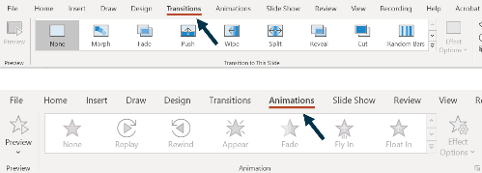
Figure 22: The Transitions and Animations tabs highlighted in the Microsoft PowerPoint Ribbon interface
Slide transitions should be avoided. Even the simpler ones such as "Wipe" (in which the slide wipes into view from one direction) can be distracting to all users, not just users with disabilities, and detract from the actual content. Not to mention there are some extremely flashy transitions that are even more of a visual onslaught. The default transition is set to None, and this is the recommended option.

Bad Example: Slide Transition Used
In this example, the transition "Random Bars" has been used. The screenshot below shows the middle of the effect, in which the slide is covered by black and white bars. This transition is distracting and visually overwhelming, and should be avoided.
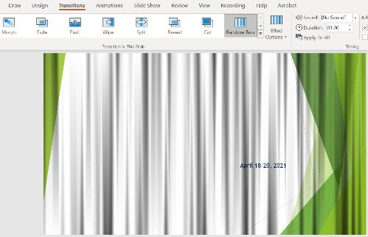
Figure 23: A PowerPoint slide partially obscured by the distracting black and white vertical bars of the Random Bars transition

Good Example: No Slide Transition
The slide below has the default transition "None" selected. The slide simply appears on screen during presentation mode, with no flashy visual transition.
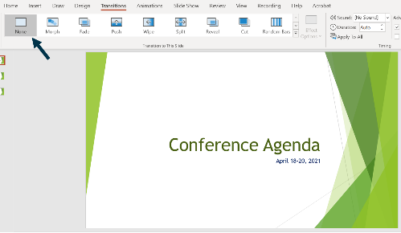
Figure 24: PowerPoint interface showing a slide with the default None transition selected in the transitions gallery

Animations SHOULD be simple (as opposed to flashy or complex).
Animations, on the other hand, can be effectively used if they are simple. For example, you may want each item in a list to appear one by one (when you are in presentation mode) so that the audience focuses on each one. The best one to use is simply "Appear," as it is very simple and doesn’t create a distraction. Most of the other animations are flashier and should be avoided.
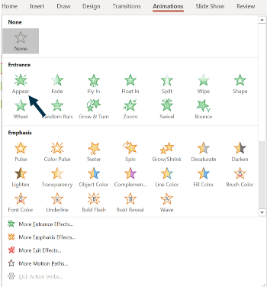
Figure 25: The PowerPoint Ribbon showing the Appear animation selected within the Animation gallery

Bad Example: Distracting Animation Used
The slide below shows a bulleted listed with the animation "Spin" applied to each item. Each item spins around in a circle (so the text appears upside down at one point) before returning to normal view. This animation is excessive and distracting and should be avoided.
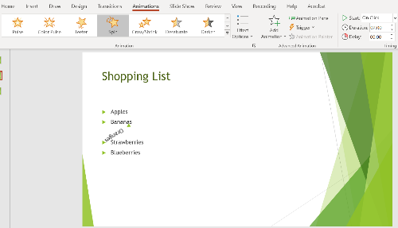
Figure 26: A slide showing bullet points rotated mid-animation to demonstrate the distracting Spin effect

Good Example: Simple Animation Used
Now the effect has been changed to simply "Appear." In presentation mode, when you advance to the next item, each one will simply appear on screen with no visually distracting movement, flashing, spinning, etc.
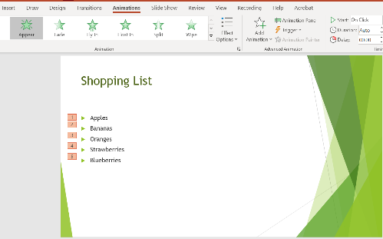
Figure 27: A clean bulleted list on a slide utilizing the simple and non-distracting Appear animation

Color Contrast

Small text and images of small text (under 18 point regular font or 14 point bold font) MUST have a contrast ratio of at least 4.5 to 1 with the background.
It’s important that text and images are easy to see against the background. This is especially helpful for users with low vision. This can be accomplished by using good color contrast of at least 4.5 to 1 with the background. This is the minimum requirement for WCAG Level AA. Keep in mind also that presentations are a little bit different from other documents because sometimes you may be presenting in a large room where users don’t have the document right in front of them. This means that while using the minimum color contrast may satisfy WCAG requirements, you may want to use even sharper contrast to provide a better user experience. For example, black text on white background has a contrast ratio of 21:1, which is excellent. Note that the default minimum text size in PowerPoint is 18 font regular, which classifies as large text (rather than small text). While WCAG doesn’t explicitly specify a minimum text size for presentations, 18 is a good minimum size and you shouldn’t use text smaller than that. In this case, the small text rules wouldn’t really apply to your presentation (but you should be aware of them anyway) and you should instead focus on the large text rules, covered further below on this page.

Small text (under 18 point regular font or 14 point bold font) SHOULD have a contrast ratio of at least 7 to 1 with the background.
A contrast ratio of 7 to 1 is better than the minimum requirement noted above. But again, the text size in your presentation should be 18 point font or greater, so the rules for small text wouldn't apply.

Bad Example: Small Text Bad Color Contrast
The slide below shows a shopping list with 5 items written in size 12 font. The items are written in light green against white, with a contrast ratio of 1.6 to 1, which is very poor and difficult to read.

Figure 28: A PowerPoint slide showing a list of text in size 12 font with very low contrast light green text on a white background.

Good Example: Small Text Good Color Contrast
Now the contrast ratio has been improved to 8.4 to 1. However, note that the font is too small to read comfortably. But we’re just using this example to illustrate the rule of color contrast for small text.

Figure 29: A PowerPoint slide showing size 12 font text with a high contrast dark green color against a white background.

Parts of graphics that are not words but still convey information MUST have a color contrast ratio of at least 3 to 1.
There are components that are neither text nor images, yet they still convey meaning and must have good color contrast. For example, a line in a line chart or pie slices in a pie graph. Another example that can be easy to miss is elements in the built-in slide templates of PowerPoint. For example, the default styling of the slide below has small light green triangles as the bullet points. They have a ratio of 2.1 to 1 with the white background, which doesn't meet the minimum requirements. This isn’t a critical element, but it does convey meaning (namely, that each item is part of a list). In this case, we’d need to go to the Bullets and Numbering section in the Home tab of the Ribbon and edit the color of the bullets.
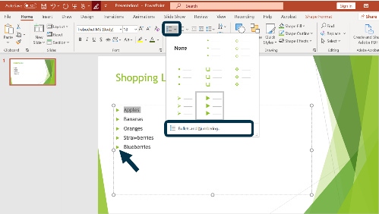
Figure 30: A PowerPoint slide where light green triangular bullets have poor contrast against the background, with an inset showing the Ribbon menu for editing bullet colors.

Large text and images of large text (at or over 18 regular font or 14 point bold font) MUST have a contrast ratio of at least 3 to 1 with the background.
All of the text in your accessible presentation should be at least 18 point font or larger. For large text, the minimum contrast ratio per WCAG is lower, 3 to 1. But again, it’s much better to use a higher color contrast. It helps to think in line with the goal of providing a great user experience, rather than the goal of satisfying minimum requirements.

Bad Example: Large Text Bad Color Contrast
Here is an example of a built-in slide design in PowerPoint with poor color contrast. The subtitle text is size 20, in the color light blue. It is against a blue gradient background, and the color contrast ranges between 2.1 to 1 and 2.5 to 1 in different areas of the gradient. This is below the minimum contrast requirement of 3 to 1 and far below the best practice of 7 to 1 and higher.

Figure 31: A PowerPoint slide with size 20 light blue subtitle text on a blue gradient background demonstrating insufficient contrast.

Good Example: Large Text Good Color Contrast
This is a different built-in slide design with good color contrast. The subtitle text was set to 16 points by default, so we increased it to 18 points for better readability. The text is a medium-tone purple against a white background with a contrast ratio of 7.5 to 1.

Figure 32: A PowerPoint slide showing size 18 purple text on a plain white background demonstrating high color contrast.

Background patterns SHOULD be avoided.
Background patterns can interfere with readability of text, so it’s best to avoid them. If you do choose to use one, the color contrast rules still apply. You’d need to check the pattern color area that has the smallest color contrast with the text and ensure that it meets the minimum contrast requirements. But again, even if you do meet this requirement, it can still make it challenging for all users to read the text.

Bad Example: Background Pattern Used
This slide uses a built-in template design in PowerPoint that includes a grey and white background pattern. Although you can still probably read the black text on it if you are a sighted user, you might notice your eyes straining.
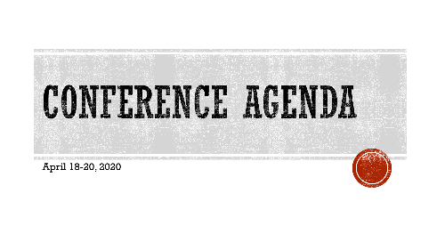
Figure 33: A PowerPoint title slide where a busy grey and white background pattern behind the black text makes reading more difficult.

Good Example: Background Pattern Doesn't Interfere with Readability
In this slide, we have another built-in template design. There is a background pattern of colored feathers, however, the background directly behind the white text is plain grey. Therefore, the pattern doesn’t interfere with readability.

Figure 34: A PowerPoint slide with a decorative feather pattern on the edges but a solid grey background behind the text areas to maintain readability.

Color to Convey Meaning

If color is used to convey information, it MUST be accompanied by a text alternative.
Some users do not depend on color to understand information. For example, people who are colorblind, people who are blind, and people who are deafblind. Any time you include meaning that depends on color (for example, a colored pie graph), you must ensure that there is a text alternative.

Bad Example: Pie Chart with No Text Alternative
The pie chart below shows favorite exercise types. There is a color legend that shows what each pie slice represents, but there are no text alternatives. Imagine looking at this chart in black and white and trying to discern what each pie slice means. Even if you do see color perfectly, at least two of the colors are quite similar and would be easy to confuse.
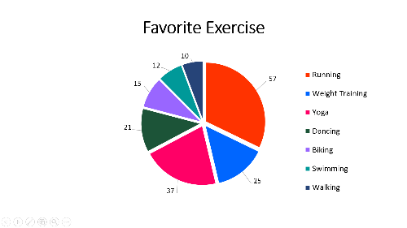
Figure 35: Pie chart showing exercise preferences using only a color-coded legend without text labels on the slices.

Good Example: Pie Chart with Text Alternative
Now we have added alt text to the pie chart that explains in text what the graph shows. To add alt text, right-click the chart and select Edit Alt Text.
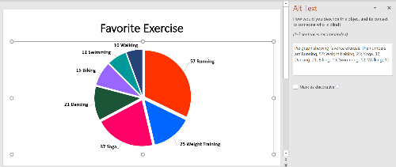
Figure 36: Pie chart depicting exercise data with descriptive alternative text provided in the metadata.
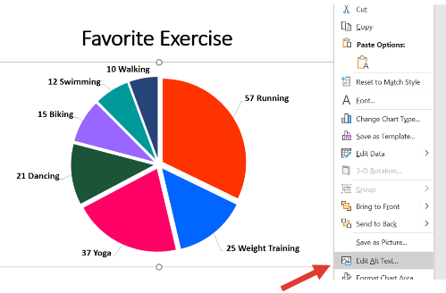
Figure 37: Screenshot of the PowerPoint context menu highlighting the Edit Alt Text option for a chart.

The text alternative for information conveyed by color MUST accurately convey the same information without color.
The text alternative must be an accurate and complete substitution for the information presented using color. Make sure that you provide all relevant information so that a user can completely understand the meaning conveyed.

Bad Example: Text Alternative is Incomplete
In the prior good example above, notice that the alt text completely describes the pie graph. It lists the count for each sport without leaving any information out. A bad way to describe the graph would be: "Pie graph showing favorite exercise, with running and yoga being the two most popular." This only highlights the top two exercises and leaves the rest out of the description.
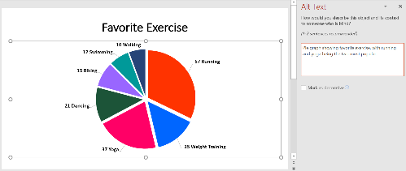
Figure 38: Pie chart with an Alt Text pane showing a summary that omits specific data points for several categories.

If color is used to convey information, it MUST be accompanied by a visible alternative (text, image, graph, etc.) that does not depend on color for meaning.

Bad Example: Pie Chart Legend Without Visible Text Labels
In this example, the pie chart includes alt text, which is good, but it doesn’t include visible text labels that would help sighted users who don’t rely on color. Alt text is hidden to sighted users unless they deliberately access it (and most don’t). So a person who is color blind wouldn’t understand the graph below, which includes only a color-based legend.
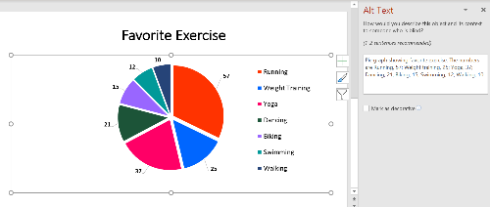
Figure 39: Pie chart using a color-only legend which is inaccessible to sighted users with color vision deficiencies.

Good Example: Pie Chart with Visible Text Labels and Alt Text
Here we have the most accessible version of this pie graph. It includes visible text labels that are placed next to each corresponding pie slice, and it includes alt text.
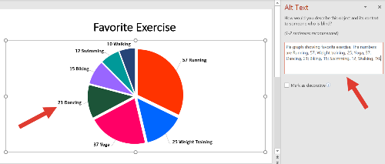
Figure 40: Fully accessible pie chart featuring both direct text labels on the slices and comprehensive alternative text.

Flashing and Blinking

Flashing or blinking content MUST be avoided (unless it meets the specific WCAG permissible criteria).
Unlike Word documents, which very rarely (if ever) have flashing or blinking content, PowerPoint files might contain these elements more often. For example, a video file with flashing or a flickering slide animation. Flashing, blinking, or flickering content can trigger photosensitive epileptic seizures in people who are susceptible to them. For this reason, it’s best to avoid this content altogether. If you include an embedded video or a link to a video, ensure that it doesn’t flash or flicker. If you use animations in your slide, choose very simple ones such as simply "Appear," rather than flickering ones. If you absolutely must use this type of content (which is almost never the case), you must adhere to specific WCAG guidelines. For example, the content must not flash more than 3 times per second. For detailed information about permissible content, please refer to the WCAG Section 2.3 on Seizures Guidelines.

Structural and Semantic Elements
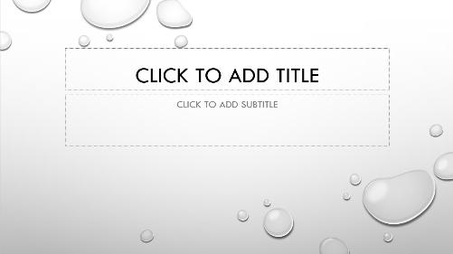
Figure 41: Abstract illustration representing document structure and infrastructure

Introduction:
Structure and semantics make up the skeleton or infrastructure of your document. They are what allow assistive technologies to effectively interact with the content and convey meaning to the user. For example, a meaningful and unique slide title allows a screen reader user to know what that slide contains before they jump into the main content and start reading.

Slide Title

Each slide MUST have an accurate, informative title.
The slide title serves the same function as a web page title does for a web page. It informs the user what the slide is about, so they can orient themselves before reading the main content. Make sure that you provide an accurate, informative title for each slide.

Bad Example: Slide Without Title
The slide below shows an agenda for a presentation, but there is no title.
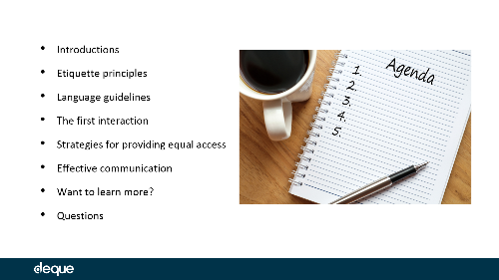
Figure 42: An agenda slide showing a list of items but lacking a structural title at the top

Good Example: Slide with Accurate and Informative Title
The slide below has a title that reads: Top 3 Tips — Interacting with Customers with Physical Disabilities. The title is exactly representative of the content in that slide, which includes 3 do’s and 3 don’ts for interacting with people with physical disabilities.
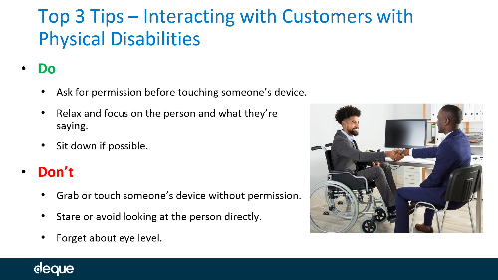
Figure 43: A PowerPoint slide featuring a clear, descriptive title followed by organized bullet points of advice

The title of each slide SHOULD be unique.
It’s best to provide a unique title for each slide. This may not be possible in all cases, but most of the time it is, and this rule is a best practice to follow. A screen reader user can then jump around to the slide they want to read and not confuse two different slides if they have the same title.

Language

The language of the presentation (and any language of parts, if present) MUST be specified.
Windows

Set Proofing Language for the Whole Document
Microsoft Office automatically detects what language your operating system uses and sets this language as the default for programs such as PowerPoint. To manually set the editing language:
- Go to the File menu
- Select More and then Options from the list in the left window pane
- Select Language from the list in the left of the Options dialog
- Under Office authoring languages and proofing, select the editing language you want to use.
- Click Set as Preferred and then OK.
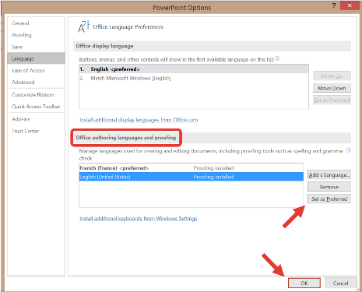
Figure 44: Language preferences dialog in PowerPoint for Windows showing Office authoring languages and proofing settings

Specify the Language of Parts
If part of your document is written in a different language (for example, a foreign language quote), you must specify this. Here is how:
- Select the text that is in a different language.
- Go to the Review tab > Language button > Set Proofing Language option.
- Choose the appropriate language in the pop-up dialog.
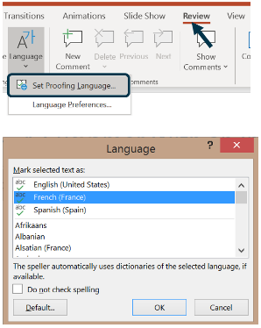
Figure 45: Set language of selected text dialog in PowerPoint for Windows displaying a list of available languages for proofing
Mac

Set Proofing Language for the Whole Document
Microsoft Office automatically detects what language your operating system uses and sets this language as the default for programs such as PowerPoint. To manually set the editing language:
- Go to Tools
- Select Language
- Select the Language you want
- Click Set As Default
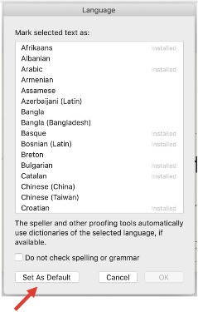
Figure 46: Language dialog box in PowerPoint for Mac showing the selection of proofing languages and the Set As Default button

Specify the Language of Parts
PowerPoint for Mac automatically detects and sets the proofing language of parts, but only if that language is installed. If not, you’ll see the squiggly underline appear (the words are marked as misspelled) because the program will mark it with the overall document language. If the language you want to use isn't already installed, review this article from the Microsoft support website, which provides step-by-step guidance on adding an editing or authoring language. Online

Set Proofing Language for the Whole Document
The default language for a PowerPoint Online document is based on the User settings within an Office Online account. You cannot change the proofing language for an entire file in PowerPoint Online. But, you can set the proofing language for words/phrases and selected boxes of text.

Specify the Language of Parts
To specify language of parts:
- Select the text in a different language.
- Right-click and select Set Proofing Language.
- Choose the language you’d like from the menu and click OK.
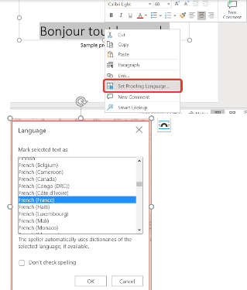
Figure 47: Dialog box in PowerPoint Online showing a searchable list of languages to set for proofing selected text

Headers and Footers

Headers and footers SHOULD be inserted in the Slide Master or Layout Masters using a new text box or an image.
If you use the feature Insert > Header/Footer from the Ribbon, this will create text boxes that are read like any other part of the slide. They are announced in the order they were placed relative to the other objects on the slide. The same is true if you apply a "traditional" header or footer from the slide/layout master view. Traditional in this case means that you use one of the pre-existing text boxes from that view (shown below), rather than creating your own.
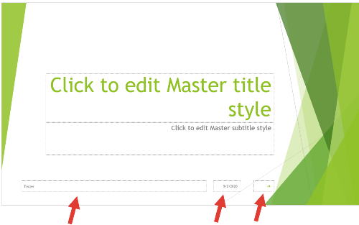
Figure 48: Slide master editing view with arrows pointing to the pre-existing footer boxes that should not be used
If you use the two options noted above, there is no way to mark a header or footer as decorative so that a screen reader ignores them (or ignores all instances except the first one). So a screen reader user would hear them announced on every slide, which is tedious and wastes time. Instead, if you need to add a header or footer, do so in the slide or layout masters by using one of these two methods:
- Create a new text box and position it at the top or bottom. Again, do not use one of the pre-existing text boxes that you see in the master view.
- Insert your header or footer as an image.
These two methods will create a header or footer that becomes part of the background in a built-in way (a user can’t tab to it). Just remember, if you include vital information in the header or footer, reproduce it somewhere in the slide body (for example, in the title slide or first body slide) so a user can tab into it one time and get the meaningful info, and then they don't have to listen to the other instances of it.

Bad Example: Header Created Using the Ribbon
The slide below includes a sample header that reads Company ABC. This has been created by using the Insert option in the Ribbon, and a user can tab into it. You can test a slide yourself and tab around to see what elements get highlighted/selected.
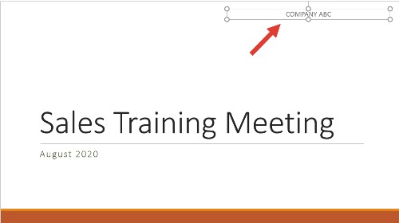
Figure 49: A PowerPoint slide showing a header that is focusable and announced by screen readers due to incorrect insertion via the Ribbon

Good Example: Footer Built Into the Slide Master
The slide below shows a footer banner with the Deque logo. It has been created using the Slide Master, and a user can’t tab into it to hear it announced.
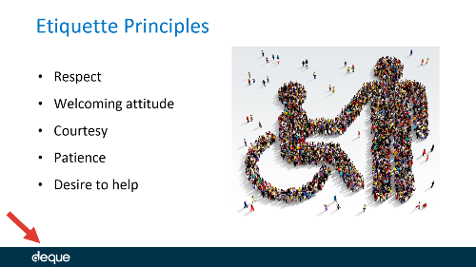
Figure 50: A PowerPoint slide with a footer correctly integrated into the background via the Slide Master, preventing repetitive screen reader announcements

Footnotes and Endnotes

Overview
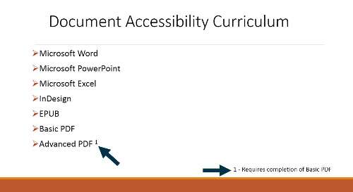
Figure 51: An example footnote on a slide, with the number 1 in superscript in the slide body and the footnote placed in a footer
Footnotes are accessible in PowerPoint. To create a footnote, type the number of the note (for example, 1, 2, etc.) in superscript next to the relevant text in the slide body. Then insert a footer and type the same number and then the rest of the footnote text. In this case, you’ll want to insert a regular footer from the Ribbon (Insert > Header & Footer) so that a user can tab into it and read it, rather than using the methods outlined in the prior section on headers and footers, which would make the footer completely inaccessible to screen reader users. Unfortunately, there is no way to jump directly from the superscript number to the relevant footnote, which means that the additional information would be read later, after the rest of the text in the slide body. By this point, the user may have forgotten what the footnote refers to, but at least they are able to navigate back and re-read if needed. Refer to this Microsoft tutorial on adding or removing footnotes for step-by-step guidance. Endnotes don't really exist as such in PowerPoint. There is no Insert Endnote option in the Ribbon, as there is in Microsoft Word. So you can include endnotes in your slide by just using a regular text box.

Columns

Columns MUST be real, semantic columns and not created using the tab key.
It’s not common to see multiple columns of text in PowerPoint, because the space is somewhat limited to begin with. However, if you do decide to create multiple columns, use the Column button in the Format Shape menu of the text box, rather than using the tab key. If you use the tab key, a screen reader will read across both columns, row-by-row, so the text would be out of order and wouldn’t make sense. You can also type the word Column in the search bar and the option "Add or Remove Columns" will appear, which is often a quicker shortcut.

How to Modify Number of Columns
Windows
- Select the text-box.
- Under the Paragraph section in the Ribbon, select the Columns button.
- Select the number of columns you’d like to use.
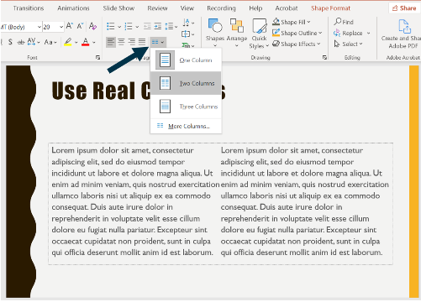
Figure 52: PowerPoint Ribbon showing the Columns button with Two Columns highlighted
Mac
- Select the text-box.
- Under the Paragraph section in the Ribbon, select the Columns button.
- Select the number of columns you’d like to use.
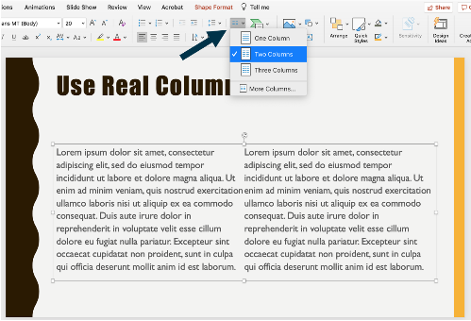
Figure 53: PowerPoint for Mac Ribbon showing the Paragraph section with the Columns button selected and 'Two Columns' highlighted.
Online
- Online
Creating multiple columns in PowerPoint Online is not possible, though you can view multiple columns in a file you've uploaded to OneDrive that was created using the full version of PowerPoint.

Superscripts and Subscripts

Superscripts and subscripts SHOULD be avoided (with some exceptions).
Superscripts and subscripts are read as regular text in most cases. This is an issue with screen readers and not with PowerPoint, but it’s good to be aware of this shortcoming. For example, if you type x squared with an exponent in PowerPoint, it would be read as "x two," which has a completely different meaning. In cases where you are using superscripts or subscripts simply for visual styling (for example writing 1st with the letters s and t in superscript), screen readers will read it correctly. But keep in mind that in cases where meaning relies on superscript and subscript formatting, such as mathematical expressions, there will likely be significant accessibility barriers. We will discuss math in more detail later in the course.

Bad Example: Superscript Exponent Used
The slide below includes the formula E equals mc squared. However, it has been written using the exponent 2 in superscript and a screen reader would read this as "E equals mc two."
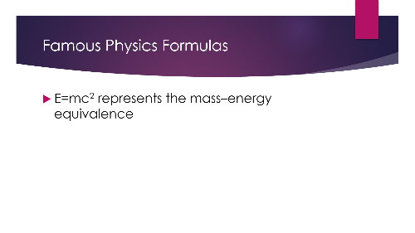
Figure 54: A PowerPoint slide showing the formula E=mc² where the '2' is a small superscript character

Good Example: Formula Written Without Superscript
Now the formula has been written with the word squared, rather than using the exponent 2 in superscript. Admittedly, this isn’t the most elegant solution, because most sighted users are used to seeing something like this written with an exponent. As screen readers become more advanced, they will likely recognize exponents more accurately.
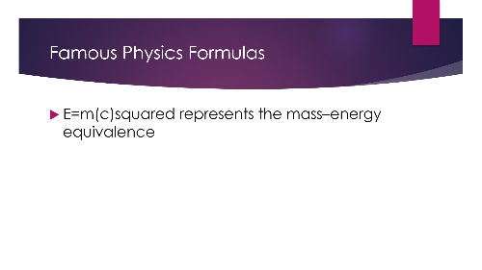
Figure 55: A PowerPoint slide showing the formula written as 'E = mc squared' using standard sized text for all words

Slide Numbers

Overview
You can choose to insert slide numbers as they may help with navigation. Whether you insert them from the Ribbon in the Insert > Header & Footer section, or by editing the Slide Master, a screen reader user will be able to tab into the text box containing the slide number and hear it announced. Do not add slide numbers manually by inserting a text box on each slide as you run the risk of incorrect reading order. The default size of slide numbers is usually quite small, so it’s recommended to increase it to the minimum size of 18 point.
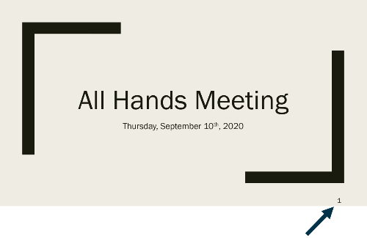
Figure 56: A PowerPoint title slide with the slide number '1' clearly visible in the bottom right corner

Text and Fonts
The topic of text and fonts is covered extensively in the Microsoft Word course, so to avoid redundancy, we’ll outline the concepts in bullet form here; they are not difficult to grasp.
- You can use both serif and sans-serif fonts.
- Avoid using overly decorative fonts, which are hard to read.
- Set the font size to at least 18 point for PowerPoint (it’s smaller for MS Word), and even larger where appropriate.
- Avoid using excessive capitalization. Note that many of PowerPoint’s built in slides unfortunately include all caps. Correct this in the slide master view: Highlight the text, then go to the Home tab, Font fly-out menu, and un-check the all caps option.
- Do not rely on bold, italic, and underline as the only way to convey meaning. Screen readers generally do not read font styling, unless a user has changed the default settings (and most users do not).
- Avoid using excessive font styling because it is difficult to read.
- Avoid using strikethrough text. Screen readers treat it as regular text unless the user changes the settings in the reader, and hardly anybody changes those particular settings.
- If you need to highlight something important, you can use the highlight text feature and also use the word "Important" right before (for users who do not rely on vision).
- Keep in mind that many symbols and special characters are not announced correctly (or at all) by screen readers. Stick to plain text as much as possible and test with a screen reader when in doubt.

Images and Other Graphics

Figure 57: Banner for Images and Graphics

Introduction:
Images and other graphics are very common in PowerPoint files. The good news is that making them accessible is quite easy and straightforward — you just need to follow a few specific steps.

Alt Text

How to Add Alternative Text
In newer versions of PowerPoint, when you insert an image (and often when you copy/paste one, as well), alt text will be automatically generated for you by the program. Do not rely on this auto-generated text, because it can be incomplete or inaccurate. Windows
- Right-click the image and select Edit Alt Text.
- Type the alt text in the menu that pops up to the right.
- If the image is decorative, write the word Decorative as the alt text (do not check the box that says "Mark as decorative"). The reason for this is explained further on this page.
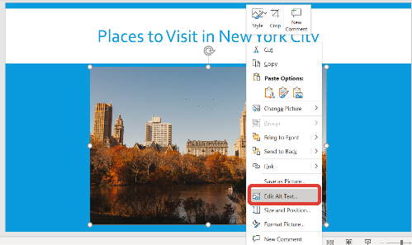
Figure 58: edit picture menu showing option for edit alt text selected
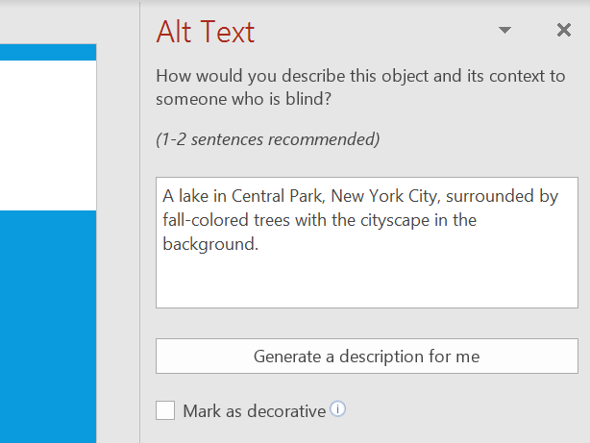
Figure 59: edit alt text pane with sample alt text filled out
Mac
- Right-click the image and select Edit Alt Text.
- Type the alt text in the menu that pops up to the right.
- If the image is decorative, write the word Decorative as the alt text (do not check the box that says "Mark as decorative"). The reason for this is explained further on this page.
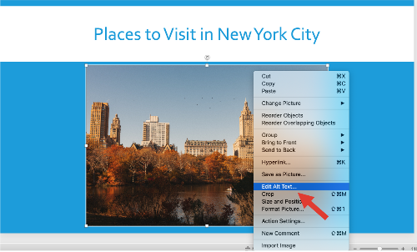
Figure 60: edit picture menu showing option for edit alt text selected
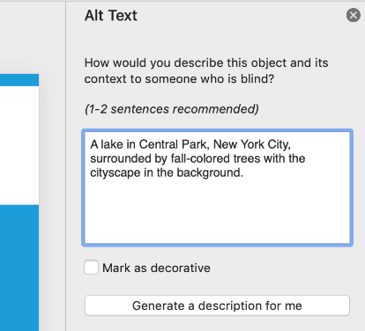
Figure 61: edit alt text pane with sample alt text filled out
Online
- Right-click the image and select Edit Alt Text.
- Type the alt text in the menu that pops up to the right.
- If the image is decorative, write the word Decorative as the alt text. The reason for this is explained further on this page.
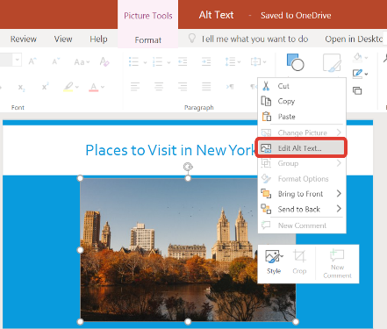
Figure 62: edit picture menu showing option for edit alt text selected
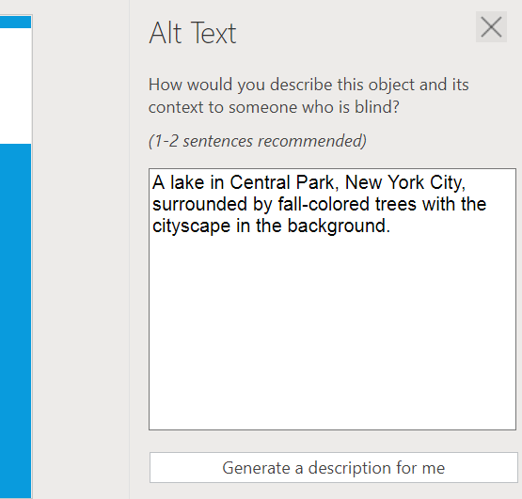
Figure 63: edit alt text pane with sample alt text filled out

Other Versions of Microsoft PowerPoint - Alt Text
If you don't see your version of Microsoft Office on this page, refer directly to the Microsoft website for guidance: Microsoft: Adding alt text

Images that convey content MUST have programmatically determinable alternative text.
Alt text is a description of an image that can be conveyed by a screen reader to users who are blind or have low vision. As noted above, newer versions of PowerPoint automatically add alt text to many images, but do not rely on it without checking it for completion and accuracy.

Bad Example: Image Missing Alt Text
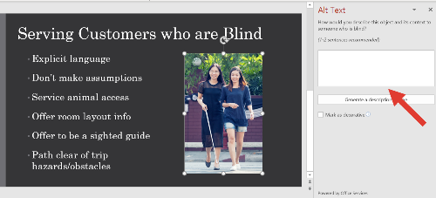
Figure 64: an image in a slide without alt text

Good Example: Alt Text Present
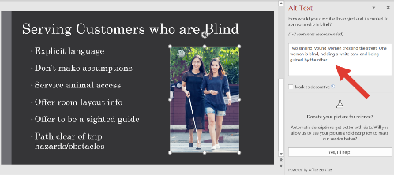
Figure 65: an image in a slide which has alt text

The alternative text for informative images MUST be meaningful (accurately conveying the purpose of the image, and the author's intent in a way that is useful to those who cannot see the image).
The purpose of alt text is to serve as a replacement for meaningful (as opposed to decorative) images. Ensure that the alt text is complete and accurate. Ask yourself, if someone were to read only the alt text, would they have a good idea of what the image is?

Bad Example: Incomplete Alt Text
The image below shows a slide from a presentation on how to best serve customers with disabilities. The focus in this slide is serving customers who are blind. The associated image shows two smiling women crossing the road, one of them who is blind, carrying a walking stick and being guided by the other. However, the alt text just reads "Two smiling women." When you are creating alt text, ensure that it provides a complete substitute for the meaning conveyed in the image. You don’t want to be too detailed (for instance, describing the type of clothes the people are wearing in this case), but being too brief results in essential meaning being lost to users with visual disabilities.
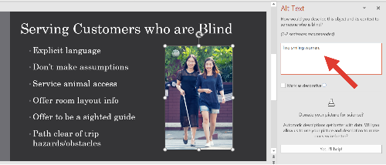
Figure 66: an image in a slide which has alt text

Alternative text SHOULD NOT include words that identify the element as a graphic or image.
Screen readers automatically announce that an object is an image, so there is no need to include the words "image of" or "picture of" in the alt text.

The length of the alternative text for informative images SHOULD be concise (no more than about 150 characters).
While there is no official limit for alt text length set by WCAG, we recommend keeping it to 150 or fewer characters. Alt text can’t be navigated in the same way as regular text (pausing and resuming, or repeating just a single word or sentence). So it should be succinct. There is a balancing act between providing complete alt text while also ensuring that it isn’t too long.

Images that do not convey content, are decorative, or are redundant to content that is already conveyed in text MUST be given alt text that identifies them as such.
Some images serve only a decorative purpose. When that is the case, place the word Decorative as the alt text. Do not check the option that says, "Mark as decorative." The intent of this feature is to allow screen readers to completely ignore the graphic (similar to including an empty alt text attribute in HTML, alt=""). Unfortunately, not all screen readers have yet caught up with this advancement. When this option for decorative image is checked, NVDA and JAWS will announce that there is a graphic present, but not anything else. So a user doesn’t know if the image is decorative or if the author simply forgot to add alt text. VoiceOver does, however, correctly announce it as a decorative image.

Bad Example: Mark as Decorative Option Checked
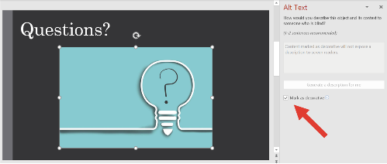
Figure 67: a decorative image in a slide with the option ‘mark as decorative’ checked

Good Example: Alt Text Given as the Word Decorative
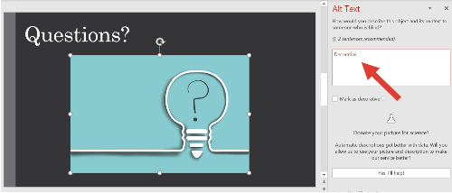
Figure 68: a decorative image in a slide with the alt text ‘decorative’

Long Descriptions

Complex images MUST be briefly described using alt text AND MUST have a more complete long description.
Some images are too complex to be adequately described in the alt text field. In this case, a longer description is needed. You can place this description in the Speaker Notes (they are accessible), in the slide body next to the image, or include a link or button to access the description elsewhere.

Bad Example: Missing Long Description
The slide below includes a complex infographic showing the number of US business applications from 2007 through 2020. There are various elements, including how many applications were submitted and year-to-year percent change. The alt text provided is insufficient to fully describe all the data presented.
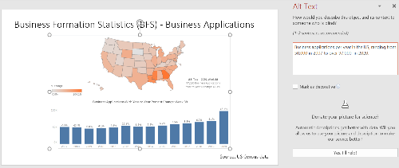
Figure 69: complex infographic with only alt text and no long description

Good Example: Complex Image With Long Description
Now we have included a link to an Excel file right after the complex image, which would serve as the long description in this case. In the alt text, we would include the brief description and then something like, "See Excel link following image for complete data."
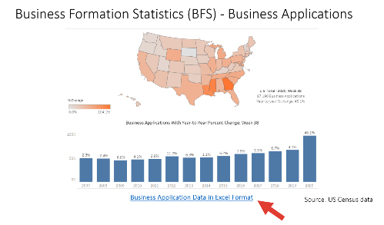
Figure 70: a complex image with a link to an Excel file that serves as the long description

The long description (or a link or button to access the long description) SHOULD be visible to sighted users.
Sighted users can also benefit from long descriptions (especially in making sense of a complicated image or graphic), so make sure that it’s visible to them. Do not hide the long description (for example, by using white font on a white background).

Watermarks and Background Images

Watermarks and background images SHOULD be avoided.
Both watermarks and other background images interfere with readability. For this reason, they should be avoided. Additionally, if you add a watermark or background image in the slide master view, it becomes part of the background in a "burned in" sort of way. Screen reader users can’t tab into it and won’t know it’s there; there is no way to add alt text to it. So if it includes essential information such as the word "confidential," some users may entirely miss it.

Bad Example: Slide With Background Image
The slide below has a background image of a pie graph. Although the transparency effect has been applied, it still makes it difficult to read the text in the foreground, "2021 Budget," without straining.
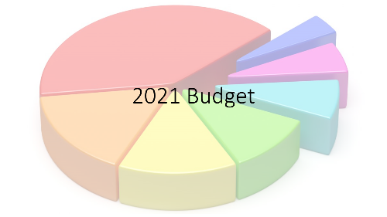
Figure 71: a slide with the title 'budget' and a background image of a pie graph

Good Example: Slide Without Background Image
It’s much easier to read text that isn’t positioned against a background image.

Figure 72: a slide with the title ‘budget’ and no background image

Text Boxes, Shapes, and Other Floating Objects

Overview
PowerPoint differs from Word in one very significant way: floating objects are easy to navigate and make up the very nature of the entire deck. The title field in a slide, for instance, is a text box. However, unlike in Word, where navigating text boxes with a screen reader is tedious, in PowerPoint, a user just needs to tab around the slide and each object will be selected, announced, and the alt text (if present) will be read. You do not need to add alt text to text boxes, since the contents are directly read by a screen reader, but you MUST add alt text to other non-text objects, including shapes and icons (and of course, images, graphs, charts, etc.).

Series of Images

A series of related images or shapes MUST be semantically grouped and marked with appropriate alt text and long description (if needed).
Sometimes you may have a series of shapes or images that create a meaningful graphic, but each individual item is not meaningful. In this case, you must semantically group them together so they create one object and mark them with appropriate alt text that describes the whole. It wouldn’t make sense to give each shape or image its own alt text since they would only be meaningful together as a whole. Review this Microsoft tutorial for detailed steps on grouping and ungrouping shapes, pictures, and other objects. In cases where the alt text is insufficient to fully describe the series of images or shapes, then provide a long description, as well.

Bad Example: Shapes Not Grouped
In this example, we have 5 star shapes (4 shaded), to demonstrate a 4 out of 5 star rating. They have not been grouped and each of them is labeled with the alt text, "star. "
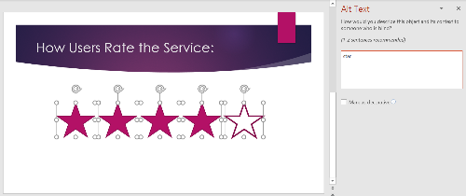
Figure 73: 5 star shapes that are not grouped and have the same alt text

Good Example: Grouped Shapes With Alt Text
Now the stars have been grouped together as a single object with appropriate alt text.
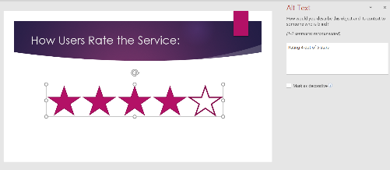
Figure 74: grouped shapes with single alt text

Graphs and Charts

Graphs and charts MUST be clearly labeled.
Make sure that all graphs and charts are clearly labeled. Include a title, axis labels, data labels, and any other relevant labels that make the graph easy to understand. This is necessary for all users, not just for users who have disabilities.

Bad Example: Graph Poorly Labeled
Here we have a chart showing the breakdown of calorie intake in a day: fruits/vegetables, meat, dairy, grains, and added fats. Each of the pie slices includes a text label, but no associated value, so a sighted user is left guessing or estimating the value of each based on how big the pie slice is, and a screen reader user would miss this information entirely (since we wouldn’t have it available to put in the alt text).
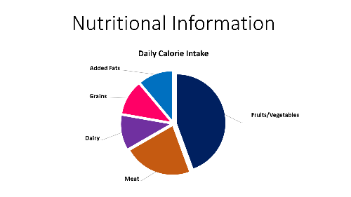
Figure 75: a pie graph with incomplete data labels showing only the text value but not the numerical value of each slice

Good Example: Graph With Complete Labels
In this improved version of the chart, the value has been added to each text label so that users can see how many calories fall in each category, and this information would need to be added to the alt text, as well.
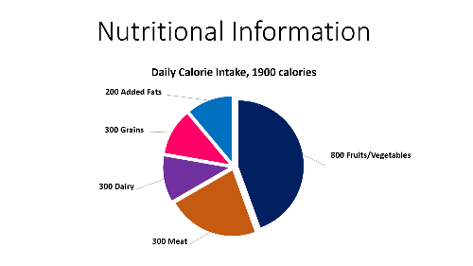
Figure 76: a pie graph with complete data labels showing the text and numerical value of each slice

Graphs and charts MUST have alt text and a long description (if needed).
Graphs and charts must include alt text and long descriptions (if needed). Like for images, the alt text for graphs and charts must be meaningful and should be succinct. The description provided should fully convey the information in the graph so that it serves as a complete substitute.

Bad Example: Graph With Incomplete Alt Text
This calorie intake pie graph is simple enough to describe fully within the alt text. But in this example, only the general idea of it has been conveyed in the alt text: "Daily calorie intake out of 1900 calories divided by different food categories." There is vital information missing — each food group name and the associated calories.
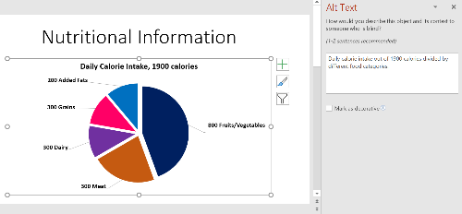
Figure 77: a pie graph with incomplete alt text

Good Example: Graph With Complete Alt Text
With the improved alt text here, a screen reader user would know the full meaning of the graph: "Daily calorie intake out of 1900 calories: 800, fruits/vegetables; 300, meat; 300, dairy; 300, grains; 200, added fats."
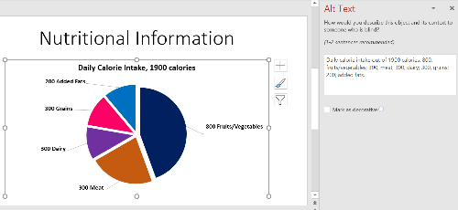
Figure 78: a pie graph complete alt text

Graphs and charts MUST follow color contrast guidelines for non-text contrast (3 to 1 minimum contrast ratio).
Graphs and charts must follow color contrast guidelines for non-text contrast (the minimum contrast ratio is 3 to 1). For example, pie slices or bar graphs must have a contrast ratio of 3 to 1 with the adjacent colors. For pie graphs, the easiest way to accomplish this is to explode or expand the chart so that the slices separate. That way, you don’t have to worry about each individual pie slice contrasting with the ones next to it (they must just all contrast well with the background). If you have a bar graph, ensure that the bars each contrast well against the background. For other graphs, ensure that all of the corresponding elements needed to read the graph effectively have good color contrast against adjacent colors. TIP: To explode a pie graph, drag the pieces out. This will create a thin separation between each slice. If you want to have a thicker separation, dragging them out further will result in a slightly misshaped/lopsided pie (as shown in some of the graphs on this page). A cleaner method is to right-click each slice and then increase the weight of the outline, matching the color to the background color (in this case, white).
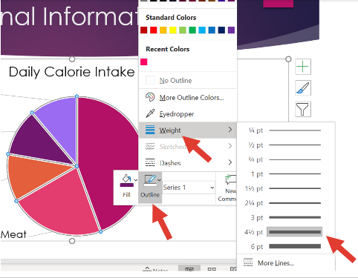
Figure 79: right-click menu for a pie slice in a graph showing the outline, weight option set to 4 and a half points

Bad Example: Graph With Poor Color Contrast
A word of caution: The Design tab of the Ribbon, where you choose pre-designed templates, has color-contrast issues. They can be easy to miss, but if you know what you’re looking for, you’ll learn to recognize them quickly. For example, many of the pre-selected colors for graphs and charts do not meet minimum color contrast requirements. Below is the same pie graph as it was created in Excel, then copy/pasted into PowerPoint, and a Design template applied. Three of the pie slices with the automatic colors applied (orange, yellow-green, and lime green) do not meet the 3 to 1 minimum ratio against the white background. So you’ll need to right-click each of those areas in the chart and modify the fill and outline color to provide better contrast.
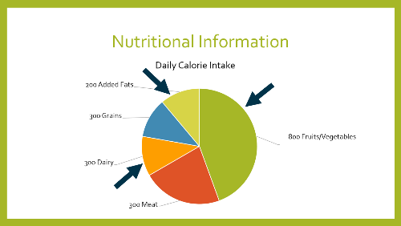
Figure 80: a pie graph some slices having poor color contrast against the white background

Good Example: Graph With Good Color Contrast
This is another pre-designed template from PowerPoint with the same graph. In this instance, only one of the slices didn’t have good color contrast and needed to have the color modified manually.
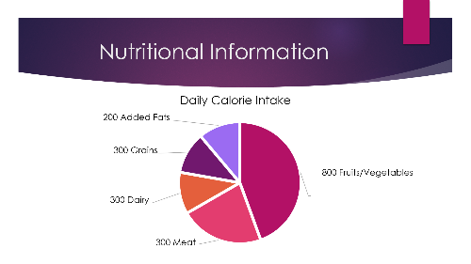
Figure 81: a pie graph with each pie slice having good color contrast against the background

Links
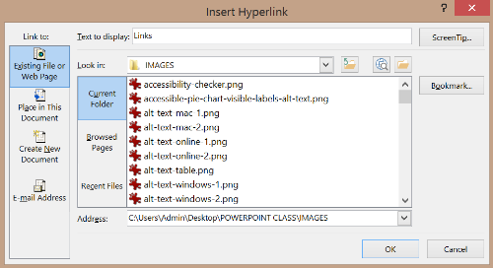
Figure 82: Banner for Links

Introduction:
Screen reader users can pull up a list of links in a document and navigate to them directly. But this is only possible if they are semantically designated as such. It’s also important to provide meaningful link text, so that a user knows where a link leads even if the link is read out of context with any surrounding text.

Designate Links Correctly

Links MUST be semantically designated as such.
In order for a screen reader to effectively navigate links, they must be semantically designated as such. When you type in a URL and hit Enter, PowerPoint automatically takes care of this for you by making the text a clickable hyperlink. If you copy/paste a URL or you type it in, but you forget to hit Enter, the link will not be a real link. So just don't forget to hit Enter and also avoid right-clicking the link and selecting Remove Link.
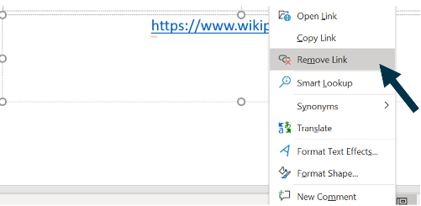
Figure 83: right-click menu showing remove link option

Note:
Links in PowerPoint can be challenging to navigate using screen readers. For example, when in editing mode, both JAWS and NVDA do not announce that something is a link unless you are reading the text line by line (rather than tabbing through each text box). In presentation mode, JAWS does announce links, but NVDA does not.

Bad Example: Link Not Semantically Designated
This slide includes the URL to the Wikipedia home page, but it has not been semantically designated and appears just as plain, non-clickable text.
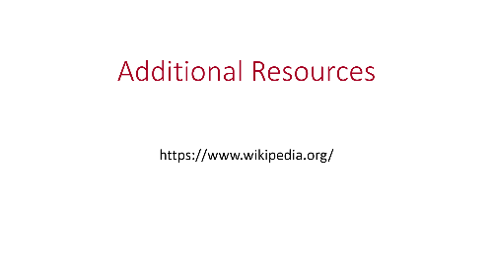
Figure 84: a non-clickable URL that appears as plain text on a slide

Good Example: Real Semantic Link
In this example, we’ve just hit Enter to make the non-link URL text from the above example a real, semantic, clickable link.
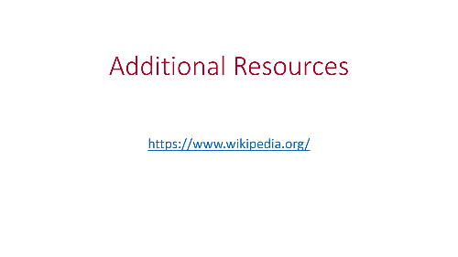
Figure 85: a clickable, real link

Link Text

The purpose of each link SHOULD be able to be determined from the link text alone.
This rule is more applicable to PowerPoint documents that will be digitally distributed (rather than ones that are only presented by someone to an audience, without distributing the slide deck). Screen reader users can navigate by various types of elements in a document, including links. If they pull up a list of links, it’s very helpful if they can recognize the purpose of each link from the link text alone, rather than needing any kind of additional context. This is referred to as "meaningful link text." The destination of some URLs can be determined relatively easily, especially if they are short and well-known (for example, Wikipedia or Facebook). But others may be a long string of characters, and without meaningful link text, a user wouldn’t know where that URL leads without having to spend time clicking and visiting the link. To add or edit meaningful link text, right-click the URL text and select Edit Link. In the dialog, place the meaningful link text in the Text to display field and then the URL in the Address field.
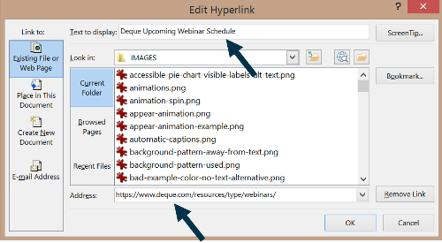
Figure 86: edit link dialog showing Text to display and Address fields

Bad Example: No Meaningful Link Text
The URL in this slide leads to the Deque webinar schedule. While the words within the URL are understandable (not a series of nonsensical characters), it’s not necessarily clear exactly what the web page is before a user visits it.

Figure 87: URL in a slide rather than meaningful link text

Good Example: Meaningful Link Text
Now the URL text has been replaced with the meaningful link text, Deque Upcoming Webinar Schedule. Again, this would be important in a document distributed to users. If you are just displaying it on screen in a presentation, then the URL should definitely be visible since otherwise no one would know what it would be.

Figure 88: link in a slide with meaningful link text

The link text SHOULD NOT repeat the word "link."
Screen readers will automatically announce that a link is a link, so including it in the meaningful link text is redundant and should be avoided.

Bad Example: Link Text Is Redundant
The three links in this slide all include the words "link to" in the link text which is unnecessary.
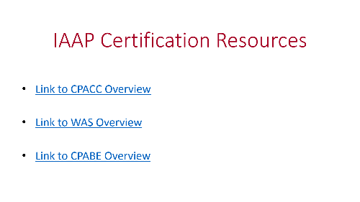
Figure 89: a slide with 3 links that all include the phrase ‘link to’ in the meaningful link text

Good Example: Link Text Is Not Redundant
Now the links remain with the same meaningful text, except that the words "link to" have been removed from each.
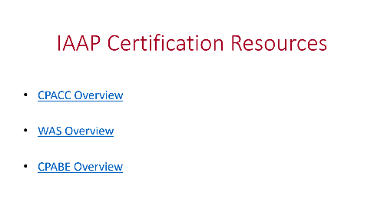
Figure 90: now the words ‘link to’ have been removed from each link text

The full URL SHOULD be included in the document (when appropriate).
As mentioned above, if you’re giving a presentation and are not distributing your slide deck to participants, then you should include the URL visibly on screen. This is also true if the presentation will be printed, since the URL would be invisible and only the meaningful link text would appear otherwise.

Good Example: Full URL Included
The three links in the slide below include both the meaningful link text, as well as the full URL next to each.
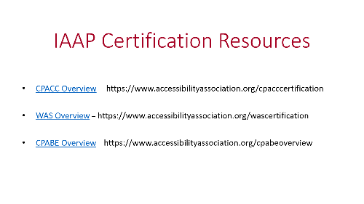
Figure 91: a slide with 3 links with meaningful link text, with the URL included visibly next to each link

Visually Distinguishable from Text

Links MUST be visually distinguishable from surrounding text.
Sighted users need to know that a link is a link. This means that it must be visually distinguishable from the surrounding text. When you include a URL and hit Enter, PowerPoint takes care of this for you by changing the color to blue and underlining it. This default option is recommended because it is customary — users expect blue, underlined text to be a link. Also, while some designers like to remove the underlining for visual styling, this can make it harder for users with low vision to distinguish links, so leave the underlining as is. Also, note that depending on which design template you have selected, the auto color for links when you type in a URL and hit Enter may not be blue so you may need to manually change it.

Good Example: Visually Distinguishable Links
The three links in this slide have the customary blue text and underline, so they are easily recognizable.
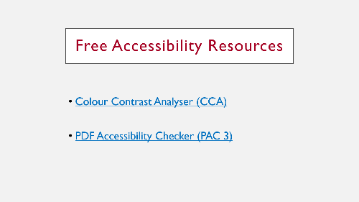
Figure 92: a slide with 3 links that are in blue, underlined text

Links to Other Slides

Linking from one slide to another SHOULD be avoided (with some exceptions).
You can link one slide to another slide within PowerPoint. For example, you might have an image button that links to another slide when activated. However, this feature is disorienting and should be avoided. A user may not realize that they have been taken to a different slide and may miss important content. The exception is if you’re just using this linking feature for yourself as the presenter, since you are familiar with navigating your slides and can jump around with ease. In cases where you are distributing a document to others, you should avoid creating links from one slide to another. To learn how to link between slides, review this Microsoft tutorial to Link to another slide in the same presentation.

Bad Example: Slide With Linked Slides
This example has been labeled as "bad" and contains a slide with four links to other slides. But again, if this is just for your own use as a presenter and you will be guiding the audience through the slides (and not distributing the deck), then it would be OK to use a slide like this.
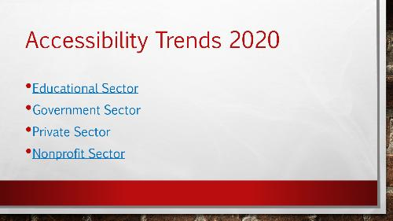
Figure 93: a slide with 4 links that link to other slides

Tables

Guidelines for Maximum Table Accessibility
If you do decide to use a table, follow these rules to ensure maximum accessibility:
- Use the Insert Table Tool in the Ribbon, and do not use the Draw Table Tool. The Draw Table tool creates a single image so a user can’t navigate it cell by cell.
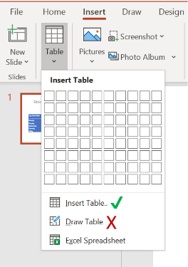
Figure 94: insert table flyout menu showing the insert table and draw table options
- Create a title for your table, which can be the slide title.
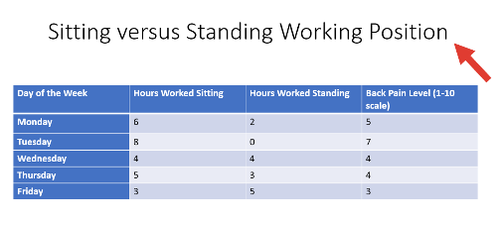
Figure 95: table with title 'Sitting versus Standing Working Position' showing hours of each type of work performed with a back pain level rating from 1 to 10, from Monday through Friday.
- Ensure that your table has real headers. On the Table Design Tab in the Ribbon, select either Header Row, First Column, or both. Although these headers are not currently recognized by screen readers, with technology improvements, they will be recognized in the future so it’s important to follow this rule to create semantic associations between header cells and data cells.
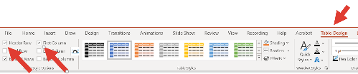
Figure 96: Table Design tab in the Ribbon showing the Header Row and First Column options checked, to create real headers
only one header row, one header column, or one of each
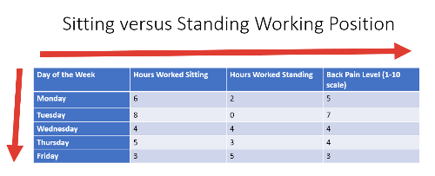
Figure 97: table with one header row and one header column
Do not use nested tables, split cells, or merged cells.
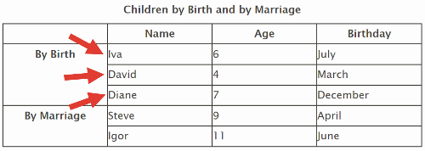
Figure 98: table with complex header associations
- Provide sufficient color contrast for your table (text against background). Note that some of the automatically-assigned colors in PowerPoint fail color contrast guidelines, so you’ll need to manually edit them or choose another color scheme.
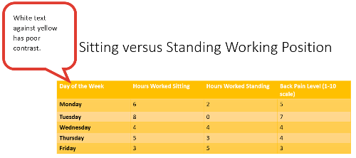
Figure 99: table headers in white text against yellow background, showing poor color contrast
- Provide alt text (and a long description if needed). Alt text can provide a brief summary of what the table is about. If the table is brief, it can even serve as a complete substitute. For the long description: you can insert an Excel or PDF file with the table into the slide (Excel and PDF tables are fully accessible), or a link to the table in HTML format, which is another accessible option.
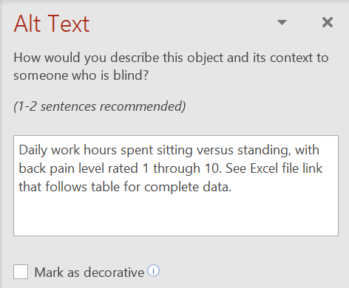
Figure 100: alt text for table: Daily work hours spent sitting versus standing, with back pain level rated 1 through 10. See Excel file link that follows table for complete data.

Tables in PowerPoint SHOULD be avoided.
Unfortunately, tables in PowerPoint are not as easy to navigate as those in Microsoft Word. When you first tab to a table, the whole object is selected. You have to enter editing mode to navigate it. Most screen readers do not announce headers in PowerPoint. A screen reader user can navigate a table in editing mode by moving from cell to cell, but the headers are not announced. It would therefore be very easy to lose your place in a table, even a short one. So while the data in a table is available to screen reader users, the semantic structure is not. For this important reason, tables should be avoided in PowerPoint.

Linked and Embedded Files

Overview
You can link to or embed other files in a PowerPoint file. If you link a file, it’s automatically updated within the PowerPoint file if the source file is changed. However, both files must be available to the end user. You can’t have the linked file on your computer, for example, and send the other person just the PowerPoint. This is a good option if the inserted object is large or complex. If you embed a file, it becomes an element within that file and can be viewed on another computer independently, since the source file is part of the PowerPoint file. This does increase the file size of the presentation, however. Review this Microsoft tutorial to learn how to Import content from other applications into PowerPoint. Note, to embed files, you have the option either to embed the file as an icon (which the user subsequently clicks to open), or to directly embed the content within the slide (almost like a snapshot of the file contents directly pasted into your slide). We do not recommend the second option because depending on the file, it can make the text very small and difficult to read.
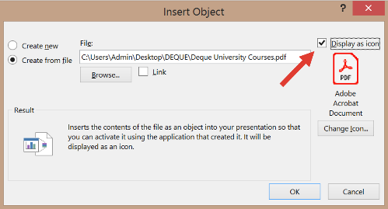
Figure 101: embed object dialog with option to display as icon checked

Linked files MUST follow the rules for links.
Follow the same guidelines as you would for any links, when creating links to files. Ensure the link text is meaningful, the color contrast is sufficient, and the link text is distinguishable from the surrounding text.

Good Example: Linked File With Meaningful Link Text
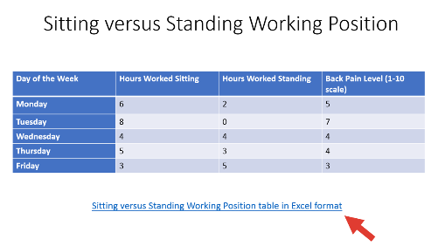
Figure 102: a linked Excel file with meaningful link text that reads: Sitting versus Standing Working Position table in Excel format

Embedded files displayed as an icon MUST have alt text.
Screen readers announce embedded files only as "embedded object." So, ensure that you specify what kind of file type it is within the alt text, as well as any other useful information. To add alt text, right-click the icon and select Edit Alt Text.

Good Example: Embedded File Icon With Alt Text
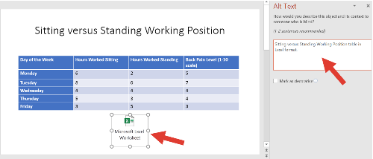
Figure 103: an embedded Excel file alt text that reads: Sitting versus Standing Working Position table in Excel format.

Multimedia

Overview
Multimedia accessibility is a broad topic with many considerations. Deque offers a full and detailed course on this topic, and it would not be feasible to cover all aspects as a subset of this course. However, below you will find several key highlights in ensuring multimedia accessibility.

Pre-recorded video MUST have synchronized captions.
Captions present the audio element of a video in text form, including dialogue and background sound effects. If you embed a video with open captions (burned-in captions that are always visible), that saves you the extra step of creating captions. If you do need to add them, review this Microsoft tutorial to Add closed captions or subtitles to media in PowerPoint.

Pre-recorded multimedia (video plus audio) SHOULD have a text transcript.
Prerecorded video files embedded within PowerPoint and containing essential information that is only conveyed visually SHOULD come with a full text alternative describing the important visual details. The transcript can be presented as an embedded file. A transcript is important so that deafblind users can easily access the information using a refreshable braille output device, since these devices do not work well (or at all) with captions, because the captions change too quickly. A text transcript is essentially a text log of all of the dialog and narration in a video, similar to the captions, but available separately from the video itself. As with captions, the text transcript should identify who is speaking, plus note sounds like applause and laughter. It should also describe other visual information — for example, descriptions of scenery, non-verbal communication between people, and anything else to provide an equivalent alternative to the content for people who are deafblind.

Pre-recorded media inserted as an object MUST have alt text.
If you insert a video or audio file as an object directly into a PowerPoint file, ensure that you provide alt text briefly describing the contents. Just right-click the object and select Edit Alt Text (just as you would for an image or other graphic). The transcript/captions would then serve as the long description.

Good Example: Video With Alt Text
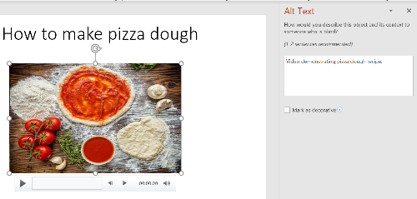
Figure 104: Screenshot of the Alt Text pane in PowerPoint showing a description for a video object

Automatic Captions and Subtitles

Overview
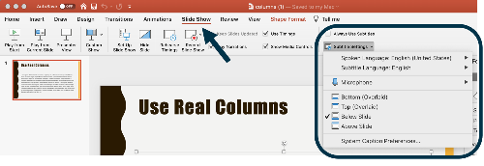
Figure 105: Screenshot of the Subtitle Settings menu under the Slide Show tab in the PowerPoint Ribbon
PowerPoint 365 for Windows and Mac and PowerPoint Online include a feature that provides real-time, automatic captions as you are giving a presentation (located in the Slide Show tab of the Ribbon). You can also choose to display them as subtitles translated to another language. Microsoft recommends the use of a headset microphone to produce more reliable transcription results. For details on using this feature, review the Microsoft tutorial, Present with real-time, automatic captions or subtitles in PowerPoint.

Math and Equations

Overview
Unfortunately, math in PowerPoint is not directly accessible. If you use the Insert Equation feature from the Ribbon, this will not produce an accessible result that can be correctly read by screen readers. So in general, you should avoid it.
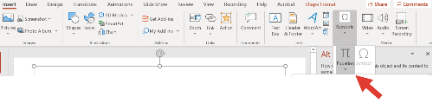
Figure 106: Screenshot showing the Insert Equation option located in the Symbols group of the Insert tab in the Ribbon
However, if you have a simple bit of math, for example, a short equation, you can use the Equation Editor and add alt text to the object, stating the equation with plain text and no symbols. For more complicated math, there are several options available, described below.
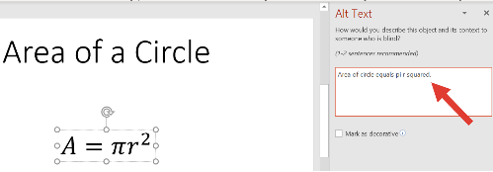
Figure 107: Screenshot of an equation object in PowerPoint with the Alt Text pane open showing: area of circle equals pi r squared

Option 1: Use MathType to Create MathML in PowerPoint
One of the best tools for creating accessible math is the MathType Equation Editor by Design Science. MathType creates MathML, which can be read intelligently by screen readers, allowing users to either read the whole equation, or pause and zoom in on parts of the equation to read them separately. MathType is not free, but it is the most complete solution currently available.

Option 2: Use MathML Cloud to Create a PNG Image with Good Alt Text
If you don't have access to MathType, you could use MathML Cloud to generate an equation as a PNG image with good alt text, and insert the image in your PowerPoint document. You will need to insert the image then add the alt text yourself (right-click and select Edit Alt Text). MathML Cloud generates intelligent alt text that works well for math equations, using words and phrasing that you might not consider if you were writing the alt text yourself. Generally we recommend that you not edit the alt text generated by MathML Cloud unless you are sure you can improve it for a specific equation.
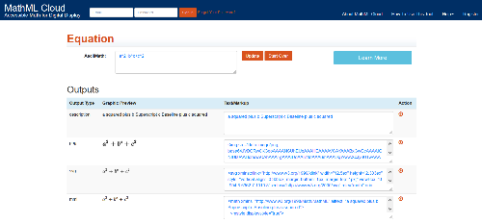
Figure 108: Screenshot of the MathML Cloud interface showing processed output options including text, PNG, SVG, and MathML
There are two main disadvantages of using this method:
- You have to write the equation in ASCII text, MathML, or LaTex. If you're not familiar with writing math using those methods, you'll have to learn.
- Even good math alt text is not as effective as MathML, because users can't navigate math equations written as alt text in the same way they can navigate math equations in MathML.

Speaker Notes and Comments

Overview
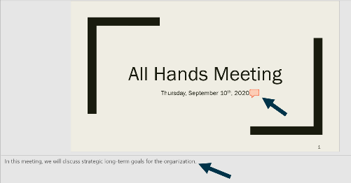
Figure 109: A PowerPoint slide showing a main content area, a side comment bubble, and the speaker notes section at the bottom
Both speaker notes and comments are accessible in PowerPoint. You don’t need to take any extra steps to ensure accessibility. To learn more about how to navigate speaker notes and comments using a screen reader, review this Microsoft tutorial.

Reading Order

Overview
As noted earlier in the course, the contents of a slide are read in the order in which they are added to the slide. If you accidentally add the title after you add the content, for example, the title will be read second. The automatic Accessibility Checker within PowerPoint does identify and flag possible errors with the reading order. However, you must not rely solely on it and must always manually verify the reading order. Use the Tab key to tab through the presentation and ensure that the reading order is logical.
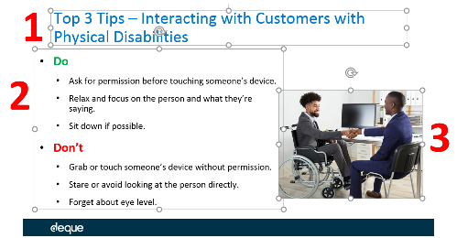
Figure 110: Diagram of a slide containing a title, text box, and image, with numbered badges 1, 2, and 3 indicating the sequence in which a screen reader will encounter them

The Selection Pane
If you choose to use the Selection Pane to check the reading order, keep in mind that it displays content items in the exact opposite of the actual reading order (this can be confusing, especially at first when you’re not used to this behavior). For example, the slide below shows a title, a content area with text, and an image (that is the sequential reading order). In the Selection Pane, this is displayed in the opposite order as:
- Picture 11
- Content Placeholder 6
- Title 5
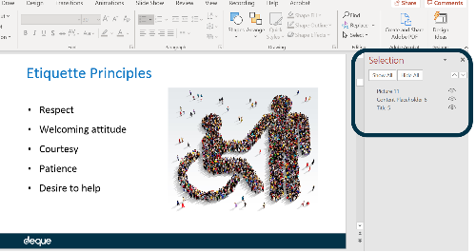
Figure 111: Screenshot showing the PowerPoint Selection Pane sidebar where slide elements are listed in reverse chronological order
The Selection Pane can be displayed by clicking anywhere in a slide, then selecting Selection Pane under the Arrange area in the Ribbon.
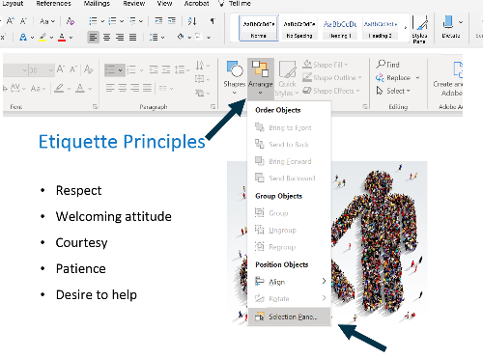
Figure 112: Screenshot of the PowerPoint Ribbon interface highlighting the Selection Pane button within the Arrange menu

Saving and Exporting

How to Save as PDF/Export
Windows
- Click File > Export.
- Click either Create Adobe PDF or Create PDF/XPS Document (if you don't have Adobe Acrobat).
- Then click the Create Adobe PDF button (or the Create PDF/XPS Document button).
- Note that the option to "Enable Accessibility and Reflow with tagged Adobe PDF" is checked by default, so just leave it as is.
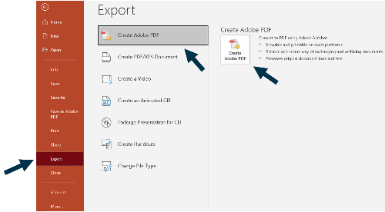
Figure 113: Screenshot of the Export menu in PowerPoint for Windows highlighting the Create Adobe PDF option
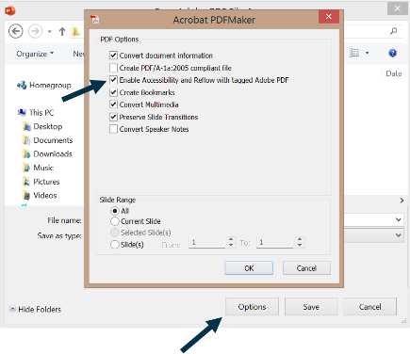
Figure 114: Screenshot of the PDF settings dialog box showing accessibility options enabled
Mac PowerPoint for Mac does not allow you to save as a tagged PDF. However, you can upload your file to OneDrive and download a tagged copy via the online version of PowerPoint. See the Online tab in this widget for instructions. Online
- Click File > Download As > Download as PDF.
- In the pop-up dialog, select Download.
- The file will automatically be created as a tagged PDF.
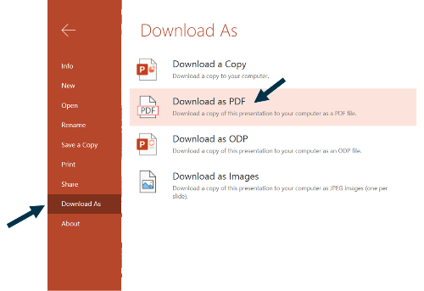
Figure 115: Screenshot of the File menu in PowerPoint Online showing the Download As PDF action
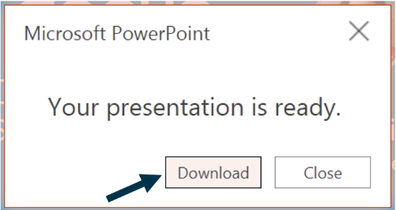
Figure 116: Screenshot of the confirmation dialog box stating your presentation is ready for download

Quirks When Exporting
Here are some behaviors we have observed when exporting to Adobe PDF. Keep in mind that you may experience other kinks and you should always manually check your PDF result to ensure that it’s properly tagged and the reading order is correct.
- Reading order might need to be adjusted (it may not match the reading order of the original PowerPoint file).
- Alt text for images carries over.
- Slide titles are tagged as paragraphs (you may want to convert them to heading tags).
- Lists may be split up into multiple list tags, or a single list may have redundant list tags (an extra nested list tag within the original one).
- Images marked as decorative by using the checkbox for "mark as decorative" within PowerPoint are correctly converted to artifacts. Again, that option should not be used in PowerPoint, for reasons discussed earlier.
- Tables are generally tagged correctly (again, be sure to manually check this).

Summary and Checklist

Summary
Congratulations! You made it to the end of this course. In this course, you learned how to make accessible PowerPoint presentations. Many of the concepts are shared with other digital documents. Understanding the similarities and differences between accessibility for different document formats will ensure that you are skillfully able to produce accessible digital content.

Checklist
See also the PDF version of the checklist.

Styles and Appearance

Slide Design/Themes
- Built-in slide themes SHOULD be used.

Slide Layout, Slide Master, and Layout Masters
- Built-in slide layouts SHOULD be used.
- Using slide and layout masters in PowerPoint allows you to make styling changes that will affect multiple slides.

Slide Transitions and Animations
- Slide transitions SHOULD be avoided.
- Animations SHOULD be simple (as opposed to flashy or complex).

Color Contrast
- Small text and images of small text (under 18 point regular font or 14 point bold font) MUST have a contrast ratio of at least 4.5 to 1 with the background.
- Small text (under 18 point regular font or 14 point bold font) SHOULD have a contrast ratio of at least 7 to 1 with the background.
- Parts of graphics that are not words but still convey information MUST have a color contrast ratio of at least 3 to 1.
- Large text and images of large text (at or over 18 regular font or 14 point bold font) MUST have a contrast ratio of at least 3 to 1 with the background.
- Background patterns SHOULD be avoided.

Color to Convey Meaning
- If color is used to convey information, it MUST be accompanied by a text alternative.
- The text alternative for information conveyed by color MUST accurately convey the same information without color.
- If color is used to convey information, it MUST be accompanied by a visible alternative (text, image, graph, etc.) that does not depend on color for meaning.

Flashing and Blinking
- Flashing or blinking content MUST be avoided (unless it meets the specific WCAG permissible criteria).

Structural and Semantic Elements

Slide Title
- Each slide MUST have an accurate, informative title.
- The title of each slide SHOULD be unique.

Language
- The language of the presentation (and any language of parts, if present) MUST be specified.

Headers and Footers
- Headers and footers SHOULD be inserted in the Slide Master or Layout Masters using a new text box or an image.

Footnotes and Endnotes
- Footnotes are accessible in PowerPoint.

Columns
- Columns MUST be real, semantic columns and not created using the tab key.

Superscripts and Subscripts
- Superscripts and subscripts SHOULD be avoided (with some exceptions).

Slide Numbers
- You can choose to insert slide numbers as they may help with navigation. You can do so in the Ribbon in the Insert > Header & Footer section, or by editing the Slide Master.

Text and Fonts
- You can use both serif and sans-serif fonts.
- Avoid using overly decorative fonts.
- Set the font size to at least 18 point.
- Avoid using excessive capitalization.
- Do not rely on bold, italic, and underline as the only way to convey meaning.
- Avoid using excessive font styling.
- Avoid using strikethrough text.
- Use the word "Important" to highlight important words or phrases for screen reader users.
- Stick to plain text as much as possible and test with a screen reader if you need to use symbols.

Images and Other Graphics

Alt Text
- To add alt text, right-click an image and select Edit Alt Text.
- Images that convey content MUST have programmatically determinable alternative text.
- The alternative text for informative images MUST be meaningful (accurately conveying the purpose of the image, and the author's intent in a way that is useful to those who cannot see the image).
- Alternative text SHOULD NOT include words that identify the element as a graphic or image.
- The length of the alternative text for informative images SHOULD be concise (no more than about 150 characters).
- Images that do not convey content, are decorative, or are redundant to content that is already conveyed in text MUST be given alt text that identifies them as such.

Long Descriptions
- Complex images MUST be briefly described using alt text AND MUST have a more complete long description.
- The long description (or a link or button to access the long description) SHOULD be visible to sighted users.

Watermarks and Background Images
- Watermarks and background images SHOULD be avoided.

Text Boxes, Shapes, and Other Floating Objects
- Floating objects in PowerPoint are accessible (unlike in Word). You do not need to add alt text to text boxes, but you MUST add alt text to other non-text objects, including shapes and icons, images, graphs, charts, etc.

Series of Images
- A series of related images or shapes MUST be semantically grouped and marked with appropriate alt text and long description (if needed).

Graphs and Charts
- Graphs and charts MUST be clearly labeled.
- Graphs and charts MUST have alt text and a long description (if needed).
- Graphs and charts MUST follow color contrast guidelines for non-text contrast (3 to 1 minimum contrast ratio).

Links

Designate Links Correctly
- Links MUST be semantically designated as such.

Link Text
- The purpose of each link SHOULD be able to be determined from the link text alone.
- The link text SHOULD NOT repeat the word "link."
- The full URL SHOULD be included in the document (when appropriate).

Visually Distinguishable from Text
- Links MUST be visually distinguishable from surrounding text.

Links to Other Slides
- Linking from one slide to another SHOULD be avoided (with some exceptions).

Tables
- Tables in PowerPoint SHOULD be avoided.
- Guidelines for Maximum Table Accessibility
Use the Insert Table Tool in the Ribbon, and do not use the Draw Table Tool. Create a title for your table, which can be the slide title. Ensure that your table has real headers.
- Ensure that your table has only one header row, one header column, or one of each.
Do not use nested tables, split cells, or merged cells.
- Provide sufficient color contrast for your table (text against background).
Provide alt text (and a long description if needed).

Linked and Embedded Files
- Linked files MUST follow the rules for links.
- Embedded files displayed as an icon MUST have alt text.

Multimedia
- Pre-recorded video MUST have synchronized captions.
- Pre-recorded multimedia (video plus audio) SHOULD have a text transcript.
- Pre-recorded media inserted as an object MUST have alt text.

Automatic Captions and Subtitles
- PowerPoint 365 for Windows and Mac and PowerPoint Online include a feature that provides real-time, automatic captions as you are giving a presentation (located in the Slide Show tab of the Ribbon).

Math and Equations
- Math in PowerPoint is not directly accessible (the Equation Editor should be generally avoided, unless the math is very simple and can be described with alt text).
- Accessible math options include using MathType or MathML Cloud.

Speaker Notes and Comments
- Both speaker notes and comments are accessible in PowerPoint. You don’t need to take any extra steps to ensure accessibility.

Reading Order
- Verify the reading order by using the Tab key to tab through the presentation and ensure that the reading order is logical.

Saving and Exporting
- Save as PDF in Windows: Click File > Export. Click either Create Adobe PDF or Create PDF/XPS Document (if you don't have Adobe Acrobat). Then click the Create Adobe PDF button (or the Create PDF/XPS Document button).
- Save as PDF in Mac: PowerPoint for Mac does not allow you to save as a tagged PDF. However, you can upload your file to OneDrive and download a tagged copy via the online version of PowerPoint.
- Save as PDF in PowerPoint Online: Click File > Download As > Download as PDF. In the pop-up dialog, select Download. The file will automatically be created as a tagged PDF.

