**CSE3501-Information security and analysis**

**NAME:** O G RAGAVI DATE: 19-08-2022

**REG NO :**20BCE1988

**LAB NO:** 4

**TITLE**: Sniffing username and passwords using Wireshark software.

**Note:**

**Step1:** Go to Wireshark and select Wifi/Local Network as per the preference.

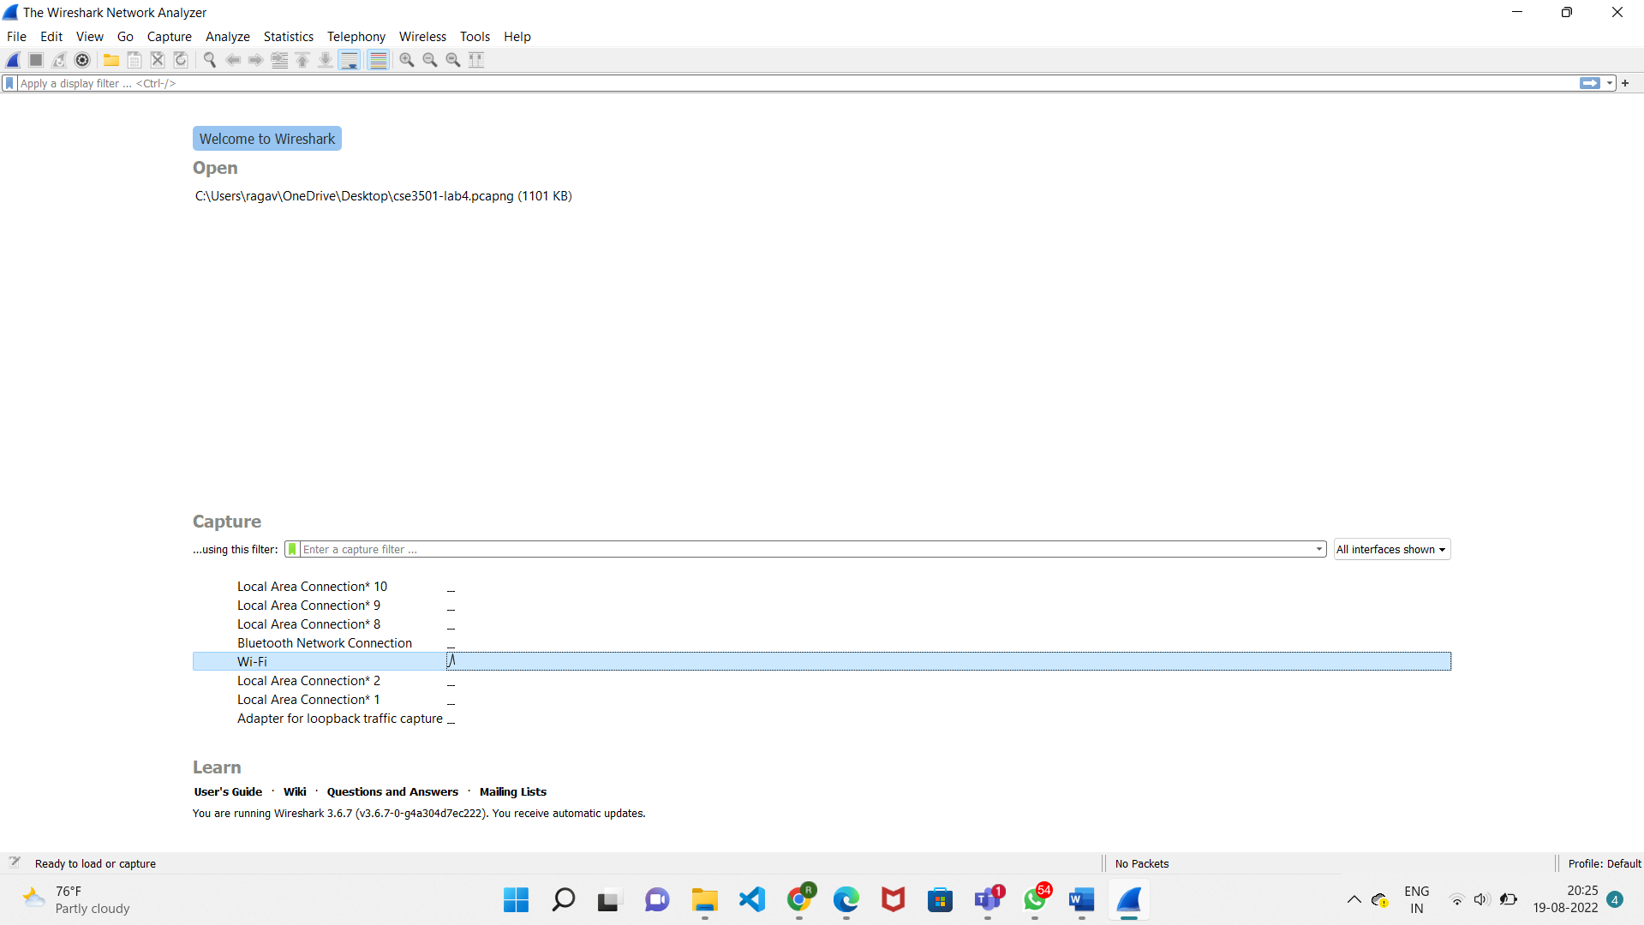

**Step2:** Then, after clicking onto the interface , start capturing the packets.

**Step3:** Go to some random website and type your username and password.

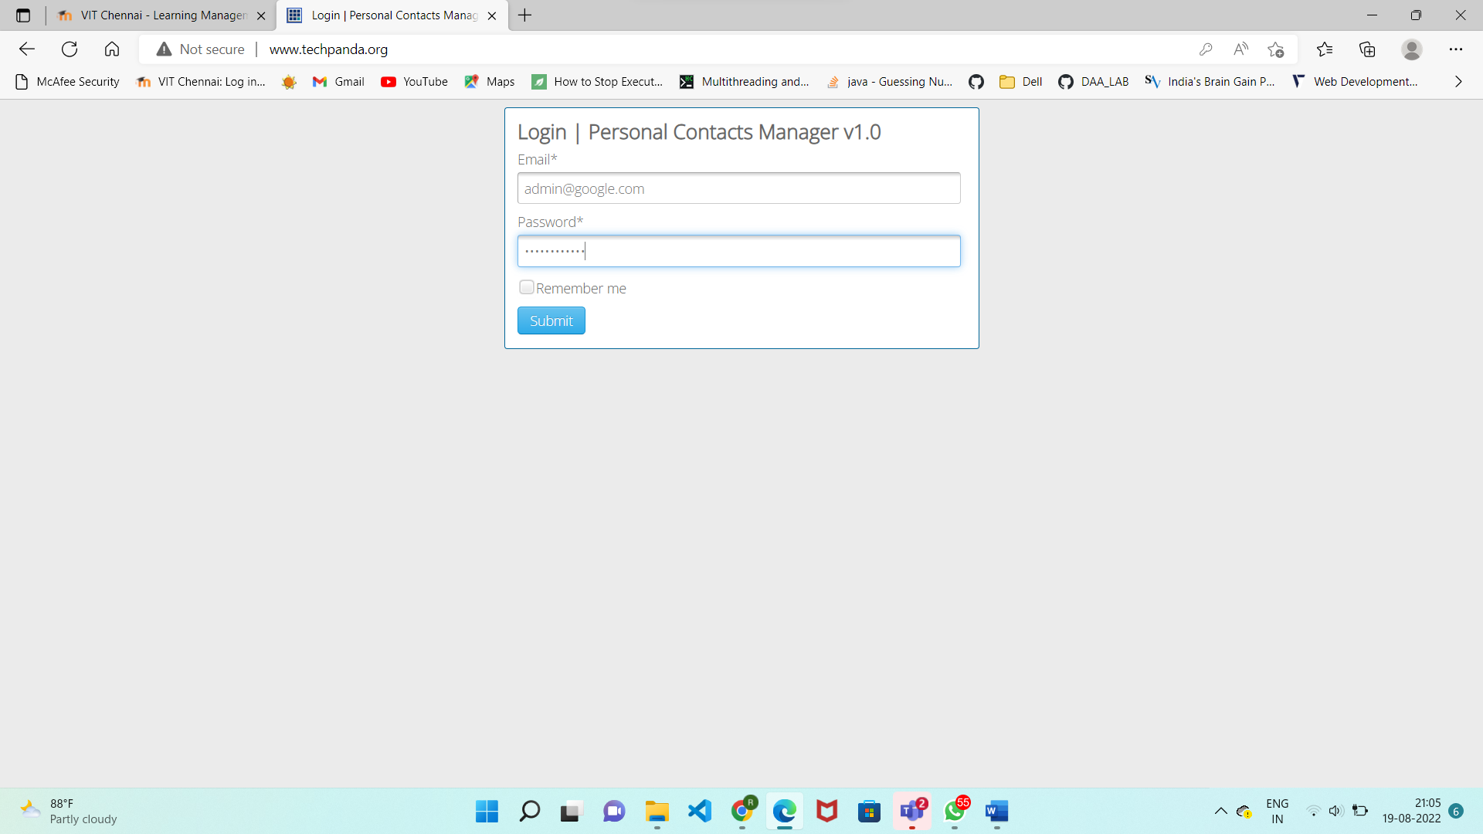

**Step4:** Come back and stop capturing the packets. Search for HTTP type. Or type (http. request. Method==POST). Just below the log entries, there is a panel with a summary of captured data. Look for the summary that says Line-based text data: **application/x-www-form-urlencoded.**Below that would be our username and password.

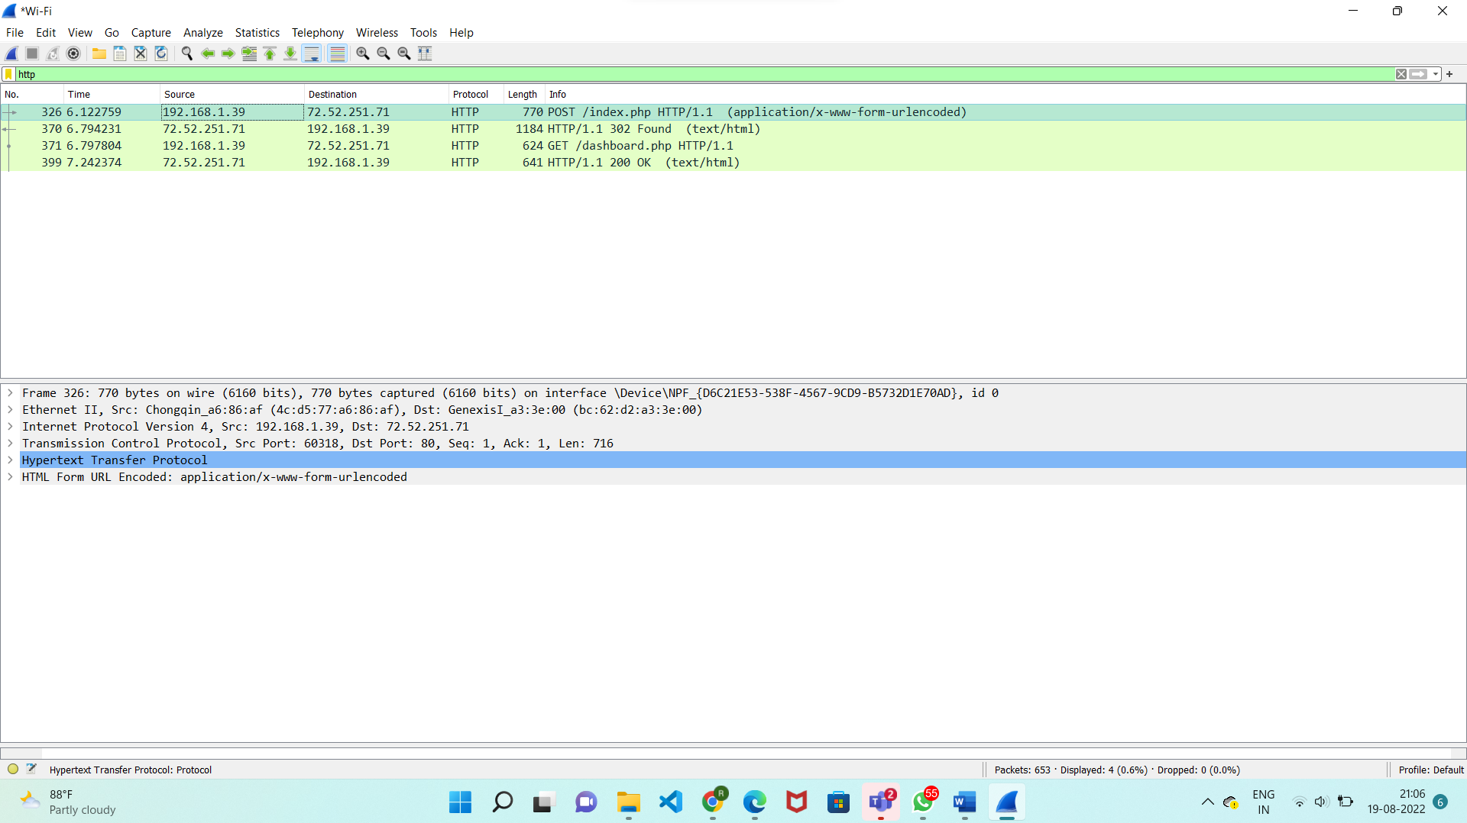

**Output:**

