**CSE3501-LAB1**

**NAME:** O G RAGAVI

**REG. NO**: 20BCE1988

**COURSE:** Information security analysis and audit -EMBEDDED LAB

**LAB EX: 1**

**TITLE:** Network configuration using cisco packet tracer.

**NOTE:**

* The complete network is constructed using 1 common router,3 switches which are in turn connected with 3 devices respectively. As, the router can connect only 2 devices, we will have to add 2 or more ports in order to connect more than 2 devices.
* Each of the available device is given a valid ip address. The default gateway for the devices connected to a common switch/hub will be the same.
* For the router, we search for the respective Fast ethernet connection, we will have to add the corresponding default gateway ip address. Then we go to RIP settings of the Router and add the corresponding default gateways.
* Now, if we simulate, we could observe that packets can be transferred between any two devices of the network.

**NETWORK CONNECTION:**

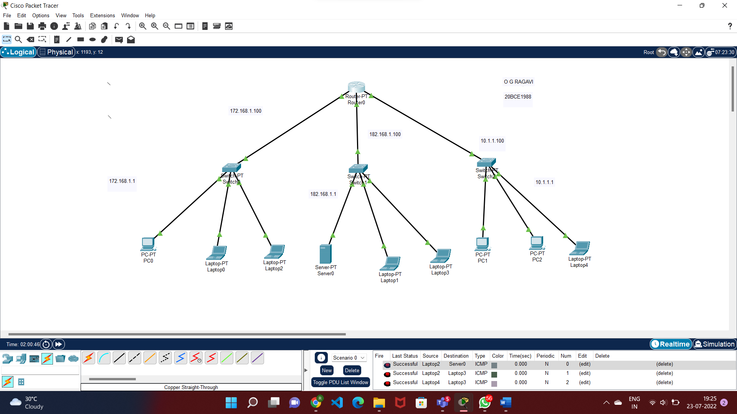

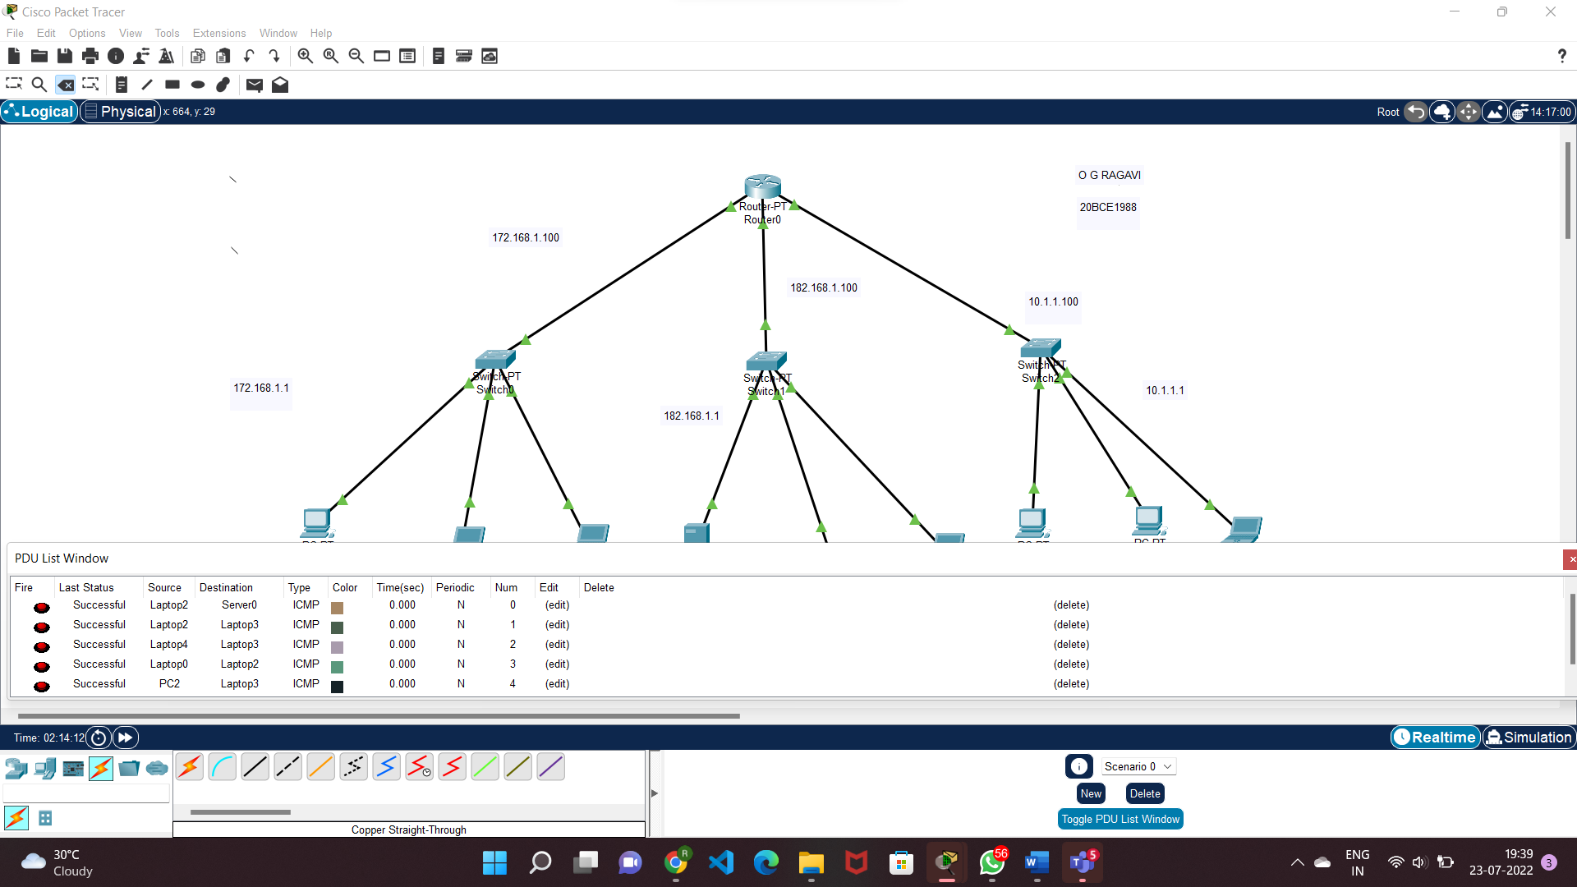

**SIMULATION RESULTS:**

1. **For laptop2 to server0:**

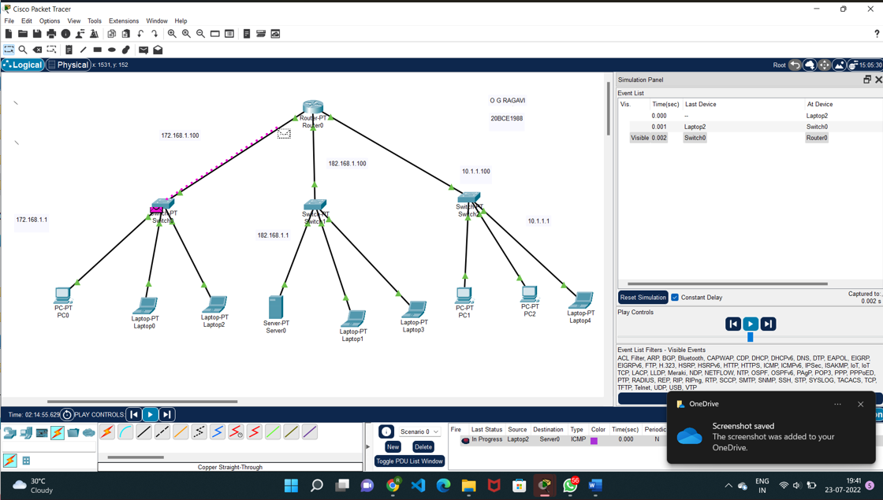

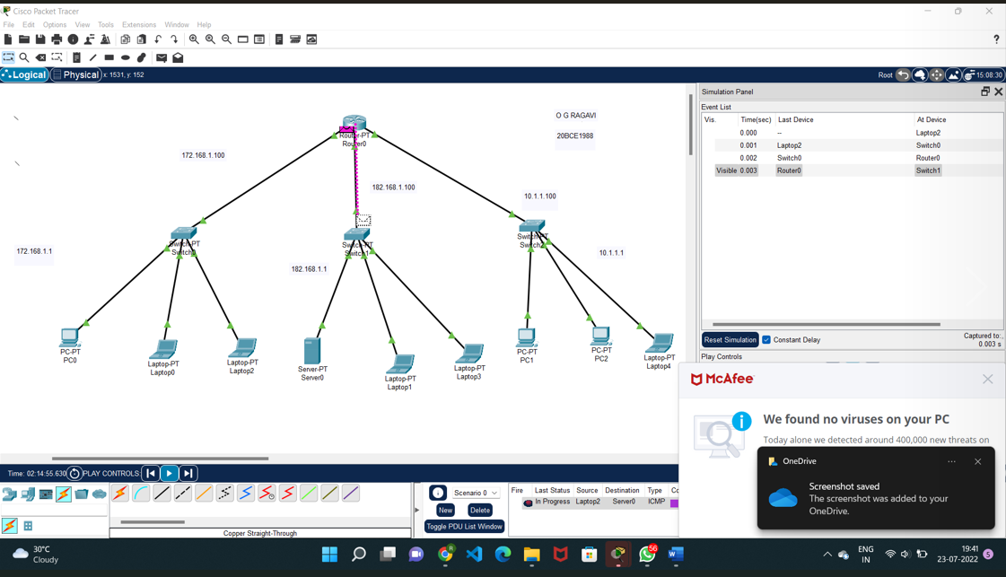

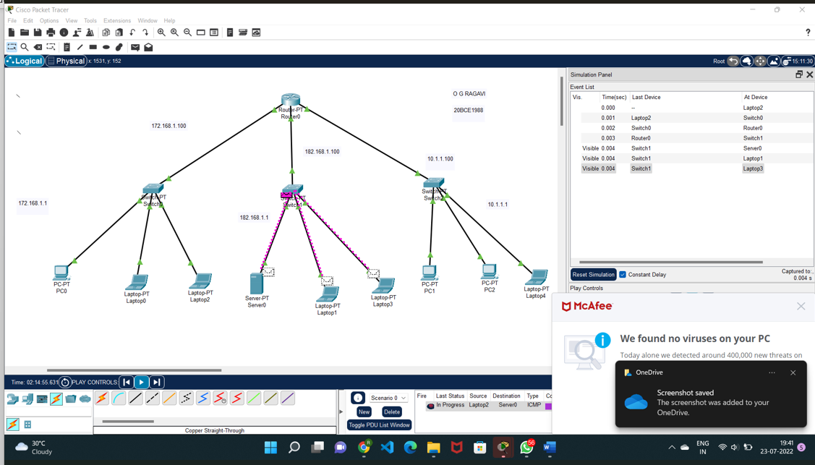

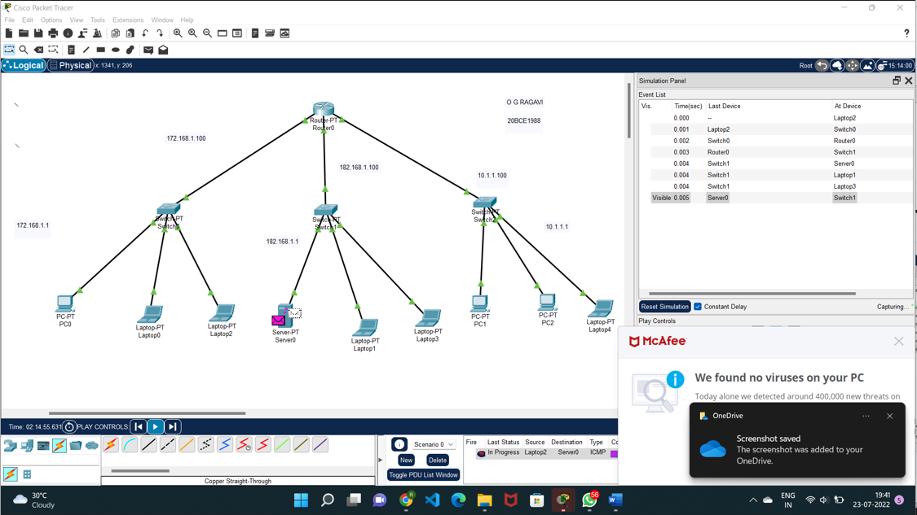

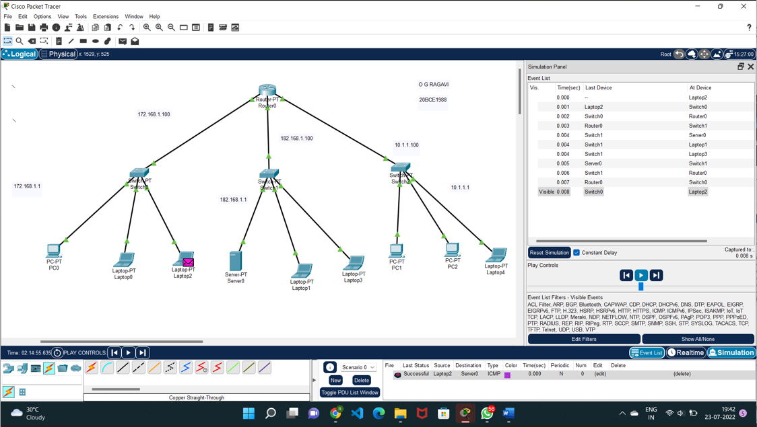

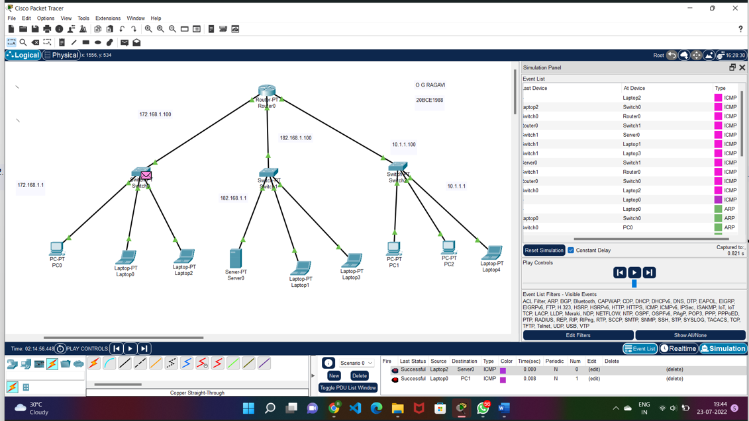

RESULT: Success.

b)For Laptop0 to PC1:

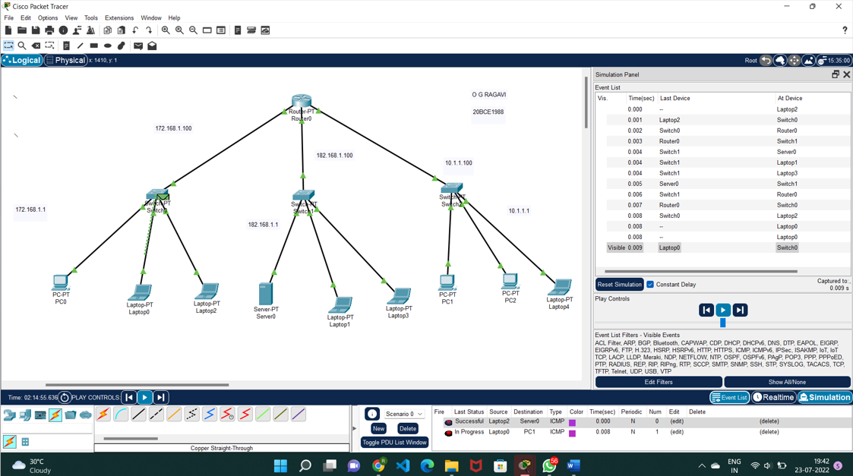

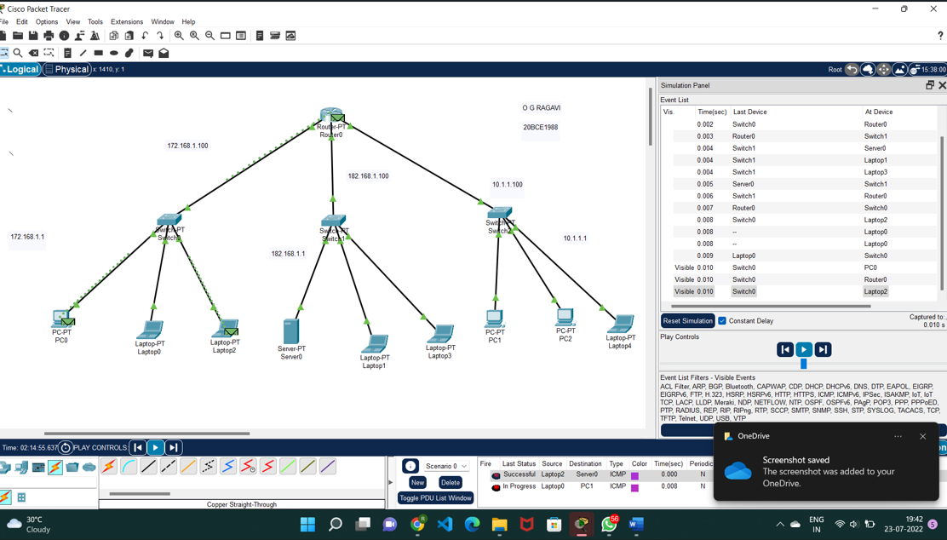

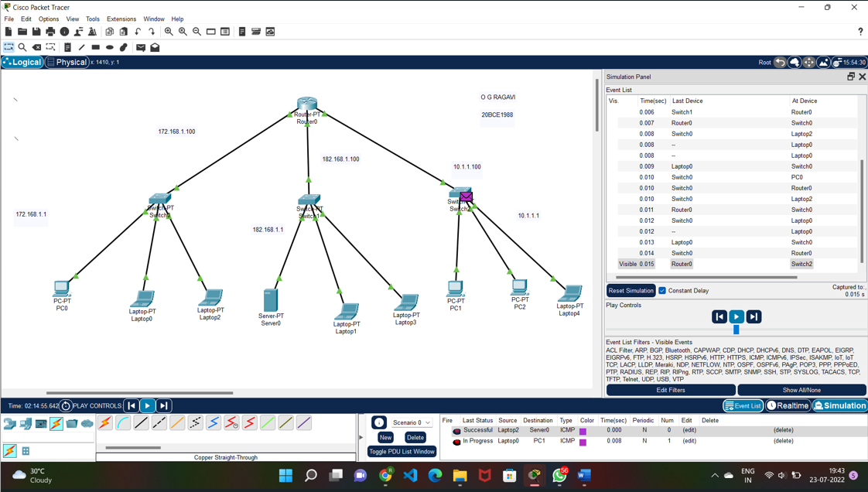

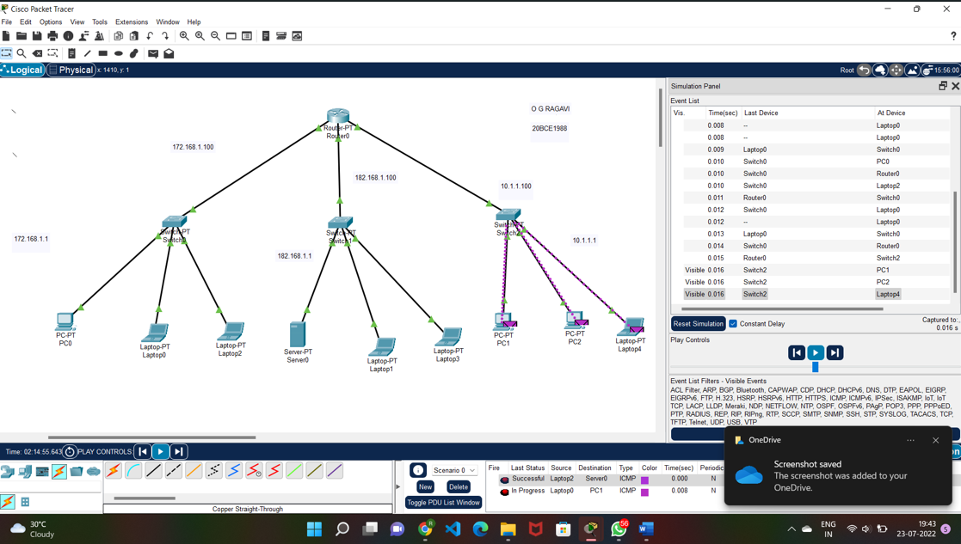

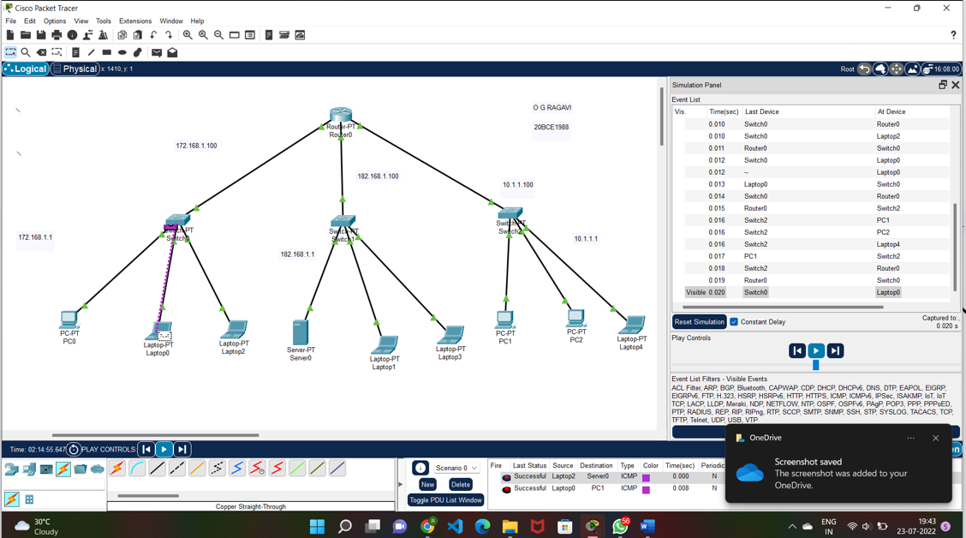

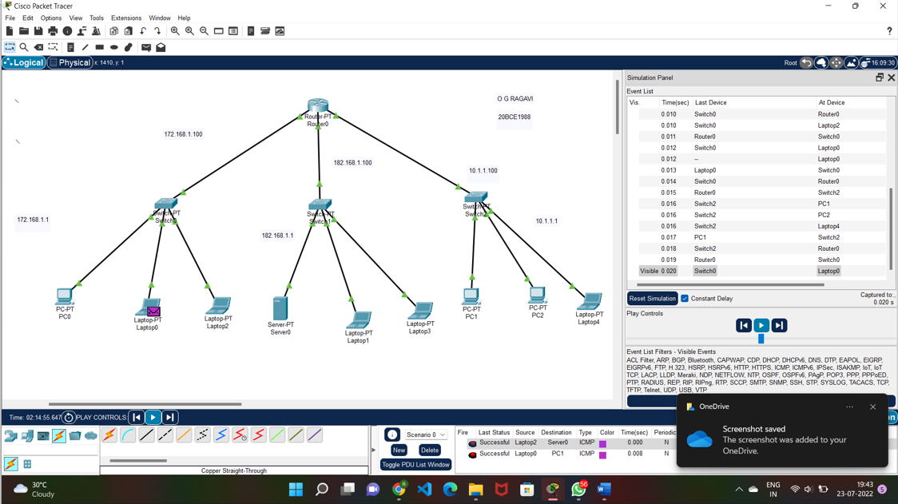

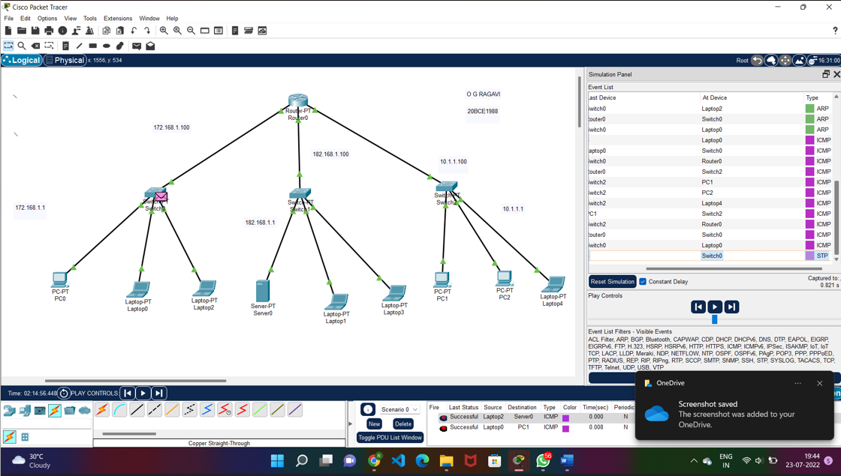

**RESULT:** Hence, the packets can be transferred successfully between any two devices.