**CSE3501-LAB2**

**NAME:** O G RAGAVI

**REG. NO**: 20BCE1988

**COURSE:** Information security analysis and audit -EMBEDDED LAB

**LAB EX: 2**

**TITLE: multiple** network configuration using cisco packet tracer.

**NOTE:**

* The complete network is constructed using 3 routers (one for each department.(admin block,security block and SCOPE block).The routers are connected to switches , which are further connected to 2 or more end devices like servers or computers.
* Each of the available device is given a valid ip address. The default gateway for the devices connected to a common switch/hub will be the same.
* For the router, we search for the respective Fast ethernet connection, we will have to add the corresponding default gateway ip address. Then we go to RIP settings of the Router and add the corresponding default gateways.
* Now, if we simulate, we could observe that packets can be transferred between any two devices of the network.

**NETWORK CONNECTION:**

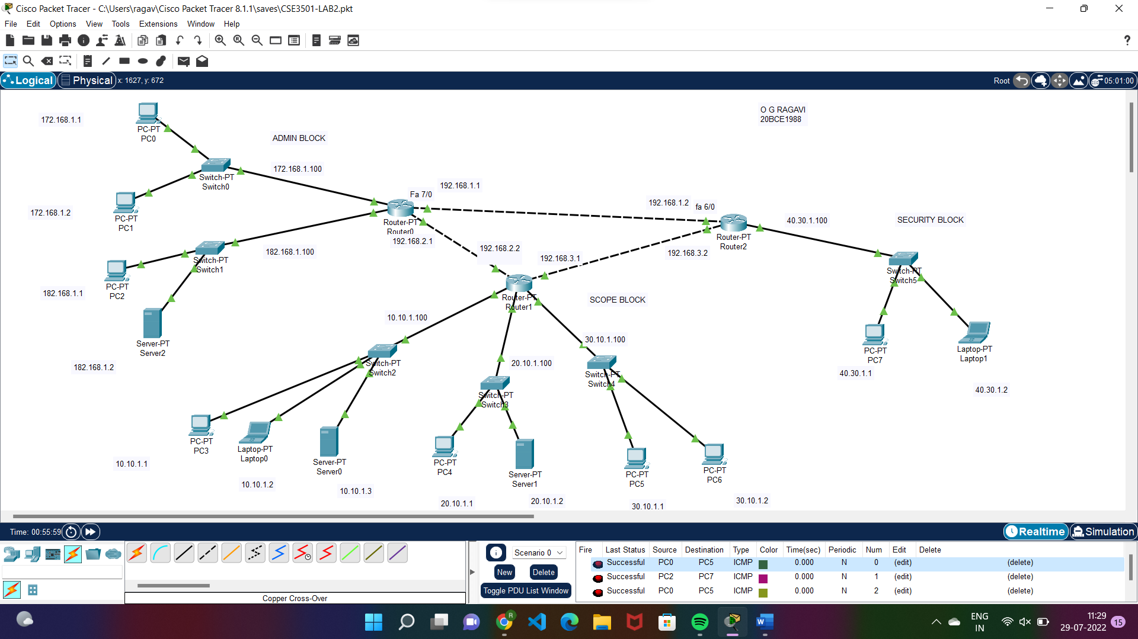

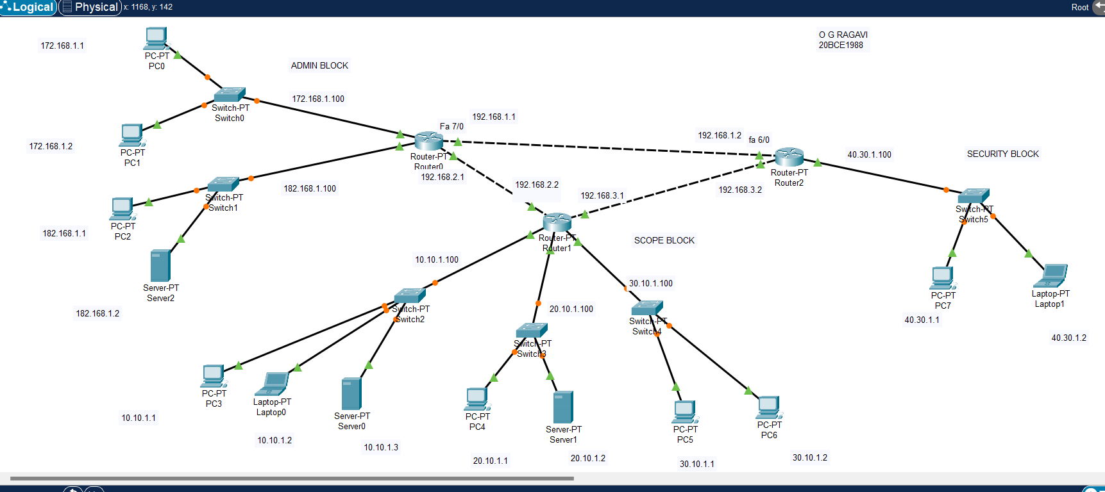

**SIMULATION:( from PC0 to PC7)**

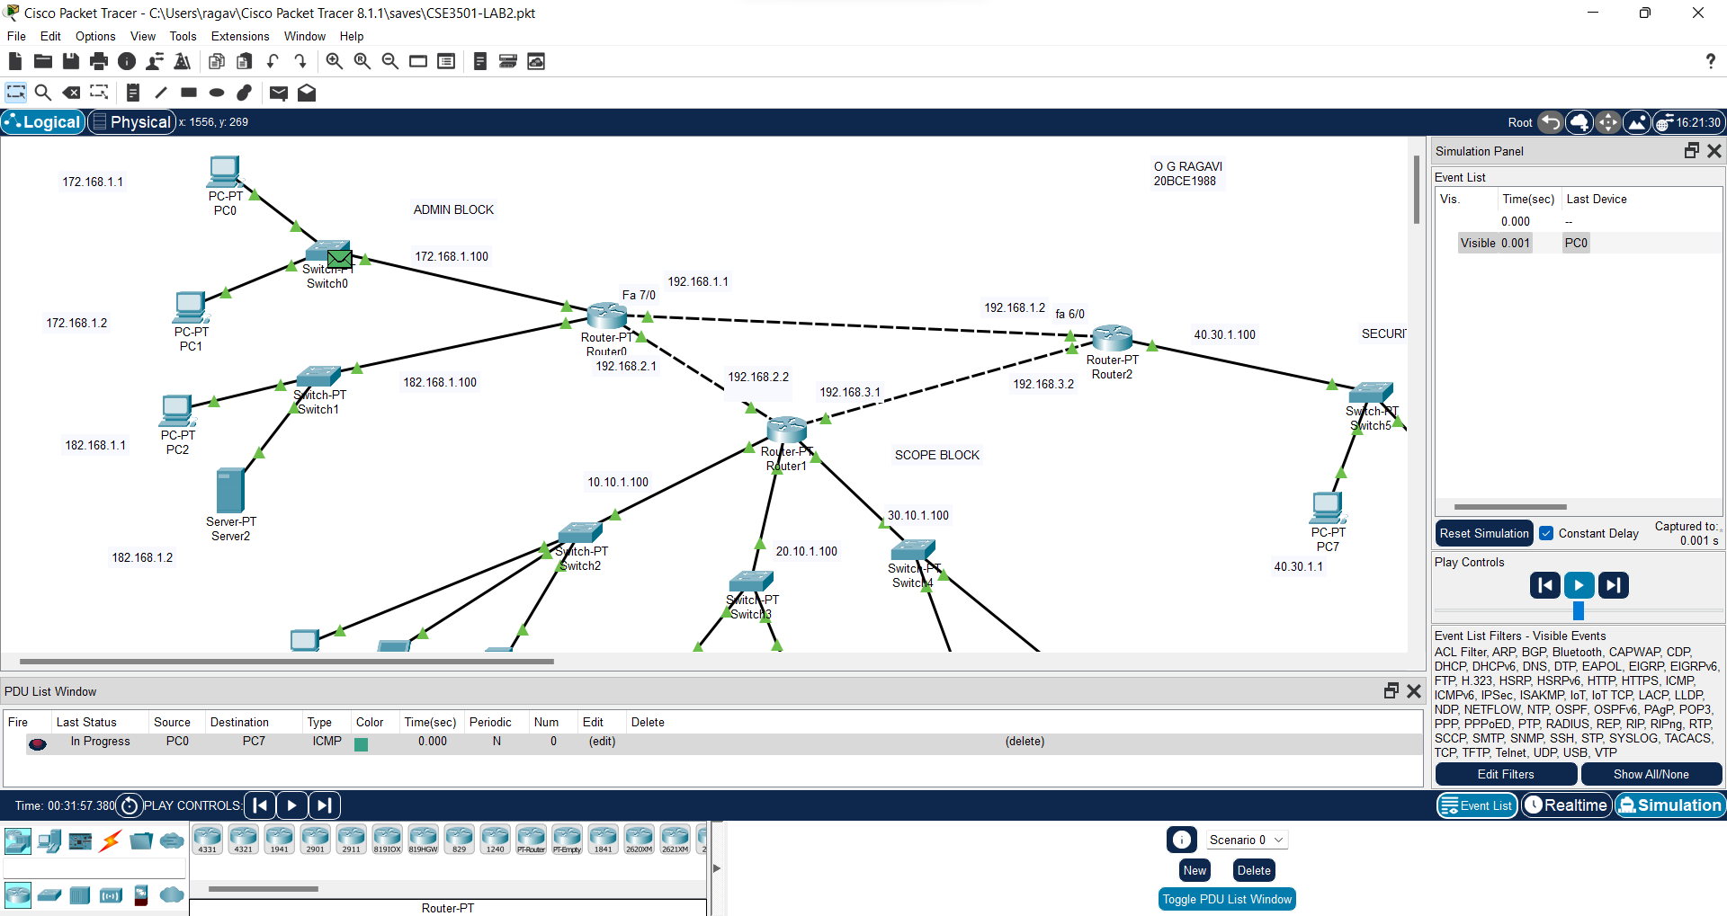

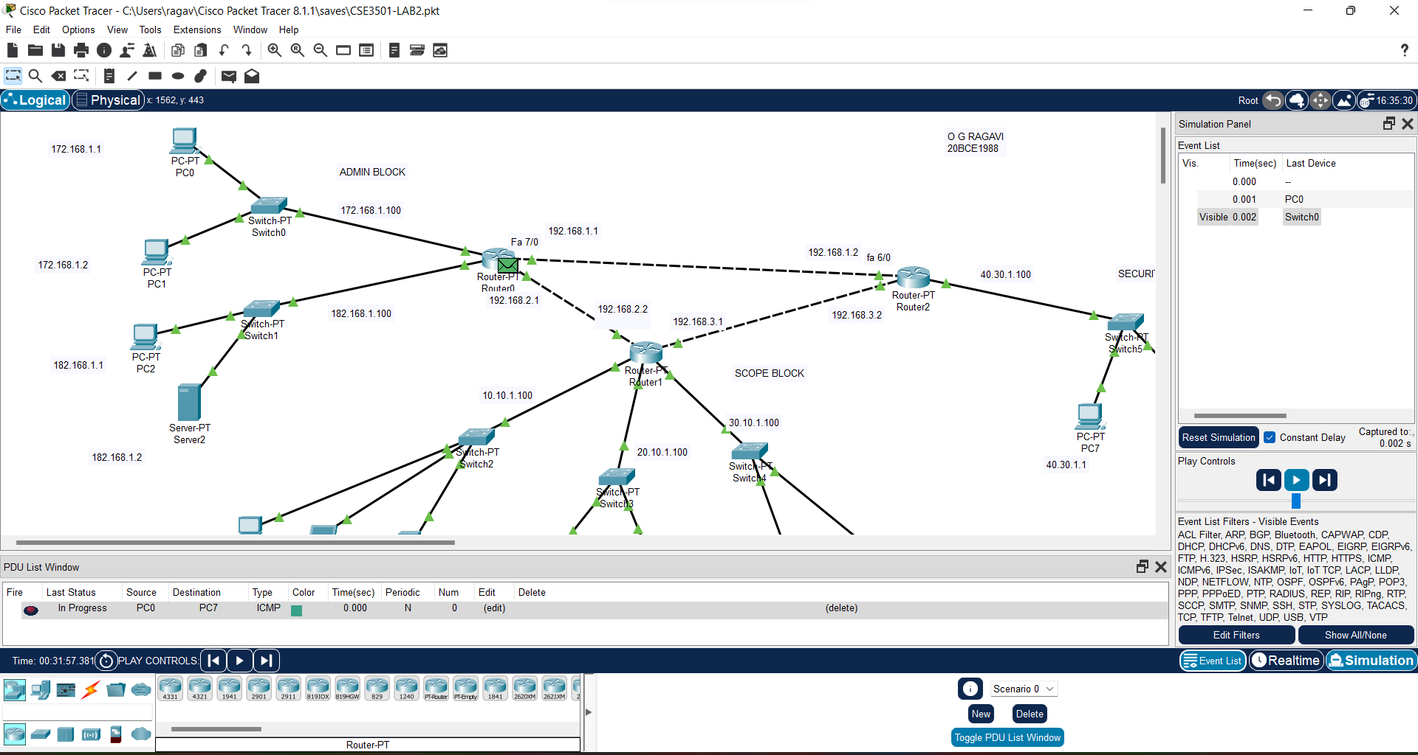

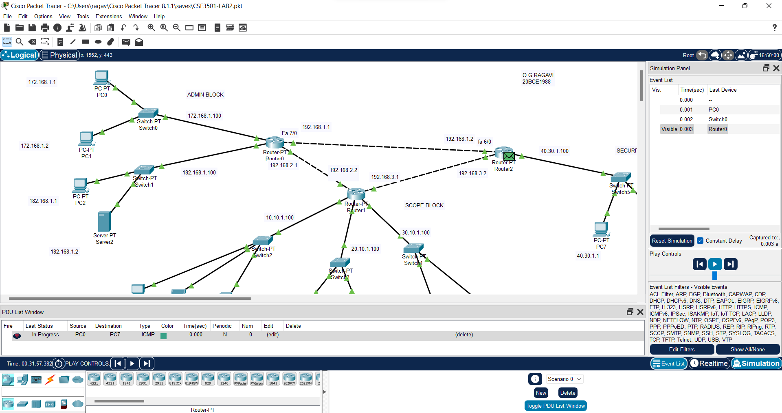

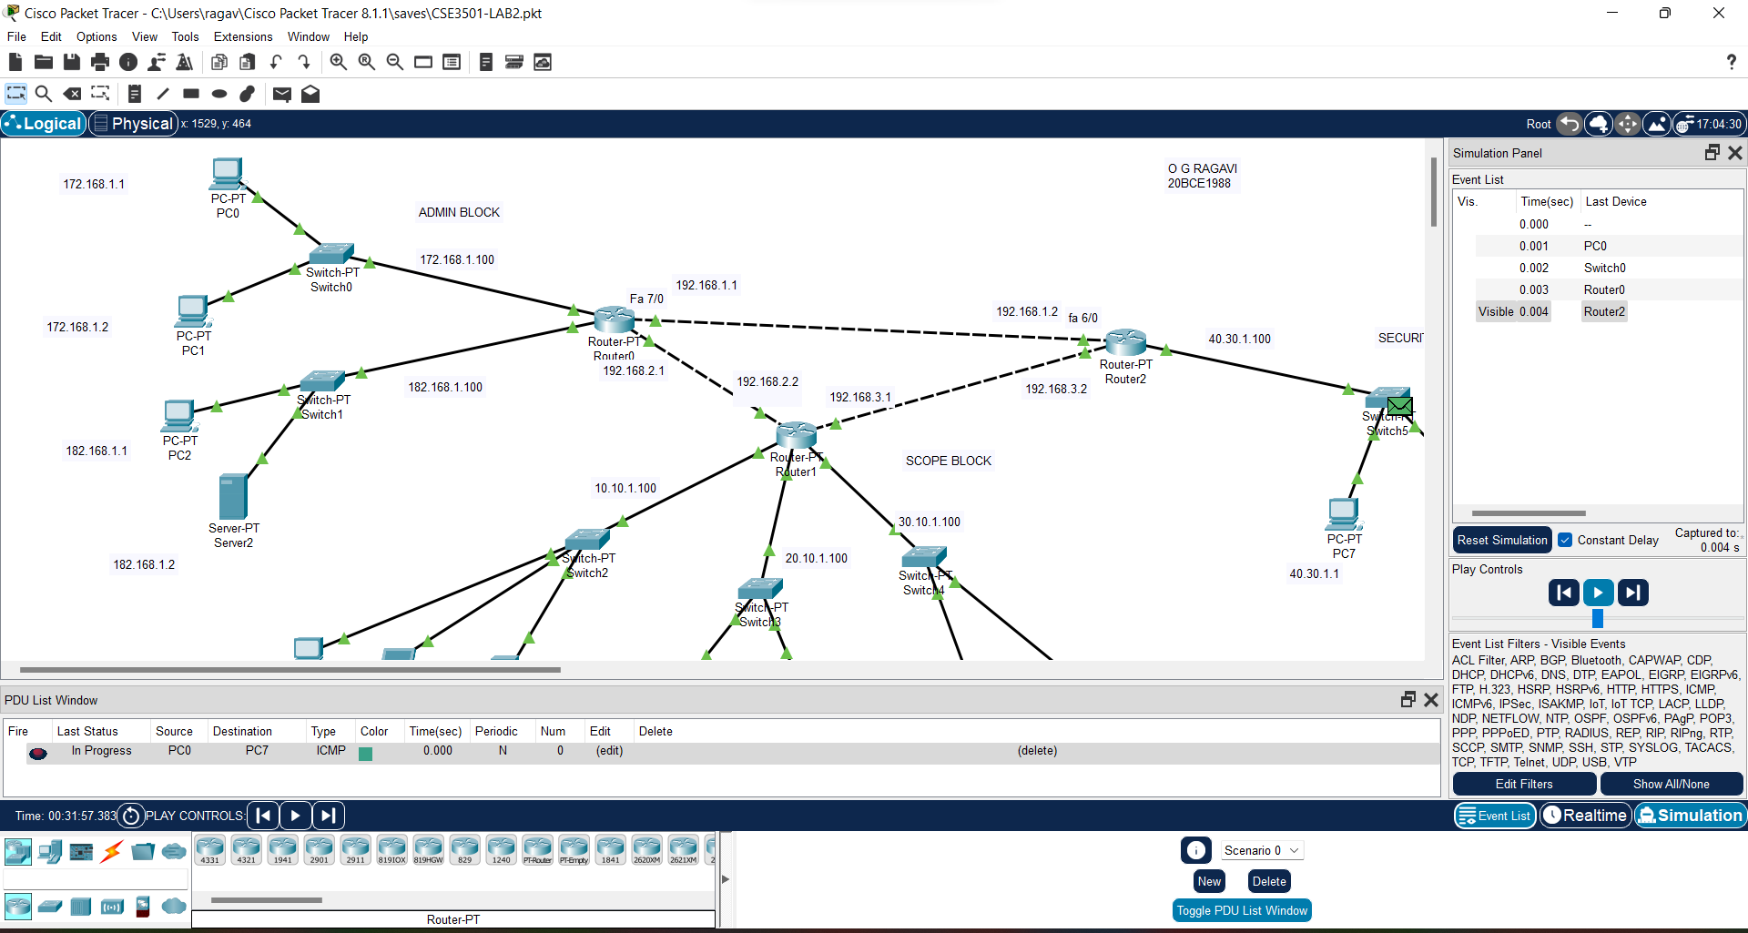

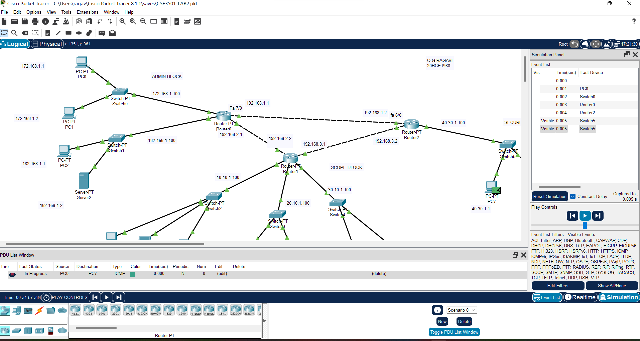

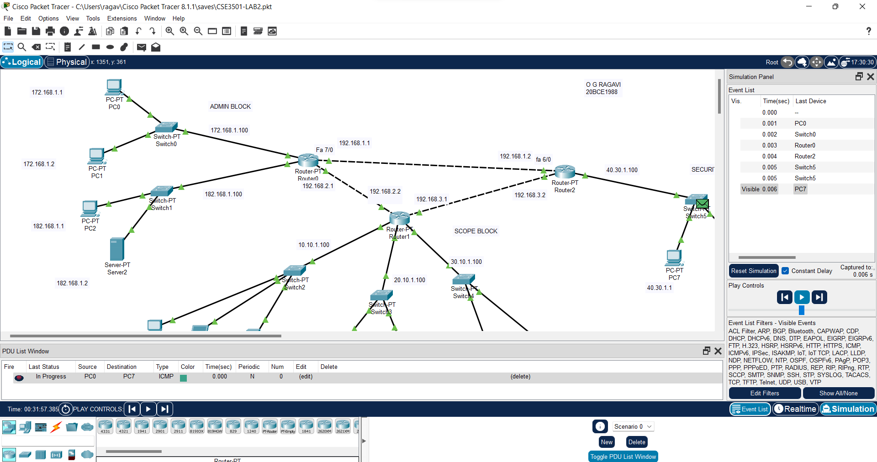

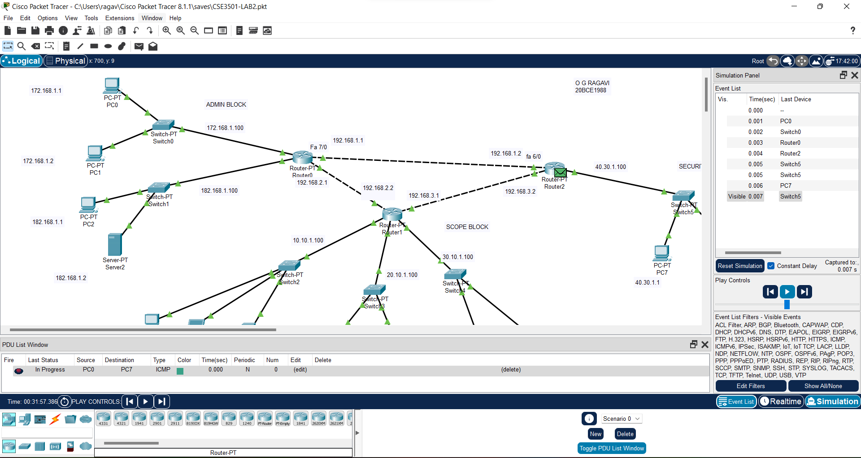

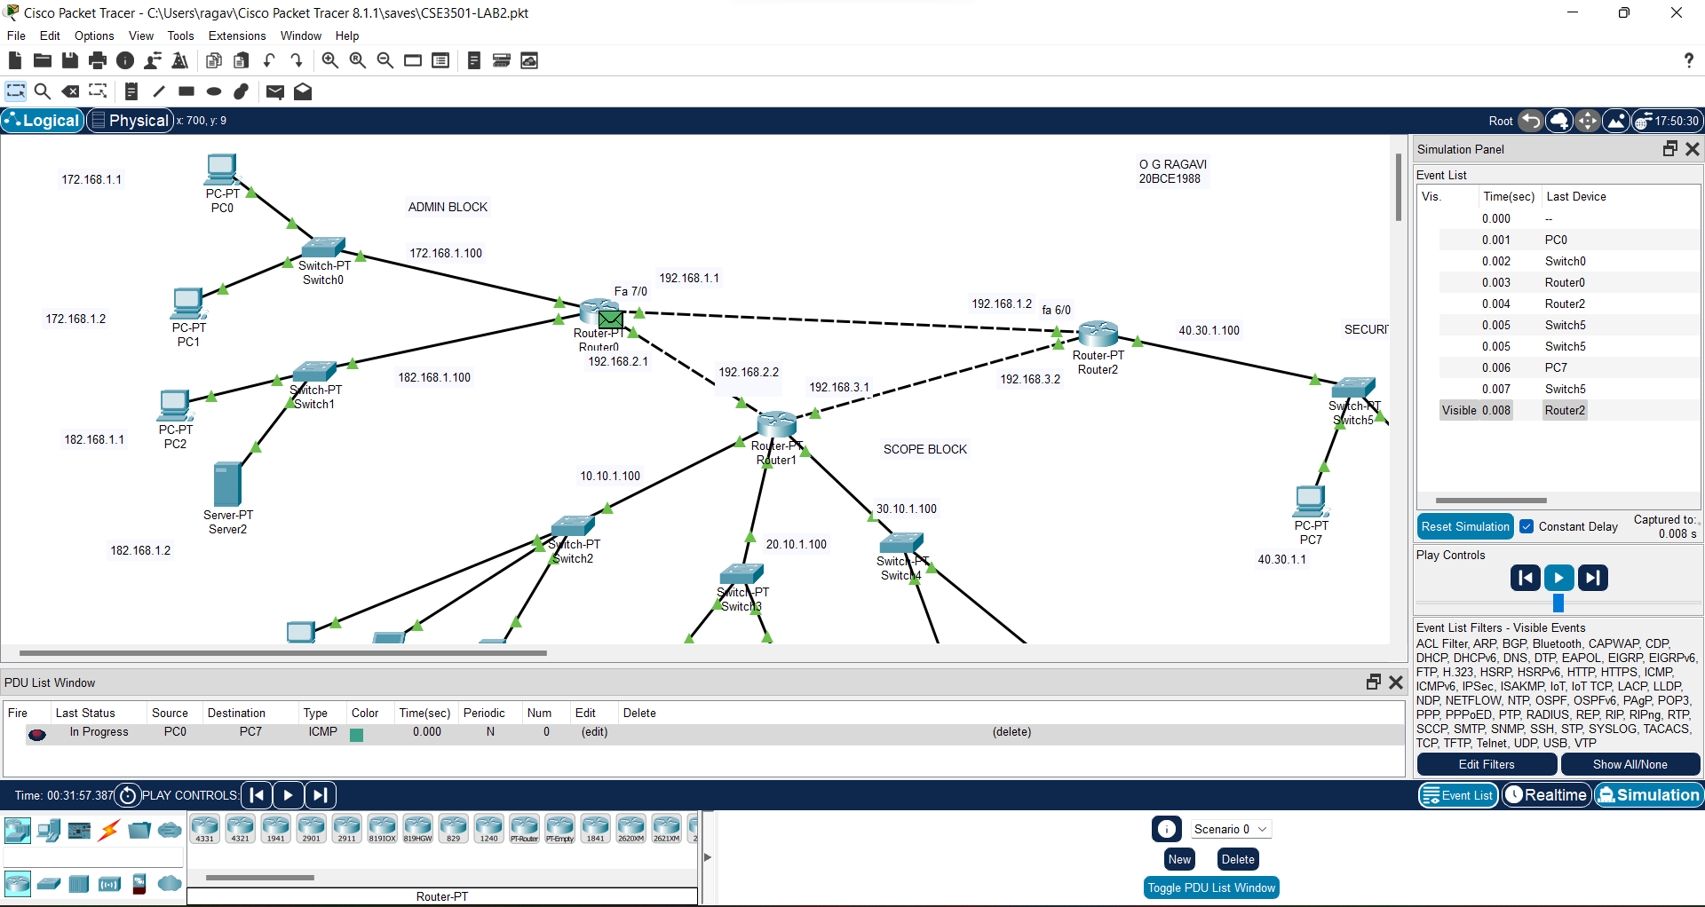

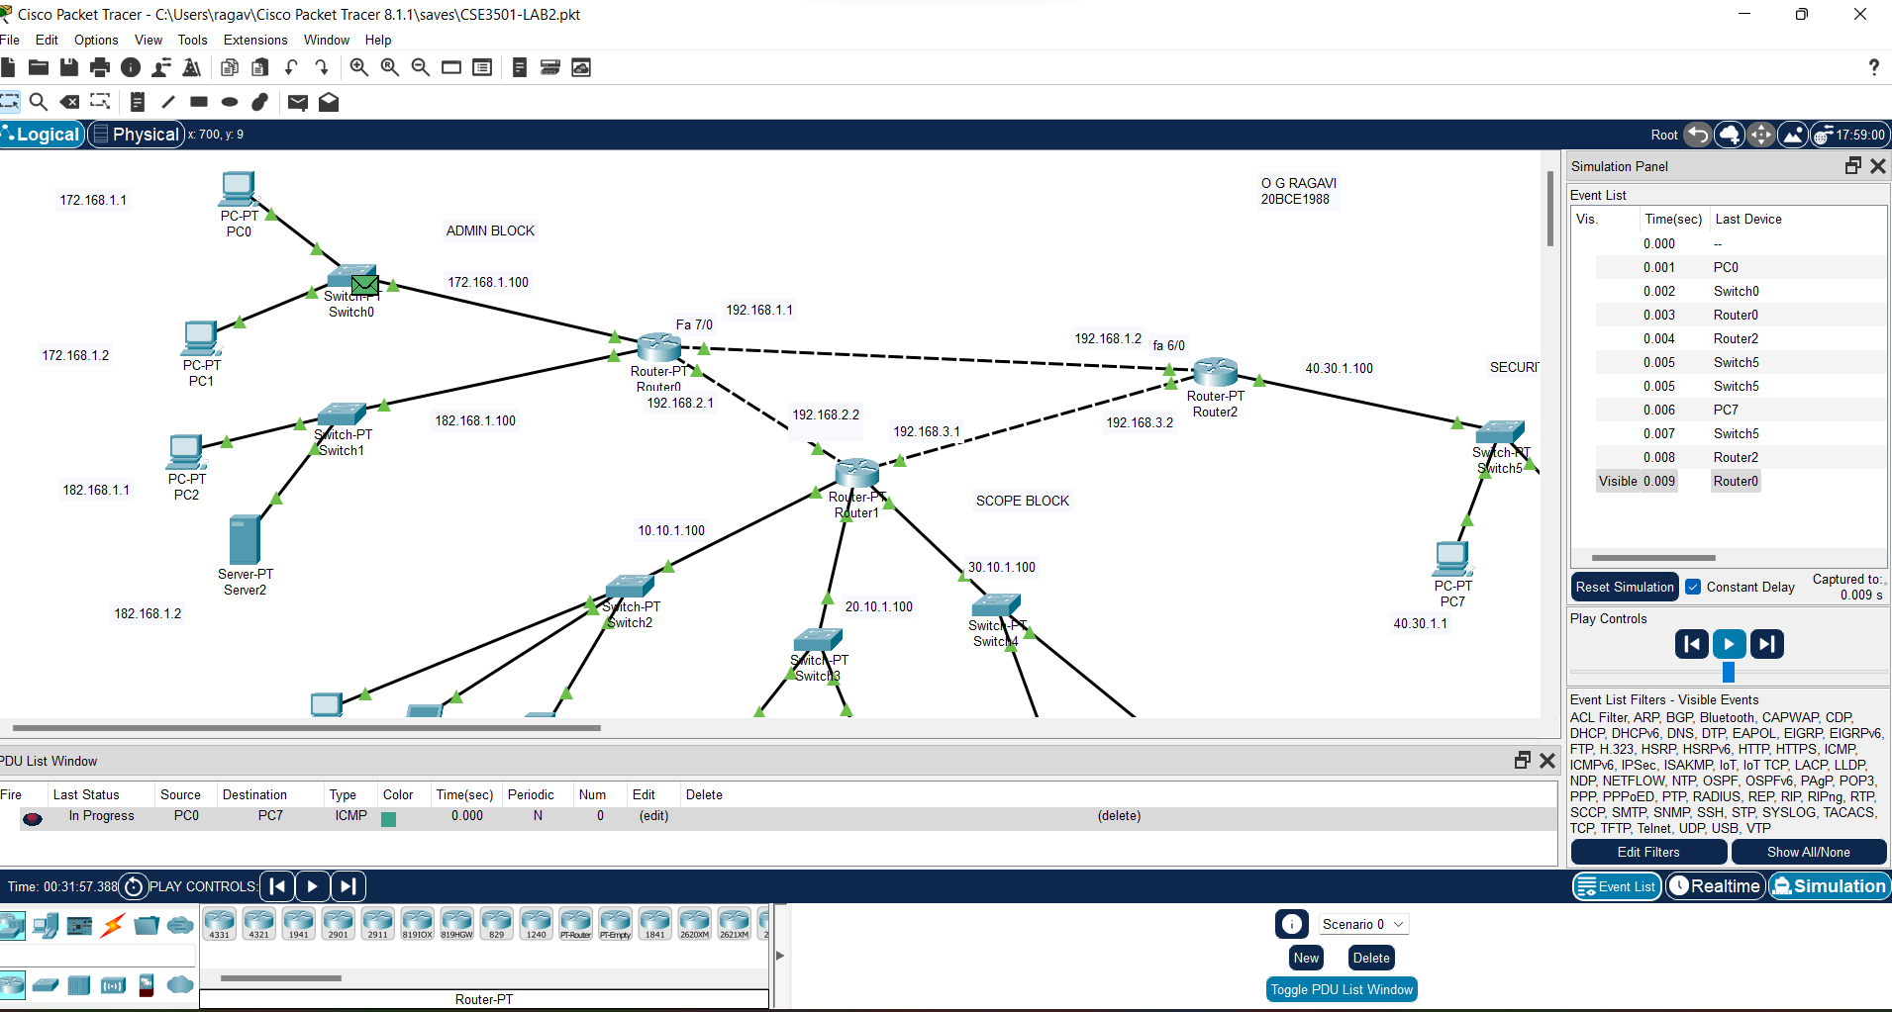

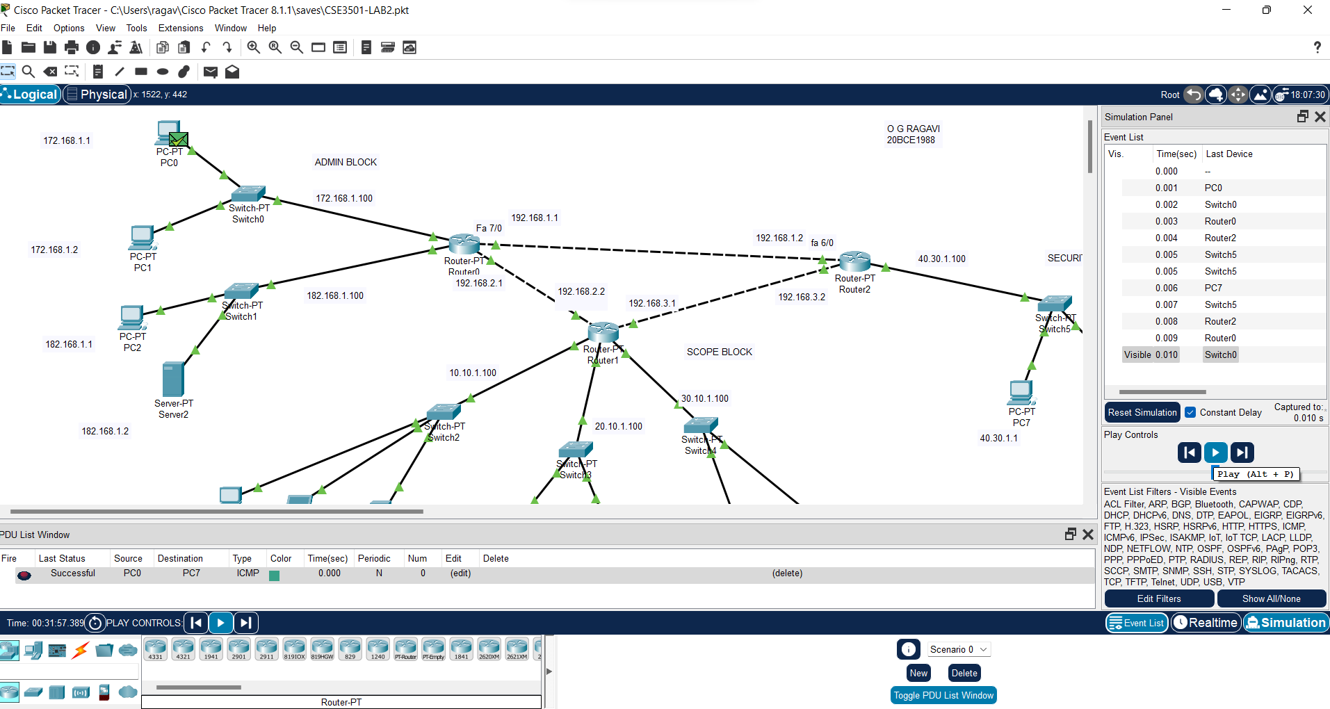

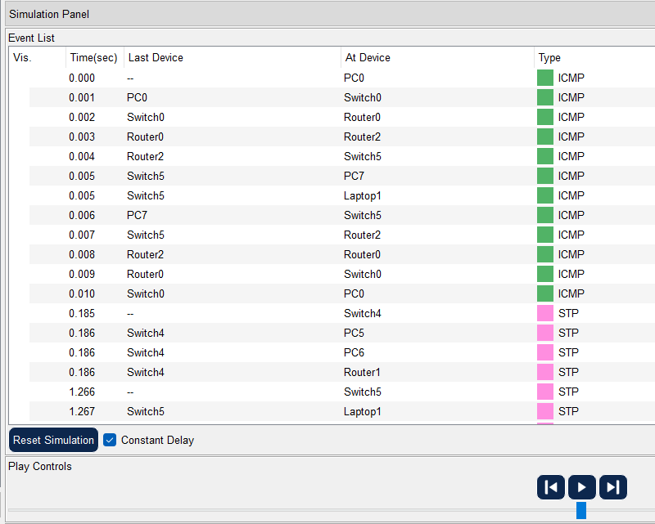

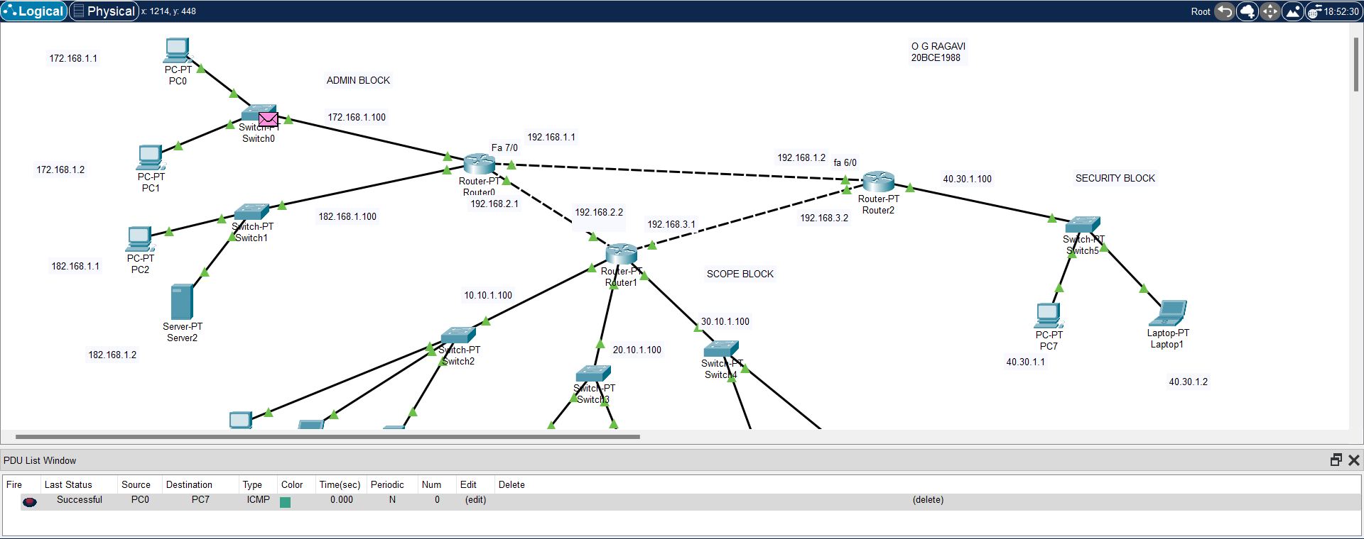

**SUCCESSFUL CONNECTIONS:**

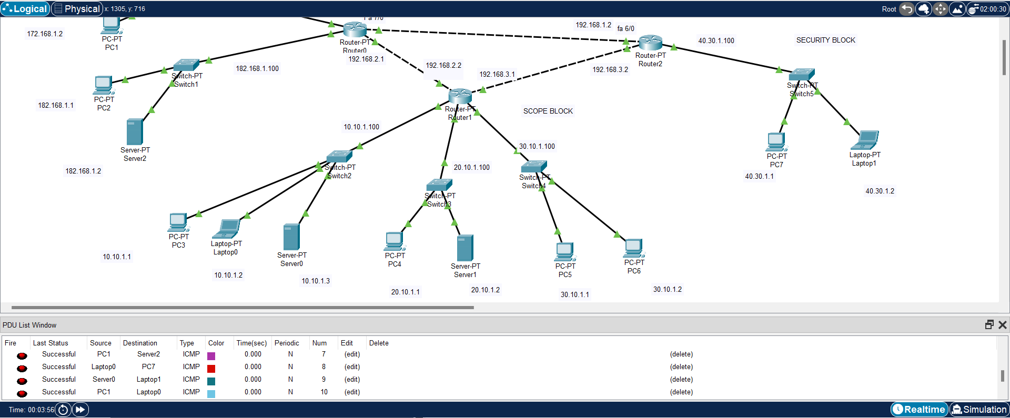

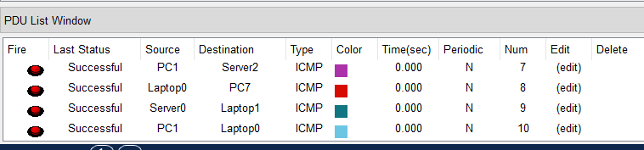

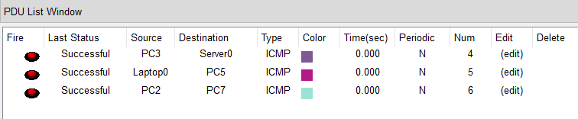

**RESULT:** Hence, the packets can be transferred successfully between any two devices.