**CSE3501-LAB3**

**NAME**: O G RAGAVI

**REG NO**: 20BCE1988

**LAB EX:** 3

**TITLE:** ACCESS CONTROL LISTS **DATE**:5.08.2022

**Note:**

An access control list (ACL) is **a list of rules that specifies which users or systems are granted or denied access to a particular object or system resource**. Access control lists are also installed in routers or switches, where they act as filters, managing which traffic can access the network.

**Router Configuration:**

The network below denies host Laptop1 with ip address

10.10.1.1 permits other devices to transfer packets with each other.

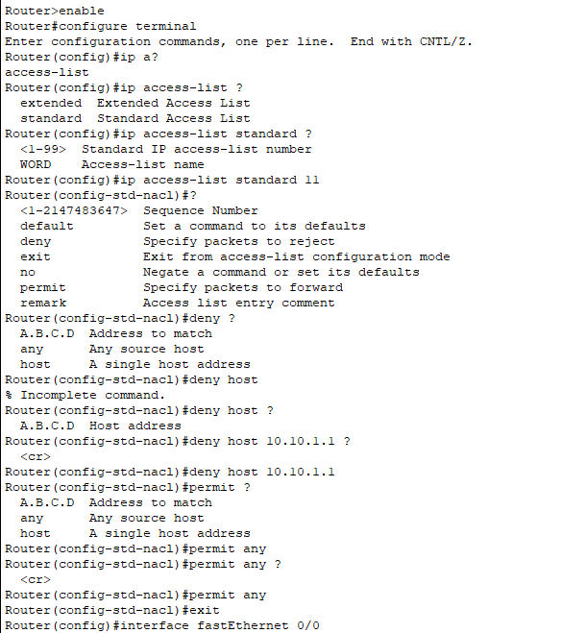

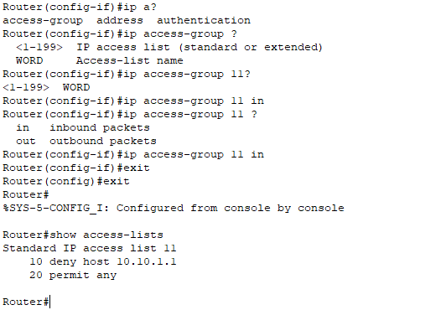

**OUTPUT:**

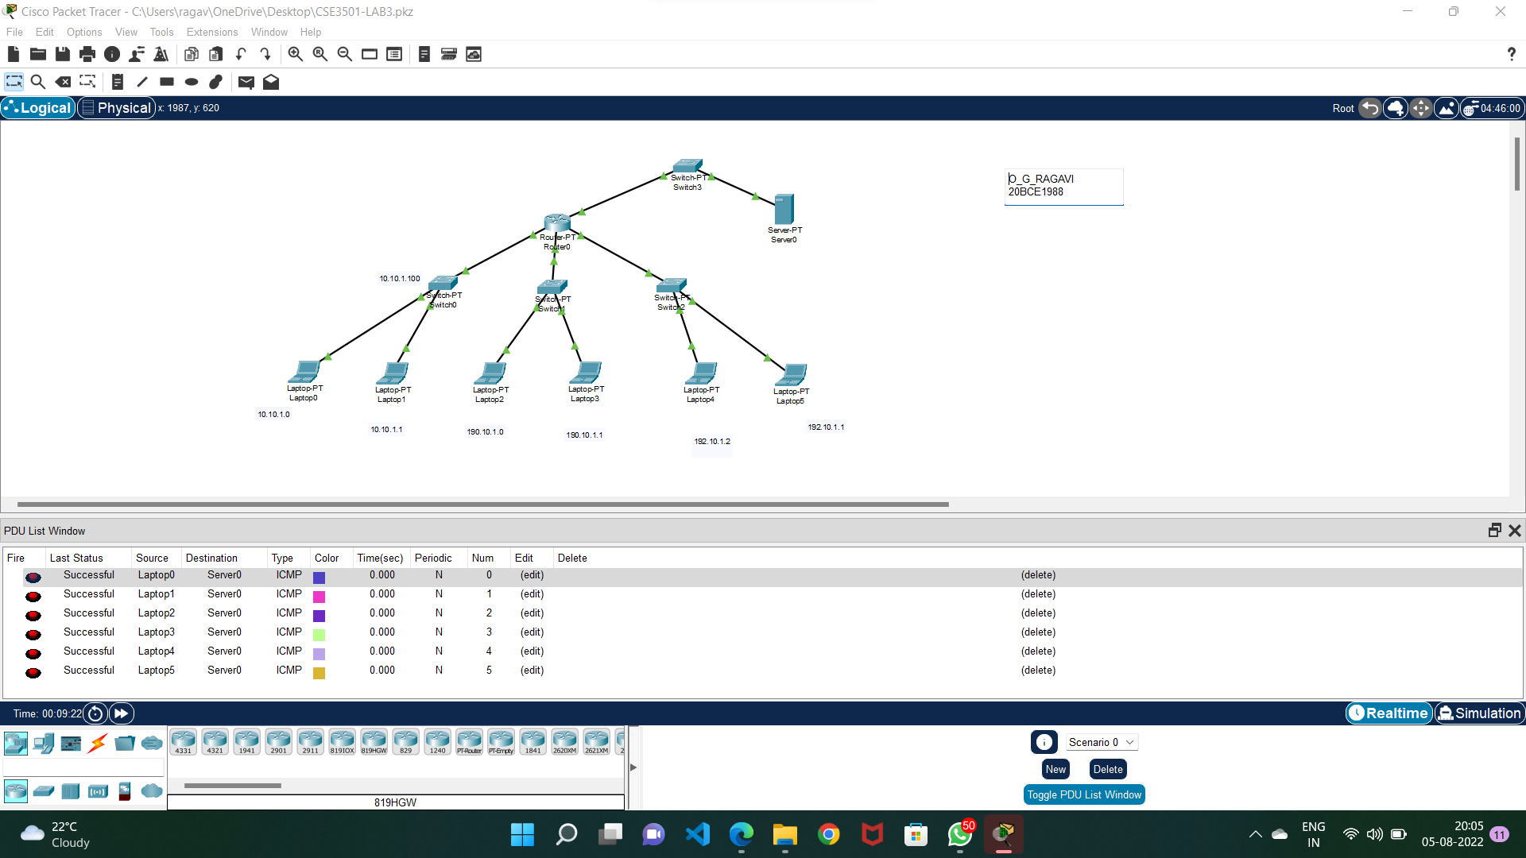

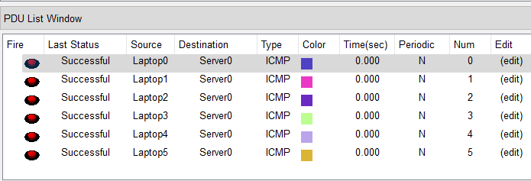

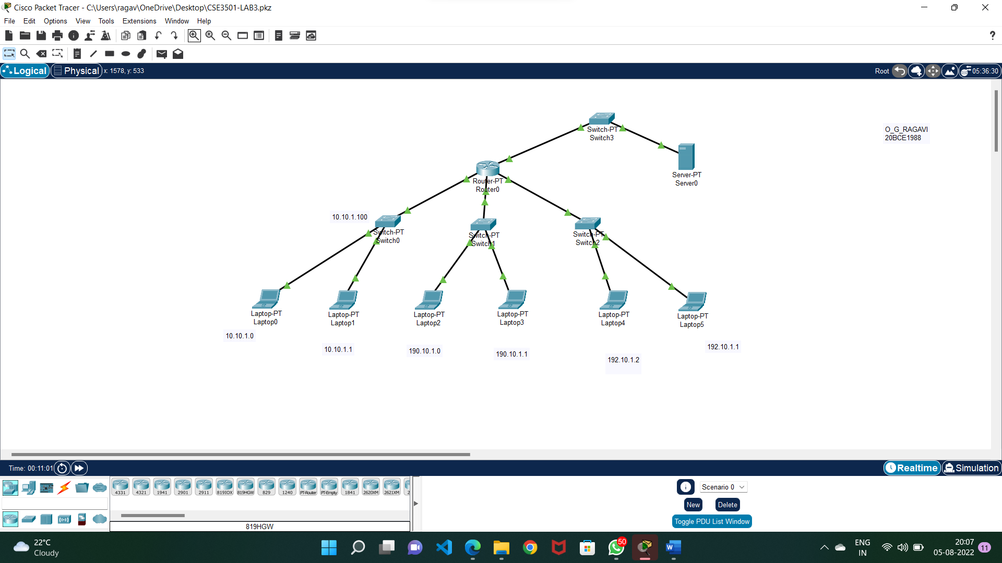

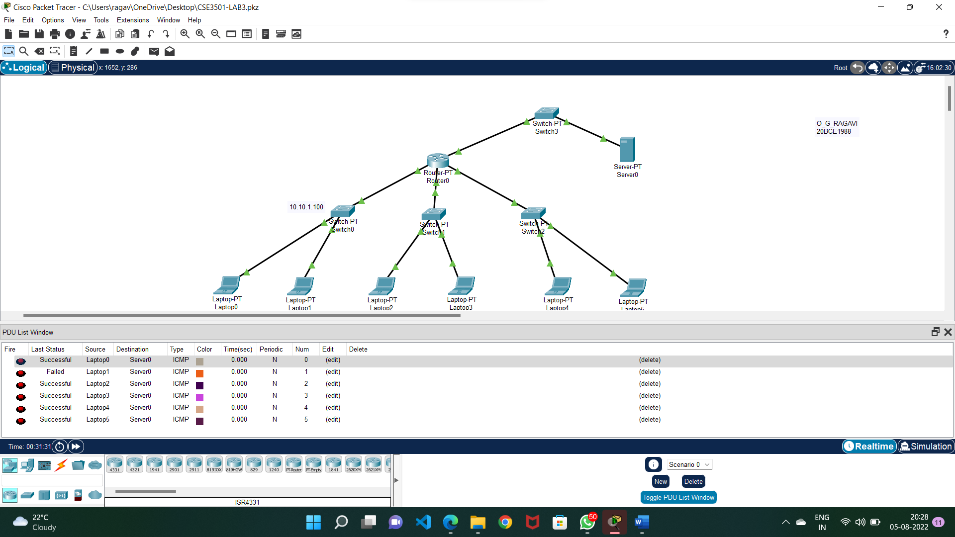

**RESULT:** Laptop1 is denied.

