**CSE3501-Information security and analysis**

**Digital assignment-2**

Name: O G Ragavi

Reg No: 20BCE1988

Title: Tryhackme

**Username:** ragavi.2020a

**Public profile:** <https://tryhackme.com/p/ragavi.2020a>

Badge1 for OWASP TOP 10: <https://tryhackme.com/ragavi.2020a/badges/owasp-10>

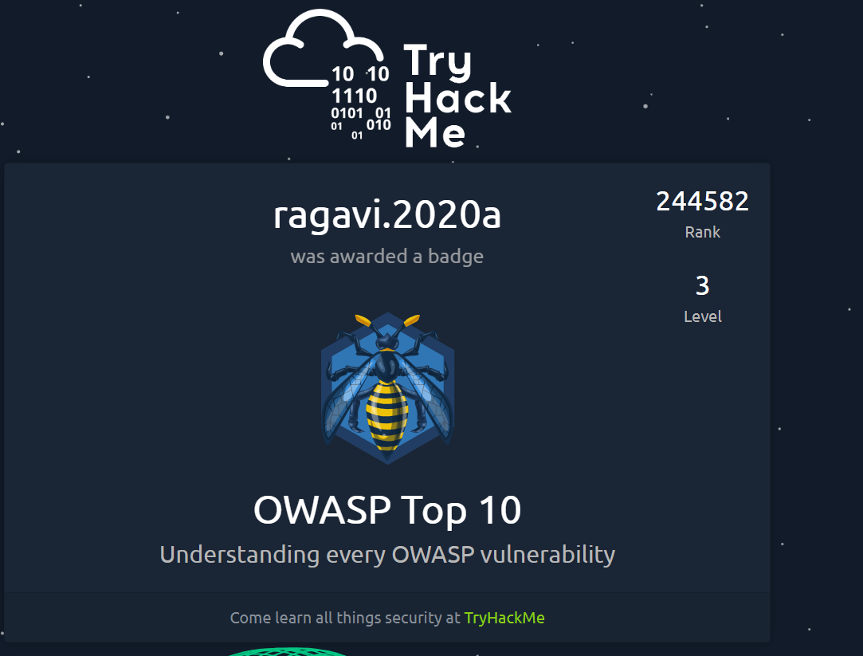

Badge 2 for Blue:

<https://tryhackme.com/ragavi.2020a/badges/blue>

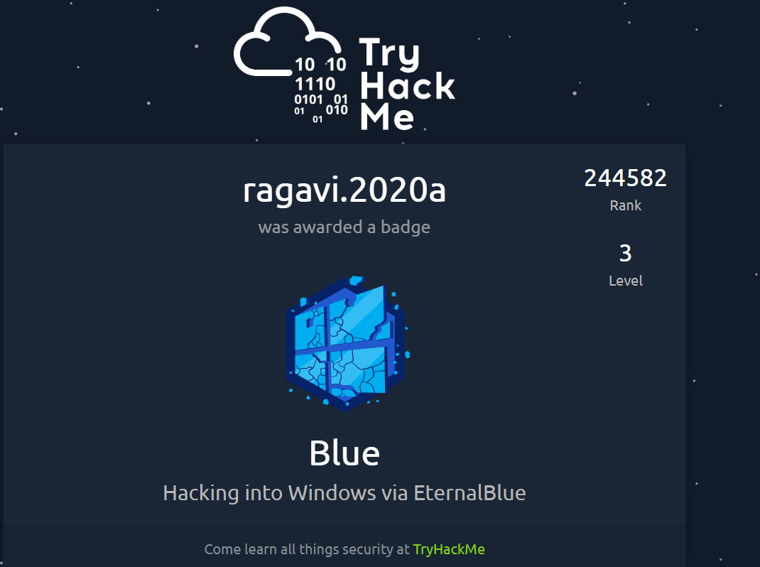

Badge 3 for Ice:

<https://tryhackme.com/ragavi.2020a/badges/ice>

