**CSE3002-Internet and Web programming**

**Name**: O G RAGAVI

**Reg No**: 20BCE1988

**Title**: JQuery and xml

**Lab Ex**: 11 **Date**: 2.11.2022

Q1)

**Code:**

**Lab11.dtd**

<!ELEMENT student (rollno,name+,dob+,class+,marks)>

<!ELEMENT rollno (#PCDATA)>

<!ELEMENT name (firstname,lastname)>

<!ELEMENT dob (day,month,year)>

<!ELEMENT class (branch,semester)>

<!ELEMENT firstname (#PCDATA)>

<!ELEMENT lastname (#PCDATA)>

<!ELEMENT day (#PCDATA)>

<!ELEMENT month (#PCDATA)>

<!ELEMENT year (#PCDATA)>

<!ELEMENT branch (#PCDATA)>

<!ELEMENT semester (#PCDATA)>

<!ELEMENT marks (#PCDATA)>

**Lab11.xml:**

<?xml version="1.0"?>

<student>

<rollno>20BCE1988</rollno>

<name>

<firstname>Ragavi</firstname>

<lastname>Ohm ganesan</lastname>

</name>

<dob>

<day>15</day>

<month>August</month>

<year>2002</year>

</dob>

<class>

<branch>Computer science</branch>

<semester>5</semester>

</class>

<marks>100</marks>

</student>

**Output:**

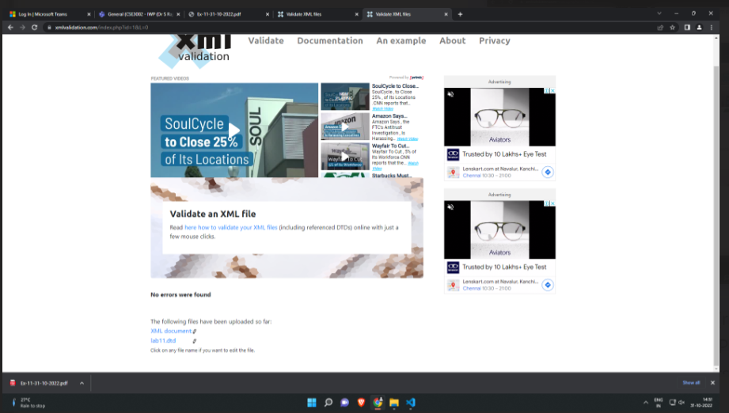

**Q2)**

**Code:**

<html>

<head>

<title>Lab 11 b</title>

<script src="https://code.jquery.com/jquery-3.6.1.js" integrity="sha256-3zlB5s2uwoUzrXK3BT7AX3FyvojsraNFxCc2vC/7pNI=" crossorigin="anonymous"></script>

<script src="https://code.jquery.com/jquery-3.5.1.min.js"></script>

</head>

<body>

<form action="">

<fieldset>

<legend>Name</legend>

<br>

<label>First Name</label>

<br>

<input type="text" name="fname" id="fname">

<br>

<label>Last Name</label>

<br>

<input type="text" name="lname" id="lname">

<br><br>

</fieldset>

<fieldset>

<legend>Other Questions</legend>

<br>

<label>Choose a drink:</label>

<br>

<input type="radio" name="drinks" id="drinks" value="coffee"><label>coffee</label>

<br>

<input type="radio" name="drinks" id="drinks" value="tea"><label>tea</label>

<br>

<input type="radio" name="drinks" id="drinks" value="hot chocoloate"><label>hot chocolate</label>

<br><br>

<label>What ice cream do you like ?</label>

<br>

<input type="checkbox" name="ice" value="Chocolate"> <label>Chocolate</label>

<br>

<input type="checkbox" name="ice" value="Chocolate pudding"><label>Chocolate pudding</label>

<br>

<input type="checkbox" name="ice" value="Chocolate Peanut Butter"><label>Chocolate peanut butter</label>

<br>

<input type="checkbox" name="ice" value="Vanilla"><label>Vanilla</label>

<br>

<input type="checkbox" name="ice" value="Strawberry"><label>Strawberry</label>

<br><br>

<label>Select a school</label>

<br>

<select name="school" id="school">

<option selected>Harvard</option>

<option>Oxford</option>

</select>

<br><br>

<label>Please provide comments:</label>

<br>

<textarea id="comments"></textarea>

</fieldset>

<br><br>

<input type="button" name="Submit" value="Submit" id="submit">

</form>

<div class="display"></div>

</body>

<script>

$("#submit").click(function(){

var fname = $('#fname').val();

var lname=$('#lname').val();

var drinks = $("input[name='drinks']:checked").val();

//var drinks=$('#drinks').val();

var flavours = [];

var flavour_count = $('input[name=ice]:checked').length;

$("input[name='ice']:checked").each(function () {

flavours.push(this.value);

});

var school = $('#school option:selected').text();

var comments = $('#comments').val();

$(".display").append("<h2>Your Bill:</h2>");

$(".display").append("<p>First Name: " + fname + "</p>");

$(".display").append("<p>Last Name: " + lname + "</p>");

$(".display").append("<p>Drink chosen: " + drinks + "</p>");

$(".display").append("<p>Flavours you like: " + flavours + "</p>");

$(".display").append("<p>School chose: " + school + "</p>");

$(".display").append("<p>Your comment: " + comments + "</p>");

});

</script>

</html>

**Output:**

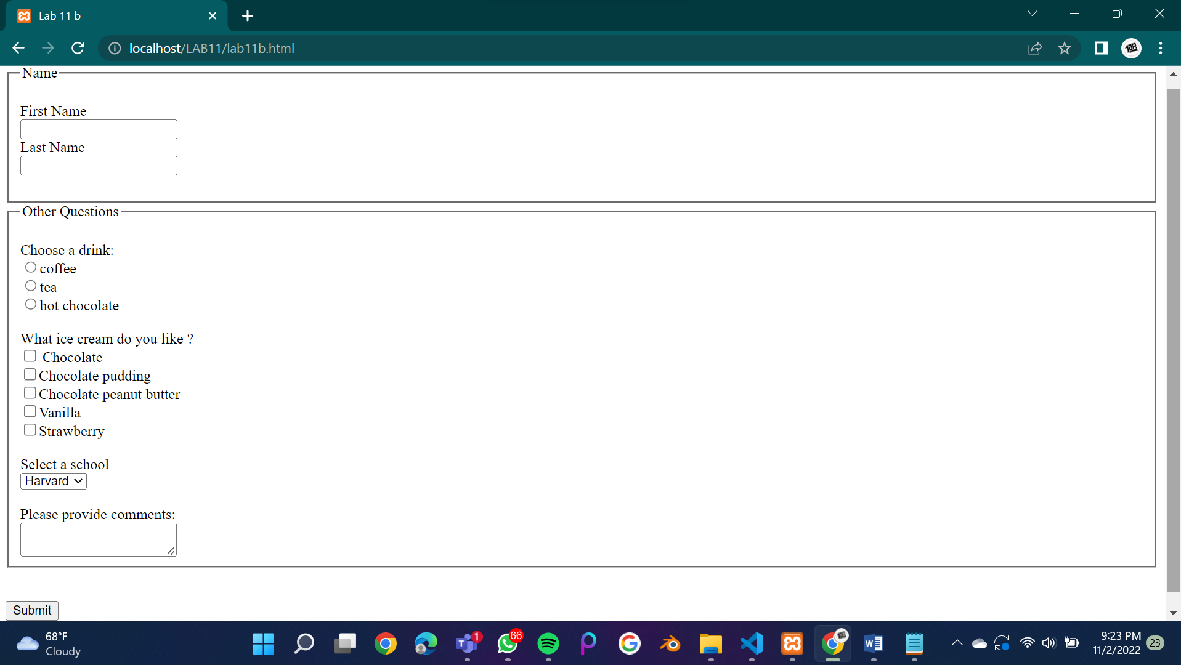

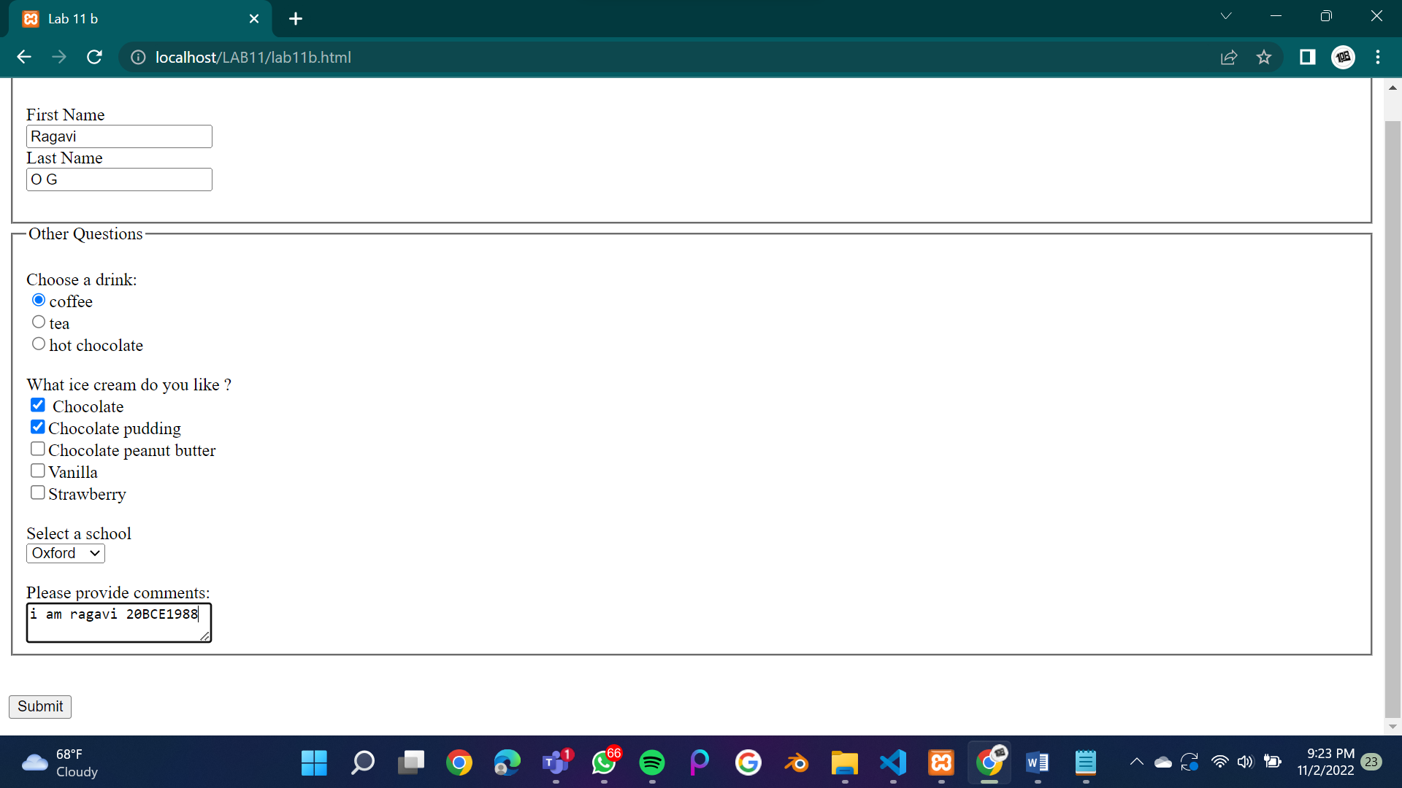

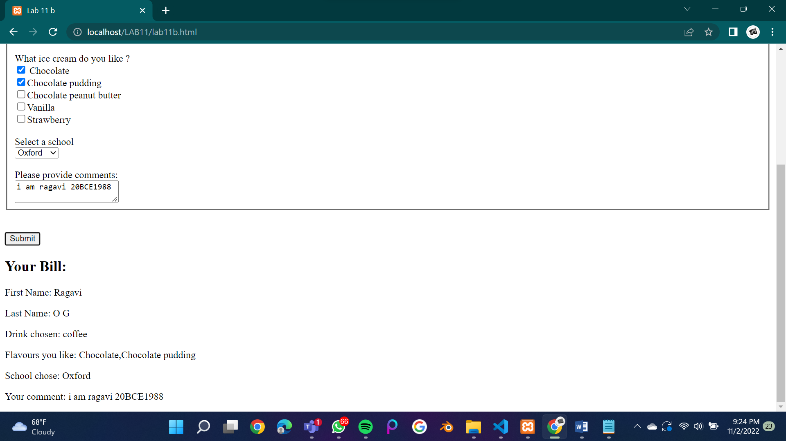

**Q3)**

**Code:**

<html>

<head>

<title>Lab 11 c</title>

<script src="https://code.jquery.com/jquery-3.6.1.js" integrity="sha256-3zlB5s2uwoUzrXK3BT7AX3FyvojsraNFxCc2vC/7pNI=" crossorigin="anonymous"></script>

</head>

<style>

.box1 {

background-color: aquamarine;

width: 21%;

}

.btn

{

color:white;

background-color:greenyellow;

border:none;

align-items:center;

padding:15px;

}

.h1

{

color:red;

}

</style>

<body>

<center><h1 class="h1">XYZ SHOP</h1></center>

<div class="box1">

<form>

<table>

<tr>

<td><label for="branch">Branch</label></td>

<td>

<select name="branch" id="branch">

<option selected>--Select Item--</option>

<option value="Adyar">Adyar</option>

<option value="Ashok nagar">Ashok nagar</option>

<option value="KK nagar">K K nagar</option>

</select>

</td>

</tr>

<tr>

<td><label for="uname">Username: </label></td>

<td> <input type="text" id="uname" name="uname"></td>

</tr>

<tr>

<td><label for="mob">Mobile : </label></td>

<td><input type="text" id="mob" name="mob"></td>

</tr>

</table>

</form>

</div>

<form>

<table>

<tr>

<th>Food Item</th>

<th colspan="2">&nbsp;&nbsp;</th>

<th>Quantity</th>

<th>Price</th>

</tr>

<tr>

<td>Item 1: </td>

<td></td>

<td>

<select name="item1" id="item1">

<option selected>--Select Item--</option>

<option value="pizza">Pizza</option>

<option value="burger">Burger</option>

</select>

</td>

<td>

<input type="number" id="n1" name="n1">

</td>

<td>

<input type="number" id="p1" name="p1" >

</td>

</tr>

<tr>

<td>Item 2: </td>

<td></td>

<td>

<select name="item2" id="item2">

<option selected>--Select Item--</option>

<option value="donut">Donut</option>

<option value="cheeseburger">Cheese burger</option>

</select>

</td>

<td>

<input type="number" id="n2" name="n2">

</td>

<td>

<input type="number" id="p2" name="p2" >

</td>

</tr>

<tr>

<td>Item 3: </td>

<td></td>

<td>

<select name="item3" id="item3">

<option selected>--Select Item--</option>

<option value="Punjabi Delight">Punjabi Delight</option>

<option value="Malai Kofta">Malai Kofta</option>

</select>

</td>

<td>

<input type="number" id="n3" name="n3">

</td>

<td>

<input type="number" id="p3" name="p3" >

</td>

</tr>

<tr>

<td>Item 4: </td>

<td></td>

<td>

<select name="item4" id="item4">

<option selected>--Select Item--</option>

<option value="Brownie">Brownie</option>

<option value="Lemontea">Lemontea</option>

</select>

</td>

<td>

<input type="number" id="n4" name="n4">

</td>

<td>

<input type="number" id="p4" name="p4" >

</td>

</tr>

<tr>

<td></td>

<td></td>

<td></td>

<td>

<input class="btn" type="button" id="bill" name="bill" value="Create Bill">

</td>

<td>

<input class="btn" type="button" id="clear" name="clear" value="Clear">

</td>

</tr>

</table>

</form>

<div class="bill" >

<h3 class="head1"></h3>

<div class="info1"></div>

<h3 class="head2"></h3>

<div class="orders">

<div class="items">

<div class="item1" ></div>

<div class="item2" ></div>

<div class="item3" ></div>

<div class="item4" ></div>

</div>

</div>

<p class="display"></p>

</div>

</body>

<script>

$('#bill').click(function () {

var uname = $('#uname').val();

$('.head1').append("Your details in the bill:");

$('.info1').append("<p>Name: " + uname + "</p>");

var branch = $('#branch option:selected').text();

$('.info1').append("<p>Branch: " + branch + "</p>");

var mob = $('#mob').val();

$('.info1').append("<p>Mobile: " + mob + "</p>");

var it1 = $('#item1 option:selected').text();

var it2 = $('#item2 option:selected').text();

var it3 = $('#item3 option:selected').text();

var it4 = $('#item4 option:selected').text();

var p1 = parseInt($('#p1').val());

var p2 = parseInt($('#p2').val());

var p3 = parseInt($('#p3').val());

var p4 = parseInt($('#p4').val());

var quan1 = parseInt($('#n1').val());

var quan2 = parseInt($('#n2').val());

var quan3 = parseInt($('#n3').val());

var quan4 = parseInt($('#n4').val());

$('.head2').append("Order taken:");

$('.item1').append("<p><b>Item 1: </b>" + it1 + "</p>");

$('.item1').append("<p><b>Quantity: </b>" + quan1 + "</p>");

$('.item1').append("<p><b>Price : </b>" + p1 + "</p>");

$('.item2').append("<p><b>Item 2: </b>" + it2 + "</p>");

$('.item2').append("<p><b>Quantity: </b>" + quan2 + "</p>");

$('.item2').append("<p><b>Price : </b>" + p2 + "</p>");

$('.item3').append("<p><b>Item 3: </b>" + it3 + "</p>");

$('.item3').append("<p><b>Quantity: </b>" + quan3 + "</p>");

$('.item3').append("<p><b>Price : </b>" + p3 + "</p>");

$('.item4').append("<p><b>Item 4: </b>" + it4 + "</p>");

$('.item4').append("<p><b>Quantity: </b>" + quan4 + "</p>");

$('.item4').append("<p><b>Price : </b>" + p4 + "</p>");

var sum = (quan1 * p1) + (quan2 * p2) + (quan3 * p3) + (quan4 * p4);

$('.display').append("<h3>Total Bill : " + sum + "</h3>");

})

</script>

</html>

**Output:**

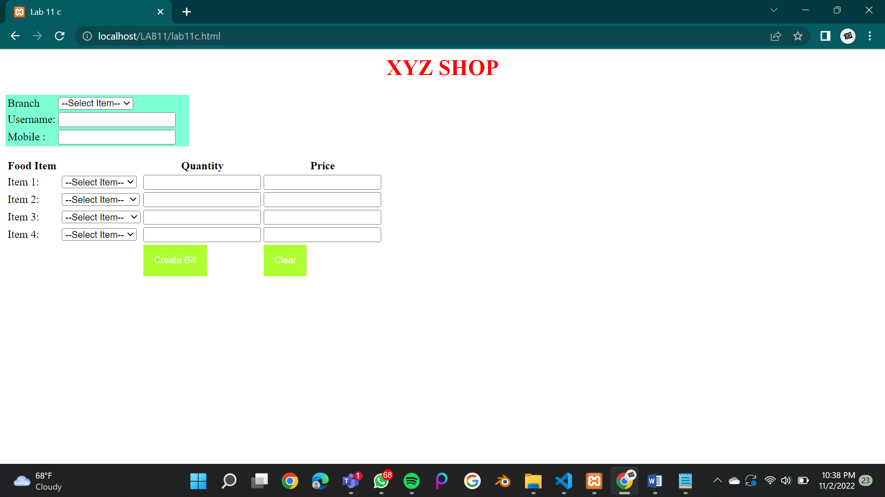

**Before clicking ‘create bill’**

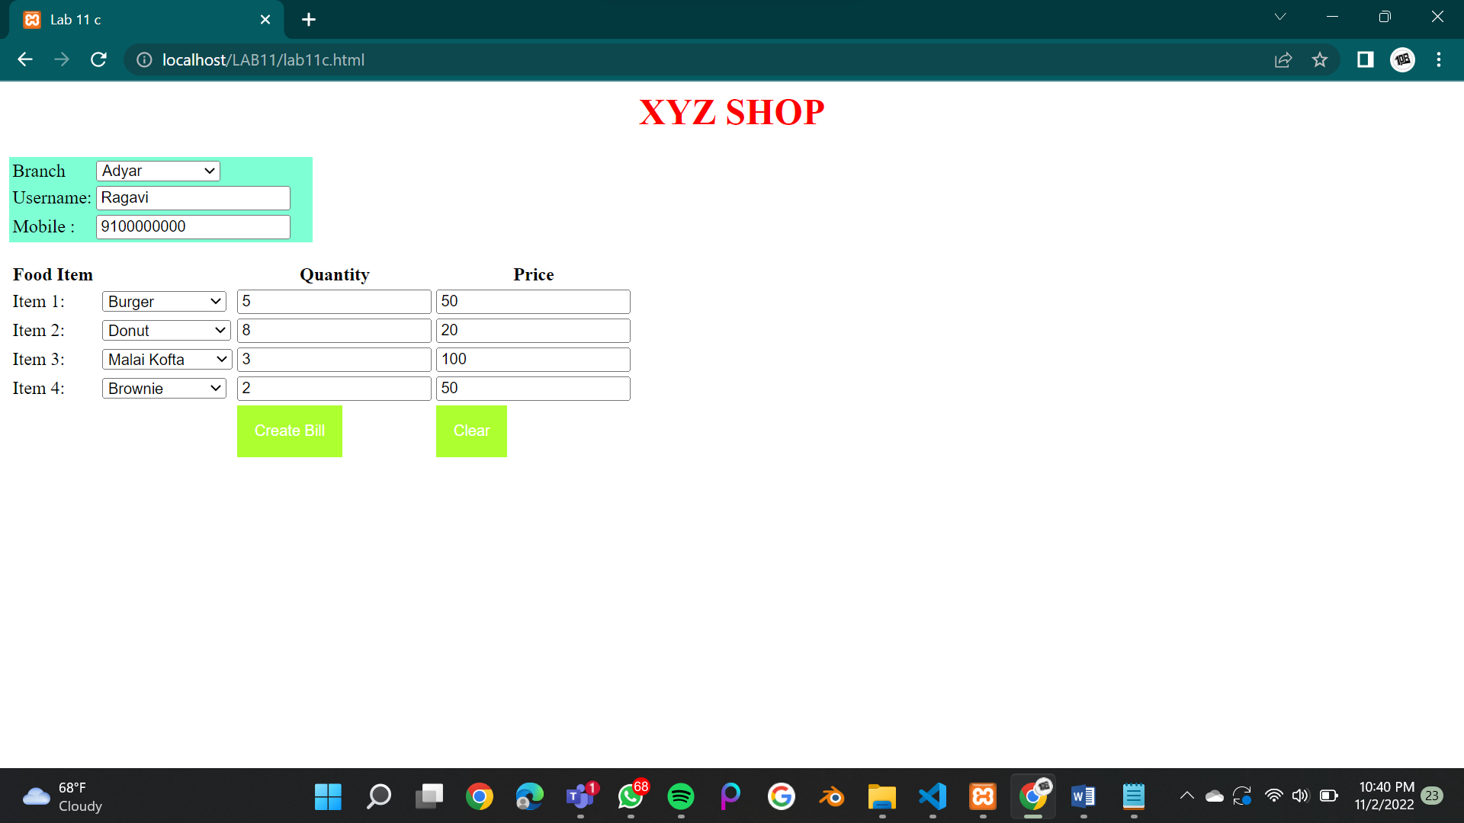

**After clicking ‘create bill’**

