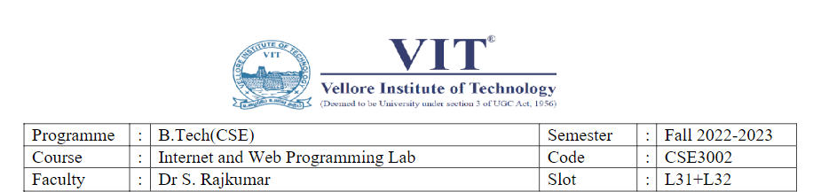

**LAB EX**: 1  **NAME**:O G Ragavi

**DATE:** 25-07-22 **REG NO:**20BCE1988

Q1)

Code:

<html>

    <head>

        <title>CSE3002-LAB1</title>

        <meta http-equiv="refresh" content="5">

    </head>

    <body background="pattern2.jpg" width="100%">

        <!--<img src="images/bg.jpg">-->

        <h2><center>A simple sample <del>dynamic</del> <u>static</u> web page</center></h2>

        <br><center><img src="html.png" width="200px" height="200px"></center>

        <center><figcaption>Figure caption</figcaption></center>

        <br>

        <center><h3>By O G Ragavi</h3>

        <h2><u>Demonstrating a few HTML features</u></h2></center>

        <code>HTML is a really a very simple language. It consists of ordinary text, with commands that are enclosed by &quot;&lt;&quot; and &quot;&gt;&quot; characters, or between an &quot;&amp;&quot; (for example &lt;html&gt;). You don't really need to know much HTML to create a page , because you can copy bits of HTML from other pages that do what you want, then change the text! This page shows on the left as it appears in your browser, and the correponding HTML code appears on the right. The HTML commands are linked to explanations of what they do.  </code>

        <br><br>

        <center><marquee><h5>Line Break</h5></marquee></center>

        <h3>HTML doesn't normally use line breaks for ordinary text. A white space of any size is treated as a single space.The code type of format can also be used in html for example </h3>

        <br>

        <br>

        <code>

           <h5>#include&lt;iostream.h&gt;</h5>

           <h5>void main()</h5>

           <h5>{</h5>

           <h5>cout&lt;&lt;&quot;This is the simple program&quot;;</h5>

           <h5>}</h5>

        </code>

        <br>

        <h3>

            If you want to put multiple spaces, then you can use non breaking space entity by multiple times.For ex,I would like to use 3 more blank spaces&nbsp;&nbsp;&nbsp;here.If you want to put a line break at a particular place,you

            can use the &quot;&lt;BR&gt;&quot; command,or,for a paragraph break,the &quot;&lt;p&gt;&quot; command,which will insert a blank line.You can also use some extended text formatting features such as a superscript,subscript and mark features like this

        </h3>

        <p>1<sup>st</sup>,2<sub>nd</sub><mark>mark</mark>and <em>emphasised format features</em></p>

        <h3>Starting and Stopping commands</h3>

        <code>&nbsp;&nbsp;&nbsp;&nbsp;&nbsp;&nbsp;&nbsp;Most of the commands come in pairs: for example, &quot;&lt;H4&gt;&quot; marks the beginning of a size 4 heading,

        and &quot;&lt;H4&gt;&quot; marks the end of it.The closing command is always the same as the opening command,except for the addition of

        &quot;/&quot;.</code>

        <br>

        <p>Modifiers are sometimes included along with the basic command,inside the opening command's &lt;&gt;.The modifier does not need to be repeated in the closing command.</p>

        <center><h1>This is a size &quot;1&quot; heading</h1></center>

        <h2>This is a size &quot;2&quot; heading</h2>

        <h3 align="right">This is a size &quot;3&quot; heading</h3>

        <br><br><br>

        <p align="center">Copyright &copy; 2022, by <font color="purple"><u><i>OG Ragavi</i></u></font> &trade;</p>

        <br>

        <center><p>The objective of the equation is to use one &alpha; two &Ocirc; three &gamma;</p>

        <p>If you would like to make a link or bookmark to this page,the URL is:</p>

        <a href="https://signup.oraclecloud.com/">https://signup.oraclecloud.com/</a></center>

        <br><br>

        <video width="320" height="240" autoplay muted controls>

            <source src="OCEAN.mp4" type="video/mp4">

        </video>

        <br><br>

        <h3>Formula</h3>

        <p>(a+b)<sup>2</sup>= a<sup>2</sup>+b<sup>2</sup>+2ab</p>

        <center><progress></progress></center>

    </body>

</html>

Output:

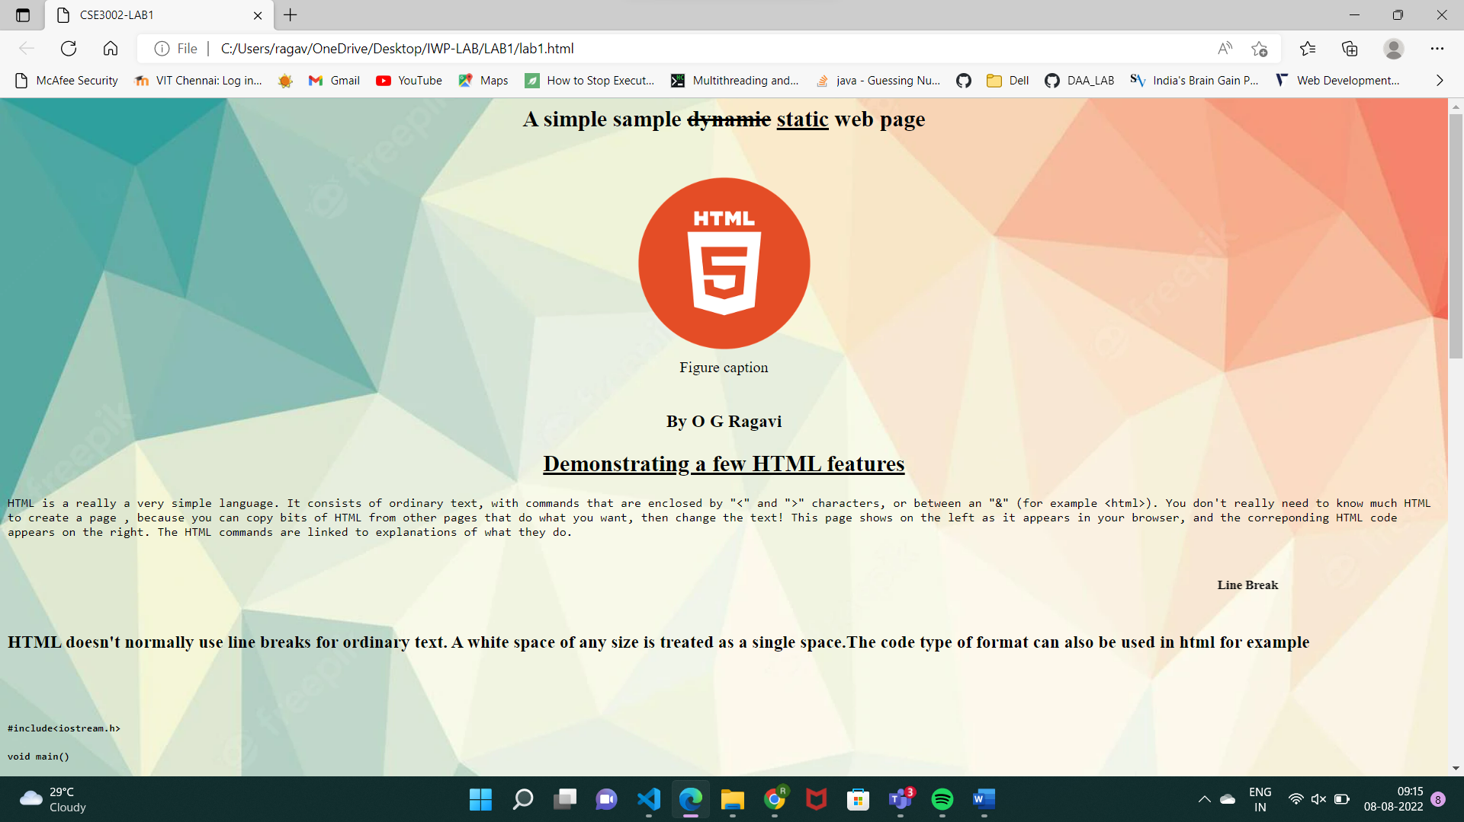

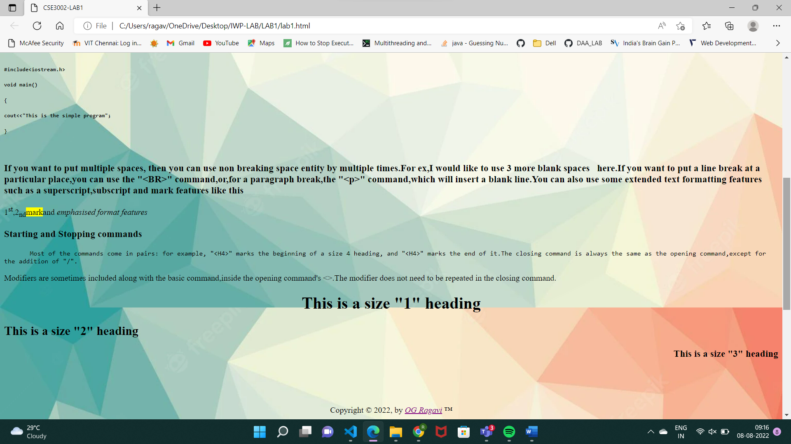

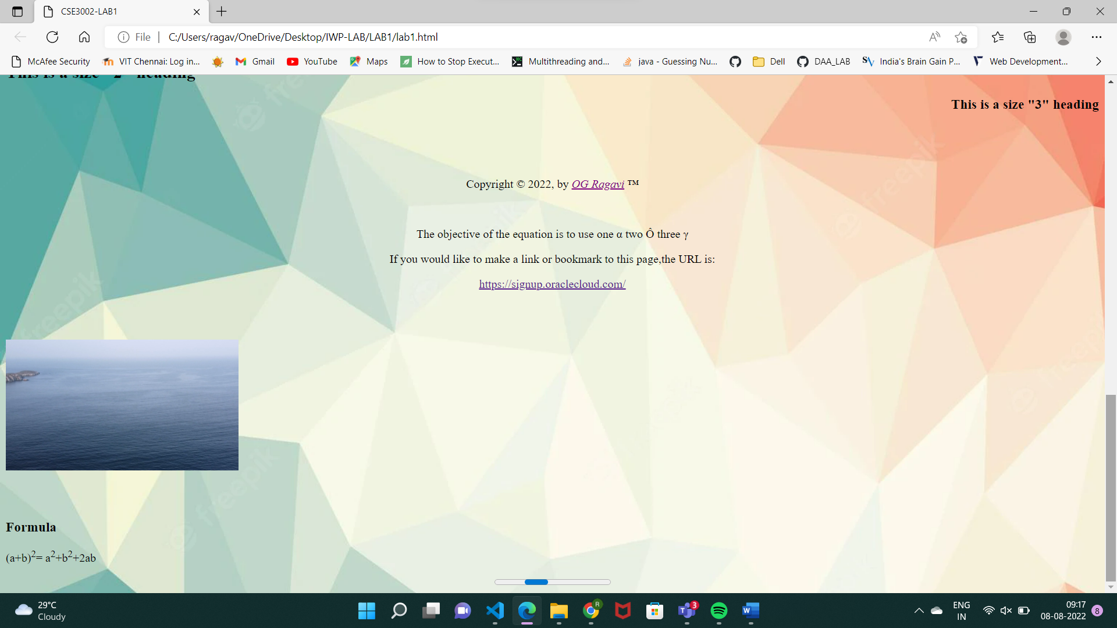

Q2)

Code:

<video width="320" height="240" autoplay muted controls>

            <source src="OCEAN.mp4" type="video/mp4">

        </video>

Output:



Q3)

Code:

<center><marquee><h5>Line Break</h5></marquee></center>

Output:

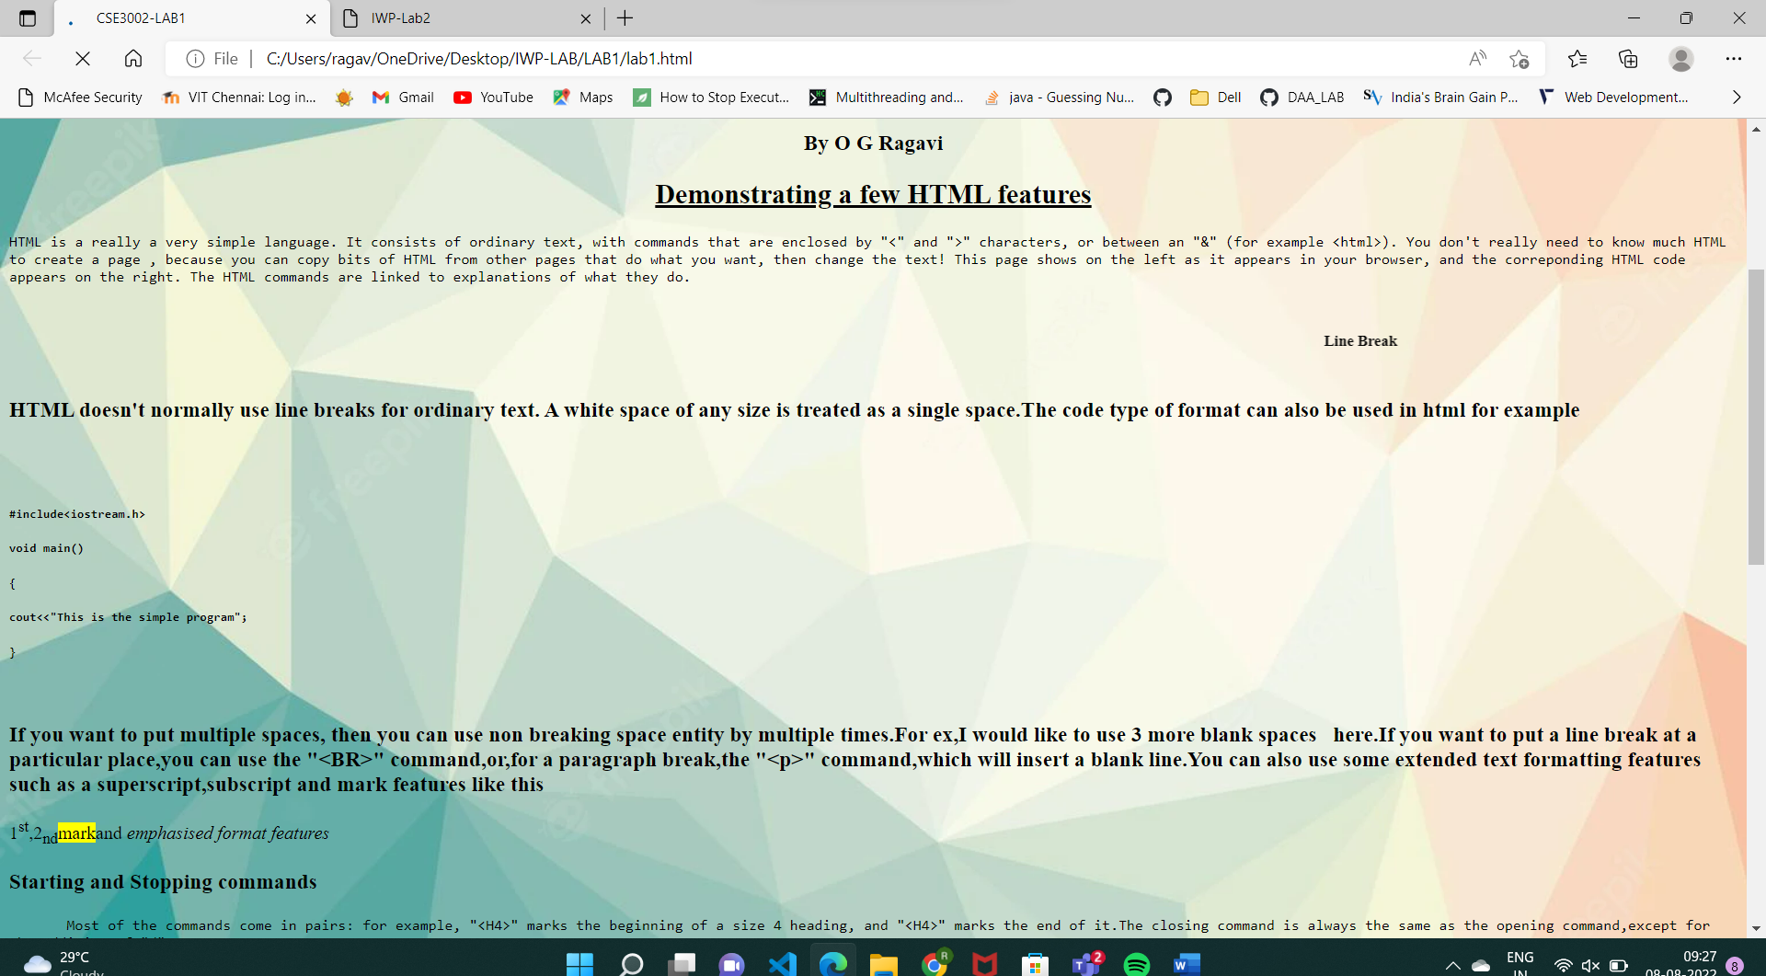

Q4)

Code:

<h3>Formula</h3>

        <p>(a+b)<sup>2</sup>= a<sup>2</sup>+b<sup>2</sup>+2ab</p>

Output:

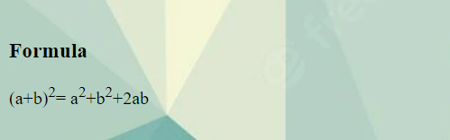

Q5)

Code:

<head>

        <title>CSE3002-LAB1</title>

        <meta http-equiv="refresh" content="5">

    </head>

Output:

