**CSE3002-INTERNET AND WEB PROGRAMMING**

**Name**: RAGAVI O G

**Reg no**:20BCE1988

**Lab No**:5

**Title:** Basics of JavaScript **Date:** 07-09-2022

Q1)

Code:

<html>

<head>

   <title>Lab5-a</title>

</head>

<body>

    <script>

        var total = 0;

        var rate = 0.1;

        var principal = parseInt(prompt("Enter the principal amount:"));

        var si = principal * rate * 1 / 100;

        total = si + principal;

        //window.alert("The total amount to pay is : " + total);

        document.write("Total amount to pay is:"+total);

    </script>

</body>

</html>

Output:

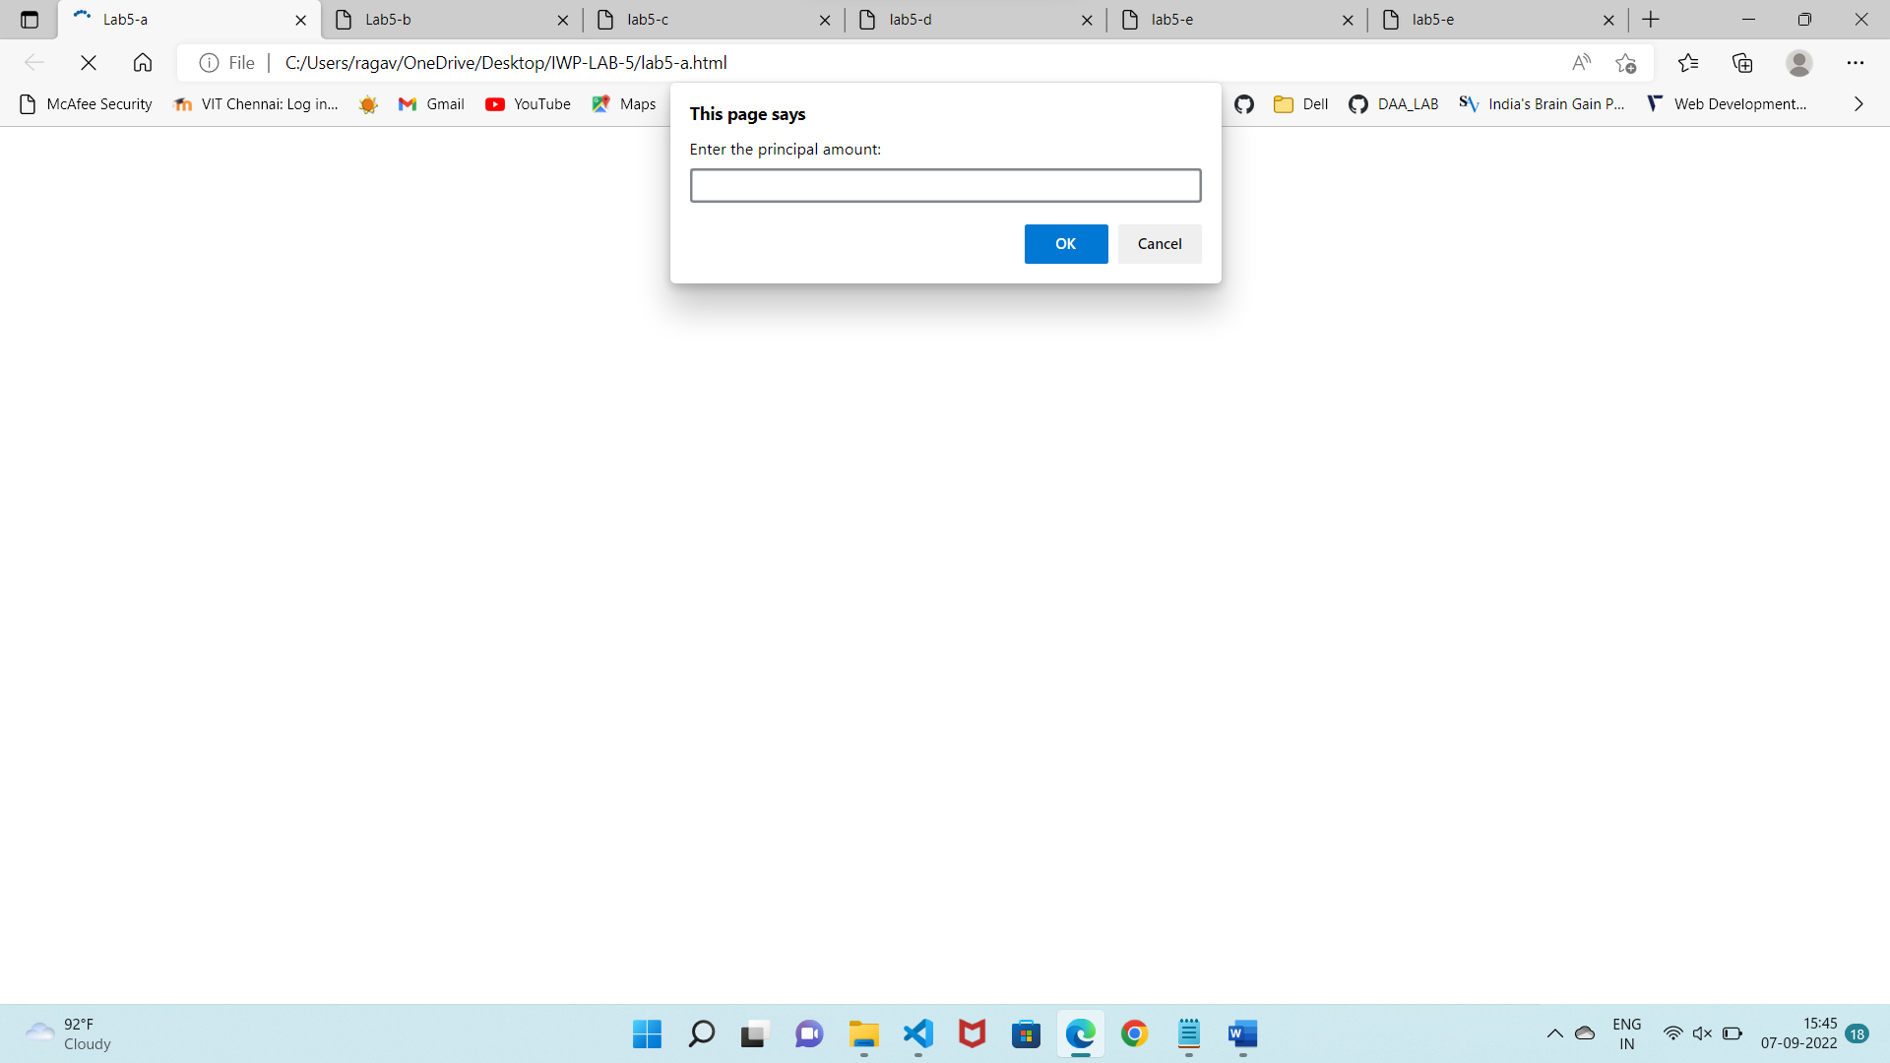

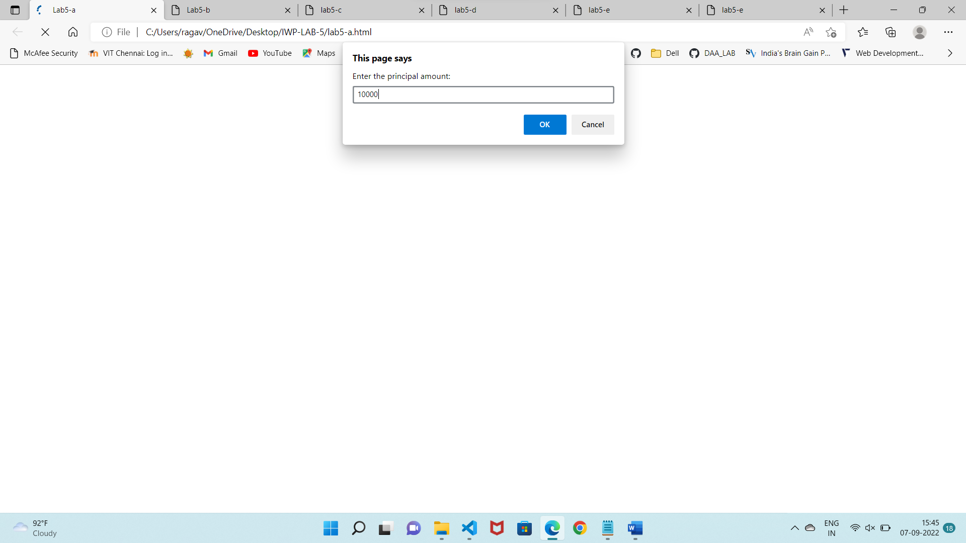

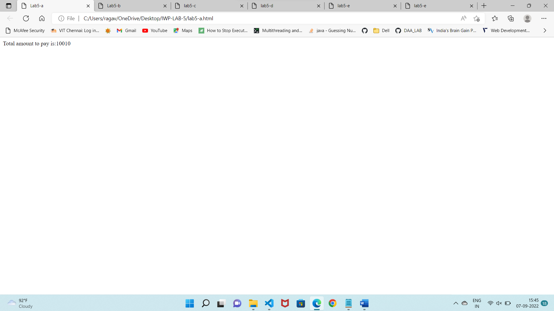

Q2)

Code:

<html>

<head>

    <title>Lab5-b</title>

</head>

<body>

    <script>

        var acc_no = parseInt(prompt("Enter the account no:"));

        var initial_balance = parseFloat(prompt("Enter the initial balance:"));

        var tot_items = parseInt(prompt("Enter the total items charged by the customer:"));

        var tot_cred = parseInt(prompt("Enter the total credits applied to customer's account:"));

        var updated = initial_balance + tot_items - tot_cred;

        document.write("Update balance of the VIP customer is:"+updated+"<br>");

        if (updated > 1000) {

            document.write("Exceeded!!!");

        }

        else {

            document.write("Not Exceeded!!!");

        }

    </script>

</body>

</html>

Output:

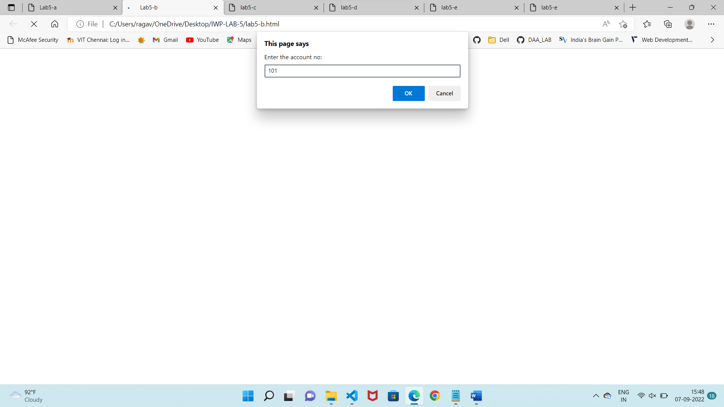

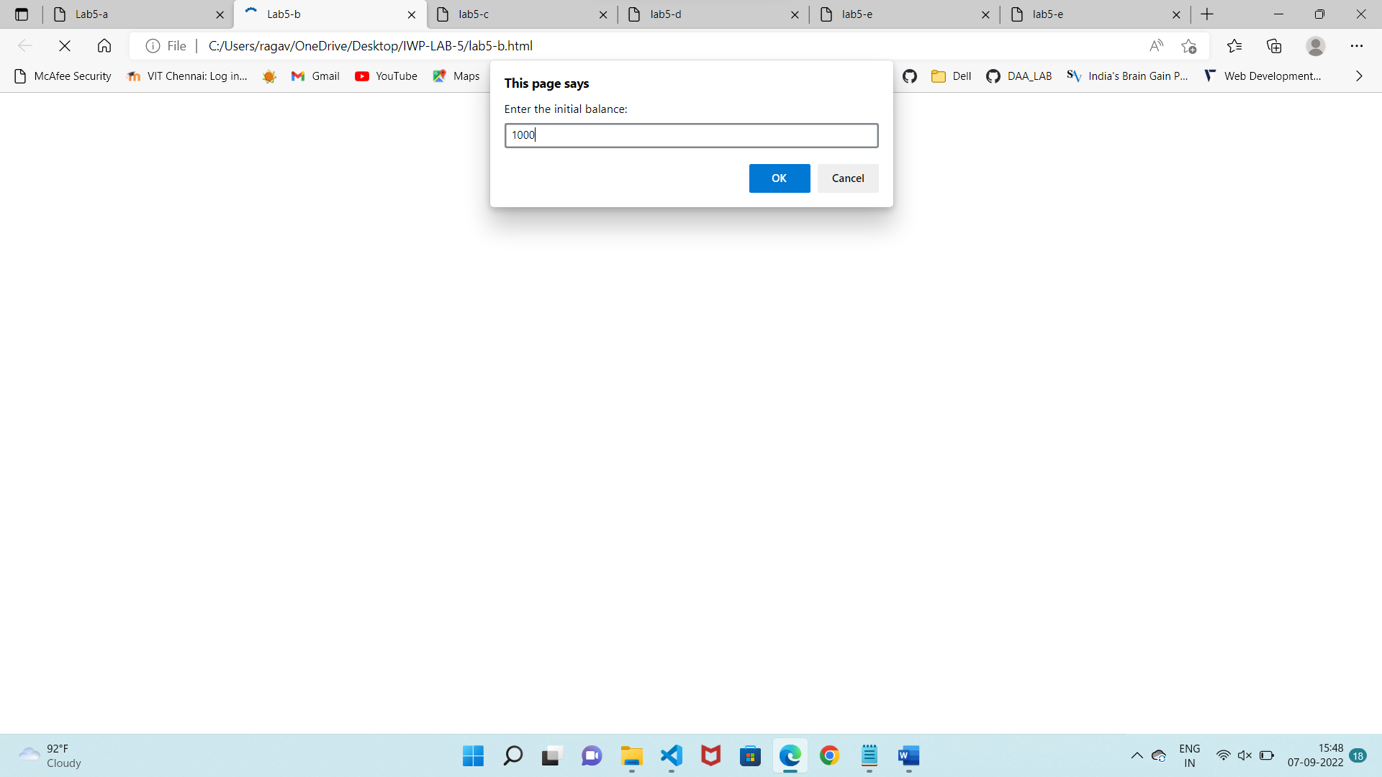

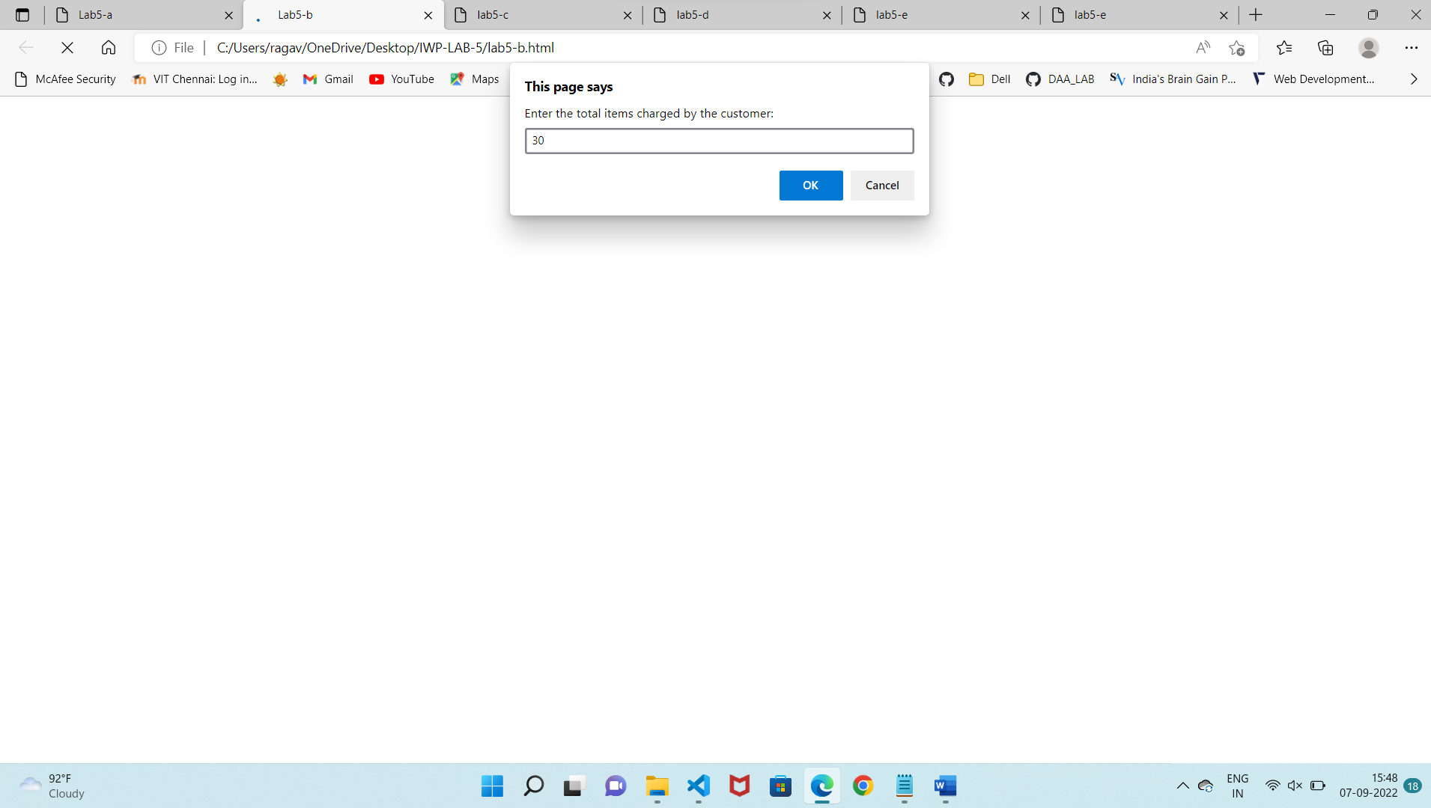

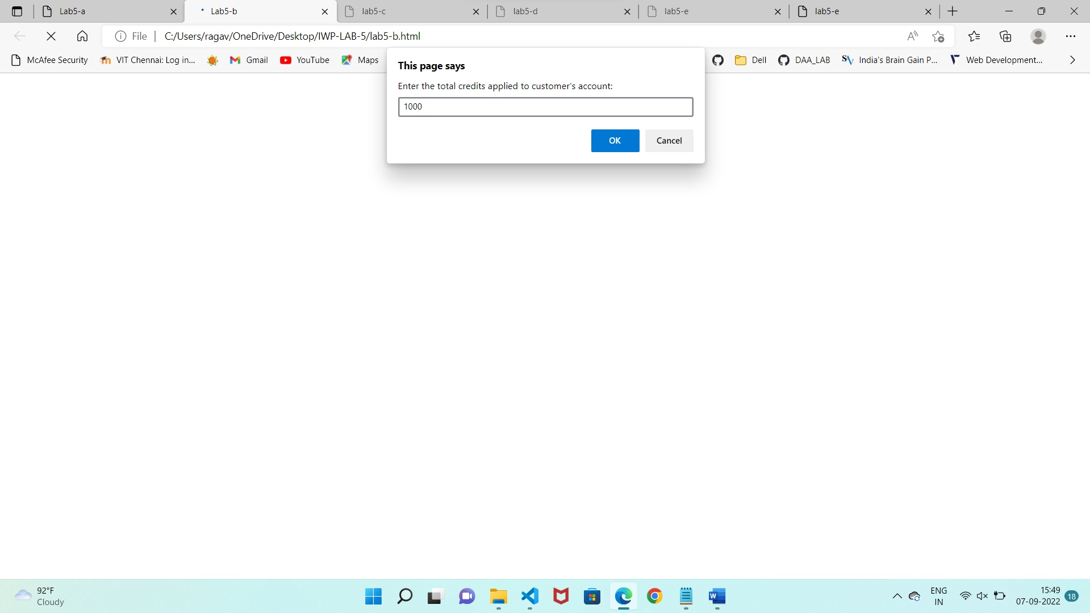

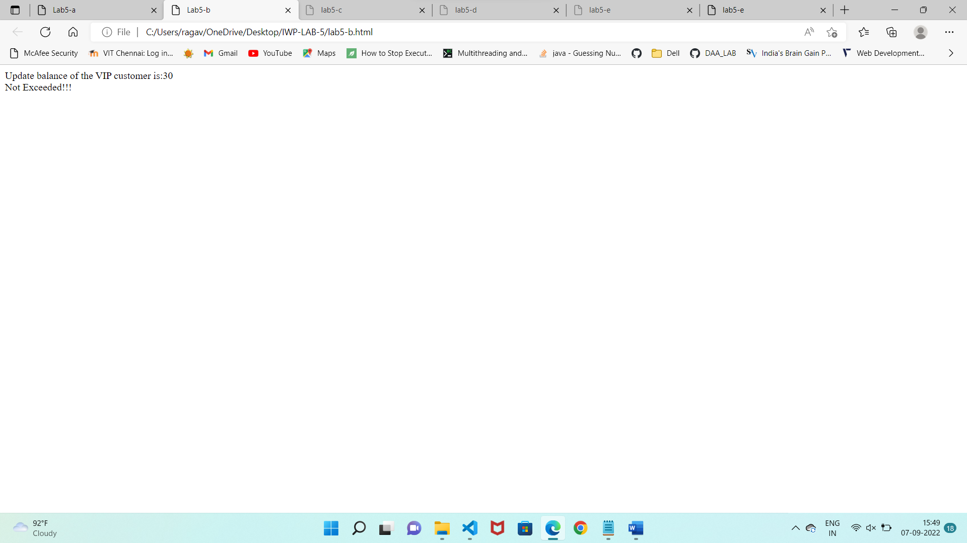

Q3)

Code:

<html>

    <head>

        <title>lab5-c</title>

        <script>

            var bp = parseFloat(window.prompt("Enter the boiling point of the substance"));

            var sub;

            if(bp >= 95 && bp <= 105)

            sub = "Water";

            else if (bp >= 339.15 && bp <= 374.85)

            sub = "Mercury";

            else if (bp >= 1127.65 && bp <= 1246.35)

            sub= "Copper";

            else if (bp >= 2083.35 && bp <= 2302.65)

            sub = "Silver";

            else if (bp>= 2527 && bp<= 2793)

            sub = "Gold";

            else

            sub = "unknown";

            window.alert("The substance is "  + sub + ".");

        </script>

    </head>

    <body>

    </body>

</html>

Output:

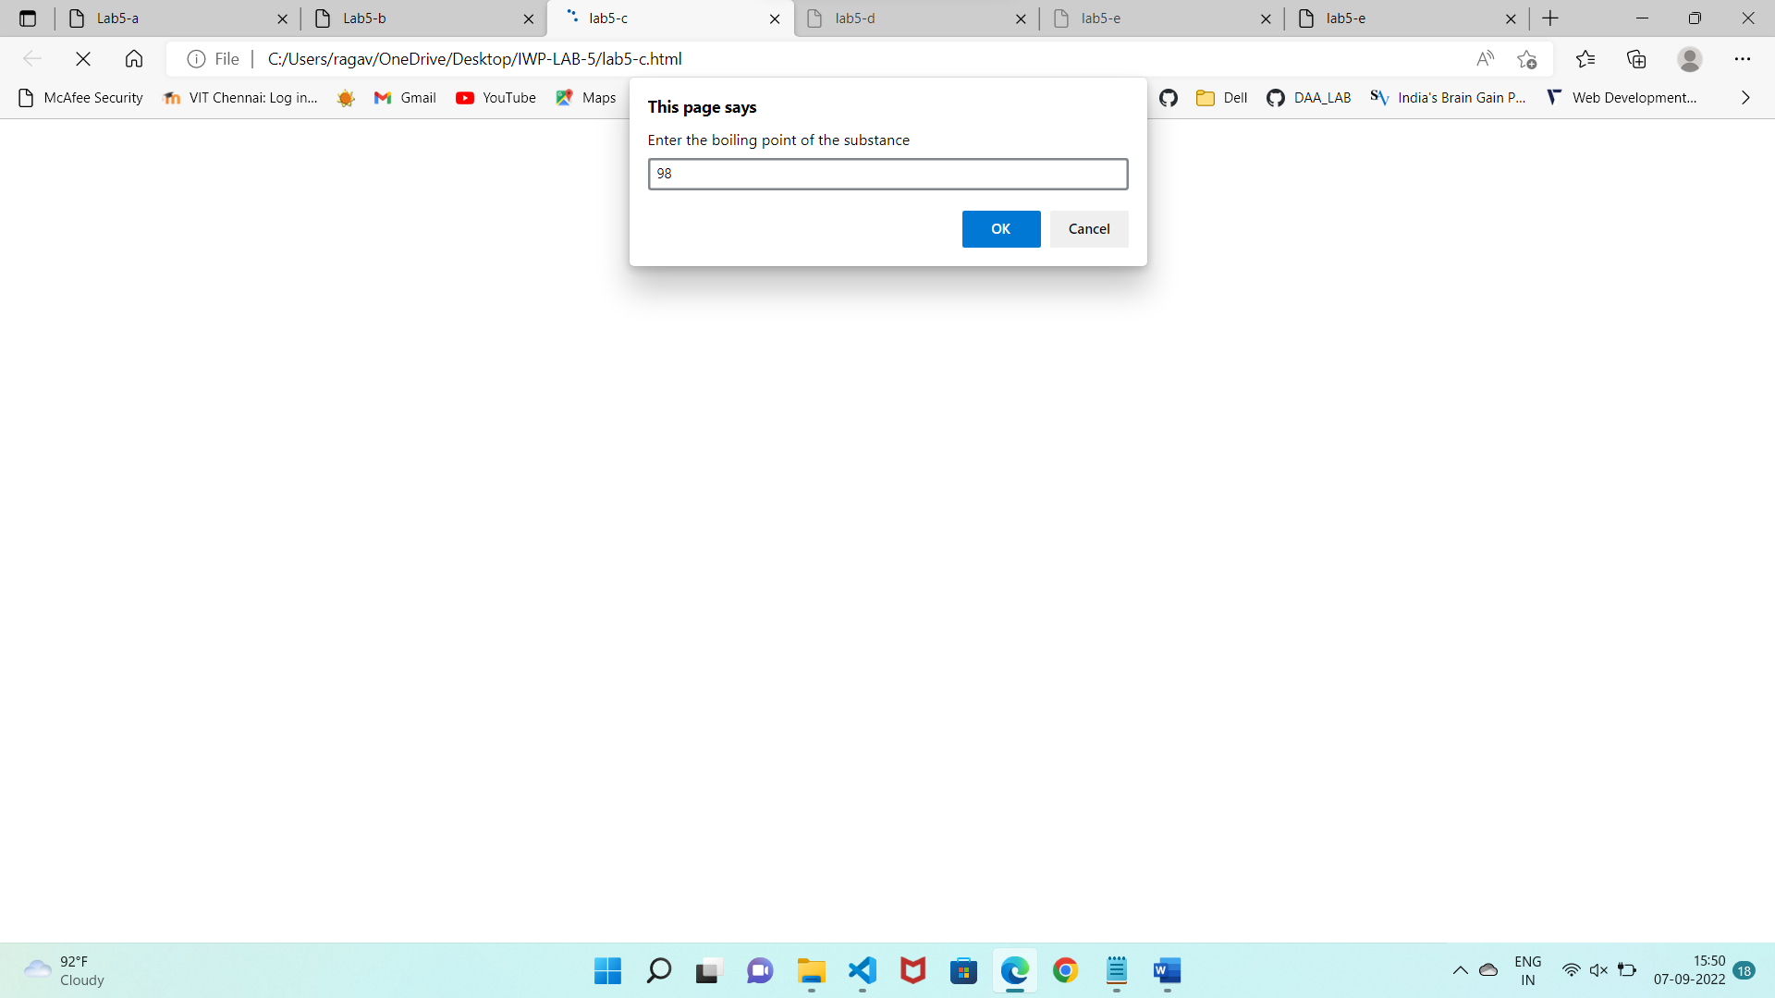

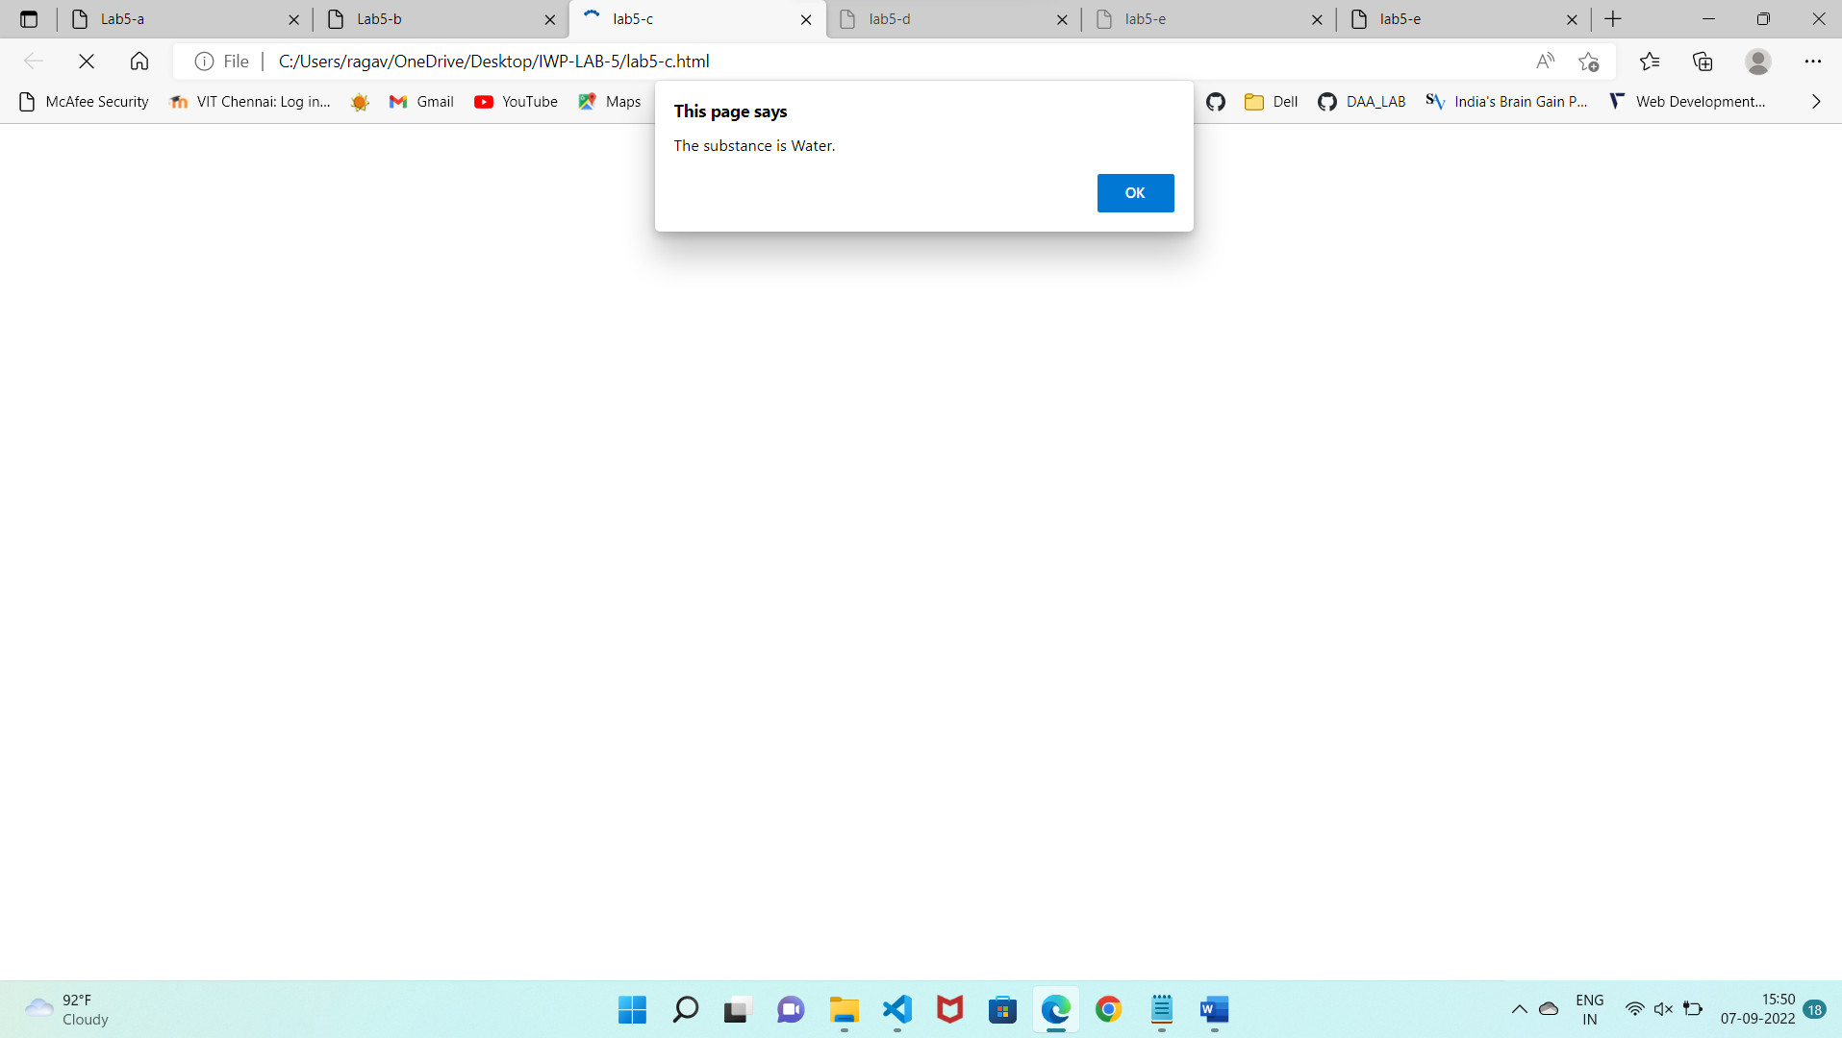

Q4)

Code:

<html>

    <head>

        <title>lab5-d</title>

    </head>

    <body>

        <center>

            <form>

                <fieldset style="border: 1px solid red; padding-bottom: 40px;width:50%">

                    <label for="temp">Enter a Temperature: </label>

                    <input type="text" id="temp"><br><br>

                    <label>Use these buttons to calculate the temperature</label><br>

                    <input type = "button" onclick="fun1()" value="F to C">

                    <input type = "button" onclick="fun2()" value="C to F"><br><br>

                    <label>Converted value based on the selected option</label><br>

                    <input type="text" id = "result">

                </fieldset>

            </form>

        </center>

    </body>

    <script>

        var res1 = 0;

        function fun1()

        {

            var fah = parseFloat(document.getElementById("temp").value);

            res1 = ((fah-32)*5/9);

            document.getElementById("result").value = res1;

        }

        function fun2()

        {

            var cel = parseFloat(document.getElementById("temp").value);

            res1 = (cel*1.8 + 32);

            document.getElementById("result").value = res1;

        }

    </script>

</html>

Output:

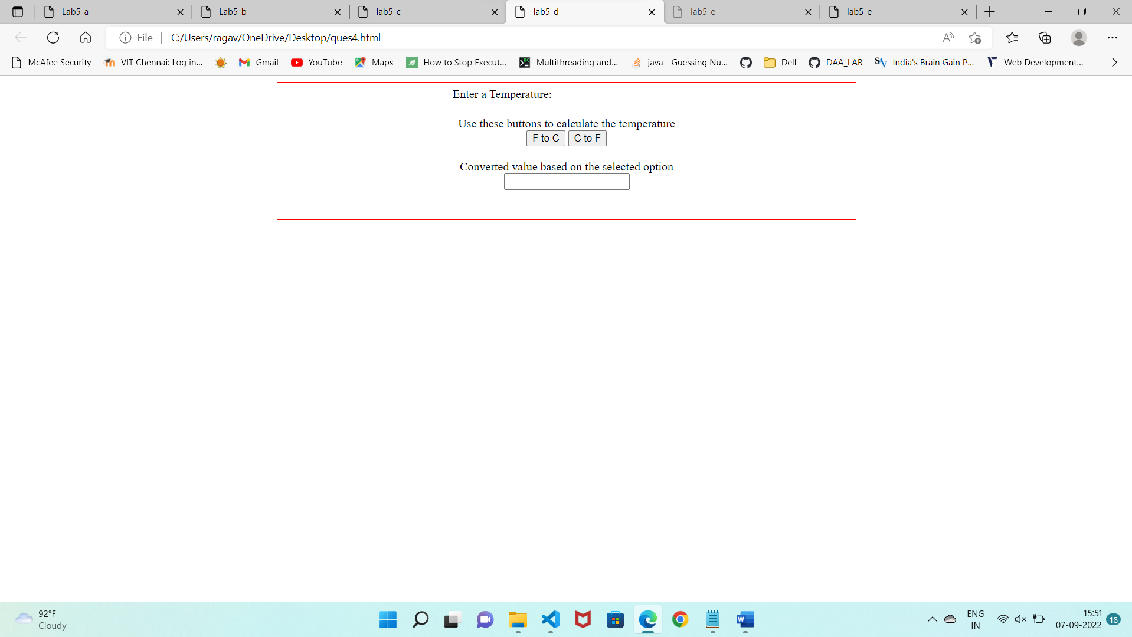

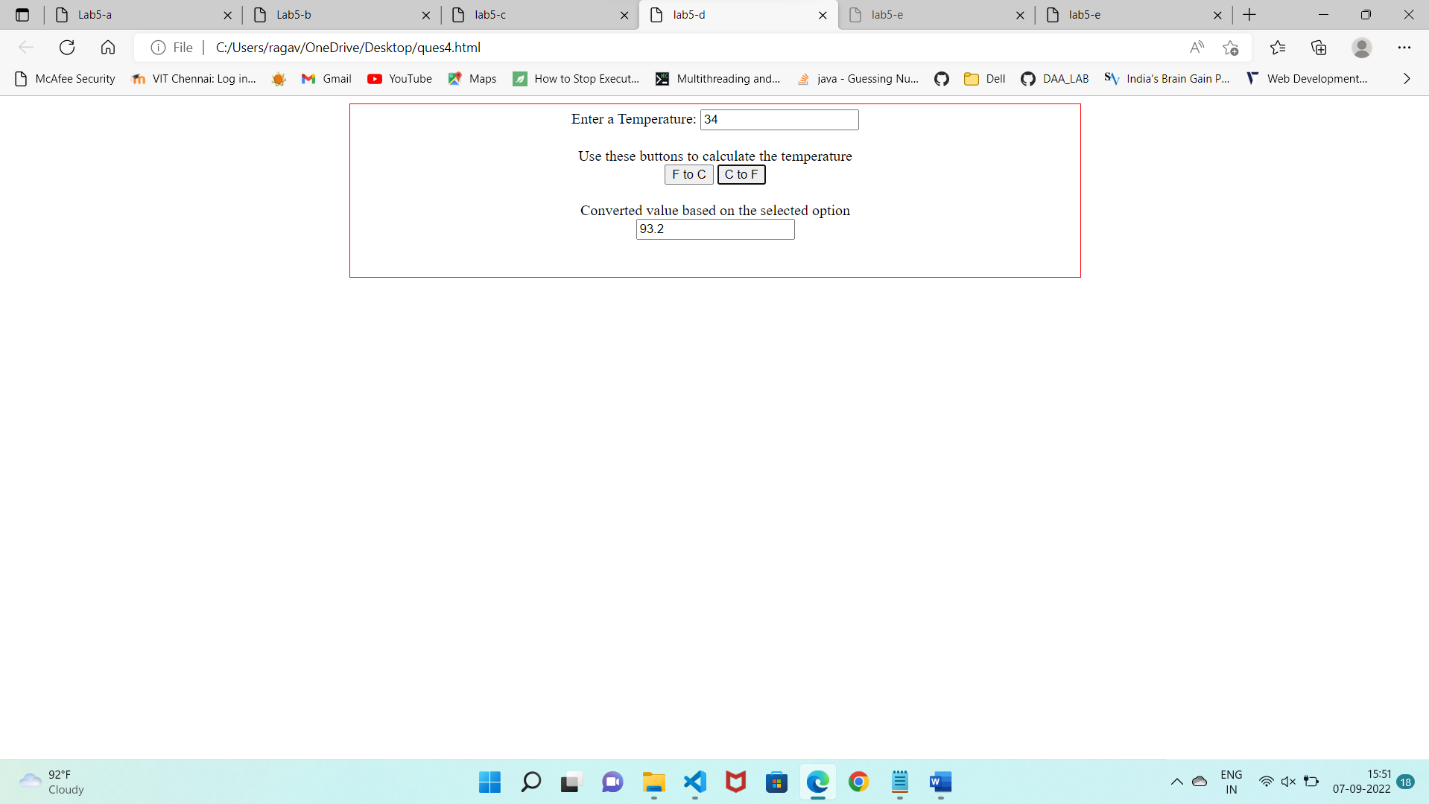

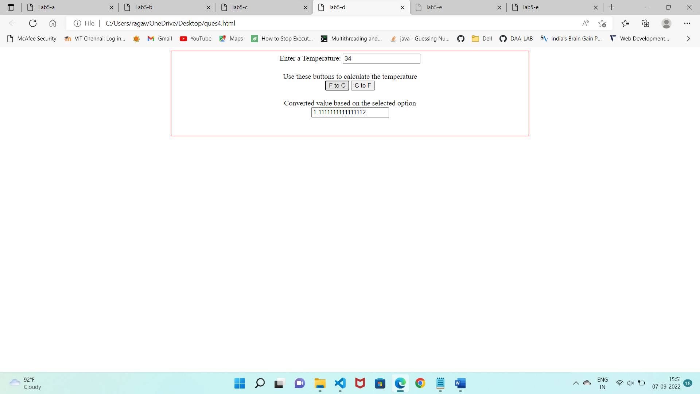

Q5)

Code:

<html>

    <head>

        <title>lab5-e</title>

    </head>

    <body>

        <form name = "forms">

            <fieldset style="border: 3px solid red; padding-bottom: 40px;width:50%">

                <legend style="font-weight:bolder">

                    Student Details

                </legend>

            <table>

                <tr>

                    <td><label>Registration no :</label></td>

                    <td><input type = "text" placeholder="Registration no"><br></td>

                </tr>

                <tr>

                    <td><label>Name: </label></td>

                    <td><input type = "text" placeholder = "Name"><br></td>

                </tr>

                <tr>

                    <td><label>Semester: </label></td>

                    <td><input type = "text" placeholder = "Semester"><br></td>

                </tr>

                <tr>

                    <td><label>Department: </label></td>

                    <td><input type = "text" placeholder = "Department"><br></td>

                </tr>

                <tr>

                    <td><label>sub1 marks: </label></td>

                    <td><input type = "number" placeholder = "sub1 marks"><br></td>

                </tr>

                <tr>

                    <td><label>sub2 marks:</label></td>

                    <td><input type = "number" placeholder = "sub2 marks"><br></td>

                </tr>

                <tr>

                    <td><label>sub3 marks:</label></td>

                    <td><input type = "number" placeholder = "sub3 marks"><br></td>

                </tr>

                <tr>

                    <td colspan="2"><input type="button" id = "submit" onclick = "display()" value = "Submit"></td>

                </tr>

            </table>

        </fieldset>

        </form>

        <br><br>

            <legend style="font-weight:bolder">

                 Details entered

            </legend>

            <textarea id="info" rows = "20" cols="50"></textarea>

    </body>

    <script>

        function display()

        {

            var sid = "Registration no: " + forms.elements[1].value + "\n";

            var name = "Name of the student: " + forms.elements[2].value + "\n";

            var sem = "Ongoing Semester: " + forms.elements[3].value + "\n";

            var dep = "Department of the student: " + forms.elements[4].value + "\n";

            var m1 = "Subject1 marks: "+forms.elements[5].value + "\n";

            var m2 = "Subject2 marks: " + forms.elements[6].value + "\n";

            var m3 = "Subject3 marks: " + forms.elements[7].value + "\n";

            var total= Number(forms.elements[5].value) + Number(forms.elements[6].value) + Number(forms.elements[7].value);

            var avg = total/3;

            var tot = "Total marks of the student: " + total + "\n";

            var avg1 = "Average marks of the student: " + avg + "\n";

            document.getElementById("info").innerHTML = sid + name + sem + dep + m1 + m2 + m3 + tot + avg1;

        }

    </script>

</html>

Output:

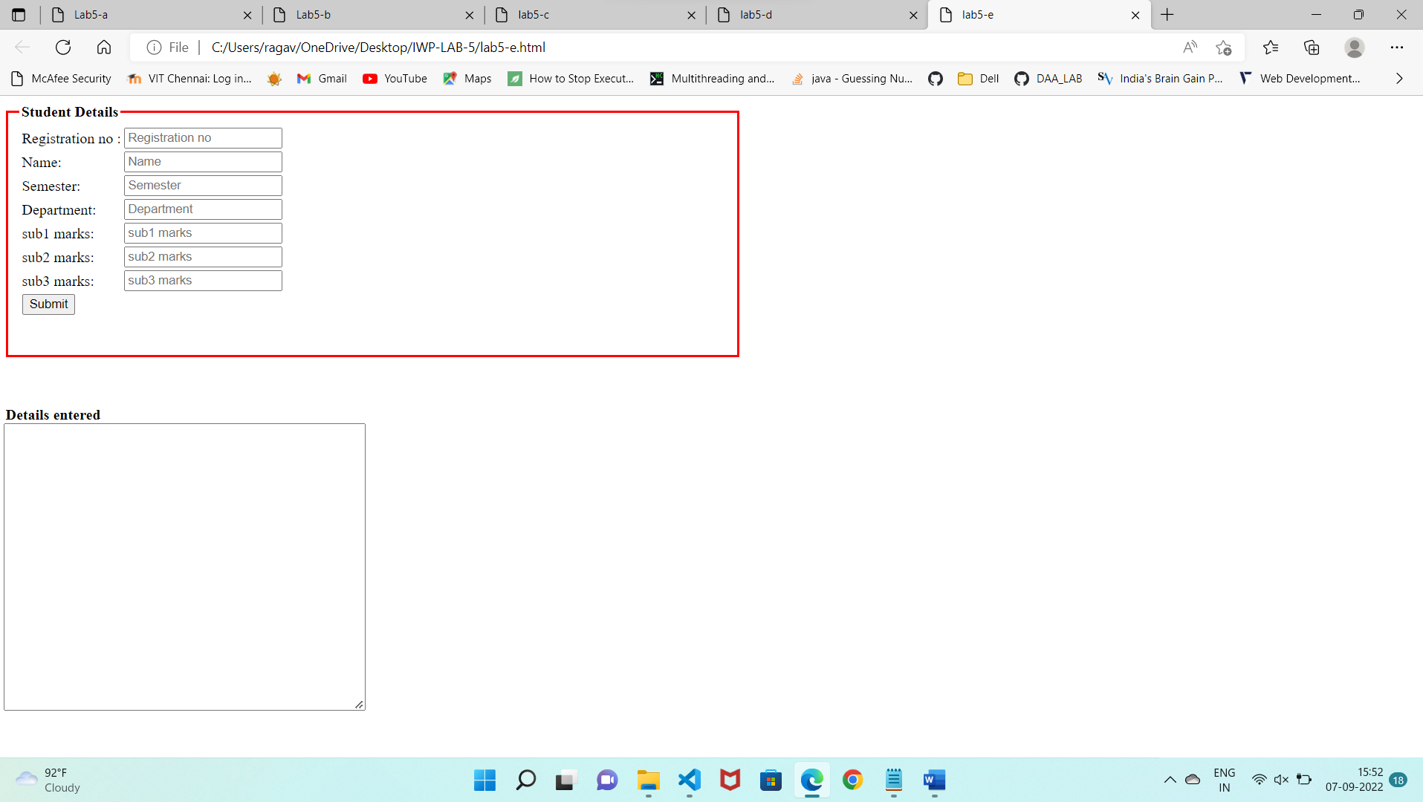

Before submitting:

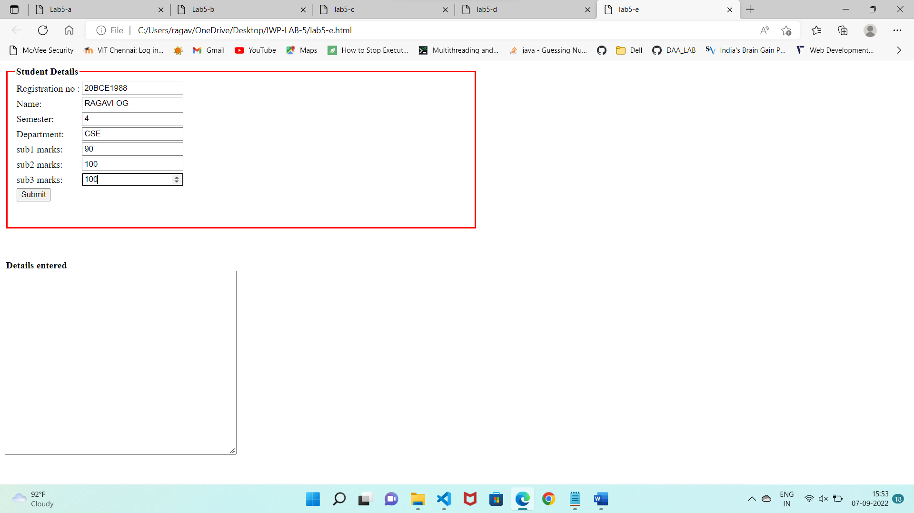

After submitting:

