**CSE2006-MICROPROCESSORS (EMBEDDED LAB)**

**NAME: O G RAGAVI REG NO:20BCE1988**

**EX:1**

**TITLE: Basic Math Operations on two hexa-decimal numbers**

**AIM:** To verify the arithmetic operation using the 8086 processor by MASM 611 assembler.

**TOOL USED:** Assembler - MASM 611

**Algorithm:**

1. Inside the code segment, moving the first value to AX (accumulator) register.

2. Move the second number to BX (base) register.

3. Perform add/sub/mul/div operation of the AX and BX register to store the final value in the accumulator.

4. Then halt the operation and end the code segment and the start of the segment.

5. Then run the code after assembling it.

**PROGRAM:**

**1.ADDITION:**

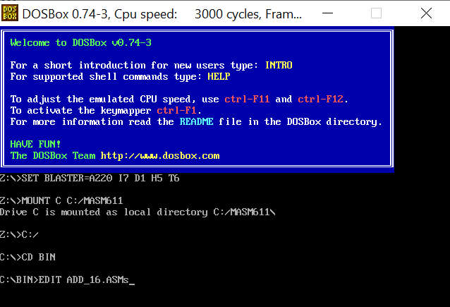

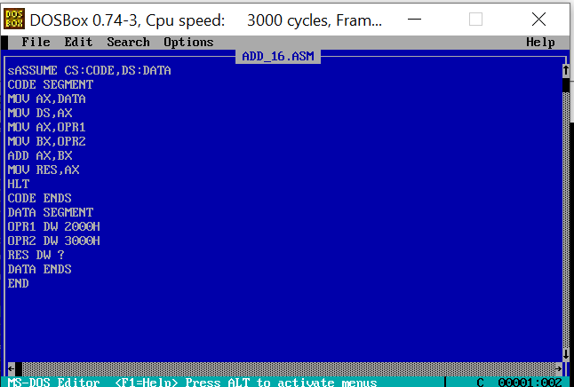

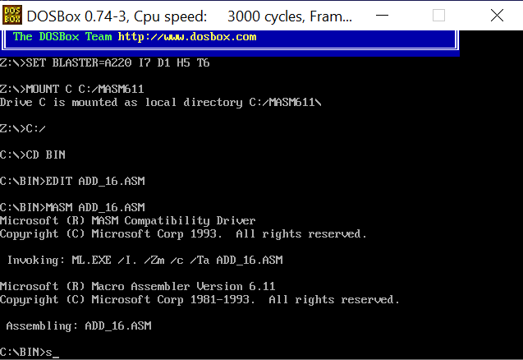

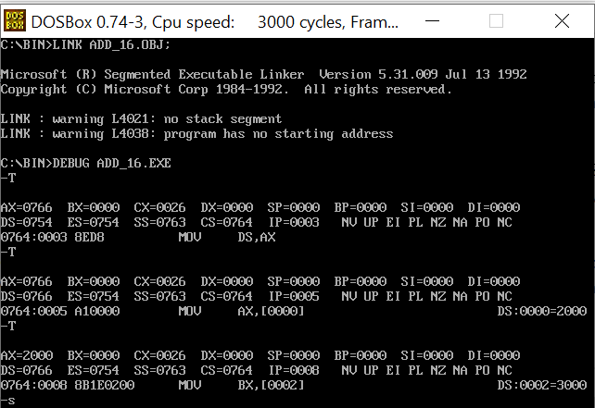

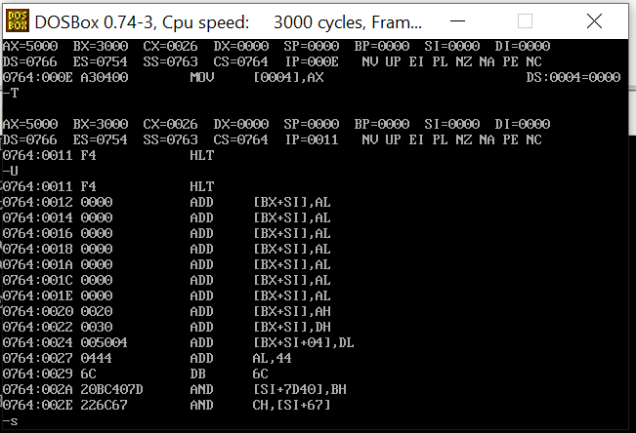

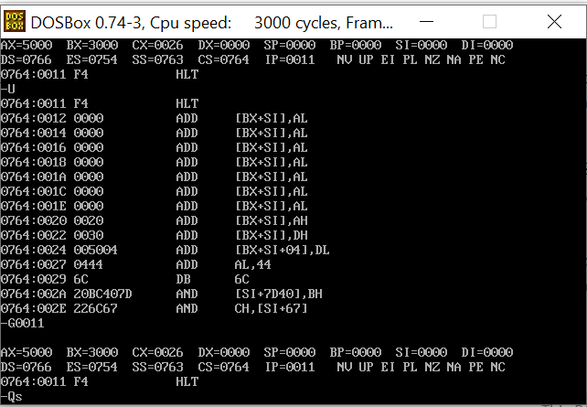

**2.SUBTRACTION:** 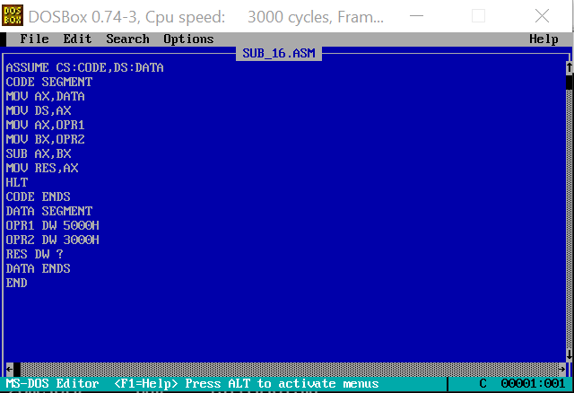

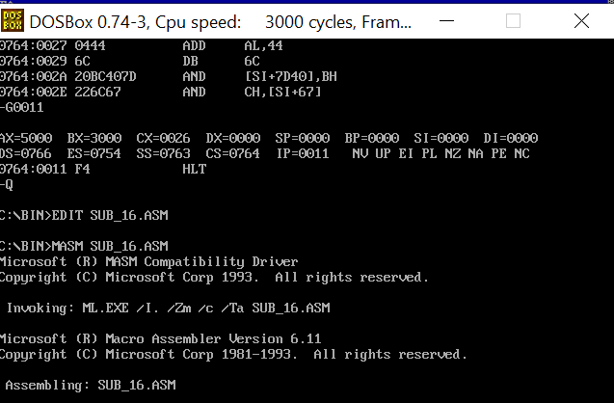

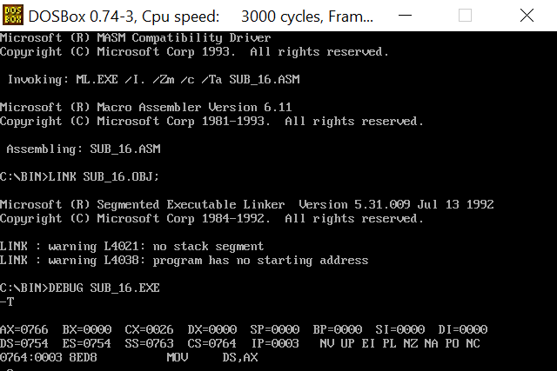

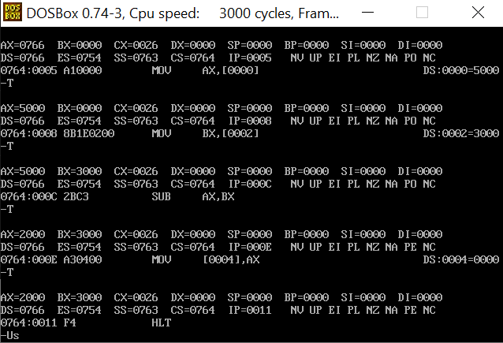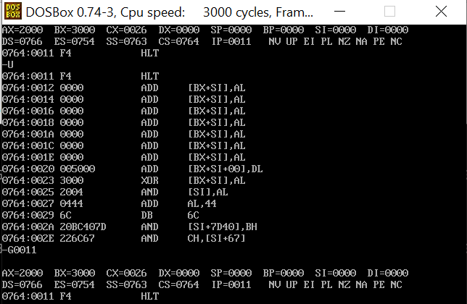

**MUTIPLICATION:**

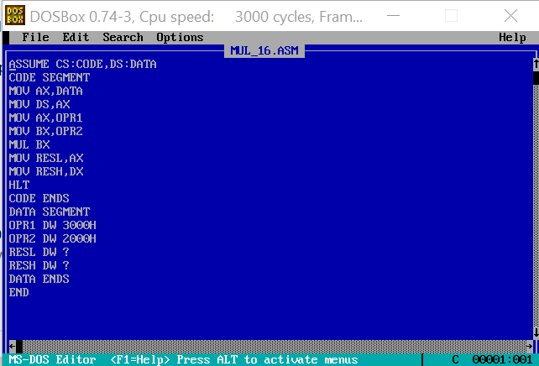

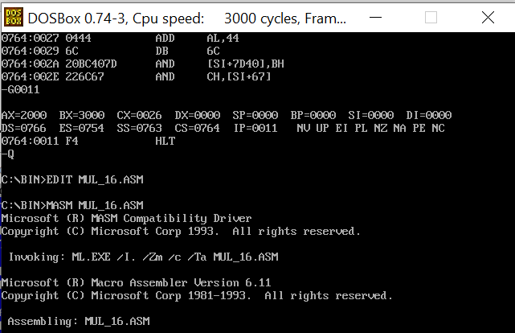

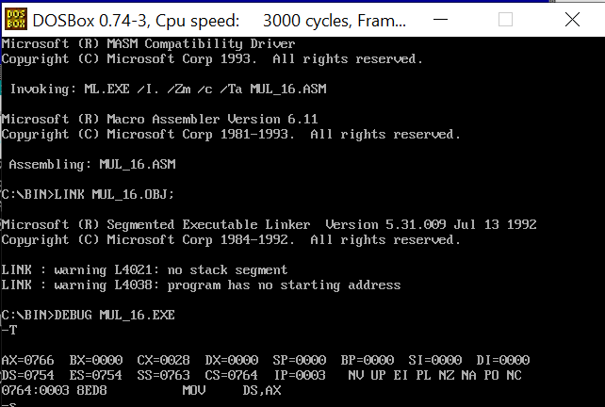

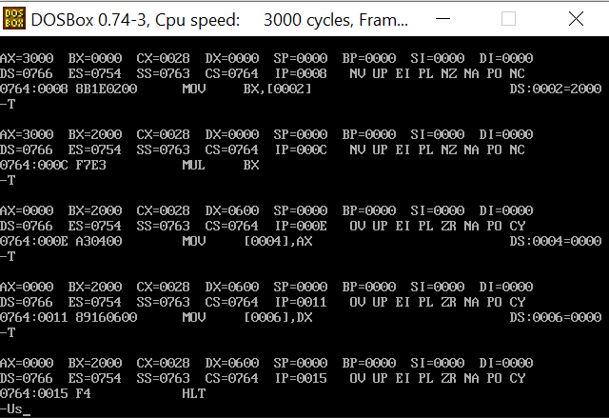

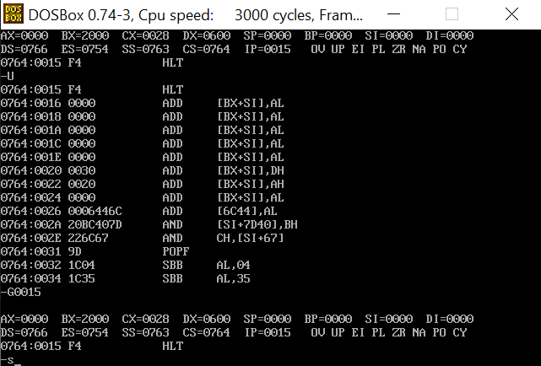

**4.DIVISION:**

