**CSE2006-MICROPROCESSERS AND INTERFACING(EMBEDDED LAB)**

**NAME**: O G RAGAVI

**REG NO:** 20BCE1988

**EX NO:** 12

**TITLE**: HARDWARE IMPLEMENTATION OF 8086 INTERFACED WITH 7-SEGMENT DISPLAY.

**AIM:** To write a 8086 ASM program to display the characters in seven segment display.

**MATERIALS REQUIRED**: 8086 processor interfaced with 7-segment display.

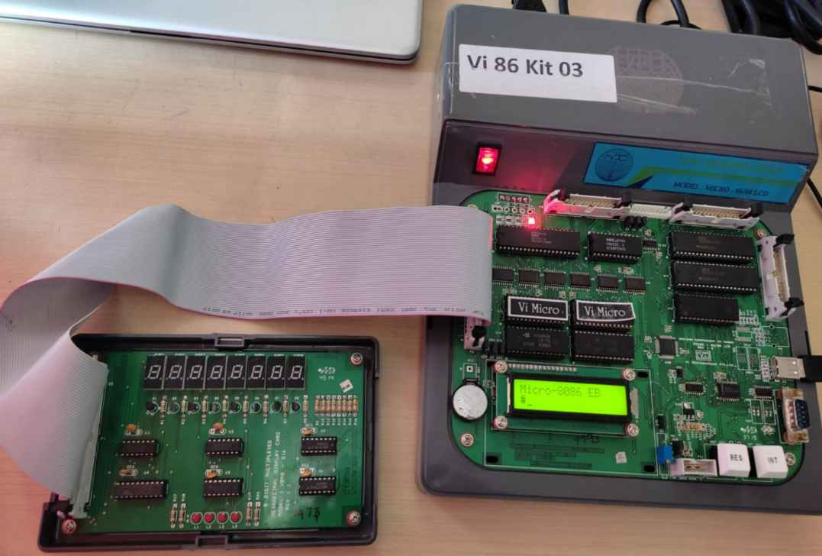

**1.Q) 7-SEGMENT DISPLAY.**

**CODE:**ENTER A

ENTER THE START ADDRESS

NOTE THE ADDRESS FOR LABEL2

LABEL2: MOV SI,1200H

MOV BL,03H

NOTE THE ADDRESS FOR LABEL1

LABEL1: DEC BL

MOV AL,BL

OUT C0,AL

MOV AL,[SI]

OUT C8,AL

CALL DELAY( enter some random address)

INC SI

CMP BL,00H

JNZ LABEL1( write the found address of label1)

JMP LABEL2(write the found address of label2)

HLT

MOV CX,0FFH

LABEL3: LOOP LABEL3(note the address of label3)

RET

**OUTPUT: (IN 8086)**

1200: 7C

1201: 5F

1202: 78

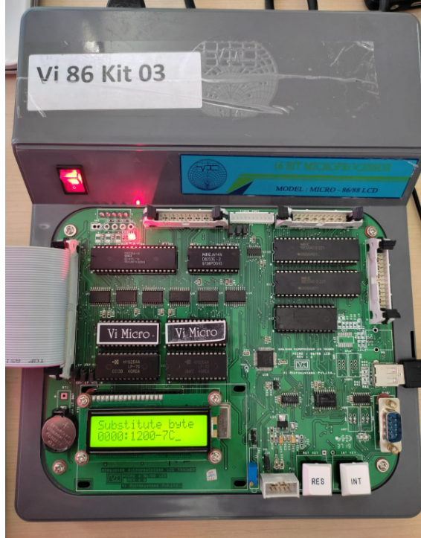

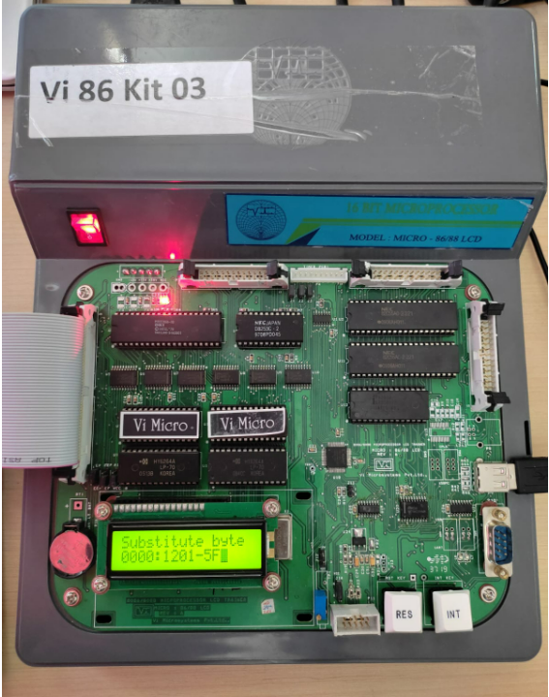

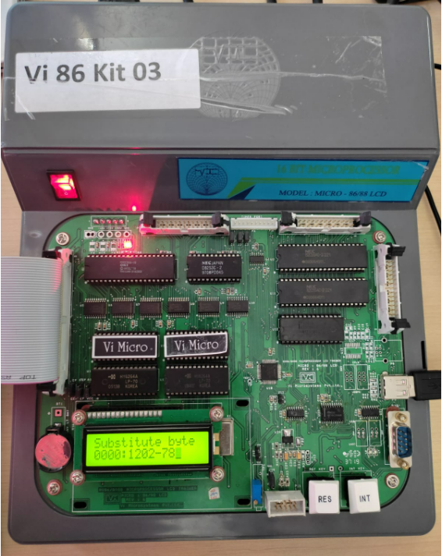

**OUTPUT: (IN 7-segment display)**

bat

