**CSE2006- MICROPROCESSORS (EMBEDDED LAB)**

**NAME: O G RAGAVI REG NO:20BCE1988**

**EX:2**

**TITLE: ASCENDING AND DESCENDING ORDER**

**AIM:** To arrange the elements of the array in ascending and descending order using assembly language.

**TOOL USED:** Assembler - MASM 611

**ALGORITHM:**

1.Two counters are used in this program i.e CH and CL which are initialized to n-1,where n is the no of elements of the array.

2.Inside the outer loop ,the effective address of the array is being loaded into the stack index(SI)

3.The inner loop is then initiated where A[i] value is stored in AL and A[i+1] value is stored BL. Both the values are compared;

If there is a carry or (A[i]<A[i+1]), then SI is incremented,Cl is decremented and inner loop continues on the condition(CL!=0)

Else if there is no carry or (A[i+1]<A[i]) ,then we swap the values in A[i] and A[i+1] using DL as temporary storage.

4.After completion of inner loop everytime,we decrement CH by one and continue with outer loop on the condition that (CH!=0).

**1.ASCENDING ORDER:**

**CODE:**

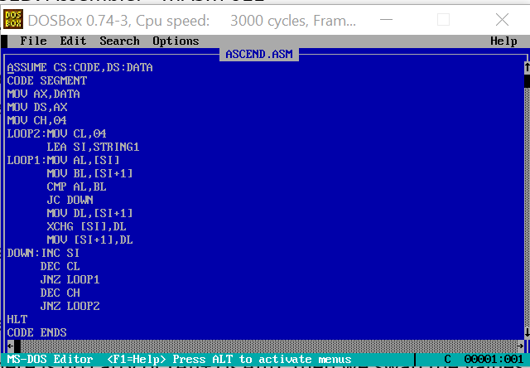

**OUTPUT:**

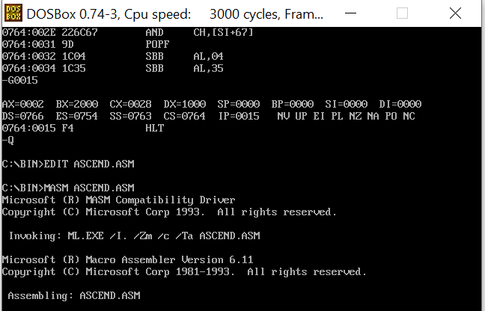

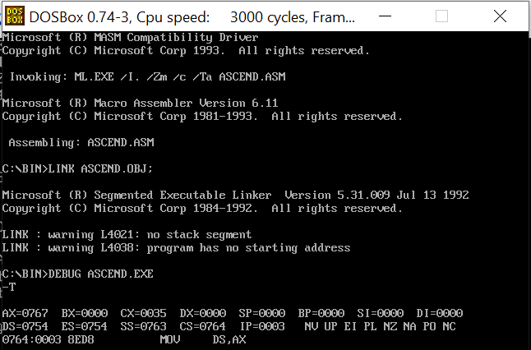

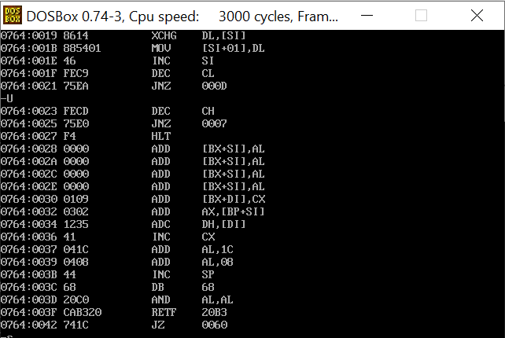

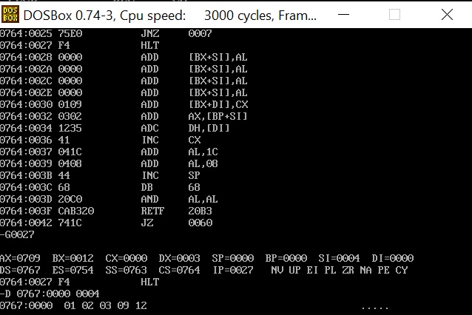

**2.DESCENDING ORDER:  
CODE:**

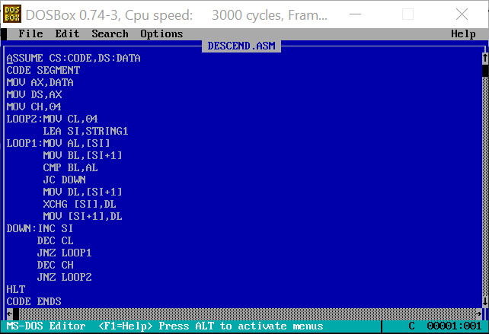

**OUTPUT:**

