**CSE2006-MICROPROCESSORS (EMBEDDED LAB)**

**NAME:** O G RAGAVI

**REG NO**: 20BCE1988

**LAB EX NO**: 7

**TOPIC**: ADDING TWO ARRAYS AND CHECKING IF A STRING IS A PALINDROME OR NOT.

1. ADDING TWO ARRAYS AND STORING THE RESULT IN ANOTHER ARRAY ‘Z’.

**ALGORITHM:**

* Load the data (array a and array b ) into the data segment.
* Initialize another array z for storing the result.
* Initialize the BX register to be 0,it is used to increment the index of the array.( say i=0)
* The no of elements of the array is stored in the CL register. The offset of the array z is stored in the destination index (DI).
* Inside the loop;

Move a[i] into AL

Add a[i] with B[i]

Increment the value of BX(i)

Store the result into array z

Decrement CL value

Move to loop if (CL!=0)

* Give INT 3H command for successful execution of the program.

**CODE:**

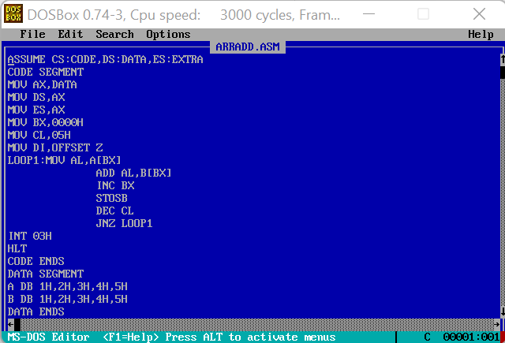

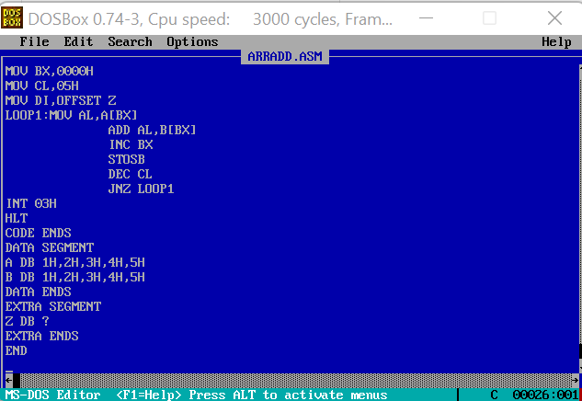

**SAMPLE INPUT:**

A 1H,2H,3H,4H,5H

B 1H,2H,3H,4H,5H

**SAMPLE OUTPUT:**

2H,4H,6H,8H,0AH

**OUTPUT:**

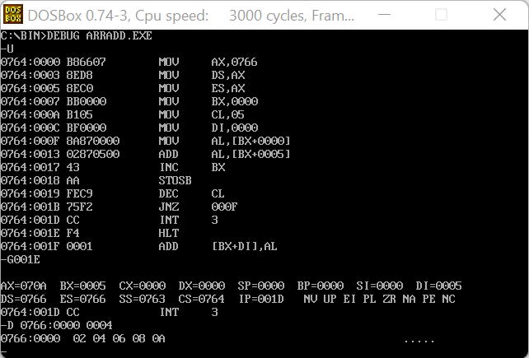

**REGISTER CONTENTS:**

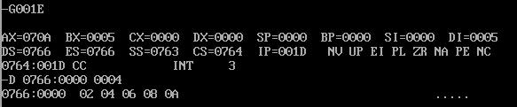

1. TO CHECK WHETHER THE GIVEN STRING IS A PALINDROME OR NOT:

**ALGORTIHM:**

**CODE:**

1. Store the string in data segment. Also store a variable to store the length of the string

2. Allocate some space in the extra segment to store the reverse of the string.

3. Add the length of the string to the pointer of the first string to go the last letter.

4. Move this character as the first letter in the extra segment.

5. Repeat the process by decrementing the pointer of first string and incrementing the pointer of the extra segment pointer.

6. After that use REP CMPSB to compare both the strings.

7. Print “PALINDROME” if they are equal, else print “NOT PALINDROME”

8. End code

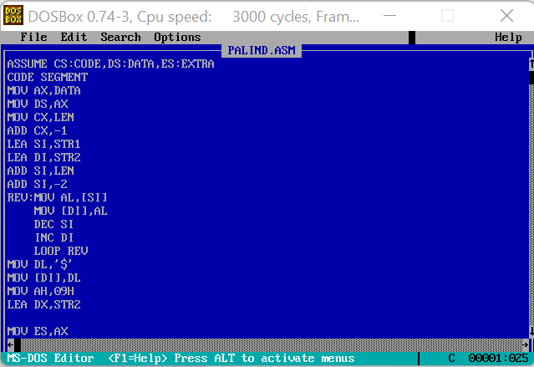

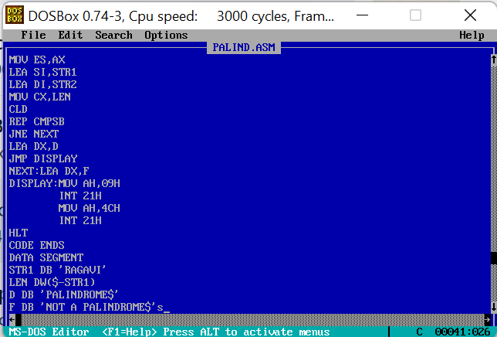

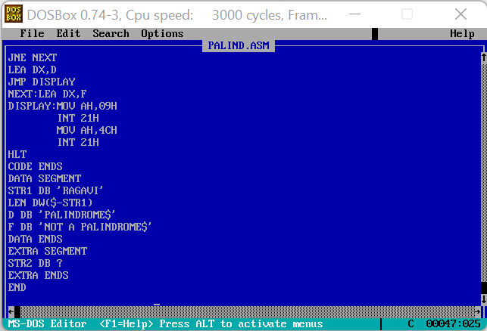

**SAMPLE INPUT1:** MADAM

**SAMPLE OUTPUT1:** PALINDROME

**SAMPLE INPUT2:** RAGAVI

**SAMPLE OUTPUT2:** NOT A PALINDROME

**OUTPUT 1:**



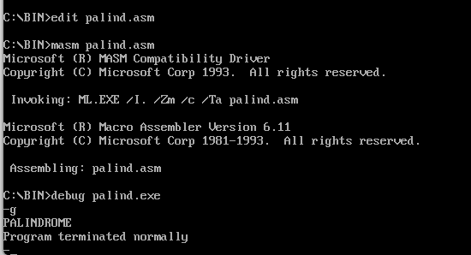

**OUTPUT 2:**





**RESULT:**

Hence, using the DOS BIOS we display the message to the monitor.

**INFERENCE:**

Hence, i) Two strings were added and the output is displayed in array z.

ii)Given a string , we are able to check whether it is a palindrome or not.