K.G. SHANKIYA 20BCE1528

Exp. 8 Square root of a number, Checking Whether the given number is even or odd, GCD and LCM

**Aim:** To implement (i)square root of a number (ii) Checking Whether the given number is even or odd (iii) GCD and LCM using the 8086 processor by MASM 611

assembler.

# Tool Used:

Assembler - MASM 611

# Steps:

Open the Dosbox Icon from Desktop or from Start menu Default Dosbox window have only Z:\>

1. Step to Mount c drive, type the command mount c c:\masm611
2. Then type C:\>
3. Then open the bin folder by using the command cd bin
4. Then create the new files by command edit filename.asm command
5. After saving code in files we assemble it by the command masm filename.asm
6. Then link it by command link filename.obj;
7. Then execute it using command debug filename.exe
8. Then type t to undergo execution process
9. Type u for identifying the address HLT
10. Type g 000F to view the register value
11. Then type q to quit

# 1.Square root of a number

**Algorithm:**

1. Inside the code segment, move zero value to CX and 64 to BX
2. In LOOP1, Move CX to AX and multiply CX and compare BX and AX and jump to STORE if flag value is 1 and increment CX and then jump to loop1 if flag value is 0.
3. In STORE, halt the program and then end the code segment and the start of the segment

# Program:

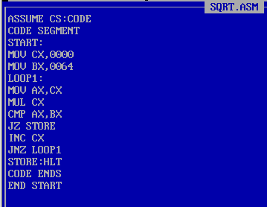

**Output: Sample input:** 64

**Sample output:**

8

# Register and memory content for I/O:

AX:0040 BX:0040 CX:0008

# Snapshots of Output:

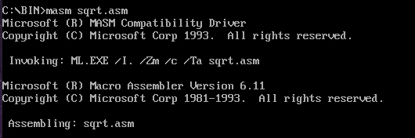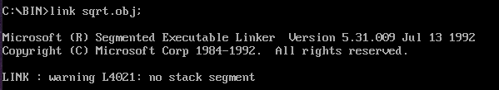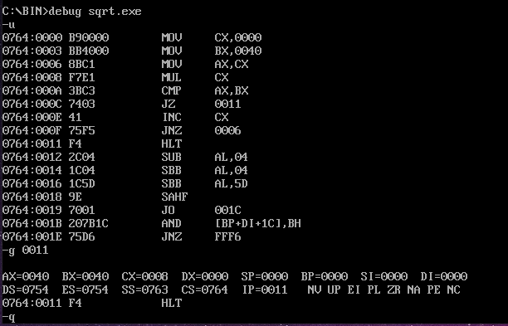

**2. Checking Whether the given number is even or odd Algorithm:**

1. Inside data segment, initialise the NUM as 6 and then making the mgs1 and msg2 point to number is even and odd respectively and end the data segment.
2. Inside the code segment, move the data to AX and moving AX to DS and then move the num to AX and rotate right AX by 1 and jump to odd if carry flag value is 1.
3. Then move offset to DX and display the string then call the interrupt handler and then jump to EXIT.
4. In odd, move the offset of m2 to dx and display the string then call the interrupt handler.
5. In EXIT, then move 4CH to AH to terminate the program and again use dos interrupt.
6. Then end the code segment and the start of the segment

# Program:

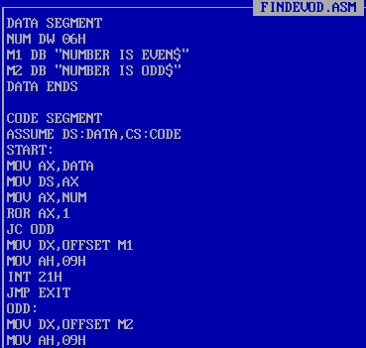

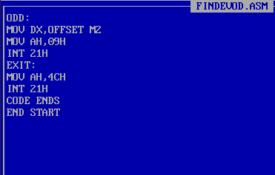

**Output:**

**Sample input:**

6

# Sample output:

NUMBER IS EVEN

# Register and memory content for I/O:

AX: 0000 DX:0011 DS:0764

# Snapshots of Output:

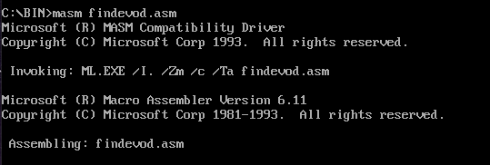

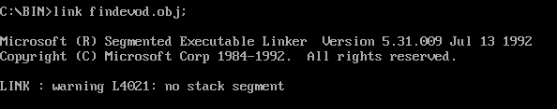

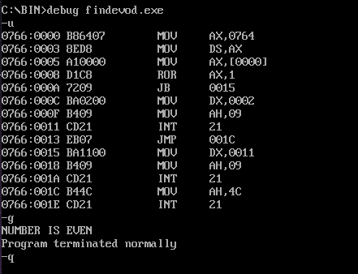

**3. GCD and LCM Algorithm:**

1. Compare two numbers and if they are equal then gcd=n2 and then goto step 5
2. If they are equal then GCD is equal to N2 and then multiply N1 and N2
3. If N1 is less than N2, swap N1, N2
4. Divide N1 by N2,if remainder is 0 then N2 is GCD and then goto step 5 and else take N2 as N1,then remainder as N2 then repeat step 4
5. multiply N1 and N2
6. Divide the product with GCD and Quotient is the LCM

# Program:

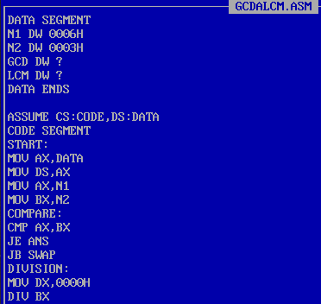

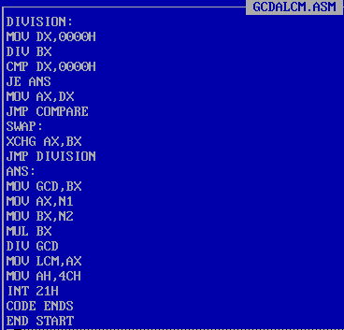

**Output:**

**Sample input:**

NUM1 6H NUM2 3H

# Sample output:

GCD: 3

LCM: 6

# Register and memory content for I/O:

AX:0006 BX:0003 DX:0000

# Snapshots of Output:

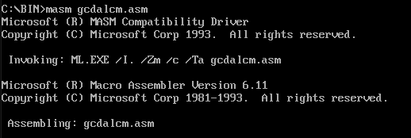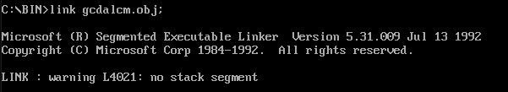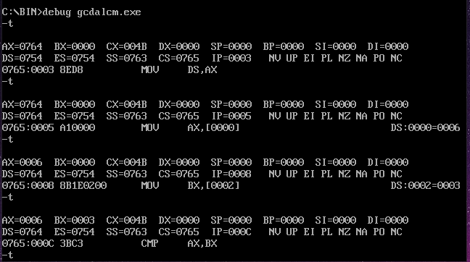

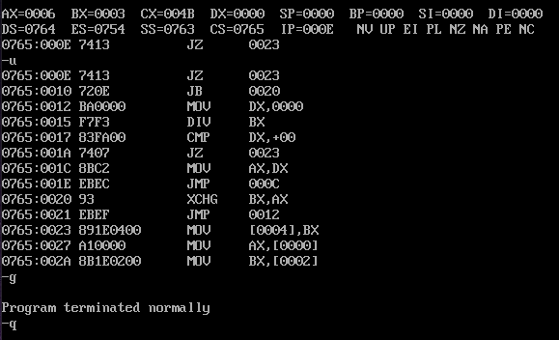

**Result:**

Hence, the operations like implement (i)square root of a number,(ii) Checking Whether the given number is even or odd,(iii) GCD and LCM are performed successfully using MASM611 assembler