**CSE2012-LAB**

NAME : O G RAGAVI

REG NO: 20BCE1988

EX NO: 6

**TITLE:** LONGEST COMMON SUBSEQUENCE

**LAB PRACTICE SHEET:**

**1.BRUTE FORCE APPROACH FOR FINDING LCS:**

**CODE:**

/* A Naive recursive implementation of LCS problem */

#include <bits/stdc++.h>

using namespace std;

int lcs( char *X, char *Y, int m, int n )

{

if (m == 0 || n == 0)

return 0;

if (X[m-1] == Y[n-1])

return 1 + lcs(X, Y, m-1, n-1);

else

return max(lcs(X, Y, m, n-1), lcs(X, Y, m-1, n));

}

int main()

{

char X[] = "ARABIAN";

char Y[] = "INDIAN";

int m = strlen(X);

int n = strlen(Y);

cout<<"Length of LCS is "<< lcs( X, Y, m, n ) ;

return 0;

}

**OUTPUT:**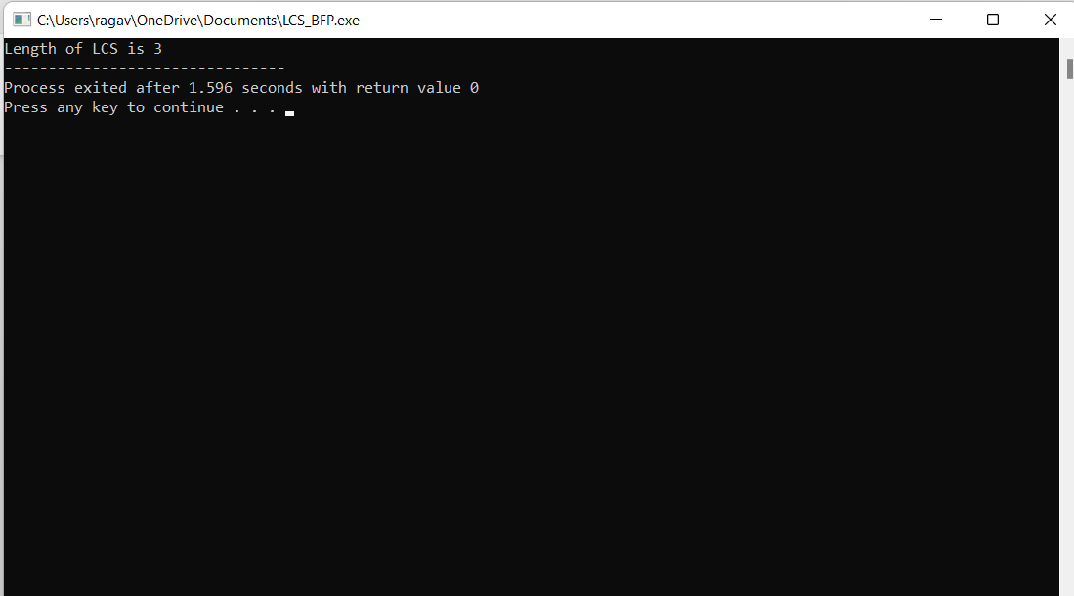

**2.RUNNING TIME COMPUTATION:**

|  |  |  |
| --- | --- | --- |
| m | n | T1(p)(in seconds) |
| 2 | 3 | 0.8701 |
| 4 | 5 | 1.237 |
| 7 | 5 | 1.515 |
| 8 | 3 | 1.751 |
| 5 | 5 | 1.865 |

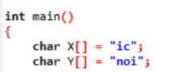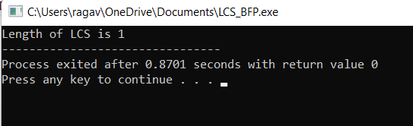

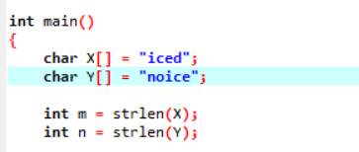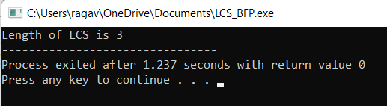

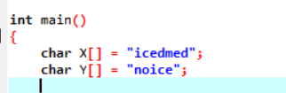

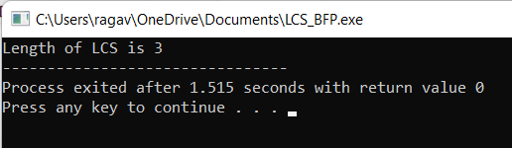

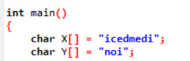

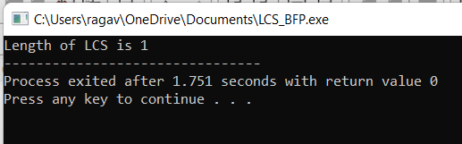

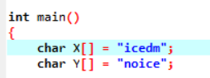

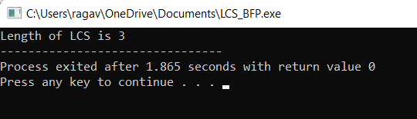

**3.DYNAMIC PROGRAMMING ALGORTIHM FOR LCS:**

CODE:

// Recursive routine

#include<iostream>

using namespace std;

#include<limits.h>

#include<vector>

int lcs_length(string x, string y, int x_index,int y_index)

{

int m,n,i,j,l1,l2;

m = x.length();

n = y.length();

if((x_index>=m)||(y_index>=n))

return 0;

if(x[x_index]==y[y_index])

{

return lcs_length(x,y,x_index+1,y_index+1)+1;

}

else

{

l1 = lcs_length(x,y,x_index,y_index+1);

l2 = lcs_length(x,y,x_index+1,y_index);

return l1>l2? l1: l2;

}

}

int main()

{

string x,y;

int i,j;

cin>>x>>y;

cout<<lcs_length(x,y,0,0);

}

**OUTPUT:**

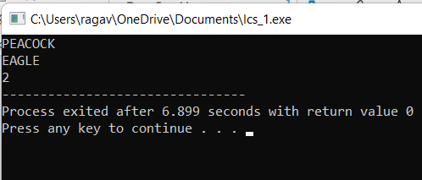

4.RUNNING TIME COMPUTATION:

|  |  |  |
| --- | --- | --- |
| m | n | T2(p)(in seconds) |
| 2 | 3 | 3.042 |
| 4 | 5 | 5.144 |
| 7 | 5 | 7.188 |
| 8 | 3 | 4.801 |
| 5 | 5 | 6.115 |

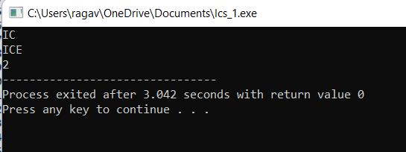

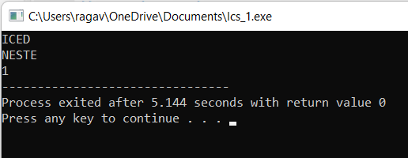

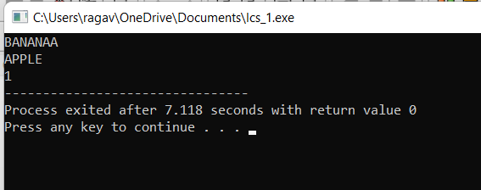

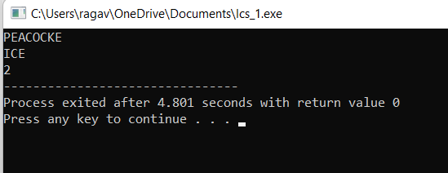

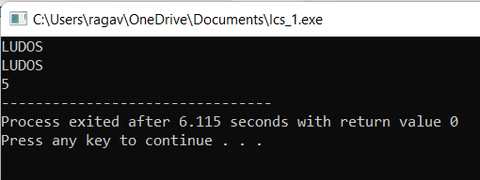

5.COMPARISON OF RUNNING TIME:

|  |  |  |  |
| --- | --- | --- | --- |
| m | n | T2(p)(in seconds) | T1(P) |
| 2 | 3 | 3.042 | 0.8701 |
| 4 | 5 | 5.144 | 1.237 |
| 7 | 5 | 7.188 | 1.515 |
| 8 | 3 | 4.801 | 1.751 |
| 5 | 5 | 6.115 | 1.865 |

6.GRAPH:

**7.RUNNING TIME COMPUTATION:**

|  |  |  |
| --- | --- | --- |
| m | n | T2(p) |
| 3 | 3 | 2.819 |
| 4 | 5 | 4.499 |
| 6 | 7 | 6.967 |
| 9 | 8 | 13.16 |
| 8 | 3 | 6.018 |

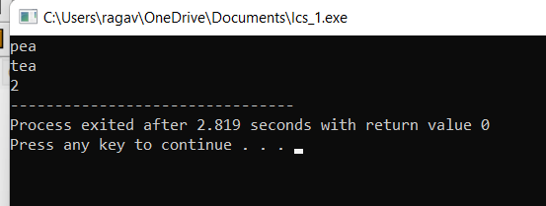

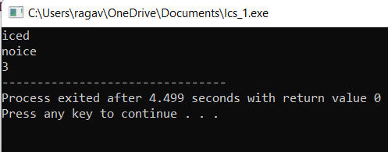

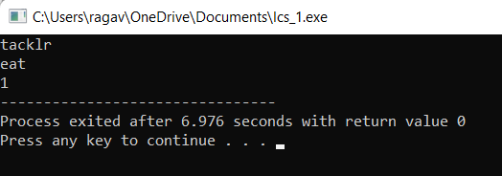

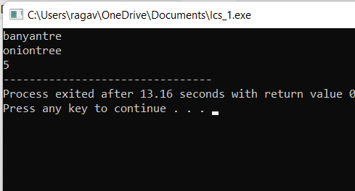

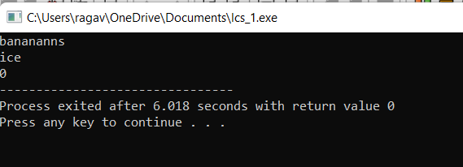

5.